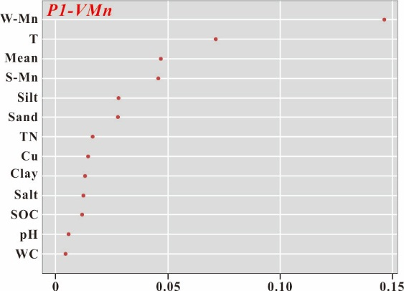 | 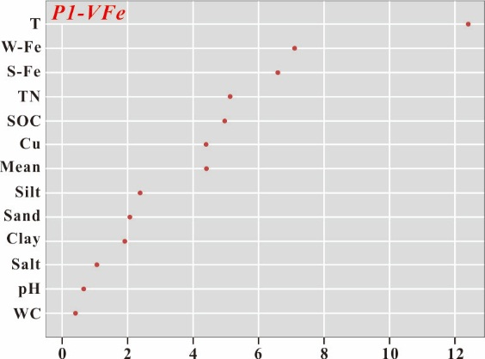
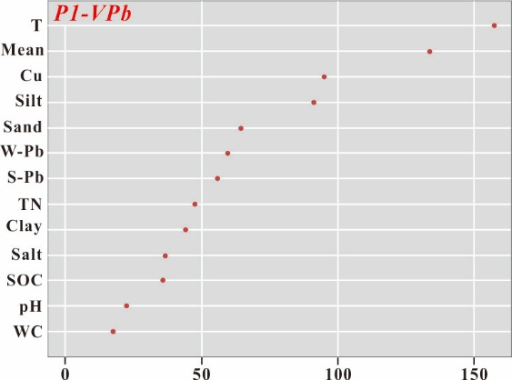 | 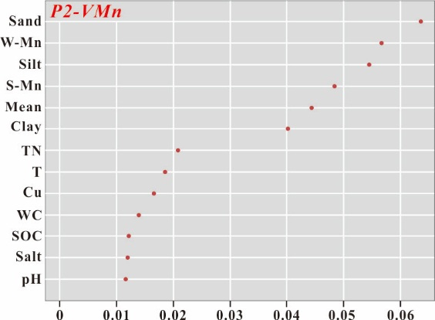
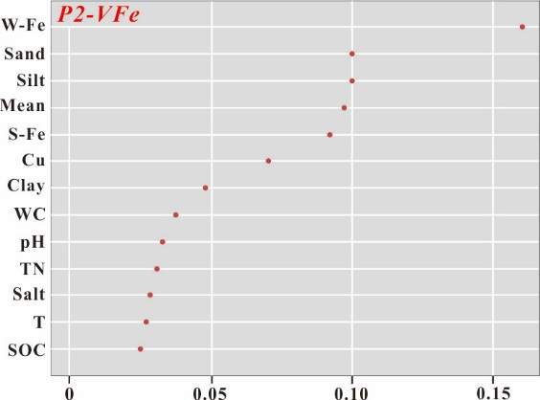 | 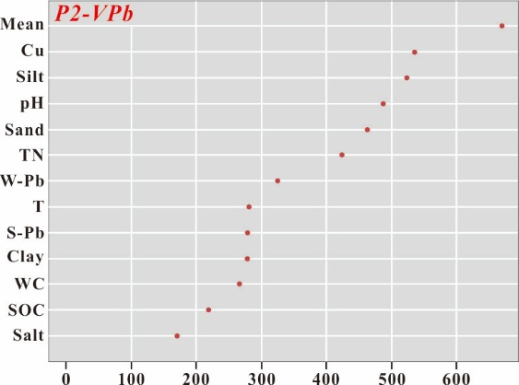
Fig. S2. This quantitatively describe importance of thirteen parameters for manganese, iron and lead content in maize for P1 and P2 profiles using the Gini index of random forest method. The higher the Gini index is, the larger the relative importance of the parameter for the spatial variation of manganese, iron and lead.

