Supplementary Information for: Identification of mantle peridotite and a possible Iapetan ophiolite sliver in south Shetland, Scottish Caledonides

Supplementary Methods
Major element compositions were measured by X-ray fluorescence (XRF) at Franklin and Marshall College using a PW 2404 PANalytical XRF vacuum spectrometer following the procedures outlined in Boyd & Mertzman (1987). Precision and accuracy for the average of 13 runs of BHVO-2 relative to USGS accepted values is estimated at <0.2% for SiO₂ and TiO₂, <1% for Al₂O₃, MgO, Fe₂O_{3T}, CaO, Na₂O, P₂O₅, and <3% for K₂O. Trace-element abundances were determined at the Scripps Isotope Geochemistry Laboratory (SIGL), with a Thermo Scientific iCAPq quadrupole inductively coupled plasma mass spectrometer, using methods described previously in Day et al. (2014). Samples were prepared with international and internal rock standards (BHVO-2, BIR-1, BCR-2, AGV-2, DTS-2b, GP-13). Reproducibility of the basaltic reference materials was generally better than 5% (RSD), and 10% (RSD) for peridotite standards.

Osmium isotope and HSE abundance analyses were performed at the SIGL. Homogenised powder aliquots were prepared along with total analytical blanks and were digested in sealed borosilicate Carius tubes, with isotopically enriched multi-element spikes (⁹⁹Ru, ¹⁰⁶Pd, ¹⁸⁵Re, ¹⁹⁰Os, ¹⁹¹Ir, ¹⁹⁴Pt), and 11 mL of a 1:2 mixture of Teflon-distilled HCl and HNO₃ that was purged of Os by reaction with H₂O₂. Samples were digested to a maximum temperature of 270˚C in an oven for 72 hours. Osmium was triply extracted from the acid using CCl₄ and then back-extracted into HBr (Cohen & Waters, 1996), prior to purification by micro-distillation (Birck et al., 1997). Rhenium and the other HSE were recovered and purified from the residual solutions using standard anion exchange separation techniques. Measurement protocols were identical to those described previously (e.g., Day et al., 2016). Isotopic compositions of Os were measured in negative-ion mode on a ThermoScientific Triton thermal ionisation mass spectrometer at the SIGL. Rhenium, Pd, Pt, Ru and Ir were measured using an Cetac Aridus II desolvating nebuliser coupled to a ThermoScientific iCAPq ICP-MS. Offline corrections for Os involved an oxide correction, an iterative fractionation correction using ¹⁹²Os/¹⁸⁸Os = 3.08271, a ¹⁹⁰Os spike subtraction, and finally, an Os blank subtraction. Precision for ¹⁸⁷Os/¹⁸⁸Os, determined by repeated measurement of the UMCP Johnson-Matthey standard was better than ±0.2% (2 St. Dev.; 0.11390 ±20; n = 5). Measured Re, Ir, Pt, Pd and Ru isotopic ratios for sample solutions were corrected for mass fractionation using the deviation of the standard average run on the day over the natural ratio for the element. External reproducibility on HSE analyses using the iCAPq was better than 0.5% for 0.5 ppb solutions and all reported values are blank-corrected. The total analytical blanks (n = 3) run with the samples had ¹⁸⁷Os/¹⁸⁸Os = 0.401 ± 0.010, with quantities (in picograms) of 4.2 ±1.3 [Re], 2.8 ±0.3 [Pd], 2.0 ±0.9 [Pt], 13.3 ±1.3 [Ru], 0.3 ±0.2 [Ir] and 0.2 ±0.1 [Os]. These blanks resulted in negligible corrections to samples (<1%).

Supplementary Discussion
Steatized rocks in the DSS have been recognized for some time, and were exploited by the Norse during their occupation of Shetland, for the manufacture of utensils (e.g., Jones et al., 2007). The anhydrous bulk-composition of the DSS talc-magnesite samples is similar to that of peridotite that has otherwise experienced extensive serpentinization and metasomatism. The bulk composition of the sample in this study, which has been steatitized and serpentinized, is broadly similar to that of the sample reported in Flinn & Moffat (1985), which was reportedly not steatitized. One principal difference is that the steatitized sample analysed in this study has much lower Mg. We suggest that this difference is due to Mg-loss or Si-gain (Malvoisin, 2015) during localized steatitization within the DSS ultramafic rocks. In the case of the DSS, alteration probably occurred in two distinct episodes. First, by serpentinisation of olivine in the reaction of forsterite → serpentine + brucite, idealized as:

2Mg₂SiO₄ + 3H₂O → Mg₃Si₂O₅(OH)₄ + Mg(OH)₂

Or through Si metasomatism in the reaction:

3Mg₂SiO₄ + 4H₂O + SiO₂ aq → 2Mg₃Si₂O₅(OH)₄

Followed by the carbonation of serpentine to form talc-magnesite, in the reaction:

2Mg₃Si₂O₅(OH)₄ + 3CO₂ → Mg₃Si₄O₁₀(OH)₂ + 3MgCO₃ + 3H₂O

Relative reduction in the Mg/Si and Al/Si ratios of peridotites has previously been demonstrated to occur during Si metasomatism (Paulick et al., 2006), although in the Dunrossness examples the low Mg in steatitized samples also leads to the possibility that loss of Mg occurred during carbonate metasomatism. The bulk compositions of our sample and that of Flinn & Moffat (1985) are therefore consistent with a peridotite protolith, an observation that is supported by the similarity in bulk composition observed between the DSS ultramafic rocks, and ultramafic rocks preserved in the SOC on Unst and Fetlar. Enrichments in Sr, Ba, Pb, U and Cs, the light REE and Eu all indicate extensive seafloor alteration of the talc-magnesite samples. The REE patterns measured in the talc-magnesite samples are similar to some serpentinized peridotites measured at the Mid-Atlantic Ridge. It has been demonstrated that vent fluids enriched in the LREE and Eu pervasively altered serpentinized peridotites at the Mid-Atlantic Ridge, 15°20′N, ODP Leg 209 (Paulick et al., 2006). In this circumstance, alteration began with serpentinization at 100-200°C under seawater-like pH values, followed by higher-temperature interactions at 300-400°C, with low pH (4-5) (e.g., Paulick et al., 2006).

The results strongly imply that the protolith to the talc-magnesite samples and, therefore, the sample measured by Flinn & Moffat (1985) - as the same outcrops were sampled - were peridotites that experienced variable degrees of serpentinization and/or steatitization in an oceanic environment. Based on prior studies of modern abyssal peridotites, most of the alteration experienced by the protoliths in the DSS could have occurred at a paleo- ridge setting, with no particular requirement for later alteration. Due to the extreme degrees of alteration of samples, it is difficult to ascertain if the protoliths were harburgite or dunite. The current data are permissive of dunitic protoliths, similar to those that make up variably thick (up to 10 m) channels and lenses in the harzburgitic mantle and the bulk of the lower crustal cumulate section in the SOC (e.g., Prichard, 1985; Flinn & Oglethorpe, 2005). Accessory Cr-spinel, usually relatively resistant to low-temperature modification, exhibits widespread alteration to more brightly reflective ferroan Cr-spinel. The ferroan Cr-spinel occurs as ragged rims on primary grains and within intra-grain microfractures. These complex alteration textures indicate there is comparatively little primary Cr-spinel remaining in the DSS samples.

In Table S1 we report present-day γ_{Os} values (-2.5 to -3.8) and rhenium depletion (T_{RD}) ages (or minimum melt depletion ages) of 0.7 to 1 Ga, assuming chondritic mantle evolution (after Shirey & Walker, 1998). These are similar to γ_{Os} values and T_{RD} ages reported for some SOC harzburgites and dunites (O’Driscoll et al., 2012). Assuming a similar Iapetus-aged heritage for the talc-magnesite samples from south Shetland, to the SOC, we also report γ_{Os} values at 495 Ma – the reported age of the SOC (Spray & Dunning, 1991). The γ_{Os} values at 495 Ma range from -1.9 to -13.6. The low γ_{Os} values likely reflect addition of Re after formation of the talc-magnesite samples as harzburgites or dunites, with addition of Re occurring during hydrothermal alteration.
Supplementary ReferencesBirck, J.-L., Roy-Barman, M., and Capmas, F., 1997. Re-Os isotopic measurements at the femtomole level in natural samples. Geostandards Newsletter, 21, 21-28.
Boyd, F.R., Mertzman, S.A., 1987. Composition and structure of the Kaapvaal lithosphere, southern Africa. In: Mysen, B.O. (Ed.) Magmatic processes – physiochemical principles. Geochemical Society Special Publications, 1, 13-24.
Cohen, A.S., Waters, F.G., 1996. Separation of osmium from geological materials by solvent extraction for analysis by thermal ionisation mass spectrometry. Analytica Chimica Acta, 332, 269-275.
Day J.M.D., Peters B.J., Janney P.E., 2014. Oxygen isotope systematics of South African olivine melilitites and implications for HIMU mantle reservoirs. Lithos, 202-203, 76-84.
Day J.M.D., Waters C. L., Schaefer B. F., Walker R. J., Turner, S., 2016. Use of Hydrofluoric acid desilicification in the determination of highly siderophile element abundances and Re-Pt-Os isotope systematics in mafic-ultramafic Rocks. Geostandards and Geoanalytical Research. 40, 49-65.
Flinn, D., Moffat, D.T., 1985. A peridotitic komatiite from the Dalradian of Shetland. Geological Journal, 20, 287-292.
Jones, R.E., Kilikoglou, V., Olive, V., Bassiakos, Y., Ellam, R., Bray, I.S.J., Sanderson, D.C.W., 2007. A new protocol for the chemical characterisation of steatite – two case studies in Europe: the Shetland Islands and Crete. Journal of Archaeological Science, 34, 626-641.
Paulick, H., Bach, W., Godard, M., De Hoog, J.C.M., Suhr, G., Harvey, J., 2006. Geochemistry of abyssal peridotites (Mid-Atlantic Ridge, 15 20′ N, ODP Leg 209): implications for fluid/rock interaction in slow spreading environments. Chemical Geology, 234, 179-210.
Puchtel, I.S., Blichert-Toft, J., Touboul, M., Walker, R.J., Byerly, G., Nisbet, E.G., Anhaeusser, C.R., 2013. Insights into early Earth from Barberton komatiites: evidence from lithophile isotope and trace element systematics. Geochimica et Cosmochimica Acta, 108, 63-90.
Prichard, H.M., 1985, The Shetland Ophiolite. In: Gee, D.G., Sturt, B.A. (Eds.) The Caledonide orogen: Scandinavia and related areas: Wiley and Sons, V. 2, p. 1173−1184.
Malvoisin, B., 2015. Mass transfer in the oceanic lithosphere: Serpentinization is not isochemical. Earth and Planetary Science Letters, 430, 75–85.
Revillon, S., Arndt, N.T., Chauvel, C., Hallot, E., 2000. Geochemical study of ultramafic volcanic and plutonic rocks from Gorgona Island, Columbia: The plumbing system of an oceanic plateau. Journal of Petrology, 41, 1127-1153.
Shirey, S.B., Walker, R.J., 1998. The Re-Os isotope system in cosmochemistry and high-temperature geochemistry. Ann. Rev. Earth Planet. Sci. 26, 423-500.
Spray, J.G., Dunning, G.R., 1991. A U/Pb age for the Shetland Islands oceanic fragment, Scottish Caledonides: evidence from anatectic plagiogranites in ‘layer 3’ shear zones. Geological Magazine 128, 667-671.
Sun, S.S. and McDonough, W.S., 1989. Chemical and isotopic systematics of oceanic basalts: implications for mantle composition and processes. Geological Society, London, Special Publications, 42(1), pp.313-345.
Supplementary Figures
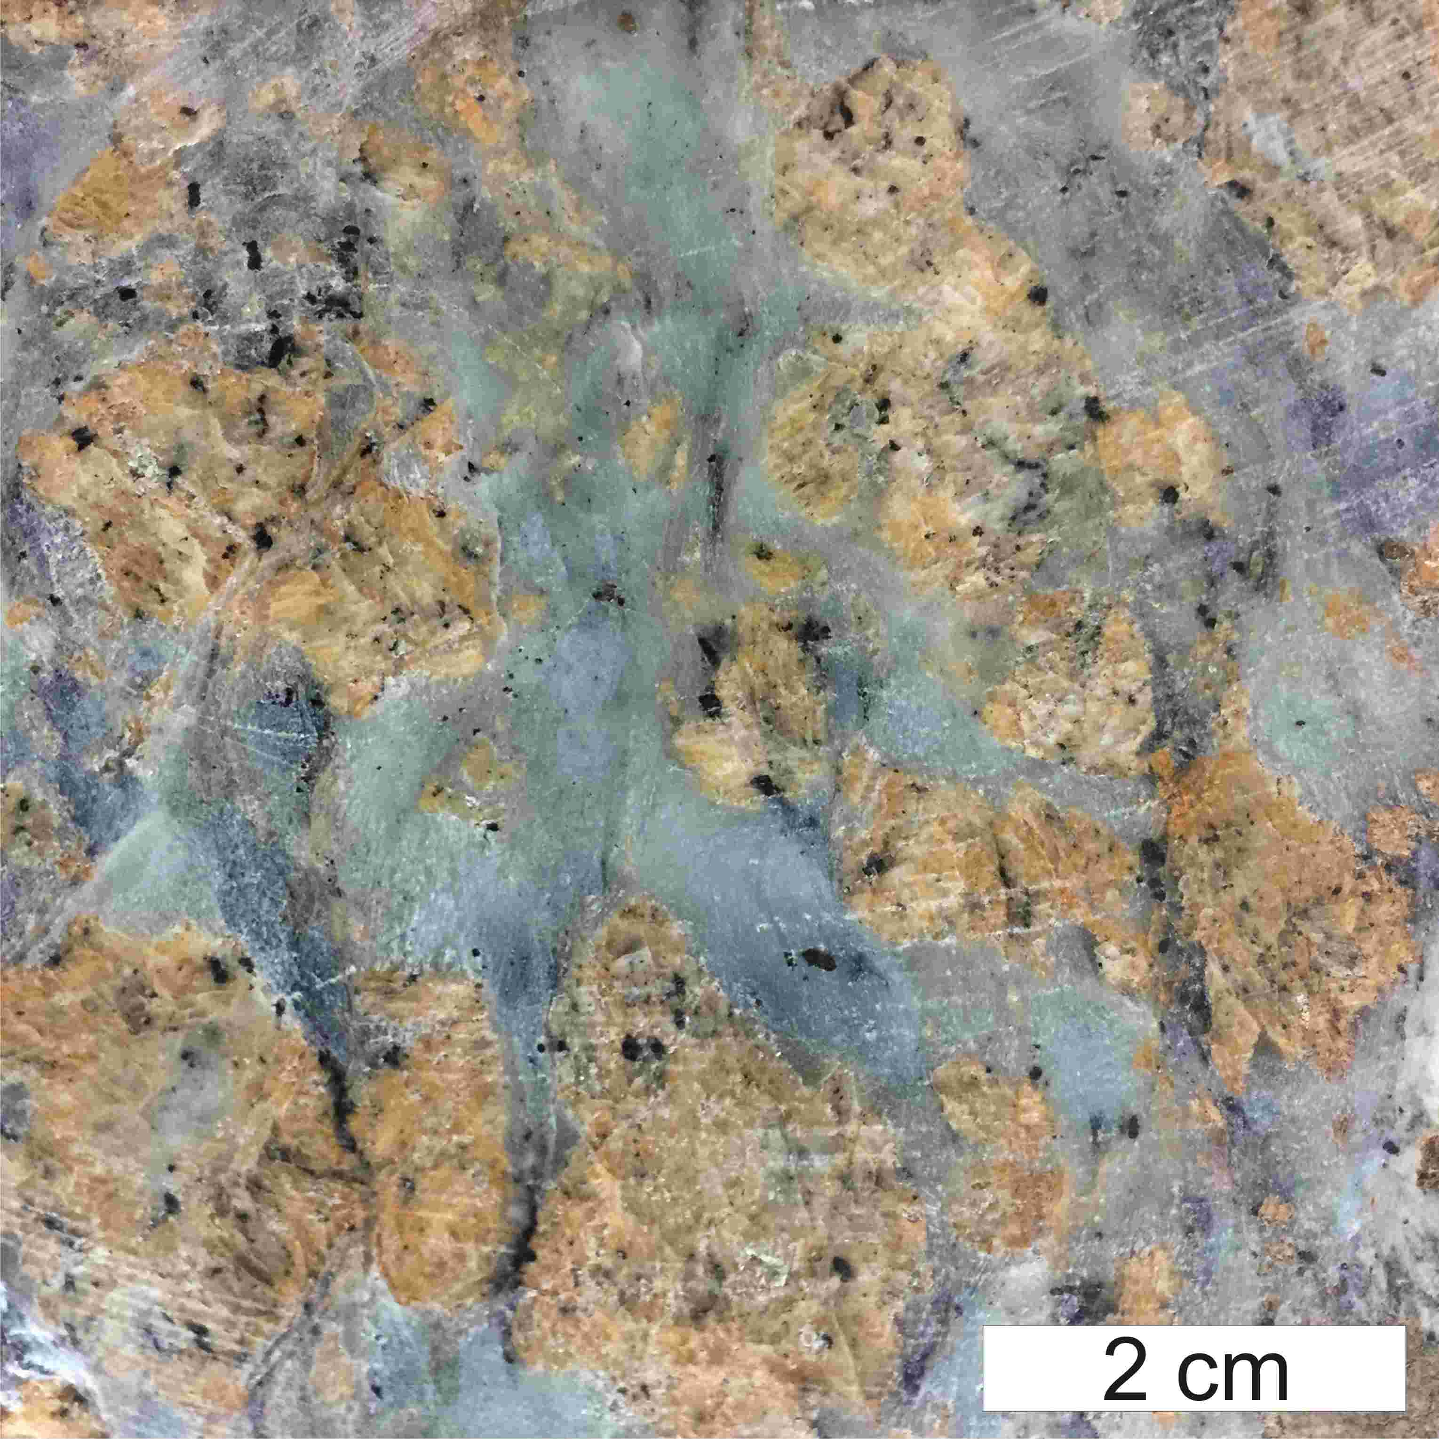

Figure S1 - Photograph of a slab-cut of one of the samples analysed in this study. The sample is a talc-magnesite metamorphic assemblage, representing the reaction of forsterite → serpentine + brucite, followed by carbonation of serpentine to form talc-magnesite. Magnesites are large orange-brown multi-crystalline masses within blue-green talc. Black grains are Cr-spinel, or alteration minerals after Cr-Spinel. Secondary pyrite is also visible in some portions of the samples.

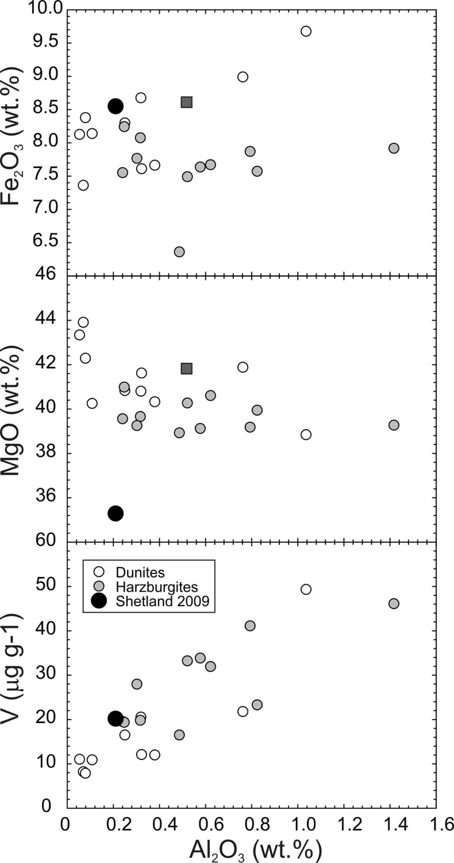

Figure S2 - Plots of Al₂O₃ versus Fe₂O₃, MgO and V for talc-magnesite samples from south Shetland (Shetland 2009), versus dunite and harzburgite compositions measured for the SOC, on Unst and Fetlar, from O’Driscoll et al. (2012). Also shown is the composition of the ‘Dalradian komatiite’ composition (filled square) from Flinn & Moffat (1985).

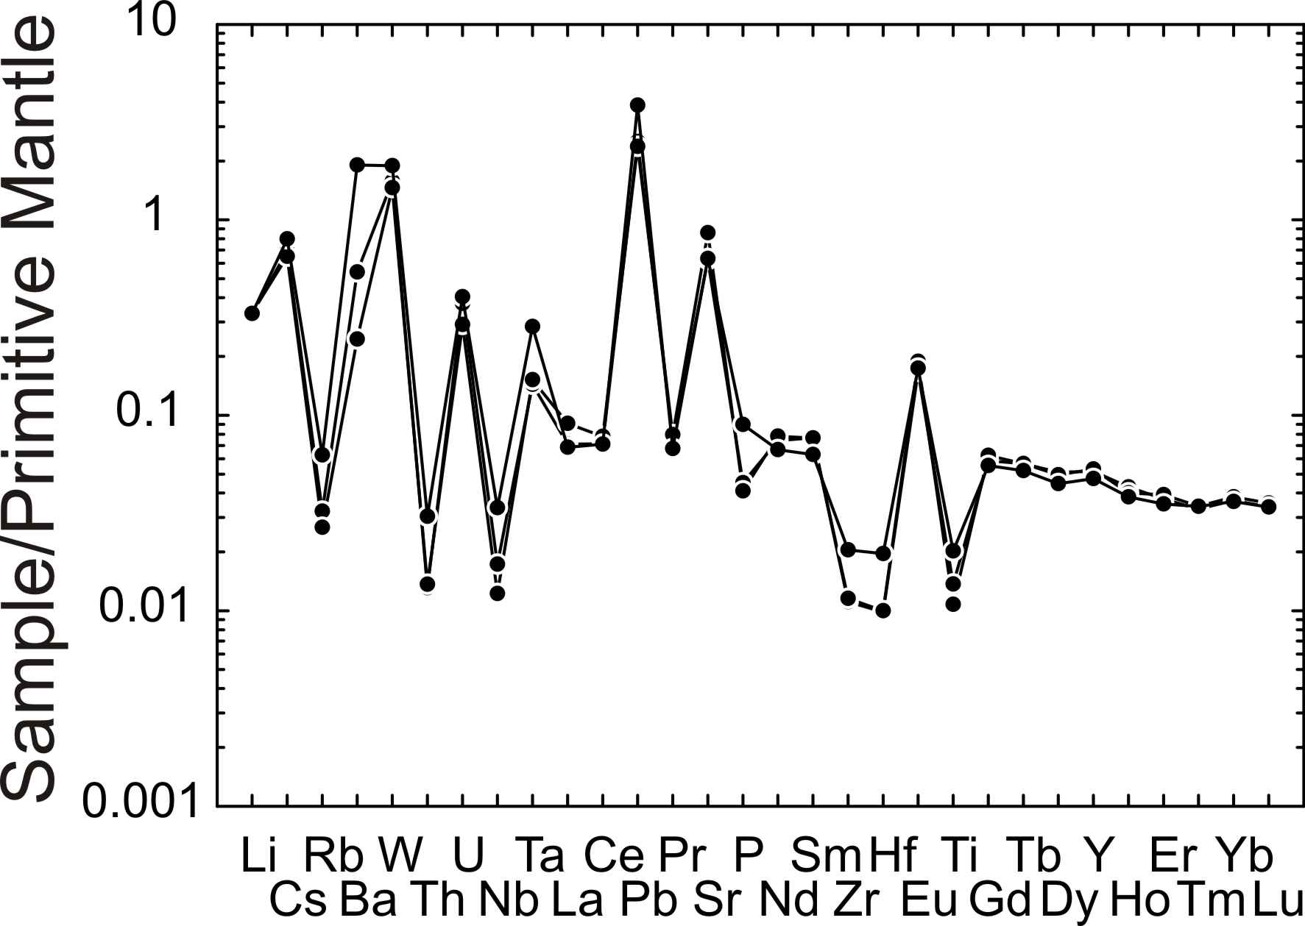

Figure S3 - Incompatible trace element patterns for talc-magnesite samples from South Shetland, normalized to a primitive mantle composition (Sun & McDonough, 1989), with increasing compatibility to the right.

