Section S1 – Amalgamation ratio.
The amalgamation ratio has been calculated for each study site. The amalgamation ratio within this paper is defined as the fraction of channel-belt bases that are in contact (i.e. amalgamated) with lower channel-belts, modified from Zhang et al. (2013). For each channel base the total length of channel-on-channel contact (blue in Fig. S1.1) was divided by the total length of the channel base (red vertical line in Fig. S1.1). The sum of all channel-on-channel contacts within the panel were then divided by the sum of all channel base lengths, and then multiplied by 100 so that the amalgamation ratio within a panel could be expressed as a percentage. Table S1 shows the calculations for each site.
 | Sandstone body | Total Sandstone body length (m) | Channel-on-channel contact length (m) | Amalgamation ratio (%)  (length of channel-on-channel contact / Total channel belt length, X 100)
Proximal | 1 | 375 | 139 | 37
 | 2 | 500 | 205 | 41
 | 3 | 500 | 340 | 68
 | 4 | 500 | 205 | 41
 | 5 | 500 | 50 | 10
 | 6 | 300 | 87 | 29
 | 7 | 475 | 38 | 8
 | 8 | 500 | 500 | 100
 | 9 | 500 | 0 | 0
 | Whole panel | 4150 | 1564 | 38
Medial | 1 | 900 | 567 | 63
 | 2 | 900 | 0 | 0
 | 3 | 900 | 90 | 10
 | 4 | 900 | 0 | 0
 | 5 | 900 | 0 | 0
 | 6 | 300 | 0 | 0
 | 7 | 900 | 0 | 0
 | Whole panel | 5700 | 657 | 12
Distal | N/A. No amalgamation observed.

Table S1. Table showing calculations for the amalgamation ratio for each site. Note that lengths are for the panels shown in Figure S1, not for the whole outcrop photo.

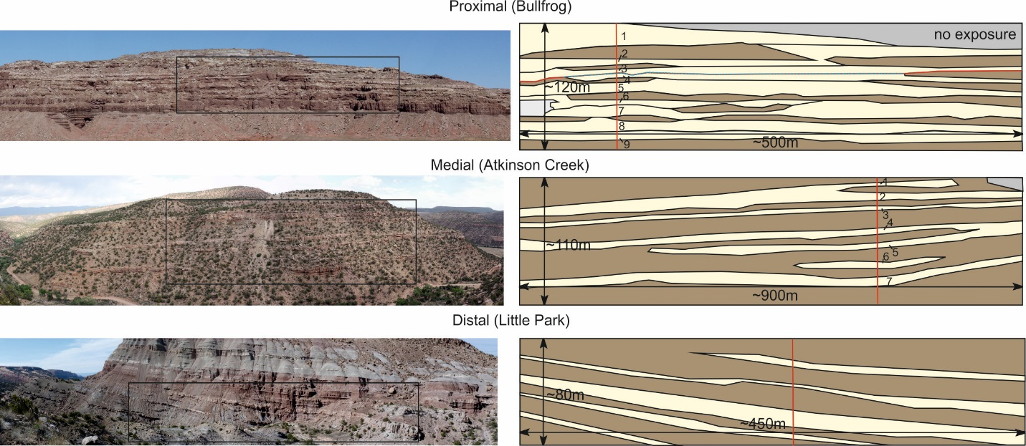
Figure S1.1. Panels for proximal, medial and distal locations on the Salt Wash DFS. See Figure 1A for location. Box on the photo panel indicates where the interpretation panel has been taken from. Red vertical line indicates where on the interpretation panel the number of sandbodies has been defined. See table S1 for statistics on each sandbody. Numbers define the sandbody number in Table S1. Colour on the interpreted panels: yellow = channel deposits, brown = floodplain, grey = no exposure.

