Supplementary Material for

Pangea's breakup: The roles of mantle plumes, orogens, and subduction retreat
By Zhuo Dang¹, Nan Zhang^{1,2}, Zheng-Xiang Li² and Peilong Yan¹

Model Setup of Australia-Antarctica breakup.

Initial conditions. In order to achieve a reasonable initial mantle structure beneath the supercontinent, we perform a three-step calculation based on previous models^{15, 21} as well as geological constraints. For the first step, we first set our model using an initial temperature profile obtained from the statistical steady-state thermal field of a pre-calculation (Supplementary Fig.1). Secondly, we use the steady-state temperature field profile from the purely thermal convection model as the initial temperature condition, and introduce reconstructed subductions as weak zones. We then use the reconstructed Pangea supercontinent at 200 Ma with orogens and a pre-existing Pacific LLSVP, and run the model for up to 150 Myr to generate a global 3D mantle structure and an appropriate upper-mantle thermal status under the supercontinent. This will avoid the influence of the initial 3D return flow structures. In the third step, the Africa LLSVP is now introduced to promote the plumes under Pangea (More details see Dang et al., 2020)
In order to obtain the recorded Karoo, Ferrer, and Kerguelen plumes, we examine the effects of the circum-Australia subduction history on the plume locations. Being different from Dang et al. (2020), we add a south-dipping subduction, initializing between 155 and 130 Ma, at the north margin of Australia based on the recent reconstruction (Yan et al., 2021). Our modelled plume locations and timings for Karoo and Ferrer are not sensitive to the reconstructed circum-Australia subduction. However, the generation of Kerguelen plume is largely changed by the initialization time of the south-dipping subduction. To reproduce the observed Kerguelen plume, we try using two alternatively initialization times, either starting from 155 Ma or 130 Ma, respectively, for the south-dipping subduction. When we initiate the south-dipping subduction, we set up a prior weakzone 10s of Myrs before the subduction initialization time to obtain a stable subducting slab (with the surface horizontal convergence velocity of ~5 cm/yr). We update the subduction history every 1 Myr from 155 or 130 Ma to the present day. The subduction migration was achieved by manually relocating the low viscosity weak zone for every 1 Myr. We find that when we chose to introduce the prior weakzone at 170 Ma (i.e., 15 Myrs before 155 Ma) for the south-dipping subduction, a relatively reasonable Kerguelen eruption time is achieved.
Classification of cratons, orogens and oceanic lithosphere by age. In our model, we use the IGCP 648 database for orogens >0.7 Ga⁴. We subdivided continental lithosphere by orogenic ages. Orogens of 2.2–1.6 Ga are those related to the assembly of the Nuna supercontinent. Orogens of 1.6–0.7 Ga are generally those related to the assembly of the Rodinia supercontinent. Orogens of 0.7–0 Ga ages are those related to the assembly of Gondwana and Pangea, and those formed after Pangea break-up (Fig. 2). Supplementary Fig. 1 represents simplified continental crustal ages. For standard model (Supplementary Fig. 1a), we give Archean cratons and Proterozoic orogens of >1.6 Ga a strong physical properties featuring larger thickness (190 km), and high viscosity (100 in non-dimensional viscosity). Orogens of 1.6–0.7 Ga ages are assigned an intermediate strength (140 km in thickness and 60 in non-dimensional viscosity) between that for the cratons and that of <0.7 Ga orogens. Orogens of <0.7 Ga are defined as weak zones (young orogens) which have weaker continental lithosphere (100km in thickness and 30 in non-dimensional viscosity) than the cratons.

Supplementary Table 1 Summary of breakup events and related plume events during Pangea break-up.
Break Event | Break Time | Plume (LIP) | Plume Eruption Time
N America and  S America- Africa | ca. 195 Ma | CAMP | 201 Ma
S America and  India-Antarctica | 170 Ma | Karoo | ca. 183 Ma
S America and  Africa | ca. 134 Ma | Parana-Entendeka | 134-132 Ma
India and  Antarctica-Australia | ca. 132 Ma | Kerguelen | 134-100 Ma
Antarctica and  Australia | ca. 100 Ma | — | —
N America and  Eurasia | ca. 65 Ma | NAIP | 65-55 Ma

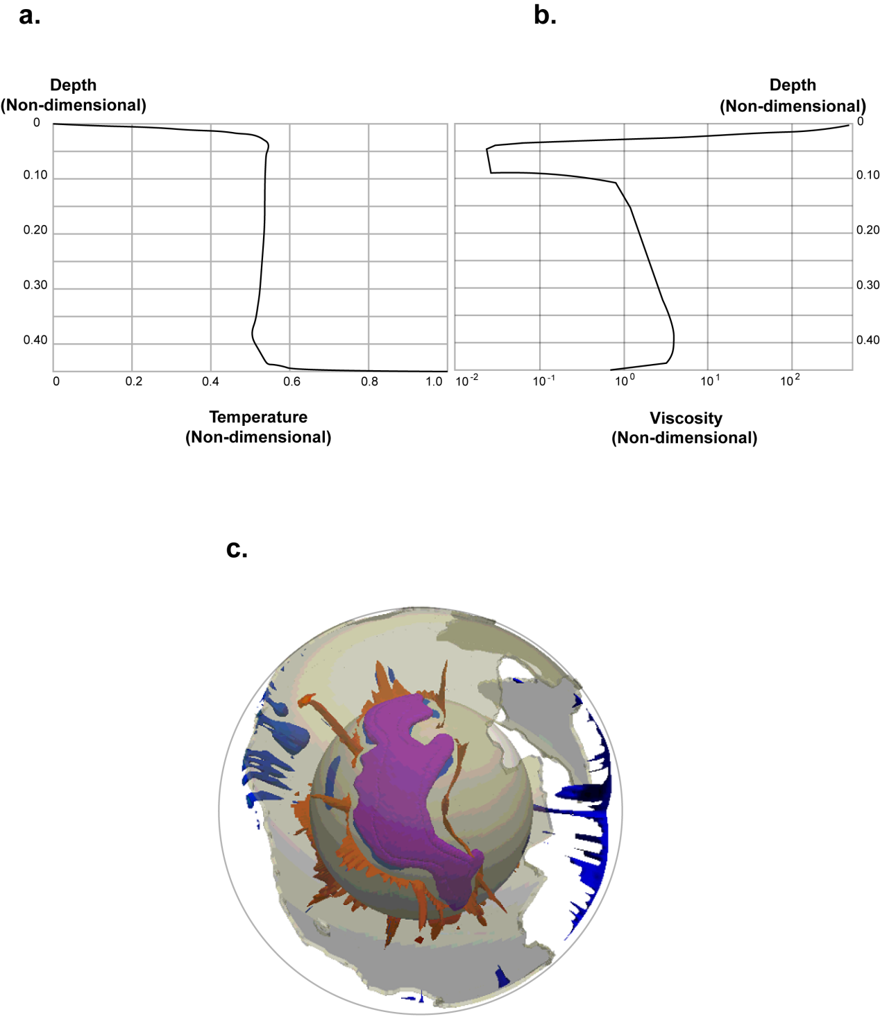
Supplementary Figure 1 | Initial non-dimensional temperature (a) and viscosity (b) profiles, and thermal structure (c), for standard Case 1. In (a) and (b), the reference depth, temperature and viscosity are 6370 km, 2850 K and 5e21 Pas, respectively. In (c), the thermal structure are plotted as contours of residual non-dimensional temperature anomalies with values at >0.1 (red) and <-0.1 (blue), respectively. The semitransparent gray cap shows Pangea.

