Supplementary information: Rivers of the Variscan Foreland: fluvial morphodynamics in the Pennant Formation of South Wales, UK
James Wood¹*, Jonah S. McLeod¹, Sinéad J. Lyster¹ and Alexander C. Whittaker¹
¹Department of Earth Science and Engineering, Imperial College London, UK, SW7 2BX.
*Correspondence (james.wood18@imperial.ac.uk)
Contents:
- S1: Field localities
- S2: Field data
- S3: Verification of flow depth scaling methods
- S4: Fluvial facies analysis
- S5: Statistical testing
S1: Field localities
Field localities for this study were selected on a number of criteria. Firstly, exposure in South Wales is sparse due to vegetation cover and urban areas. This means outcrops that were openly accessible and facilitated working at the rockface were limited, making a reconnaissance mission prior to data collection invaluable for planning. Next, field localities were selected based on their stratigraphic interval to test temporal trends in the Pennant Sandstone. Figure 2 (main text) shows this was accomplished successfully. Finally, spatial (downstream) trends were of interest so various sites of a similar interval across the coalfield were sampled. While this is difficult with such limited exposure, data was collected spanning across much of the South Wales Coalfield. Table S1 provides detail on how to access the 19 field sites data was collected at for this study. A KMZ file with field localities is provided.
Table S1: Detail on field localities of this study and their access.
Loc # | Name | Northing (BNG) | Easting (BNG) | Member | BGS Map Name | Access
1.1 | Amphitheatre | 5138.7 | -00333.6 | Rhondda | 248: Pontypridd | A4107
2.1 | Lower Bwlch Mountain Road | 5138.7 | -00331.94 | Llynfi | 248: Pontypridd | Bwlch-Y-Clawdd Road
2.2 | Upper Bwlch Mountain Road | 5138.55 | -00332.12 | Rhondda | 248: Pontypridd | Bwlch-Y-Clawdd Road
2.3 | Welcome to the Valleys Sign | 5138.4 | -00332.09 | Rhondda | 248: Pontypridd | Bwlch-Y-Clawdd Road
3.1 | Top of Disused Mineral Railway | 5138.52 | -00347.71 | Hughes | 247: Swansea | The Incline - Briton Ferry Woods Car Park
3.2 | Below Mountain Coal - Disused Mineral Railway | 5138.46 | -00348.06 | Hughes | 247: Swansea | The Incline - Briton Ferry Woods Car Park
3.3 | Kilvey Hill West | 5137.60 | -00354.91 | Llynfi | 247: Swansea | Path off Harbour View Road
3.4 | Kilvey Hill East | 5137.60 | -00354.80 | Llynfi | 247: Swansea | Path off Harbour View Road
4.1 | Darren Serth Quarry: First Storey | 5143.73 | -00356.95 | Swansea | 230: Ammanford | Lliw Reservoir Car Park
4.2 | Darren Serth Quarry: Round Corner | 5143.78 | -00356.86 | Swansea | 230: Ammanford | Lliw Reservoir Car Park
4.3 | Darren Serth Quarry: Second Storey | 5143.72 | -00356.95 | Swansea | 230: Ammanford | Lliw Reservoir Car Park
5.1 | Llanwonno Road Quarry | 5140.24 | -00322.43 | Brithdir | 248: Pontypridd | Llanwonno Road *No Access to rock*
5.2 | Llanwonno Road | 5140.24 | -00322.43 | Brithdir | 248: Pontypridd | Llanwonno Road
5.3 | Quarry Above Porth | 5137.56 | -00323.96 | Brithdir | 248: Pontypridd | Layby off Graigwen Road
6.1 | Above Abercynon | 5139.47 | -00319.88 | Hughes | 248: Pontypridd | Layby on unnamed road off Goitre-Coed Road
6.2 | Mynydd Cilfach-yr-encil | 5142.75 | -00319.79 | Brithdir | 231: Merthyr Tydfil | Dowlais Road *Forest track*
6.3 | Bridge Street | 5136.71 | -00323.034 | Rhondda | 248: Pontypridd | Bridge Street
7.1 | Nolton Haven North Cliff | 5149.43 | -00506.65 | Rhondda | 226/227: Milford | Nolton Haven Car Park
7.2 | Maidenhall Point | 5150.58 | -00506.99 | Rhondda | 226/227: Milford | Pebbles Café Car Park

S2: Field data
Primary field data for this study is provided in the supplementary information.
S3: Verification of flow depth scaling methods
The scaling methods of Leclair and Bridge (2001) and Bradley and Venditti (2017) were independently verified to validate the use of the methods on the Pennant Sandstone Formation. Package thicknesses (both accretion and channel body packages) provide a proxy for maximum formative flow depth of the rivers of an outcrop. Fig. S1 plots the maximum measured package thicknesses against the n = 2004 calculated flow depths using the methods of Leclair and Bridge (2001) and Bradley and Venditti (2017). Fig. S1 shows that only 4 percent of the calculated flow depths exceed 1.25 times the measured maximum package height at the corresponding field locality suggesting, within error, the scaling methods used here provide valid results.
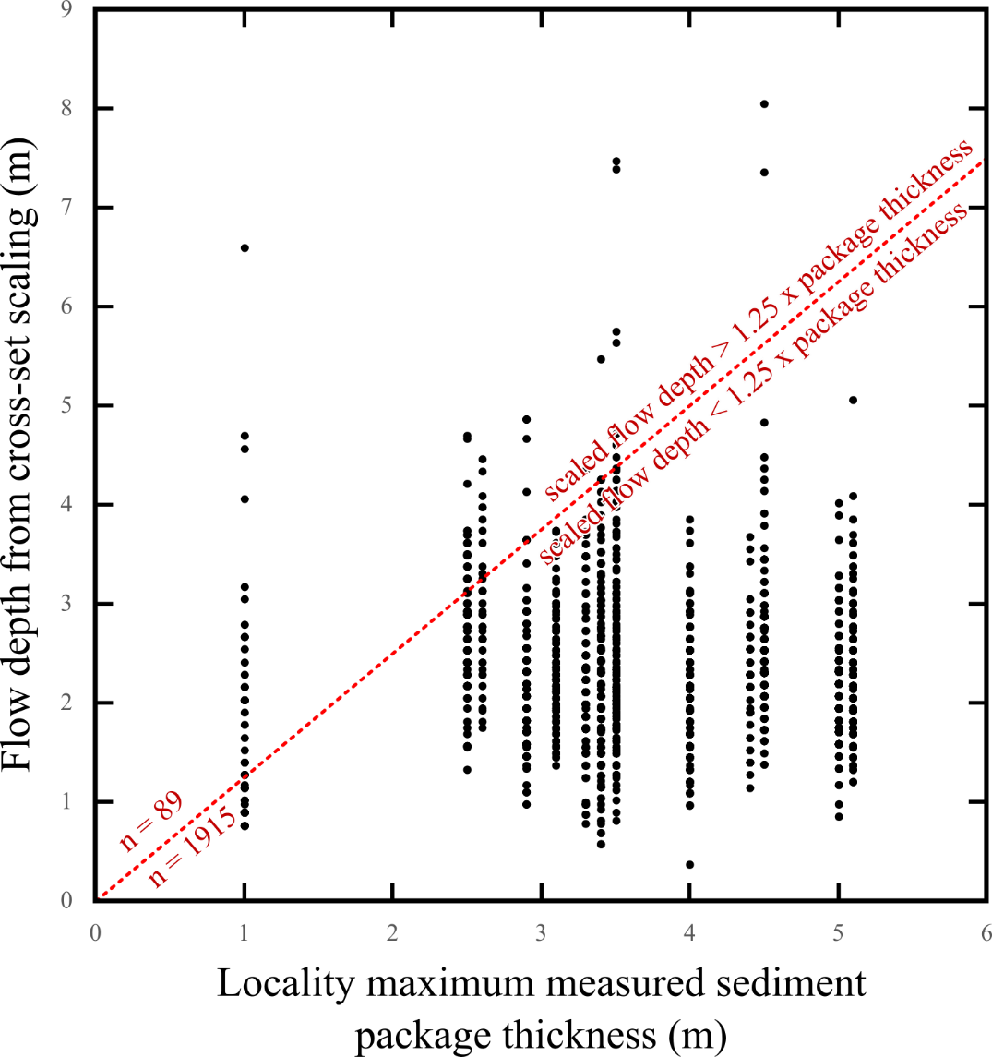
Fig. S1: Plot of each locality’s maximum measured package height against every flow depth scaled from measured cross-sets. A line of y = 1.25x is plotted to act as a maximum valid boundary condition for reconstructed flow depths.
S4: Fluvial facies analysis
To complement the quantitative fluvial style reconstructions used in the main text, facies-based analyses have been conducted. The rose diagrams in Fig. S2 show dip directions of lateral accretion surfaces at 11 localities where it was possible to gather >5 measurements on these planes.
For single-threaded channels, it is expected to see all accretion surfaces dipping in broadly the same direction. Here this is seen clearly in locality 3.4 and less confidently in localities 1.1, 3.1, 3.2, 4.3, 5.2 and 6.3. Additionally, for a single-threaded channel with high sinuosity, we expect to see accretion surfaces broadly perpendicular to flow direction as these packages represent point-bar deposits on meander bends. This arrangement perpendicular to palaeocurrent is seen clearly in locality 3.2 and less confidently in localities 3.4 and 5.3. All other localities show flow in a direction broadly parallel to accretion surfaces or in multiple directions which suggests a braided or anastomosing fluvial style.
This analysis reinforces the idea from the quantitative analysis (Fig. 10: main text) that some outcrops in the Llynfi and Hughes Members of the South Wales Coalfield (here localities 3.2 and 3.4) were likely single-threaded sections while the majority of the Pennant’s rivers were multi-thread.
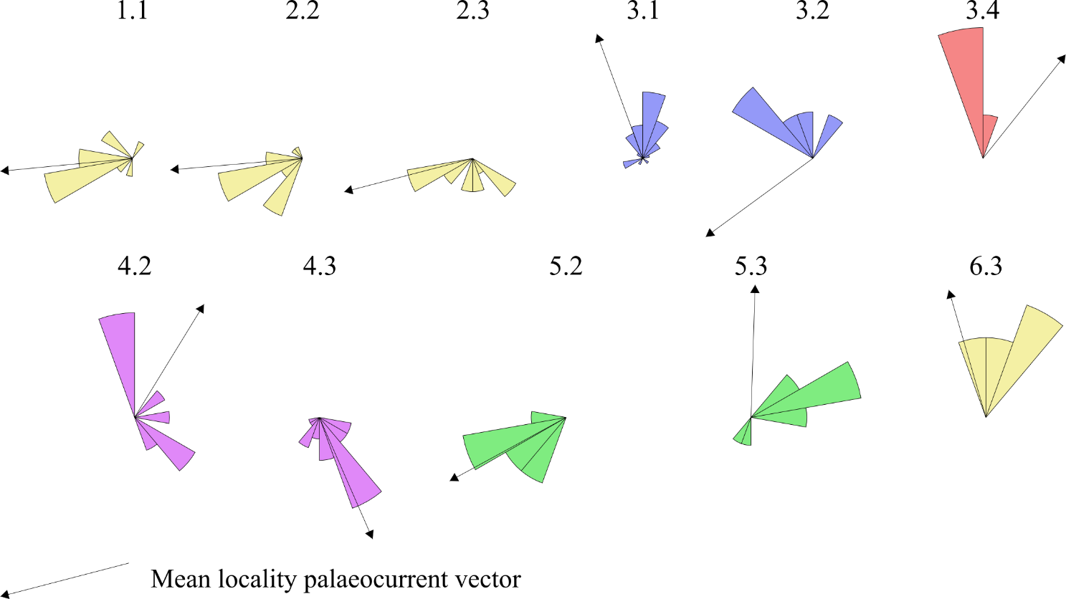
Fig. S2 Rose diagrams of accretion surface orientation at each locality where n > 5 measurements existed. Mean palaeocurrent vector added from Fig. 7 (Main text).

S5: Statistical testing
Kolmogorov-Smirnov (KS) tests have been performed on the dataset to understand if distributions of reconstructed flow dynamics are statistically different or similar. Two-sample KS tests are used to compare two distributions of values and provide a D-stat value which is calculated as the maximum difference between the percentage of the values of the two distributions in each bin. This is then compared to a critical value, D-crit. If D-stat exceeds D-crit, the distributions are considered to be statistically significantly different.
Table S2a shows D-stat and D-crit values of KS tests performed between resolved palaeoslopes of each of the stratigraphic members of the Pennant Sandstone Formation. In all instances, D-stat is less than D-crit meaning there is no statistically significant variation in palaeoslope between members of the Pennant.
Another place where two sample KS tests have been used is to show that the three sampled localities in the Brithdir Member produced statistically different distributions of palaeoslope (Table S2b). D-crit values between localities 5.2 and 5.3, and 5.2 and 6.2 of 0.165 and 0.157 respectively (α = 0.1) are exceed by respective D-test values of 0.200 and 0.166. This shows spatial trends in the Brithdir Member are statistically significant.
A spreadsheet with these KS tests in their entirety is provided.
a | Swansea |  | Hughes |  | Brithdir |  | Rhondda |  | Llynfi
All Pennant | D-stat | 0.026 | D-stat | 0.055 | D-stat | 0.035 | D-stat | 0.014 | D-stat | 0.023
 | D-crit | 0.079 | D-crit | 0.072 | D-crit | 0.078 | D-crit | 0.059 | D-crit | 0.097
Swansea |  |  | D-stat | 0.081 | D-stat | 0.043 | D-stat | 0.025 | D-stat | 0.030
 |  |  | D-crit | 0.098 | D-crit | 0.103 | D-crit | 0.089 | D-crit | 0.118
Hughes |  |  |  |  | D-stat | 0.087 | D-stat | 0.055 | D-stat | 0.069
 |  |  |  |  | D-crit | 0.097 | D-crit | 0.083 | D-crit | 0.113
Brithdir |  |  |  |  |  |  | D-stat | 0.042 | D-stat | 0.055
 |  |  |  |  |  |  | D-crit | 0.088 | D-crit | 0.117
Rhondda |  |  |  |  |  |  |  |  | D-stat | 0.037
 |  |  |  |  |  |  |  |  | D-crit | 0.105
b | Loc 5.3 |  | Loc 6.2
Loc 5.2 | D-stat | 0.2000 | D-stat | 0.1661
 | D-crit | 0.1651 | D-crit | 0.1565

Table S2. – D-stat and D-crit values of Kolmogorov-Smirnov (KS) tests performed on: a) distributions of reconstructed palaeoslope between each member of the Pennant Sandstone and the complete dataset of reconstructed palaeoslopes (α = 0.05) and b) distributions of reconstructed palaeoslope between three localities of the Brithdir Member (see Fig 7, main text, for locations). Distributions are considered significantly different to each other if D-stat > D-crit.
References:
Bradley, R. W., & Venditti, J. G. 2017. Reevaluating dune scaling relations. In Earth-Science Reviews (Vol. 165, pp. 356–376). Elsevier B.V. https://doi.org/10.1016/j.earscirev.2016.11.004

Leclair, S. F., & Bridge, J. S. 2001. Quantitative Interpretation of Sedimentary Structures Formed by River Dunes. Journal of Sedimentary Research; 71 (5): 713–716. https://doi.org/10.1306/2DC40962-0E47-11D7-8643000102C1865D

