Supporting Information Document: Mineralogy and K-Ar geochronology of clay alteration associated with uranium mineralization in the Patterson Lake Corridor, Saskatchewan
J.W. Powell¹, J.B. Percival¹, E.G. Potter¹, R. van der Lelij², R. Xie²
¹Geological Survey of Canada, 601 Booth Street, Ottawa, Ontario KIA 0E8

²Geological Survey of Norway, Leiv Eirikssons Vei 39, 7040 Trondheim, Norway

Contents
- Text and tables corresponding to XRD analyses of samples from the Spitfire discovery
- Table comparing HALO, TSG and XRD data
- Text and tables corresponding to Athabasca Basin Mineral Standards dataset
- Figure showing clay morphologies for various size fractions
- Text and figure discussing western Athabasca Basin geochronology
Introduction
This supporting information incorporates an additional XRD dataset from the Spitfire discovery that is discussed in the text (Table S1, S2), as well as an Athabasca Basin Mineral Standards dataset that is partially illustrated in Figures 6 and 7 (Table S4 – S11; Figure S1 – S7). A table comparing mineralogy identified by XRD analyses with the proximal VNIR-SWIR reflectance profiles derived mineralogy by HALO and TSG is also provided (Table S3). Additional figures include SEM images of a series of size fractions from 18PUA146 (Fig. S8) , and a radial plot displaying data from this study (Fig. S9) against all available U-Pb, K-Ar and ⁴⁰Ar/³⁹Ar data from uraninite and clay alteration across the western Athabasca Basin (Table S12).
Text S1. Expanded mineralogy text, including XRD results of clay alteration from the Spitfire discovery and a comparison of mineralogy identified from reflectance spectra (HALO, TSG) and XRD
For this study, the Sedimentology Laboratory (Northern Canada Division) developed a new routine to separate a series of silt fractions for detailed mineralogy. In addition to the traditional clay-size fraction (< 2 µm), the 2-6 µm , 6-10 µm and 10-63 µm fractions of five samples were prepared using a combination of sieving and centrifugation methods. These fractions were then prepared for X-ray diffraction (XRD) analyses as pressed powders (10-63 µm) for whole rock analyses and as smear mounts for detailed silt/clay mineralogy. The 10-63 µm fraction was analysed by both methods; the pressed powder method allows for quantification and identification of illite polytypes. Results of analyses of the air-dried smear samples are semi-quantitative. Analyses following glycol saturation and heat treatment of the smear mounts confirms identification of the clay minerals.
Quantitative results for whole rock analyses of the 10-63 µm are given in Table S1. Four of the five samples contain abundant to minor quartz, whereas one sample (17PUA075) only contained trace amounts. All samples contain abundant to minor illite, abundant chlorite (sudoite in four and clinochlore in one sample) and minor to trace siderite, crandallite, calcite, hematite, kaolinite and tourmaline in some of the samples. The goodness of fit is moderate to poor. One sample, 17PUA76, contains a trace amount of a mixed-layer clay mineral based on a broadening of the chlorite 14 Å X-ray peak. Note that sudoite, a di-trioctahedral chlorite, is identified based on the very intense 4.74 Å X-ray peak relative to the other chlorite peaks (e.g., 14 Å, 7 Å, 3.54 Å, 2.83 Å).

In order to determine illite polytypes, the analyses were repeated using a slower count time (~ 5 hours) after addition of 10% corundum as an internal standard (see Table S1). This enables adjusting the XRD pattern to an exact position using the 2.08 Å X-ray peak of corundum, especially important when quartz is not present. Based on these results, it was determined that all samples contain a 2M₁ illite polytype, and one sample, 17PUA072, also contains a 1M polytype. The 2M₁ illite was identified by the presence of 4.29 Å, 4.09 Å, 3.88 Å, 3.72 Å, 3.49 Å, 3.20 Å and 2.86 Å [hkl] X-ray peaks whereas the 1M polytype was identified by the 4.35 Å, 3.66 Å and 3.07 Å [hkl] X-ray peaks. Note that these latter peaks may also be present in a 2M₂ illite polytype. There was no evidence for a 3T polytype (e.g., 3.60 Å or 3.11 Å X-ray peaks). This information is based on X-ray powder patterns of muscovite reported in Brindley and Brown (1980).
Table S2 provides the semi-quantitative XRD results for the smear mounts. The silt and clay fractions are dominated by illite and chlorite (sudoite or clinochlore). Although quartz is abundant in the coarse 10-63 µm fraction for four of the five samples, it decreases with decreasing grain size. Quartz was not detectable in the clay-size fraction. Tournaline was detectable in sample 17PUA056, siderite in 17PUA075 and crandalite in samples 17PUA056, 17PUA076 and in the coarse fraction of 17PUA097.
Table S3 compares mineralogy identified from VNIR-SWIR spectra processed using two different commercially-available software packages with XRD analyses of the clay alteration from samples. Reflectance spectra were acquired from drill core, and mineralogy was determined using pattern recognition software (Halo = the TerraSpec® Halo onboard library via Malvern Panalytical; TSG = The Spectral Geologist software, via CSIRO). Reflectance spectra in Table 3 were selected based on their proximity to XRD analyses of bulk powdered samples from DDH PLS14-175 and AR-16-78-c1 (Table 4).
Text S2. Athabasca Basin Mineral Standards database
Reflectance spectra of Athabasca mineral standards was collected in 2002 using a FieldSpec Pro® (Analytical Spectral Devices, Inc, now Malvern Panalytical) portable reflectance spectrometer following a field campaign to the eastern Athabasca Basin. These standards were provided by Cameco and include mineral separates from the Basin and other reference minerals and artificial mixtures (Zhang et al. 2001). The purpose was to compare semi-quantitative mineralogical results using the MINSPEC program (Earle 1995, 1996) on spectra collected by the industry-standard PIMA-II (Portable Infrared Mineral Analyser; Integrated Spectronics Pty. Ltd.) and the FieldSpec Pro® (Percival et al. 2002). MINSPEC was developed to distinguish six minerals and polytypes including dickite, illite, kaolinite, S-kaolinite, sudoite and magnesiofoitite (Gerard Zaluski, pers. Comm. 2020) that are invaluable for exploration (Table S4). Reflectance spectra corresponding to mechanical mixtures of these are available in Tables S5-S11. These mixtures are a useful reference for qualitatively assessing the relative proportion of clay alteration in a sample on the basis of absorption features (Fig. S1 – S7).
Text S3. Western Athabasca Basin geochronology
In order to investigate broad, regional trends in the geochronology of uranium deposits from the western Athabasca Basin, we plotted all available uraninite U-Pb and clay K-Ar and ⁴⁰Ar/³⁹Ar geochronology data on a radial plot, and performed finite mixture modelling to separate potential age populations in the dataset. Data were synthesized from basement and sandstone-hosted deposits and discoveries west of the Snowbird Tectonic Zone (Fig 1, Table S12). Radial plots are a useful visualization tool for data with unequal measurement uncertainties (Vermeesch 2018). A radial axis is drawn at a distance from the origin, and the angular position of a data point reflects its age, whereas the distance along the horizontal axis reflects its precision: ages that are more precise plot towards radial axis on the right-hand side of the axis, whereas imprecise ages plot towards the origin on the left-hand side. Finite mixture modelling searches for statistical populations in overdispersed datasets. Radial plots were created using the software IsoplotR by Vermeesch (2018). Ages were input using their reported errors. Chemical U-Pb ages, for which error are often not reported, were input assuming a standard 10% error (Fig. S9). To facilitate a comparison with new data from this study, K-Ar ages reported in this manuscript were overlain.
Peak ages interpreted via mixture modelling of the western Athabasca Basin geochronology data include c. 1400 Ma, c. 916 Ma, c. 380 Ma, c. 145 Ma, and c. 48 Ma. The oldest of these two dates overlap with the age of illite generations reported by Clauer et al. (2020) from the Dominique Peter district of the Carswell structure (1450 ± 50 Ma; 940 ± 40 Ma).
References
Alexandre, P. and Kyser, T.K. 2006. Geochemistry of uraniferous bitumen in the Southwest Athabasca basin, Saskatchewan, Canada. Economic Geology, 101, 1605–1612, https://doi.org/10.2113/gsecongeo.101.8.1605.
Alexandre, P., Kyser, K. and Jiricka, D. 2009a. Critical geochemical and mineralogical factors for the formation of unconformity-related uranium deposits:Comparison between barren and mineralized systems in the athabasca basin, Canada. Economic Geology, 104, 413–435, https://doi.org/10.2113/gsecongeo.104.3.413.
Alexandre, P., Kyser, K., Thomas, D., Polito, P. and Marlat, J. 2009b. Geochronology of unconformity-related uranium deposits in the Athabasca Basin, Saskatchewan, Canada and their integration in the evolution of the basin. Mineralium Deposita, 44, 41–59, https://doi.org/10.1007/s00126-007-0153-3.
Alexandre, P., Kyser, K., Jiricka, D. and Witt, G. 2012. Formation and evolution of the centennial unconformity-related uranium deposit in the South-Central Athabasca Basin, Canada. Economic Geology, 107, 385–400, https://doi.org/10.2113/econgeo.107.3.385.
Bell, K. 1985. Geochronology of the Carswell area, northern Saskatchewan. In: Lainé, R., Alonso, D. and Svab, M. (eds) The Carswell Structure Uranium Deposits: Geological Association of Canada, Special Paper, 29,. 33–45.
Brindley, G.W. and Brown, G. (eds.). 1980. Crystal Structures of Clay Minerals and their X-ray Identification. Mineralogical Society Monograph no. 5, London, 495 pp.
Carl, C., Von Pechmann, E., Hohndorf, A. and Ruhrmann, G. 1992. Mineralogy and U/Pb, Pb/Pb, and Sm/Nd geochronology of the Key Lake uranium deposit, Athabasca Basin, Saskatchewan, Canada. Canadian Journal of Earth Sciences, 29, 879–895, https://doi.org/10.1139/e92-075.
Clauer, N. 2020. How can technical aspects help improving K-Ar isotopic data of illite-rich clay materials into meaningful ages? The case of the dominique peter uranium deposit (Saskatchewan, Canada). Geosciences (Switzerland), 10, 1–15, https://doi.org/10.3390/geosciences10080285.
Clauer, N., Ey, F. and Gauthier-Lafaye, F. 1985. K-Ar dating of different rock yypes from the Cluff Lake uranium ore deposits (Saskatchewan-Canada). In: Laine, R., Alonso, D. and Svab, M. (eds) Carswell Structure Uranium Deposits, Saskatchewan; Special Paper. 47–54.
Creaser, R.A., Fayek, M., McElroy, R. and Ramaekers, P. 2019. New geochronological data from specific alteration facies, Patterson Lake uranium-mineralized area, Saskatchewan. In: Saskatchewan Geological Survey, Saskatchewan Ministry of Energy and Resources, Open House 2019 Abstract Volume, Miscellaneous Report 2019-3. 5.
Cumming, G.L. and Krstic, D. 1992. The age of unconformity-related uranium mineralization in the Athabasca Basin, northern Saskatchewan. Canadian Journal of Earth Sciences, 29, 1623–1639, https://doi.org/10.1139/e92-128.
Earle, S. (1995): Quantitative reflectance spectrometry for analysis of the clay mineralogy of the Athabasca Basin rock samples; Unpublished Report, Cameco Corp., Saskatoon, Saskatchewan, 7p.

Earle, S. 1996. Evaluation of the Reliability of Mineral Proportion Estimates from PIMA-II Reflectance Spectrometer and MINSPEC1 Program.
Develipment of the Patterson Lake Corridor. University of Saskatchewan.
Koning, E. and Robbins, J. 2006. The Cluff Lake deposits, west Athabasca Basin, Saskatchewan. In: Quirt, D. (ed.) In Uranium: Athabasca Deposits and Analogues, Uranium Field Conference. 18.
Kotzer, T.G. and Kyser, T.K. 1995. Petrogenesis of the Proterozoic Athabasca Basin, northern Saskatchewan, Canada, and its relation to diagenesis, hydrothermal uranium mineralization and paleohydrogeology. Chemical Geology, 120, 45–89, https://doi.org/10.1016/0009-2541(94)00114-N.
Laverret, E., Clauer, N., Fallick, A., Mercadier, J., Patrier, P., Beaufort, D. and Bruneton, P. 2010. Applied Geochemistry K – Ar dating and d18O – dD tracing of illitization within and outside the Shea Creek uranium prospect, Athabasca Basin, Canada. Applied Geochemistry, 25, 856–871, https://doi.org/10.1016/j.apgeochem.2010.03.004.
Percival, J.B., Wasyliuk, K., Reif, T., Bernier, S., Drever, G. and Perkins, C.T. 2002. Mineralogical Aspects of Three Drill Cores Along the McArthur River Transect Using a Portable Infrared Spectrometer. In: Summary of Investigations 2002, Volume 2. 1–15.
Sheahan, C., Fayek, M., Quirt, D. and Jefferson, C.W. 2016. A combined ingress-egress model for the kianna unconformity-related uranium deposit, Shea Creek Project, Athabasca Basin, Canada. Economic Geology, 111, 225–257, https://doi.org/10.2113/econgeo.111.1.225.
Vermeesch, P. 2018. IsoplotR: A free and open toolbox for geochronology. Geoscience Frontiers, 9, 1479–1493, https://doi.org/10.1016/j.gsf.2018.04.001.
Zhang, G., Wasyliuk, K. and Pan, Y. 2001. The characterization and quantitative analysis of clay minerals in the Athabasca basin, Saskatchewan: Application of shortwave infrared reflectance spectroscopy. Canadian Mineralogist, 39, 1347–1363, https://doi.org/10.2113/gscanmin.39.5.1347.

Figure S1. Stacked VNIR-SWIR reflectance spectra displaying mechanical mixtures of illite and chlorite standards from the Athabasca Mineral Standards database (Table S5)

Figure S2. Stacked VNIR-SWIR reflectance spectra displaying mechanical mixtures of illite and dickite standards from the Athabasca Mineral Standards database (Table S6)

Figure S3. Stacked VNIR-SWIR reflectance spectra displaying mechanical mixtures of illite and kaolinite standards from the Athabasca Mineral Standards database (Table S7)

Figure S4. Stacked VNIR-SWIR reflectance spectra displaying mechanical mixtures of chlorite and kaolinite standards from the Athabasca Mineral Standards database (Table S8)

Figure S5. Stacked VNIR-SWIR reflectance spectra displaying mechanical mixtures of dickite and kaolinite standards from the Athabasca Mineral Standards database (Table S9)

Figure S6. Stacked VNIR-SWIR reflectance spectra displaying mechanical mixtures of kaolinite and tourmaline standards from the Athabasca Mineral Standards database (Table S10)

Figure S7. Stacked VNIR-SWIR reflectance spectra displaying mechanical mixtures of illite, kaolinite and tourmaline standards from the Athabasca Mineral Standards database (Table S11)

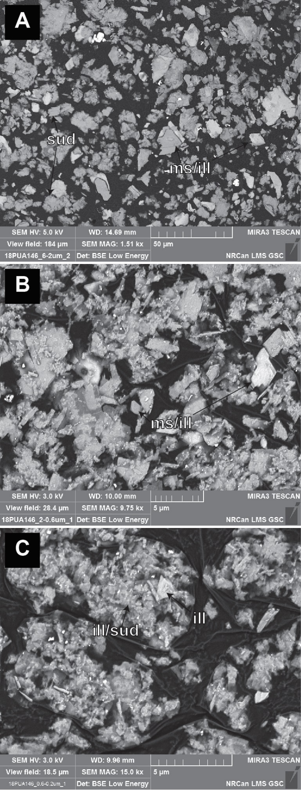
Figure S8. A) SEM image of clay minerals from the 6 – 2 µm fraction of 18PUA146, showing coarse, subhedreal plates of muscovite/illite (ms/ill) and tattered mats of sudoite (sud). B) 2 – 0.6 µm fraction of 18PUA146. Muscovite/illite now present as sub-anhedral plates, and long lathe-like grains. Fine-grained sudoite crystal coat the surface of other clay minerals. C) 0.6 – 0.2 µm fraction of 18PUA146. Fine-grained, anhedral illite crystals within a very fine-grained illite-sudoite (ill/sud) matrix. The wispy textures of illite-sudoite are indicative of hydrothermal conditions.

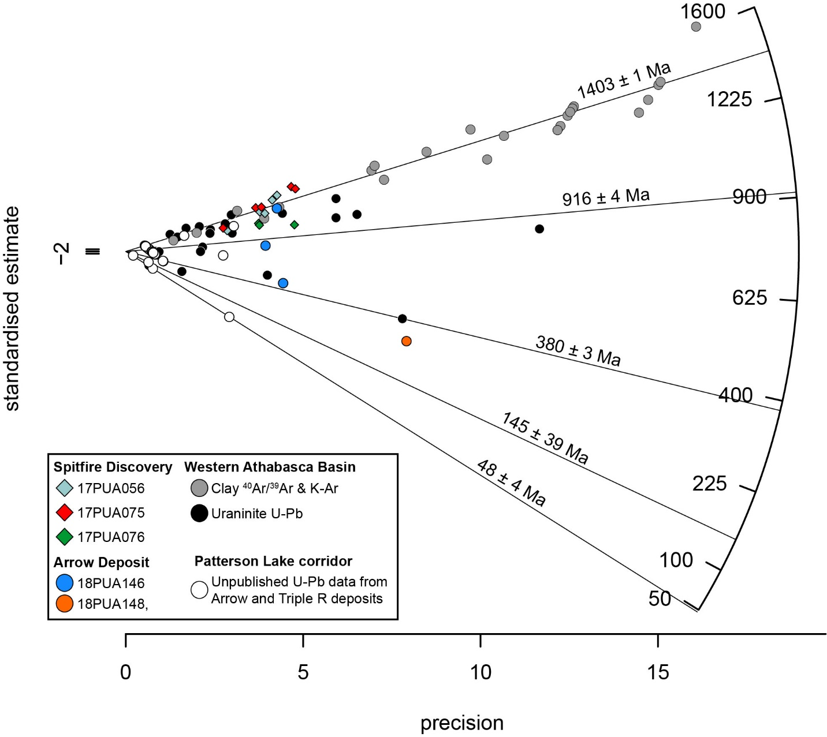
Figure S9. Radial plot displaying published and unpublished U-Pb uraninite and clay K-Ar and ⁴⁰Ar/³⁹Ar dates from the western Athabasca Basin. Peak ages were determined using finite mixture modelling. K-Ar data from the PLC (this study) are displayed alongside the western Athabasca Basin dataset for context.

