Supplemental Material For:
Transition to magma-driven rifting in the South Turkana Basin: Part 1
James. D. Muirhead^{1*}, Christopher A. Scholz², Tyrone Rooney³
¹School of Environment, University of Auckland, Auckland 1142, New Zealand
²Department of Earth Sciences, Syracuse University, Syracuse, New York 13244, USA
³Dept. of Earth and Environmental Sciences, Michigan State University, East Lansing, MI 48823, USA
*Corresponding author: james.muirhead@fulbrightmail.org

Summary of content
S1. Inferring feeder dike orientations from cone lineaments.
S2. Fault propagation folding in the South Turkana basin.
S3. Age model for Lake Turkana sediments from core 46P.

Supplemental Text 1: Inferring feeder dike orientations from cone lineaments
Small monogenetic volcanic cones were mapped using Google Earth satellite imagery, supplemented by published maps (Dunkley et al., 1993). The idealized shapes (circular to elliptical) of cones and their craters were determined and each was classified as a cone, cleft cone, or crater (Fig. S1). We expect that the reliability of the mapped cone morphology is not affected by image resolution resolution (~0.5-2.0 m), which is an order of magnitude greater than the typical dimensions of the monogenetic cones (30-1000 m radii). Nonetheless, we ranked the reliability of of each cone (1 = probable; 2 = likely; 3 = unknown) depending on the degree of observable erosion. Consistent with the methods of Muirhead et al. (2015), the cone was considered to produce a lineament if it had a reliability ranking of 1 or 2 and a cone or crater axial ratio (long axis to short axis) >1.2. If both criteria were met, the recorded long axes of the cone and crater were interpreted to mimic the dike that fed the cone. Further, the long axis of the crater was favored in instances where both the cone base and cone crater exhibited an axial ratio >1.2. Finally, breaching direction (Fig. S1) was also used as a direct indicator of feeder dike orientation (i.e., Tibaldi, 1995). These features are described as cone lineaments in this paper, and are inferred to reflect the strike of the dike that fed the volcanic cone. All cone data can be found in Table S2.

Supplemental Text 2: Fault propagation folding in the South Turkana basin
Importantly, in the South Turkana basin, normal faults with minor offsets in shallow lake sediments often exhibit monoclinal folds. This type of folding is characteristic of upward normal fault propagation, and often referred to as a fault propagation fold (Fig. 2). Fault propagation folds are observed and documented in rift zones elsewhere, such as Iceland (Grant & Kattenhorn, 2004), Hawaii (Martel & Langley, 2006), and the Asal Rift (Pinzuti et al., 2010), and have been identified in CHIRP seismic reflection data for propagating faults in the Lake Thinvallavatn rift in southwest Iceland (Bull et al., 2003, 2005). Numerical modeling results support the development of monoclinal folds in the shallow subsurface during the upward propagation of blind normal faults (i.e., fault planes that do not intersect the ground surface) (Grant and Kattenhorn, 2004). Although these structures do not appear as distinct normal fault planes, fault propagation folds do offset the shallow subsurface, with the magnitudes of these fold being roughly equivalent to throw accumulated at depth along the fault plane (Grant & Kattenhorn, 2004; Muirhead et al., 2019). Once the upward propagating fault plane intersects the shallow monocline, the process of folding ceases, and extensional strain at this depth is primarily accommodated via fault slip.
Monoclinal folds are a common feature in shallow sediments of the South Turkana Basin. It is likely that these structures represent fault propagation folds for the following reason:
- All monoclinal folds have limited amplitudes (3.7 m max.). This is presumably because there is a maximum amount of strain, i.e. folding near the surface and faulting at depth, that can accumulate before the upward propagating fault intersections the shallow monocline. At this point, the folding processes cease.
- In places, faults transition upward from a distinct fault plane into a monoclinal fold.
- Faults also transition along-strike into monoclinal folds near their distal ends. Similar observations are observed for fault propagation folds in the Lake Thinvallavatn, Iceland (Bull et al., 2005)
Based on these observations it is critical that our fault throw data, used for estimating Holocene extension in the South Turkana basin, account for fault propagation folding above fault tips during initial fault growth. Consistent with previous reflection seismic and field studies of normal faults associated with fault-propagation faults (e.g., Homberg et al., 2017; Lăpădat et al., 2017), our throw measurements account for both discontinuous (fault breaks) and continuous (fold) displacements associated with the observed normal faulting (Figs. S2 and S3). For our analyses, if a monocline is observed above a distinct fault plane, the throw is estimated by measuring the height of the fold structure. Additionally, monoclinal folds observed in seismic sections, that can also be traced along-strike into neighbor lines, are also assumed to be fault propagation folds and included in our structural dataset.

Supplemental Text 3: Age model for Lake Turkana sediments from core 46P
To constrain the age of Horizon 3 in the South Turkana Basin, we utilize core 46P of Morrissey and Scholz (2014), which was collected using a Kullenberg piston coring system (Fig. S4). This 10.6 m-long core was collect ~6 km from the shoreline in the northeastern part of the basin at a water depth of 56 m. Morrisey and Scholz (2014) described the core lithology immediately after splitting and performed measurements of bulk density at Brown University using a GEOTEK MSCL-S whole core scanner, recorded at 1 cm intervals.
Core-to-seismic correlation for the 10.6 m-long core utilized both observations of lithologic contrasts and density data, where high amplitude reflections observed in the CHIRP seismic line Turk10-58 were matched with layers that recorded sharp changes in bulk density and lithology (e.g., boundaries between sand and mud layers). Based on these correlations, we then calculated the expected seismic velocities as an independent test of our interpretation, as acoustic velocities in fresh water and shallow, water-saturated sediments should range between 1450-1500 m/s. Accordingly, our interpretation correlates to seismic velocities of 1490 m/s in the upper 10 m of syn-rift sediments in Lake Turkana, lending confidence to our correlations. These seismic velocities were also adopted for our velocity-to-depth conversions for the presented fault throw data. This correlation would place Horizon 3 at a depth of 610.5 cm below the lake surface (Fig. S4).
In order to constrain the age of Horizon 3, we applied an age model for core 46P based on eleven AMS ¹⁴C samples of bulk organic matter, bulk carbonate, plant material, and shells (Table S1). These samples were collected by Morrissey and Scholz (2014) at depths of 6.5 - 849.0 cm (Fig. S4 and Table S1). The flexible Bayesian age depth program, “Bacon” (Blaauw & Christen, 2011), was used to construct the age models of all three cores. Radiocarbon ages for these model runs were calibrated using the IntCal13 calibration curve. In all, our core-to-seismic correlation and age model data support of a radiocarbon age of 9,571 + 442 - 401 yr BP for Horizon 3 (Fig. S4). However, the radiocarbon age scale uses a commence date of 1950 CE, whereas the reflection seismic data were collected in 2010 CE; therefore, 60 years were added to these radiocarbon ages to account for the time interval between deposition of the seismic horizon and the seismic data collection.

References
Blaauw, M., & Christen, J. A. (2011). Flexible paleoclimate age-depth models using an autoregressive gamma process. Bayesian Analysis, 6, 457–474.
Bull, J. M., Minshull, T. A., Mitchell, N. C., Thors, K., Dix, J. K., & Best, A. I. (2003). Fault and magmatic interaction within Iceland’s western rift over the last 9 kyr. Geophysical Journal International, 154(1), F1–F7. https://doi.org/10.1046/j.1365-246X.2003.01990.x
Bull, J. M., Minshull, T. A., Mitchell, N. C., Dix, J. K., & Hardardottir, J. (2005). Magmatic and tectonic history of Iceland’s western rift zone at Lake Thingvallavatn. Geological Society of America Bulletin, 117(11–12), 1451–1465. https://doi.org/10.1130/b25729.1
Dunkley, P., Smith, M., Allen, D. J., & Darling, W. G. (1993). The geothermal activity and geology of the northern sector of the Kenya Rift Valley. British Geological Survey Scientific Report SC/93/1.
Grant, J. V, & Kattenhorn, S. A. (2004). Evolution of vertical faults at an extensional plate boundary, southwest Iceland. Journal of Structural Geology, 26(3), 537–557. https://doi.org/10.1016/j.jsg.2003.07.003
Homberg, C., Schnyder, J., Roche, V., Leonard, V., & Benzaggagh, M. (2017). The brittle and ductile components of displacement along fault zones. Geological Society, London, Special Publications, 439, 395–412.
Lăpădat, A., Imber, J., Yielding, G., Iacopini, D., McCaffrey, K. J. W., Long, J. J., & Jones, R. R. (2017). Occurrence and development of folding related to normal faulting within a mechanically heterogeneous sedimentary sequence: a case study from Inner Moray Firth, UK. Geological Society, London, Special Publications, 439, 373–394.
Martel, S. J., & Langley, J. S. (2006). Propagation of normal faults to the surface in basalt, Koae fault system, Hawaii. Journal of Structural Geology, 28(12), 2123–2143. https://doi.org/10.1016/j.jsg.2005.12.004
Morrissey, A., & Scholz, C. A. (2014). Paleohydrology of Lake Turkana and its influence on the Nile River system. Palaeogeography Palaeoclimatology Palaeoecology, 403, 88–100. https://doi.org/10.1016/j.palaeo.2014.03.029
Muirhead, J D, Kattenhorn, S. A., & Le Corvec, N. (2015). Varying styles of magmatic strain accommodation in the East African Rift. Geochemistry, Geophysics, Geosystems, 16. https://doi.org/10.1002/2015gc005918
Muirhead, James D, Wright, L. J. M., & Scholz, C. A. (2019). Rift evolution in regions of low magma input in East Africa. Earth and Planetary Science Letters, 506, 332–346. https://doi.org/10.1016/j.epsl.2018.11.004
Pinzuti, P., Mignan, A., & King, G. C. P. (2010). Surface morphology of active normal faults in hard rock: Implications for the mechanics of the Asal Rift, Djibouti. Earth and Planetary Science Letters, 299(1–2), 169–179. https://doi.org/10.1016/j.epsl.2010.08.032
Tibaldi, A. (1995). Morphology of pyroclastic cones and tectonics. Journal of Geophysical Research-Solid Earth, 100(B12), 24521–24535. https://doi.org/10.1029/95jb02250
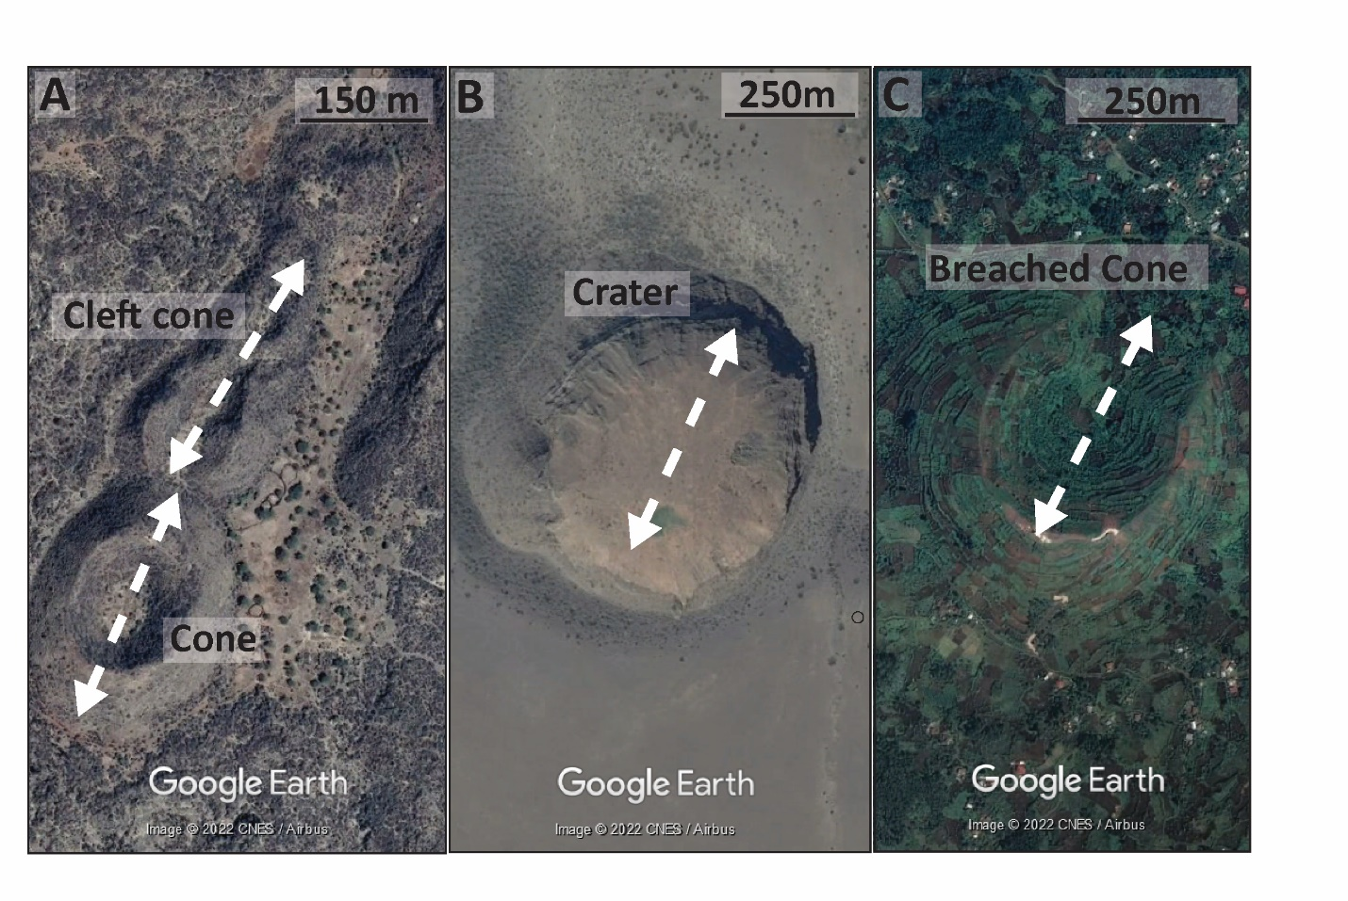
Figure S1. Example images from Google Earth representing the classification of cone morphologies used to determine cone lineaments in the current study, which follow that of Muirhead et al. (2015). Examples are from the Boset segment in Ethiopia (A), Natron Basin in Tanzania (B), and Virungu Province in the Democratic Republic of Congo (C). Double-sided arrows show the orientation of the cone lineaments for each cone based on crater elongation (A & B) and breaching direction (C).

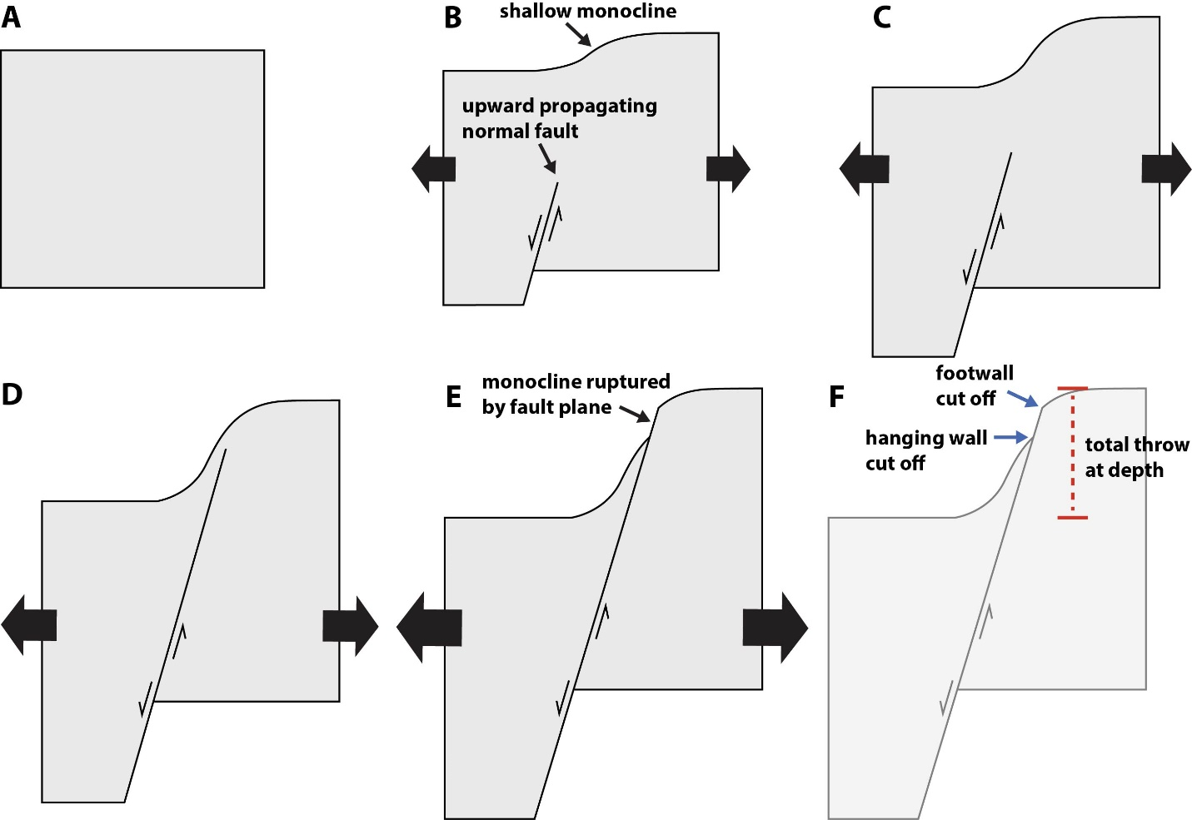
Figure S2: Conceptual model for the development of fault propagation folds based on Grant and Kattenhorn (2004) and Martel and Langley (2006).

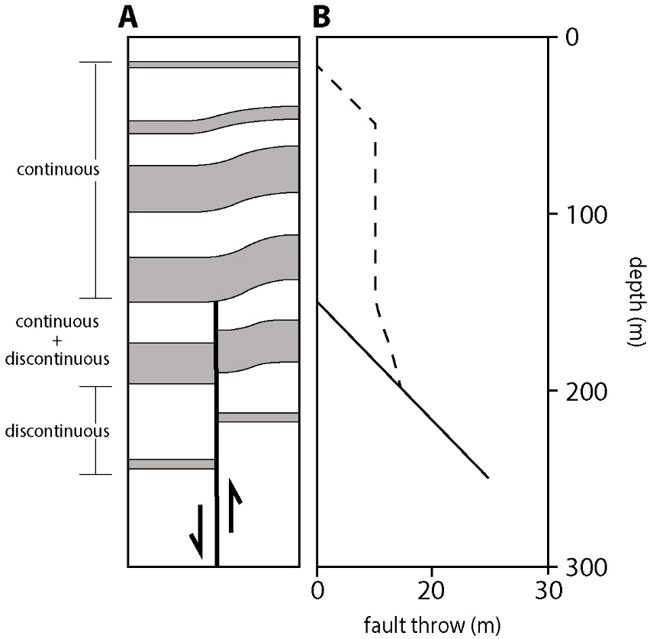
Figure S3. Conceptual illustration of continuous (fault breaks) and discontinuous displacements (fault-related folds) observed in growth faults in reflection seismic data (A). At depth, a distinct fault break is observed, with throw values (i.e., vertical separation between footwall and hanging wall cutoffs) represented as a black line on the plot in B. Dotted line represents throw values that also accommodate for observed continuous displacements related to fault-propagation folding.
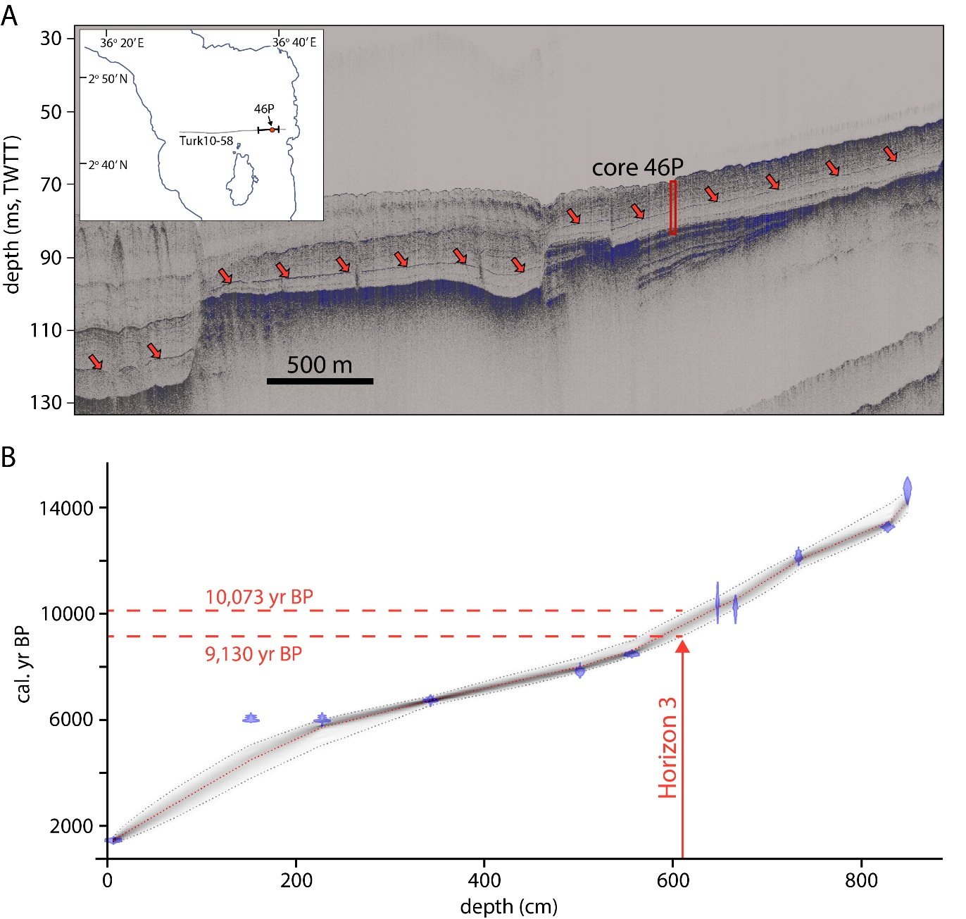
Fig S4. (A) location of core 46P, which was used to date Horizon 3 (red arrows point to the horizon) at depth of 610.5 cm in the recovered core. (B) Age-model produced from the flexible Bayesian age depth program, Bacon. Radiocarbon ages were calibrated using the IntCal13 calibration curve. Blue polygons represent the radiocarbon-dated samples summarized in Table S1. Note that radiocarbon age scale has a reference age of 1950 CE, and thus 60 years was added to the radiocarbon age shown in this figure, to correspond to the year that the seismic data were collected (2010 CE).
Table S1. Radiocarbon ages for samples collected from core 46P in the South Turkana Basin. M = Macrophyte; OM = Organic Mud; OS = Ostracode Shells; CM = Carbonate Mud; GS = Gastropod Shells

ID | Type | age | error | depth
Turk10-46P-6.5 | M | 1445 | 80 | 6.5
Turk10-46P-152.5 | OM | 6031 | 77 | 152.5
Turk10-46P-228 | OM | 5960 | 42 | 228
Turk10-46P-343 | OM | 6723 | 84 | 343
Turk10-46P-501.5 | M | 7819 | 155.5 | 501.5
Turk10-46P-556.5 | OM | 8484 | 52 | 556.5
Turk10-46P-647.5 | M | 10,470 | 316 | 647.5
Turk10-46P-666.5 | M | 10,170 | 410.5 | 666.5
Turk10-46P-733.5 | GS | 12,234 | 184 | 733.5
Turk10-46P-828 | OM | 13,350 | 127 | 828
Turk10-46P-849 | OS | 14,800 | 302 | 849

