Supplementary Material
Supplementary methods 1. Data acquisition
Genomic data for two heterotardigrade species (Actinarctus doryphorus and Echiniscus bisetosus, Heterotardigrada) and a transcriptome of Nectonema munidae (Nematomorpha) were generated at the University of Bristol Genomic Service. For the tardigrade species, total DNA from a pool of individuals was homogenized and processed with Qiagen’s QIAamp DNA Micro Kit according to the manufacturer’s instructions. DNA extractions from a pool of tardigrades yield low concentration levels. Therefore, we performed a whole genome amplification to increase the amount with the Kit (REPLI-g Mini kit, Qiagen). RNA extraction of Nectonema munidae was performed using TRIzol® Reagent (ThermoFisher scientific) following the manufacturer’s protocol. The total DNA extractions were prepared into libraries using the Illumina Truseq® Nano LT Kit, whereas for the RNA extraction the NEXTFLEX® Rapid Directional RNA-Seq Kit was used. The genomics and transcriptome libraries were sequenced at Bristol Genomic services, all paired-end, using an Illumina NextSeq 500 platform and deposited on NCBI (National Center for Biotechnology Information) (see Table S1).
For Actinarctus doryphorus and Echiniscus bisetosus genomic raw reads were inspected for quality using FastQC (Andrews 2010) and trimmed for adapter contaminations, low-quality bases and removal of overrepresented Kmers using Trimmomatic (Bolger et al. 2014). The reads were then assembled using AbySS (Simpson et al. 2009) under multiple runs to ascertain the ideal Kmer value for the assemblies. Blobology (Kumar et al. 2013) was then used to identify potential contaminant reads in the assemblies: both tardigrade reads were found to be highly contaminated with bacterial and viral sequences. The contaminant reads were thus removed and the putatively true tardigrade reads reassembled with AbySS. AUGUSTUS (Stanke et al. 2006) was used for the gene prediction on the assembled genomes, using the proteomes of ecdysozoan species available in Augustus database as references (Nasonia vitripennis, Tribolium castaneum, Drosophila melanogaster, Caenorhabditis elegans and Brugia malayi). The output files from AUGUSTUS were converted into a fasta file, concatenated and the redundant sequences were removed by using CD-HIT-EST (Li and Godzik 2006) with a 95% similarity cut-off.
For Nectonema munidae raw sequences were assembled using Trinity version 2.0.3 under default parameters and using Trimmomatic for quality control. To predict the putative protein from the Trinity (Haas et al. 2013) assembly results, Transdecoder (part of the Trinity platform) was used.
In addition, raw sequences from Illumina transcriptomes of several ecdysozoan taxa were downloaded from public repositories. Assembly and protein prediction of these raw reads was carried out using Trinity and Transdecoder as explained above.

Table S1. List of ecdysozoan sequence data used in this study
Taxon | Affinity | Source
Acanthoscurria gomesiana | Arthropoda (Araneae) | SAMN00176452
Actinarctus doryphorus | Tardigrada (Heterotardigrada) | SAMN24271371
Anoplodactylus eroticus | Arthropoda (Pycnogonida) | SRR9439291
Armorloricus elegans | Scalidophora (Loricifera) | SRR2131253
Artemia franciscana | Arthropoda (Branchiopoda) | SRR1324814
Ascaris sum | Nematoda (Chromadorea) | Campbell et al. (2011)
Brugia malayi | Nematoda (Chromadorea) | Campbell et al. (2011)
Caenorhabditis elegans | Nematoda (Chromadorea) | Campbell et al. (2011)
Calopteryx splendens | Arthropoda (Odonata) | GAYM00000000.2
Cercopis vulnerata | Arthropoda (Hemiptera) | GAUN00000000.2
Chaerilus celebensis | Arthropoda (Scorpiones) | SRR1721804
Daphnia magna | Arthropoda (Branchiopoda) | GDIP00000000.1
Daphnia pulex | Arthropoda (Branchiopoda) | PRJNA12756
Echiniscus bisetosus | Tardigrada (Heterotardigrada) | SAMN24271372
Echiniscus testudo | Tardigrada (Heterotardigrada) | ftp.ncbi.nlm.nih.gov/sra/wgs_aux/GD/AL/GDAL01/GDAL01.1.fsa_nt.gz
Echinoderes horni | Scalidophora (Kinorhyncha) | SRR9439288
Echinoderes sp. | Scalidophora (Kinorhyncha) | SRX5426494
Ephemera danica | Arthropoda (Ephemeroptera) | GAUK00000000.2
Epiperipatus sp. | Onychophora (Peripatidae) | Roeding et al. (2007)
Euperipatoides kanagrensis | Onychophora (Peripatopsidae) | SRR9439289
Euroleon nostras | Arthropoda (Neuroptera) | GAXW00000000.2
Eurytemora affinis | Arthropoda (Copepoda) | GEAN00000000.1
Folsomia candida | Arthropoda (Collembola) | GASX00000000.2
Glomeridesmus sp. | Arthropoda (Diplopoda) | SRR941771
Gynaikothrips ficorum | Arthropoda (Thysanoptera) | GAXG00000000.2
Halicryptus spinulosus | Scalidophora (Priapulida) | PRJNA184952
Hypsibius dujardini | Tardigrada (Eutardigrada) | PRJNA309530
Ixodes scapularis | Arthropoda (Acari) | Villar et al. (2015)
Limulus polyphemus | Arthropoda (Xiphosura) | Sharma et al. (2014)
Lithobius forficatus | Arthropoda (Chilopoda) | GBKE00000000
Litopenaeus vannamaei | Arthropoda (Decapoda) | GETZ00000000
Mantis religiosa | Arthropoda (Dictyoptera) | GASW00000000.2
Meganyctiphanes norvegica | Arthropoda (Euphausiacea) | GETT00000000.1
Meinertellus cundinamarcensis | Arthropoda (Archaeognatha) | GAUG00000000.2
Meiopriapulus sp. | Scalidophora (Priapulida) | SRR9670664
Milnesium tardigradum | Tardigrada (Eutardigrada) | PRJNA34121
Nasonia sp. | Arthropoda (Hymenoptera) | GBEB00000000
Necotonema munidae | Nematomorpha (Nectonematoida) | SAMN24271374
Neoscona arabesca | Arthropoda (Araneae) | SRR1145741
Gordius sp. | Nematomorpha (Gordiida) | https://kups.ub.uni-koeln.de/6746/1/Thesis_revised.pdf
Parides euridedes | Arthropoda (Lepidoptera) | GAXH00000000.2
Peripatus sp. | Onychophora (Peripatidae) | Campbell et al. (2011)
Periplaneta americana | Arthropoda (Dictyoptera) | GAWS00000000.2
Peruphasma schultei | Arthropoda (Phasmatodea) | GAWJ00000000.2
Petrolisthes cinctipes | Arthropoda (Decapoda) | Campbell et al. (2011)
Platycentropus radiatus | Arthropoda (Trichoptera) | GASS00000000.2
Polydesmus angustus | Arthropoda (Diplopoda) | GBKG00000000
Polyxenus lagurus | Arthropoda (Diplopoda) | GBKF00000000
Priapulus caudatus | Scalidophora (Priapulida) | PRJNA20497
Pristionchus pacificus | Nematoda (Chromadorea) | Campbell et al. (2011)
Prostemmiulus sp. | Arthropoda (Diplopoda) | SRR945439
Pycnogonum sp. | Arthropoda (Pycnogonida) | SRR8745912
Pycnophyes kielensis | Scalidophora (Kinorhyncha) | SRR1141803
Ramazzottius varieornatus | Tardigrada (Eutardigrada) | PRJDB4588
Richtersius coronifer | Tardigrada (Eutardigrada) | SRR9439303
Scutigera coleoptrata | Arthropoda (Chilopoda) | SRR9439304
Siro boyerae | Arthropoda (Opiliones) | SRR1145699
Strigamia maritima | Arthropoda (Chilopoda) | SRR1267275
Tetrix subulata | Arthropoda (Orthoptera) | GASQ00000000.2
Tigriopus japoniscus | Arthropoda (Copepoda) | GCHA00000000.1
Tribolium castaneum | Arthropoda (Coleoptera) | PRJNA12540
Trichinella spiralis | Nematoda (Enoplea) | Campbell et al. (2011)
Trichuris muris | Nematoda (Enoplea) | Campbell et al. (2011)
Xibalbanus tumulensis | Arthropoda (Remipedia) | SRR4113501
Xiphinema index | Nematoda (Enoplea) | Campbell et al. (2011)

Supplementary methods 2. Orthology and matrix assembly
We compiled a supermatrix with data from 76 species (65 ecdysozoans, 7 spiralians, 4 deuterostomes) for 228 genes, based on the dataset of (Lozano-Fernandez et al. 2016, 2019; Howard et al. 2020). This set of manually curated genes was selected to maximise the inclusion of known single-copy, slowly evolving and informative genes (to reduce the negative impact of saturation-dependent tree reconstruction artifacts, such as Long Branch Attraction (Lozano-Fernandez et al. 2019) .
New ecdysozoan sequences matching those in this gene-sample were acquired through a custom Perl script (available at github.com/jairly/MoSuMa_tools/) (Lozano-Fernandez et al. 2016, 2019; Tanner et al. 2017). This software selects sequences with the highest significant expected values (e-values) among BLAST hits, taking the lowest e-values and any other significant hits within three orders of magnitude of the most significant hit. The minimum e-value threshold was set at the stringent value of 10⁻³⁰ to exclude false positive orthologs. Selected sequences were aligned using MUSCLE (Edgar 2004) (with default parameters) to produce alignments for each of the genes. Maximum likelihood phylogenies were inferred for each gene using IQ-TREE (Nguyen et al. 2015) v.1.6.3 under the LG+G (Le and Gascuel 2008) model⁠. This relatively simple model was chosen to have a quick estimate of the distribution of branch length in each of the gene trees. Accordingly, sequences producing long branches were removed from each single-gene alignment matrix, with a long branch considered to be more than twice the standard deviation of the average away from the average branch length for the gene in question (as in (Lozano-Fernandez et al. 2016, 2019; Tanner et al. 2017)⁠; scripts available at github.com/jairly/MoSuMa_tools/). Ambiguously aligned positions were removed from the gene alignments by GBlocks v0.91b (Castresana 2000) (using the parameters b2 = 70%, b3 = 10, b4 = 5, b5 = half). These gene alignments, thus cleaned of ambiguous positions and long ranching-sequences, were concatenated using FASconCAT (Kück and Meusemann 2010), with a resulting super matrix of 43.852 amino acids positions across 76 taxa.

Supplementary methods 3. Phylogenetic analyses
Phylogenetic analyses were performed in PhyloBayes MPI (Lartillot et al. 2013) v1.5a under both the CAT-Poisson+G and the CAT-GTR+G models (Lartillot and Philippe 2004). CAT type site-heterogeneous models are implemented only in PhyloBayes and therefore their relative fit to site-homogeneous models (like LG, WAG) can only be tested using Bayesian cross-validation. However, this test requires expensive calculations, and it has been shown multiple times in the past that site-homogeneous models are outperformed by site-heterogeneous ones at model testing. We therefore performed our phylogenetic analyses using only these two models, given that they have also proven to be appropriate substitution models to deal with across-site heterogeneity and long-branch biases (Feuda et al, 2017). For both the models, we performed two independent runs and we checked the convergence using the bpcomp and tracecomp commands, applying a burnin of 10% of the total number of generations. The statistics of the model parameters of the two analyses (from the PhyloBayes output trace file) are summarized in Figs. S1-3. After ~11.000 generations, CAT-Poisson+G chains converged (bpdiff=0.04). CAT-GTR+G chains ran for ~21,000 generations, and although it converged in the parameters of the substitution model, it did not fully converge topologically due to an unstable position of copepods (bpdiff=0.73). Nonetheless, it recovered the same topology of CAT-Poisson in all the ecdysozoan key nodes, with a posterior of value of 1 (Figs. S4 and S5). Because CAT-Poisson+G converged, we used the topology from this analysis for our dating analysis. However, we also present the unconverged CAT-GTR+G tree, that we used for the alternative topologies experiments. We decided to test both trees because CAT-GTR+G generally fits the data better than CAT-Poisson+G. However, the similarity between the CAT-GTR+G and the CAT-Poisson+G trees suggests that no major topological changes should have been expected if CAT-GTR+G converged. We also performed Posterior Predictive Analyses (PPA) to test the absolute fit of CAT-Poisson+G and CAT-GTR+G to the data. The results, expressed as Z-scores, are comparable (Z-score CAT-GTR+G = 5; Z-score CAT-Poisson+G = 7), confirming that the fit of CAT-Poisson+G and CAT-GTR+G is similar, justifying the use of CAT-Poisson+G for our main analyses in the absence of a converged CAT-GTR+G tree.

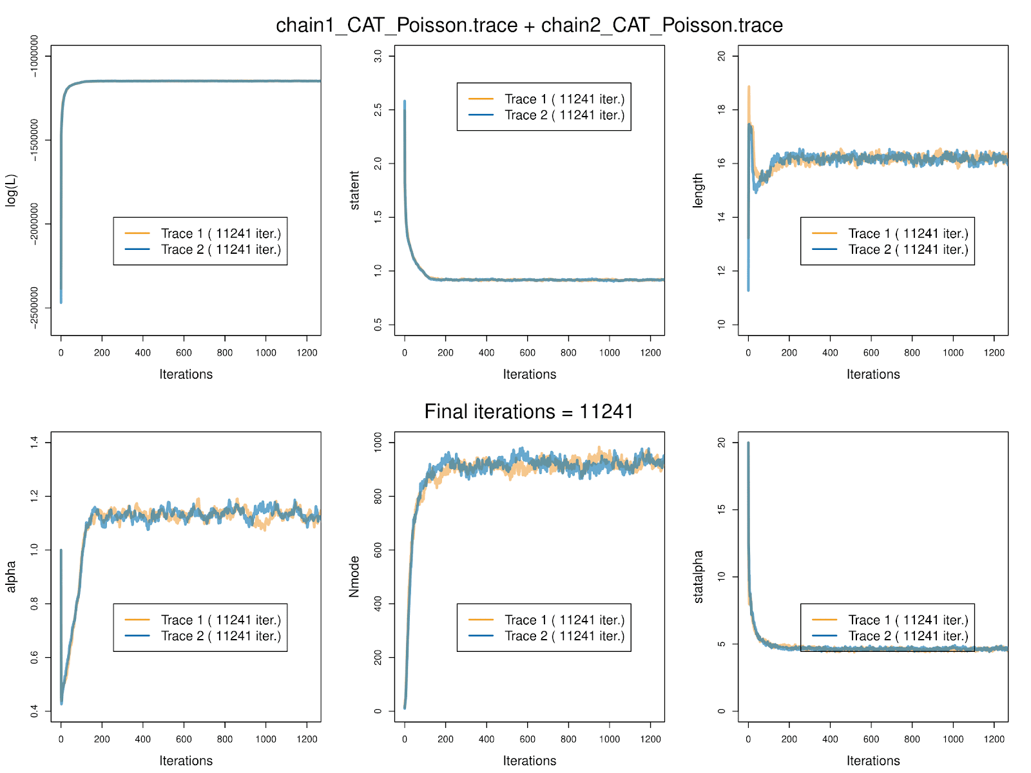
Figure S1. Summarized statistics for the model parameters of the CAT-Poisson+G analysis. Plotted using the package graphylo (https://github.com/wrf/graphphylo).

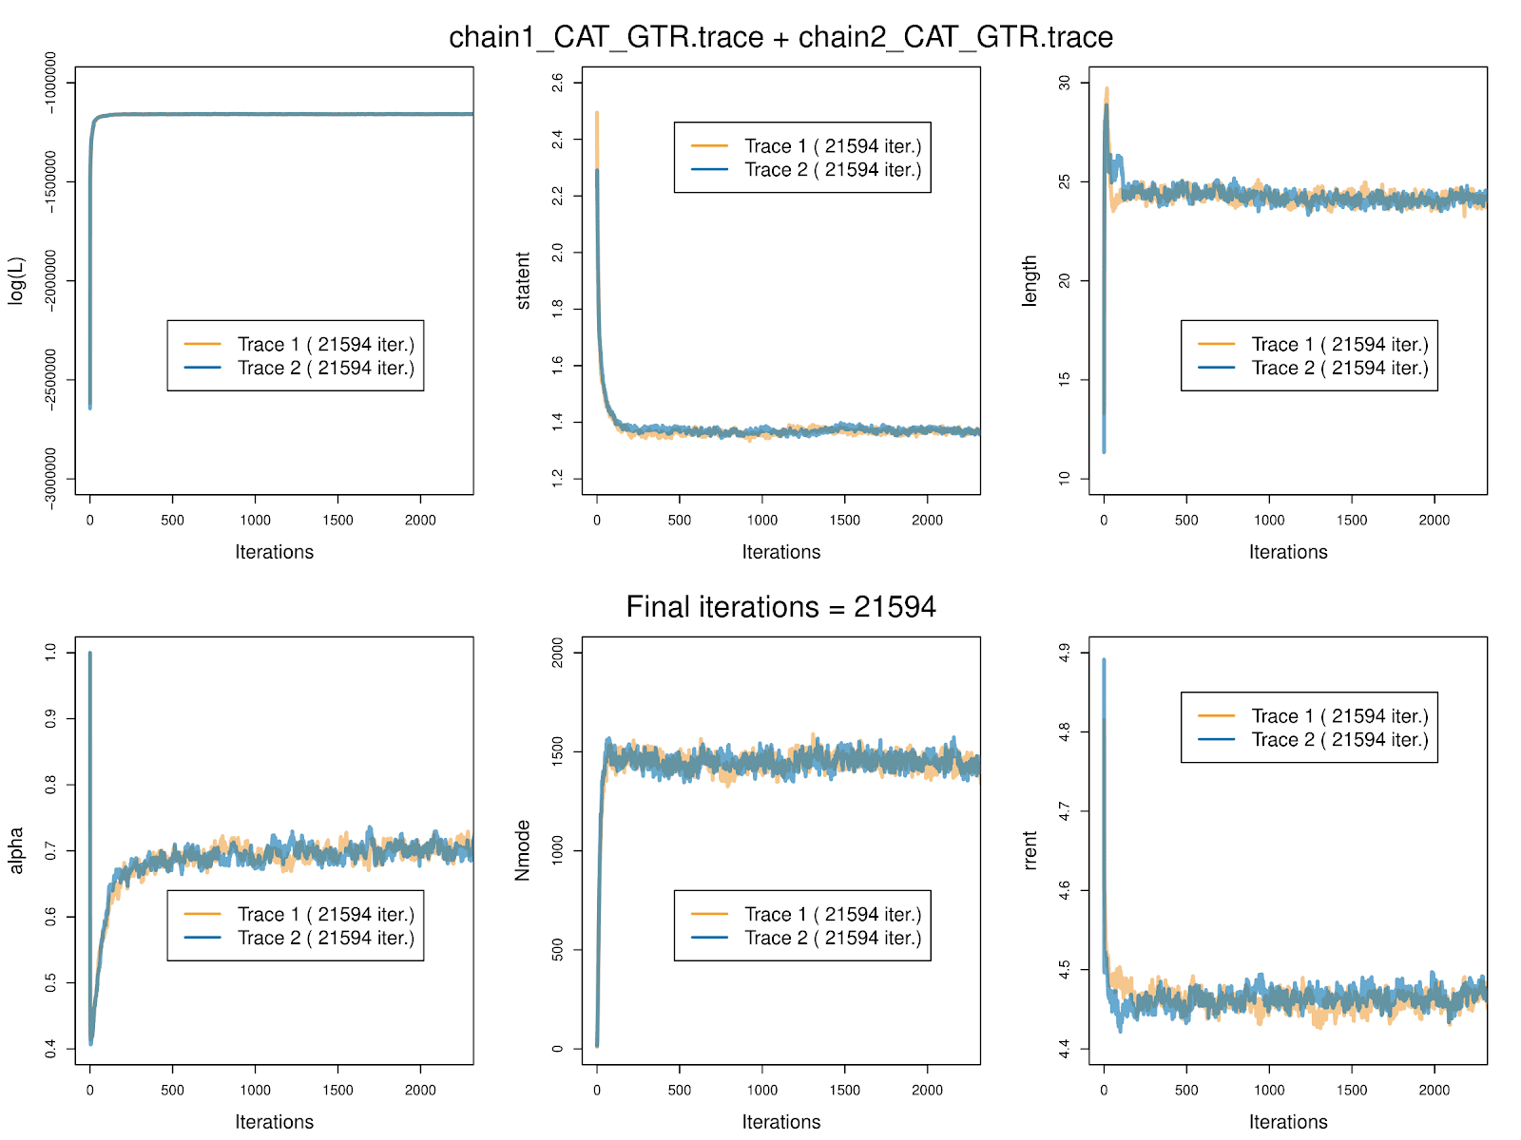
Figure S2. Summarized statistics for the model parameters of the CAT+GTR+G analysis. Plotted using the package graphylo (https://github.com/wrf/graphphylo).

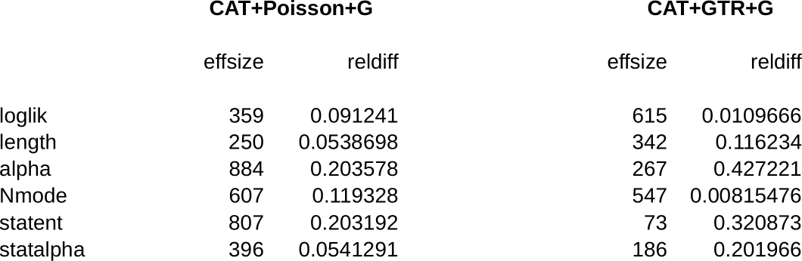

Figure S3. tracecomp statistics. CAT-Poisson+G and CAT-GTR+G analyses.

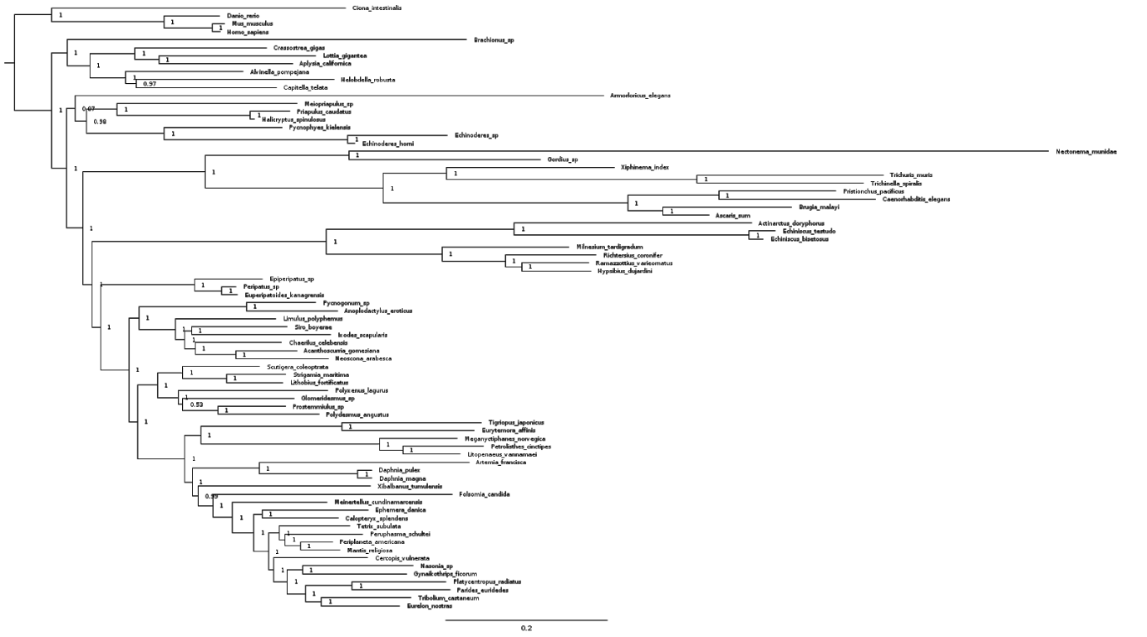
Figure S4. Ecdysozoan tree recovered under CAT-Poisson+G model. Tree search conducted in PhyloBayes, node support = posterior probability.

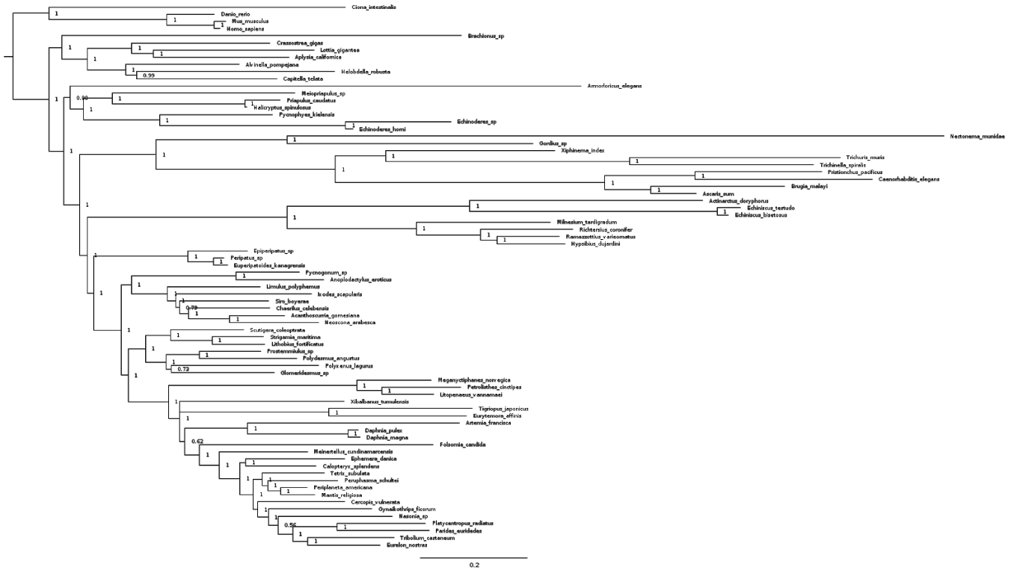

Figure S5. Ecdysozoan tree recovered under CAT-GTR+G model. Tree search conducted in PhyloBayes, node support = posterior probability.

Supplementary methods 4. Molecular dating analyses
The tree recovered by Bayesian phylogenetic analysis was calibrated using 55 fossil ages, following standard node calibration procedure (Benton and Donoghue 2006; Donoghue and Benton 2007). These calibrations were compiled and/or revised from Benton et al. (2015) and Wolfe et al. (2016), in addition to newly described calibrations (see Appendix for complete list of described fossil calibrations used in this study).
All the molecular dating analyses were conducted using the program MCMCTree v.4.9h in the PAML4.9 package (Yang 2007) under the normal approximation method, using the CODEML function to generate a Hessian matrix. We used LG+G model for all our divergence time analyses. For the priors on node ages, a birth-death process with λ=μ=1 and ρ = 0 was used. In addition, a diffuse gamma-Dirichlet prior was given for the molecular rate (Γ = 2, 20) and the diffusion rate ( σ2 = 2, 2). Both the independent (IR) and autocorrelated (AR) rates models (Rannala and Yang 2007) were used. We didn’t perform Bayesian selection of the clock model because it requires expensive exact likelihood calculations, which cannot be performed on the full dataset.

Supplementary methods 4.1 Sensitivity tests using alternative partition strategies
In order to evaluate how a partitioning experiment could have affected our age estimates, we partitioned our dataset according to the gene-wise evolutionary rate of 228 markers in our dataset. This experiment was performed as follows. 1) A maximum likelihood analysis was performed on each gene of our alignment using the program IQTree with the LG+G model. 2) The total length of each resulting gene-tree (i.e. substitutions per position across all the branches) was divided by the number of taxa present in that particular tree to give a rough estimate of the relative rate of evolution for each gene (dos Reis et al. 2014; Telford et al. 2014) (Fig. S6). 3) Genes were then classified based on this value from the slowest to the fastest and divided into two, four and five partitions (see infinite-sites plots, Fig. 2 in the main text for the posterior time estimates under alternative partition strategies). Each of the partitions contained an approximately equal number of genes.
In addition, using the rate as a proxy, we performed four other molecular dating analyses: one using only the slowest genes group (11,883 sites), one with only the fastest (7,442 sites), one with both the slowest and the fastest groups excluded (12,784 sites) and one with only the genes with a taxon occupancy higher than 70% (29,796 sites) (Fig. S7).

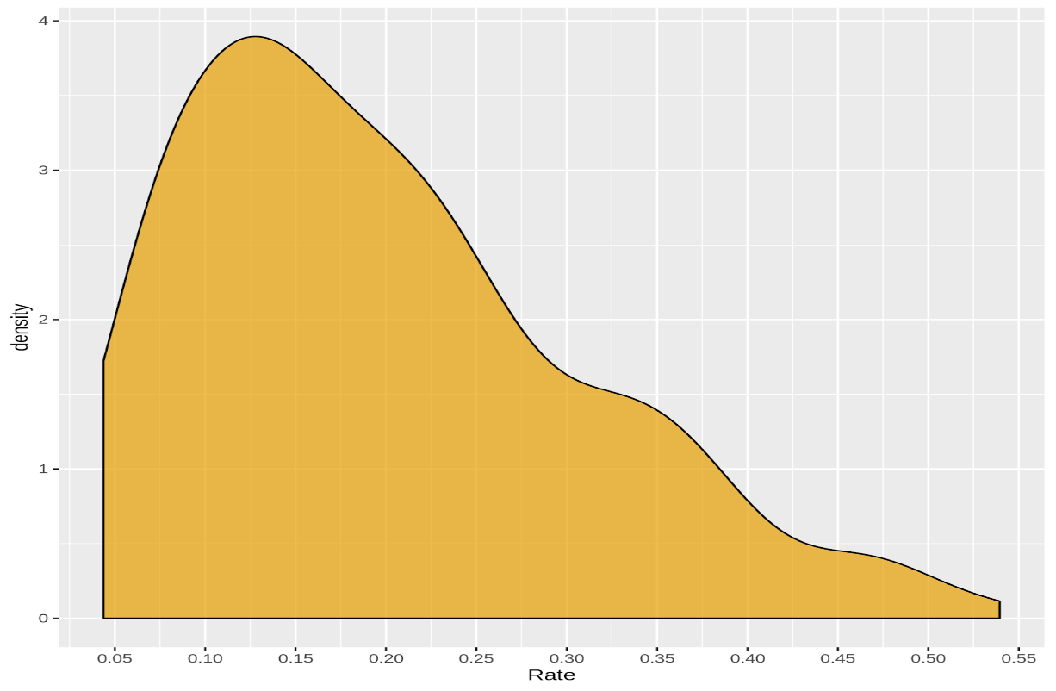
Figure S6: Rate density plot. The relative evolutionary rate of the 228 genes in our dataset.

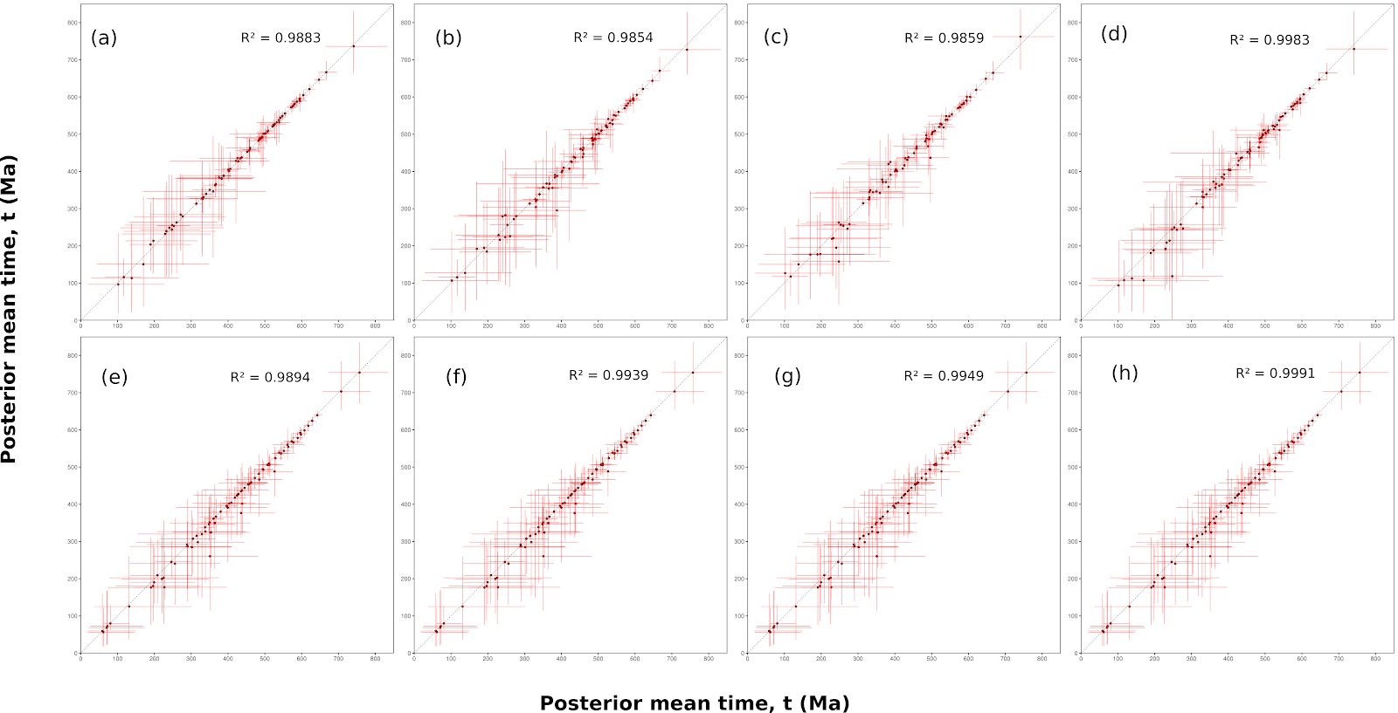
Figure S7: Scatter plot of the estimated posterior mean times estimated using alternative datasets against the complete dataset (always on the x-axis), under both the relaxed clock models. Top row: AR model. Bottom row: IR model. (a, e) complete dataset vs only slowest evolving genes; (b, f) complete dataset vs only fastest evolving genes; (c, g) complete dataset vs slowest and fastest genes excluded; (d, h) complete dataset vs genes with a taxon occupancy >70%.

Supplementary methods 4.2 Sensitivity tests using alternative calibration densities
We conducted a series of sensitivity tests, in order to explore the parameter space associated with our data, and make use of MCMCTree’s calibration input format, which allows for customisable calibration densities. Here we selected four calibration densities (uniform, 5%, 50% and 95% truncated Cauchy distributions) representing alternative interpretations of palaeontological evidence (dos Reis et al. 2015; Betts et al. 2018), which were applied to the 15 nodes of higher ecdysozoan relationships - the focus of our study. In contrast to how the truncated Cauchy distribution was employed at its introduction to molecular clock calibration (Inoue et al. 2010), attached to just a minimum age constraint, we parameterised the truncated Cauchy distribution to fit between minimum and maximum constraints. To achieve this, the p and c values were derived analytically using the R package MCMCtreeR (Puttick 2019).
The uniform distribution represents agnosticism concerning the true clade age between the minimum and maximum bounds; true clade age is equiprobable per unit time, between these bounds. By contrast the truncated Cauchy distributions (5%, 50% and 95%) represent varying degrees of faith in the approximation of clade ages from the fossil minima; in each instance, the percentage value reflects the peak prior probability as a percentage of the minimum-maximum span of the calibration (it does not reflect the p and c parameter values which are derived analytically using the R package MCMCtreeR (Puttick 2019) to achieve this end). The 5% truncated Cauchy distribution positions the bulk of the probability close to the minimum bound, with a tail of low probability extending back in time, reflecting an optimistic interpretation of the fossil record. The 95% truncated Cauchy distribution positions the bulk of the prior probability skewed towards the maximum bound, reflecting a pessimistic interpretation of the fossil record. The 50% truncated Cauchy distribution reflects an intermediate position. All the divergence time estimates are summarized in the scatter plots below (Figs. S8 and S9).

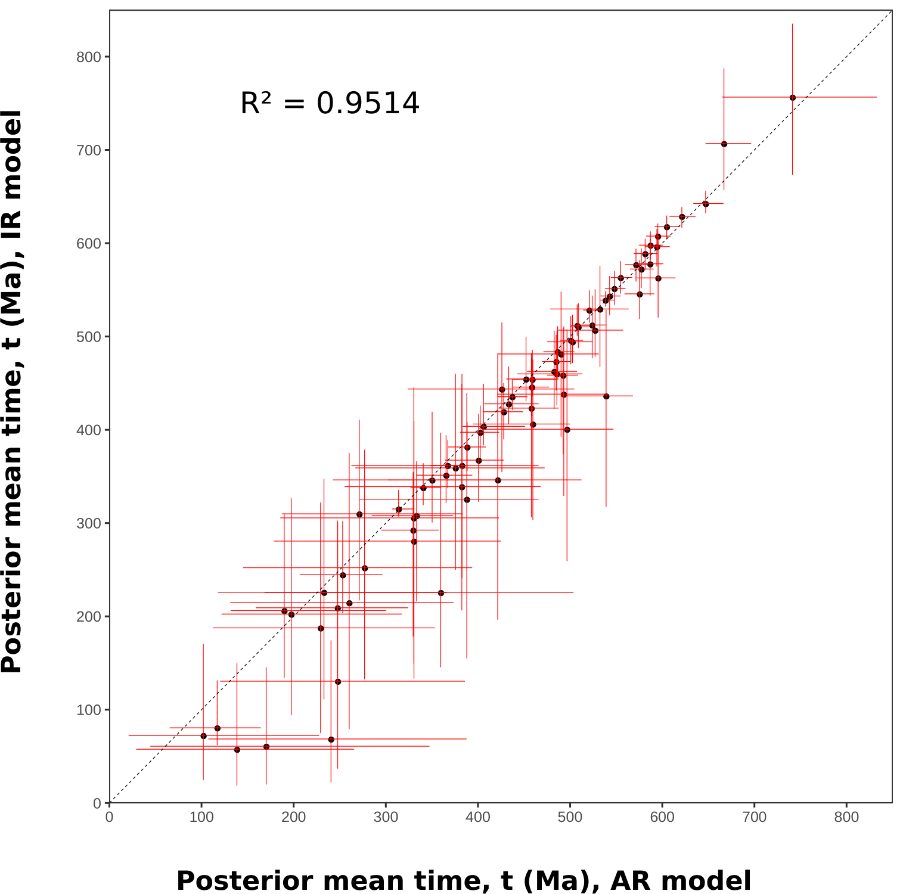
Figure S8: Scatter plot of the estimated posterior mean times estimated using a uniform prior distribution. X-axis = autocorrelated clock model, y-axis = independent rates clock model. Red lines represent the 95% HPD.

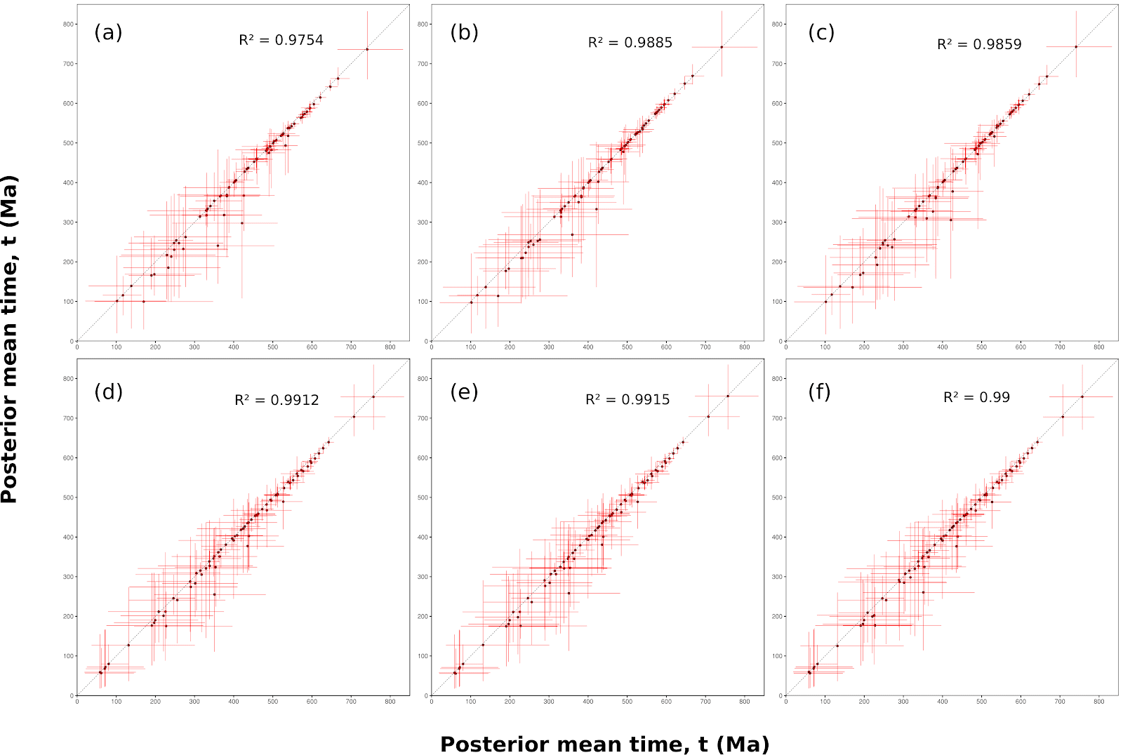
Figure S9. Scatter plot of the estimated posterior mean times estimated using alternative calibration densities priors, under both the relaxed clock models. a) uniform (x-axis) vs Cauchy 5% (y-axis) posterior estimates, AR model; b) uniform (x-axis) vs Cauchy 50% (y-axis) posterior estimates, AR model; c) uniform (x-axis) vs Cauchy 95% (y-axis) posterior estimates, AR model; d) uniform (x-axis) vs Cauchy 5% (y-axis) posterior estimates, IR model; e) uniform (x-axis) vs Cauchy 50% (y-axis) posterior estimates, IR model; f) uniform (x-axis) vs Cauchy 95% (y-axis) posterior estimates, IR model. Red lines represent the posterior 95% confidence intervals.

Supplementary methods 4.3 Sensitivity tests using alternative ecdysozoan topologies
In order to take into account the phylogenetic uncertainty across the ecdysozoan tree, we performed four further MCMC runs using alternative arrangements of the main ecdysozoan lineages, which we gave as fixed topologies to MCMCTree: Nematoda sister group to Tardigrada, Loricifera sister group to Priapulida, Tardigrada sister group to Arthropoda and Remipedia sister group to Hexapoda. We analyzed them with both AR and IR models, using a uniform prior distribution for the calibrated nodes (Fig. S10).
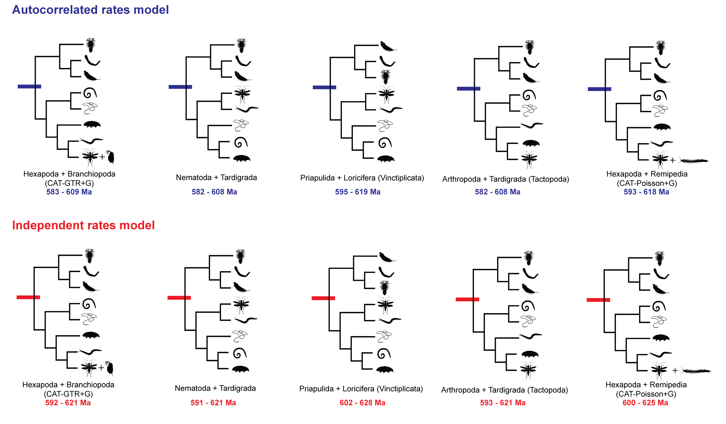
Figure S10. Alternative trees. Posterior confidence interval estimates for crown-group Ecdysozoa under alternative phylogenetic hypotheses.

Data availability
All data generated or analysed during this study are included in this published article (and its supplementary information files).
Appendix: Fossil calibrations
Descriptions of all fossil calibration points used in our molecular dating analyses. Full descriptions according to the format of Benton and Donoghue (2007) provided for new calibrations in green, and original literature cited canonical calibrations.
1) Crown Metazoa (n80)
Min 550.25 Ma
Max 833 Ma
As in Benton et al. (2015).
2) Crown Eumetazoa (n82)
Min 550.25 Ma
Max 636.1 Ma
As in Benton et al. (2015).
3) Crown Bilateria (n83)
Min 550.25 Ma
Max 636.1 Ma
As in Benton et al. (2015).
4) Crown Chordata (n84)
Min 517.33 Ma
Max 636.1 Ma
As in Benton et al. (2015), with new minimum reflecting the most recent radiometric dating of the Chengjiang Biota (Yang et al. 2018).

5) Crown Osteichthyes (n85)
Min 420.7 Ma
Max 453.7 Ma
As in Benton et al. (2015).

6) Crown Euarchontoglires (n86)
Min 61.6 Ma
Max 164.6 Ma
As in Benton et al. (2015).

7) Crown Protostomia (n87)
Min 550.25 Ma
Max 636.1 Ma
As in Benton et al. (2015).

8) Crown Spiralia/Lophotrochozoa (n88)
Min 550.25 Ma
Max 636.1 Ma
As in Benton et al. (2015) (=Lophotrochozoa). Equating to Rotifera + Mollusca + Annelida in here.

9) Mollusca + Annelida (n89)
Min 532 Ma
Max 636.1 Ma
As in Benton et al. (2015) for Mollusca, with maximum relaxed to 636.1 to accommodate the more inclusive clade.

10) Bivalvia + Gastropoda (n90)
Min 532 Ma
Max 549 Ma
As in Benton et al. (2015) for Mollusca.

11) Lottia + Aplysia (n91)
Min 470.2 Ma
Max 531.5 Ma
As in Benton et al. (2009).

12) Crown Annelida (n92)
Min 476.5 Ma
Max 636.1 Ma
Benton et al. (2015).

13) Capitella-Helobdella (n93)
Min 305.5 Ma
Max 636.1 Ma
As in Benton et al. (2009).

14) Crown Ecdysozoa (n94)
Min 532 Ma
Max 636.1 Ma
A younger minimum for Ecdysozoa (528.28) is given by previous authors (Benton et al. 2015; Wolfe et al. 2016) based on the oldest biostratigraphically constrained occurrence of the arthropod-grade trace fossil Rusophycus in the Chapel Island Formation of Newfoundland. We revise this minimum to 532 Ma to reflect the minimum age of the top of the Anabarites trisulcatus-Protohertzina anabarica Assemblage Biozone, thereby accommodating the phosphatic microfossils of the Kuanchanpu Formation of Shaanxi Province, China (Steiner et al. 2004a; Peng et al. 2012). A number of described taxa from the Kuanchanpu Formation are recovered within this biozone, preserved as phosphatic microfossils recovered from acid digestion. Among them are certain ecdysozoans, including ecdysozoan embryos (Steiner et al. 2004b; Dong et al. 2005, 2010; Donoghue et al. 2006) and a range of total group scalidophoran worms (Zhang et al. 2015, 2018; Liu et al. 2014, 2018, 2019; Shao et al. 2016, 2019, 2020; Wang et al. 2019, 2020). We therefore arbitrarily fix this minimum on the holotype for the Kuanchanpu scalidophoran Eopriapulites sphinx, deposited in at the Geological Museum of Chang’an University – CGM16, Figs. 2-3 in Liu et al. (2014). Trace fossils attributable to priapulan-like feeding/burrowing behaviour (treptichnids, see Vannier et al. 2010; Kesidis et al. 2018) are present in the terminal Ediacaran (Buatois et al. 2013; Buatois 2018). However, it is difficult to confirm the exact age of the oldest triptichnids, and their systematic affinity. Whereas Rusophycus provides unambiguous evidence for euarthropod limb morphology, treptichnids provide only evidence of an anterior terminal mouth and the probing action of an introvert – which are not limited to crown-group Priapulida. As such, treptichnids are not appropriate calibrations for crown-group Ecdysozoa, Scalidophora or Priapulida. Essentially, the affinity of treptichnids is undoubtedly ecdysozoan, but it is not clear which node they should calibrate, whereas the Kuanchanpu and equivalent taxa exhibit clear scalidophoran characters in 3-dimensional detail and are considered unequivocal as a minimum age calibration.

15) Crown Scalidophora (n95)
Min 517.33 Ma
Max 636.1 Ma
Node calibrated. The crown clade comprising Priapulida, Loricifera and Kinorhyncha, their last common ancestor, and all of its descendants. Monophyly is supported by our phylogenetic analyses, though not by another study that also sampled all three scalidophoran phyla (Laumer et al. 2019). A close relationship between these three clades is clearly evident from a suite of morphological characters including rings of scalids on the introvert, two rings of introvert retractor muscles and sensory flosculi (Kristensen 1991; Ahlrichs 1995; Lemburg 1995; Neuhaus et al. 1997; Nielsen 2001; Neuhaus and Higgins, 2002). However, some morphological analyses have recovered Loricifera rather than Kinorhyncha as the sister group to Priapulida (Dong et al. 2005, 2010; Donoghue et al. 2006; Wills et al. 2012). Characters including the lorica, indirect development with a larval stage, a neck region with rectangular plates in the larvae, nine short introvert retractors, and various characteristics of the urogenital system have been proposed as synapomorphies for a Priapulida + Loricifera clade – Vinctiplicata (Lemburg 1999). The structure of the introvert has been homologised between Priapulida and Kinorhyncha (Conway Morris 1977), with the two sharing a “collar” (zone II) which represents a diastema between the region of circumoral armature (zone I) and the region of pharyngeal armature (zone III). In addition, a sister group relationship between Kinorhyncha and Loricifera has also been proposed (Kristensen 1991; Neuhaus 1993; Neuhaus 1994; Lemburg 1999) based on the following characters: elongate scalids, scalids in the first ring with blunt tips, trichoscalids with basal plates, the mouth cone, and modified spermatozoa. Essentially, it is clear from morphology that Priapulida, Kinorhyncha and Loricifera are closely related, but morphology has been unable to resolve the sister group relationships between the three. Our study is the first to our knowledge to support scalidophoran monophyly from molecular data.
Fossil taxon and specimens. Maotianshania cylindrica (Sun & Hou 1987; Huang 2005; Hou et al. 2017). Known from thousands of specimens, this taxon is abundant in the Chengjiang Biota of Yunnan Province, China (Eoredlichia-Wutingaspis Biozone). We arbitrarily fix this calibration on a specimen figured in Hou et al. (2017) (Fig. 17.2c, 17.2d, YKLP13864), deposited at Yunnan Key Laboratory for Palaeobiology, Yunnan University.
Phylogenetic justification. Maotianshania cylindrica represents a stem-group priapulan, typically described as a palaeoscolecid-like form – a group (or more possibly grade) of slender, introvert-bearing, multiannulated worms with distinct cuticular ornamentation. Palaeoscolecid-like worms have been considered as plesiomorphic ecdysozoans, but this has not held up to phylogenetic scrutiny (Harvey et al. 2010).
Age justification. The exceptionally preserved Chengjiang Biota of Yunnan Province occurs within the mudstones of the Yu’anshan Member of the Heilinpu Formation, which has been assigned to the Eoredlichia-Wutingaspis Biozone. Biostratigraphic correlation has been historically problematic due to faunal endemism, but recent U-Pb dating analyses of detrital zircons recovered a minimum of 518.03 +/- 0.69/071 Ma = (517.33 Ma) (Yang et al. 2018). The maximum age represents the upper estimate for the age of the Lantian Biota (Condon et al. 2005; Yuan et al. 2011) as is currently standard in high-level animal taxa (Benton et al. 2015; Wolfe et al. 2016). The Lantian exhibits Orsten and Burgess Shale type preservation models but does not preserve anything that can be interpreted as a total group eumetazoan.
Discussion. The Chengjiang Biota has yielded an abundance of priapulan-like taxa, and we therefore consider our minimum age robust to further interrogation of the systematic affinities of Maotianshania. Essentially, this calibration merely represents the age of Chengjiang, as a host of suitable fossils representing stem-group and probably crown-group Priapulida are present among this biota (see Hou et al. 2017). Crown-group Loricifera is unambiguously present in the Cambrian Deadwood Formation of western Canada (Harvey and Butterfield 2017), but this material is considerably younger than Chengjiang.

16) Priapulida + Kinorhyncha (n96)
Min 517.33 Ma
Max 636.1 Ma
Node calibrated. The crown clade comprising Priapulida, Kinorhyncha, their last common ancestor and all its descendants. See Scalidophora for discussion of shared characters and previous systematic interpretations.
Fossil taxon and specimens. As for Scalidophora.
Phylogenetic justification. As for Scalidophora.
Age justification. As for Scalidophora.
Discussion. Eokinorhynchus rarus (Zhang et al. 2015, 2018), a scalidophoran taxon with supposed kinorhynch affinities from the Xinli Member, Dengying Formation (Terreneuvian Series, Fortunian Stage) is considerably older than the Chengjiang Biota, but its phylogenetic affinity is not well-justified. No diagnostic kinorhynch characters that are not probable plesiomorphies for Scalidophora are identifiable in E. rarus, with no characters to suggest it is any more proximal to total group Kinorhyncha than to any other scalidophoran clade. E. rarus exhibits a heteronomous trunk annulation (i.e. individual annuli are not identical due to cuticular ornamentation) with approximately 20 “macroannuli”, and this is posited by previous authors as comparative with the condition of body segmentation in Kinorhyncha (Zhang et al. 2015, 2018). Modern kinorhynchs have 11 trunk segments (zonites), with 1 dorsal (tergal) and up to 3 ventral (sternal) cuticular plates covering each segment – this is invariable and considered a key apomorphy for the group (Neuhaus 2013). The comparison between E. rarus and kinorhynchs is based on a reduction of trunk annulation, which is not an appropriate synapomorphy to ally E. rarus to Kinorhyncha without more fossils illustrating the acquisition of the fixed and distinctive 11 trunk zonites exhibited by all known Kinorhyncha. Similarly, other scalidophoran taxa known from the early Cambrian of China such as Eopriapulites sphinx (Liu et al. 2014; Shao et al. 2016) lack any apomorphic characters to indicate any affinity more derived than the scalidophoran total group and are not considered to be appropriate calibration fossils. Other candidates include palaeoscolecid sclerite arrays from the Early Cambrian Sinsk Formation from the Siberian Platform (Ivantsov and Wrona 2004), which are probably taxonomically proximal to Priapulida, but do not represent complete individuals and the Bergeroniellus guarii Biozone they are recovered from cannot be ascertained to be stratigraphically older than the Chengjiang Biota (Peng et al. 2012).

17) Crown Priapulida (n97)
Min 306.9 Ma
Max 636.1 Ma
Node calibrated. The crown clade comprising Megaintroverta, Halicryptus, Maccabaeus, Meiopriapulus, Tubiluchus, their common ancestor and all its descendants.
Fossil taxon and specimens. Priapulites konecniorum (Schram 1973), a certain crown group priapulan with a large introvert and caudal appendage from the Carboniferous Mazon Creek Biota. This taxon is known from multiple specimens, and we arbitrarily fix the calibration on the holotype PE21555 in the fossil invertebrate collections of the Field Museum of Natural History, Chicago, Illinois, USA.
Phylogenetic justification. This species bears a large introvert and a caudal appendage, and is bracketed by Halicryptus and Megaintroverta in multiple phylogenetic studies (e.g. Harvey et al. 2010; Wills et al. 2012; Ma et al. 2014).
Age justification. Specimens are in the form of nodules derived from the Wesphalian D aged Francis Creek Shale Member of the Carbondale Formation, Mazon Creek, Illinois, USA (Baird et al. 1985). This is equivalent to the Moscovian Stage of the Pennsylvanian (Richards 2013). The upper boundary of the Moscovian (307.0 Ma +/- 0.1 Myr) therefore provides the minimum age.
Discussion. The fossil record of crown-group Priapulida may be considerably older than the Carboniferous. Several early Cambrian Chengjiang Biota taxa may represent crown group priapulans, but there is instability in their phylogenetic position across various studies. The best candidates are Xiaoheiqingella peculiaris and Yunnanpriapulus halteroformis (see Huang et al. 2004) resolved as a crown group priapulan by some analyses (Harvey et al. 2010; Ma et al. 2014) but not others (Wills et al. 2012). Priapulites konecniorum is essentially indistinguishable from extant Megaintroverta, and is the more reliable calibration fossil candidate.
18) Cryptovermes (n101)
Min 528.82 Ma
Max 636.1 Ma
Node calibrated. The crown clade comprising Nematoida (Nematoda + Nematomorpha) and Panarthropoda (Arthropoda + Onychophora + Tardigrada). Morphological synapomorphies are conspicuously absent, but clustering of nematoid and panarthropod taxa has been recovered by phylogenomic studies (Hejnol et al. 2009; Campbell et al. 2011; Borner et al. 2014; Yoshida et al. 2017; Laumer et al. 2015, 2019), albeit frequently recovering a close relationship between nematodes and tardigrades that is likely a long branch artefact (Campbell et al. 2011).
Fossil taxon and specimens. As in Wolfe et al. Arthropoda/Euarthropoda.
Phylogenetic justification. As in Wolfe et al. Arthropoda/Euarthropoda.
Age justification. As in Wolfe et al. Arthropoda/Euarthropoda.

19) Crown Nematoida (n102)
Min 405 Ma
Max 636.1 Ma
Node calibrated. The crown clade comprising Nematoda, Nematomorpha, their last common ancestor, and all of its descendants. There is generally strong phylogenetic support for a sister group relationship between nematodes and nematomorphs, proposed synapomorphies (Schmidt-Rhaesa 1998) including longitudinal dorsal and ventral epidermal unpaired nerve cords, the absence of ring musculature, the absence of protonephridia, and the cloaca in both sexes.Some comprehensively sampled molecular phylogenies have also recovered Nematoida (Campbell et al. 2011). Nevertheless, the nematomorph larva bears a retractable proboscis, and this has been among the primary lines of evidence to support a relationship between Nematomorpha and the introvert bearing worms as Phylum Cephalorhyncha (Malakhov 1980; Adrianov and Malakhov 1995); or those groups together with the nematodes to encompass Introverta (Nielsen 1995)/Cycloneuralia (Ahlrichs 1995). The circumpharyngeal brain and introvert are the key synapomorphies but may be also interpreted as ecdysozoan plesiomorphies. Furthermore, detailed investigation suggests the hollow scalid-bearing introverts of priapulids, kinorhynchs and loriciferans are probably not homologous to the hexaradial larval nematomorphan proboscis (Schmidt-Rhaesa 1998), and molecular phylogenies generally do not recover Introverta/Cycloneuralia/Cephalorhyncha. Several alternative molecular topologies have been recovered but are variously more contentious. These include: 1) A sister group relationship between Nematomorpha and Loricifera reported from analysis of limited 18s rRNA and Histone 3 data (Sørensen et al. 2008). 2) a novel sister group relationship between Kinorhyncha and Nematomorpha from expressed sequence tags (Hejnol et al. 2000). 3) A persistent clustering of tardigrade sequences with either nematodes (Hejnol et al. 2009; Borner et al. 2014; Laumer et al. 2015, 2019) or nematoids (Dunn et al. 2008), has been attributed to long-branch attraction (Campbell et al. 2011).
Fossil taxon and specimens. Palaeonema phyticum (Poinar et al. 2008), from the Early Devonian (Pragian) Rhynie Chert – the oldest known unequivocal nematoid body fossil. Hundreds of individuals of various ontogenetic stages are reported as parasites preserved in the stomatal chambers of the terrestrial plant Aglaophyton major. We fix this calibration on the holotype for P. phyticum (Figs. 2A, B + C in Poinar et al. 2008), deposited in the Forschung für Paläobotanik, Westfälische Wilhelms-Universität, Münster, Germany, see (Poinar et al. 2008) – a complete female specimen preserved in longitudinal section.
Phylogenetic justification. Palaeonema phyticum is conservatively assigned to its own monotypic family, Palaeonematidae (Poinar et al. 2008). P. phyticum was compared in the original description to the modern family Tripyloididae based on shared features including: inconspicuous lips, a division of the buccal cavity into two separate chambers, teeth in the buccal cavity, didelphic and reflexed ovaries, spiral amphidial apertures and a cylindrical pharynx. Regardless of exact phylogenetic affinity within or outside the nematode lineage, P. phyticum is an uncontroversial member of the nematode total group, and therefore the nematoid total group.
Age justification. The Rhynie Chert lies within the polygonalis-emsiensis Spore Assemblage Biozone and is dated between the early (but not earliest) Pragian to the early Emsian (Richardson and McGregor 1986; Wellman 2004, 2006). Radiometric dating has indicated an age of ca. 411 Ma for the underlying Milton of Noth Andesite (Parry et al. 2011, 2013), which through investigation of its temporal relationship to hot spring related activity associated with the Rhynie Chert, has been determined to predate the global dating of the base of the Pragian Stage (Mark et al. 2011, 2013). Therefore, 405 Ma, extrapolated from the global Pragian-Emsian boundary date (407.6 Ma ± 2.6 Myr) is assigned as the minimum age for Palaeonema phyticum. Maximum based on upper estimate of the Lantian Biota as for other higher clades and phyla (see Scalidophora).
Discussion. The systematic interpretations of Poinar et al. (2008) place P. phyticum as a potentially derived nematode in the crown group, but the described characters are somewhat tenuous in the figured material. However, the body shape and apparently phytoparasitic habit are unambiguously indicate an affinity within or proximal to Nematoda – and therefore the fossil is suitable for placing a minimum constraint on Nematoida. A potential nematode from the Ordovician of southern China has been described (Muir et al. 2014), but no robust characters are present to ally this fossil to Nematoda – only a paucity of characters is seen as indicative of nematode affinity by the authors, which is not sufficient to make this fossil a reliable calibration point.

20) Crown Nematomorpha (n103)
Min 98.17 Ma
Max 636.1
Node calibrated. The crown clade including Gordiida, Nectonematomorpha, their last common ancestor and all its descendents. Monophyly is uncontroversial, and the group is generally considered to be the sister group to Nematoda (Schmidt-Rhaesa 1998).
Fossil taxa and specimens. Cretachordodes burmitis (Poinar and Buckley 2006), a probable male gordiid preserved in burmite (amber) – recovered from an amber mine in Hukawng Valley, Kachin State, Myanmar. We fix this calibration on the specimen figured in Poinar and Buckley (2006) (Figs. 3-12). This holotype and only known specimen is retained in the private amber collection of Ron Buckley of Florence, Kentucky – an ethical concern (see Nature Ecology & Evolution editorial “Fossilized ethics”)
Phylogenetic justification. Nematomorph systematics is plagued by a lack of morphological characters, making taxonomic interpretations of fossils limited. However, Cretachordodes burmitis is attributed to an extant family, the Chordodidae, based on the shape of the head and tail. No additional justification is given, and therefore the affinity of Cretachordodes with regard to living Gordiida may be considered unresolved. However, phylogenetic analysis of combined morphology and 18S rRNA has resolved the two principal nematomorph taxa (the freshwater Gordiida and marine genus Nectonema) as sister taxa (Bleidorn et al. 2002) – and therefore as at least a total group gordiid, Cretachordodes burmitis is an appropriate minimum divergence marker.
Age justification. The age of burmite has been estimated through U-Pb dating of zircons in the volcanoclastic matrix that surrounds burmite deposits, giving an estimate of 98.79 Ma +/- 0.62 Myr, therefore minimum = 98.17 Ma (Shi et al. 2012). Maximum based on upper estimate of the Lantian Biota (see Scalidophora).
Discussion. Only 2 other nematomorph fossil taxa have been reported (Voigt 1938; Poinar 1999), both of which are Cenozoic in age.

21) Crown Nematoda (n104)
Min 129.41 Ma
Max 636.1 Ma
Node calibrated. The crown clade comprising Enoplia, Dorylaimia and Chromadorea, their common ancestor and all its descendants. The phylogeny of the phylum Nematoda is particularly problematic; studies are typically biased towards economically significant species (phytophages, plant and animal/human parasites etc). Only a rough outline is recognised as the subgroups Enoplia, Dorylaimia and Chromadorea; though their interrelationships are not confirmed (De Ley and Blaxter 2002; Holterman et al. 2006; Meldal et al. 2007; Schmidt-Rhaesa 2014), and some lineages may not fall into these larger subgroups.
Fossil taxa and specimens. Heleidomermis libani (Poinar et al. 1994), JS 404 deposited in the Acra Lebanese amber collection, figured in Poinar et al. (1994) (Fig. 1) and in Schmidt-Rhaesa (2014) (Fig. 6.2). A mermithid nematode preserved in Lebanese amber parasitizing a female biting midge (Ceratopogonidae).
Phylogenetic justification. Heleidomermis is an extant genus and several characters exhibited by H. libani support this affinity, including the occurrence of the final moult within the host, absence of cross fibres in the cuticle and the absence of a tail projection on the post parasitic juvenile. Regardless of the position of H. libani within Mermithida, the Mermithida are crown group nematodes – recovered within or proximal to Dorylaimia (De Ley and Blaxter 2002; Holterman et al. 2006; Meldal et al. 2007).
Age justification. H. libani was recovered from the Jezzine amber deposits of southern Lebanon, which have been correlated to the early Barremian (Maksoud et al. 2017). The upper boundary for the early Barremian is constrained by the first appearance of the ammonite Ancycloceras vandenheckii, which is dated at 129.41 Ma (Ogg et al. 2012) – providing a minimum age estimate for H. libani. Maximum based on upper estimate of the Lantian Biota (see Scalidophora).
Discussion. A rhabditid (Chromadorea) taxon is also described from Lebanese amber – Vetus libani (Poinar 2011), and is a suitable arbitrary alternative to H. libani. Palaeonema phyticum (Poinar et al. 2008) was compared to the living family Tripyloididae, but conservatively assigned to a monotypic family of uncertain affinity due to incompleteness of material. As such, P. phyticum is less suitable to confirm the minimum divergence of the nematode crown group. Another Palaeozoic nematode is also known, the Carboniferous Nemavermes mackeei of the Mazon Creek Biota (Schram 1973, 1979), but is also of unknown affinity and therefore not suitable, likewise is the Jurassic Eophasma jurasicum (Arduini 1983).

22) Crown Enoplea (n105)
Min 129.41 Ma
Max 636.1 Ma
Node calibrated. The crown clade comprising Enoplia, Dorylaimia, their common ancestor and all its descendants. The relationships between the principal nematode subgroups are disputed (Schmidt-Rhaesa 2014) and comprehensive phylogenomic research is urgently required. Dorylaimia has been placed as more derived than enoplian clades (Holterman et al. 2006), but Enoplia + Dorylaimia has been recovered by more studies (De Ley and Blaxter 2002; Meldal et al. 2007) including this one. Therefore, we tentatively consider Enoplea as a monophylum for the purposes of this molecular dating study.
Fossil taxa and specimens. As for Nematoda.
Phylogenetic justification. Mermithida is recovered within or proximal to Dorylaimia in multiple molecular phylogenetic studies (DeLey and Blaxter 2002; Holterman et al. 2006; Meldal et al. 2007).
Age justification. As for Nematoda.
Discussion. Palaeonema phyticum has been compared to the extant enoplid family Tripyloidae based on some characters observable in the fossil material (Poinar et al. 2008), but it was conceded that others were obscured and that the male morphology was unknown – and therefore placed P. phyticum in its own monotypic family of uncertain affinity. Therefore, as with the nematode crown group, P. phyticum is not a suitable calibration point for the minimum divergence of Enoplea.

23) Rhabditida + (Spirurida + Ascarida) (n107)
Min 129.41 Ma
Max 636.1 Ma
Node calibrated. Essentially =Chromadorea, i.e. the crown clade comprising the nematode orders Ascarida, Rhigonematida, Spirurida (including Camallanida), Oxyurida, Gnathostomatoidea, Rhabditida (including Strongylida), Tylenchida, Plectida, Araeolaimida, Monhysterida, Desmodorida, Chromadorida and Desmoscolecida, their common ancestor and all its descendants. Chromadorea appears to be the best resolved major nematode subgrouping, apparently showing a transition from free-living to parasitic forms (Schmidt-Rhaesa 2014).
Fossil taxon and specimens. Vetus libani (Poinar 2011). Holotype Milki 194-7 in the American University of Beirut amber collection, figured in (Poinar 2011) (Fig. 24).
Phylogenetic justification. Vetus is not a natural systematic unit, but is the name used for any fossil nematodes exhibiting characters identifiable to the order Rhabditida – see (Poinar 2011).
Age justification. As for Nematoda.

24) Crown Rhabditida (n108)
Min 129.41 Ma
Max 636.1 Ma
Node calibrated. The crown clade comprising nematodes of the order Rhabditida, including the Strongylida (Sudhaus 2011), their common ancestor and all its descendants.
Fossil taxon and specimens. As for Rhabditida - (Spirurida+Ascarida).
Phylogenetic justification. As for Rhabditida - (Spirurida+Ascarida).
Age justification. As for Rhabditida - (Spirurida+Ascarida).

25) Crown Panarthropoda (n110)
Min 528.82 Ma
Max 636.1 Ma
Node calibrated. The crown clade comprising Euarthropoda, Onychophora, Tardigrada, their common ancestor and all its descendants. Preceding the advent of molecular phylogenetics in zoological systematics, arthropods were considered to form a taxon with the segmented annelids (Articulata). In the phylogenomic age, a relationship between nematodes and tardigrades has persisted in some molecular analyses (Dunn et al. 2008; Hejnol et al. 2009; Borner et al. 2014; Laumer et al. 2015), but has been attributed to long branch attraction (Campbell et al. 2011).
Fossil taxon and specimens. As for Cryptovermes
Phylogenetic justification. As for Cryptovermes.
Age justification. As for Cryptovermes.

26) Crown Tardigrada (n111)
Min 89.5 Ma
Max 636.1 Ma
Node calibrated. The crown clade comprising Heterotardigrada, Eutardigrada, their common ancestor and all its descendants.
Fossil taxon and specimens. Milnesium swolenskyi (Bertolani and Grimaldi 2000), a eutardigrade preserved in amber from the Cretaceous of New Jersey, deposited in the American Museum of Natural History (holotype AMNH NJ-796).
Phylogenetic justification. An unambiguous eutardigrade, assignable to the extant family Milnesiidae based on characters pertaining to claw structure and the paired lateral papillae.
Age justification. The age of New Jersey amber is constrained to the Turonian Stage of the Cretaceous based on lithostratigraphy and palynology (Grimaldi et al. 2000). The minimum age for Milnesium swolenskyi is therefore defined as the minimum age of the upper boundary of the Turonian: 89.5 Ma (Ogg et al. 2012).
Discussion. Another crown group tardigrade is known from Cretaceous Canadian amber, Beorn leggi (Cooper 1964), but is considerably younger.

27) Crown Onychophora + Arthropoda (n117)
Min 528.82 Ma
Max 636.1 Ma
As in Benton et al. (2015).

28) Crown Onychophora (n118)
Min 142 Ma
Max 636.1 Ma
As in Rota-Stabelli et al. (2013), with maxima relaxed to 636.1 Ma to accommodate maximum age of the Lantian Biota (see Scalidophora).

29) Crown Arthropoda (n120)
Min 514 Ma
Max 636.1 Ma
As in Wolfe et al. (2016).

30) Crown Chelicerata (n121)
Min 509 Ma
Max 636.1 Ma
As in Wolfe et al. (2016).

31) Crown Pantopoda (n122)
Min 429.8 Ma
Max 636.1 Ma
As in Wolfe et al. (2016).

32) Crown Euchelicerata (n123)
Min 500.5 Ma
Max 636.1 Ma
As in Wolfe et al. (2016).

33) Crown Arachnida (n124)
Min 435.15 Ma
Max 636.1 Ma
As in Wolfe et al. (2016).

34) Crown Arachnopulmonata (n126)
Min 435.15 Ma
Max 514 Ma
Node calibrated. The crown clade comprising Tetrapulmonata, Scorpiones, their common ancestor and all its descendants. Monophyly supported by several independent molecular phylogenetic studies (Sharma et al. 2014; Balesteros and Sharma 2019; Lozano-Fernandez et al. 2019, 2020; Howard et al. 2020; Noah et al. 2020), with some showing that Pseudoscorpiones may belong in this clade as the sister group of Scorpiones (Lozano-Howard et al. 2020; Ontano 2021). Furthermore, evidence for monophyly comes from a shared whole genome duplication among arachnopulmonates (Schwager et al. 2017; Leite et al. 2018), and shared characters of the book lungs (Scholtz and Kammenz 2006) and haemolymph vascular system (Klußmann‐Fricke and Wirkner 2016).
Fossil taxon and specimens. As in Wolfe et al. (2016) for Arachnida.
Phylogenetic justification. As in Wolfe et al. (2016) for Arachnida.
Age justification. As for Arachnida, with maximum lowered to the maximum age of the oldest known chelicerate (see Wolfe et al. 2016).

35) Crown Araneae (n127)
Min 298.75 Ma
Max 514 Ma
As in Wolfe et al. (2016).

36) Crown Mandibulata (n128)
Min 514 Ma
Max 636.1 Ma
As in Wolfe et al. (2016).

37) Crown Myriapoda (n129)
Min 424.7 Ma
Max 636.1 Ma
As in Wolfe et al. (2016).
Discussion. This dating drew upon Cowiedesmus eroticopodus, one of three species of archipolypodan millipedes from Dictyocaris Member of the Cowie Formation near Stonehaven, Scotland (Wilson and Anderson 2004). This unit was until recently interpreted as Silurian (late Wenlock-early Ludlow) based on spores but has been redated to the Early Devonian (Lockkovian) based on new U/Pb dates (Suarez et al. 2017; Brookfield et al. 2020). Following Lozano-Fernandez et al. (2020), another Silurian species used therein as a calibration for the subordinate taxon Progoneata serves as an alternative calibration for Myriapoda; resulting in a small difference in minimum date for Myriapoda compared to the Wolfe et al. (2016) calibration employed here. This is Casiogrammus ichthyeros Wilson, 2005: holotype NMS (National Museum of Scotland) 1970.2, from the Fish Bed Formation, Glenbuck Group, Smithy Burn, Hagshaw Inlier, Lanarkshire, Scotland. The Fish Bed Formation receives a Wenlock date based on its spores (Wellman and Richardson 1993). A minimum date using the base of the Ludlow Series is applied, 427.4 Ma ± 0.5 Myr (=426.9 Ma), yielding only a very slightly older minima (2.2 myrs older) than the one used here.

38) Crown Chilopoda (n130)
Min 416 Ma
Max 636.1 Ma
As in Wolfe et al. (2016).

39) Crown Pleurostigomorpha (n131)
Min 382.7 Ma
Max 521 Ma
As in Wolfe et al. (2016).

40) Crown Diplopoda (n132)
Min 424.7 Ma
Max 636.1 Ma
As in Wolfe et al. (2016).
Discussion. As noted above under Myriapoda, this dating from Wolfe et al. (2016) drew on Cowiedesmus eroticopodus, one of three species of archipolypodans from the Dictyocaris Member of the Cowie Formation near Stonehaven, Scotland. This was until recently interpreted as Silurian (late Wenlock-early Silurian) based on spores but has been redated to the Early Devonian (Lochkovian) based on new U/Pb dates (Suarez et al. 2017; Brookfield et al. 2020). As such, a slightly older alternative is provided by Casiogrammus ichthyeros Wilson, 2005: holotype NMS (National Museum of Scotland) 1970.2, from the Fish Bed Formation, Glenbuck, Smithy Burn, Hagshaw Inlier, Lanarkshire, Scotland, part and counterpart preserved as an articulated series of 19 partly exfoliated trunk segments in siltstone. The Fish Bed Formation receives a Wenlock date based on its spores (Wellman and Richarson 1993). A minimum date using the base of the Ludlow Series is applied, 427.4 Ma ± 0.5 Myr (=426.9 Ma), yielding only a very slightly older minima (2.2 myrs older) than the one used here.
Phylogenetic justification for Casiogrammus ichthyeros alternative. Casiogrammus was originally classified together with a Carboniferous millipede, Zosterogrammus stichostrethus Wilson, 2005, in an extinct order, Zosterogrammida, based on sharing broad terga with distinctive ornament. The better known Zosterogrammus provides most of the relevant data for assigning Zosterogrammida to Chilognatha. Coding C. ichthyeros in a morphological dataset recovers it as total-group Chilognatha, and accordingly crown-group Diplopoda (Fernández et al. 2018: Fig. 2e).
41) Crown Pancrustacea (n135)
Min 514 Ma
Max 636.1 Ma
As in Wolfe et al. (2016).

42) Crown Branchiopoda (n142)
Min 405 Ma
Max 521 Ma
As in Wolfe et al. (2016).

43) Crown Hexapoda (n144)
Min 405 Ma
Max 521 Ma
As in Wolfe et al. (2016).

44) Crown Insecta (n145)
Min 405 Ma
Max 521 Ma
As in Wolfe et al. (2016). The calibration fossil, Rhyniognatha hirsti, was attributed to Insecta based on the structure of its mandibles. The diagnostic presence of an anterior acetabulum could not be established with confidence upon restudy of the specimen (Haug and Haug 2017). Although an interpretation as mouthparts and parts of the head capsule of a myriapod is an alternative, an insect identity “cannot fully be excluded” fide Haug and Haug (2017).

45) Crown Pterygota (n146)
Min 322.83 Ma
Max 521 Ma
As in Wolfe et al. (2016).
Discussion.

46) Crown Palaeoptera (n147)
Min 319.9 Ma
Max 521 Ma
As in Wolfe et al. (2016).

47) Crown Neoptera (n148)
Min 319.9 Ma
Max 521 Ma
As in Wolfe et al. (2016).

48) Crown Polyneoptera (n149)
Min 319.9 Ma
Max 411 Ma
As in Wolfe et al. (2016).

49) Crown Dictyoptera (n151)
Min 130.3 Ma
Max 411 Ma
As in Wolfe et al. (2016).

50) Crown Eumetabola (n152)
Min 319.9 Ma
Max 411 Ma
As in Wolfe et al. (2016).

51) Crown Holometabola (n153)
Min 313.7 Ma
Max 411 Ma
As in Wolfe et al. (2016). We acknowledge the anomalous position of Gynaikothrips thrips in our tree, but the clade we recognise as Holometabola remains compatible with our calibration. If the addition of the thrip to this clade makes it possible for an older minimum constraint, it does not invalidate our existing minimum, as defined in Wolfe et al (2016).

52) Crown Aparaglossata (n155)
Min 313.7 Ma
Max 411 Ma
As in Wolfe et al. (2016).

53) Crown Amphiesmenoptera (n156)
Min 201.6 Ma
Max 411 Ma
As in Wolfe et al. (2016), with minimum updated to reflect glossatan lepidopteran scales recovered from Triassic-Jurassic boundary sediments from northern Germany (van Eldijk et al. 2018).

54) Coleopterida + Neuropterida (n157)
Min 306.9 Ma
Max 411 Ma
As in Wolfe et al. (2016) for Coleopterida.

Supplementary references
- Ahlrichs, W.H. 1995. Ultrastruktur und Phylogenie von Seison nebaliae (Grube 1859) und Seison annulatus (Claus 1876): Hypothesen zu phylogenetischen Verwandschaftsverhältnissen innerhalb der Bilateria. Cuvillier, Göttingen, 310p.
- Andrews, S. 2010. FastQC: a quality control tool for high throughput sequence data. https://www.bioinformatics.babraham.ac.uk/projects/fastqc/.
- Arduini, P., Pinna, G. & Teruzzi, G. 1983. Eophasma jurassicum ngn sp., a new fossil nematode of the Sinemurian of Osteno in Lombardy. Atti della Società italiana di scienze naturali e del museo civico di storia naturale di Milano, 124, 61-64.
- Baird, G.C., Sroka, S.D., Shabica, C.W., & Beard, T.L. 1985. Mazon Creek-type fossil assemblages in the US midcontinent Pennsylvanian: their recurrent character and palaeoenvironmental significance. Philosophical Transactions of the Royal Society of London. B, Biological Sciences, 311, 87-99.
- Ballesteros, J.A., & Sharma, P.P. 2019. A critical appraisal of the placement of Xiphosura (Chelicerata) with account of known sources of phylogenetic error. Systematic Biology, 68, 896-917.
- Benton, M.J. & Donoghue, P.C.J. 2006. Paleontological Evidence to Date the Tree of Life. Molecular Biology and Evolution, 24, 26–53.
- Benton, M.J., Donoghue, P.C.J. & Asher, R.J. 2009. "Calibrating and constraining molecular clocks" in The Timetree of Life. In Blair Hedges, S. & Kumar, S. (eds.). Oxford University Press, pp. 35–86.
- Benton, M.J., Donoghue, P.C.J., Asher, R.J., Friedman, M., Near, T.J. & Vinther, J. 2015. Constraints on the timescale of animal evolutionary history. Palaeontologia Electronica, 18.1FC.
- Bertolani, R. & Grimaldi, D. 2000. A new Eutardigrade (Tardigrada: Milnesiidae) in amber from the Upper Cretaceous (Turonian) of New Jersey. In Studies on Fossils in Amber, with Particular Reference to the Cretaceous of New Jersey, Grimaldi, D. (ed.). Backhuys, pp. 103-110.
- Betts, H.C., Puttick, M.N., Clark, J.W., Williams, T.A., Donoghue, P.C.J. & Pisani D. 2018. Integrated genomic and fossil evidence illuminates life’s early evolution and eukaryote origins. Nature Ecology & Evolution, 2, 1556-1562.
- Bleidorn, C., Schmidt-Rhaesa, A. & Garey, J.R. 2002. Systematic relationships of Nematomorpha based on molecular and morphological data. Invertebrate Biology, 121, 357–364.
- Bolger, A.M., Lohse, M. & Usadel, B. 2014. Trimmomatic: a flexible trimmer for Illumina sequence data. Bioinformatics, 30, 2114–2120.
- Brookfield, M.E., Catlos, E.J. & Suarez, S.E. 2020. Myriapod divergence times differ between molecular clock and fossil evidence: U/Pb zircon ages of the earliest fossil millipede-bearing sediments and their significance. Historical Biology.
- Campbell, L.I., Rota-Stabelli, O., Edgecombe, G.D., Marchioro, T., Longhorn, S.J., Telford, M. J., Philippe, H., Rebecchi, L., Peterson, K.J. & Pisani, D. 2011. MicroRNAs and phylogenomics resolve the relationships of Tardigrada and suggest that velvet worms are the sister group of Arthropoda. PNAS, 108, 15920-15924.
- Buatois, L.A. 2018. Treptichnus pedum and the Ediacaran–Cambrian boundary: significance and caveats. Geological Magazine, 155, 174-180.
- Buatois, L.A., Almond, J. & Germs, G.J.B. 2013. Environmental tolerance and range offset of Treptichnus pedum: Implications for the recognition of the Ediacaran-Cambrian boundary. Geology, 41, 519-522.
- Campbell, L.I., Rota-Stabelli, O., Edgecombe, G.D., Marchioro, T., Longhorn, S.J., Telford, M. J., Philippe, H., Rebecchi, L., Peterson, K.J. & Pisani, D. 2011. MicroRNAs and phylogenomics resolve the relationships of Tardigrada and suggest that velvet worms are the sister group of Arthropoda. PNAS, 108, 15920-15924.
- Castresana, J. 2000. Selection of Conserved Blocks from Multiple Alignments for Their Use in Phylogenetic Analysis. Molecular Biology and Evolution, 17, 540–552.
- Condon, D., Zhu, M-Y., Bowring, S., Wang, W., Yang, A-H. & Jin, Y-G. 2005. U-Pb Ages from the Neoproterozoic Doushantuo Formation, China. Science, 308, 95-98.
- Conway Morrris, S. 1977. Fossil priapulid worms. Special papers in Palaeontology, 20, 1–95.
- Cooper, K.W. 1964. The first fossil tardigrade: Beorn leggi Cooper, from Cretaceous amber. Psyche: A Journal of Entomology, 71, 41-48.
- De Ley, P. & Blaxter, M.L. 2002. “Systematic Positon and Phylogeny”. In The Biology of Nematodes, Lee, D.L. (ed.). Taylor Francis.
- Dong, X-P., Donoghue, P.C.J., Cunningham, J.A, Liu, J-B., & Cheng, H. 2005. The anatomy, affinity and phylogenetic significance of Markuelia. Evolution & Development, 7, 468–482.
- Dong, X-P., Bengston, S., Gostling, N.J., Cunningham, J.A., Harvey, T.H.P., Kouchinsky, A., Val’Kov, A.K., Repetski, J.E., Stampanoni, M., Marone, F. & Donoghue, P.C.J. 2010. The anatomy, taphonomy, taxonomy and systematic affinity of Markuelia: Early Cambrian to Early Ordovician scalidophorans. Palaeontology, 53, 1291–1314.
- Donoghue, P.C.J. & Benton, M.J. 2007. Rocks and clocks: calibrating the Tree of Life using fossils and molecules. Trends in Ecology & Evolution, 22, 424–431.
- Donoghue, P.C.J., Bengston, S., Dong, X-P., Gostling, N.J., Huldtgren, T., Cunningham, J.A., Yin, C-Y., Yue, Z., Peng, F. & Stampanoni, M. 2006. Synchrotron X-ray tomographic microscopy of fossil embryos. Nature, 442, 680–683.
- dos Reis, M., Zhu, T-Q. & Yang, Z-H. The Impact of the Rate Prior on Bayesian Estimation of Divergence Times with Multiple Loci. Systematic Biology, 63, 555–565.
- dos Reis, M., Thawornawattana, Y., Angelis, K., Telford, M.J., Donoghue, P.C.J. & Yang, Z-H. 2015. Uncertainty in the Timing of Origin of Animals and the Limits of Precision in Molecular Timescales. Current Biology, 25, 2939-2950.
- Dunn, C.W., Hejnol, A., Matus, D.Q., Pang, K., Browne, W.E., Smith, S.A., Seaver, E., Rouse, G.W., Obst, M., Edgecombe, G.D., Sørensen, M.V., Haddock, S.H.D., Schmidt-Rhaesa, A., Okusu, A., Kristensen, R.M., Wheeler, W.C., Martindale, M.Q. & Giribet, G. 2008. Broad phylogenomic sampling improves resolution of the animal tree of life. Nature, 452, 745-749.
- Edgar, R. C. 2004. MUSCLE: multiple sequence alignment with high accuracy and high throughput. Nucleic Acids Research, 32, 1792–1797.
- Feuda, R., Dohrmann, M., Pett, W., Philippe, H., Rota-Stabelli, O., Lartillot, N., Wörheide, G. & Pisani, D. 2017. Improved Modeling of Compositional Heterogeneity Supports Sponges as Sister to All Other Animals. Current Biology, 27, 3864-3870.
- Anon. 2021. Fossilized ethics. Nature Ecology & Evolution, 5, 703-705.
- Grimaldi, D., Shedrinsky, A. & Wampler, T.P. 2000. A remarkable deposit of fossiliferous amber from the Upper Cretaceous (Turonian) of New Jersey. Studies on Fossils in Amber, with Particular Reference to the Cretaceous of New Jersey, D. Grimaldi, (ed.). Backhuys, pp. 1-76.
- Haas, B.J., Papanicolaou, A., Yassour, M., Grabherr, M., Blood, P. D., Bowden, J. & Regev, 2013. A De novo transcript sequence reconstruction from RNA-seq using the Trinity platform for reference generation and analysis. Nature Protocols, 8, 1494–1512.
- Harvey, T.H.P., Dong, X-P. & Donoghue, P. C. J. 2010. Are palaeoscolecids ancestral ecdysozoans? Evolution & Development, 12, 177–200.
- Harvey, T.H.P. & Butterfield, N.J. 2017. Exceptionally preserved Cambrian loriciferans and the early animal invasion of the meiobenthos. Nature Ecology & Evolution, 1, 0022.
- Haug, C. & Haug, J.T. 2017. The presumed oldest flying insect: more likely a myriapod? PeerJ, 5, e3402.
- Hejnol, A., Obst, M., Stamatakis, A., Ott, M., Rouse, G.W., Edgecombe, G.D., Martinez, Baguñà, J., Bailly, X., Jondelius, U., Wiens, M., Müller, W.E.G., Seaver, E., Wheeler, W.C., Martindale, M.Q., Giribet, G. & Dunn, C.W. 2009. Assessing the root of bilaterian animals with scalable phylogenomic methods. Proceedings of the Royal Society B: Biological Sciences, 276, 4261-4270.
- Holterman, M., van der Wurff, A., van den Elsen, S., van Megen, H., Bongers, T., Holovachov, O., Bakker, J. & Helder, J. 2006. Phylum-Wide Analysis of SSU rDNA Reveals Deep Phylogenetic Relationships among Nematodes and Accelerated Evolution toward Crown Clades. Molecular Biology and Evolution, 23, 1792–1800.
- Hou, X-G., Siveter, D.J., Siveter, D.J., Aldridge, R.J., Cong, P.Y., Gabbot, S.E., Ma, X-Y., Purnell, M.A. & Williams, M. 2017. The Cambrian fossils of Chengjiang, China: the flowering of early animal life, 2nd edition. Wiley Blackwell, Chichester, 316 pp.
- Howard, R.J., Puttick, M.N., Edgecombe, G.D. & Lozano-Fernandez, J. 2020. Arachnid monophyly: Morphological, palaeontological and molecular support for a single terrestrialization within Chelicerata. Arthropod Structure & Development, 59, 100997.
- Huang, D-Y. 2005. Early Cambrian Worms from SW China: Morphology, Systematics, Lifestyle and Evolutionary Significance. Unpublished PhD thesis, Nanjing Institute of Geology and Palaeontology, Chinese Academy of Sciences, Nanjing. 245 pp.
- Ivantsoc, A.Y. & Wrona, R. 2004. Articulated palaeoscolecid sclerite arrays from the Lower Cambrian of eastern Siberia. Acta Geologica Polonica, 54, 1–22.
- Kesidis, G., Slater, B. J., Jensen, S. & Budd, G. E. 2019. Caught in the act: priapulid burrowers in early Cambrian substrates. Proceedings of the Royal Society B: Biological Sciences, 286, 20182505.
- Klußmann‐Fricke, B. J., & Wirkner, C. S. 2016. Comparative morphology of the hemolymph vascular system in Uropygi and Amblypygi (Arachnida): complex correspondences support Arachnopulmonata. Journal of Morphology, 277, 1084-1103.
- Kristensen, R.M. 1991. Loricifera. In Microscopic Anatomy of Invertebrates, vol. 4: Aschelminthes Harrison, F.W. & Ruppert, E.E. (eds.). Wiley-Liss, New York, pp. 351-375.
- Kück, P. & Meusemann, K. 2010. FASconCAT: Convenient handling of data matrices. Molecular Phylogenetics and Evolution, 56, 1115–1118.
- Kumar, S., Jones, M., Koutsovoulos, G., Clarke, M. & Blaxter, M. 2013. Blobology: exploring raw genome data for contaminants, symbionts and parasites using taxon-annotated GC-coverage plots. Frontiers in Genetics, 4, 237.
- Lartillot, N. & Philippe, H. 2004. A Bayesian Mixture Model for Across-Site Heterogeneities in the Amino-Acid Replacement Process. Molecular Biology and Evolution, 21, 1095–1109.
- Lartillot, N., Rodrigue, N., Stubbs, D. & Richer, J. 2013. PhyloBayes MPI: Phylogenetic Reconstruction with Infinite Mixtures of Profiles in a Parallel Environment. Systematic Biology, 62, 611–615.
- Laumer, C.E., Bekkouche, N., Kerbl, A., Goetz, F., Neves, R., Sørensen, M.V., Kristensen, R.M., Hejnol, A., Dunn, C.W., Giribet, G. & Worsaae, K. 2015. Spiralian Phylogeny Informs the Evolution of Microscopic Lineages. Current Biology, 25, 2000-2006.
- Laumer, C.E., Fernández, R., Lemer, S., Comsbosch, D., Kocot, K.M., Riesgo, A. Andrade, S.C.S., Sterrer, W., Sørensen, M.V. & Giribet, G. 2019. Revisiting metazoan phylogeny with genomic sampling of all phyla. Proceedings of the Royal Society B: Biological Sciences, 286, 20190831.
- Le, S.Q. & Gascuel, O. 2008. An Improved General Amino Acid Replacement Matrix. Molecular Biology and Evolution, 25, 1307–1320.
- Lemburg, C. 1995. Ultrastructure of sense organs and receptor cells of the neck and lorica of the Halicrypus spinulosus larva (Priapulida). Microfauna Marina, 10, 7-30.
- Lemburg, C. 1999. Hypothesen zur Phylogenie der Priapulida und deren Bedeutung für die Evolution der Nemathelminthes. Cuvillier, Göttingen, 275p.
- Leite, D.J., Baudouin-Gonzalez, L., Iwasaki-Yokozawa, S., Lozano-Fernandez, J., Turetzek, N., Akiyama-Oda, Y., Prpic, N-M., Pisani, D., Oda, H., Sharma, P.P. & McGregor, A.P. 2018. Homeobox Gene Duplication and Divergence in Arachnids. Molecular Biology and Evolution, 35, 2240–2253.
- Li, W. & Godzik, A. 2006. Cd-hit: a fast program for clustering and comparing large sets of protein or nucleotide sequences. Bioinformatics, 22, 1658–1659.
- Liu, Y-H., Xiao, S-H., Shao, T-Q., Broce, J., Zhang, H-Q. 2014. The oldest known priapulid‐like scalidophoran animal and its implications for the early evolution of cycloneuralians and ecdysozoans. Evolution & Development 16, 155-165.
- Liu, Y-H., Wang, Q., Shao, T-Q., Zhang, H-Q., Qin, J-C., Chen, L., Liang, Y-C., Chen, C., Xue, J-Q. & Liu, X-W. 2018. New material of three-dimensionally phosphatized and microscopic cycloneuralians from the Cambrian Paibian Stage of South China. Journal of Paleontology, 92, 87-98.
- Liu, Y-H., Qin, J-C., Wang, Q., Maas, A., Duan, B-C., Zhang, Y-N., Zhang, H-Q., Shao, T-Q. & Zhang, H-Q. 2019. New armoured scalidophorans (Ecdysozoa, Cycloneuralia) from the Cambrian Fortunian Zhangjiagou Lagerstätte, South China. Papers in Palaeontology, 5, 241-260.
- Lozano-Fernandez, J., Carton, R., Tanner, A.R., Puttick, M.N., Blaxter, M., Vinther, J. & Pisani, D. 2016. A molecular palaeobiological exploration of arthropod terrestrialization. Philosophical Transactions of the Royal Society B: Biological Sciences, 371, 20150133.
- Lozano-Fernandez, J., Tanner, A.R., Giacomelli, M., Carton, R., Vinther, J., Edgecombe, G.D., & Pisani, D. 2019. Increasing species sampling in chelicerate genomic-scale datasets provides support for monophyly of Acari and Arachnida. Nature Communications, 10, 2295.
- Lozano-Fernandez, J., Tanner, A.R., Puttick, M.N., Vinther, J., Edgecombe, G.D. & Pisani, D. 2020. A Cambrian–Ordovician terrestrialization of arachnids. Frontiers in genetics, 11, 182.
- Ma, X-Y., Aldridge, R.J., Siveter, D.J., Siveter, D.J., Hou, X-G. & Edgecombe, G.D. 2014. A New Exceptionally Preserved Cambrian Priapulid From The Chengjiang Lagerstätte. Journal of Paleontology, 88, 371–384.
- Maksoud, S., Azar, D., Granier, B. & Gèze, R. 2017. New data on the age of the Lower Cretaceous amber outcrops of Lebanon. Palaeoworld, 26, 331–338.
- Malakhov, V.V. 1980. Cephalorhyncha, a new type of animal kingdom uniting Priapulida, Kinorhyncha, Gordiacea, and a new system of Aschelminthes worms. Zoologicheskiĭ zhurnal 59, 485–499.
- Malakhov, V.V. & Adrianov, A.V. 1995. Cephalorhyncha—a new phylum of the animal kingdom. KMK Scientific Press, Moscow.
- Mark, D.F., Rice, C.M., Fallick, A.E., Trewin, N.H., Lee, M.R., Boyce, A. & Lee, J.K.W. 2011. 40Ar/ 39Ar dating of hydrothermal activity, biota and gold mineralization in the Rhynie hot-spring system, Aberdeenshire, Scotland. Geochimica et Cosmochimica Acta, 75, 555–569.
- Mark, D.F., Rice, C.M. & Trewin, N.H. 2013. Discussion on “A high-precision U–Pb age constraint on the Rhynie Chert Konservat-Lagerstätte: time scale and other implications.” Journal of the Geological Society, 170, 701–703.
- Meldal, B.H., Debenham, N.J., De Ley, P., De Ley, I.T., Vanfleteren, J.R., Vierstraete, A.R., Bert, W., Borgonie, G., Moens, T., Tyler, P.A., Austen, M.C., Blaxter, A.D., Rogers, A.D. & Lambshead, P.J. 2007. An improved molecular phylogeny of the Nematoda with special emphasis on marine taxa. Molecular Phylogenetics and Evolution, 42, 622–636.
- Muir, L.A., Ng, T-W., Li, X-F., Zhang, Y-D. & Lin, J-P. 2014. Palaeoscolecidan worms and a possible nematode from the Early Ordovician of South China. Palaeoworld, 23, 15-24.
- Neuhaus, B. 1993. Postembryonic Development of Pycnophyes kilensis and P. dentatus (Kinorhyncha) from the North Sea. Microfauna Marina, 8, 163–193
- Neuhaus, B. 1994. Ultrastructure of alimentary canal and body cavity, ground pattern, and phylogenetic relationships of Kinorhyncha. Microfauna Marina, 9, 61–156.
- Neuhaus, B. 2013. Kinorhyncha (=Echinodera). In Handbook of Zoology: Gastrotricha, Cycloneuralia, Gnathifera, Volume 1: Nematomorpha, Priapulida, Kinorhyncha, Loricifera. Schmidt-Rhaesa, A. (ed.). de Gruyter, pp. 181-348.
- Neuhaus, B. & Higgins, R.P. 2002. Ultrastructure, Biology, and Phylogenetic Relationships of Kinorhyncha. Integrative and Comparative Biology, 42, 619–632.
- Neuhaus, B., Kristensen, R.M. & Peters, W. Ultrastructure of the cuticle of Loricifera and demonstration of chitin using gold-labelling wheat germ agglutinin. Acta Zoologica, 78, 215–155.
- Nielsen, C. 1995. Animal Evolution: Interrelationships of the Living Phyla. Oxford University Press, Oxford.
- Nielsen, C. 2001. Animal Evolution: Interrelationships of the Living Phyla. Oxford University Press, Oxford.
- Noah, K.E., Hao, J-S., Li, L-Y., Sun, X-Y., Foley, B., Yang, Q. & Xia, X-H. 2020. Major revisions in arthropod phylogeny through improved supermatrix, with support for two possible waves of land invasion by chelicerates. Evolutionary Bioinformatics, 16, 1176934320903735.
- Ogg, J.G., Hinno, L.A. & Huang, C. 2012. Cretaceous. In The Geologic Timescale Gradstein, F.M., Ogg, J.G., Schmitz, M.D. & Ogg, G.M. (eds.). Elsevier, pp. 793-853.
- Ontano, A.Z., Gainett, G., Aharon, S., Ballesteros, J.A., Benavides, L.R., Corbett, K.F., Gavish-Regev, E., Harvey, M.S., Monsma, S., Santibáñez-López, C.E., Setton, E.V.W., Zehma, J.T., Zeh, J.A., Zeh, D.W. & Sharma, P.P. Taxonomic sampling and rare genomic changes overcome long-branch attraction in the phylogenetic placement of pseudoscorpions. Molecular biology and evolution, 38, 2446-2467.
- Parry, S.F., Noble, S.R., Crowley, Q.G. & Wellman, C.H. 2011. A high-precision U-Pb age constraint on the Rhynie Chert Konservat-Lagerstatte: time scale and other implications. Journal of the Geological Society, 168, 863–872.
- Parry, S.F., Noble, S.R., Crowley, Q.G. & Wellman, C.H. 2013. Reply to Discussion on ‘A high-precision U–Pb age constraint on the Rhynie Chert Konservat-Lagerstätte: time scale and other implications.’ Journal of the Geological Society, 170, 702–706.
- Peng, S. Babcock, L.E. & Cooper R.A. 2012. The Cambrian Period. In The Geologic Timescale, Gradstein F.M, Ogg, J.G., Schmitz, M.D. & Ogg, G.M. (eds.). Elsevier, pp. 437–488.
- Poinar, G. 1999. Paleochordodes protus n.g., n.sp. (Nematomorpha, Chordodidae), Parasites of a Fossil Cockroach, with a Critical Examination of Other Fossil Hairworms and Helminths of Extant Cockroaches (Insecta: Blattaria). Invertebrate Biology 118, 109–115
- Poinar, G. 2011. The Evolutionary History of Nematodes: As revealed in stone, amber and mummies. Nematology Monographs and Perspectives, 9.
- Poinar, G. & Buckley, R. 2006. Nematode (Nematoda: Mermithidae) and hairworm (Nematomorpha: Chordodidae) parasites in Early Cretaceous amber. Journal of Invertebrate Pathology, 93, 36–41
- Poinar, G., Acra, A. & Acra, F. 1994. Earliest fossil nematode (Mermithidae) in Cretaceous Lebanese amber. Fundamentals of Applied Nematology, 17, 475–477.
- Poinar, G., Kerp, H. & Hass, H. 2008. Palaeonema phyticum gen. n., sp. n. (Nematoda: Palaeonematidae fam. n.), a Devonian nematode associated with early land plants. Nematology, 10, 9-14.
- Puttick, M.N. 2019. MCMCtreeR: functions to prepare MCMCtree analyses and visualize posterior ages on trees. Bioinformatics, 34, 5321-5322.
- Rambaut, A., Drummond, A.J., Xie, D., Baele, G. & Suchard, M.A. 2018. Posterior Summarization in Bayesian Phylogenetics Using Tracer 1.7. Systematic Biology, 67, 901–904.
- Rannala, B. & Yang, Z-H. 2007. Inferring speciation times under an episodic molecular clock. Systematic Biology, 56, 453-466.
- Richards, B.C. 2013. Current status of the international Carboniferous time scale. The Carboniferous-Permian Transition, Bulletin, 60, 348-353.
- Richardson, J.B. & McGregor, D.C. 1986. Silurian and Devonian spore zones of the Old Red Sandstone continent and adjacent areas. Geological Survey of Canada Bulletin, 364, 1–79.
- Rota-Stabelli, O., Daley, A.C. & Pisani, D. 2013. Molecular Timetrees Reveal a Cambrian Colonization of Land and a New Scenario for Ecdysozoan Evolution. Current Biology, 23, 392-398.
- Schmidt-Rhaesa, A. 1998. Phylogenetic relationships of the Nematomorpha - a discussion of current hypotheses. Zoologischer Anzeiger, 236, 203–216.
- Schmidt-Rhaesa, A. 2014. Handbook of zoology: Gastrotricha, Cycloneuralia, Gnathifera. Volume 2. Nematoda. De Gruyter.
- Scholtz, G. & Kamenz, C. 2006. The book lungs of Scorpiones and Tetrapulmonata (Chelicerata, Arachnida): evidence for homology and a single terrestrialisation event of a common arachnid ancestor. Zoology, 109, 2-13.
- Schram, F.R. 1973. Pseudocoelomates and a Nemertine from the Illinois Pennsylvanian. Journal of Paleontology, 47, 985-989.
- Schram, F.R. 1979. The Mazon Creek biotas in the context of a Carboniferous faunal continuum. In Mazon Creek Fossils. Academic Press, pp. 159-190.
- Schwager, E.E. et al. 2017. The house spider genome reveals an ancient whole-genome duplication during arachnid evolution. BMC Biology, 15, 62.
- Shao, T-Q., Liu, Y-H., Wang, Q., Zhang, H-Q., Tang, H-H. & Li, Y. 2016. New material of the oldest known scalidophoran animal Eopriapulites sphinx. Palaeoworld, 25, 1-11.
- Shao, T-Q., Qin, J-C., Shao, Y., Liu, Y-H., Waloszek, D., Maas, A., Duan, B-C., Wang, Q., Xi, Y. & Zhang, H-Q. 2019. New macrobenthic cycloneuralians from the Fortunian (lowermost Cambrian) of South China. Precambrian Research, 105413.
- Shao, T-Q., Wang, Q., Liu, Y-H, Qin J-C., Zhang, Y-N., Liu, M-J., shao, Y., Zhao, J-Y. & Zhang H-Q. 2020. A new scalidophoran animal from the Cambrian Fortunian Stage of South China and its implications for the origin and early evolution of Kinorhyncha. Precambrian Research, 105616.
- Sharma, P.P., Kaluziak, S.T., Pérez-Porro, A.R., González, V.L., Hormiga, G., Wheeler, W.C. & Giribet, G. 2014. Phylogenomic interrogation of Arachnida reveals systemic conflicts in phylogenetic signal. Molecular Biology and Evolution, 31, 2963-2984.
- Shi, G-H., Grimaldi, D.A., Harlow, G.E., Wang, J., Wang, J., Yang, M-C., Lei, W-Y., Li, Q-L. & Li, X-H. 2012. Age constraint on Burmese amber based on U–Pb dating of zircons. Cretaceous Research, 37, 155–163.
- Simpson, J.T., Wong, K., Jackman, S.D., Schein, J.E., Jones, S.J. & Birol, I. 2009. ABySS: A parallel assembler for short read sequence data. Genome Research, 19, 1117–1123.
- Sørensen M.V., Hebsgaard, M.B., Heiner, I., Glenner, H., Willerslev, E. & Kristensen, R.M. 2008. New data from an enigmatic phylum: evidence from molecular sequence data supports a sister-group relationship between Loricifera and Nematomorpha. Journal of Zoological Systematics and Evolutionary Research, 46, 231–239.
- Stanke, M., Keller, O., Gunduz, I., Hayes, A., Waack S. & Morgenstern, B. 2006. AUGUSTUS: ab initio prediction of alternative transcripts. Nucleic Acids Research, 34, 435–439.
- Steiner, M., Li, G-X., Qian, Y. & Zhu, M-Y. 2004a Lower Cambrian Small Shelly Fossils of northern Sichuan and southern Shaanxi (China), and their biostratigraphic importance. Geobios, 37, 259–275.
- Steiner, M., Zhu, M-Y., Li, G-X., Qian, Y. & Erdtmann, B.D. 2004. New Early Cambrian bilaterian embryos and larvae from China. Geology, 32, 833-836.
- Sudhaus, W. 2011. Phylogenetic systematisation and catalogue of paraphyletic "Rhabditidae" (Secernentea, Nematoda). Journal of Nematode Morphology and Systematics, 14, 113-178.
- Suarez, S.E., Brookfield, M.E., Catlos, E.J. & Stöckli, D.F. 2017. A U-Pb zircon age constraint on the oldest-recorded air-breathing land animal. PLoS One, 12, e0179262, 10.
- Sun, W-G. & Hou, X-G. 1987. Early Cambrian worms from Chengjiang, Yunnan, China: Maotianshania sp. nov. Acta Palaeontologica Sinica, 26, 300–305.
- Tanner, A.R., Fuchs, D., Winkelmann, I.E., Gilbert, M.T.P., Pankey, M.S., Ribeiro, M., & Vinther, J. 2017. Molecular clocks indicate turnover and diversification of modern coleoid cephalopods during the Mesozoic Marine Revolution. Proceedings of the Royal Society B: Biological Sciences, 284, 20162818.
- Telford, M.J., Lowe, C.J., Cameron, C.B., Ortega-Martinez, O., Aronowicz, J., Oliveri, P. & Copley, R.R. 2014. Phylogenomic analysis of echinoderm class relationships supports Asterozoa. Proceedings of the Royal Society B: Biological Sciences, 281, 20140479.
- Vannier, J. Calandra, I., Gaillard, C., Żylińska, A. 2010. Priapulid worms: Pioneer horizontal burrowers at the Precambrian-Cambrian boundary. Geology 38, 711-714.
- Voigt, E. 1938. Ein fossiler Saitenwurm (Gordius tenuifibrosus n. sp.) aus der eozänen Braunkohle des Geiseltales. Nova Acta Leopoldina N. F. 5, 351–360.
- van Eldijk, T.J., Wappler, T., Strother, P.K., van der Weijst, C.M., Rajaei, H., Visscher, H. & van de Schootbrugge, B. 2018. A Triassic-Jurassic window into the evolution of Lepidoptera. Science Advances, 4, e1701568.
- Wang, D., Vannier, J., Schumann, I., Wang, X., Yang, X-G., Komiya, T., Uesugi, K., Sun, J. & Han, J. 2019. Origin of ecdysis: fossil evidence from 535-million-year-old scalidophoran worms. Proceedings of the Royal Society B: Biological Sciences, 286, 20190791.
- Wang, D., Vannier, J., Yang, X-G., Sun, J., Sun, Y-F., Hao, W-J., Tang, Q-Q, Liu, P & Han, J. 2020. Cuticular reticulation replicates the pattern of epidermal cells in lowermost Cambrian scalidophoran worms. Proceedings of the Royal Society B: Biological Sciences, 287, 20200470.
- Wellman, C.H. 2004. Palaeoecology and palaeophytogeography of the Rhynie chert plants: evidence from integrated analysis of in situ and dispersed spores. Proceedings of the Royal Society of London B: Biological Sciences, 271, 985–992.
- Wellman, C.H. 2006. Spore assemblages from the Lower Devonian “Lower Old Red Sandstone” deposits of the Rhynie outlier, Scotland. Transactions of the Royal Society of Edinburgh Earth Sciences, 97, 167–211.
- Wellman, C.H. & Richardson, J.B. 1993. Terrestrial plant microfossils from Silurian inliers of the Midland Valley of Scotland. Palaeontology, 36, 155-193.
- Wills, M.A., Gerber, S., Ruta, M. & Hughes, M. 2012. The disparity of priapulid, archaeopriapulid and palaeoscolecid worms in the light of new data. Journal of Evolutionary Biology, 25, 2056–2076.
- Wilson, H.M. 2005. Zosterogrammida, a new order of millipedes from the middle Silurian of Scotland the Upper Carboniferous of Euramerica. Palaeontology, 48, 1101-1110.
- Wilson. H.M. & Anderson, L.I. 2004. Morphology and taxonomy of Paleozoic millipedes (Diplopoda: Chilognatha: Archipolypoda) from Scotland. Journal of Paleontology, 78, 169-184.
- Wolfe, J.M., Daley, A.C., Legg, D.A. & Edgecombe, G.D. 2016. Fossil calibrations for the arthropod Tree of Life. Earth-Science Reviews, 160, 43-110.
- Yang, Z-H. 2007. PAML 4: phylogenetic analysis by maximum likelihood. Molecular Biology and Evolution 24, 1586-1591.
- Yang, C., Lu, X-H., Zhu, M-Y., Condon, D.J. & Chen, J-Y. 2018. Geochronological constraint on the Cambrian Chengjiang biota, South China. Journal of the Geological Society, 175, 659-666.
- Yoshida, Y., Koutsovolous, G., Laetsch, D.R., Stevens, L., Kumar, S., Horikawa, D.D., Ishino, K., Komine, S., Kunieda, T., Tomita, M., Blaxter, M. & Arakawa, K. 2017. Comparative genomics of the tardigrades Hypsibius dujardini and Ramazzottius varieornatus. PLOS Biology, 15, e2002266.
- Yuan, X-L., Chen, Z., Xiao, S-H., Zhou, C-M. & Hua, H. 2011. An early Ediacaran assemblage of macroscopic and morphologically differentiated eukaryotes. Nature, 470, 390-393.
- Zhang, H-Q., Xiao, S-H., Liu, Y-H., Yuan, X-L., Wan, B., Muscente, A. D., Shao, T-Q., Gong, H. & Cao, G-H. 2015. Armored kinorhynch-like scalidophoran animals from the early Cambrian. Scientific Reports 5, 16521.
- Zhang, H-Q., Maas, A. & Waloszek, 2018. A. New material of scalidophoran worms in Orsten-type preservation from the Cambrian Fortunian Stage of South China. Journal of Paleontology 92, 14-25.

