Supplemental Material

Numerical Simulations

Model Geometry and Resolution
The governing equations are solved on a 2D gridded domain which spans 800 by 400 km in the horizontal and vertical dimensions. The grid resolution is successively refined from 2 km below 120 km depth to 1 km (110-120 km depth) and 0.5 km (above 110 km depth). Throughout the model domain we use quadratic elements (Q2) elements to solve the advection-diffusion equation for temperature and composition, while the Stokes equation is solved on elements that are quadratic for velocity and continuous linear for pressure (Q2Q1).

Governing equations
We use the open-source, mantle convection and lithospheric dynamics code ASPECT (Kronbichler et al., 2012; Heister et al., 2017) to model 2D continental extension following the general approach of Naliboff et al. (2020). The model solves the incompressible Boussinesq approximation of momentum, mass and energy equations, combined with advection-diffusion equations which are outlined below. The Stokes equation which solves for velocity and pressure is defined as:
$$\begin{aligned}∇⋅u = 0 \#\left(1\right)\end{aligned}$$
$\begin{aligned}-∇⋅2 μ \dot{ε}\left(u\right)+ ∇p = ρg \#\left(2\right)\end{aligned}$Where $u$ is the velocity, $μ$ is the viscosity, $\dot{ε}$ is the second deviator of the strain rate tensor [1/2 u eq], $p$ is pressure, $ρ$ is density, and $g$ is gravitational acceleration.
Temperature evolves through a combination of advection, heat conduction, shear heating, and adiabatic heating:
$$\begin{aligned}ρC_{p}\left(\frac{∂T}{∂t}+u⋅∇T\right)-∇⋅k ∇T = ρH + 2η \dot{ε}\left(u\right) + αT \left(u ∙ ∇p\right)\#(3)\end{aligned}$$
where $C_{p}$ is the heat capacity, $T$ is temperature, $t$ is time, $κ$ is thermal diffusivity, and $H$ is the rate of internal heating. Respectively, the terms on the right-hand side correspond to internal head production, shear heating, and adiabatic heating.
Density varies linearly as a function of the reference density ($ρ_{0}$), thermal expansivity ($α$), reference temperature ($T_{0}$) and temperature:
$$\begin{aligned}ρ={ ρ}_{0} \left(1-α \left(T-T_{0}\right)\right) \#\left(4\right)\end{aligned}$$

Rheological Formulation
Rheological behaviour combines nonlinear viscous flow with brittle failure (see Glerum et al., 2018). Viscous flow follows dislocation creep, formulated as:
$$\begin{aligned}σ_{II}^{'}=A^{-\frac{1}{n}} \dot{ε} _{II}^{\frac{1}{n}} e^{\frac{Q+P V}{n R T}} \#\left(5\right)\end{aligned}$$
Above, $σ_{II}^{'}$ is the second invariant of the deviatoric stress, $A$ is the viscous prefactor, $n$ is the stress exponent, ${\dot{ε}}_{II}$ is the second invariant of the deviatoric strain rate (effective strain rate), $Q$ is the activation energy, $P$ is pressure, $V$ is the activation volume, $T$ is temperature, and $R$ is the gas constant.
Brittle plastic deformation follows a Drucker Prager yield criterion, which accounts for softening of the angle of internal friction ($ϕ$ ) and cohesion ($C$ ) as a function of accumulated plastic strain:
$$\begin{aligned}σ_{II}^{'}=C \cos{ϕ}+ P \sin{ϕ}\#\left(6\right)\end{aligned}$$
The initial friction angle and cohesion are 30 and 20 MPa respectively, and linearly weaken by a factor of 4 between plastic strains of 0.5 and 1.5. We localise deformation in the center of the model by prescribing both randomized brittle strain, in addition to the inherited transform fault or weak viscous seed. The initial plastic strain field is partitioned into 1 km coarse blocks which are randomly assigned a value 0.5 or 1.5. Models with an inherited transform fault contain both brittle (4x) and viscous (10x) strength reductions within the transform fault, which is 2 km wide and extends to the base of the lithosphere. The files composition_transform.txt and composition_weak_seed.txt, respectively, contain the initial composition data used by the ASPECT parameter files.
The viscosity is calculated using the viscosity rescaling method, where if the viscous stress exceeds plastic yield stress, the viscosity is reduced such that the effective stress matches the plastic yield (see Glerum et al., 2018). Nonlinearities from the Stokes equations are addressed by applying defect-Picard iterations (Fraters et al., 2019) to a tolerance of 1e-4. We note that in some models the non-linear residual is not reached in approximately the first 1-5 time steps (in most cases only on the first time step), due an imposed limit of 20 non-linear iterations. However, the non-linear solver tolerances typically reaches 2e-4 to 3e-4 and additional testing revealed that further non-linear iterations produces no identifiable change in the model solution. The maximum numerical time step is limited to 20 kyr.

Initial Conditions
The model domain contains three distinct compositional layers, representing the upper crust (0-20 km depth), lower crust (20-30 km depth), and lithospheric mantle (40-92 km depth). Distinct background densities (2800, 2900, 3300 kg m⁻³) and viscous flow laws for dislocation creep (wet quartzite (Gleason and Tullis, 1995), wet anorthite (Rybacki et al., 2003), dry olive (Hirth and Kohlstedt (2003)) distinguish these three layers, which deform through a combination of nonlinear viscous flow and brittle (plastic) deformation (Glerum et al., 2018; Naliboff et al., 2020). Supplementary Table 1 contains the specific parameters for each flow law.
The initial temperature distribution follows a characteristic conductive geotherm for the continental lithosphere (Chapman, 1986). We solve for the conductive profile by first assuming a thermal conductivity of 2.5 W m⁻¹ K⁻¹, a surface temperature of 273 K, and a surface heat flow of 55 mW/m2, and constant radiogenic heating in each compositional layer (Supplementary Table 1) which we use to calculate the temperature with depth within each layer. The resulting temperature at the base of the upper crust, lower crust, and mantle lithosphere, respectively, are 633, 768, and 1573 ºK. The depth of the lithosphere-asthenosphere boundary (1573 ºK) is pre-calculated, and an adiabatic thermal gradient (0.25 ºC/km) is assigned from the lithosphere-asthenosphere boundary to the base of the model. In the models presented Supplemental Fig. 1, an adiabatic profile throughout the entire model domain is combined with a conductive profile in the lithosphere.

Supplementary Table 1. Material properties for distinct compositional layers
Compositional layer | Upper crust | Lower crust | Mantle lithosphere
Reference density | 2800 kg m⁻³ | 2900 kg m⁻³ | 3250 kg m⁻³
Viscosity prefactor ( A*) | 8.57 x 10⁻²⁸ Pa^{-n} m^{-p} s⁻¹ | 7.13 x 10⁻¹⁸ Pa^{-n} m^{-p} s⁻¹ | 6.52 x 10⁻¹⁶ Pa^{-n} m^{-p} s⁻¹
N | 4 | 3 | 3.5
Activation energy (Q) | 223 kJ mol⁻¹ | 345 kJ mol⁻¹ | 530 kJ mol⁻¹
Activation volume (V) | N/A | N/A | 18 x 10⁶ m³ mol⁻¹
Specific heat (C_{p}) | 750 J kg⁻¹ k⁻¹ | 750 J kg⁻¹ k⁻¹ | 750 J kg⁻¹ k⁻¹
Thermal conductivity (k) | 2.5 W m⁻¹ K⁻¹ | 2.5 W m⁻¹ K⁻¹ | 2.5 W m⁻¹ K⁻¹
Thermal expansivity (A) | 2.5 x 10⁻⁵ K⁻¹ | 2.5 x 10⁻⁵ K⁻¹ | 2.5 x 10⁻⁵ K⁻¹
Heat production (H) | 1 x 10⁻⁶ W m⁻³ | 0.25 x 10⁻⁶ W m⁻³ | 0
Initial friction angle | 30 ° | 30 ° | 30 °
Initial Cohesion | 20 MPa | 20 MPa | 20 MPa

Boundary Conditions
Deformation is driven by prescribed outflow velocities on the left and right sides (i.e., orthogonal extension) down to 150 km depth, with inflow between 250-400 km depth balancing the outflow. The model base is free slip and the top of is a free surface (Rose et al., 2015), which is advected normal to the velocity field. The total extension rate (i.e., the prescribed outward velocity) is 10, 20, or 40 mm/yr. The temperature at the base of the model is fixed through time, while the temperature on the top boundary (free surface) follows the initial depth-dependent geothermal profile (Fig. 4, Supplemental Fig. 1) or is fixed (Supplemental Fig. 2). Temperature on the model sides is allowed to evolve through time (e.g., insulating boundary conditions).

Supplementary Results
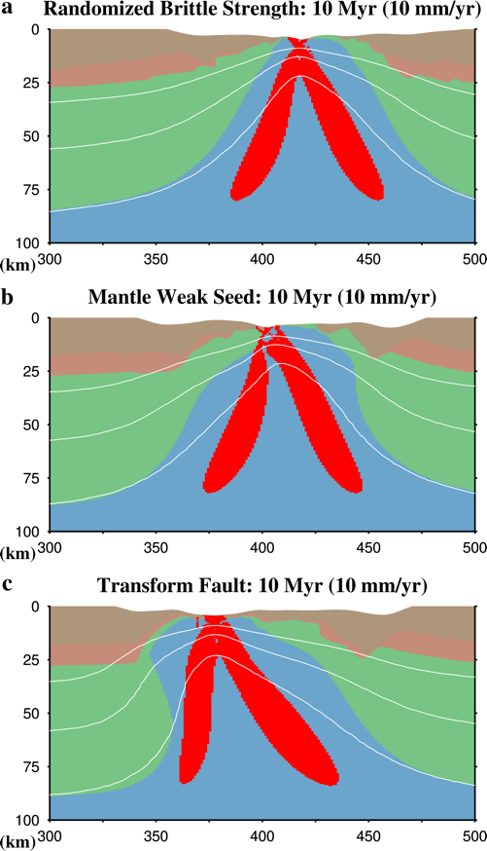
Supplementary Figure 1. Rifted margin structure near the time of breakup for models containing only random strength perturbations (a) a viscous weak seed in the mantle (b) or a lithospheric-scale transform (c). The full extension rate is 10 mm/yr. Background colours represent lithology for the upper crust (dark brown), lower crust (reddish-brown), lithospheric mantle (green), and asthenosphere (blue). White lines represent temperature contours of 600, 900, and 1200 ºC. Regions containing a strain rate (second invariant) between 1e-12 and 1e-14 s⁻¹ are illustrated. Unlike figure 4 in the main text, the initial lithospheric geotherm is a combination of a conductive and adiabatic profile.

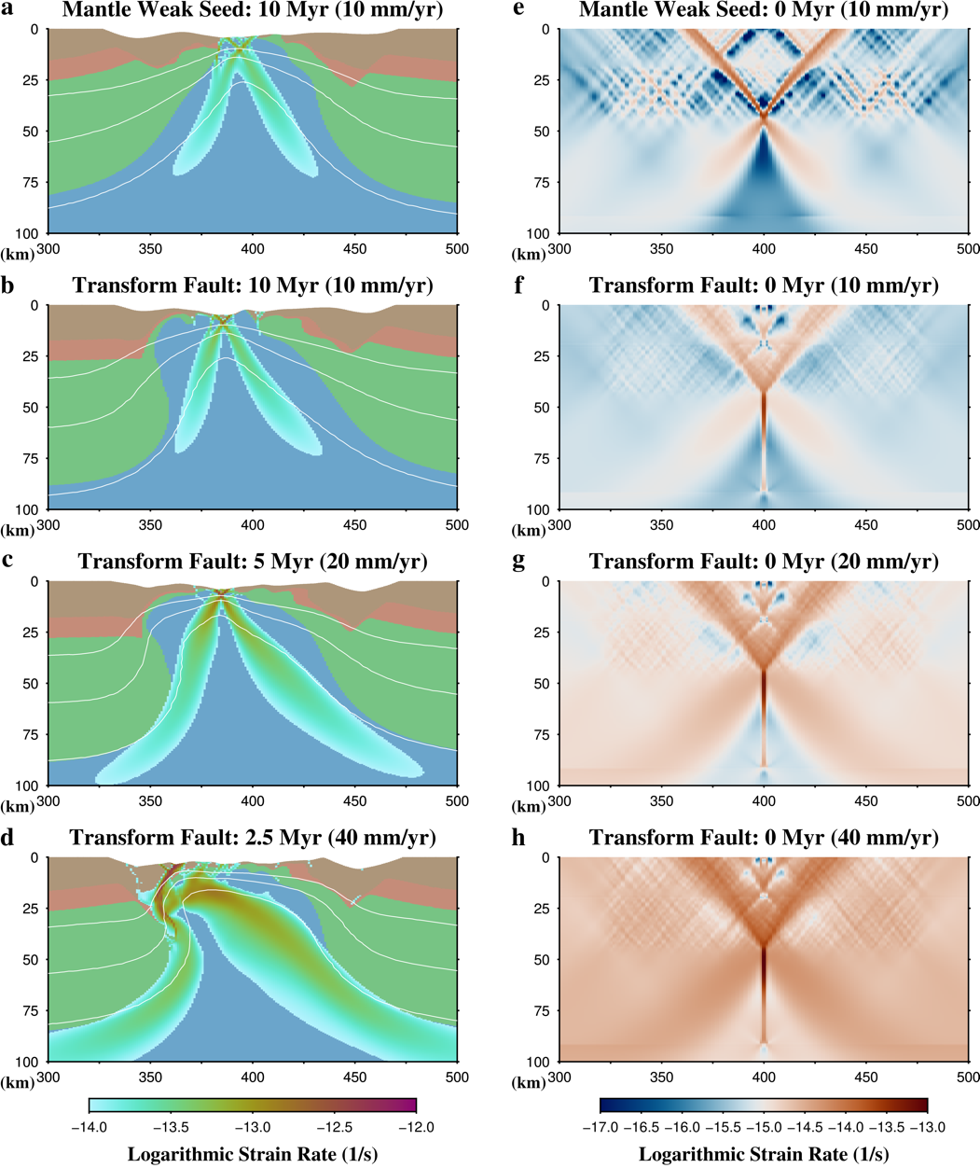
Supplementary Figure 2. Rifted margin structure near the time of breakup for models where the temperature at the model surface varies in accordance with the initial temperature-depth profile. Aside from the surface temperature boundary conditions, the models are identical those in figure 4 where deformation is initiated (a) or lithospheric-scale transform (b-d). Examined full extension rates are: a and b) 10 mm/yr, c) 20 mm/yr, and d), or 40 mm/yr. Background colors represent lithology for the upper crust (dark brown), lower crust (reddish-brown), lithospheric mantle (green), and asthenosphere (blue). White lines represent temperature contours of 600, 900, and 1200 ºC. Regions containing a strain rate (second invariant) between 1e-12 and 1e-14 s⁻¹ are illustrated. Right Column (e-h): Deformation rate (second strain rate invariant, s⁻¹) of the four models in the left column at the onset of extension (e.g., 0 MY). A distinct color scale and range of values is used for the strain rate in each column due to the significant change in relevant values between the onset of extension and near breakup.

Compiling and Running ASPECT
The model in this study were run with ASPECT version 2.3.0-pre at commit cdb0f267e. This version of ASPECT can be obtained with git checkout cdb0f267e from the master branch after cloning the main aspect repository (e.g., git clone https://github.com/geodynamics/aspect) . Alternatively, the branch can be obtained by cloning https://github.com/naliboff/aspect and git checkout lundin_etal_2021. The models were run on 64 processors on the UC Davis cluster Peloton. Additional libraries used when compiling ASPECT include deal.II 9.2.0, Trilinos 12.18.1, p4est 2.2.0, and OpenMPI 4.0.2. deal.II was installed with the candi installer package: https://github.com/dealii/candi. All of the results from the main paper can be reproduced with the ASPECT parameter file (aspect.prm) and the two .txt files that contain data for the initial composition, which are located within a folder of the git branch listed above: https://github.com/naliboff/aspect/tree/lundin_etal_submitted/lundin_etal_submitted_supplementary_files.

REFERENCES
- Chapman, D.S., 1986. Thermal gradients in the continental crust. Geological Society, London, Special Publications, 24(1), pp.63-70.
- Dillencourt, M.B., Samet, H. and Tamminen, M., 1992. A general approach to connected-component labeling for arbitrary image representations. Journal of the ACM (JACM), 39(2), pp.253-280.
- Duclaux, G., Huismans, R.S. and May, D.A., 2020. Rotation, narrowing, and preferential reactivation of brittle structures during oblique rifting. Earth and Planetary Science Letters, 531, p.115952.
- Fraters, M.R., Bangerth, W., Thieulot, C., Glerum, A.C. and Spakman, W., 2019. Efficient and practical Newton solvers for non-linear Stokes systems in geodynamic problems. Geophysical Journal International, 218(2), pp.873-894.
- Gleason, G.C. and Tullis, J., 1995. A flow law for dislocation creep of quartz aggregates determined with the molten salt cell. Tectonophysics, 247(1-4), pp.1-23.
- Glerum, A., Thieulot, C., Fraters, M., Blom, C. and Spakman, W., 2018. Nonlinear viscoplasticity in ASPECT: benchmarking and applications to subduction. Solid Earth, 9(2), pp.267-294.
- Heister, T., Dannberg, J., Gassmöller, R. and Bangerth, W., 2017. High accuracy mantle convection simulation through modern numerical methods–II: realistic models and problems. Geophysical Journal International, 210(2), pp.833-851.
- Hirth, G. and Kohlstedf, D., 2003. Rheology of the upper mantle and the mantle wedge: A view from the experimentalists. Geophysical Monograph-American Geophysical Union, 138, pp.83-106.
- Huismans, R.S. and Beaumont, C., 2007. Roles of lithospheric strain softening and heterogeneity in determining the geometry of rifts and continental margins. Geological Society, London, Special Publications, 282(1), pp.111-138.
- Kronbichler, M., Heister, T., and Bangerth, W. (2012), High accuracy mantle convection simulation through modern numerical methods, Geophysical Journal International, 191 (1) , 12-29, doi:10.1111/j.1365-246X.2012.05609.x.
- Lavier, L.L., Buck, W.R. and Poliakov, A.N., 2000. Factors controlling normal fault offset in an ideal brittle layer. Journal of Geophysical Research: Solid Earth, 105(B10), pp.23431-23442.
- Naliboff, J.B., Glerum, A., Brune, S., Péron‐Pinvidic, G. and Wrona, T., 2020. Development of 3‐D rift heterogeneity through fault network evolution. Geophysical Research Letters, 47(13), p.e2019GL086611.
- Rose, I., Buffett, B. and Heister, T., 2017. Stability and accuracy of free surface time integration in viscous flows. Physics of the Earth and Planetary Interiors, 262, pp.90-100.
- Rybacki, E., Gottschalk, M., Wirth, R. and Dresen, G., 2006. Influence of water fugacity and activation volume on the flow properties of fine‐grained anorthite aggregates. Journal of Geophysical Research: Solid Earth, 111(B3).
- Thieulot, C., 2011. FANTOM: Two-and three-dimensional numerical modelling of creeping flows for the solution of geological problems. Physics of the Earth and Planetary Interiors, 188(1-2), pp.47-68.

