Contrasting transform and passive margin subsidence history and heat flow evolution: insights from 3D thermo-mechanical modelling

Attila Balázs^{1*}, Taras Gerya¹, Dave May² and Gábor Tari³

¹ Department of Earth Sciences, ETH Zürich, 8048, Switzerland
² Scripps Institution of Oceanography, UC San Diego, CA 92037, USA
³ OMV Upstream, Vienna, 1020, Austria

*Corresponding author (e-mail: attila.balazs@erdw.ethz.ch)

Introduction
This supplementary material includes the numerical methodology and further description and data of the numerical model results.

Numerical methods
The model is based on the thermomechanical code I3ELVIS (Gerya & Yuen, 2007; Gerya, 2010; Gerya et al., 2015), which solves the mass, momentum and energy conservation equations for incompressible media. Physical properties are transported by Lagrangian markers that move with the velocity field interpolated from the fix grid. The code uses non-Newtonian visco-plastic rheologies (Table 1) to simulate multiphase flow and is specifically designed to study dynamic processes during subduction.
The numerical algorithm, based on staggered finite-differences and marker-in-cell techniques, solves the mass (1), momentum (2) and energy conservation (3) equations for incompressible media:
$\frac{∂v_{i}}{∂x_{i}}=0$ (1)
$\frac{∂σ_{ij}}{∂x_{j}}- \frac{∂P_{i}}{∂x_{i}}= -ρg_{i}$ (2)
$ρC_{p,eff}\frac{DT}{Dt}= \frac{∂}{∂x_{i}}\left(k\frac{∂T}{∂x_{i}}\right)+ H_{r}+ H_{s}+ H_{a}$ (3)
$H_{a}=Tα \frac{DP}{Dt}$ (4)
$ρ_{T,P}=ρ_{0}(1-α\left(T-T_{0}\right))(1+β_{c}(P-P_{0}))$ (5)
where $v$ is velocity, $σ$ is the deviatoric stress tensor, $P$ is the total pressure (mean normal stress), $ρ$ is the density, $g$ is the gravitational acceleration, $C_{p,eff}$ is the effective isobaric heat capacity, $T$ is the temperature, $k$ is the thermal conductivity, which depends on pressure, temperature and rock composition, $H_{r}$ is radioactive heating that is constant for a given rock composition, $H_{s}$ is shear heating (product of deviatoric stress and strain rate), $H_{a}$ is the adiabatic heating (see equation 4), $η_{eff}$ is the effective viscosity for non-linear visco-plastic deformation, $α$ is the thermal expansion, and $β_{c}$ is the coefficient of compressibility.
The model accounts for simplified magma-related processes, such as thermal accretion of the lithospheric mantle, partial melting of the mantle assuming the parameterized model of Katz et al. (2003), melt extraction and percolation towards the ridge, crystallization of the oceanic crust. Lagrangian markers track the amount of melt extracted during model evolution. Size and shape
of the magma chambers form spontaneously and is regulated by the dynamics of melt supply from the bottom, crustal extension at the top and magma crystallization in response to cooling from the walls. Furthermore, hydrothermal circulation at the axis of the ridge is parametrized with an enhanced thermal conductivity of the oceanic crust, assuming Nusselt number Nu=2, and 6 km cutoff maximum depth of hydrothermal circulation, resulting in its rapid cooling. Further description of these processes and their sensitivity analysis is written in previous studies (Gerya 2013; Liao and Gerya 2015). The temperature equation is solved in Lagrangian form and temperature advection is implemented through a marker-in-cell technique. The Einstein notation is used for the indexes $i$ and $j$, which denote spatial directions $i=(x,y, z)$ and $j=(x, y, z)$ in 3D.
Diffusion and dislocation creep flow laws combined with the Drucker-Prager yield criterion (e.g., Ranalli, 1995), was used to determine whether viscous or plastic deformation occurs. These are implemented in the models and accounts for visco-plastic behavior. The effective creep viscosity $η$ of a material is determined as following:
$\frac{1}{η_{eff}}= \frac{1}{η_{diff}}+ \frac{1}{η_{disl}}$ (6)
where $η_{diff}$ and $η_{disl}$ are calculated by using Newtonian diffusion creep and power law dislocation creep, respectively:
$η_{diff}= \frac{1}{2} A_{D}^{-1} σ_{crit}^{1-n}\exp\left(\frac{PV_{a}+E}{RT}\right)$ (7)
$η_{disl}= \frac{1}{2} A_{D}^{1/n} {\dot{ε}}_{II}^{(1-n)/n}\exp\left(\frac{PV_{a}+E}{nRT}\right)$ (8)
where $A_{D}$ is the pre-exponential factor, n is the power law exponent, $V_{a}$ is the activation volume, E is the activation energy, R is the universal gas constant, $σ_{crit}=10 kPa$ is the transition stress from diffusion to dislocation creep (Turcotte and Schubert, 2002) and ${\dot{ε}}_{II}$ is the second invariant of strain rate. Plasticity is implemented using the following yield criterion $σ_{II} ≤ σ_{yield}$, which limits creep viscosity, altogether yielding an effective viscosity limit:
$η_{eff}≤\frac{σ_{yield}}{2{\dot{ϵ}}_{II}}= \frac{C_{0}+P_{e} sinφ}{2{\dot{ϵ}}_{II}}$ (9)
where $C_{0}$ is the cohesion, $φ$ is the friction angle, $P_{e}$ is the effective pressure (total pressure subtracting the hydrostatic fluid pressure), ${\dot{ϵ}}_{II}$ is the second invariant of strain rate. Plastic strain weakening is implemented by linearly decreasing the cohesion and friction angle over the strain interval of 0.1–1. A constant plastic healing rate (10⁻¹⁴ s⁻¹) is applied to heal deactivated shear zones over time (Gerya 2013). Effective creep viscosity is limited between 1e¹⁸ and 1e²⁴ Pa s.

References
Gerya, T.V. and Yuen, D. 2007. Robust characteristics method for modelling multiphase viscoelasto-plastic thermo-mechanical problems. Phys. Earth Planet. Inter., 163, 83–105.
Gerya, T.V. 2013. Initiation of transform faults at rifted continental margins: 3d petrological-thermomechanical modeling and comparison to the Woodlark basin. Petrology, 21, 550–560.
Gerya, T. V., Stern, R. J., Baes, M., Sobolev, S. V., Whattam, S. A., 2015 Plate tectonics on the Earth triggered by plume-induced subduction initiation. Nature 527, 221–225.
Katz, R.F., Spiegelman, M., Langmuir, C.H. 2003. A new parameterization of hydrous mantle melting, Geochem. Geophys. Geosystems, 4, 1073.
Turcotte, D. L., and Schubert, G. 2002. Geodynamics. Cambridge, UK: Cambridge University Press. https://doi.org/10.1017/CBO9780511807442

Additional model results

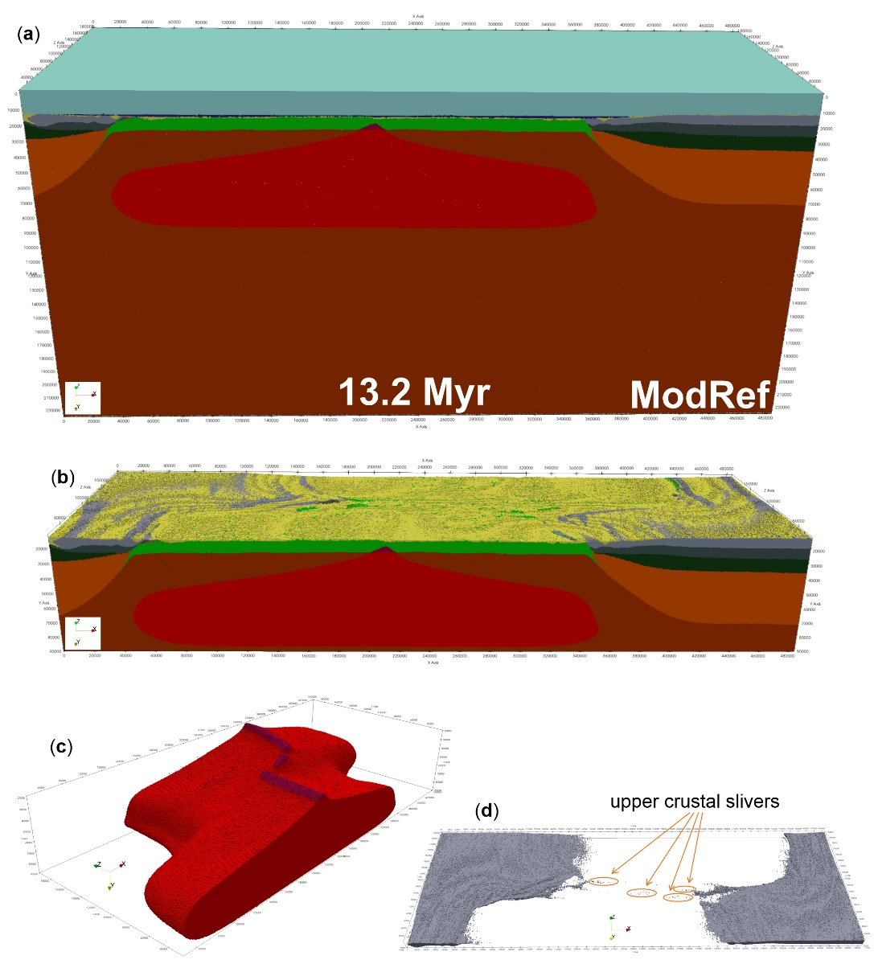

Figure S1. Rock composition of the reference model. (a) Entire model domain including the sticky air layer along the upper boundary in light blue and water phase in dark blue. (b) Model result without showing air and water layers. (c) Same model result only showing the partially molten mantle in red and the magma chamber in purple. (d) Same model result only showing the continental upper crust composition. Note that crustal slivers are present all along the oceanic transform fault zone.

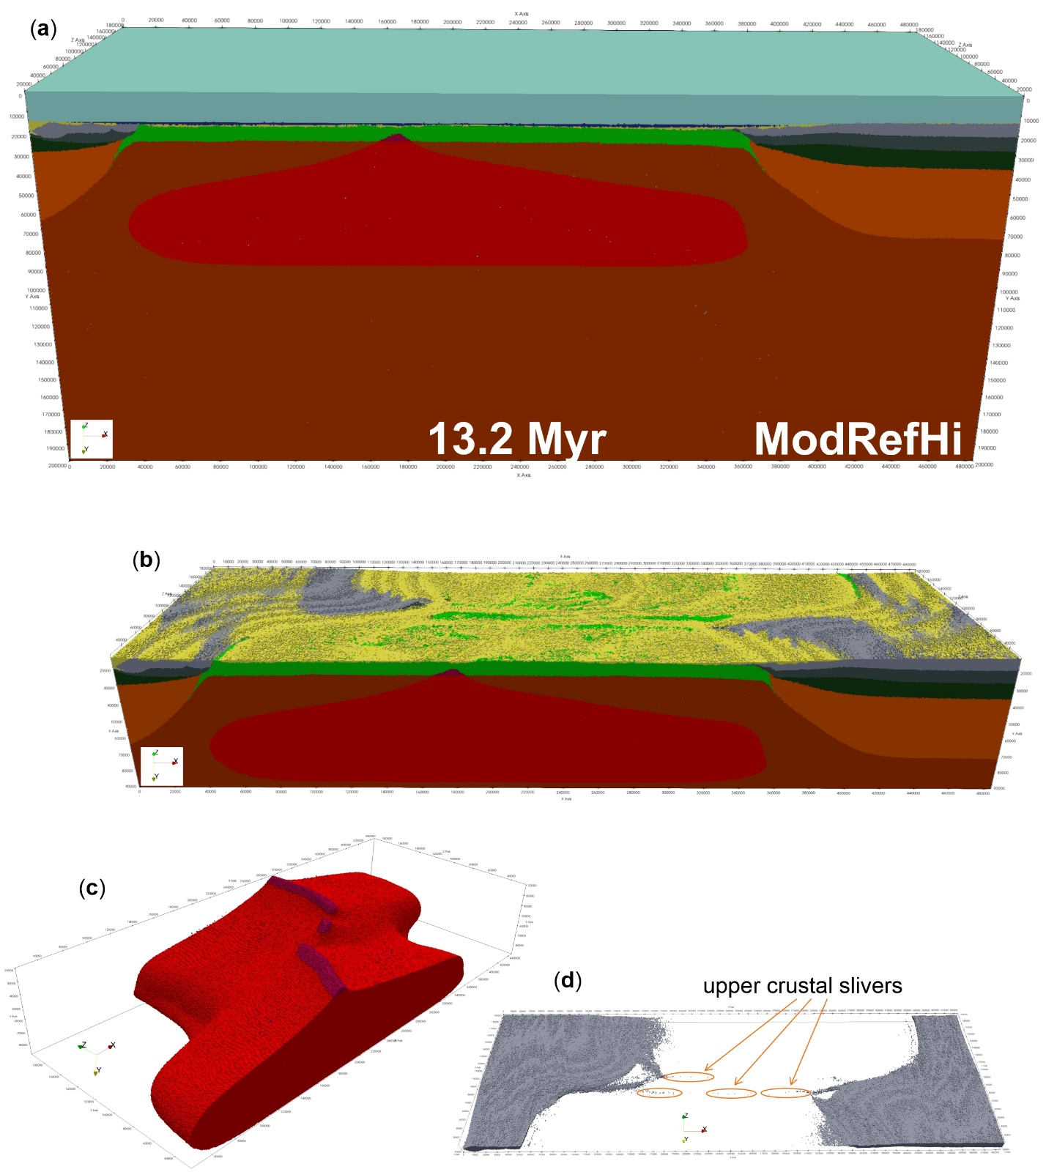
Figure S2. Rock composition of the model with higher erosion and sedimentation rates: ModRefHi. (a) Entire model domain including the sticky air layer along the upper boundary in light blue and water phase in dark blue. (b) Model result without showing air and water layers. (c) Same model result only showing the partially molten mantle in red and the magma chamber in purple. (d) Same model result only showing the continental upper crust composition. Note that crustal slivers are present all along the oceanic transform fault zone.
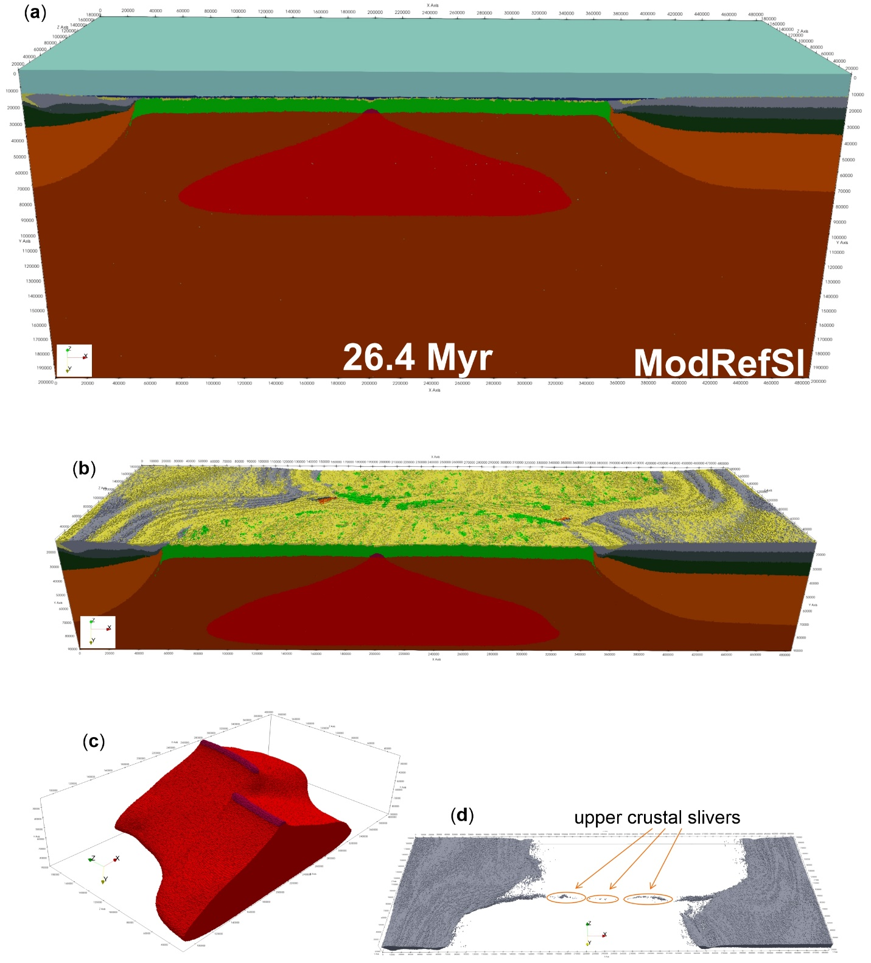
Figure S3. Rock composition of the model with lower divergence velocities: ModRefSl. (a) Entire model domain including the sticky air layer along the upper boundary in light blue and water phase in dark blue. (b) Model result without showing air and water layers. (c) Same model result only showing the partially molten mantle in red and the magma chamber in purple. (d) Same model result only showing the continental upper crust composition. Note that crustal slivers are present all along the oceanic transform fault zone.

