Table 1. Location data for U-Pb detrital zircon and ⁴⁰Ar/³⁹Ar tuff biotite samples
Sample Name | Stratigraphic level (m) | Latitude (°S) | Longitude (°W)
Detrital zircon U-Pb samples
300618-07 | 6690 | 17.99992 | 67.83933
300618-06 | 4125 | 17.96842 | 67.81998
300618-05 | 2775 | 17.94960 | 67.81707
CQT-2 | 2439 | 17.94287 | 67.82296
CQT-5 | 2092 | 17.94085 | 67.81725
300618-04 | 727 | 17.92167 | 67.80939
300618-03 | 530 | 17.91787 | 67.80824
300618-02 | 175 | 17.90814 | 67.81114
CQT-1 | 163 | 17.91343 | 67.80394
300618-01 | -50 | 17.90596 | 67.81043
290618-02 | -700 | 17.91679 | 67.77167
Tuff biotite ⁴⁰Ar/³⁹Ar samples
CBR2 | 6445 | 17.99822 | 67.829713
03BE2 | 6927 | 17.99422 | 67.851573
CQT13 | 6949 | 17.99491 | 67.852006
CBR5 | 7127 | 17.99761 | 67.853615
CQT16 | 7336 | 17.99795 | 67.858242

Table 2: Estimates for the time intervals (∆t) in the Chuquichambi I and Chuquichambi II stratigraphic sections.
 | Number of paleomagnetic sites (N) | Number of reversals found (R) | Probability p = R/(N-1) | Mean spacing of paleomagnetic sitesª  S = f(p) | Expected time interval^{b}  ∆t = SτN  (m.y.)
Chuquichambi I | 166 | 24 | 0.1454 | 0.205 | 12.3 ± 4.5 (1σ)
Chuquichambi II | 115 | 27 | 0.2368 | 0.450 | 18.6 ± 4.5 (1σ)
ª From Johnson and McGee (1983, equation 7 (P = S/(2S +1)). Assuming that samples are distributed with a uniform randomness over the stratigraphic interval. The statistical terms used their paper are S-bar and τ-bar.
^{b} An estimate of the median length of polarity intervals (τ) for the late Paleogene is 3.6 x 10⁵ yr.

Methods
⁴⁰Ar/³⁹Ar geochronology methods
Biotite minerals were separated using density and magnetic separation techniques followed by microscope selection of crystals free of weathering, alteration, or recystallization. Biotite separates for each sample were irradiated for 15 hours in the 5C position of the research nuclear reactor at McMaster University, Ontario, Canada using Fish Canyon sanidine (27.8 Ma; (Renne et al., 1994)) as a flux monitor to calculate J-factors and using K₂SO₄ and CaF₂ salts to calculate correction factors for interfering neutron reactions. Incremental step-heating experiments, consisting of 10 release steps per sample, were conducted in a Ta crucible within a double-vacuum resistance furnace. Total-fusion analyses were conducted using a continuous 5-W Ar ion laser; ~30 mg aliquots of ~0.5 mm crystals were fused per analysis. ⁴⁰Ar/³⁹Ar isotopic measurements were made using a VG 1200S automated mass spectrometer. To facilitate comparison with previously published isotopic ages, reported errors represent total age uncertainties, which include analytical errors and uncertainties in J factors and irradiation parameters.
During the incremental step-heat ⁴⁰Ar/³⁹Ar analyses, most samples exhibit a degassing behavior in which the calculated weighted-mean, isochron, and total-gas ages of individual samples are indistinguishable within error. Several samples show evidence of excess argon or other complexities in the initial gas release during the lowest-temperature steps, possibly the result of trace amounts of inherited older grains or non-atmospheric trapped Ar components (e.g., Heizler and Harrison, 1988; Kelley, 2002). Because these initial steps show considerably larger errors (for example, CBR2), the weighted-mean ages are considered to be most representative of depositional ages.
  - Magnetostratigraphy methods
    - Magnetostratigraphy field methods
Measurement of the section with a Jacob’s Staff and Abney Level proceeded during sample collection. Stratigraphic description and sample locations were also recorded during measurement. A minimum of three oriented cores was collected with a Pomeroy Drill from 336 stations. Samples were collected from mudstones, siltstones, and very fine-grained sandstones in the hope that the magnetic mineral grains would be sufficiently fine to deliver a consistent signal from each station. Drillhole patterns were drawn into the field notes to assist in future relocation of specific sites. The Chuquichambi I magnetostratigraphic section is 3,527 m thick and the Chuquichambi II magnetostratigraphic section completes the remaining 3,003 m of strata, the lowest 138 m of which were collected in a fault zone. We estimate that ~800 m of section was obscured in the fault zone and were missed between the two sections. Where possible, an attempt was made to space sample sites ~20 m apart, stratigraphically. Considerable variation exists in the actual spacings because of incomplete exposure in the lower portion of the section and the presence of coarse-grained strata at some desired levels, particularly in the Chuquichambi II section. Considerable variation exists in the actual spacings because of incomplete exposure in the lower portion of the section and the presence of coarse-grained strata at some desired levels, particularly in the Chuquichambi II section. Samples were cut into 2.5 cm cores in the lab to accommodate the analytical equipment.
Samples Q-1 to Q-37 were collected from the base of the lower section by Brian Hampton in the summer of 2000 for a preliminary study of the paleomagnetic signatures of the strata. This initial sample spacing was too wide for our purposes, so these sites were relocated and new sites were placed about half way between them.
Above Site Q-37, our sampling program proceeded with two teams using Pomeroy drills leapfrogging through the section. Interbedded tuff layers were noted and collected for isotopic age analysis but problems at the Lehigh Argon Laboratory prevented receiving usable data, delaying publication of the paleomagnetic results.
  - Subsidence methods
Tectonic subsidence was evaluated using one-dimensional backstrip calculation was done with the Backstrip MATLAB script of Cardozo (2016). If some degree of flexural support is assumed, the tectonic subsidence would be slightly greater than that calculated under assumptions of purely Airy isostatic compensation.
  - Detrital zircon U-Pb geochronology methods
Eleven sandstone samples for detrital zircon U-Pb geochronology were collected after measurement of the stratigraphic section and correlated into the measured stratigraphic section by tracing well-exposed sandstone ridges from the collection points to the stratigraphic section.
Eight of the samples were analyzed at the University of Houston. Following crushing and density and magnetic separation these samples were rinsed in nitric acid. Zircon was then high-graded by hand and then non-discriminatorily mounted on double-sided tape. U-Pb ages were determined via ablation by a Photon Machine Excite 193nm ArF laser system coupled to a Varian 810 quadrupole inductively-coupled-plasma mass spectrometer (ICP-MS) Individual zircon grains were lased with 240–200 shots at 10 Hz repetition rate, a 30–25 µm spot size and a fluence of 2.99 J/cm². We corrected for inter- and intra-element fractionation for U-Pb data using the Bohemian Massif potassic granulite Plešovice (337.13± 0.37 Ma, 2σ) (Sláma et al., 2008) as the primary zircon standard. The accuracy of the fractionation correction was verified by evaluation of FC5z from the Duluth Complex (1099.1 ± 0.5 Ma, 2σ) (Paces and Miller Jr., 1993) as the secondary standard. Analyses of every 10 unknowns were separated by an analysis of the primary standard. In turn, every third analysis of the primary standard was coupled with a secondary standard analysis. Ages were determined with U-Pb Toolbox, a MATLAB-based application, which calculates integrated isotopic ratios from raw counts per second that are exported from Quantum software, corrects for machine bias and fractionation, and filters the data based on user-defined parameters (Shaulis et al., 2010; Sundell, 2017). Zircons were filtered using a 20% uncertainty cutoff, and 20% and -10% discordance cutoffs. Instead of a common Pb correction (Stacey and Kramers, 1975) for ages <600 Ma, we accept grains whose 2σ uncertainty envelope is <15% discordant by comparison of the ²⁰⁶Pb/²³⁸U and ²⁰⁷Pb/²³⁵U ages. Individual analyses were background corrected by taking the mean counts per second for each isotope for the first ~7 seconds and subtracting that value from each spectrum for the total analysis time. A constant integration window was chosen for each sample run (between 12–27 seconds analysis time) in order to calculate mean isotopic ratios and 2σ standard error for each integration. Integration windows were held constant for all analyses and standards for individual runs because no downhole fractionation correction was conducted (c.f., Košler et al., 2002). Zircons were filtered using a 20% uncertainty cutoff, and 20% and -10% discordance cutoffs. Instead of a common Pb correction (Stacey and Kramers, 1975) for ages <600 Ma, we accept grains whose 2σ uncertainty envelope is <15% discordant by comparison of the ²⁰⁶Pb/²³⁸U and ²⁰⁷Pb/²³⁵U ages.
The remaining three samples were analyzed at the LaserChron Center at the University of Arizona following methods outline by Gehrels et al. (2008). In-run analysis of fragments of a large Sri Lanka zircon crystal (generally every fifth measurement) with known age of 564 ± 4 Ma (2σ) was used to correct for inter- and intra- element fractionation (Gehrels et al., 2008). The uncertainty resulting from the calibration correction is generally 1–2% (2σ) for both ²⁰⁶Pb/²⁰⁷Pb and ²⁰⁶Pb/²³⁸U ages. Common Pb was corrected using the measured ²⁰⁴Pb and assuming an initial Pb composition from Stacey and Kramers (1975) (with uncertainties of 1.0 for ²⁰⁶Pb/²⁰⁴Pb and 0.3 for ²⁰⁷Pb/²⁰⁴Pb). Details of operating conditions and analytical procedures are available in Gehrels et al., (2008). For each analysis, errors in determining ²⁰⁶Pb/²³⁸Uand ²⁰⁶Pb/²⁰⁴Pb result in a measurement error of ~1–2% (2σ) in the ²⁰⁶Pb/²³⁸U age. The errors in measurement of ²⁰⁶Pb/²⁰⁷Pb and ²⁰⁶Pb/²⁰⁴Pb also result in ~1–2% (2σ) uncertainty in age for grains >1.0 Ga, but are substantially larger for younger grains due to low intensity of the ²⁰⁷Pb signal. For most analyses, the crossover in precision of ²⁰⁶Pb/²³⁸Uand ²⁰⁶Pb/²⁰⁷Pb ages occurs at 0.8–1.0 Ga. A cutoff between ²⁰⁶Pb/²³⁸U-based ages and ²⁰⁶Pb/²⁰⁷Pb-based ages of 0.97 Ga was chosen to prevent artificially separating zircon populations in an age mode of ~1 Ga. Analyses with >10% uncertainty, >30% discordance (by comparison of ²⁰⁶Pb/²³⁸Uand ²⁰⁶Pb/²⁰⁷Pb ages) or >5% reverse discordance are omitted from further consideration.
  - Maximum depositional age calculations
We calculated maximum depositional ages (MDA) for all samples using three methods, the Youngest Statistical Population method (Coutts et al., 2019), Youngest Graphical Peak (Coutts et al., 2019), and the Maximum Likelihood Age (Vermeesch, 2021) (Supplemental Table S6). Youngest Statistical Population method proceeds by calculating the weighted average of the youngest group of grains such that the Mean Square of Weighted Deviation (MSWD) is as close to one as possible. An MSWD of one indicates that the dispersion in the dates is proportional to the uncertainty of the measurements (Wendt and Carl, 1991). In contrast an MSWD greater than one indicates a grouping of ages that is overdispersed relative to the reported uncertainties, and an MSWD of less than one indicates a group of ages that is underdispersed relative to the reported uncertainties. Although this does not guarantee that the group of zircon ages are from a single volcanic source (Spencer et al., 2016), it does mean that variation within that group of zircons cannot be further resolved with the observed precision (Condon and Bowring, 2011). The Youngest Graphical Peak method is based on fitting a Gaussian curve to the youngest age mode in the sample. The age and uncertainty are then based on the mean and standard deviation of the fitted Gaussian curve. The maximum likelihood was calculated using IsoplotR (Vermeesch, 2018). The three methods yield overlapping results in most cases.
  - Flexural modeling methods
The load and lithosphere are assumed to be infinite in the third dimension (i.e., perpendicular to the plane of the cross-section). Following previous modeling, the Western and Eastern cordilleras were modeled as 140 km-wide loads distributed across seven 20 km-wide blocks (Hampton, 2002; Horton et al., 2002) (Figure 4). We consider the distances between the Corque syncline and the modeled loads to be minima, because there is no evidence for progressive unconformities (a.k.a growth strata) in the Corque syncline as would be required by the model of Buford Parks and McQuarrie (2019), suggesting that the tectonic loads were probably further from the depocenter than indicated by their balanced cross-section. In the first sets of models, we determined the optimum model result given conservative independent geological constraints (Figure 4a and b). We use stable isotope-based paleoelevation estimates as first-order constraints on the magnitude of the orogenic load, because Saylor et al., (2020) demonstrated that flexural deflections matching observed stratigraphic thicknesses in the North American cordillera can be achieved with loads that match paleoelevation estimates. Leier et al., (2013) conclude that the Eastern Cordillera was at <1.5 km elevation prior to 25 Ma. Similarly, Saylor and Horton (2014) and Sundell et al. (2019) concluded that the Western Cordillera to the north in Peru was at <2 km prior to ~20 Ma. We initialized these unconstrained models with the optimum results of the constrained models from the first modeling step.
Results
Appendix I: Magnetic Polarity Stratigraphy Field and Laboratory Collection and Analysis

Thermal demagnetization plots (Hatakeyama, 2018) of the Chuquichambi I samples all suggest that a minor component of magnetite is present but that hematite is the primary carrier of remanent magnetization (see Supplemental Text Figure A1). Although this generally holds true for the Chuquichambi II samples, Sample 199A, located at the top of the fault zone, has magnetite as the primary carrier with only a minor hematite component. Sample Q-253A is a reversely polarized sample (see Supplemental Text Figure A2) with a moderate Bruhnes Normal overprint. The overprint was removed by the first three treatments, increasing the total magnetization. Magnetite is present in greater abundance in some samples, particularly those sites located among the tuffaceous horizons.

Supplemental Text Figures A2 and A3 representative vector end-point thermal demagnetization plots (Zijderveld, 1967) using online plotting protocols of MagePlot/P v. 1.21 (Hatakeyama, 2018). All samples except Q-199A exhibit a Bruhnes normal overprint that was removed by the initial treatments. Once removed, a single component of magnetization was revealed that exhibited a steady decline in intensity as temperatures were elevated.

Analytical results
We present 51 geomagnetic field reversals in our sampling program, defining 53 polarity zones (Fig. 6). The Chuquichambi I section reveals 24 reversals and 25 polarity zones (12 Normal and 13 Reversed) and the Chuquichambi II section presents 27 reversals with 28 polarity zones (14 Normal and 14 Reversed). The Chuquichambi I section contains 3 Normal and 0 Reversed single-site polarity zones while the Chuquichambi II section produced 2 Normal and 4 Reversed single-site zones. Ordinarily, a resampling program to substantiate these polarity zones would be attempted but because of the difficult access and expense, we elected to present these shortfalls in our data set and not return for further sampling.

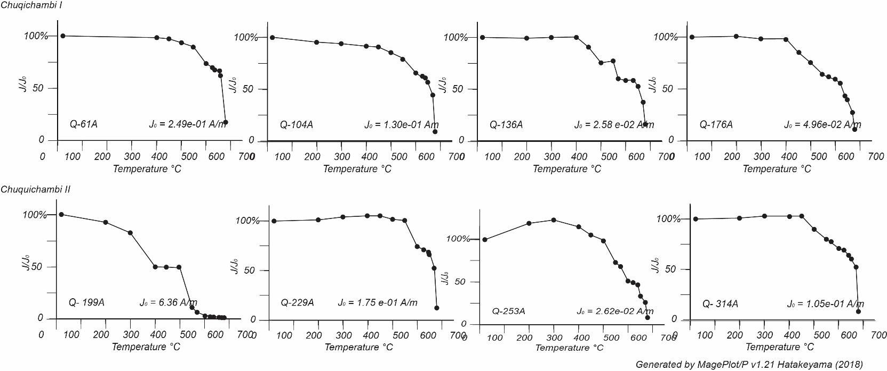
Figure A1. Thermal demagnetization plots (Temperature (°C) vs. Percent Magnetization (J/Jo) where Jo (Am-1) represents the NRM) for representative samples collected in the Chuquichambi and Belen sections: Vector end-point thermal demagnetization plots for the same samples are shown in Figure A3.

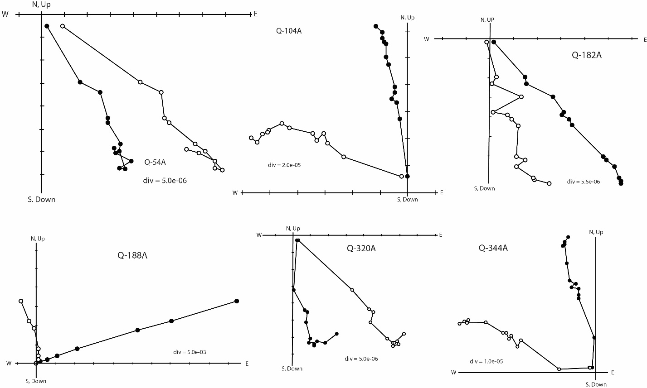
Figure A2. Vector end-point diagrams (Zijderveld (1967) showing the thermal demagnetization progression of representative samples. Samples Q-54A, Q-104A, Q-182A, and Q-188A are from the Chuqichambi I section and Q-320A and Q-344A are from the Chuquichambi II section. Most samples exhibited a Bruhnes Normal component that was removed by the low temperature demagnetization steps. A single component of remanant magnetization then directs the vector toward the origin.
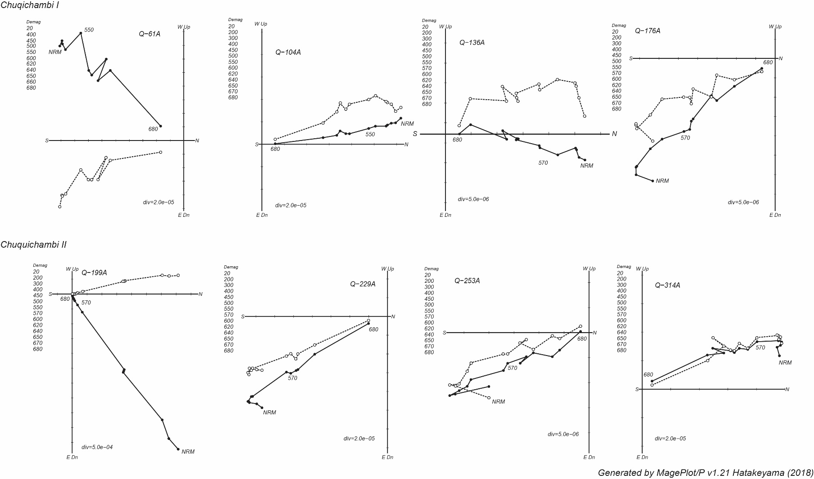
Figure A3. Representative vector end-point thermal demagnetization plots (Zijderveld, 1967) for representative samples collected in the Chuquichambi I and II sections: Thermal demagnetization plots for the same samples are shown in Figure A1
Sediment accumulation rate and tectonic subsidence
If we assume that the linear sediment accumulation rate continued to the top of the section at the axis of the Corque Syncline, an estimate for the age of deformation can be made. To do this, we measured a distance of ~16 km from the top of our paleomagnetic section to the axis of the syncline on aerial photos. By assuming a linear decrease in dip from the top of the paleomagnetic section, where the dip was 35°, to the synclinal axis, we can estimate the thickness (y) of the remaining section using the following equations (Crowell and Slesnick, 1968):
$y= \int{\tan\left(x\right) dx= -\ln\left|cos⁡(x)\right|}+C$
Eq. 1

y = $\int_{x0}^{xmax}{\tan\left(θ\right) dx= -ln}\left|cos⁡(θ)\right|+C$
Eq. 2

$y= \int_{x0}^{xmax}{\tan\left(θ\right) dx=}$- $\frac{180}{π}*\frac{xmax}{35}*(-ln\left|\cos\left(35-35*(\frac{x}{xmax}))*\frac{π}{180}\right)\right|)$

Eq. 3
where:
$θ=\left(α-α\left(\frac{x}{xmax}\right)\right)*\frac{π}{180}$,  = 35° (the dip at the top of the paleomagnetic section),
$dθ= -\frac{35}{xmax}∙\frac{π}{180}dx$and x₀ = 0 and x_{max} = 16,000 m (the distance from the top of the paleomagnetic section to the synclinal axis).
Solving for equation (3), we estimate an additional 5,225 m of section which we round downward to 5,000 m. We regard this as a maximum number because minor structural repetitions of strata almost certainly occur toward the axis of the syncline. Using a sediment accumulation rate of 0.4 km/Myr projects that the remaining strata were deposited over a 12.5 million-year period. This yields an age of top of the section of approximately 6.2 Ma and the Corque Syncline was folded during or after this time.
Works Cited

Buford Parks, V.M., McQuarrie, N., 2019. Kinematic, flexural, and thermal modelling in the Central Andes: Unravelling age and signal of deformation, exhumation, and uplift. Tectonophysics 766, 302-325.
Cardozo, N., 2016. Nestor Cardozo Matlab Scripts.
Condon, D.J., Bowring, S.A., 2011. Chapter 9 A user's guide to Neoproterozoic geochronology. Geological Society, London, Memoirs 36, 135-149.
Coutts, D.S., Matthews, W.A., Hubbard, S.M., 2019. Assessment of widely used methods to derive depositional ages from detrital zircon populations. Geoscience Frontiers 10, 1421-1435.
Crowell, R.H., Slesnick, W.E., 1968. Calculus with Analytic Geometry. WW Norton.
Gehrels, G.E., Valencia, V.A., Ruiz, J., 2008. Enhanced precision, accuracy, efficiency, and spatial resolution of U-Pb ages by laser ablation-multicollector-inductively coupled plasma-mass spectrometry. Geochem. Geophys. Geosyst. 9.
Hampton, B.A., 2002. Early-middle Tertiary deposition in the Corque syncline, Altiplano plateau, Bolivia. Louisiana State University, p. 135.
Heizler, M.T., Harrison, T.M., 1988. Multiple trapped argon isotope components revealed by 40Ar39Ar isochron analysis. Geochim. Cosmochim. Acta 52, 1295-1303.
Horton, B.K., Hampton, B.A., LaReau, B.N., Baldellon, E., 2002. Tertiary provenance history of the Northern and Central Altiplano (central Andes, Bolivia): A detrital record of plateau-margin tectonics. J. Sediment. Res. 72, 711–726.
Kelley, S., 2002. Excess argon in K–Ar and Ar–Ar geochronology. Chem. Geol. 188, 1-22.
Košler, J., Longerich, H.P., Tubrett, M.N., 2002. Effect of oxygen on laser-induced elemental fractionation in LA-ICP-MS analysis. Analytical and Bioanalytical Chemistry 374, 251–254.
Leier, A., McQuarrie, N., Garzione, C.N., Eiler, J., 2013. Oxygen isotope evidence for multiple pulses of rapid surface uplift in the Central Andes, Bolivia. Earth Planet. Sci. Lett. 371, 49–58.
Paces, J.B., Miller Jr., J.D., 1993. Precise U-Pb ages of Duluth Complex and related mafic intrusions, northeastern Minnesota: Geochronological insights to physical, petrogenetic, paleomagnetic, and tectonomagmatic processes associated with the 1.1 Ga Midcontinent Rift System. Journal of Geophysical Research: Solid Earth 98, 13997-14013.
Renne, P.R., Deino, A.L., Walter, R.C., Turrin, B.D., Swisher , C.C., III, Becker, T.A., Curtis, G.H., Sharp, W.D., Jaouni, A.-R., 1994. Intercalibration of astronomical and radioisotopic time. Geology 22, 783-786.
Saylor, J.E., Horton, B.K., 2014. Nonuniform surface uplift of the Andean plateau revealed by deuterium isotopes in Miocene volcanic glass from southern Peru. Earth Planet. Sci. Lett. 387, 120–131.
Saylor, J.E., Rudolph, K.W., Sundell, K.E., van Wijk, J.W., 2020. Laramide orogenesis driven by Late Cretaceous weakening of the North American lithosphere. Journal of Geophysical Research-Solid Earth 125, e2020JB019570.
Shaulis, B., Lapen, T.J., Toms, A., 2010. Signal linearity of an extended range pulse counting detector: Applications to accurate and precise U-Pb dating of zircon by laser ablation quadrupole ICP-MS. Geochemistry Geophysics Geosystems 11.
Sláma, J., Košler, J., Condon, D.J., Crowley, J.L., Gerdes, A., Hanchar, J.M., Horstwood, M.S.A., Morris, G.A., Nasdala, L., Norberg, N., Schaltegger, U., Schoene, B., Tubrett, M.N., Whitehouse, M.J., 2008. Plešovice zircon — A new natural reference material for U–Pb and Hf isotopic microanalysis. Chem. Geol. 249, 1–35.
Spencer, C.J., Kirkland, C.L., Taylor, R.J., 2016. Strategies towards statistically robust interpretations of in situ U–Pb zircon geochronology. Geoscience Frontiers 7, 581-589.
Stacey, J., Kramers, J., 1975. Approximation of terrestrial lead isotope evolution by a 2-stage model. Earth Planet. Sci. Lett. 26, 207–221.
Sundell, K.E., 2017. Cenozoic Surface Uplift and Basin Formation in the Peruvian Central Andes, Earth and Atmospheric Sciences. University of Houston, Houston, p. 256.
Sundell, K.E., Saylor, J.E., Lapen, T.J., Horton, B.K., 2019. Implications of variable late Cenozoic surface uplift across the Peruvian central Andes. Scientific Reports 9, 4877.
Vermeesch, P., 2018. IsoplotR: A free and open toolbox for geochronology. Geoscience Frontiers 9, 1479-1493.
Vermeesch, P., 2021. Maximum depositional age estimation revisited. Geoscience Frontiers 12, 843-850.
Wendt, I., Carl, C., 1991. The statistical distribution of the mean squared weighted deviation. Chemical Geology: Isotope Geoscience section 86, 275-285.

