Supplementary material, Journal of the Geological Society

Dynamic interplay of biogeochemical C, S, and Ba cycles in response to Shuram oxygenation event

Huan Cui ^{1,2}*, Alan J. Kaufman³, Shuhai Xiao⁴, Chuanming Zhou⁵, Maoyan Zhu^{5,6}, Mengchun Cao⁷, Sean Loyd⁸, Peter Crockford^{9, 10}, Xiao-Ming Liu¹¹, Steven Goderis¹², Wei Wang⁵, Chengguo Guan⁵

- Equipe Géomicrobiologie, Institut de Physique du Globe de Paris (IPGP), Université de Paris, 75005 Paris, France
- Stable Isotope Laboratory, Department of Earth Sciences, University of Toronto, Toronto, ON M5S 3B1, Canada
- Department of Geology and Earth System Science Interdisciplinary Center, University of Maryland, College Park, MD 20742, USA
- Department of Geosciences and Global Change Center, Virginia Tech, Blacksburg, VA 24061, USA
- State Key Laboratory of Palaeobiology and Stratigraphy, Nanjing Institute of Geology and Palaeontology, and Center for Excellence in Life and Paleoenvironment, Chinese Academy of Sciences, Nanjing 210008, China
- College of Earth and Planetary Sciences, University of Chinese Academy of Sciences, Beijing 100049, China
- School of Earth Sciences and Engineering, and Frontiers Science Center for Critical Earth Material Cycling, Nanjing University, Nanjing 210023, China
- Department of Geological Sciences, California State University, Fullerton, Fullerton, CA 92831, USA
- Department of Earth and Planetary Sciences, Weizmann Institute of Science, Rehovot 76100, Israel
- Department of Earth and Planetary Sciences, Harvard University, Cambridge, MA 02138, USA
- Department of Geological Sciences, University of North Carolina, Chapel Hill, NC 27599, USA
- Research Group of Analytical, Environmental and Geo-Chemistry, Vrije Universiteit Brussel, Brussels, Belgium
* Correspondence: Huan.Cui@ipgp.fr; https://orcid.org/0000-0003-0705-3423

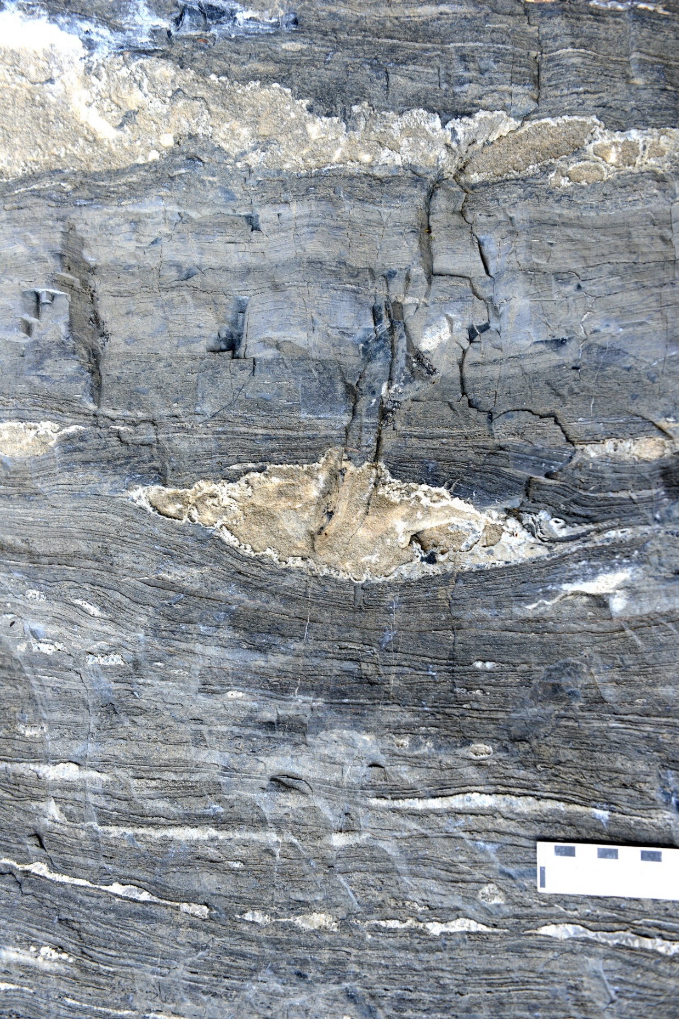
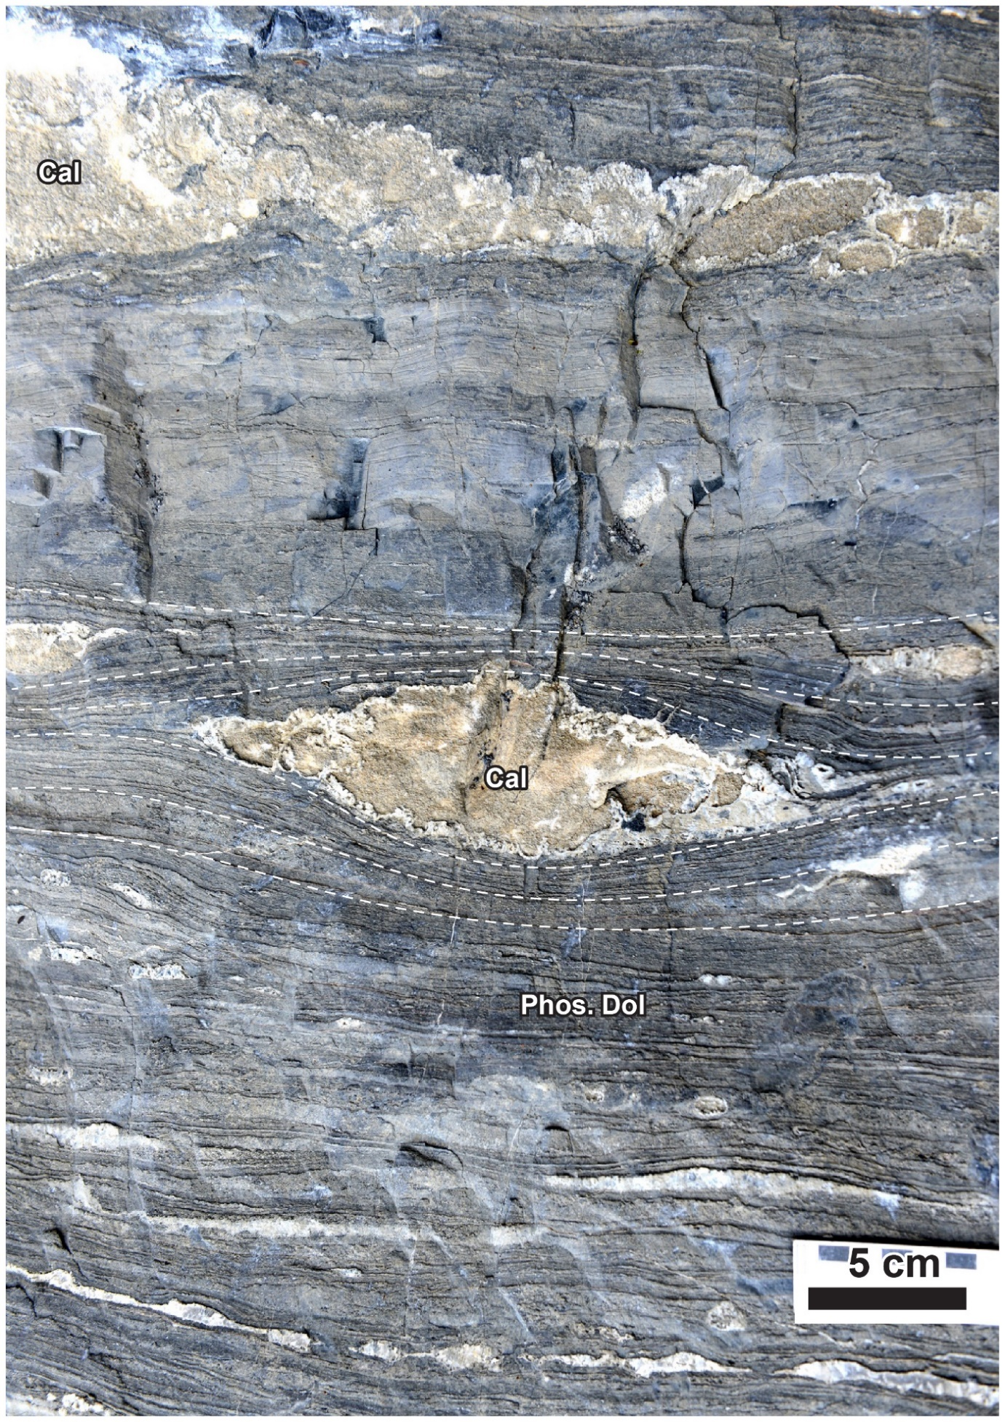
Figs. S1 and S2: Enlarged photos of the calcite lenses (after gypsum) in the uppermost Doushantuo Formation, outer shelf Nanbeizhen section, South China. The Nanbeizhen section is located very close to and in the SW direction of the Zhongling section. Note the warping laminations surrounding the nodules, indicating that the calcite lenses formed before sediment compaction.

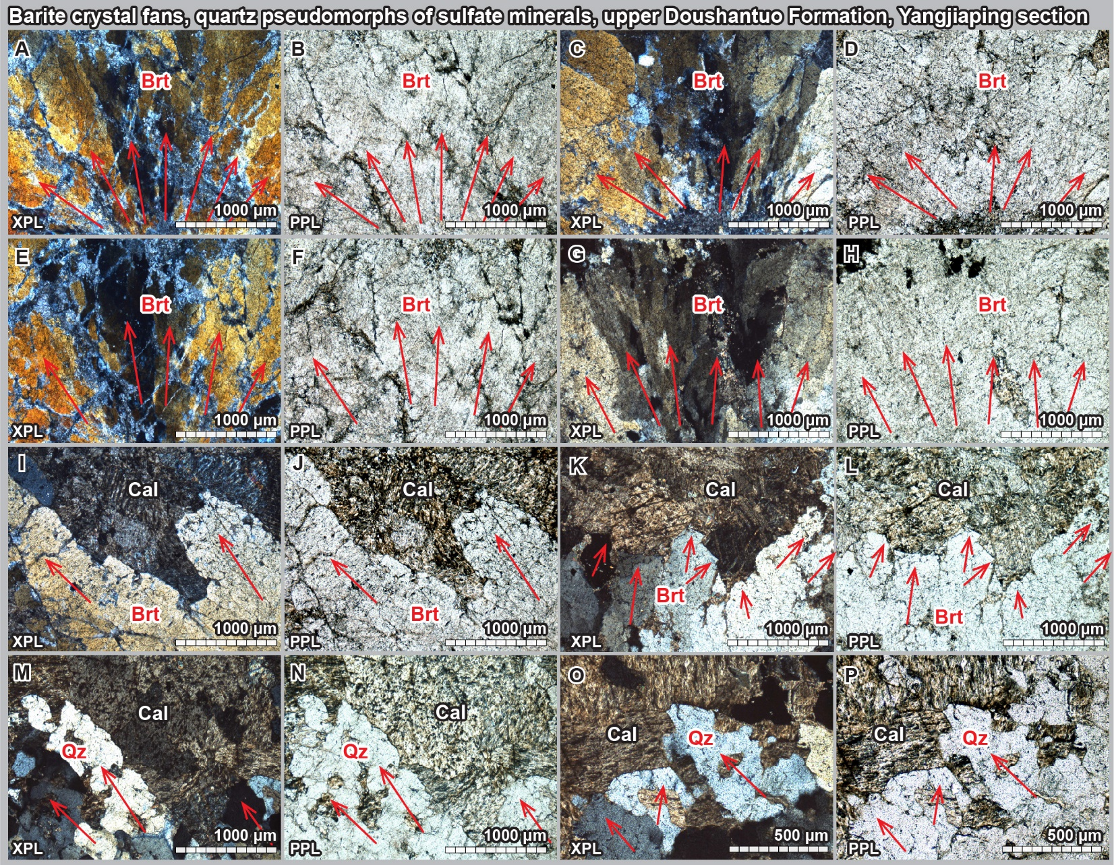
Fig. S3. Paired XPL and PPL petrographic images of sulfate minerals from the upper Doushantuo Formaiton, outer shelf Yangjiaping section, Hunan Province, South China. Red arrows denote crystal directions of sulfate minerals (or their pseudomorphs when they are silicified). (A–L) Barite crystals associated with ¹³C-depleted calcite. Note the undulatory extinction of barite crystals. (M–P) Quartz pseudomorphs of sulfate minerals. Sample codes and stratigraphic positions: A–L (YJP-R4, 105 m, Yangjiaping), M–P (YJP-R5, 105 m, Yangjiaping). Images A, C, O are from Cui et al. (2016). Abbreviations: Brt = barite; Cal = calcite; PPL = plane polarized light; Qz = quartz; XPL = cross polarized light.
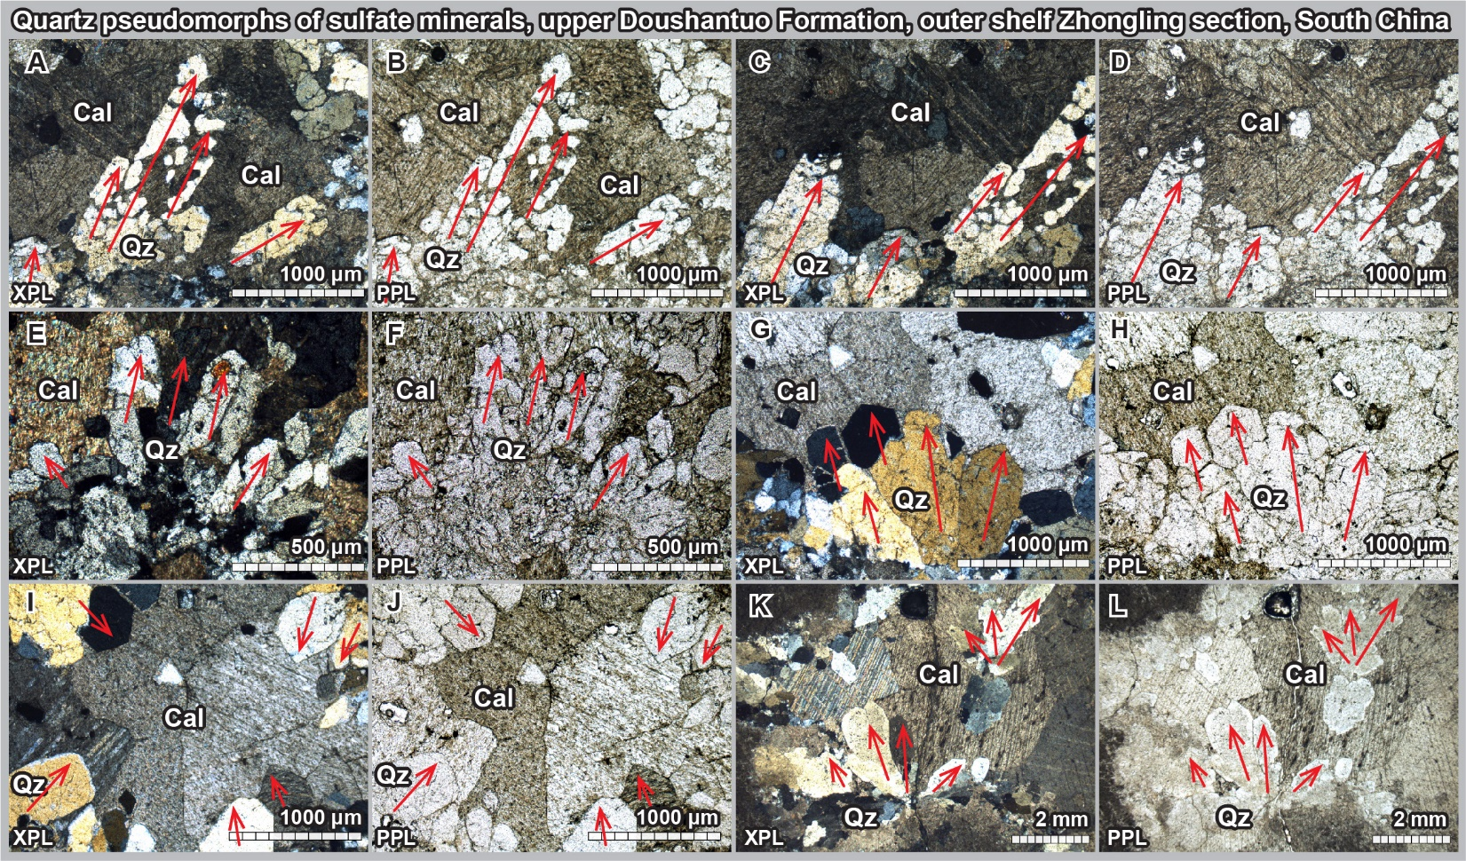
Fig. S4. Paired XPL and PPL petrographic images of silificied sulfate minerals from the upper Doushantuo Formaiton, outer shelf Zhongling section, Hunan Province, South China. Red arrows denote crystal directions of silicified sulfate minerals. Sample codes and stratigraphic positions: A–J (14ZL-4.5, 254.5 m, Zhongling), K–L (12ZL-21.6, 237.4 m, Zhongling). Images C, I, K, L are from Cui et al. (2017). Abbreviations: Cal = calcite; PPL = plane polarized light; Qz = quartz; XPL = cross polarized light.

Table S1: Data of the Upper Clemente Formation at the CR-1 and CR-2 sections, Cerro Rajón, Sonora State, Mexico. Samples were dissolved by 1 M HCl for Ba concentration analysis. Detailed analytical method of [Ba] analysis follows the study of Zhang et al. (2019). Data source: δ¹³C and δ¹⁸O data (Loyd et al., 2012; Loyd et al., 2013); Ba concentration data (this study).

Clemente | Lab  number | Sample  number | Height  (m) | δ¹³C  (‰, VPDB) | δ¹⁸O  (‰, VPDB) | [Ba]  (ppm)
CR–1 | CRC–1 | CRC-110 | 138.50 | 0.79 | –12.20 | 154.63
CR–1 | CRC–2 | CRC-160 | 188.50 | 3.82 | –10.23 | 8.62
CR–1 | CRC–3 | CRC-190 | 218.50 | 2.56 | –9.47 | 16.34
CR–1 | CRC–4 | CRCm–203 | 231.50 | –0.08 | –8.30 | 61.21
CR–1 | CRC–5 | CRCm–310 | 338.50 | 1.17 | –4.59 | 21.93
CR–1 | CRC–6 | CRCm–328 | 356.50 | –1.32 | –5.88 | 21.67
CR–1 | CRC–7 | CRCm–333 | 361.50 | –3.02 | –7.45 | 674.85
CR–1 | CRC–8 | CRCm–334.6 | 363.10 | –7.52 | –10.35 | 39.98
CR–1 | CRC–9 | CRCm–335.7 | 364.20 | –8.59 | –14.90 | 31.76
CR–1 | CRC–10 | CRCM–UL1 | 373.50 | –8.06 | –16.30 | 47.59
CR–1 | CRC–11 | CRCM–UL2 | 373.50 |  |  | 57.04
CR–1 | CRC–12 | CRCM–40mbp | 383.50 | –8.61 | –6.40 | 35.84
CR–1 | CRC–13 | CRCM–30mbp | 393.50 | –7.58 | –9.06 | 13.05
CR–1 | CRC–14 | CRCM–427mbp | 396.50 | –7.46 | –9.41 | 117.95
CR–1 | CRC–15 | CRCM–bp | 423.50 | –5.90 | –9.05 | 13.99
CR–1 | CRC–16 | CRG–0 | 500.50 | 0.00 | –2.93 | 5.64
CR–1 | CRC–17 | CRG–45 | 545.50 | 3.02 | –3.11 | 3.74
CR–1 | CRC–18 | CRG–65 | 565.50 | 1.29 | –3.79 | 1.90
CR–1 | CRC–19 | CRG–80 | 580.50 | 2.14 | –3.04 | 6.01
CR–1 | CRC–20 | CRG–135 | 630.50 | 2.53 | –2.04 | 2.76
CR–1 | CRC–21 | CRPa–0 | 660.50 | –1.00 | –5.37 | 2.57
CR–1 | CRC–22 | CRPa–22 | 672.50 | –1.60 | –3.37 | 4.27
CR–1 | CRC–23 | CRPa–40 | 690.50 | 2.32 | –3.83 | 3.14
CR–1 | CRC–24 | CRPa–80 | 730.50 | 1.30 | –2.81 | 2.55
CR–1 | CRC–25 | CRPa–97 | 747.50 | –0.59 | –3.24 | 1.98
CR–2 | CO–1 | CO–0 | 0.00 | –5.00 | –8.50 | 120.48
CR–2 | CO–2 | CO–30 | 0.30 | –4.80 | –9.60 | 420.29
CR–2 | CO–3 | CO–60 | 0.60 | –5.30 | –7.70 | 112.15
CR–2 | CO–4 | CO–90 | 0.90 | –9.30 | –10.50 | 146.37
CR–2 | CO–5 | CO–120 | 1.20 | –8.20 | –12.10 | 221.58
CR–2 | CO–6 | CO–150 | 1.50 | –9.60 | –12.80 | 28.75
CR–2 | CO–7 | CO–200 | 2.00 | –9.20 | –12.60 | 20.25
CR–2 | CO–8 | CO–230 | 2.30 | –8.30 | –12.60 | 150.21
CR–2 | CO–9 | CO–260 | 2.60 | –8.10 | –13.40 | 62.56

Table S2: Geochemical data of the upper Doushantuo Formation at the outer shelf Yangjiaping section, Hunan Province, South China. Samples were dissolved by 0.4 M HNO₃ for Ba concentration analysis. Detailed analytical method of [Ba] analysis follows the studies of Liu et al. (2016) and Liu et al. (2021). Data source: δ¹³C and δ¹⁸O data (Cui et al., 2015); Ba concentration data (this study).

Yangjiaping  section | Height  (m) | Lithology | Carbonate  (wt.%) | δ¹³C  (‰,VPDB) | δ¹⁸O  (‰,VPDB) | [Ba]  ppm
Yd1 | 1 | limestone | 68.1 | 5.2 | ‒6.0 | 15.80
Yd2 | 4 | limestone | 69.3 | 4.8 | ‒5.8 | 20.42
Yd3 | 8 | dolostone | 62.3 | 4.8 | ‒6.0 | 31.26
Yd5 | 16 | dolostone | 70.1 | 4.8 | ‒6.3 | 12.53
Yd6 | 20 | limestone | 81 | 4.7 | ‒6.7 | 15.54
Yd8 | 28 | phosphatic limestone | 97.2 | 7.1 | ‒7.6 | 3.64
Yd9 | 32 | limestone | 97.6 | 6.7 | ‒7.6 | 5.62
Yd10 | 36 | limestone | 94.4 | 6.8 | ‒6.6 | 7.11
Yd11 | 40 | dolostone | 76.6 | 6.2 | ‒5.6 | 11.92
Yd12 | 44 | dolostone | 96.7 | 6 | ‒5.1 | 12.24
Yd13 | 49 | limestone | 95.2 | 6.5 | ‒7.0 | 8.70
Yd14 | 53 | limestone | 96.2 | 6.2 | ‒7.3 | 5.76
Yd15 | 56 | oolitic limestone | 97.6 | 6.4 | ‒6.7 | 10.49
Yd16 | 60 | oolitic limestone | 97.3 | 6.9 | ‒6.9 | 7.53
Yd17 | 65 | oolitic limestone | 98.7 | 6.9 | ‒7.4 | 6.53
Yd18 | 70 | oolitic limestone | 98.4 | 6.9 | ‒7.7 | 9.49
Yd19 | 75 | oolitic limestone | 98.9 | 6.7 | ‒7.7 | 8.72
Yd20 | 79 | oolitic limestone | 97.5 | 3.8 | ‒8.0 | 6.66
Yd21 | 84 | oolitic limestone | 73.9 | 3.4 | ‒8.3 | 5.20
Yd22 | 88 | oolitic limestone | 91.3 | 4.6 | ‒6.4 | 12.95
Yd23 | 94 | dolostone | 63.4 | 3.5 | ‒5.3 | 17.95
Yd24 | 96 | oolitic limestone | 98.7 | ‒1.8 | ‒6.8 | 10.56
Yd25 | 98 | limestone | 84.3 | ‒2.7 | ‒5.1 | 27.50
Yd26 | 103.4 | phosphorite | 59 | ‒6.8 | ‒6.3 | 137.25

Table S3: Sample list of the SEM-EDS images. See online PowerPoint slides for detailed results.

Sample #  (McFadden et al., 2008) | Sample #  (Cui et al., 2021) | Height above Nantuo diamictite, Jiulongwan | δ¹³C_{carb}  (VPDB, microdrilled,  GS-IRMS) | SEM-EDS results | Stratigraphic  position | Lithology
SSFT39.6 | Sample S4 | 110.6 m | –8.9‰ | Barite, pyrite | EN3b, Mb. IV | Dolomitic limestone
HND9.1 | Sample S5 | 121.9 m | –9.1‰ | Barite, pyrite | EN3b, Mb. IV | Dolomitic limestone
HND18.05 | Sample S7 | 130.9 m | –8.6‰ | Barite, pyrite, including pyrite pseudomorph of evaporite minerals | EN3b, Mb. IV | Dolomitic limestone
HND27.75* | Sample S8 | 140.55 m | –8.4‰ | Barite, pyrite | EN3b, Mb. IV | Dolomitic limestone

REFERENCES:

Cui, H., Kaufman, A.J., Xiao, S., Zhu, M., Zhou, C., Liu, X.-M., 2015. Redox architecture of an Ediacaran ocean margin: Integrated chemostratigraphic (δ¹³C–δ³⁴S–⁸⁷Sr/⁸⁶Sr–Ce/Ce*) correlation of the Doushantuo Formation, South China. Chemical Geology, 405, 48–62. https://dx.doi.org/10.1016/j.chemgeo.2015.04.009.
Cui, H., Xiao, S., Zhou, C., Peng, Y., Kaufman, A.J., Plummer, R.E., 2016. Phosphogenesis associated with the Shuram Excursion: Petrographic and geochemical observations from the Ediacaran Doushantuo Formation of South China. Sedimentary Geology, 341, 134–146. https://dx.doi.org/10.1016/j.sedgeo.2016.05.008.
Cui, H., Kaufman, A.J., Xiao, S., Zhou, C., Liu, X.-M., 2017. Was the Ediacaran Shuram Excursion a globally synchronized early diagenetic event? Insights from methane-derived authigenic carbonates in the uppermost Doushantuo Formation, South China. Chemical Geology, 450, 59–80. https://dx.doi.org/10.1016/j.chemgeo.2016.12.010.
Cui, H., Kitajima, K., Orland, I.J., Xiao, S., Baele, J.-M., Kaufman, A.J., Denny, A., Zhou, C., Spicuzza, M.J., Fournelle, J.H., Valley, J.W., 2021. Deposition or diagenesis? Probing the Ediacaran Shuram excursion in South China by SIMS. Global and Planetary Change, 103591. https://dx.doi.org/10.1016/j.gloplacha.2021.103591.
Liu, X.-M., Kah, L.C., Knoll, A.H., Cui, H., Kaufman, A.J., Shahar, A., Hazen, R.M., 2016. Tracing Earth’s O₂ evolution using Zn/Fe ratios in marine carbonates. Geochemical Perspectives Letters, 2, 24–34. https://dx.doi.org/10.7185/geochemlet.1603.
Liu, X.-M., Kah, L.C., Knoll, A.H., Cui, H., Wang, C., Bekker, A., Hazen, R.M., 2021. A persistently low level of atmospheric oxygen in Earth’s middle age. Nature Communications, 12, 351. https://dx.doi.org/10.1038/s41467-020-20484-7.
Loyd, S.J., Marenco, P.J., Hagadorn, J.W., Lyons, T.W., Kaufman, A.J., Sour-Tovar, F., Corsetti, F.A., 2012. Sustained low marine sulfate concentrations from the Neoproterozoic to the Cambrian: Insights from carbonates of northwestern Mexico and eastern California. Earth and Planetary Science Letters, 339–340, 79–94. https://dx.doi.org/10.1016/j.epsl.2012.05.032.
Loyd, S.J., Marenco, P.J., Hagadorn, J.W., Lyons, T.W., Kaufman, A.J., Sour-Tovar, F., Corsetti, F.A., 2013. Local δ³⁴S variability in ~580Ma carbonates of northwestern Mexico and the Neoproterozoic marine sulfate reservoir. Precambrian Research, 224, 551–569. https://dx.doi.org/10.1016/j.precamres.2012.10.007.
McFadden, K.A., Huang, J., Chu, X., Jiang, G., Kaufman, A.J., Zhou, C., Yuan, X., Xiao, S., 2008. Pulsed oxidation and biological evolution in the Ediacaran Doushantuo Formation. Proceedings of the National Academy of Sciences, 105, 3197–3202. https://dx.doi.org/10.1073/pnas.0708336105.
Zhang, F., Xiao, S., Romaniello, S.J., Hardisty, D., Li, C., Melezhik, V., Pokrovsky, B., Cheng, M., Shi, W., Lenton, T.M., Anbar, A.D., 2019. Global marine redox changes drove the rise and fall of the Ediacara biota. Geobiology, 17, 594–610. https://dx.doi.org/10.1111/gbi.12359.

