Appendix 1: Characteristics and interpretations of volcaniclastic-rich layers
"Hand lens" or "microscope" indicates method of observation
Position cm (bsf) | Carbonate (Figure 7) | Grain size assessment (Figure 2) | Bed basal boundary type and sedimentary structures (Figure 2) | Glass shard compositional variability (Appendix 2) | Particle morphology (Appendix 3) | Interpreted facies and emplacement mechanism
1215
73-77 |  | Fine to medium sand (microscope) | Reworked and irregular contact | Few measurable glass samples due to oxidation but those measured appear heterogeneous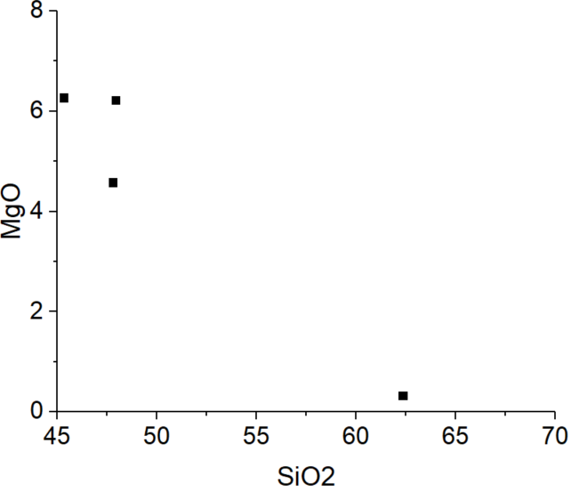 |  | F2a? Secondary volcaniclastic turbidite.
102-106 |  | Fine to medium sand (hand-lens) | Diffuse bioturbated contact | Heterogeneous  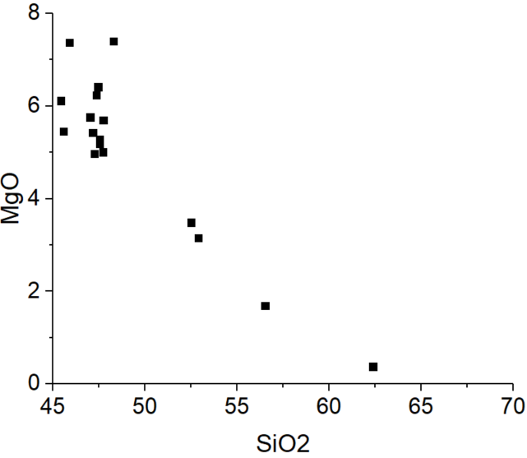 |  | F2a? Secondary volcaniclastic turbidite F2a?
133-137 |  | Fine to medium sand (hand-lens) | Irregular bioturbated contact | Homogeneous  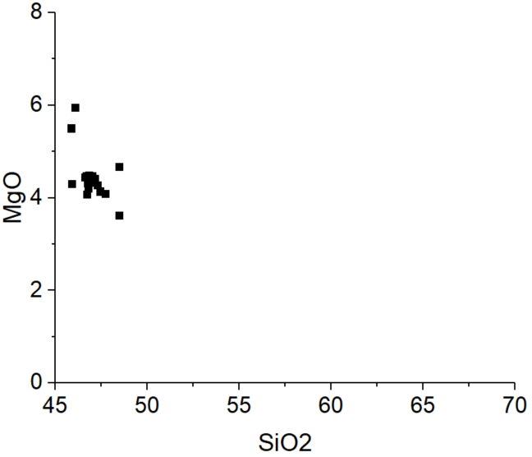 |  | F2b? Primary fallout (?)
175-188 | Many bioclasts (microscope) | Fine to coarse sand (microscope) | Sharp and erosive contact, irregular stratification in middle of bed | Few measurable glass samples due to oxidation but those measured appear heterogeneous | Low NPL (rounded) | F2a, Secondary volcaniclastic turbidite (?)
203-216 | high carbonate content (XRD) | Medium to coarse sand (microscope) | Slightly erosive and irregular contact, vaguely laminated bed | Heterogeneous  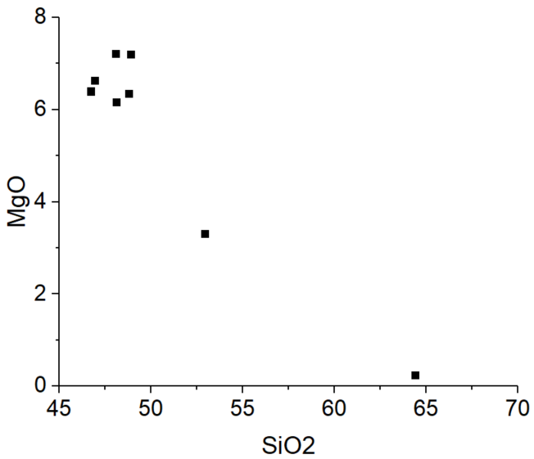 | Low NPL (rounded) | F2a, Secondary volcaniclastic turbidite (?)
216-227 | Many bioclasts (microscope) | Tuffaceous sandy silt (microscope) | Diffusive bioturbated contact. Two lenses of coarse ash in the bed centre. | Genetically related range of homogeneous glass compositions  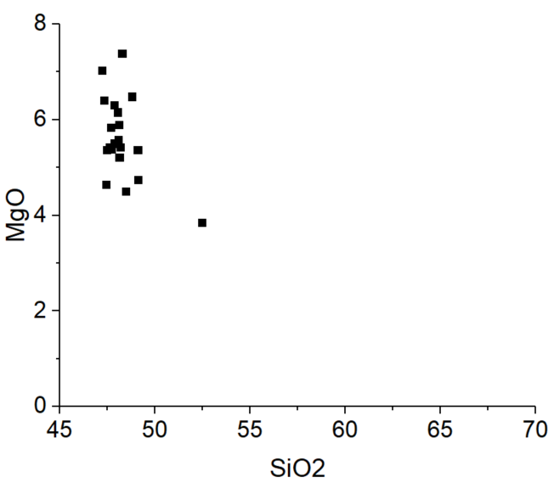 | Low NPL (rounded) | F2a, Primary volcaniclastic turbidite
227-234 |  | Tuffaceous silt (hand-lens) | Irregular, slightly bioturbated contact | Homogeneous  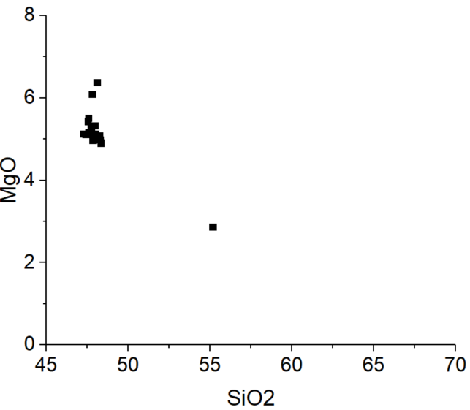 | Angular lapilli (visual) | F2b? Primary fallout or primary volcaniclastic turbidite
1219
10-20 | Many bioclasts (microscope) | Sandy silt (microscope) | Diffuse bioturbated contact. Lower part of bed is laminated | Homogeneous  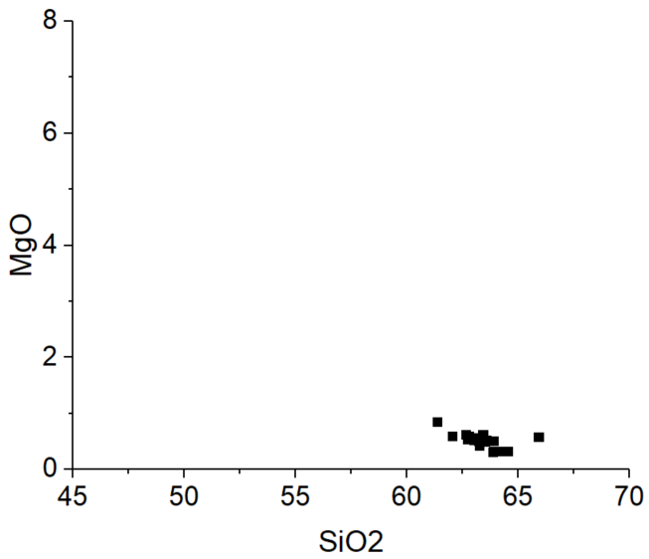 | Low NPL (rounded) | F2a, Primary volcaniclastic turbidite
22-28 | Rare bioclasts (microscope) | Fine sand to gravel (microscope) | Sharp, slightly erosive boundary, inversely graded bed | Homogeneous with rare outliers  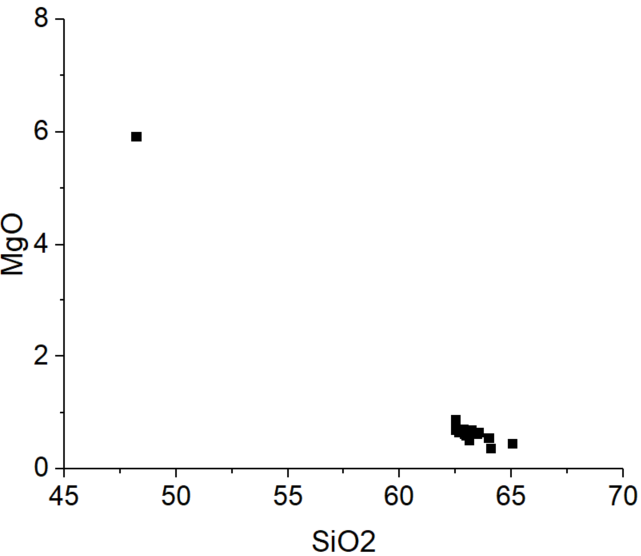 | Low NPL (rounded) | F2b, Primary volcaniclastic turbidite
37-46 | Rare bioclasts (microscope) | Medium sand (hand-lens) | Irregular contact, normally graded and laminated ash at the top | Homogeneous  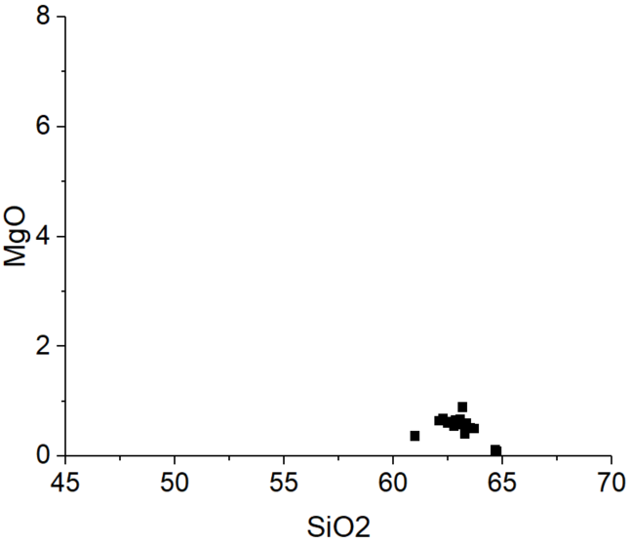 |  | F2b, Primary volcaniclastic turbidite (?)
46-55 | Rare bioclasts | Medium sand (microscope) | Irregular contact | Homogeneous with rare outlier  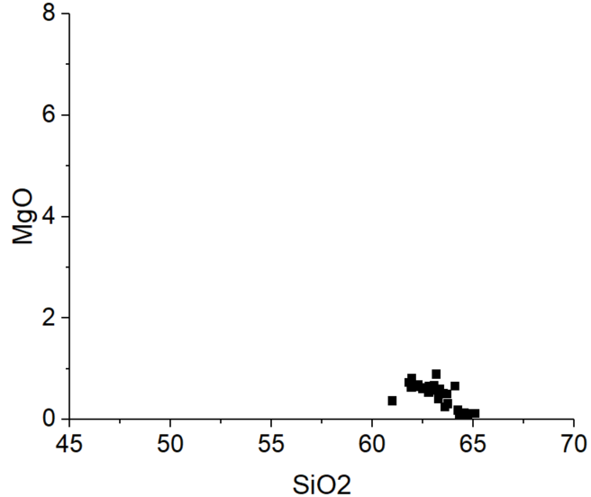 | Low NPL (rounded) | F2b, Primary volcaniclastic turbidite
55-59 | low carbonate content (XRD) | Very coarse sand to pebble (microscope) | Irregular contact, inversely graded bed | Heterogeneous  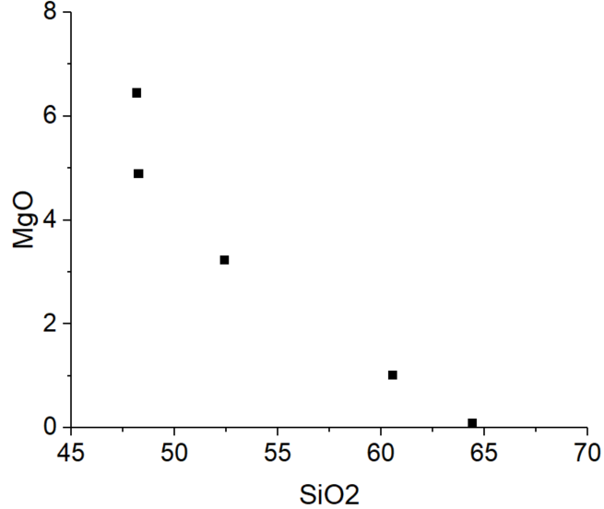 | Low NPL (rounded) | F2b, Secondary volcaniclastic turbidite
59-66 | Rare bioclasts (microscope) | Coarse sand to very coarse sand (microscope) | Diffusive contact. Normally graded | Genetically related range of homogeneous glass compositions with outliers  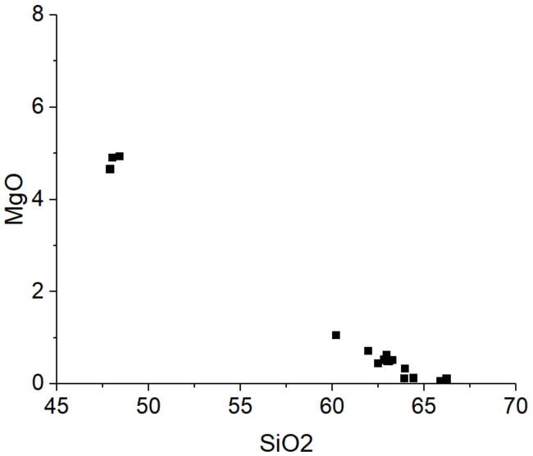 | Low NPL (rounded) | F2b, Secondary volcaniclastic turbidite
130-132 | Biogenic matterial likely introduced by later bioturbation (microscope) | Fine to medium sand (microscope) | Sharp irregular contact | Genetically related range of homogeneous glass compositions with outliers  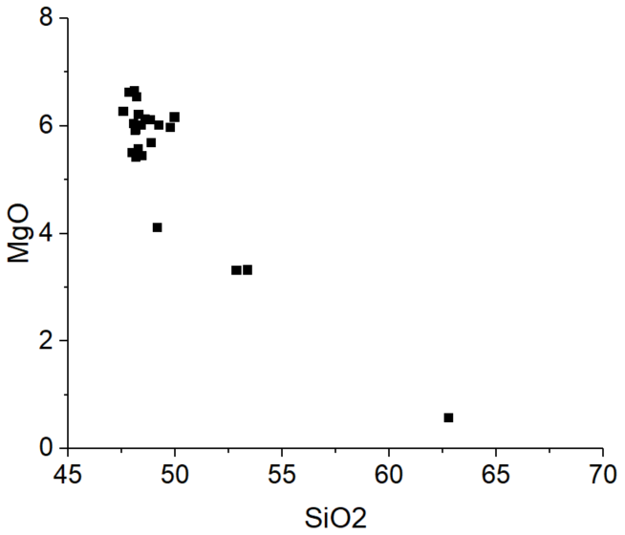 | High NPL (angular) | F2a, Primary fallout (?)
168-175 | high carbonate content (XRD) | Fine to medium (microscope) | Sharp irregular contact | Genetically related range of homogeneous glass compositions  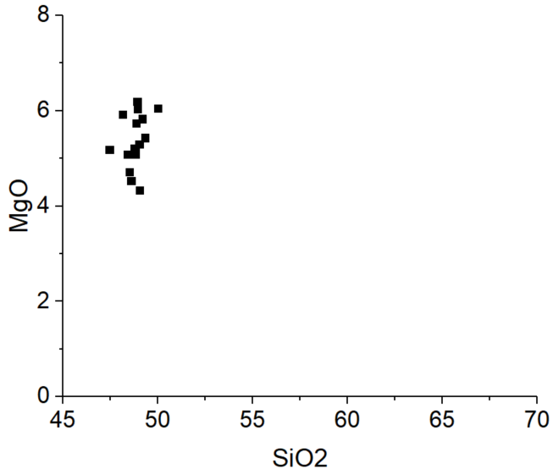 | High NPL (angular) | F2a, Primary volcaniclastic turbidite
184-210 | biofragments | Sandy silt | Diffusive lower contact, weakly laminated | Genetically related range of homogeneous glass compositions  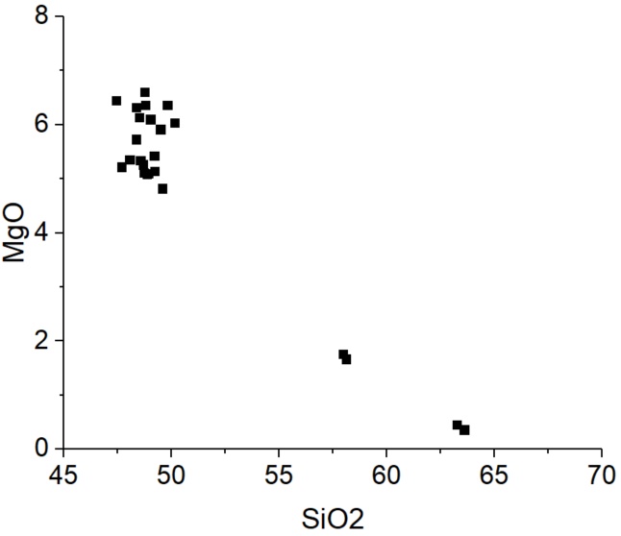 |  | F2a, Primary volcaniclastic turbidite
232-235 | Many bioclasts (microscope) | Sandy silt (microscope) | Bioturbated contact, slightly laminated bed | Heterogeneous  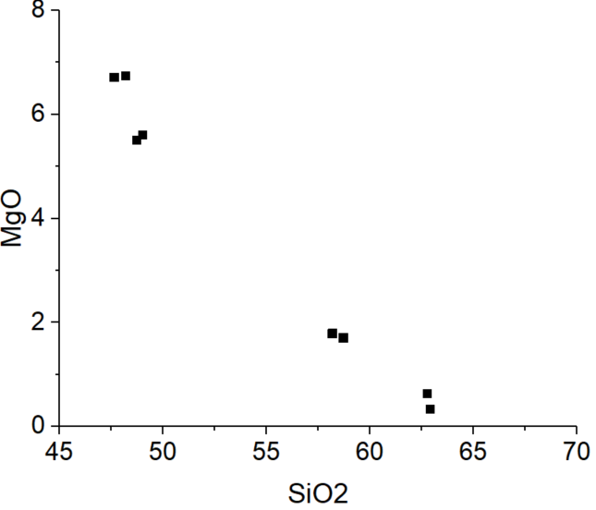 |  | F2a, Secondary volcaniclastic turbidite
284-286 | Biogenic material  (microscope) | Coarse sand (hand-lens) | Diffusive contact | Heterogeneous  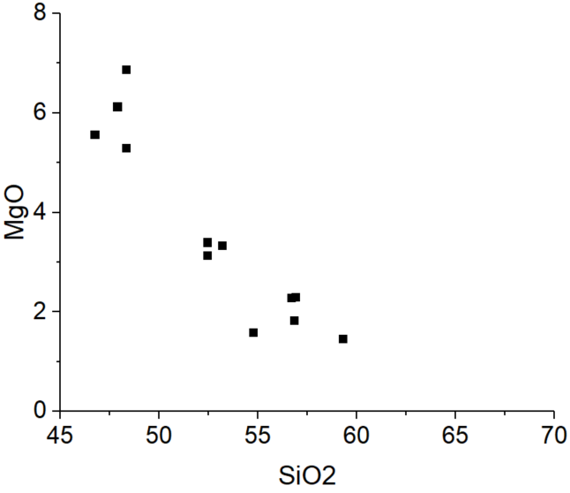 |  | F2a, Secondary volcaniclastic turbidite
310-319 | Biogenic material likely introduced by bioturbation | Sandy silt (hand-lens) | Bioturbated irregular contact | Homogeneous with rare outliers  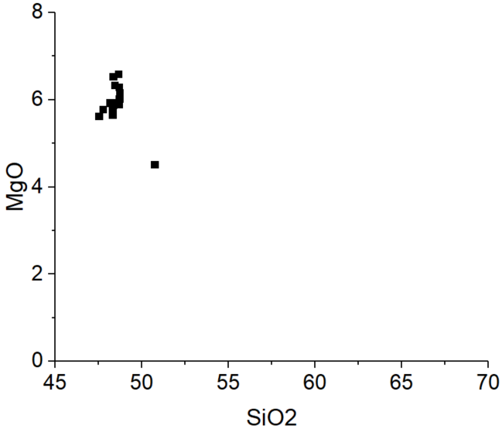 |  | F2a, Primary fallout (?)
458-463 | Biogenic material (microscope) |  | Irregular bioturbated contact | Heterogeneous  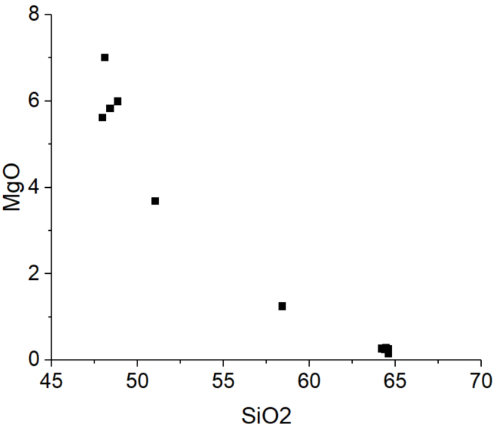 |  | F2a, Secondary volcaniclastic turbidite
1226
17-40 | high carbonate content (XRD) likely introduced by bioturbation | Fine to medium sand (microscope) | Irregular bioturbated contact | Genetically related range of homogeneous glass compositions with outliers  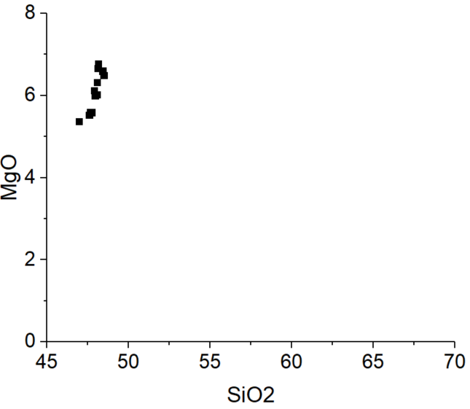 | High NPL (angular) | F2a, Primary fallout or primary volcaniclastic turbidite
40-49 | Many bioclasts (microscope) | Sandy silt (hand-lens) | Bioturbated contact, bioclasts and reworked ash from above and below |  |  | F2a, Secondary volcaniclastic turbidite
49-54 | Many bioclasts likely introduced by bioturbation | Medium to coarse sand (hand-lens) | Bioturbated contact. | Homogeneous with outliers  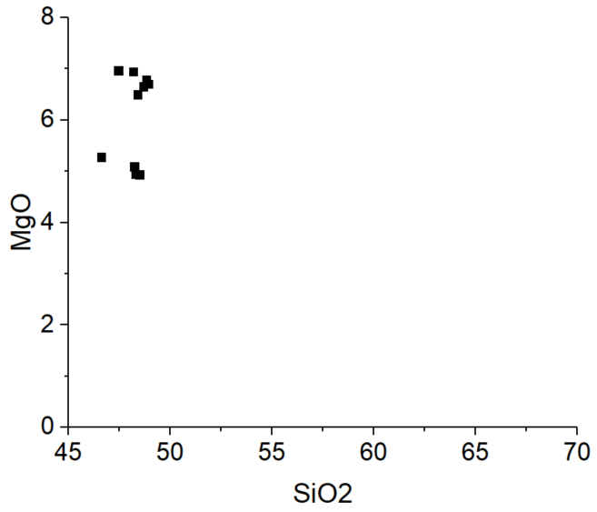 |  | F2a, Primary volcaniclastic turbidite
63-86 | high carbonate content (XRD) | Silty clay with dispersed sand. Medium sand at below (hand-lens) | Sharp erosive contact, cross-laminated ripple structures. Thick bed |  |  | F2a, Secondary volcaniclastic turbidite
86-140 | low carbonate content (XRD) | Medium to coarse sand (microscope) | Irregular contact, normally graded massive bed with vague stratification in between. Particles at 86-100 cm are reworked by bioturbation | Homogeneous  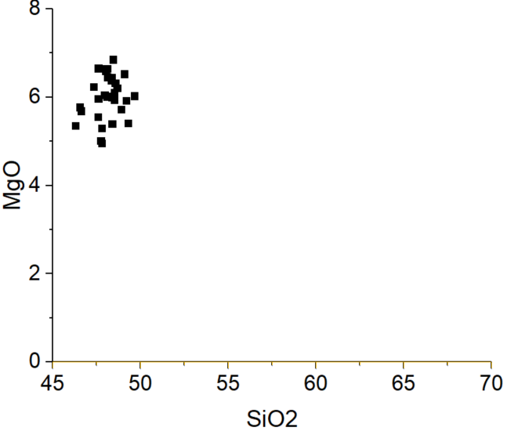 | High NPL (angular) | F2b, Primary volcaniclastic turbidite (?)
140-147 | Many bioclasts (microscope) likely introduced by bioturbation | Clayey silt (hand-lens) | Erosive contact. Highly bioturbated and dispersed reworked ash from below. Two lenses of coarse ash in the middle. | Homogeneous  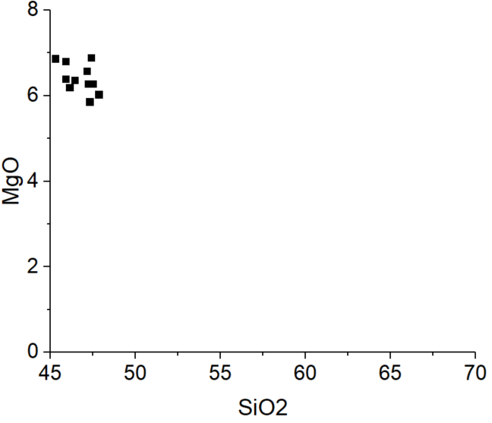 |  | F2a?, Secondary volcaniclastic turbidite
147-160 | Rare bioclasts (microscope) | Fine sand (microscope) | Sharp and erosive contact. Laminated and stratified bed. | Homogeneous  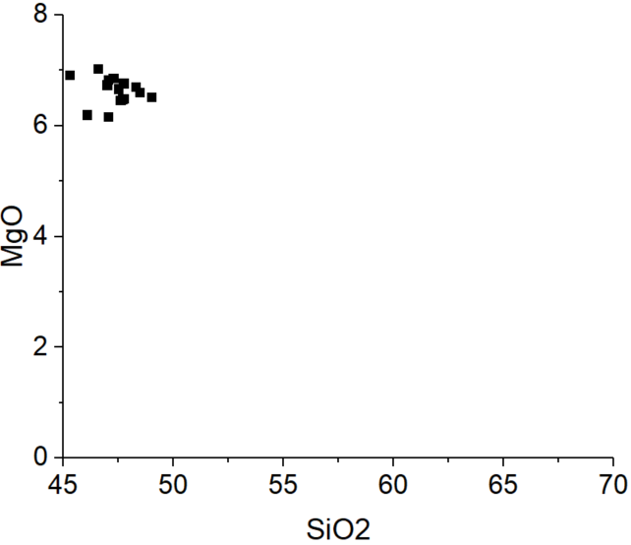 | High NPL (angular) | F2b, Primary volcaniclastic turbidite
169-173 | Rare bioclasts (microscope) | Coarse sand (microscope) | Sharp and erosive contact. Bioturbated at top | Genetically related range of homogeneous glass compositions (?)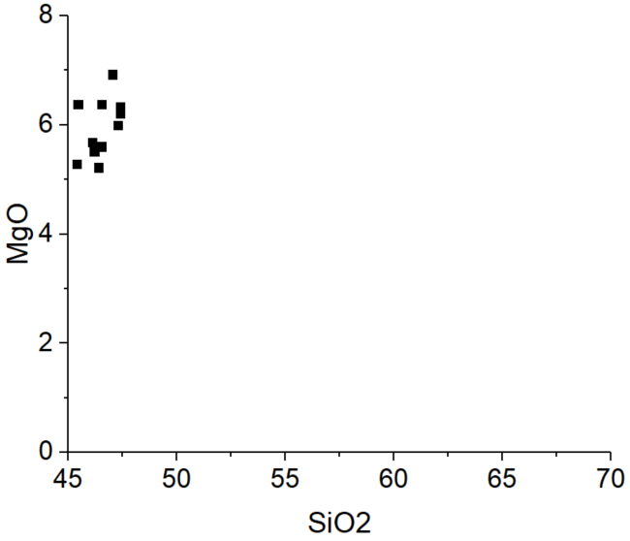 | High NPL (angular) | F2b, Primary volcaniclastic turbidite
174-176 | Rare bioclasts (microscope) | Sandy silt (microscope) | Sharp contact | Genetically related range of homogeneous glass compositions?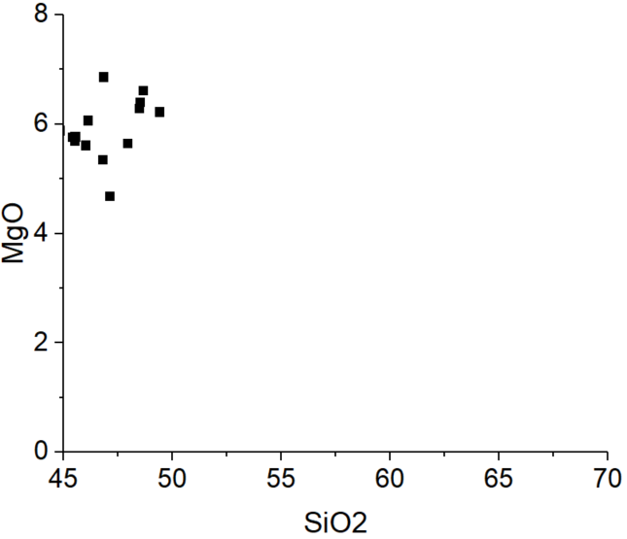 | High NPL (angular) | F2b, Primary volcaniclastic turbidite (?)
177-179 | Rare bioclasts (microscope) | Sandy silt (microscope) | Irregular contact, weakly laminated bed | Homogeneous with outliers or genetically related range of homogeneous  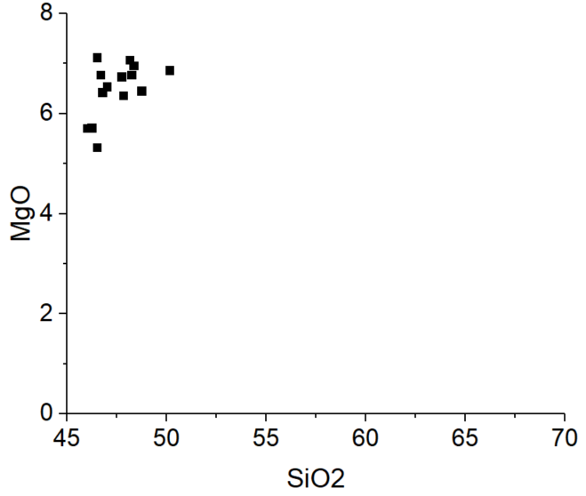 |  | F2b, Primary volcaniclastic turbidite (?)
179-183 | high carbonate content (XRD) | Silt with dispersed reworked fine sand (microscope) | Sharp contact, laminated bed |  |  | F2a, Primary or secondary volcaniclastic turbidite
183-200 | Rare bioclasts (microscope) | Very fine to coarse sand (microscope) | Sharp contact. Normally graded bed. | Homogeneous or genetically related range of homogeneous  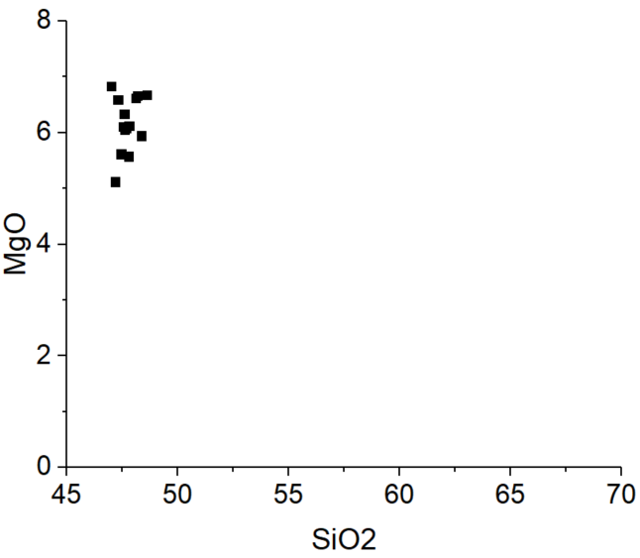 | High NPL (angular) | F2b, Primary fallout or primary volcaniclastic turbidite
200-210 | Rare bioclasts (microscope) | Medium to coarse sand (hand-lens) | Base of bed not penetrated. Irregular top. | Homogeneous or genetically related range of homogeneous  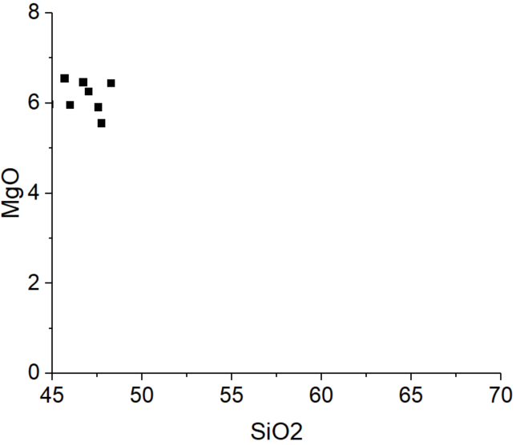 |  | F2b, Primary volcaniclastic turbidite (?)
1230
43-66 | Many bioclasts in bed (microscope) but low carbonate content (XRD) near bed base | Very fine sand to coarse sand (microscope) | Sharp contact. Normally graded. Thick bed. | Appears heterogeneous, or might be bimodal with some outliers  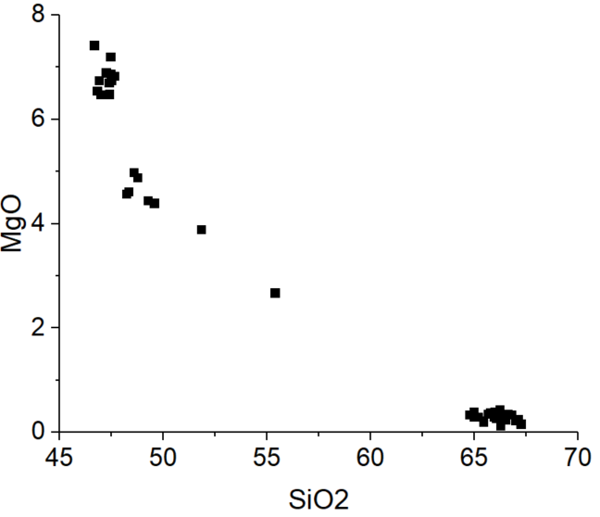 | Low NPL (rounded) | F2a, Secondary volcaniclastic turbidite
78-86 |  | Very fine sand to fine sand (hand-lens) | Sharp and slightly irregular contact | Bimodal with rare outliers  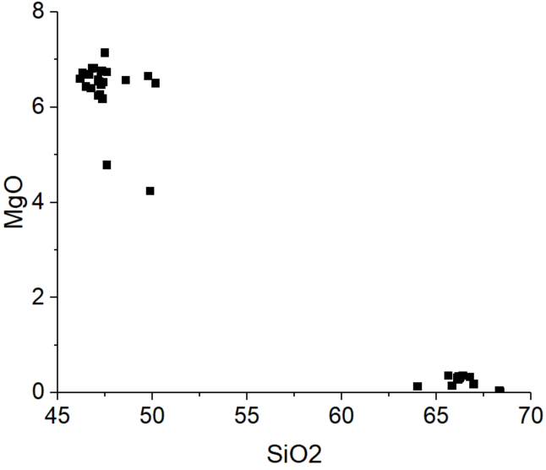 |  | F2a? Primary volcaniclastic turbidite
131-140 | Low carbonate content (XRD) | Coarse to very coarse sand (microscope) | Sharp contact. Weakly stratified bed | Homogeneous with outliers  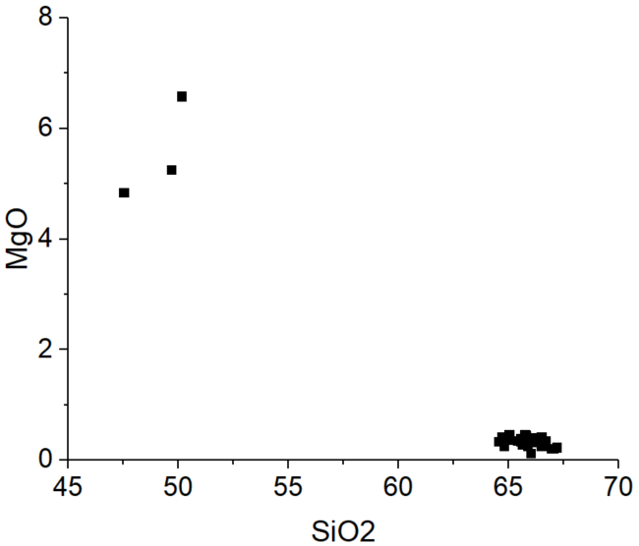 | Low NPL (rounded) | F2b, Primary volcaniclastic turbidite
149-150 |  | Sandy silt (hand-lens) | Irregular and diffuse contact | Homogeneous with an outlier  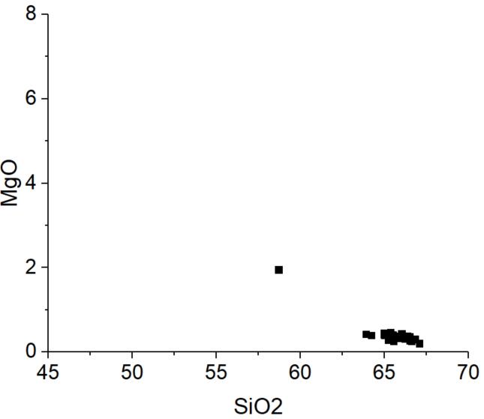 |  | F2b?, Primary fallout (?)
157-159 | Bioclasts (microscope) likely introduced by bioturbation | Coarse sand (microscope) | Wavy basal contact and irregular reworked top | Homogeneous  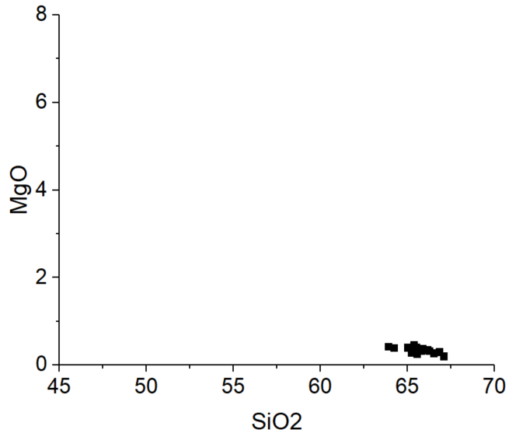 | High NPL (angular) | F2a, Primary fallout (?)
164-167 | Rare bioclasts (microscope) | Medium sand (hand-lens) | Gradual basal contact and reworked top | Homogeneous  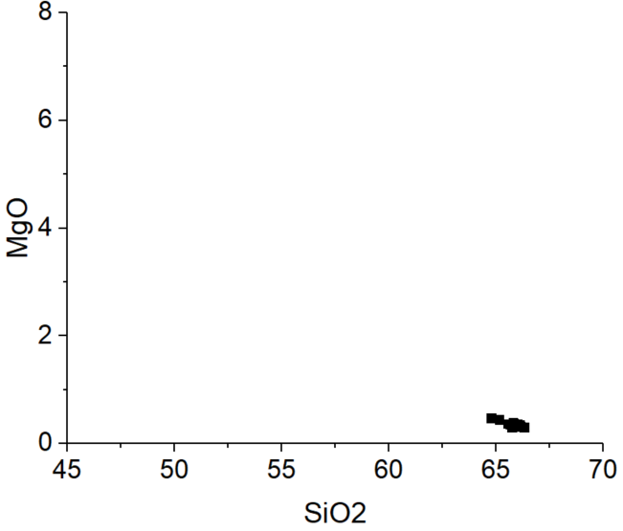 |  | F2b, Primary fallout (?)
262-368 | high carbonate content (XRD) | Fine sand to very coarse sand (microscope) | Base of bed not penetrated, irregular top. Massive normally graded bed. | Homogeneous with rare outliers  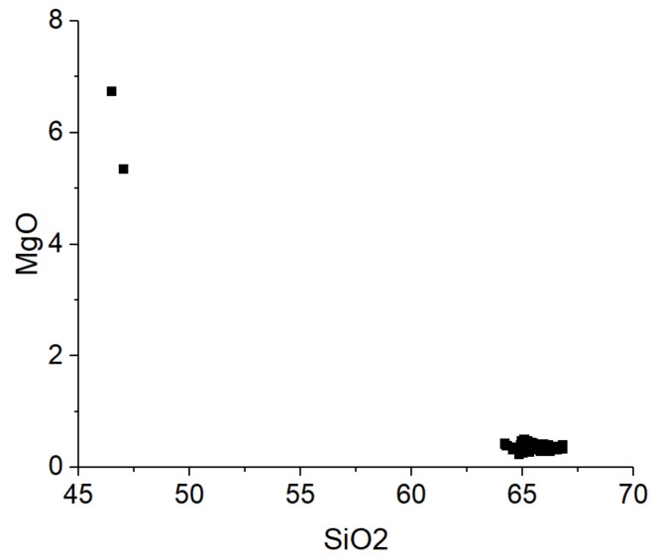 | Low NPL (rounded) | F2a, Primary volcaniclastic turbidite

