Photos of groundmass minerals on the microscope AztecLive Advanced Ultim Max 40.
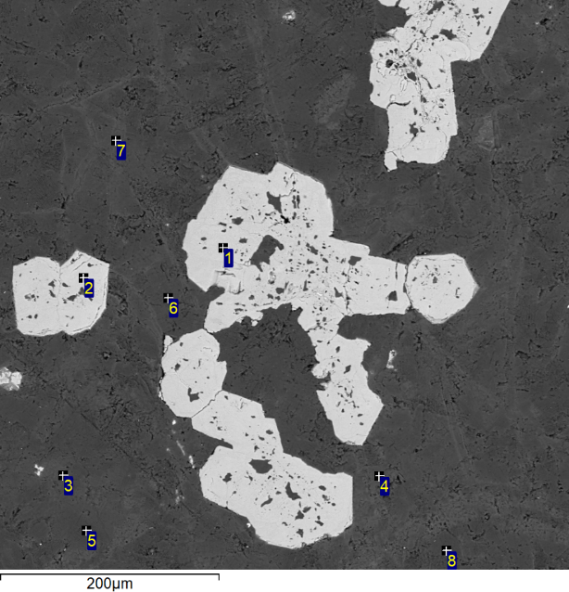
Fig. 1. Dyke 1. Area 1-1. Intergrowths of polycrystalline idiomorphic magnetite grains 200x100 microns in size.
1 | Mag
2 | Mag
3 | Talk_
4 | Talk
5 | Talk
6 | Talk
7 | Talk
8 | Talk

Fig. 2. Dyke 1. Area 1-1. Groundmass of lamproite.
1 | Ilmenite
2 | Apatite
3 | Zircon
4 | Zircon
5 | Apatite
6 | Talk_
7 | Chlorite

Ilm 50x25 mµ
Ap from 2-3mµ to 250x100 mµ

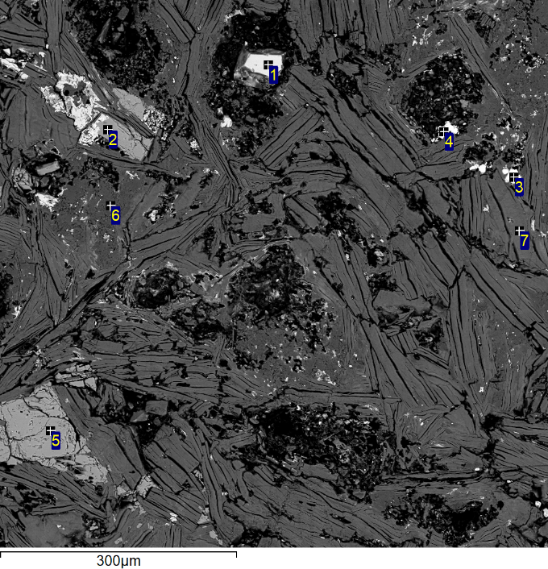

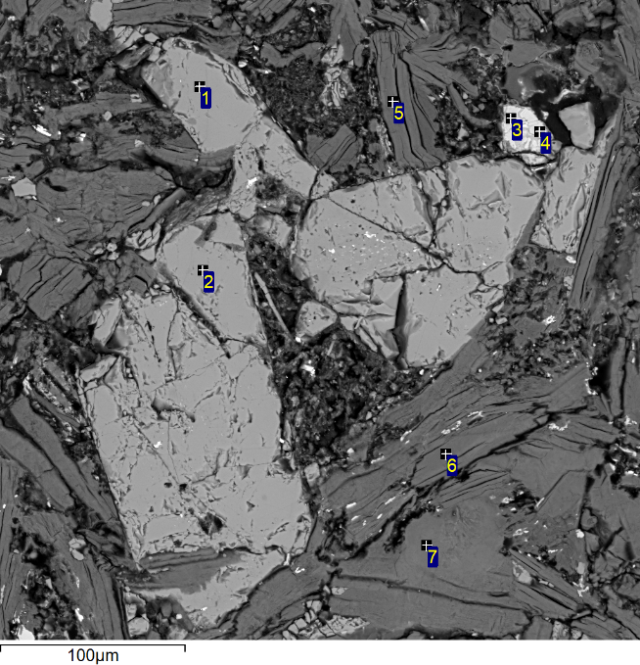
Fig. 3. Dyke 1. Area 1-1. Intergrowths of polycrystalline idiomorphic magnetite.
1 | Apatite
2 | Apatite
3 | 0xide_
4 | 0xide
5 | Chlorite
7 | Chlorite

Fig. 4. Dyke 1. Area 1-1. Groundmass of lamproite. The elongated shape of apatite grains obeys the elongated shape of chlorite and talc grains.
8 | Apatite
9 | Chlorite
10 | Ilmenite
11 | Apatite
12 | Talk
13 | Biotite
14 | Apatite
15 | Ilmenite

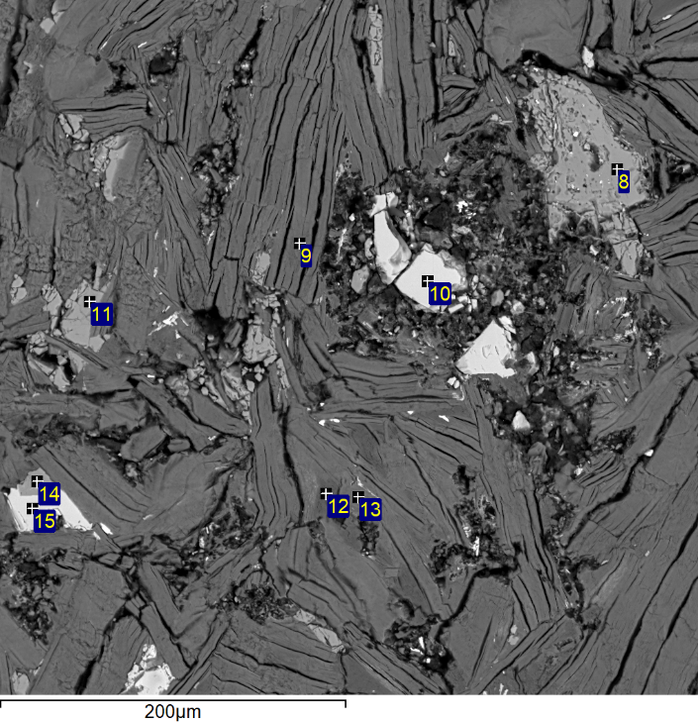

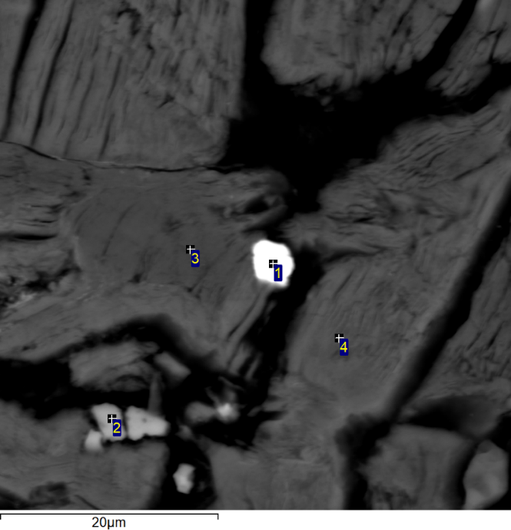
Fig. 5. Dyke 1. Area 2-1. The grain of monazite in the groundmass.
1 | Monazite
2 | Mag
3 | Talk_
4 | Chlorite

Monazite 5x4 mµ

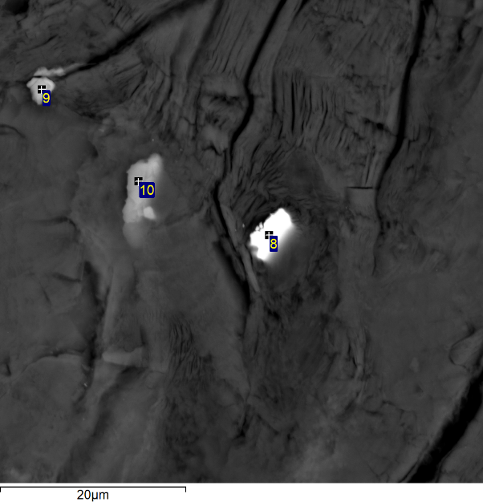
Fig. 6. Dyke 1. Area 2-1. The grains of monazite and ilmenite in the groundmass.
8 | Monazite
9 | Ilm
10 | Ilm
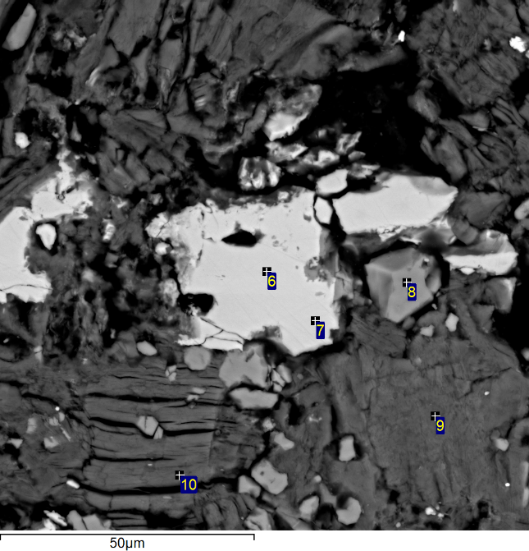

Fig. 7. Dyke 1. Area 2-2. The grain of ilmenite.
6 | Ilm
7 | Ilm
8 | Ap
9 | Chlorite
10 | Chlorite

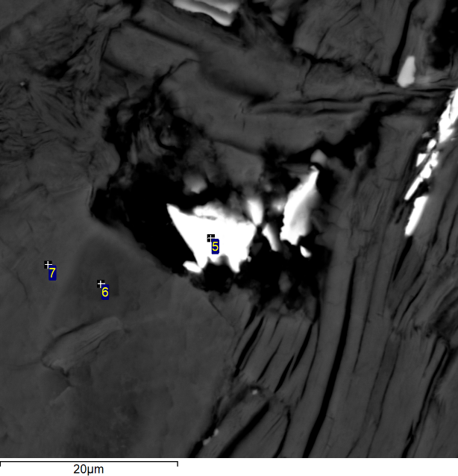

Fig.8 . Dyke 1. Area 2-2. The grains of monazite.
5 | Monazite
6 | Chlorite
7 | Chlorite

Grain 5 of monazite 10x7 mµ

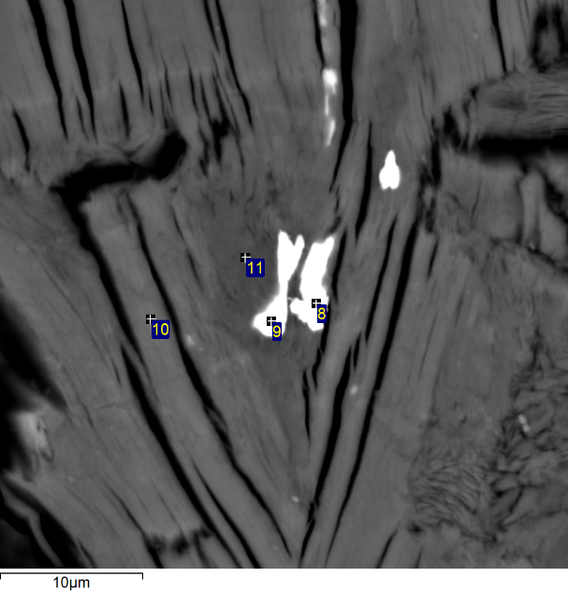
Fig. 9. Dyke 1. Area 1-2. The grains of monazite.
8 | Monazite
9 | Monazite
10 | Chlorite
11 | Talk

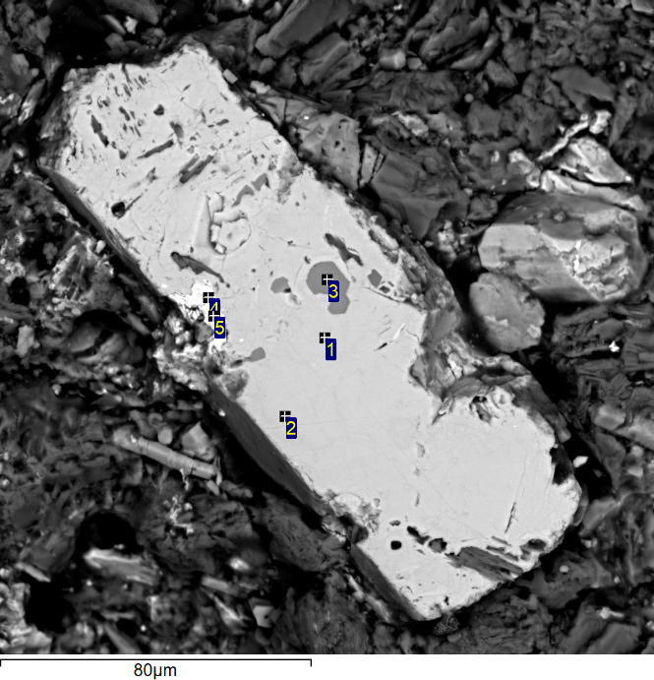
Fig. 10. Dyke 1. Area 2-1. Magnetite crystal 160x60 microns in size with inclusions of apatite and zircon.
1 | Mag
2 | Mag
3 | Apatite
4 | Zircon
5 | Zircon

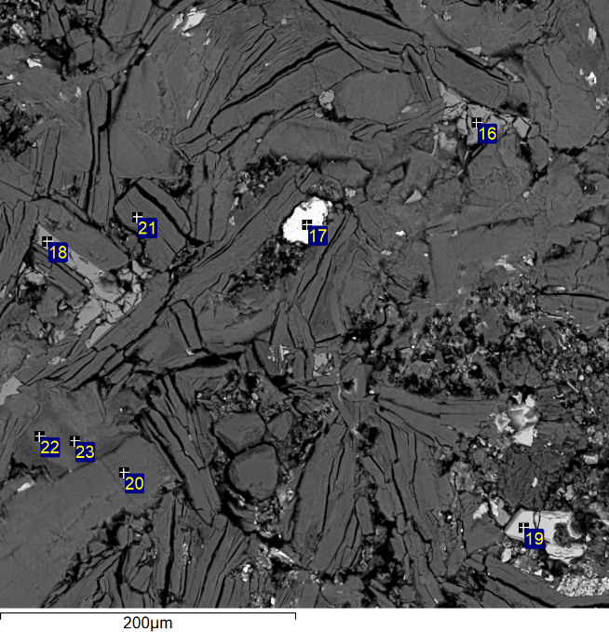
Fig. 11. Dyke 1. Area 3-1. Groundmass of lamproite.
16 | Apatite
17 | Zircon_
18 | Apatite
19 | Ilmenite
20 | Chlorite
21 | Mag
22 | Chlorite
23 | Talk_

Zrc – 40x20 mµ
Ilm – 50x25 mµ

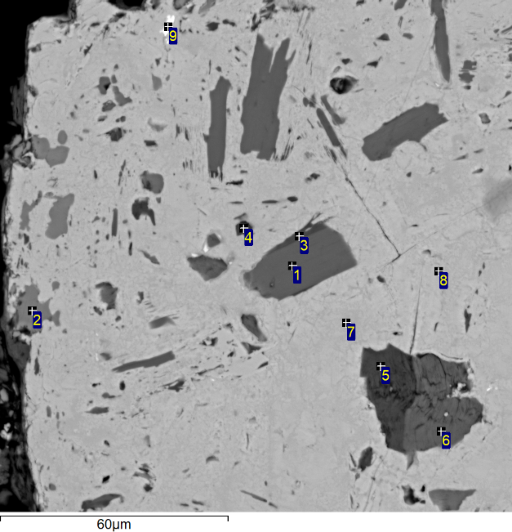
Fig. 12. Dyke 1. Area 3-1. The grain of magnetite 0.35x0.25 mm, containing tiny inclusions of groundmass fragments points 1-9):
1 | Biotite
2 | Apatite
3 | Chlorite
4 | Chlorite
5 | Chlorite
6 | Biotite
7 | Mag
8 | Mag
9 | Monazite

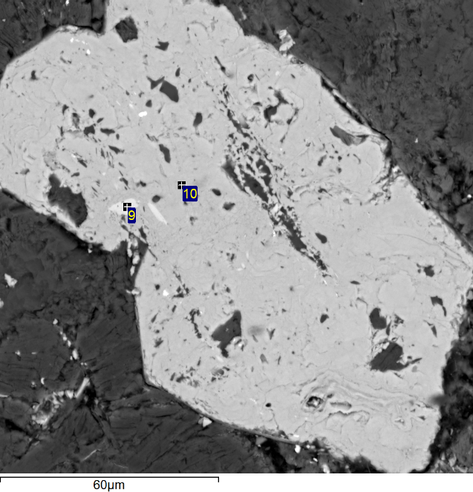
Fig. 13. Dyke 1. Area 1-2. The grain of magnetite 150x70 mµ, containing tiny inclusions of groundmass fragments points 9, 10):
9 | Ru
10 | Mag

