Journal of the Geological Society
Supplementary Material for jgs2021-021R1

Primary tissues dominated ground-level trunk diameter in Sigillaria: evidence from the Wuda Tuff, Inner Mongolia

Michael P. D’Antonio, C. Kevin Boyce, Wei-Ming Zhou, Hermann W. Pfefferkorn, Jun Wang
Here, where possible, we further detail those specimens that could not be recovered from the field and were destroyed within the mine after study. Figures S1 and S2 include photographs of specimens ‘Unaccessioned 1’ and ‘Unaccessioned 3’ that provide additional relevant information about those individuals. We do not have photographs of specimens ‘Unaccessioned 2’ and ‘Unaccessioned 4’ in addition to those in the text figures that add additional relevant information about those individuals. However, we are happy to provide any and all photographs of these specimens upon request.
To provide as much information as possible, we include Figure S3 showing where the stele was measured in specimen 0069, Nanjing Institute of Geology and Palaeontology, Chinese Academy of Sciences, Nanjing, China (text Figure 3).
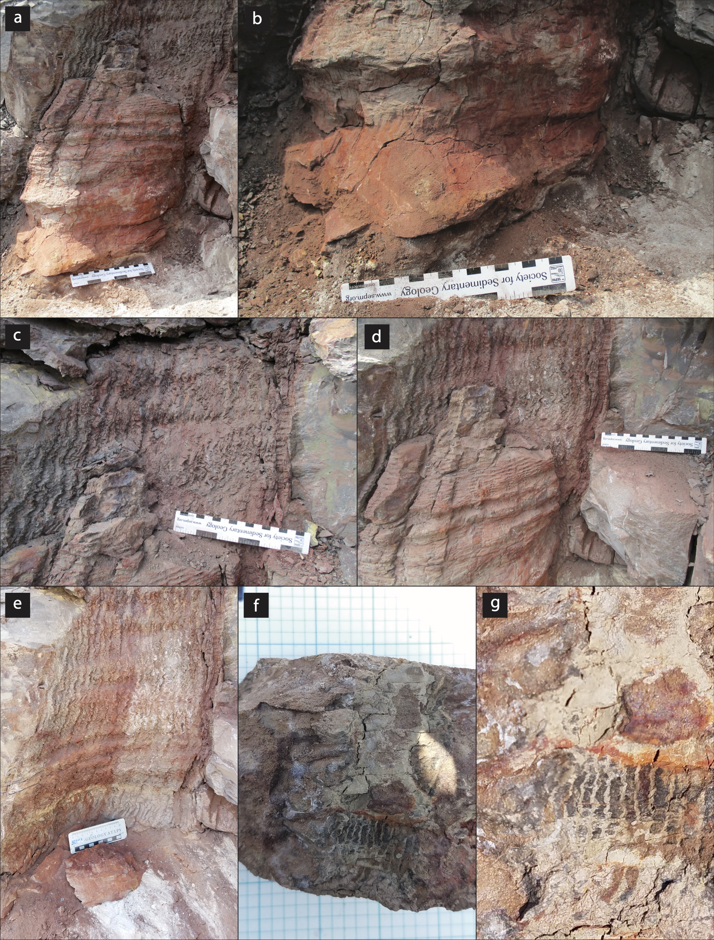
Figure S1. Additional field photographs of specimen ‘Unaccessioned 1’ that provide additional relevant information about the individual. (a) Overview of the stump within the tuff layer with waviness of the periderm visible in the tuff. (b) Close-up of the base of the stump. (c) Waviness of the periderm interior within the tuff. The periderm thickness can be seen on the right margin of the waviness. (d) Tree stump with periderm in the tuff. (e) Periderm waviness within the tuff after the stump was removed. (f) Counterpart of the stele with longitudinal bands corresponding to the corona seen when the removed stump split radially. (g) Inset of the stele counterpart.

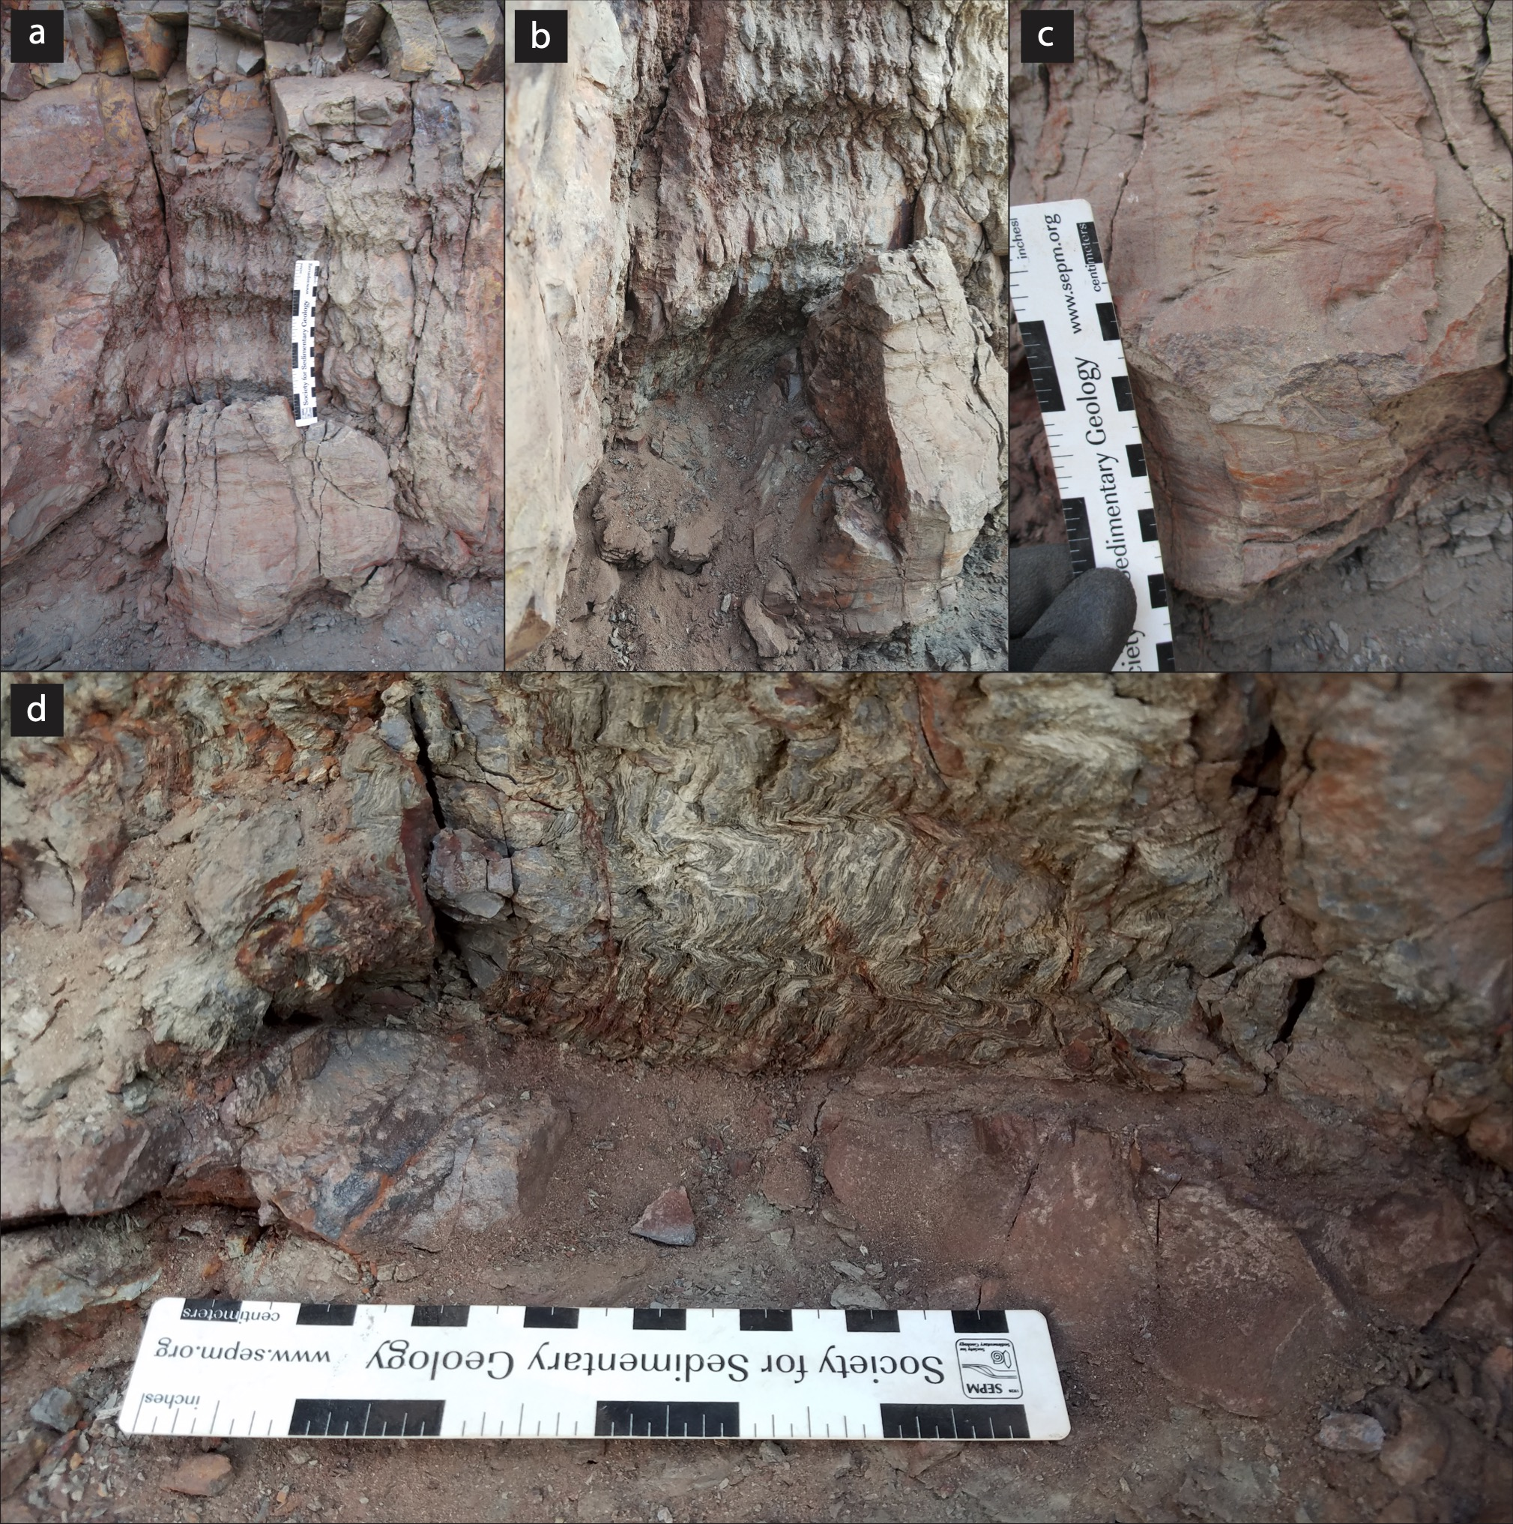
Figure S2. Additional field photographs of specimen ‘Unaccessioned 3’ that provide additional relevant information about the individual. (a) Overview of the stump within the tuff layer with waviness of the periderm visible in the tuff. (b) Lateral view of the stump. Note that the stump is highly elliptical. (c) Base of the stump with two columns of shallow parichnos visible. (d) Periderm waviness within the tuff after the stump was removed.

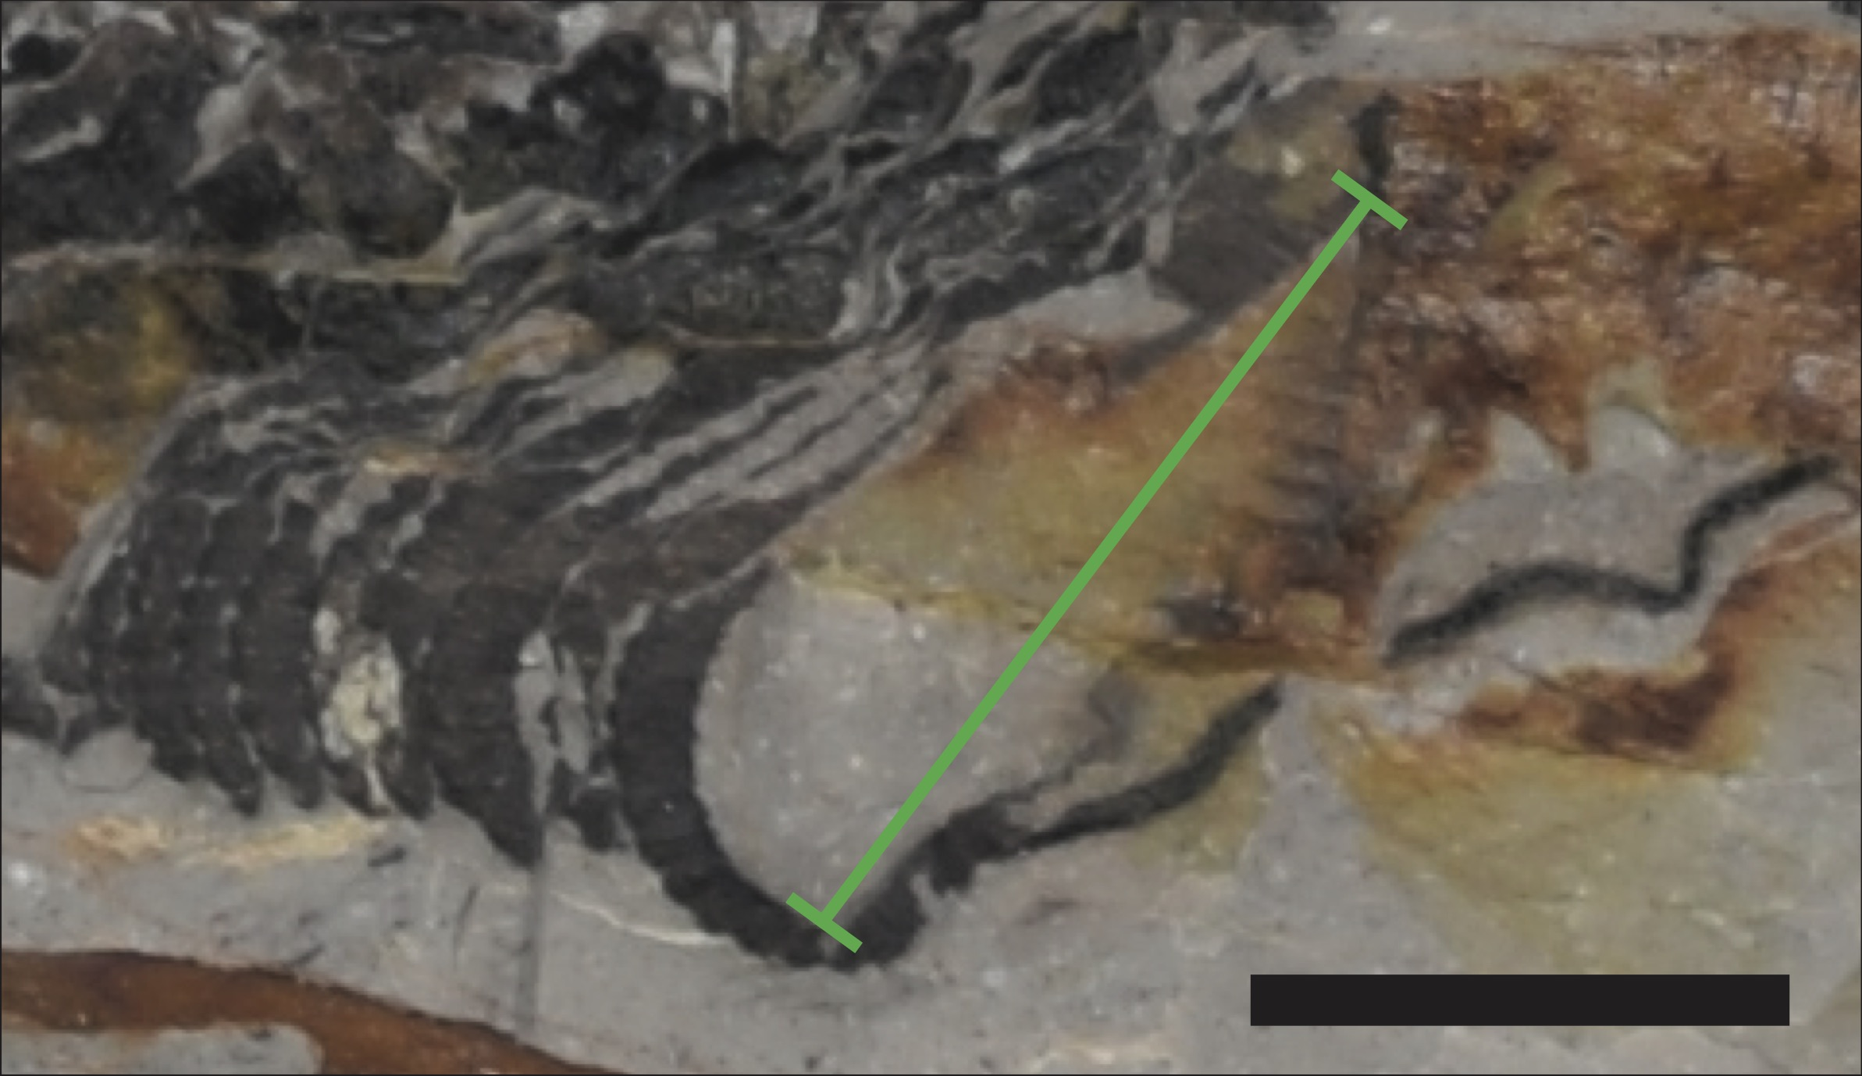
Figure S3. Reproduction of text Figure 3b showing where the measurement of the stele’s diameter was made (green line).

