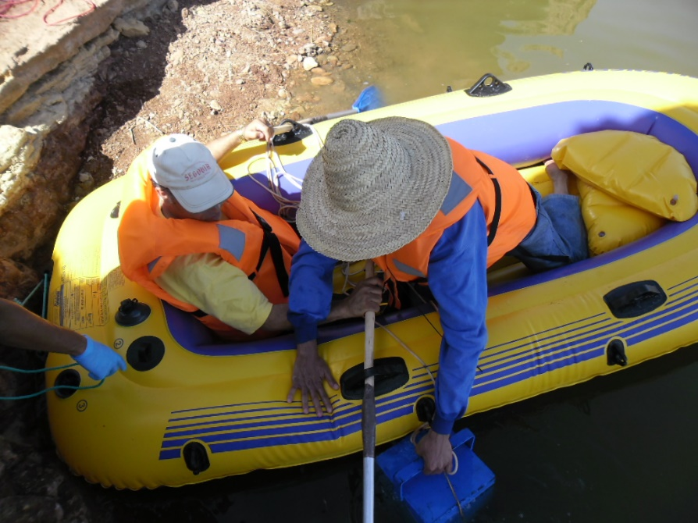

Figure 9: Preparing the boat and the merkos to enter in the lake

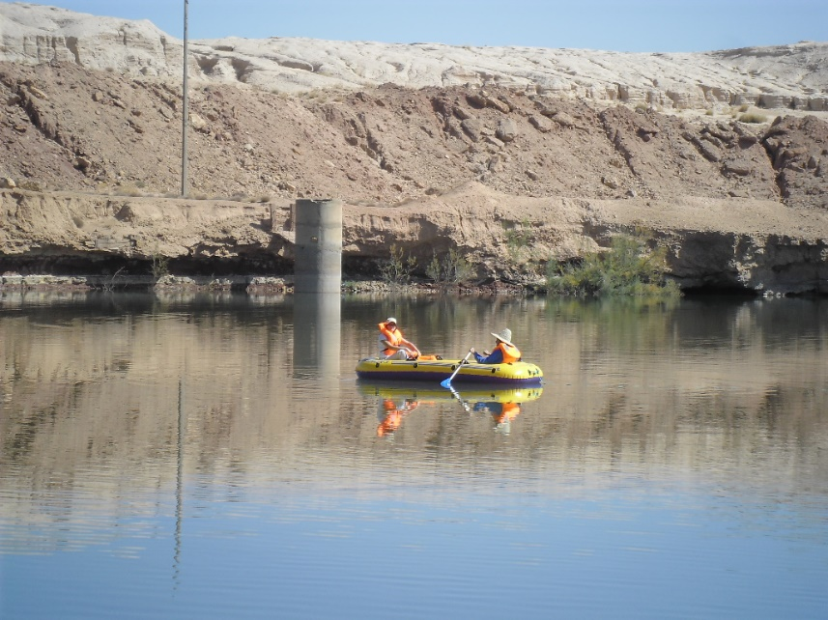

Figure 10: Boat in the centre lake

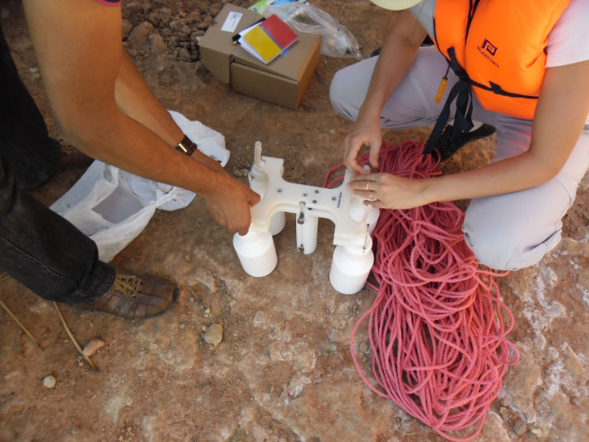

Figure 11: preparation of the merkos analyzer

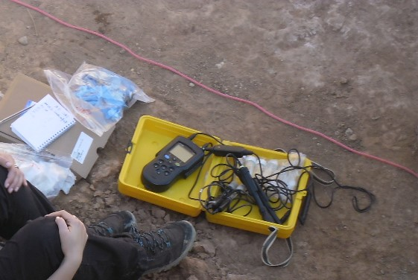

Figure 12: HQ40d portable multi-parameter (HACH Co., Loveland, CO, USA)

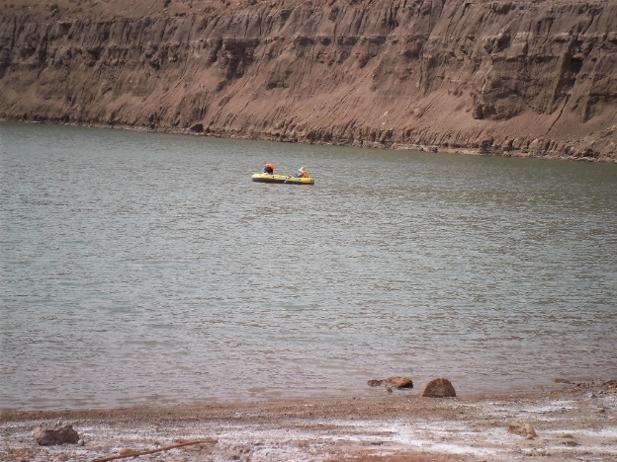

Figure 13: General view of the boat on mission in the lake

