The palaeolatitudinal distribution of the Ediacaran macrobiota

Supplementary Information

Methods
In compiling our dataset, we took several decisions to ensure effective comparison of taxa and morphogroups, and their relationship to palaeolatitude over geological time, as detailed below.

Selection of time-bins
We opted to use time-bins of regular intervals through the late Ediacaran to avoid imposing the widely cited tripartite Avalon-White Sea-Nama division of biotic assemblages onto the dataset because of the temporal overlap they have. Time-bins also permitted standardisation of the data, since there was wide variation in error bars surrounding available radiometric dates (see Supp. File 2). 10 Myr intervals were chosen since grouping at a coarser scale would reduce resolution of patterns in the data, while many sites are insufficiently well-dated to permit examination of the data at a finer scale. We treated fossils in the >581 Ma and 580–571 Ma time-bins separately, but we have plotted them together on the maps in the manuscript both because there are few sites in these time-bins, and because most >581 Ma sites have poor age constraints.
Where possible, we used age constraints with error bars of <5 Myrs to date fossil-bearing portions of the stratigraphy (favouring U-Pb ages obtained from zircons), ensuring that our dating errors are smaller than the time-bins. We then used the stated date to calibrate our dataset (e.g. for a date of 571±3.5 Myrs, we took the age of the dated horizon to be 571 Ma, with beds above that horizon considered to be <571 Ma, and those below >571 Ma). For sites without radiometric dating constraints (e.g. the Ediacara Member of the Rawnsley Quartzite in South Australia), we followed accepted practice in the literature (in that case, the suggestion that the Ediacara Member is of a similar age to the White Sea biota of Russia, putting the site within the 560–551 Ma time-bin).

Selection of taxa
We only considered macroscopic taxa of Ediacaran age, to enable direct comparison with previous work. Microfossil taxa (including for example Protolagena, Ramatubulus and Yangtzitubus, Liu et al., 2008; Waltheria, Titanotheca and Soldadotubulus, Gaucher & Sprechmann, 1999; and Doushantuo microfossils), and microbial mat fabrics/impressions, were not included because they were not the focus of this study. Data from new publications were not added to the database after March 2021.
Simple discoidal fossils (such as Aspidella, Beltanella, Eoporpita, Hiemalora and Inaria) were excluded, since they have either been confirmed as, or are suspected to be, the holdfast structures of frondose taxa or microbial colonies, rather than being discrete organisms (Gehling et al., 2000; Grazhdankin and Gerdes, 2007; Serezhnikova, 2013; Burzynski et al., 2017). Impressions widely interpreted as trace fossils (such as Epibaion; Ivantsov, 2013) or taphomorphs (such as Ivesheadia and other Ivesheadiomorphs; Liu et al., 2011), were also excluded (though see Trace Fossils below).
We compiled a list of all previously described Ediacaran taxa fulfilling these criteria, and their location data, via a comprehensive literature review. We considered taxa at a generic level (as opposed to species) to minimise biases that may be introduced by the over-splitting of taxa, and for consistency with previous data compilations. Visual assessment of figured holotype specimens was used to exclude a small number of dubiofossils from consideration (such as Elasenia, Papillionata and Vendella). We have followed published synonymisation of taxa wherever possible (this includes suggested synonymisation proposed in the Atlas of Ediacaran macrofossil taxa in Fedonkin et al., 2007). The full list of taxa included in our study, and their assignment to various morphogroups and ‘Types’, is presented in the accompanying Supplementary File 2. Below we highlight a few key groupings, explaining our rationale for presenting them in this way, and stating the taxa they comprise.

Classification of taxa
Morphogroups
To assess potential patterns in the palaeolatitudinal distribution of taxa, we followed previous authors in considering taxa to belong within established ‘morphogroups’ (see Erwin et al., 2011; Laflamme et al., 2013; Grazhdankin, 2014). These morphogroups group taxa of a similar grade, although some may reflect clades (Dececchi et al., 2017). Erwin et al. (2011) divided the Ediacaran macrobiota into Rangeomorpha, Erniettomorpha, Dickinsoniomorpha, Arboreomorpha, Triradialomorpha, Kimberellamorpha, Bilateralomorpha, Tetraradialomorpha, Pentaradialomorpha, Sponges and Valid Problematica. Grazhdankin (2014) alternatively split the biota into eight taxonomic groups, which were then grouped into three major clades: Vendobionta (Rangeomorphs, Dickinsoniomorphs, Petalonamae and Palaeopascichnids), Frondomorpha, and Eumetazoa (Tribrachiomorphs, Bilateralomorphs and Psammocorals). There is considerable overlap between some of the groups in these two schemes, but there are also important differences, with some rare morphotypes not included in the latter scheme.
We here follow the Erwin et al. (2011) classification scheme because it encompasses a greater range of taxa and makes fewer assumptions about phylogenetic relationships between groups. In addition to the Erwin et al. (2011) morphogroups, we have added Tubular, Algal, Protist, Complex discoidal (for non-holdfast discoidal taxa that do not fall into other groups, e.g. Eoandromeda, Hallidaya, Kuckaraukia, Persimedusites and Suvorovella), and Cnidarian groups, to which taxa were assigned on the basis of either their gross morphology, or their interpretation in the published literature. Taxa that could not be assigned to any of these morphogroups were assigned to a Miscellaneous group. The morphogroups considered in this study are therefore:

- Algae
- Arboreomorpha
- Bilateralomorpha
- Cnidarians
- Dickinsoniomorpha
- Complex discoidal
- Erniettomorpha
- Kimberellamorpha
- Miscellaneous
- Pentaradialomorpha
- Protists
- Rangeomorpha
- Sponges
- Tetraradialomorpha
- Triradialomorpha
- Tubular

We note that our inclusion of a taxon within a pre-existing morphogroup with a phylogenetically informative name (e.g. ‘Sponges’), in line with previous compilations, does not necessarily mean that we consider the evidence in support of that designation to be conclusive. We also note that here, and for the ‘Types’ below, the terminology we use encompasses a mixture of morphological, phylogenetic, and ecological groupings. Given the current state of Ediacaran palaeobiological understanding, whereby the field has more confidence in the phylogenetic placement of some taxa than others, this is unfortunately unavoidable. In seeking to track evolutionary patterns through time, we would ideally prefer to assess phylogenetic groupings of taxa. However, as so few taxa can be confidently assigned to such groupings at present, we feel using morphological groupings is currently the best available approach.

Problematic taxa
Several genera are subject to ongoing debate regarding their morphological characters or the morphogroup to which they belong. These taxa require further study and possible future revision of the groupings to which they are assigned here, and include:
- Attenborites (Miscellaneous). Droser et al. (2020) suggest that this inferred pelagic organism could have been related to ctenophores, cnidarians, or something else. Given this uncertainty, even though a metazoan affinity is considered likely, we place it within the Miscellaneous grouping here.
- Gibbavasis (Miscellaneous). Exhibiting distinct pore-shaped depressions within a seemingly rigid framework, Gibbavasis has been considered a poriferan-grade organism capable of filter feeding (Vaziri et al., 2018). However, spicules are absent (as for all proposed late Ediacaran sponges), and therefore secure interpretation of Gibbavasis as a sponge is not possible. We have therefore grouped it within the Miscellaneous group.
- Nenoxites (Tubular). Nenoxites has been considered as a trace fossil (Seilacher et al., 2005; Rogov et al., 2012), and alternatively as a tubular body fossil (Brasier et al., 2013; Ivantsov, 2018; Luo and Miao, 2020). This study follows the most recent interpretation of the genus as a tubular body fossil, but we recognise that this discussion is far from resolved.
- Podolimirus (Dickinsoniomorpha). Most specimens of Podolimirus are fragmentary, apart from those presented in Dzik and Martyshyn (2015). Although rare, this taxon has been included in the dataset as a valid body fossil within the Dickinsoniomorpha group.
Types
In order to investigate broad trends within the data, and to undertake statistical tests with sufficient sample numbers, the taxa were grouped into eight ‘Types’, as detailed in Supplementary Table 1. Bilateral Type fossils are those with bilateral symmetry, which we consider to be the most likely candidates for true bilaterian taxa. Radial Type fossils include all forms of radial symmetry. Frondomorph Type fossils include all frondose organisms (here incorporating Rangeomorphs and Arboreomorphs, rather than following the use of this term by Grazhdankin, 2014). Note that despite some Erniettomorphs (e.g. Swartpuntia) being ‘frondose’, we have not included Erniettomorph taxa within the Frondomorph Type, since not all of them bear a frondose gross morphology. Aside from the Algal and Protist Types, our groupings here largely reflect morphological groups. The Bilateral group is the only other grouping here that could potentially have phylogenetic weight, but we cannot exclude the possibility that some taxa in our Tubular Type may also ultimately be recognised as bilaterian metazoans (e.g. Cloudina as interpreted by Schiffbauer et al., 2020; Yang et al., 2020).

Types | Morphogroups included
Algal | Algae
Bilateral | Bilateralomorpha; Dickinsoniomorpha; Kimberellamorpha
Radial | Complex discoidal; Pentaradialomorpha; Tetraradialomorpha; Triradialomorpha
Frondomorph | Arboreomorpha; Rangeomorpha
Erniettomorph | Erniettomorpha
Protist | Protists
Tubular | Tubular
Miscellaneous | Miscellaneous; Cnidarians; Sponges

Supplementary Table 1: The morphogroups included in each Type grouping.

There is much debate within the literature over the morphology and phylogenetic placement of Dickinsonia. Sprigg (1947) originally described it as possibly a cnidarian or a worm. Since then, further studies have produced multiple competing Dickinsonia interpretations, with recent work largely converging on it being bilaterian (Gold et al., 2015; Evans et al., 2017), placozoan (Sperling and Vinther, 2010), or a member of the Proarticulata (Ivantsov et al., 2020). Much of this debate surrounds the question of whether Dickinsonia originally possessed bilateral symmetry (as observed in many South Australian specimens of D. costata for example), or a glide plane of symmetry (e.g. Ivantsov et al., 2020). Other dickinsoniomorph taxa clearly show a glide plane that is unlikely to be taphonomic in origin (e.g. Yorgia and Andiva), but such a symmetry state is not necessarily incompatible with a bilaterian affinity. Although there remains debate regarding the composition of the Dickinsoniomorpha group (e.g. Dunn et al., 2018), assuming that this morphogroup is robust, and that Dickinsonia costata is a representative taxon for the group (we appreciate that this assumption is also contentious), we follow Gold et al. (2015) in considering Dickinsonia, and therefore Dickinsoniomorphs, within our Bilateral Type.
Biomineralising taxa
Taxa are grouped by body composition as being: CaCO₃ biomineralised; SiO₂ biomineralised; organic template; agglutinated; or soft-bodied, following Selly et al. (2020). Biomineralised taxa are thought to have possessed a biomineralised (calcium carbonate, calcium phosphate, or silica) hard shell or external structures. ‘Organic template’ taxa are inferred to have possessed non-mineralised walls made of organic biomolecules (e.g. collagen) that provided some degree of external structural integrity. Taxa assigned to the biomineralised, organic template and agglutinated groupings are listed in Supplementary Table 2, alongside all soft-bodied tubes (see Figure 5).

Group | Taxa included
Complex discoidal, CaCO₃ biomineralised | Suvorovella
Bilateralomorpha, CaCO₃ biomineralised | Namacalathus
Tubular, CaCO₃ biomineralised | Cambrotubulus, Cloudina, Multiconotubus, Sinotubulites
Tubular, SiO₂ biomineralised | Anulitubus, Coniculus, Fistula
Cnidarian, organic template | Paraconularia
Tubular, organic template | Conotubus, Convolutubus, Corumbella, Costatubus, Gaojiashania, Saarina, Shaanxilithes, Zuunia
Sponges, organic template | Coronacollina
Protist, agglutinated | Orbisiana, Palaeopascichnus
Tubular, agglutinated | Archaeichnium
Tubular, soft bodied | Annulatubus, Aulozoon, Calyptrina, Funisia, Nenoxites, Plexus, Protoconites, Sabellidites, Sekwitubulus, Sinospongia, Somatohelix, Wutubus

Supplementary Table 2: All genera categorised into biomineralised (CaCO₃ or SiO₂), organic template, or soft-bodied tubular groupings.

There has been recent debate over whether Cloudina was originally biomineralised, or whether it instead possessed an organic template (Yang et al., 2020). We have followed the classic biomineralised interpretation here. Meanwhile, Namapoikia has recently been re-interpreted as a microbial structure (Mehra et al., 2020) rather than a sponge (Wood et al., 2002), and in light of this new data Namapoikia is excluded from our analysis. There is also debate over whether Suvorovella and Coronacollina had organic or biomineralised skeletons. We have followed the biomineralised interpretation discussed in Wood et al. (2017) for Suvorovella. The original description of Coronacollina leaves open both possibilities, and we have assigned it to the organic template group here, on the basis that primary biominerals have not yet been observed (Clites et al., 2012).

Trace fossils
Perhaps the most compelling evidence for late Ediacaran bilaterian metazoans comes from trace fossils, and so we have incorporated the latitudinal distribution of reported bilaterian ichnotaxa into our analysis. Since we cannot be sure whether the full spectrum of ichnodiversity was created by one taxon or many, we have taken a conservative approach of simply grouping multiple ichnotaxa as one data point, with bilaterian trace fossils being either present (regardless of the number of ichnogenera) or absent at each body fossil locality within a given time-bin. Ichnogenera commonly considered to record the activity of bilaterians included within this study include Helminthoidichnites, Archaeonassa, and Lamonte (see also Jensen et al., 2006). Metazoan trace fossils from the ~565–560 Ma Mistaken Point and Fermeuse Formations of Newfoundland are not included, since they are not considered to have been produced by bilaterian organisms (Liu et al., 2010; Menon et al., 2013; Liu and McIlroy, 2015). The presence of trace fossils is factored into our dendrogram analysis.

Environmental data within the database
To test whether observed trends in the data may result from differences in water depth or environment, rather than palaeolatitude, we collated published information on the broad-scale bathymetry and sedimentation regime of each fossil locality. Individual localities often record multiple fossil-bearing facies. Considerable variability also exists in terms of how well individual localities have been environmentally constrained, and in the strength of evidence in support of their specific depositional settings. We therefore divided the sites simply as lacustrine, or shallow or deep marine (with the slope break taken as the boundary, i.e. nearshore or offshore), and carbonate or siliciclastic dominated (Figure 6; Supp. Fig. 2).

Assumptions with environment and age
Since there is little consistency at different localities in the magnitude of errors surrounding radiometric dates, the number and quality of available dates, or the level of detail to which facies at individual localities have been characterised, we have had to make several decisions regarding assignment of individual localities to time-bins, environmental categories, and lithologies. The references that guided our thinking, as well as notes explaining our decisions, can be found in Supplementary File 2 under the ‘Localities’ tab, and in the reference list below. In each case, our interpretations focus on the units or beds within which the fossils are found.

Sampling biases
To interpret palaeolatitudinal data, our plots group northern and southern latitudes together by their palaeolatitude (n.b. very few palaeocontinents are considered to have occupied high northern latitudes during the late Ediacaran in Neoproterozoic plate reconstructions). Grouping in this way ensures that palaeolatitude, rather than global position (i.e. palaeogeography), is the focus of the analyses. Latitudes were separated into 20° bins for graphical plots.
Sources of bias in species-diversity datasets include variation in outcrop volume, research intensity for each locality, and ease of sample collection/study (Allison and Briggs, 1993). To determine whether visual signals from the plotted maps may simply reflect the palaeolatitudinal distribution of fossil sites, we employed the following tests:
- Chi-squared tests performed in R (Version 3.6.1) within RStudio (Version 1.2.5019; RStudio Team, 2019) determined whether visual signals seen in the maps are statistically significant. These tests are intended to account for sampling variation, but can only indicate whether a signal is significant or not, rather than identifying the cause of the signal. To perform the chi-squared tests, the data were split into two 45° latitudinal bands (corresponding to high and low palaeolatitudes), and for each group studied the data were divided into those within a given category, and those outside it. To avoid false positives from performing multiple tests on a single dataset we used the Bonferroni correction at a 5% significance level. If the p-value falls below this corrected significance level, then a result is deemed significant. Weakly-significant signals were defined between a 5–10% significance level, also using the Bonferroni correction.

- Kruskal-Wallis tests were performed in R to determine whether taxonomic distribution through time correlates with locality distribution through time. These tests can only state whether a signal is significant, rather than identifying the cause. The number of localities and number of taxa were compared for each of the two 45° latitudinal bands (low and high latitude), to determine whether they follow the same distribution. A 5% significance level was taken.

Supplementary Results
The results described in this section refer to the distribution of Ediacaran macrofossils on the Scotese (2001) (SCO01) palaeogeographic reconstruction, and comparison to the distribution on the Merdith et al. (2021) (MER21) reconstruction described in the main text. The distribution of fossil-bearing localities in the two reconstructions varies most notably in the positioning of the Laurentia-Siberia-Baltica palaeocontinental cluster (Supp. Fig. 1).

Overall diversity through time
The distribution of fossil Types through time in the SCO01 reconstruction (Supp. Fig. 13 initially appears similar to that in the MER21 reconstruction, with the two localities in the oldest pre-581 Ma time-bin (the Lantian Formation and Kimberley) both positioned at low palaeolatitudes (< 45º), but further from the Equator. In the next 10 Myr interval, three localities (the Nadaleen Formation, Finnmark and Newfoundland) are present at high palaeolatitudes (> 45º), so a global distribution for Frondomorphs cannot be assessed, but assuming protistan taxa in the pre-581 Ma time-bin persisted in the low latitude regions, that group can be inferred to exhibit a global distribution by this point. The diversification between 560–551 Ma, and subsequent apparent dip in generic diversity in the final 10 Myr of the Ediacaran Period, appears to occur similarly in both latitudinal bands (Supp. Figs 13 inset; 14), albeit weakly or not significantly.
A Kruskal-Wallis test of whether the distribution in taxon diversity significantly differs from the distribution of localities across 20° palaeolatitudinal bands, with the null hypothesis being that they follow the same distribution, revealed a significant signal (KW test, p = 0.009; Supp. Table 3; Supp. Fig. 18b).
Kruskal-Wallis tests to assess whether the distribution of diversity is significantly identical to the number of localities through time reveal weakly-significant signals at high palaeolatitudes (KW test, p = 0.094; Supp. Table 3), and non-significant signals at low palaeolatitudes (KW test, p = 0.141; Supp. Table 3). Non-significant signals are observed between low and high palaeolatitude taxa (KW test, p = 0.754, Supp. Table 3) and low and high palaeolatitude localities (KW test, p = 1, Supp. Table 3). These signals are similar to those observed in the MER21 reconstruction (Table 1).
The overall diversity (of all macrobiota across the entire late Ediacaran) and the number of localities across latitudes are both higher at low palaeolatitudes than at high palaeolatitudes (Supp. Fig. 18b). When the data are normalised to sampling intensity, no significant difference is recovered (Supp. Fig. 20a), so, as on the MER21 reconstruction (Supp. Fig. 9a), the apparent difference between low and high palaeolatitudes cannot be visually differentiated from a flat overall latitudinal distribution of taxa during the Ediacaran.
Contrary to the MER21 reconstruction, the distribution of Frondomorph taxa does not exhibit a statistically significant signal when compared with non-Frondomorph taxa between high and low palaeolatitudes (χ²(1, N = 214) = 2.935, p = 0.087; Supp. Table 3), whilst Algal taxa show a statistically significant difference (χ²(1, N = 214) = 6.954, p = 0.008; Supp. Table 3). The distribution of Tubular taxa is not statistically significant (χ²(1, N = 214) = 4.704, p = 0.030; Supp. Table 3), as on the MER21 reconstruction. Sampling for Radial taxa on the SCO01 reconstruction permits a valid test, indicating no significant difference (χ²(1, N = 214) = 0.159, p = 0.691; Supp. Table 3), whilst other Types remain too poorly sampled to perform valid chi-squared tests. The Bonferroni corrected p-value for 5% significance is 0.006 for the chi-squared tests performed for taxa on the SCO01 reconstruction (Supp. Table 3).

Bilateral Taxa
Body fossils of Bilateral-Type taxa, and trace fossils interpreted to have been produced by bilaterian taxa, occur globally in the SCO01 reconstruction (Bilateralomorpha, Dickinsoniomorpha and Kimberellamorpha; Supp. Figs 18a,c, 21). A chi-squared test comparing Bilateral taxa against non-bilateral taxa at low and high palaeolatitudes is non-significant (χ²(1, N = 214) = 0.825, p = 0.364; Supp. Table 3). Therefore, the apparent latitudinal restriction of Bilateral taxa resolved in the MER21 reconstruction is not observed in the SCO01 reconstruction (Supp. Fig. 18).

Biomineralisers and Tubular fossils
The distribution of both tubular and biomineralising organisms in the SCO01 reconstruction is global, spanning equatorial to almost polar palaeolatitudes (Supp. Fig. 19), as similarly observed in the MER21 reconstruction. The distribution of taxa by body composition (biomineralising, organic template and soft-bodied; Supp. Fig. 19b–d) shows no significant latitudinal signal distinguishable from the sampling density, with the diversity of taxa roughly following the distribution of fossil localities (Supp. Fig. 20d–f). The biomineralising organism distribution is predominantly dictated by tubular component organisms. Whereas a chi-squared test comparing biomineralising and organic template taxa with soft-bodied and agglutinating taxa (i.e. non-biomineralising and non-organic-template taxa), at low and high palaeolatitudes confirms no significant signal, as in the MER21 reconstruction (χ²(1, N = 214) = 3.277, p = 0.070; Supp. Table 3), a chi-squared test between soft-bodied taxa (non-algal) and non-soft-bodied taxa at low and high palaeolatitudes (performed to distinguish the difference between algal taxa and non-algal soft-bodied taxa) is significant (χ²(1, N = 214) = 7.590, p = 0.006). This result is likely a reflection of the significant Algal signal, since soft-bodied (algal) taxa dominate over the lower diversity groups also included in the comparison group, which contains all non-soft-bodied taxa and algal taxa (soft-bodied (algal), biomineralising, organic template and agglutinating). The algal signal is likely to be heavily driven by diverse populations of constituent taxa in South China. These comparisons are made across the entire late Ediacaran.

Test type | Comparison | Chi-squared | p-value
Kruskal-Wallis | Low latitude localities—Low latitude taxa | 2.164 | 0.141
Kruskal-Wallis | High latitude localities—High latitude taxa | 2.810 | 0.094
Kruskal-Wallis | Low latitude taxa—High latitude taxa | 0.098 | 0.754
Kruskal-Wallis | Low latitude localities—High latitude localities | 0 | 1
Kruskal-Wallis | Overall taxa—Localities (20° bands) | 6.818 | 0.009
Chi-squared | Algal—Non-algal | 6.954 | 0.008
Chi-squared | Bilateral—Non-bilateral | 0.825 | 0.364
Chi-squared | Frondomorph—Non-frondomorph | 2.935 | 0.087
Chi-squared | Radial—Non-radial | 0.159 | 0.691
Chi-squared | Tubular—Non-tubular | 4.704 | 0.030
Chi-squared | Soft-bodied—Non-soft-bodied | 7.590 | 0.006
Chi-squared | Biomineralising and Organic Template—Soft and Agglutinating | 3.277 | 0.070
Chi-squared | Miscellaneous—Non-miscellaneous (control) | 1.380 | 0.240

Supplementary Table 3: Key statistical results from the SCO01 reconstruction. Significant and weakly-significant p-value results in bold. Significant and weakly-significant p-values for Kruskal-Wallis tests are below 0.05 and between 0.05–0.10, respectively. Significant and weakly-significant p-values for chi-squared tests on Types are corrected to 0.006 and 0.013 using the Bonferroni correction, respectively.
Supplementary Figures

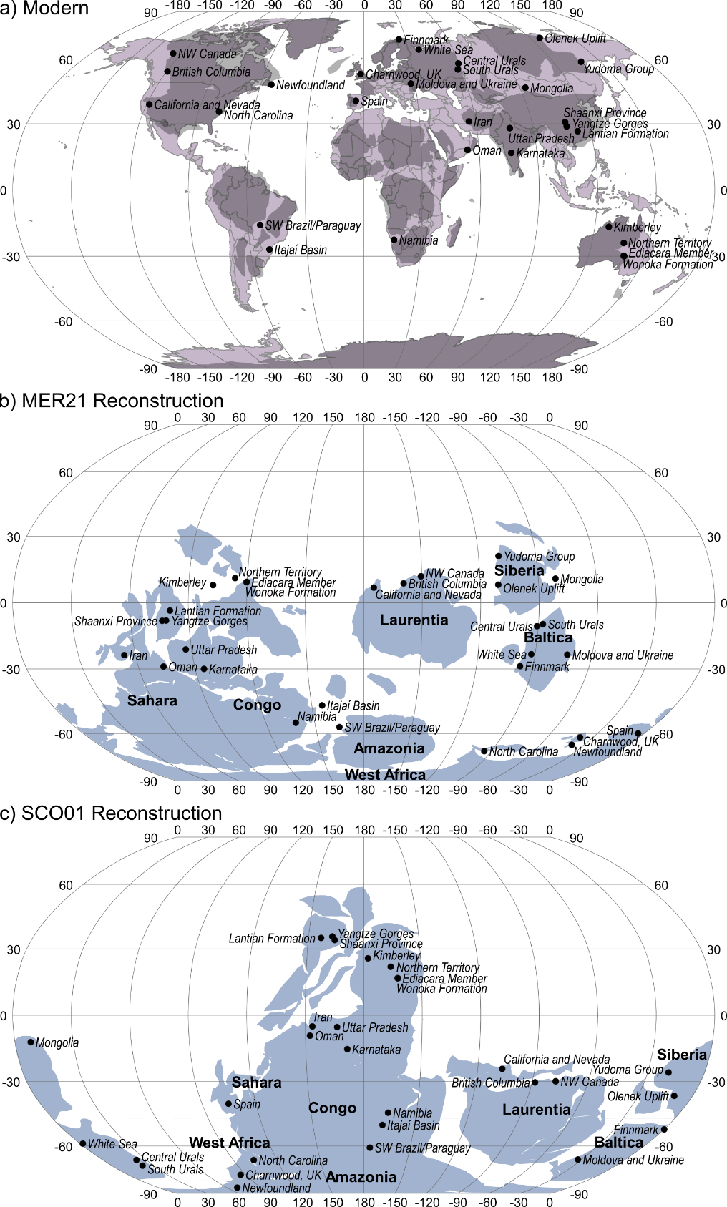

Supplementary Figure 1: Precambrian cratons, and the locations of Ediacaran fossil localities included in this study (in italic), plotted on: (a) the modern global map (cratons shaded), (b) the projected MER21 reconstruction at 555 Ma, and; (c) the projected SCO01 reconstruction at 555 Ma.
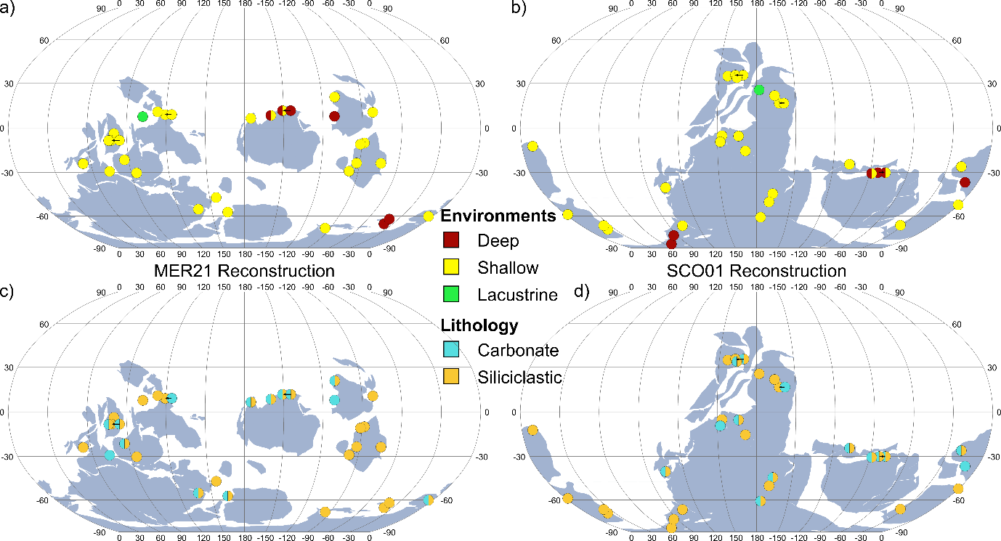

Supplementary Figure 2: (a–b) Maps showing the distribution of depositional environments for Ediacaran fossil localities on the MER21 and SCO01 reconstructions, respectively. (c–d) Maps showing the distribution of lithologies of Ediacaran fossil localities on both MER21 and SCO01 reconstructions, respectively. Black arrows indicate the palaeo-location in cases where two sites are so closely spaced that their symbols have been moved for clarity.

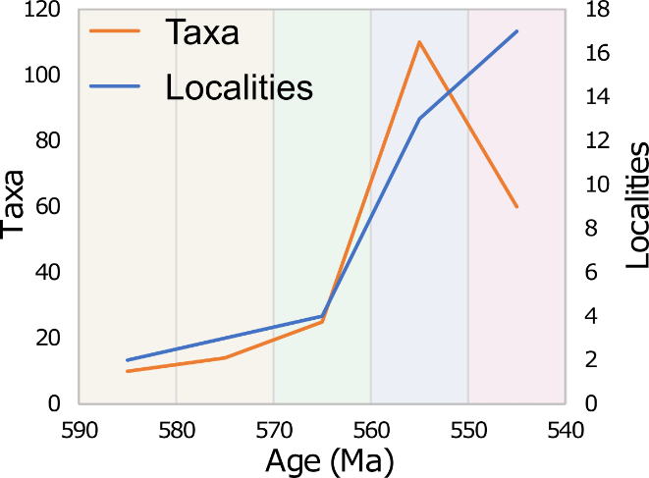

Supplementary Figure 3: Overall generic diversity of Ediacaran macrobiota (orange) and corresponding variation in locality density (blue) through late Ediacaran time. A significant Kruskal-Wallis result (p-value = 0.047, Table 1) suggests that the distribution of sampled localities cannot fully describe the distribution of genera through time.
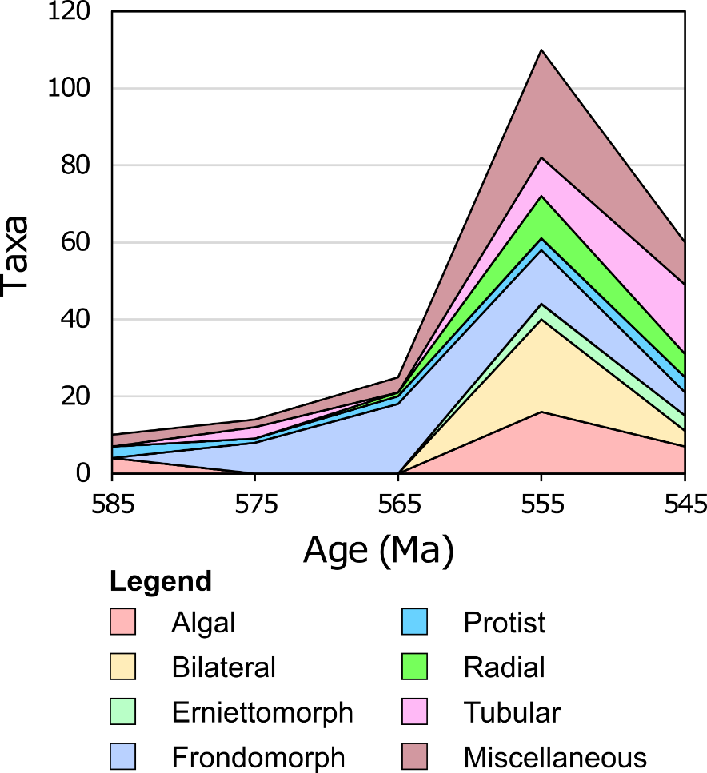

Supplementary Figure 4: Stacked area chart representing the overall diversity of Ediacaran macrobiota genera through the late Ediacaran, arranged by ‘Type’. Note the late appearance of Bilateral and Erniettomorph Types in the 560–551 Ma time-bin.
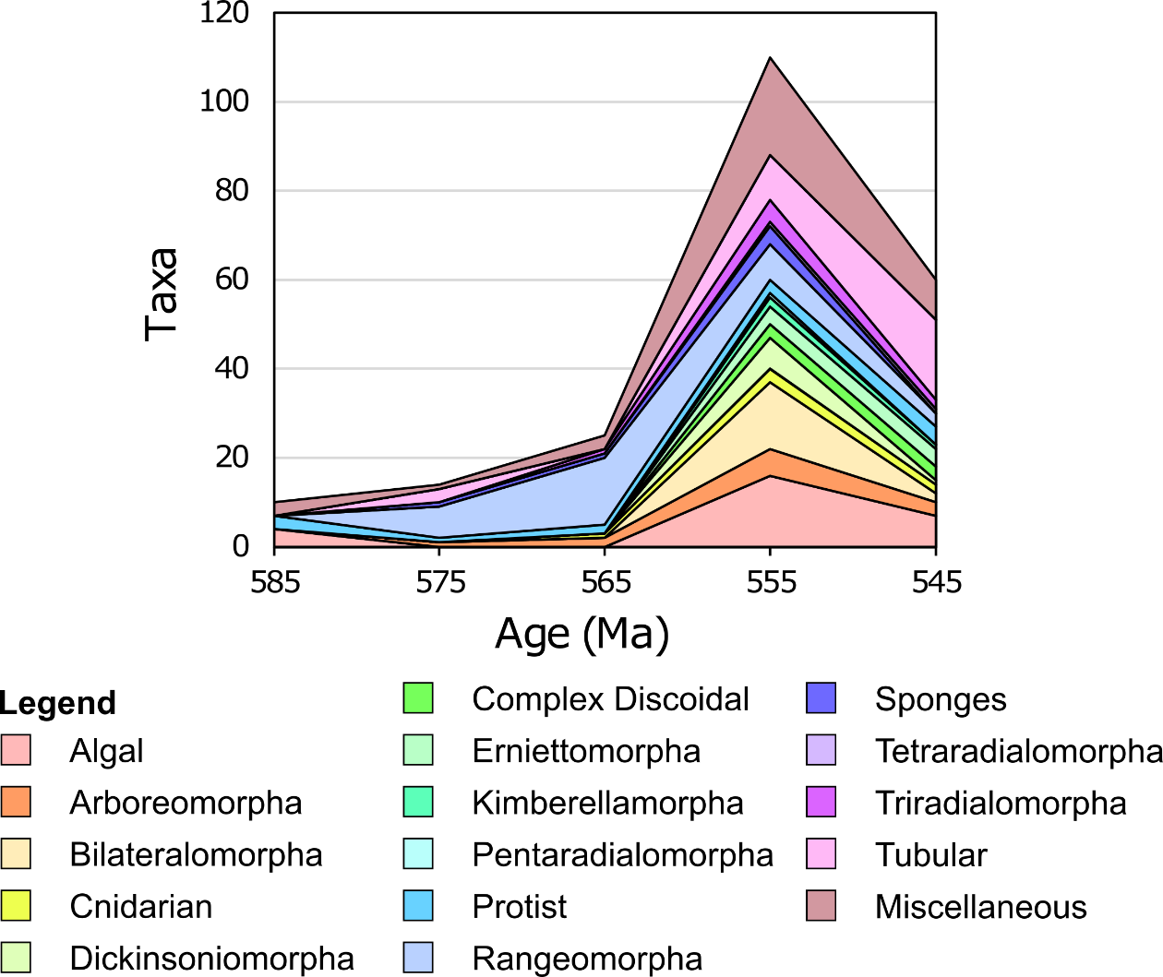

Supplementary Figure 5: Stacked area chart representing the overall diversity of Ediacaran macrobiota genera through the late Ediacaran, arranged by Morphogroup. Note the substantial increase in morphogroup diversity after 560 Ma.

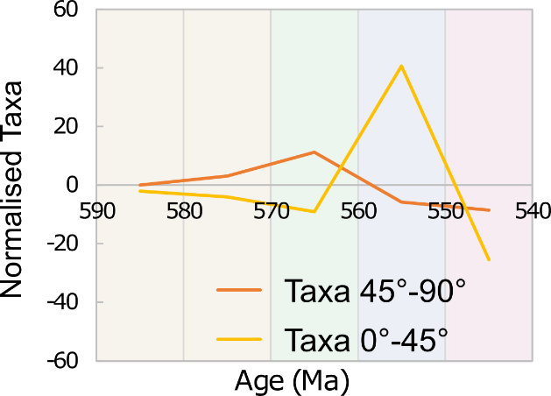

Supplementary Figure 6: Variation in generic diversity at low (yellow) and high (orange) palaeolatitudes through late Ediacaran time, normalised against locality density, on the MER21 reconstruction. ‘Normalised taxa’ axis scale is equivalent to that used for taxonomic diversity in Figure 2. There are notably more taxa at low palaeolatitudes in the 560–551 Ma time-bin than would be expected from locality coverage alone, and fewer taxa at low palaeolatitudes than would be expected in the 550–539 Ma time bin.

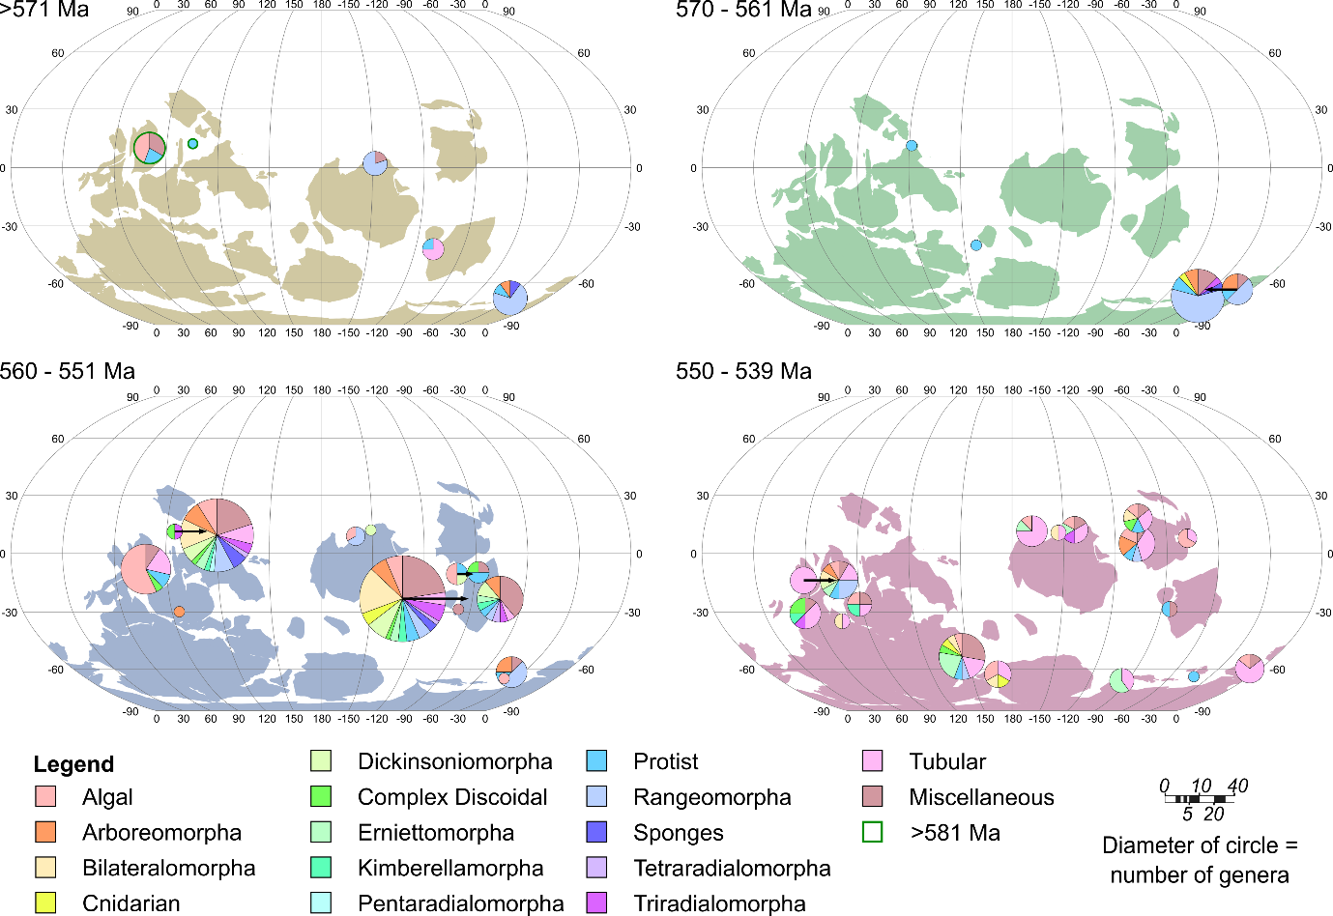

Supplementary Figure 7: Distribution of Morphogroups on the MER21 reconstruction, with each locality presented as a pie chart centred on the locality (black arrows indicate the palaeo-location where necessary), and each map plotted with palaeocontinents positioned as estimated at the mid-point of each time-bin (Precambrian craton shapes are colour coded for each bin). Pie chart scaling represents the number of genera within each Morphogroup, with the circle area being equivalent to the total number of genera at each locality.

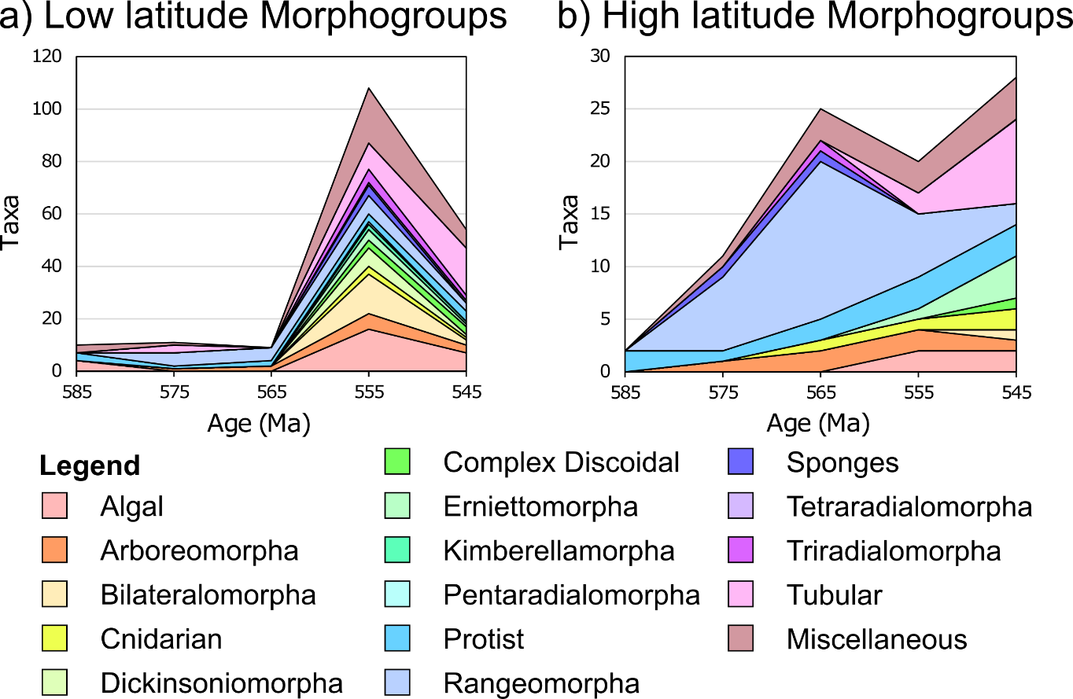

Supplementary Figure 8: Stacked area chart representing the overall variation in Ediacaran macrobiota generic diversity by Morphogroup at (a) low and (b) high palaeolatitudes through time, on the MER21 reconstruction.

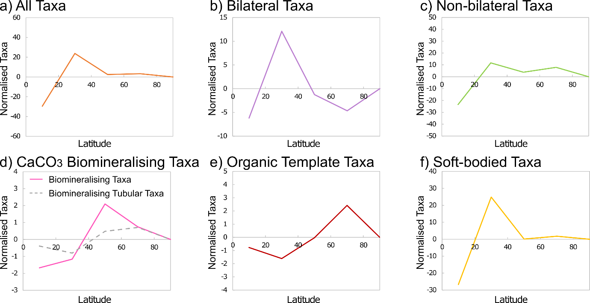

Supplementary Figure 9: The latitudinal generic diversity variation of various Ediacaran macrofossil groups across the late Ediacaran (i.e. >581–539 Ma), normalised against locality density, on the MER21 reconstruction. The ‘normalised taxa’ axis values are equivalent to those used for taxon diversity in Figures 4 and 5. All Bilateral taxa included in (b) are found between 560–539 Ma, and all CaCO₃ biomineralising and organic template taxa (d–e) are found between 550–539 Ma. Bilateral taxa (b) produce a weakly-significant chi-squared result when compared to non-bilateral taxa at low and high latitudes (p-value = 0.013, Table 1), whereas the trends shown by other groups are non-significant.

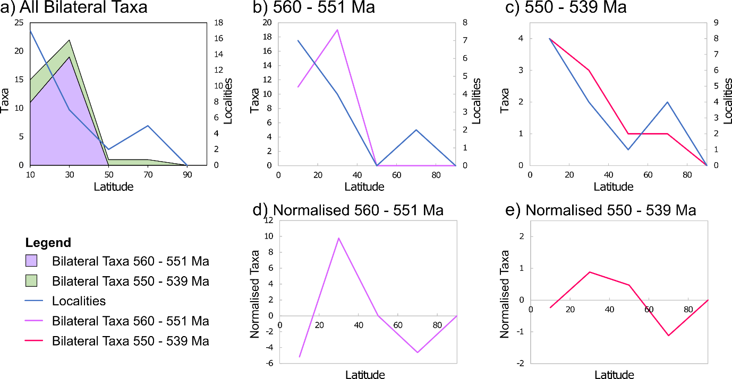

Supplementary Figure 10: The palaeolatitudinal diversity distribution of Bilateral Type taxa on the MER21 reconstruction. (a) Stacked area chart revealing how Bilateral taxa are distributed across palaeolatitudes across all time-bins, compared with the distribution of Ediacaran fossil sites across the late Ediacaran (blue). (b–c) Graphs comparing the distribution of Ediacaran fossil sites in the corresponding time-bin (blue) to the distribution of (b) Bilateral taxa found between 560–551 Ma, and (c) Bilateral taxa found between 550–539 Ma. (d–e) Graphs of Bilateral taxon distribution normalised against locality density. The ‘normalised taxa’ axes are equivalent to those used for taxon diversity in (b–c). The sample sizes of Bilateral taxa in individual time-bins are not sufficient to perform valid chi-squared tests.

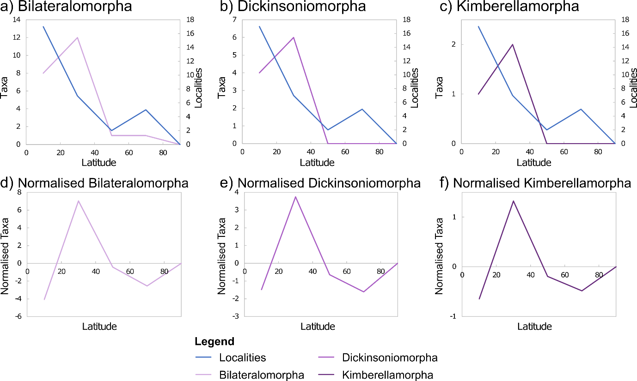

Supplementary Figure 11: The palaeolatitudinal diversity distribution of the three individual Bilateral morphogroups on the MER21 reconstruction, across the late Ediacaran (i.e. >581–539 Ma). (a–c) Graphs comparing the distribution of Ediacaran fossil sites (blue) to the distribution of (a) Bilateralomorpha, (b) Dickinsoniomorpha, and (c) Kimberellamorpha. (d–f) Graphs normalised against locality density. All taxa included here are found between 560–539 Ma. The ‘normalised taxa’ axes are equivalent to those used for taxon diversity in (a–c). The sample sizes of these morphogroups are not sufficient to perform valid chi-squared tests.

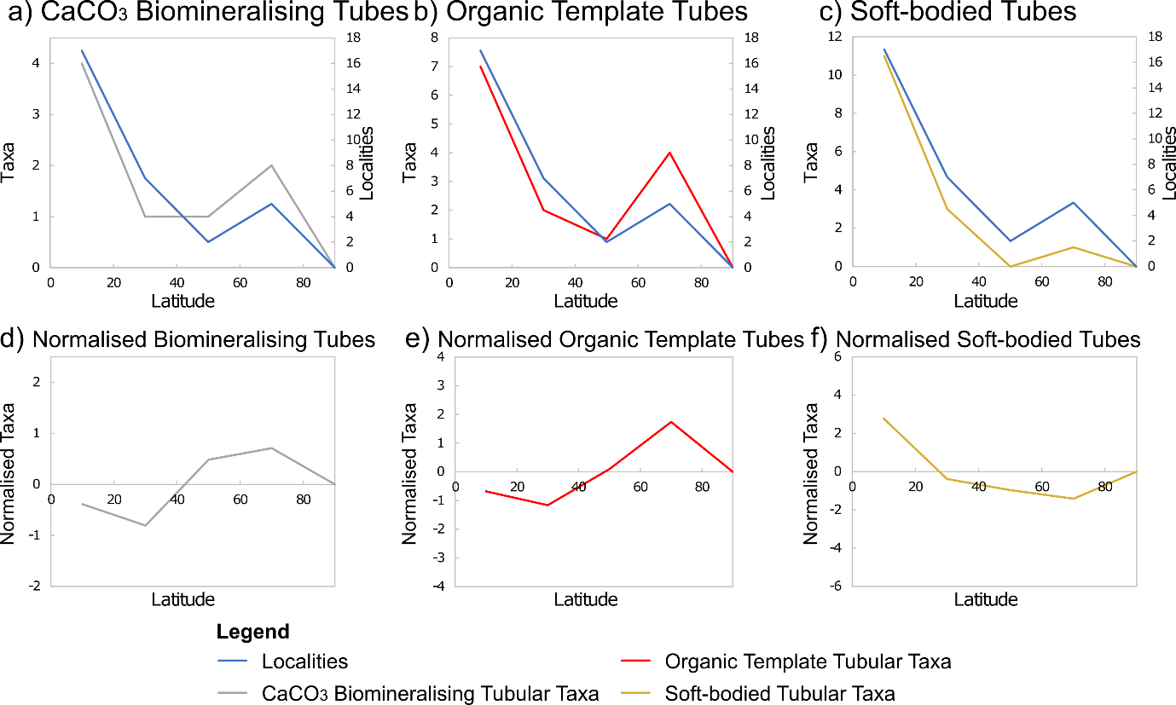

Supplementary Figure 12: The distribution of Ediacaran fossil sites relative to the distribution of tubular organisms on the MER21 reconstruction, across the late Ediacaran (i.e. >581–539 Ma). (a–c) Comparisons between the distribution of Ediacaran fossil sites (blue) and the distribution of (a) CaCO₃ biomineralising tubes, (b) organic template tubes, and (c) soft bodied tubes (see also Figure 5). (d–f) Graphical plots normalised against locality density. All CaCO₃ biomineralising and organic template tubes included in (a–b, d–e) are found between 550–539 Ma. The ‘normalised taxa’ axes are equivalent to those used for taxon diversity in (a–c). The sample sizes of these groups are not sufficient to perform valid chi-squared tests.

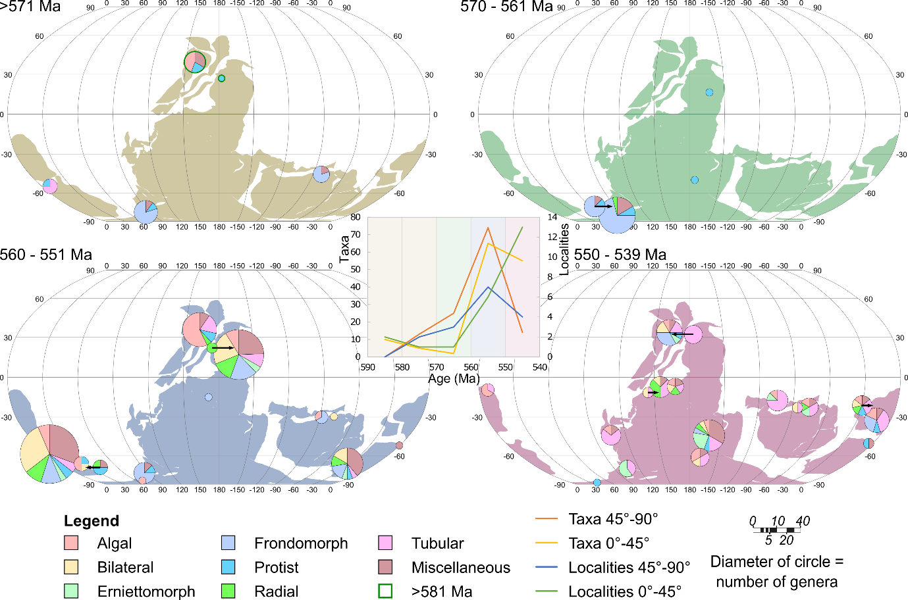

Supplementary Figure 13: Distribution of Ediacaran macrobiota Fossil Types on the SCO01 reconstruction, with each locality presented as a pie chart centred on its locality (black arrows indicate the palaeo-location where it has been necessary to move pie charts to avoid overlap), and with each map plotted with palaeocontinents positioned as estimated at the mid-point of each time-bin (Precambrian craton shapes are colour coded for each bin). Pie charts are scaled to represent the number of genera within each Type, with the circle area being equivalent to the total number of genera at each locality. Inset: graph comparing the distribution of Ediacaran fossil sites within two palaeolatitudinal bands to the distribution of taxa throughout the late Ediacaran (a weakly-significant Kruskal-Wallis result is observed when comparing high palaeolatitude taxa against high palaeolatitude localities, p-value = 0.094, Supp. Table 3).

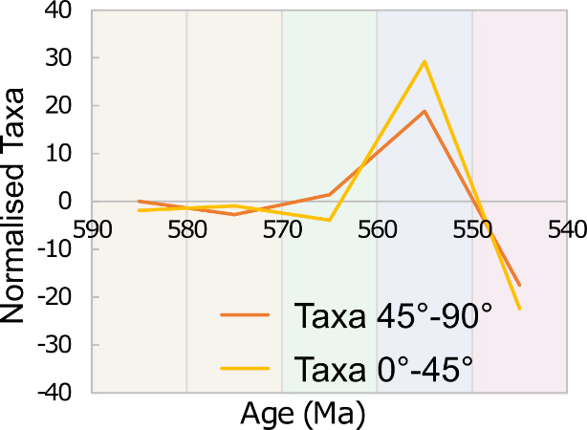

Supplementary Figure 14: Graph illustrating the overall generic diversity of the Ediacaran macrobiota at high and low palaeolatitudes (orange and yellow lines, respectively) through time, normalised against locality density, on the SCO01 reconstruction. The ‘normalised taxa’ axis scale is equivalent to that used for taxon diversity in Supplementary Figure 13.

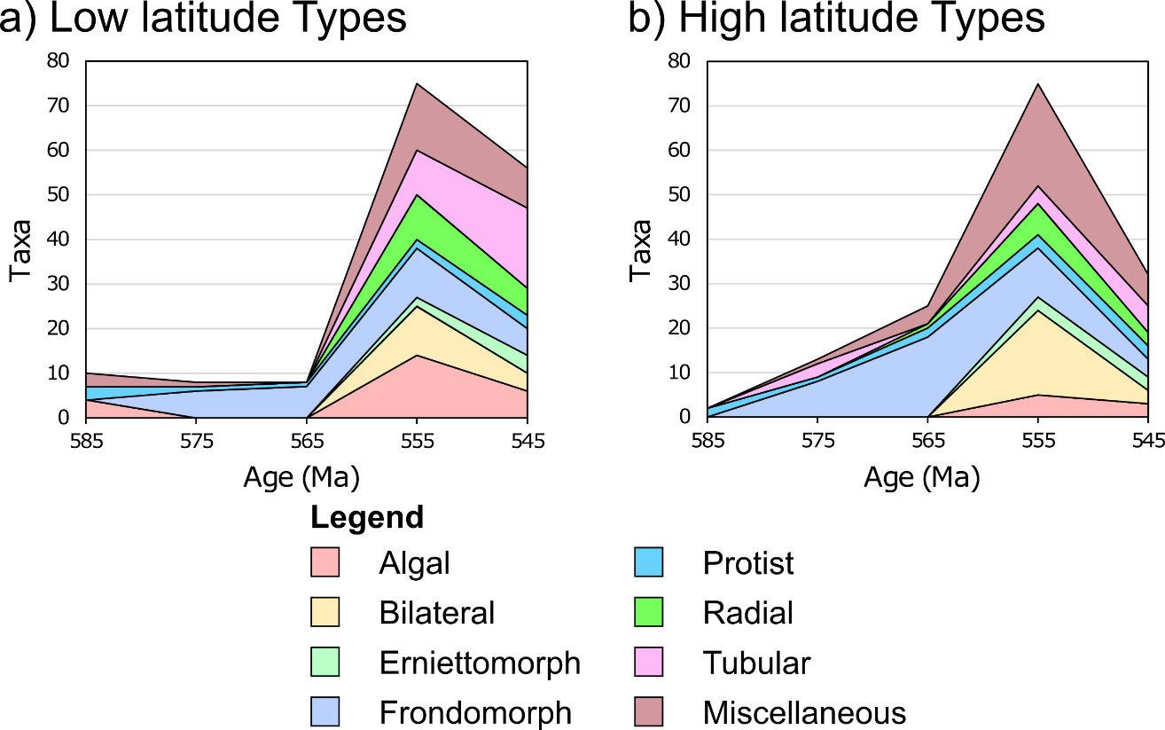

Supplementary Figure 15: Stacked area chart representing Ediacaran macrobiota generic diversity variation by Type at (a) low and (b) high palaeolatitudes through time, on the SCO01 reconstruction.
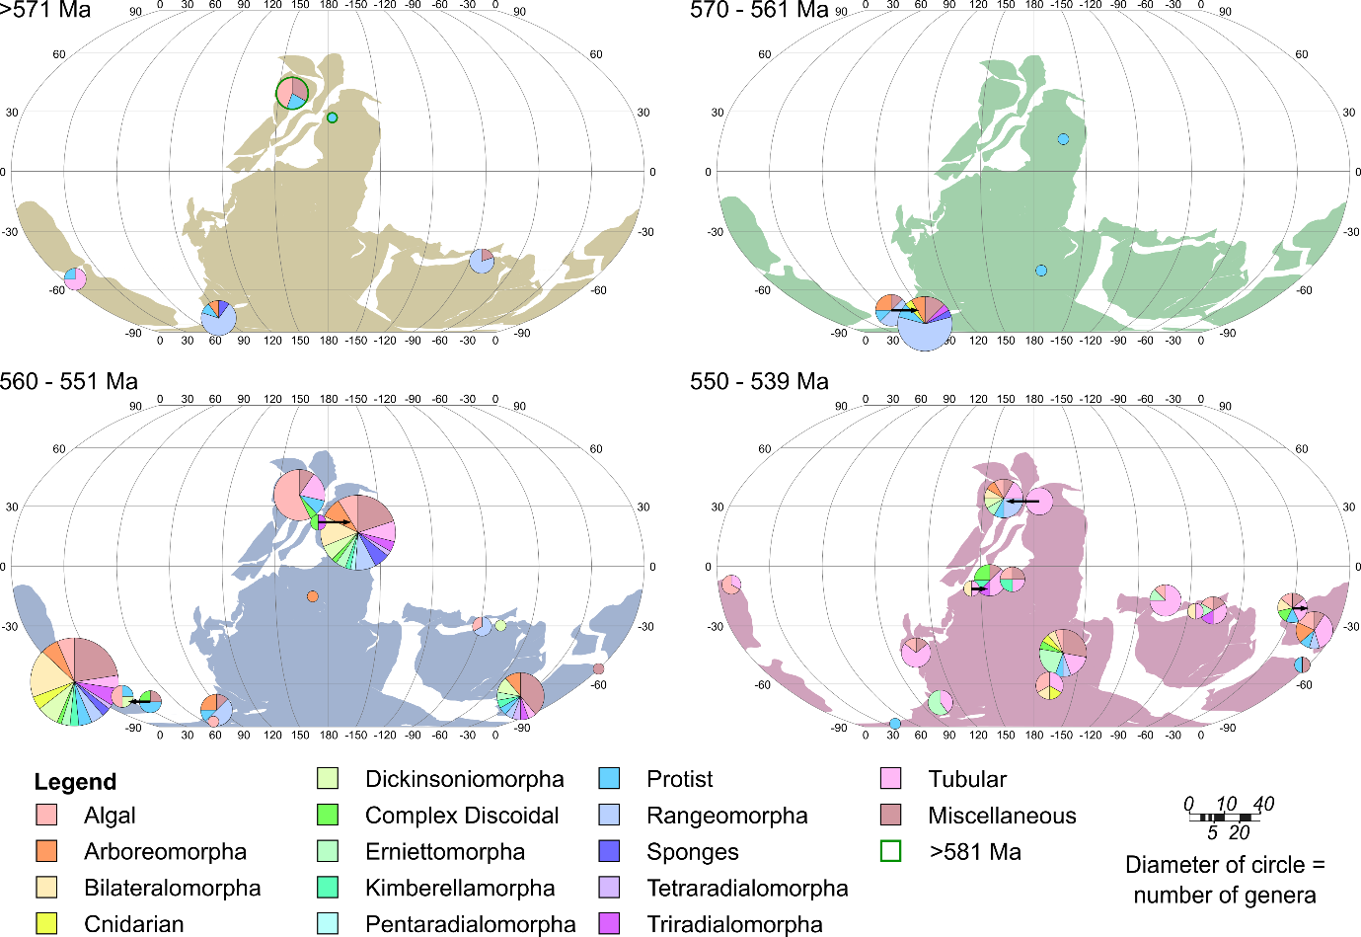

Supplementary Figure 16: Morphogroups presented as pie charts centred over their locality (black arrows indicate the palaeo-location where necessary) at the mid-point of each time-bin on the SCO01 reconstruction (Precambrian craton shapes coloured for each bin). The pie charts on all plots represent the number of genera within each morphogroup, and the circle area represents the total number of genera at each locality.

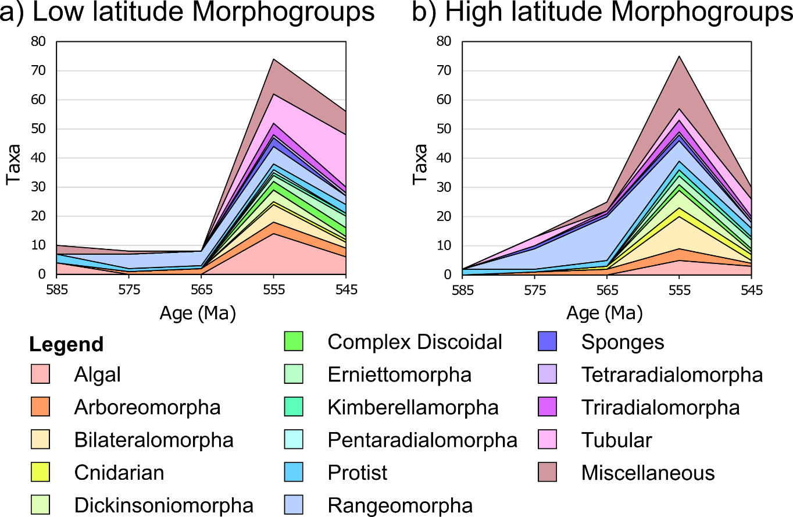

Supplementary Figure 17: Stacked area chart representing Ediacaran macrobiota generic diversity variation by Morphogroup at (a) low and (b) high palaeolatitudes through time, on the SCO01 reconstruction.
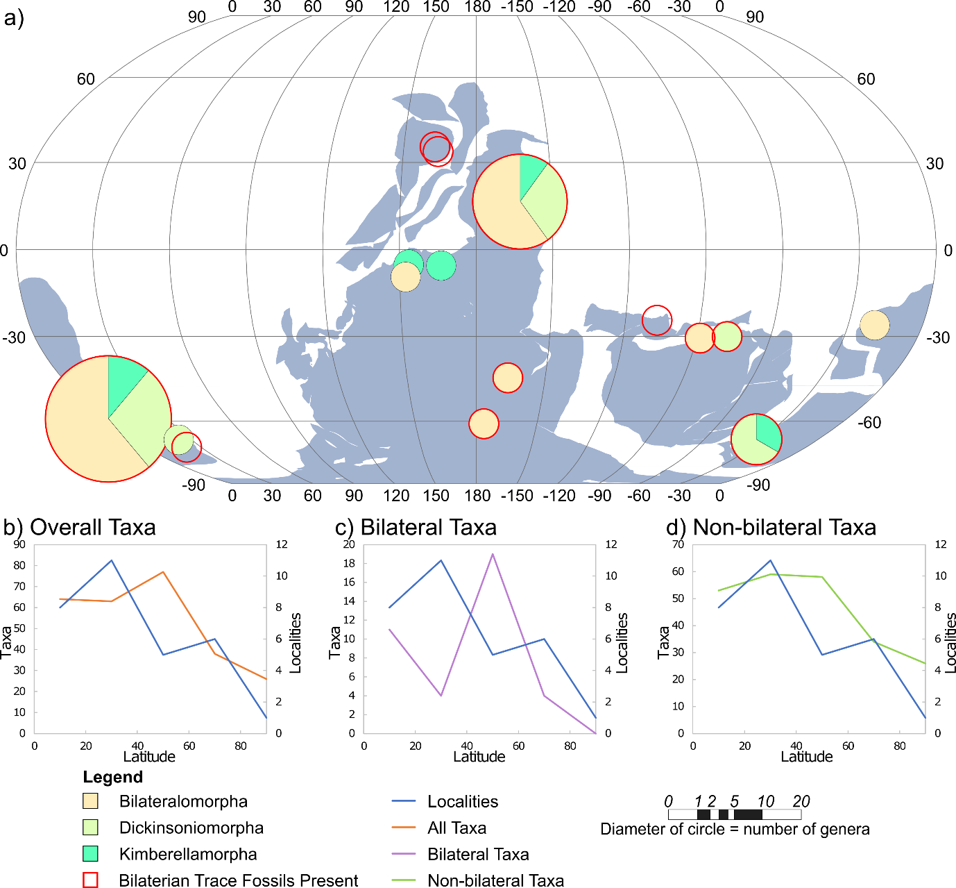

Supplementary Figure 18: The global distribution of Bilateral Type fossils on the SCO01 reconstruction. (a) Bilateral body and trace fossils presented as pie charts featuring the relative proportion of constituent morphogroups centred over the locality at which they are found at 555 Ma. The area of the circles represents the number of genera at each locality. The distribution appears more global on this reconstruction than on the MER21 reconstruction. Note that we have considered trace fossils as one data point, and so the true diversity of bilateral organisms represented by documented traces is not reflected by these plots. (b–d) Graphs comparing the distribution of Ediacaran fossil sites across the late Ediacaran (i.e. >581–539 Ma) (blue) to the distribution of (b) all taxa, (c) Bilateral taxa, and (d) non-bilateral taxa. All Bilateral taxa included in (c) are found between 560–539 Ma. None of the distributions in plots (b–d) show a statistically significant difference between high and low latitudes.
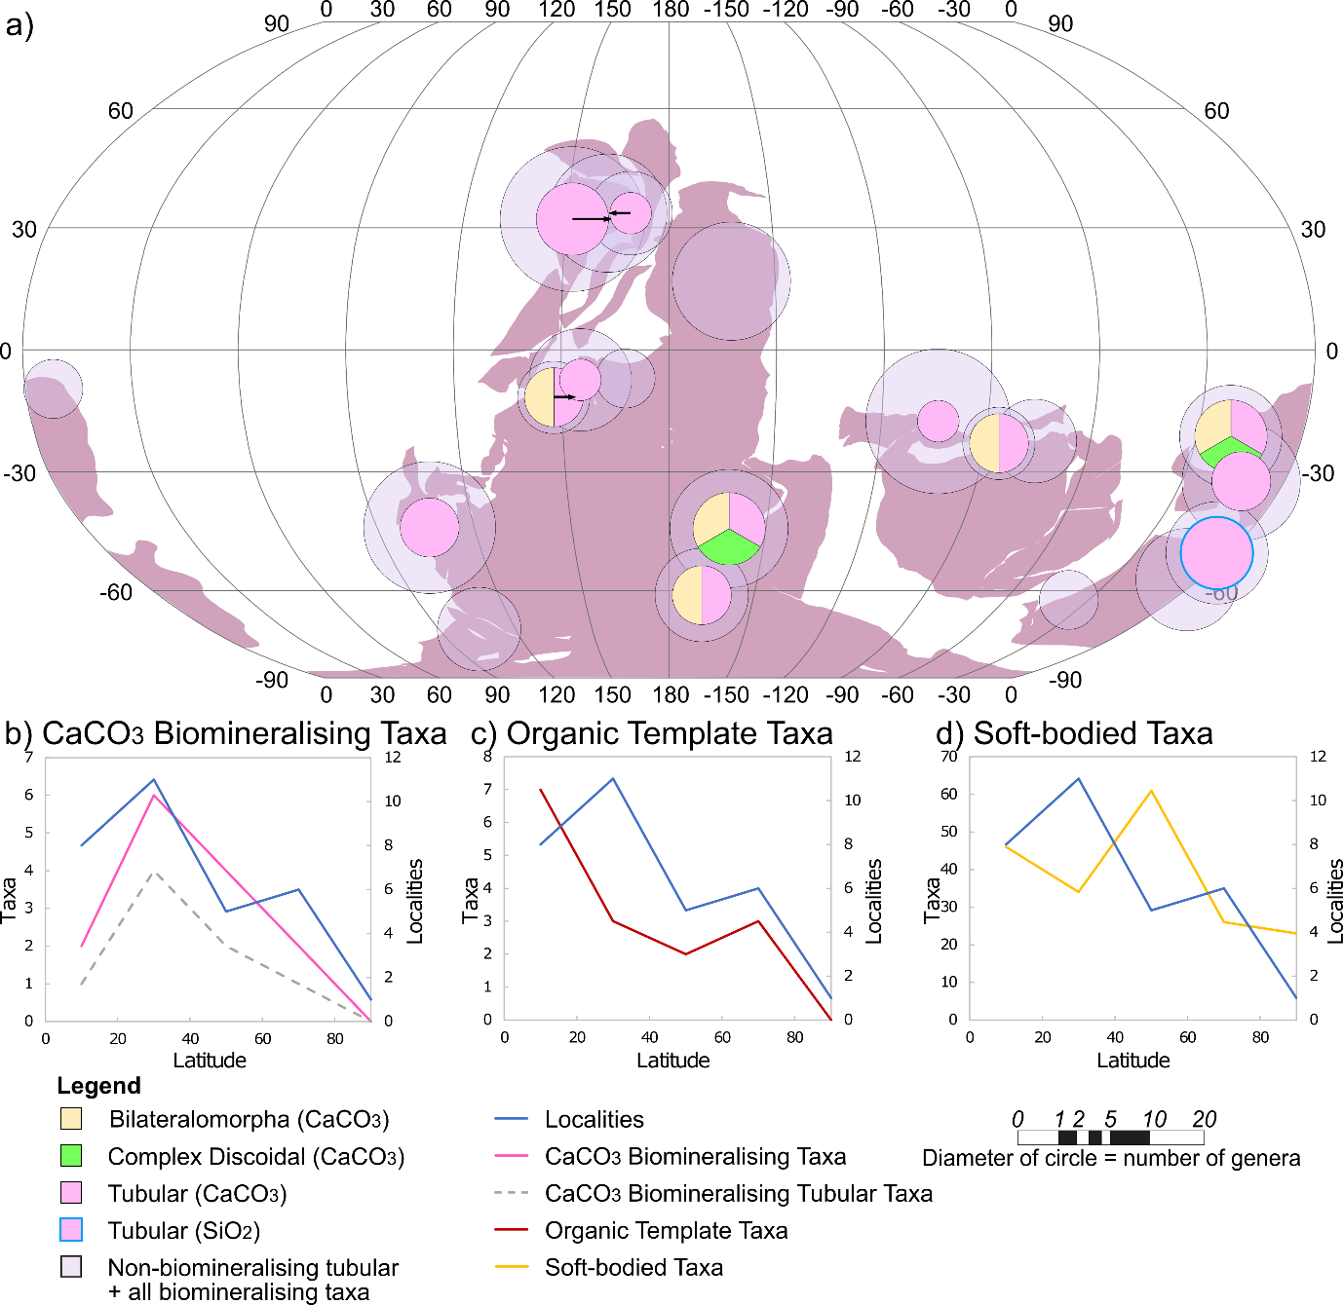

Supplementary Figure 19: The global distribution of biomineralising and tubular Ediacaran taxa on the SCO01 reconstruction. (a) Tubular fossils and all other biomineralising fossils (faint circles), with pie charts of only biomineralising organisms overlain (solid circles), centred over the locality at which they are found at 545 Ma (black arrows indicate the palaeo-location where necessary). The area of the circles is proportional to the number of relevant genera at each locality. A global distribution is observed for both tubular and biomineralising organisms. Biomineralising organisms are dominated by tubular taxa, and are often found along with non-biomineralising tubular organisms. (b–d) Graphs comparing the distribution of Ediacaran fossil sites across the late Ediacaran (i.e. >581–539 Ma) (blue) to the distribution of: (b) CaCO₃ biomineralising taxa; (c) organic template taxa; and (d) soft bodied taxa. This latter group has a significant chi-squared result when compared with non-soft bodied taxa at low and high latitudes (p-value = 0.006, Supp. Table 3). All CaCO₃ biomineralising and organic template taxa (b–c) are found between 550–539 Ma.

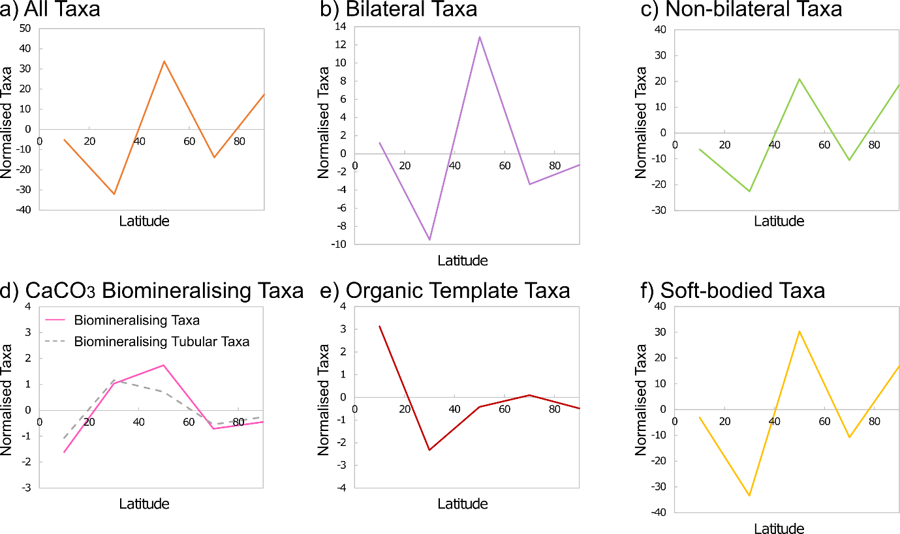

Supplementary Figure 20: Variation in the palaeolatitudinal generic diversity of selected groups, normalised against locality density across the late Ediacaran (i.e. >581–539 Ma), on the SCO01 reconstruction. All Bilateral taxa included in (b) are found between 560–539 Ma, and all CaCO₃ biomineralising and organic template taxa (d–e) are found between 550–539 Ma. The ‘normalised taxa’ axes are equivalent to those used for taxon diversity in Supplementary Figures 18 and 19.

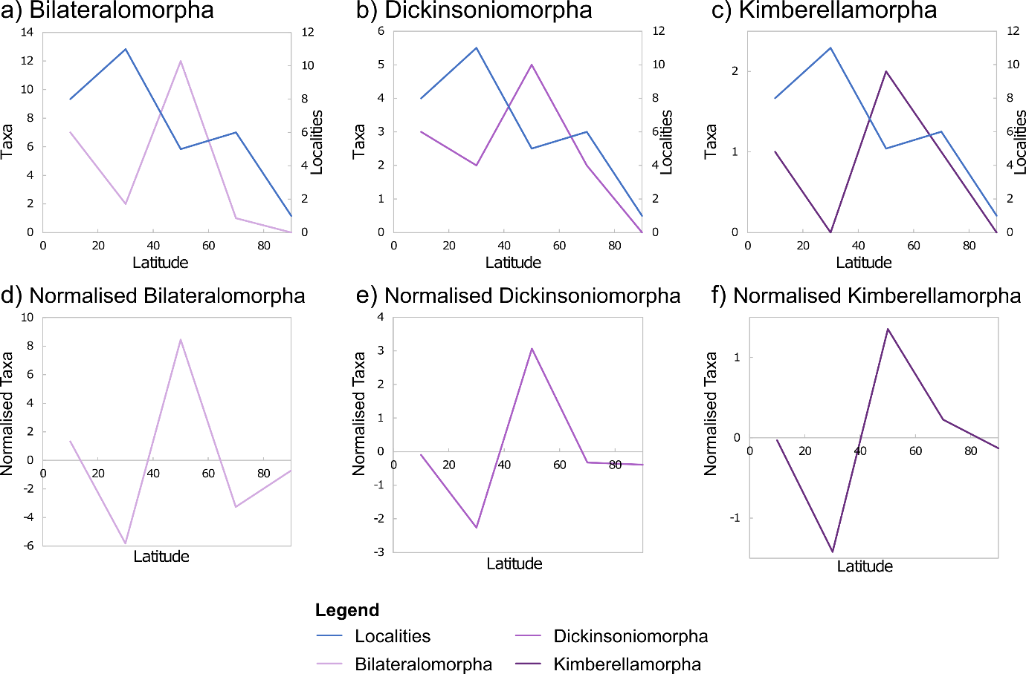

Supplementary Figure 21: The palaeolatitudinal diversity distribution of the three individual ‘Bilateral Type’ morphogroups on the SCO01 reconstruction, across the late Ediacaran (i.e. >581–539 Ma). (a–c) Graphs comparing the distribution of Ediacaran fossil sites (blue) to the distribution of (a) Bilateralomorpha, (b) Dickinsoniomorpha, and (c) Kimberellamorpha. (d–f) Graphs normalised against locality density. All taxa included here are found between 560–539 Ma. The ‘normalised taxa’ axes are equivalent to those used for taxon diversity in (a–c). The sample sizes of these morphogroups are not sufficient to perform valid chi-squared tests.

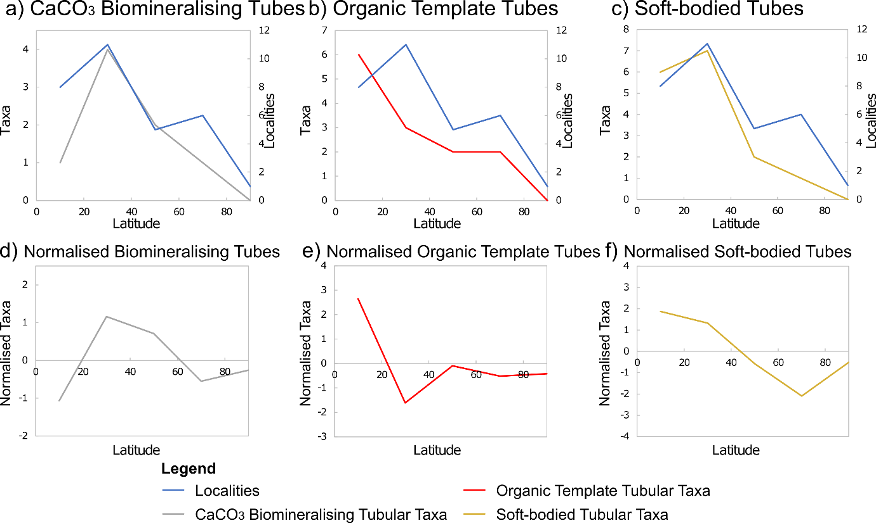

Supplementary Figure 22: Comparison of the palaeolatitudinal distribution of Ediacaran fossil localities with the distribution of tubular organisms on the SCO01 reconstruction, across the late Ediacaran (i.e. >581–539 Ma). (a–c) Graphs comparing the distribution of Ediacaran fossil sites (blue) to the distribution of (a) CaCO₃ biomineralising tubes, (b) organic template tubes, and (c) soft bodied tubes. (d–f) Graphs normalised against locality density. All CaCO₃ biomineralising and organic template tubes included in (a–b, d–e) are found between 550–539 Ma. The ‘normalised taxa’ axes are equivalent to those used for taxon diversity in (a–c). The sample sizes of these groups are not sufficient to perform valid chi-squared tests.
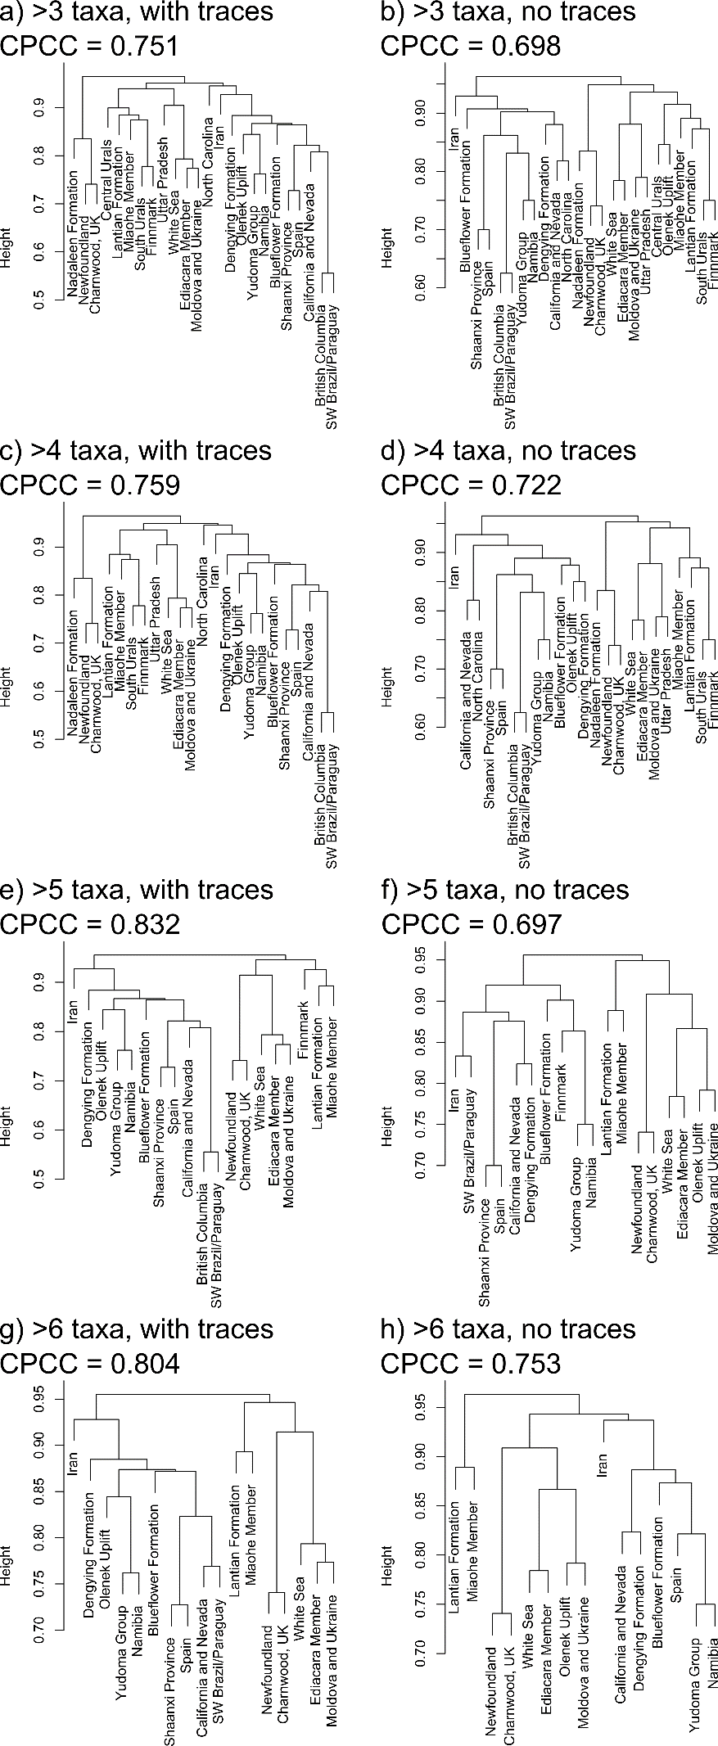
Supplementary Figure 23: Alternative dendrograms featuring localities with >3, >4, >5 and >6 taxa, with or without the inclusion of data for the presence/absence of bilaterian trace fossils. The corresponding cophenetic correlation coefficients (CPCC) are also presented. The nodes vary with even small changes to the data, suggesting limited support for these trees. Incorporation of data from sites with fewer taxa increases mixing of “traditional” (Waggoner, 2003) assemblages. The most consistent trends as judged by CPCC occur when sites with few taxa are excluded, but such plots necessarily include fewer localities. The inclusion of the presence/absence of bilaterian traces improves the CPCC, and so traces were included for our main analysis (Figure 6).
Supplementary File 2 contents
Our database contains base data, plotted data (graphical and maps), and analysis data. Plotted data and analysis data are derived from the base data, using formulae in Excel. These data and corresponding Excel formulae are presented in the following worksheets within Supplementary File 2:
Data - Taxa – Dataset of all genera along with their Morphogroup, Location, Age, Body Composition, Type, Palaeolatitude on both MER21 and SCO01 reconstructions, and References.
Data - Localities – Dataset of all Localities along with their Age, Palaeolatitude on both MER21 and SCO01 reconstructions, Environment, Lithology, and References.
Plots - Temporal Data – Data extracted from the two datasets to study trends through time:
- Overall diversity through time provides the number of localities and number of taxa in each 10 Myr time-bin, used for Supp. Fig. 3.
- Diversity through time in 45° palaeolatitudinal bands provides the number of localities and taxa in both low and high palaeolatitudes for both MER21 and SCO01 reconstructions, in each 10 Ma time-bin, used for Figure 2 inset and Supp. Fig. 13 inset.
- Normalised taxon diversity for locality density through time in 45° palaeolatitudinal bands, taxon data normalised to account for varying locality density through time, used for Supp. Figs 6 and 14.
- Type and Morphogroup data through time provides the number of each taxon Type/morphogroup in each 10 Ma time-bin, used for Figure 3 and Supp. Figs 4, 5, 8, 15 and 17.
Plots - Palaeolatitudinal Data – Data extracted from the two datasets to study trends across palaeolatitude on both the MER21 and SCO01 reconstructions:
- Diversity in 20° palaeolatitudinal bands provides the number of Taxa (total and grouped for Bilateral and body composition plots) in each 20° palaeolatitudinal band, used for Figures 4, 5 and Supp. Figs 10–12 (MER21) and Supp. Figs 18, 19, 21 and 22 (SCO01).
- Normalised diversity for locality density, taxon data normalised to account for varying locality density across 20° palaeolatitudinal bands, used for Supp. Figs 9–12 (MER21) and Supp. Figs 19–22 (SCO01).
R - All Data – Data extracted from the two datasets to perform statistical analyses in R:
- Overall diversity through time provides the number of localities and number of taxa in each 10 Ma time-bin, used for Kruskal-Wallis tests “Localities—Taxa”.
- Diversity through time in 45° palaeolatitudinal bands provides the number of localities and taxa in both low and high latitudes for both MER21 and SCO01 reconstructions, in each 10 Ma time-bin, used for Kruskal-Wallis tests “Low latitude localities—Low latitude taxa”; “High latitude localities—High latitude taxa”; “Low latitude taxa—High latitude taxa” and “Low latitude localities—High latitude localities”.
- Taxa and locality counts in 20° palaeolatitudinal bands provides the number of taxa and localities in each 20° latitudinal band, used for Kruskal-Wallis test “Overall taxa—Localities (20° bands)”.
- Type and body composition counts in 45° palaeolatitudinal bands provides localities and taxa (overall, Types and body composition) across low and high latitudes, used for chi-squared tests in both MER21 and SCO01 “Algal—Non-algal”; “Bilateral—Non-bilateral”; “Frondomorph—Non-frondomorph”; “Radial—Non-radial” (SCO01 only); “Tubular—Non-tubular”; “Soft-bodied—Non-soft-bodied”; “Biomineralising and Organic Template—Soft and Agglutinating” and “Miscellaneous—Non-misc. (control)”.
Maps - >571 Ma – Data extracted from the dataset to plot the maps with all Types and morphogroups in the two oldest time-bins (>581 Ma in red), up to 571 Ma, used for Figure 2, Supp. Figs 7, 13 and 16.
Maps - 570–561 Ma – Data extracted from the dataset to plot the maps with all Types and morphogroups between 570–561 Ma, used for Figure 2, Supp. Figs 7, 13 and 16.
Maps - 560–551 Ma – Data extracted from the dataset to plot the maps with all Types and morphogroups between 560–551 Ma, used for Figure 2, Supp. Figs 7, 13 and 16.
Maps - 550–539 Ma – Data extracted from the dataset to plot the maps with all Types and morphogroups between 550–539 Ma, used for Figure 2, Supp. Figs 7, 13 and 16.
Maps – Bilateral&Biomineraliser – Data extracted from the dataset to plot the maps for Bilateral morphogroups and Biomineralising morphogroups and Tubular taxa, used for Figures 4, 5, Supp. Figs 18, 19.
Coordinates – Coordinates of all localities at the mid-point of the four youngest time-bins used to plot the map data and determine latitudinal bands.

Supplementary File 3 contents
Code for all chi-squared and Kruskal-Wallis tests. Data exported to run these tests can be found in Supplementary File 2 (R - All Data).

References (for Supplementary Files 1 and 2)
Allison, P.A. and Briggs, D.E.G. 1993. Paleolatitudinal sampling bias, Phanerozoic species diversity, and the end-Permian extinction. Geology, 21, 65–68.
Álvaro, J.J., Cortijo, I., Jensen, S., Mus, M.M. and Palacios, T. 2020. Cloudina-microbial reef resilience to substrate instability in a Cadomian retro-arc basin of the Iberian Peninsula. Precambrian Research, 336, 105479.
Amorim, K.B., Afonso, J.W.L., Leme, J.D.M., Diniz, C.Q.C., Rivera, L.C.M., Érrez, J.C.G.G., Boggiani, P.C.É. and Trindade, R.I.F. 2020. Sedimentary facies, fossil distribution and depositional setting of the late Ediacaran Tamengo Formation (Brazil). Sedimentology, 67, 3422–3450.
Amthor, J.E., Grotzinger, J.P., Schröder, S., Bowring, S.A., Ramezani, J., Martin, M.W. and Matter, A. 2003. Extinction of Cloudina and Namacalathus at the Precambrian-Cambrian boundary in Oman. Geology, 31, 431–434.
An, Z., Jiang, G., Tong, J., Tian, L., Ye, Q., Song, H. and Song, H. 2015. Stratigraphic position of the Ediacaran Miaohe biota and its constrains on the age of the upper Doushantuo δ¹³C anomaly in the Yangtze Gorges area, South China. Precambrian Research, 271, 243–253, https://doi.org/10.1016/j.precamres.2015.10.007
Bamforth, E. and Narbonne, G.M. 2009. New Ediacaran rangeomorphs from Mistaken Point, Newfoundland, Canada. Journal of Paleontology, 83, 897–913, https://doi.org/10.1666/09-047.1
Becker-Kerber, B., Paim, P.S.G., Junior, F.C., Girelli, T.J., da Rosa, A.L.Z., El Albani, A., Osés, G.L., Prado, G.M., Figueiredo, M., Simões, L.S.A. and Pacheco, M.L.A.F. 2020. The oldest record of Ediacaran macrofossils in Gondwana (~ 563 Ma, Itajaí Basin, Brazil). Gondwana Research, 84, 211–228, https://doi.org/10.1016/j.gr.2020.03.007
Bekker, Y.R. 2013. Ichnofossils—a new paleontological object in the Late Precambrian stratotype of the Urals. Litosfera, 1, 52–80.
Bobrovskiy, I., Hope, J.M., Krasnova, A., Ivantsov, A.Y. and Brocks, J.J. 2018b. Molecular fossils from organically preserved Ediacara biota reveal cyanobacterial origin for Beltanelliformis. Nature Ecology & Evolution, 2, 437–440, https://doi.org/10.1038/s41559-017-0438-6
Boggiani, P.C., Gaucher, C., Sial, A.N., Babinski, M., Simon, C.M., Riccomini, C., Ferreira, V.P., and Fairchild, T.R. 2010. Chemostratigraphy of the Tamengo Formation (Corumbá Group, Brazil): a contribution to the calibration of the Ediacaran carbon-isotope curve. Precambrian Research, 182, 382–401, https://doi.org/10.1016/j.precamres.2010.06.003
Bowers, A. 2013. Precambrian fossil discoveries and new fossil localities in Charnwood Forest, Leicestershire. Mercian Geologist, 18, 91–98.
Bowring, S.A., Grotzinger, J.P., Isachsen, C.E., Knoll, A.H., Pelechaty, S.M. and Kolosov, P. 1993. Calibrating rates of Early Cambrian evolution. Science, 261, 1293–1298.
Bowring, S.A., Grotzinger, J.P., Condon, D.J., Ramezani, J., Newall, M.J. and Allen, P.A. 2007. Geochronologic constraints on the chronostratigraphic framework of the Neoproterozoic Huqf Supergroup, Sultanate of Oman. American Journal of Science, 307, 1097–1145.
Brasier, M.D., McIlroy, D., Liu, A.G., Antcliffe, J.B., & Menon, L.R. 2013. The oldest evidence of bioturbation on Earth: Comment. Geology, 41, e289, https://doi.org/10.1130/G33606C.1
Burzynski, G., Narbonne, G.M., Dececchi, T.A. and Dalrymple, R.W. 2017. The ins and outs of Ediacaran discs. Precambrian Research, 300, 246–260, https://doi.org/10.1016/j.precamres.2017.08.012
Bykova, N., LoDuca, S.T., Ye, Q., Marusin, V., Grazhdankin, D. and Xiao, S. 2020. Seaweeds through time: Morphological and ecological analysis of Proterozoic and early Paleozoic benthic macroalgae. Precambrian Research, 350, 105875, https://doi.org/10.1016/j.precamres.2020.105875
Cai, Y., Hua, H., Xiao, S., Schiffbauer, J.D. and Li, P. 2010. Biostratinomy of the late Ediacaran pyritized Gaojiashan lagerstätte from southern Shaanxi, south China: importance of event deposits. PALAIOS, 25, 487–506.
Cai, Y., Schiffbauer, J.D., Hua, H. and Xiao, S. 2011. Morphology and paleoecology of the late Ediacaran tubular fossil Conotubus hemiannulatus from the Gaojiashan Lagerstätte of southern Shaanxi Province, South China. Precambrian Research, 191, 46–57, https://doi.org/10.1016/j.precamres.2011.09.002
Cai, Y., Cortijo, I., Schiffbauer, J.D. and Hua, H. 2017. Taxonomy of the late Ediacaran index fossil Cloudina and a new similar taxon from South China. Precambrian Research, 298, 146–156, https://doi.org/10.1016/j.precamres.2017.05.016
Carbone, C.A., Narbonne, G.M., Macdonald, F.A. and Boag, T.H. 2015. New Ediacaran fossils from the uppermost Blueflower Formation, northwest Canada: disentangling biostratigraphy and paleoecology. Journal of Paleontology, 89, 281–291, https://doi.org/10.1017/jpa.2014.25
Carney, J.N. 1999. The old (late Precambrian-early Cambrian) rocks of Charnwood Forest. Geology Today, 15, 221–229.
Chen, Z., Zhou, C., Xiao, S., Wang, W., Guan, C., Hua, H. and Yuan, X. 2014. New Ediacara fossils preserved in marine limestone and their ecological implications. Scientific Reports, 4, 4180, https://doi.org/10.1038/srep04180
Chen, Z., Zhou, C., Yuan, X. and Xiao, S. 2019. Death march of a segmented and trilobate bilaterian elucidates early animal evolution. Nature, 573, 412–415, https://doi.org/10.1038/s41586-019-1522-7
Clapham, M.E., Narbonne, G.M., Gehling, J.G., Greentree, C. and Anderson, M.M. 2004. Thectardis avalonensis: A new Ediacaran fossil from the Mistaken Point biota, Newfoundland. Journal of Paleontology, 78, 1031–1036, https://doi.org/10.1017/S0022336000043857
Clites, E.C., Droser, M.L. and Gehling, J.G. 2012. The advent of hardpart structural support among the Ediacara biota: Ediacaran harbinger of a Cambrian mode of body construction. Geology, 40, 307–310, https://doi.org/10.1130/G32828.1
Condon, D., Zhu, M., Bowring, S., Wang, W., Yang, A. and Jin, Y. 2005. U-Pb ages from the Neoproterozoic Doushantuo Formation, China. Science, 308, 95–98.
Conway Morris, S., Mattes, B.W. and Chen, M. 1990. The early skeletal organism Cloudina: new occurrences from Oman and possibly China. American Journal of Science, 290, 245–260.
Cui, H., Grazhdankin, D., Xiao, S., Peek, S., Rogov, V., Bykova, N.V., Sievers, N.E., Liu, X.-M. and Kaufman, A.J. 2016. Redox-dependent distribution of early macro-organisms: Evidence from the terminal Ediacaran Khatyspyt Formation in Arctic Siberia. Palaeogeography, Palaeoclimatology, Palaeoecology, 461, 122–139, https://doi.org/10.1016/j.palaeo.2016.08.015
Darroch, S.A.F., Rahman, I.A., Gibson, B., Racicot, R.A. and Laflamme, M. 2017. Inference of facultative mobility in the enigmatic Ediacaran organism Parvancorina. Biology Letters, 13, 20170033, https://doi.org/10.1098/ rsbl.2017.0033
Dececchi, T.A., Narbonne, G.M., Greentree, C., and Laflamme, M. 2017. Relating Ediacaran fronds. Paleobiology, 43, 171–180, https://doi.org/10.1017/pab.2016.54
Dornbos, S.Q., Oji, T., Kanayama, A. and Gonchigdorj, S. 2016. A new Burgess Shale-type deposit from the Ediacaran of western Mongolia. Scientific Reports, 6, 23438, https://doi.org/10.1038/srep23438
Droser, M.L. and Gehling, J.G. 2008. Synchronous Aggregate Growth in an Abundant New Ediacaran Tubular Organism. Science, 319, 1660–1662, https://doi.org/10.1126/science.1152595
Droser, M.L., Gehling, J.G., Dzaugis, M.E., Kennedy, M.J., Rice, D. and Allen, M.F. 2014. A New Ediacaran Fossil with a Novel Sediment Displacive Life Habit. Journal of Paleontology, 88, 145–151, https://doi.org/10.1666/12-158
Droser, M.L., Evans, S.D., Dzaugis, P.W., Hughes, E.B. and Gehling, J.G. 2020. Attenborites janeae: a new enigmatic organism from the Ediacara Member (Rawnsley Quartzite), South Australia. Australian Journal of Earth Sciences, 67, 915–921, https://doi.org/10.1080/08120099.2018.1495668
Dunn, F.S., Liu, A.G. and Donoghue, P.C.J. 2018. Ediacaran developmental biology. Biological Reviews, 93, 914–932, https://doi.org/10.1111/ brv.12379
Dunn, F.S., Liu, A.G. and Gehling, J.G. 2019a. Anatomical and ontogenetic reassessment of the Ediacaran frond Arborea arborea and its placement within total group Eumetazoa. Palaeontology, 62, 851–865, https://doi.org/10.1111/pala.12431
Dunn, F.S., Wilby, P.R., Kenchington, C.G., Grazhdankin, D., Donoghue, P.C.J. and Liu, A.G. 2019b. Anatomy of the Ediacaran rangeomorph Charnia masoni. Papers in Palaeontology, 5, 157–176, https://doi.org/10.1002/spp2.1234
Dzaugis, P.W., Evans, S.D., Droser, M.L., Gehling, J.G. and Hughes, I.V. 2020. Stuck in the mat: Obamus coronatus, a new benthic organism from the Ediacara Member, Rawnsley Quartzite, South Australia. Australian Journal of Earth Sciences, 67, 897–903, https://doi.org/10.1080/08120099.2018.1479306
Dzik, J. 2002. Possible ctenophoran affinities of the Precambrian “sea-pen” Rangea. Journal of Morphology, 252, 315–334, https://doi.org/10.1002/jmor.1108
Dzik, J. and Martzyshyn, A. 2015. Taphonomy of the Ediacaran Podolimirus and associated dipleurozoans from the Vendian of Ukraine. Precambrian Research, 269, 139–146, https://doi.org/10.1016/j.precamres.2015.08.015
Erwin, D.H., Laflamme, M., Tweedt, S.M., Sperling, E.A., Pisani, D. and Peterson, K.J. 2011. The Cambrian Conundrum: Early Divergence and Later Ecological Success in the Early History of Animals. Science, 334, 1091–1097, https://doi.org/10.1126/science.1206375
Evans, S.D., Droser, M.L. and Gehling, J.G. 2017. Highly regulated growth and development of the Ediacara macrofossil Dickinsonia costata. PLoS One, 12, e0176874, https://doi.org/10.1371/journal.pone.0176874
Evans, S.D., Dzaugis, P.W., Droser, M.L. and Gehling, J.G. 2020. You can get anything you want from Alice’s Restaurant Bed: exceptional preservation and an unusual fossil assemblage from a newly excavated bed (Ediacara Member, Nilpena, South Australia). Australian Journal of Earth Sciences, 67, 873–883, https://doi.org/10.1080/08120099.2018.1470110
Fedonkin, M.A. and Ivantsov, A.Y. 2007. Ventogyrus, a possible siphonophorelike trilobozoan coelenterate from the Vendian Sequence (late Neoproterozoic), northern Russia. Geological Society of London Special Publication, 286, 187–194, https://doi.org/10.1144/SP286.14
Fedonkin, M.A., Gehling, J.G., Grey, K., Narbonne, G.M. and Vickers-Rich, P. 2007. The Rise of Animals: Evolution and Diversification of the Kingdom Animalia. JHU Press. isbn: 9780801886799.
Fedonkin, M.A., Vickers-Rich, P., Swalla, B.J., Trusler, P. and Hall, M. 2012. A new metazoan from the Vendian of the White Sea, Russia, with possible affinities to the ascidians. Paleontological Journal, 46, 1–11, https://doi.org/10.1134/S0031030112010042
Francovschi, I., Grădinaru, E., Li, H., Shumlyanskyy, L. and Ciobotaru, V. 2021. U–Pb geochronology and Hf isotope systematics of detrital zircon from the late Ediacaran Kalyus Beds (East European Platform): palaeogeographic evolution of southwestern Baltica and constraints on the Ediacaran biota. Precambrian Research, 355, 106062, https://doi.org/10.1016/j.precamres.2020.106062
Gaucher, C. and Sprechmann, P. 1999. Upper Vendian skeletal fauna of the Arroyo del Soldado Group, Uruguay. Beringeria, 23, 55-91.
Gaucher, C., Boggiani, P., Sprechmann, P., Sial, A. and Fairchild, T. 2003. Integrated correlation of the Vendian to Cambrian Arroyo del Soldado and Corumbá Groups (Uruguay and Brazil): palaeogeographic, palaeoclimatic and palaeobiologic implications. Precambrian Research, 120, 241-278, https://doi.org/10.1016/S0301-9268(02)00140-7
Gehling, J.G. 1987. Earliest known echinoderm — a new Ediacaran fossil from the Pound Subgroup of South Australia. Alcheringa, 11, 337–345, https://doi.org/10.1080/03115518708619143
Gehling, J.G. 2000. Environmental interpretation and a sequence stratigraphic framework for the terminal Proterozoic Ediacara Member within the Rawnsley Quartzite, South Australia. Precambrian Research, 100, 65–95.
Gehling, J.G. and Narbonne, G.M. 2007. Spindle-shaped Ediacara fossils from the Mistaken Point assemblage, Avalon Zone, Newfoundland. Canadian Journal of Earth Sciences, 44, 367–387, https://doi.org/10.1139/e07-003
Gehling, J.G. and Droser, M.L. 2008. Ediacaran stratigraphy and the biota of the Adelaide Geosyncline, South Australia. Episodes, 35. 236–246, https://doi.org/10.1.1.854.8709
Gehling, J.G., Narbonne, G.M. and Anderson, M.M. 2000. The first named Ediacaran body fossil, Aspidella terranovica. Palaeontology, 43, 427-456, https://doi.org/10.1111/j.0031-0239.2000.00134.x
Gnilovskaya, M.B. 1975. New data on the nature of vendotaenid. Dokl. Akad. Nauk SSSR, 221, 953-955.
Gold, D.A., Runnegar, B., Gehling, J.G. and Jacobs, D.K. 2015. Ancestral state reconstruction of ontogeny supports a bilaterian affinity for Dickinsonia. Evolution and Development, 17, 315–324, https://doi.org/10.1111/ede.12168
Grazhdankin, D.V. 2004. Patterns of distribution in the Ediacaran biotas: facies versus biogeography and evolution. Paleobiology, 30, 203–221, https://doi.org/10.1666/0094-8373(2004)030<0203:PODITE>2.0.CO;2
— 2014. Patterns of Evolution of the Ediacaran Soft-Bodied Biota. Journal of Paleontology, 88, 269–283, https://doi.org/10.1666/13-072
— 2016. Forbidden fruits in the Garden of Ediacara. PalZ, 90, 649–657, https://doi.org/10.1007/s12542-016-0327-3
Grazhdankin, D.V. and Gerdes, G. 2007. Ediacaran microbial colonies. Lethaia, 40, 201-210, https://doi.org/10.1111/j.1502-3931.2007.00025.x
Grazhdankin, D.V., Nagovitsin, K.E. and Maslov, A.V. 2007. Late Vendian Miaohe-type ecological assemblage of the East European Platform. Doklady Earth Sciences, 417, 1183.
Grazhdankin, D.V., Balthasar, U., Nagovitsin, K.E. and Kochnev, B.B. 2008. Carbonate-hosted Avalon-type fossils in arctic Siberia. Geology, 36, 803–806, https://doi.org/10.1130/G24946A.1
Grazhdankin, D.V., Maslov, A.V. and Krupenin, M.T. 2009. Structure and depositional history of the Vendian Sylvitsa Group in the western flank of the Central Urals. Stratigraphy and Geological Correlation, 17, 476–492, https://doi.org/10.1134/S0869593809050025
Grazhdankin, D.V., Marusin, V.V., Meert, J., Krupenin, M.T. and Maslov, A.V. 2011, September. Kotlin regional stage in the South Urals. Doklady Earth Sciences, 440, 1222–1226.
Grey, K. and Calver, C.R. 2007. Correlating the Ediacaran of Australia. Geological Society, London, Special Publications, 286, 115–135.
Grotzinger, J.P., Bowring, S.A., Saylor, B.Z. and Kaufman, A.J. 1995. Biostratigraphic and geochronologic constraints on early animal evolution. Science, 270, 598–604.
Grytsenko, V. 2016. A New Discovery of Metazoa Imprints and Ichnofossils in the Vendian Mohyliv Suite from the Bernashivka Quarry. Proceedings of the National Museum of Natural History, 14.
Hagadorn, J.W. and Waggoner, B. 2000. Ediacaran fossils from the southwestern Great Basin, United States. Journal of Paleontology, 74, 349–359, https://doi.org/10.1666/0022-3360(2000)074<0349:EFFTSG>2.0.CO;2
Haines, P.W. 2000. Problematic fossils in the late Neoproterozoic Wonoka Formation, South Australia. Precambrian Research, 100, 97–108.
Hall, C.M.S., Droser, M.L., Clites, E.C. and Gehling, J.G. 2020. The short-lived but successful tri-radial body plan: a view from the Ediacaran of Australia. Australian Journal of Earth Sciences, 67, 885–895, https://doi.org/10.1080/08120099.2018.1472666
Hibbard, J.P., Pollock, J.C., Brennan, M., Samson, S.D. and Secor, D. 2009. Significance of new Ediacaran fossils and U-Pb zircon ages from the Albemarle Group, Carolina terrane of North Carolina. The Journal of Geology, 117, 487–498.
Hofmann, H.J. and Mountjoy, E.W. 2001. Namacalathus-Cloudina assemblage in Neoproterozoic Miette Group (Byng Formation), British Columbia: Canada's oldest shelly fossils. Geology, 29, 1091–1094.
Hofmann, H.J. and Mountjoy, E.W. 2010. Ediacaran body and trace fossils in Miette Group (Windermere Supergroup) near Salient Mountain, British Columbia, Canada. Canadian Journal of Earth Sciences, 47, 1305-1325, https://doi.org/10.1139/E10-070
Hofmann, H.J., O’Brien, S.J. and King, A.F. 2008. Ediacaran biota on Bonavista Peninsula, Newfoundland, Canada. Journal of Paleontology, 82, 1–36, https://doi.org/10.1666/06-087.1
Huang, T., Chen, D., Ding, Y., Zhou, X. and Zhang, G. 2020. SIMS U-Pb Zircon geochronological and carbon isotope chemostratigraphic constraints on the Ediacaran-Cambrian boundary succession in the Three Gorges Area, South China. Journal of Earth Science, 31, 69–78.
Husson, J.M., Maloof, A.C., Schoene, B., Chen, C.Y. and Higgins, J.A. 2015. Stratigraphic expression of Earth's deepest δ¹³C excursion in the Wonoka Formation of South Australia. American Journal of Science, 315, 1–45.
Ivantsov, A.Yu. 2013. Trace fossils of Precambrian metazoans “Vendobionta” and “Mollusks”. Stratigraphy and Geological Correlation, 21, 252-264, https://doi.org/10.1134/S0869593813030039
– 2017. The most probable Eumetazoa among late Precambrian macrofossils. Invertebrate Zoology, 14, 127–133, https://doi.org/10.15298/invertzool. 14.2.05
– 2018. Vendian Macrofossils of the Yudoma Group, Southeast of the Siberian Platform. Paleontological Journal, 52, 1335–1346, https://doi.org/10.1134/S0031030118120092
Ivantsov, A.Yu., Gritsenko, V.P., Konstantinenko, L.I. and Zakrevskaya, M.A. 2014. Revision of the problematic Vendian macrofossil Beltanelliformis (=Beltanelloides, Nemiana). Paleontological Journal, 48, 1415–1440, https://doi.org/10.1134/S0031030114130036
Ivantsov, A.Yu., Gritsenko, V.P., Paliy, V.M., Velіkanov, V.A., Konstantinenko , L.I., Menasova, A.Sh., Fedonkin, M.A., Zakrevskaya, M.A. and Serezhnikova, E.A. 2015. Upper Vendian macrofossils of Eastern Europe. Middle Dniester area and Volhynia. PIN RAS, Moscow, 145 p.
Ivantsov, A.Yu., Narbonne, G.M., Trusler, P.W., Greentree, C. and Vickers-Rich, P. 2016. Elucidating Ernietta: new insights from exceptional specimens in the Ediacaran of Namibia. Lethaia, 49, 540–554, https://doi.org/10.1111/let.12164
Ivantsov, A.Yu., Fedonkin, M.A., Nagovitsyn, A.L. and Zakrevskaya, M.A. 2019a. Cephalonega, A New Generic Name, and the System of Vendian Proarticulata. Paleontological Journal, 53, 447–454, https://doi.org/10.1134/S0031030119050046
Ivantsov, A.Yu., Nagovitsyn, A.L. and Zakrevskaya, M.A. 2019b. Traces of Locomotion of Ediacaran Macroorganisms. Geosciences, 9, 395 https://doi.org/10.3390/geosciences9090395
Ivantsov, A.Yu., Zakrevskaya, M.A. and Nagovitsyn, A.L. 2019c. Morphology of integuments of the Precambrian animals, Proarticulata. Invertebrate Zoology, 16, 19–26, https://doi.org/10.15298/invertzool.16.1.03
Ivantsov, A.Yu., Vickers-Rich, P., Zakrevskaya, M.A., Hall, M. 2019d. Conical Thecae of Precambrian Macroorganisms. Paleontological Journal, 53, 1134–1146, https://doi.org/10.1134/S0031030119110054
Ivantsov, A.Yu., Zakrevskaya, M.A., Nagovitsyn, A.L., Krasnova, A., Bobrovskiy, I. and Luzhnaya, E. 2020. Intravital damage to the body of Dickinsonia (Metazoa of the late Ediacaran). Journal of Paleontology, 94, 1019–1033.
Jenkins, R.J.F. and Nedin, C. 2007. The provenance and palaeobiology of a new multi-vaned, chambered frondose organism from the Ediacaran (later Neoproterozoic) of South Australia. Geological Society, London, Special Publications, 286, 195–222, https://doi.org/10.1144/SP286.15
Jensen, S., Droser, M.L. and Gehling, J.G. 2006. A Critical Look at the Ediacaran Trace Fossil Record. Neoproterozoic Geobiology and Paleobiology, 27, https://doi.org/10.1007/1-4020-5202-2_5
Jensen, S., Högström, A.E., Høyberget, M., Meinhold, G., McIlroy, D., Ebbestad, J.O.R., Taylor, W.L., Agić, H. and Palacios, T. 2018. New occurrences of Palaeopascichnus from the Stáhpogieddi Formation, Arctic Norway, and their bearing on the age of the Varanger Ice Age. Canadian Journal of Earth Sciences, 55, 1253–1261.
Joel, L.V., Droser, M.L. and Gehling, J.G. 2014. A New Enigmatic, Tubular Organism from the Ediacara Member, Rawnsley Quartzite, South Australia. Journal of Paleontology, 88, 253–262, https://doi.org/10.1666/13-058
Kenchington, C.G., Dunn, F.S. and Wilby, P.R. 2018. Modularity and overcompensatory growth in Ediacaran rangeomorphs demonstrate early adaptations for coping with environmental pressures. Current Biology, 28, 3330–3336.e2, https://doi.org/10.1016/j.cub.2018.08.036
Kolesnikov, A.V. and Bobkov, N.I. 2019. Revisiting the age of the Asha Group in the South Urals. Estudios Geológicos, 75, e103.
Kolesnikov, A.V., Rogov, V.I., Bykova, N.V., Danelian, T., Clausen, S., Maslov, A.V. and Grazhdankin, D. 2018a. The oldest skeletal macroscopic organism Palaeopascichnus linearis. Precambrian Research, 316, 24–37, https://doi.org/10.1016/j.precamres.2018.07.017
Kolesnikov, A.V., Liu, A.G., Danelian, T. and Grazhdankin, D. 2018b. A reassessment of the problematic Ediacaran genus Orbisiana Sokolov 1976. Precambrian Research, 316, 197–205, https://doi.org/10.1016/j.precamres.2018.08.011
Kumar, S. and Pandey, S.K. 2009. Note on the occurrence of Arumberia banksi and associated fossils from the Jodhpur Sandstone, Marwar Supergroup, Western Rajasthan. Journal of the Palaeontological Society of India, 54, 171.
Laflamme, M., Flude, L.I. and Narbonne, G.M. 2012. Ecological tiering and the evolution of a stem: the oldest stemmed frond from the Ediacaran of Newfoundland, Canada. Journal of Paleontology, 86, 193–200, https://doi.org/10.1666/11-044.1
Laflamme, M., Darroch, S.A., Tweedt, S.M., Peterson, K.J. and Erwin, D.H. 2013. The end of the Ediacara biota: Extinction, biotic replacement, or Cheshire Cat? Gondwana Research, 23, 558–573, https://doi.org/10.1016/j.gr.2012.11.004
Laflamme, M., Gehling, J.G. and Droser, M.L. 2018. Deconstructing an Ediacaran frond: three-dimensional preservation of Arborea from Ediacara, South Australia. Journal of Paleontology, 92, 323–335, https://doi.org/10.1017/jpa.2017.128
Lan, Z.W. and Chen, Z.Q. 2012. Possible animal body fossils from the late Neoproterozoic interglacial successions in the Kimberley region, northwestern Australia. Gondwana Research, 21, 293–301.
Leonov, M.V. 2007. Macroscopic plant remains from the base of the Ust’Pinega Formation (Upper Vendian of the Arkhangelsk Region). Paleontological Journal, 41, 683–691, https://doi.org/10.1134/S0031030107060123
Levashova, N.M., Bazhenov, M.L., Meert, J.G., Kuznetsov, N.B., Golovanova, I.V., Danukalov, K.N. and Fedorova, N.M. 2013. Paleogeography of Baltica in the Ediacaran: Paleomagnetic and geochronological data from the clastic Zigan Formation, South Urals. Precambrian Research, 236,16–30, https://doi.org/10.1016/j.precamres.2013.06.006
Liang, D., Cai, Y., Nolan, M. and Xiao, S. 2020. The terminal Ediacaran tubular fossil Cloudina in the Yangtze Gorges area of South China. Precambrian Research, 351, 105931, https://doi.org/10.1016/j.precamres.2020.105931
Linnemann, U., Ovtcharova, M., Schaltegger, U., Gärtner, A., Hautmann, M., Geyer, G., Vickers‐Rich, P., Rich, T., Plessen, B., Hofmann, M. and Zieger, J. 2019. New high‐resolution age data from the Ediacaran–Cambrian boundary indicate rapid, ecologically driven onset of the Cambrian explosion. Terra Nova, 31, 49–58, https://doi.org/10.1111/ter.12368
Liu, A.G. and McIlroy, D. 2015. Horizontal Surface Traces from the Fermeuse Formation, Ferryland (Newfoundland, Canada), and their Place within the Late Ediacaran Ichnological Revolution. McIlroy, D., ed., Ichnology: Papers from ICHNIA III: Geological Association of Canada, Miscellaneous Publication, 9, 141–156.
Liu, A.G. and Tindal, B.H. 2021. Ediacaran macrofossils prior to the ~580 Ma Gaskiers glaciation in Newfoundland, Canada. Lethaia, 54, 260–270, https://doi.org/10.1111/let.12401
Liu, A.G., Mcllroy, D. and Brasier, M.D. 2010. First evidence for locomotion in the Ediacara biota from the 565 Ma Mistaken Point Formation, Newfoundland. Geology, 38(2), 123–126.
Liu, A.G., McIlroy, D., Antcliffe, J.B. and Brasier, M.D. 2011. Effaced preservation in the Ediacara biota and its implications for the early macrofossil record. Palaeontology, 54, 607–630, https://doi.org/10.1111/j.1475-4983.2010.01024.x
Liu, A.G., Matthews, J.J., Menon, L.R., McIlroy, D. and Brasier, M.D. 2014. Haootia quadriformis n. gen., n. sp., interpreted as a muscular cnidarian impression from the Late Ediacaran period (approx. 560 Ma). Proceedings of the Royal Society B: Biological Sciences, 281, 20141202, https://doi.org/10.1098/rspb.2014.1202
Liu, P., Xiao, S., Yin, C., Zhou, C., Gao, L. and Tang, F. 2008. Systematic description and phylogenetic affinity of tubular microfossils from the Ediacaran Doushantuo Formation at Weng’an, South China. Palaeontology, 51, 339-366, https://doi.org/10.1111/j.1475-4983.2008.00762.x
Luo, C. and Miao, L. 2020. A Horodyskia-Nenoxites-dominated fossil assemblage from the Ediacaran-Cambrian transition (Liuchapo Formation, Hunan Province): Its paleontological implications and stratigraphic potential. Palaeogeography, Palaeoclimatology, Palaeoecology, 545, 109635, https://doi.org/10.1016/j.palaeo.2020.109635
Macdonald, F.A., Strauss, J.V., Sperling, E.A., Halverson, G.P., Narbonne, G.M., Johnston, D.T., Kunzmann, M., Schrag, D.P. and Higgins, J.A. 2013. The stratigraphic relationship between the Shuram carbon isotope excursion, the oxygenation of Neoproterozoic oceans, and the first appearance of the Ediacara biota and bilaterian trace fossils in northwestern Canada. Chemical Geology, 362, 250–272.
MacNaughton, R.B. 2020. Neoproterozoic–Cambrian stratigraphy of the Mackenzie Mountains, northwestern Canada, part I: Ediacaran measured sections and updated lithostratigraphy, NE Sekwi Mountain map area (NTS 105-P).
Maithy, P.K., and Kumar, G. 2007. Biota in the terminal Proterozoic successions on the Indian subcontinent: a review. Geological Society, London, Special Publications, 286, 315–330, https://doi.org/10.1144/SP286.22
Mapstone, N.B. and McIlroy, D. 2006. Ediacaran fossil preservation: taphonomy and diagenesis of a discoid biota from the Amadeus Basin, central Australia. Precambrian Research, 149, 126–148.
Martin, M.W., Grazhdankin, D.V., Bowring, S.A., Evans, D.A.D., Fedonkin, M.A. and Kirschvink, J.L. 2000. Age of Neoproterozoic bilaterian body and trace fossils, White Sea, Russia: Implications for metazoan evolution. Science, 288, 841–845.
Maslov, A.V., Meert, J., Levashova, N.M., Ronkin, Y.L., Grazhdankin, D.V., Kuznetsov, N.B., Krupenin, M.T., Fedorova, N.M. and Ipat'eva, I.S. 2013, March. New constraints for the age of Vendian glacial deposits (Central Urals). Doklady Earth Sciences, 449, 322–327.
Mason, S.J. and Narbonne, G.M. 2016. Two new Ediacaran small fronds from Mistaken Point, Newfoundland. Journal of Paleontology, 90, 183–194, https://doi.org/10.1017/jpa.2016.14
Matthews, J.J., Liu, A.G., Yang, C., McIlroy, D., Levell, B. and Condon, D.J. 2021. A chronostratigraphic framework for the rise of the Ediacaran macrobiota: new constraints from Mistaken Point Ecological Reserve, Newfoundland. GSA Bulletin, 133, 612–624, https://doi.org/10.1130/B35646.1
McIlroy, D. and Brasier, M.D. 2017. Ichnological evidence for the Cambrian explosion in the Ediacaran to Cambrian succession of Tanafjord, Finnmark, northern Norway. Geological Society, London, Special Publications, 448, 351–368, https://doi.org/10.1144/SP448.7
McMahon, W.J., Liu, A.G., Kleinhans, M.G. 2020. Ediacaran life close to land: Coastal and shoreface habitats of the Ediacaran macrobiota, the central Ikara-Flinders Ranges, South Australia. Journal of Sedimentary Research, 90, 1463–1499.
Menon, L.R., McIlroy, D. and Brasier, M.D. 2013. Evidence for Cnidaria-like behavior in ca. 560 Ma Ediacaran Aspidella. Geology, 41, 895–898, https://doi.org/10.1130/G34424.1
Merdith, A.S., Collins, A.S., Williams, S.E., Pisarevsky, S., Foden, J.D., Archibald, D.B., Blades, M.L., Alessio, B.L., Armistead, S., Plavsa, D., Clark, C. and Müller, R.D. 2017. A full-plate global reconstruction of the Neoproterozoic. Gondwana Research, 50, 84–134, https://doi.org/10.1016/j.gr.2017.04.001
Merdith, A.S., Williams, S.E., Collins, A.S., Tetley, M.G., Mulder, J.A., Blades, M.L., Young, A., Armistead, S.E., Cannon, J., Zahirovic, S. and Müller, R.D. 2021. Extending Full-Plate Tectonic Models into Deep Time: Linking the Neoproterozoic and the Phanerozoic. Earth Science Reviews, 214, 103477.
Meyer, M., Schiffbauer, J.D., Xiao, S., Cai, Y. and Hua, H. 2012. Taphonomy of the Upper Ediacaran enigmatic ribbonlike fossil Shaanxilithes. PALAIOS, 27, 354–372, https://doi.org/10.2110/palo.2011.p11-098r
Mitchell, E.G., Bobkov, N., Bykova, N., Dhungana, A., Kolesnikov, A.V., Hogarth, I.R., Liu, A.G., Mustill, T.M., Sozonov, N., Rogov, V.I. and Xiao, S. 2020. The influence of environmental setting on the community ecology of Ediacaran organisms. Interface Focus, 10, 20190109.
Moczydłowska, M., Westall, F. and Foucher, F. 2014. Microstructure and biogeochemistry of the organically preserved Ediacaran metazoan Sabellidites. Journal of Paleontology, 88, 224–239, https://doi.org/10.1666/13-003
Moczydłowska, M., Kear, B.P., Snitting, D., Liu, L., Lazor, P. and Majka, J. 2021. Ediacaran metazoan fossils with siliceous skeletons from the Digermulen Peninsula of Arctic Norway. Journal of Paleontology, 95, 440–475, https://doi.org/10.1017/jpa.2020.105
Moynihan, D.P., Strauss, J.V., Nelson, L.L. and Padget, C.D. 2019. Upper Windermere Supergroup and the transition from rifting to continent-margin sedimentation, Nadaleen River area, northern Canadian Cordillera. GSA Bulletin, 131, 1673–1701.
Muscente, A.D., Bykova, N., Boag, T.H., Buatois, L.A., Mángano, M.G., Eleish, A., Prabhu, A., Pan, F., Meyer, M.B., Schiffbauer, J.D. and Fox, P. 2019. Ediacaran biozones identified with network analysis provide evidence for pulsed extinctions of early complex life. Nature Communications, 10, 1–15.
Narbonne, G.M., Laflamme, M., Trusler, P.W., Dalrymple, R.W. and Greentree, C. 2014. Deep-water Ediacaran fossils from northwestern Canada: taphonomy, ecology, and evolution. Journal of Paleontology, 88, 207–223.
Nesterovsky, V.A., Martyshyn, A.I. and Chupryna, A.M. 2018. New biocenosis model of Vendian (Ediacaran) sedimentation basin of Podilia (Ukraine). Journal of Geology, Geography and Geoecology, 27, 95–107, https://doi.org/10.15421/111835
Noble, S.R., Condon, D.J., Carney, J.N., Wilby, P.R., Pharaoh, T.C. and Ford, T.D. 2015. Age and global context of the Ediacaran fossils of Charnwood Forest, Leicestershire, UK. GSA Bulletin, 127, 250–265.
Oji, T., Dornbos, S.Q., Yada, K., Hasegawa, H., Gonchigdorj, S., Mochizuki, T., Takayanagi, H. and Iryu, Y. 2018. Penetrative trace fossils from the late Ediacaran of Mongolia: early onset of the agronomic revolution. Royal Society Open Science, 5, 172250, https://doi.org/10.1098/rsos.172250
Parry, L.A., Boggiani, P.C., Condon, D.J., Garwood, R.J., Leme, J.D.M., McIlroy, D., Brasier, M.D., Trindade, R., Campanha, G.A., Pacheco, M.L., Diniz, C.Q. and Liu, A.G. 2017. Ichnological evidence for meiofaunal bilaterians from the terminal Ediacaran and earliest Cambrian of Brazil. Nature Ecology & Evolution, 1, 1455–1464.
Paterson, J.R., Gehling, J.G., Droser, M.L. and Bicknell, R.D.C. 2017. Rheotaxis in the Ediacaran epibenthic organism Parvancorina from South Australia. Scientific Reports, 7, 45539, https://doi.org/10.1038/srep45539
Razumovskiy, A.A., Ivantsov, A.Y., Novikov, I.A. and Korochantsev, A.V. 2015. Kuckaraukia multituberculata: A new Vendian fossil from the Basa Formation of the Asha Group in the South Urals. Paleontological Journal, 49, 449–456, https://doi.org/10.1134/S0031030115050111
Razumovskiy, A.A., Novikov, I.A., Ryazantsev, A.V., Rud’ko, S.V., Kuznetsov, N.B. and Yashunskiy, Y.V. 2020. The Oldest Vendian (Ediacaran) Fossils of Eurasia: U–Pb Isotope Age of the Basa Formation (Asha Group, Southern Urals). Doklady Earth Sciences, 495, 2, 867–871, https://doi.org/10.1134/S1028334X20120090
Rogov, V., Marusin, V., Bykova, N., Goy, Y., Nagovitsin, K., Kochnev, B., Karlova, G. and Grazhdankin, D. 2012. The oldest evidence of bioturbation on Earth. Geology, 40, 395–398, https://doi.org/10.1130/G32807.1
Ronkin, Y.L., Grazhdankin, D.V., Maslov, A.V., Mizens, G.A., Matukov, D.I., Krupenin, M.T., Petrov, G.A., Lepikhina, O.P. and Kornilova, A.Y. 2006. U-Pb (SHRIMP II) age of zircons from ash beds of the Chernokamen Formation, Vendian Sylvitsa group (Central Urals). Doklady Earth Sciences, 411, 2, 1341.
Rooney, A.D., Cantine, M.D., Bergmann, K.D., Gómez-Pérez, I., Al Baloushi, B., Boag, T.H., Busch, J.F., Sperling, E.A. and Strauss, J.V. 2020. Calibrating the coevolution of Ediacaran life and environment. Proceedings of the National Academy of Sciences, 117, 16824–16830.
Rowland, S.M. and Rodriguez, M.G. 2014. A multicellular alga with exceptional preservation from the Ediacaran of Nevada. Journal of Paleontology, 88, 263–268, https://doi.org/10.1666/13-075
RStudio Team. 2019. RStudio: Integrated Development for R. RStudio, Inc., Boston, MA, http://www.rstudio.com/
Sappenfield, A., Droser, M.L. and Gehling, J.G. 2011. Problematica, Trace Fossils, and Tubes within the Ediacara Member (South Australia): Redefining the Ediacaran Trace Fossil Record One Tube at a Time. Journal of Paleontology, 85, 256–265, https://doi.org/10.1666/10-068.1
Saylor, B.Z., Poling, J.M. and Huff, W.D. 2005. Stratigraphic and chemical correlation of volcanic ash beds in the terminal Proterozoic Nama Group, Namibia. Geological Magazine, 142, 519–538.
Scotese, C.R. 2001. Atlas of Earth History, Volume 1, Paleogeography, PALEOMAP Project, Arlington, Texas, 52 pp. www.scotese.com.
Seilacher, A. 1989. Vendozoa: Organismic construction in the Proterozoic biosphere. Lethaia, 22, 229–239.
Seilacher, A., Grazhdankin, D. and Legouta, A. 2003. Ediacaran biota: The dawn of animal life in the shadow of giant protists. Palaeontological Research, 7, 43–54.
Seilacher, A., Buatois, L.A. and Mángano, M.G. 2005. Trace fossils in the Ediacaran–Cambrian transition: Behavioral diversification, ecological turnover and environmental shift. Palaeogeography, Palaeoclimatology, Palaeoecology, 227, 323–356, https://doi.org/10.1016/j.palaeo.2005.06.003
Selly, T., Schiffbauer, J.D., Jacquet, S.M., Smith, E.F., Nelson, L.L., Andreasen, B.D., Huntley, J.W., Strange, M.A., O’Neil, G.R., Thater, C.A. and Bykova, N. 2020. A new cloudinid fossil assemblage from the terminal Ediacaran of Nevada, USA. Journal of Systematic Palaeontology, 18, 357–379, https://doi.org/10.1080/14772019.2019.1623333
Serezhnikova, E.A. 2013. Attachments of Vendian fossils: Preservation, morphology, morphotypes, and possible morphogenesis. Paleontological Journal, 47, 231–243, https://doi.org/10.1134/S0031030113030088
Serezhnikova, E.A. and Ivantsov, A.Yu. 2007. Fedomia mikhaili – A new spicule-bearing organism of sponge grade from the Vendian (Ediacaran) of the White Sea, Russia. Palaeoworld, 16, 319–324, https://doi.org/10.1016/j. palwor.2007.07.004
Shen, B., Xiao, S., Zhou, C. and Yuan, X. 2009. Yangtziramulus zhangi new genus and species, a carbonate-hosted macrofossil from the Ediacaran Dengying Formation in the Yangtze Gorges area, South China. Journal of Paleontology, 83, 575–587, https://doi.org/10.1666/08-042R1.1
Shen, B., Xiao, S., Zhou, C., Dong, L., Chang, J. and Chen, Z. 2017. A new modular palaeopascichnid fossil Curviacus ediacaranus new genus and species from the Ediacaran Dengying Formation in the Yangtze Gorges area of South China. Geological Magazine, 154, 1257–1268, https://doi.org/10.1017/S001675681700036X
Shore, A.J., Wood, R.A., Butler, I.B., Zhuravlev, A.Y., McMahon, S., Curtis, A. and Bowyer, F.T. 2021. Ediacaran metazoan reveals lophotrochozoan affinity and deepens root of Cambrian Explosion. Science Advances, 7 , eabf2933, https://doi.org/10.1126/sciadv.abf2933
Shukla, Y. and Sharma, M. 2020. Ediacaran Discs from the Bhima Group, Karnataka, South India. Journal of the Geological Society of India, 95, 483–490.
Singh, V.K., Babu, R. and Shukla, M. 2009. Discovery of carbonaceous remains from the Neoproterozoic shales of Vindhyan Supergroup, India. Journal of Evolutionary Biology Research, 1, 1–17, https://doi.org/10.5897/JEBR.9000005
Smith, E.F., Macdonald, F.A., Petach, T.A., Bold, U. and Schrag, D.P. 2016. Integrated stratigraphic, geochemical, and paleontological late Ediacaran to early Cambrian records from southwestern Mongolia. GSA Bulletin, 128, 442–468.
Smith, E.F., Nelson, L.L., Tweedt, S.M., Zeng, H. and Workman, J.B. 2017. A cosmopolitan late Ediacaran biotic assemblage: new fossils from Nevada and Namibia support a global biostratigraphic link. Proceedings of the Royal Society B: Biological Sciences, 284, 20170934, https://doi.org/10.1098/rspb.2017.0934
Sokolov, B.S. and Fedonkin, M.A. 1990. The Vendian System: Volume 2 Regional Geology. Springer. isbn: 9783540516828.
Soldatenko, Y., El Albani, A., Ruzina, M., Fontaine, C., Nesterovsky, V., Paquette, J.L., Meunier, A. and Ovtcharova, M. 2019. Precise U-Pb age constraints on the Ediacaran Biota in Podolia, East European Platform, Ukraine. Scientific Reports, 9, 1675.
Sperling, E.A. and Vinther, J. 2010. A placozoan affinity for Dickinsonia and the evolution of late Proterozoic metazoan feeding modes. Evolution & Development, 12, 201–209, https://doi.org/10.1111/j.1525-142X.2010.00404.x
Sperling, E.A., Peterson, K.J. and Laflamme, M. 2011. Rangeomorphs, Thectardis (Porifera?) and dissolved organic carbon in the Ediacaran oceans. Geobiology, 9, 24–33.
Sprigg, R.C. 1947. Early Cambrian (?) jellyfishes from the Flinders Ranges, South Australia. Royal Society of South Australia Transactions, 71, 212– 224.
Steiner, M., Erdtmann, B.D. and Chen, J. 1992. Preliminary assessment of new Late Sinian (Late Proterozoic) large siphonous and filamentous “mega-algae” from eastern Wulingshan, north-central Hunan, China. Berliner geowissenschaftliche Abhandlungen, 3, 305–319.
Tarhan, L.G., Hughes, N.C., Myrow, P.M., Bhargava, O.N., Ahluwalia, A.D. and Kudryavtsev, A.B. 2014. Precambrian–Cambrian boundary interval occurrence and form of the enigmatic tubular body fossil Shaanxilithes ningqiangensis from the Lesser Himalaya of India. Palaeontology, 57, 283–298, https://doi.org/10.1111/pala.12066
Tarhan, L.G., Myrow, P.M., Smith, E.F., Nelson, L.L. and Sadler, P.M. 2020. Infaunal augurs of the Cambrian explosion: An Ediacaran trace fossil assemblage from Nevada, USA. Geobiology, 18, 486–496, https://doi.org/10.1111/gbi.12387
Tewari, V.C. 1999. Vendotaenids: Earliest megascopic multicellular algae on Earth. Geoscience Journal, 20, 77–85.
Trestman, M. 2013. The Cambrian Explosion and the Origins of Embodied Cognition. Biological Theory, 8, 80–92, https://doi.org/10.1007/s13752-013-0102-6
Van Iten, H., Marques, A.C., Leme, J.d.M., Pacheco, M.L.A.F. and Simões, M.G. 2014. Origin and early diversification of the phylum Cnidaria Verrill: major developments in the analysis of the taxon’s Proterozoic–Cambrian history. Palaeontology, 57, 677–690, https://doi.org/10.1111/pala.12116
Vaziri, S., Majidifard, M. and Laflamme, M. 2018. Diverse Assemblage of Ediacaran fossils from Central Iran. Scientific Reports, 8, 5060, https://doi.org/10.1038/s41598-018-23442-y
Vaziri, S., Majidifard, M., Darroch, S. and Laflamme, M. 2021. Ediacaran diversity and paleoecology from central Iran. Journal of Paleontology, 95, 236–251, https://doi.org/10.1017/jpa.2020.88
Vickers-Rich, P., Soleimani, S., Farjandi, F., Zand, M., Linnemann, U., Hofmann, M., Wilson, S.A., Cas, R. and Rich, T.H. 2018. A preliminary report on new Ediacaran fossils from Iran. Alcheringa, 42, 230–243.
Waggoner, B. 2003. The Ediacaran Biotas in Space and Time. Integrative and Comparative Biology, 43, 104–113, https://doi.org/10.1093/icb/43.1.104
Wan, B., Xiao, S., Yuan, X., Chen, Z., Pang, K., Tang, Q., Guan, C. and Maisano, J.A. 2014. Orbisiana linearis from the early Ediacaran Lantian Formation of South China and its taphonomic and ecological implications. Precambrian Research, 255, 266–275, https://doi.org/10.1016/j. precamres.2014.09.028
Wan, B., Yuan, X., Chen, Z., Guan, C., Pang, K., Tang, Q. and Xiao, S. 2016. Systematic description of putative animal fossils from the early Ediacaran Lantian Formation of South China. Palaeontology, 59, 515–532, https://doi.org/10.1111/pala.12242
Wan, B., Chen, Z., Yuan, X., Pang, K., Tang, Q., Guan, C., Wang, X., Pandey, S.K., Droser, M.L. and Xiao, S. 2020. A tale of three taphonomic modes: the Ediacaran fossil Flabellophyton preserved in limestone, black shale, and sandstone. Gondwana Research, 84, 296–314, https://doi.org/10.1016/j.gr.2020.04.003
Wang, X., Pang, K., Chen, Z., Wan, B., Xiao, S., Zhou, C. and Yuan, X. 2020. The Ediacaran frondose fossil Arborea from the Shibantan limestone of South China. Journal of Paleontology, 94, 1034–1050, https://doi.org/10.1017/jpa.2020.43
Wang, X.P., Chen, Z., Pang, K., Zhou, C.M., Xiao, S., Wan, B. and Yuan, X.L. 2021 Early Online. Dickinsonia from the Ediacaran Dengying Formation in the Yangtze Gorges area, South China. Palaeoworld, doi: 10.1016/j.palwor.2021.01.002
Wang, Y. and Wang, X. 2011. New observations on Cucullus Steiner from the Neoproterozoic Doushantuo Formation of Guizhou, South China. Lethaia, 44, 275–286, https://doi.org/10.1111/j.1502-3931.2010.00241.x
Warren, L.V., Quaglio, F., Simões, M.G., Gaucher, C., Riccomini, C., Poiré, D.G., Freitas, B.T., Boggiani, P.C. and Sial, A.N. 2017. Cloudina-Corumbella-Namacalathus association from the Itapucumi Group, Paraguay: Increasing ecosystem complexity and tiering at the end of the Ediacaran. Precambrian Research, 298, 79–87, https://doi.org/10.1016/j.precamres.2017.05.003
Warren, L.V., Freitas, B.T., Riccomini, C., Boggiani, P.C., Quaglio, F., Simões, M.G., Fairchild, T.R., Giorgioni, M., Gaucher, C., Poiré, D.G. and Cáceres, A.A. 2019. Sedimentary evolution and tectonic setting of the Itapucumi Group, Ediacaran, northern Paraguay: From Rodinia break-up to West Gondwana amalgamation. Precambrian Research, 322, 99–121.
Weaver, P.G., McMenamin, M.A. and Tacker, R.C. 2006. Paleoenvironmental and paleobiogeographic implications of a new Ediacaran body fossil from the Neoproterozoic Carolina Terrane, Stanly County, North Carolina. Precambrian Research, 150, 123–135.
Wood, D.A., Dalrymple, R.W., Narbonne, G.M., Gehling, J.G. and Clapham, M.E. 2003. Paleoenvironmental analysis of the late Neoproterozoic Mistaken Point and Trepassey formations, southeastern Newfoundland. Canadian Journal of Earth Sciences, 40, 1375–1391.
Wood, R.A., Grotzinger, J.P. and Dickson, J.A.D. 2002. Proterozoic modular biomineralized metazoan from the Nama Group, Namibia. Science, 296(5577), 2383–2386.
Wood, R.A., Zhuravlev, A.Y., Sukhov, S.S., Zhu, M.Y. and Zhao, F.C. 2017. Demise of Ediacaran dolomitic seas marks widespread biomineralization on the Siberian Platform. Geology, 45, 27–30.
Xiao, S., Narbonne, G.M., Zhou, C., Laflamme, M., Grazhdankin, D.V., Moczydłowska-Vidal, M. and Cui, H. 2016. Towards an Ediacaran time scale: problems, protocols, and prospects. Episodes, 39, 540–555, https://doi.org/10.18814/epiiugs/2016/v39i4/103886
Xiao, S., Gehling, J.G., Evans, S.D., Hughes, I.V. and Droser, M.L. 2020. Probable benthic macroalgae from the Ediacara Member, South Australia. Precambrian Research, 350, 105903, https://doi.org/10.1016/j.precamres.2020.105903
Xiao, S., Chen, Z., Pang, K., Zhou, C. and Yuan, X. 2021. The Shibantan Lagerstätte: insights into the Proterozoic–Phanerozoic transition. Journal of the Geological Society, 178, doi: 10.1144/jgs2020-135.
Yang, B., Steiner, M., Zhu, M., Li, G., Liu, J. and Liu, P. 2016. Transitional Ediacaran–Cambrian small skeletal fossil assemblages from South China and Kazakhstan: Implications for chronostratigraphy and metazoan evolution. Precambrian Research, 285, 202–215, https://doi.org/10.1016/j. precamres.2016.09.016
Yang, B., Steiner, M., Schiffbauer, J.D., Selly, T., Wu, X., Zhang, C. and Liu, P. 2020. Ultrastructure of Ediacaran cloudinids suggests diverse taphonomic histories and affinities with non-biomineralized annelids. Scientific Reports, 10, 535.
Ye, Q., Tong, J., An, Z., Hu, J., Tian, L., Guan, K. and Xiao, S. 2019. A systematic description of new macrofossil material from the upper Ediacaran Miaohe Member in South China. Journal of Systematic Palaeontology, 17, 183–238, https://doi.org/10.1080/14772019.2017.1404499
Yuan, X., Chen, Z., Xiao, S., Zhou, C. and Hua, H. 2011. An early Ediacaran assemblage of macroscopic and morphologically differentiated eukaryotes. Nature, 470, 390–393, https://doi.org/10.1038/nature09810
Zhu, M., Gehling, J.G., Xiao, S., Zhao, Y. and Droser, M.L. 2008. Eight-armed Ediacara fossil preserved in contrasting taphonomic windows from China and Australia. Geology, 36, 867–870, https://doi.org/10.1130/G25203A.1
Zhuravlev, A.Y., Liñán, E., Vintaned, J.A.G., Debrenne, F. and Fedorov, A.B. 2012. New Finds of Skeletal Fossils in the Terminal Neoproterozoic of the Siberian Platform and Spain. Acta Palaeontologica Polonica, 57, 205–224, https://doi.org/10.4202/app.2010.0074

