Supplementary data file B
SPSS data

Table B Sa. Summary of the discriminant function analysis (DFA) results.
Sample | Flows | Chem. type | M-distance | Function 1 | Function 2 | SW formation match
S4 | F37 | C | 48.44 | -1.00 | 0.54 | ?
S6 | F36 |  | 30.42 | 0.26 | -0.42 | ?
S9 | F36 (K) |  | 18.41 | 0.19 | 1.56 | (T)
S11 | F35 |  | 10.77 | 2.36 | 0.12 | Ambenali
S13 | F34 |  | 12.36 | 2.07 | -0.26 | Ambenali
S16 | F33 |  | 18.66 | 0.18 | -0.35 | Poladpur
S101 | F32 |  | 10.53 | 1.87 | 0.61 | Ambenali
S104 | F31 (K) |  | 14.59 | -0.48 | 0.67 | (T)
S97 | F30 |  | 62.73 | 1.97 | 0.23 | ?
S96 | F29 (K) |  | 6.86 | 0.75 | 0.45 | (T)
S92 | F28 (K) |  | 9.17 | 1.73 | -0.45 | (T)
S90 | F27 |  | 61.42 | -1.35 | 0.40 | ?
S85 | F26 (K) |  | 22.78 | 2.62 | -0.28 | (T)
S83 | F25 |  | 103.93 | -1.95 | -1.28 | ?
S87 | F24 |  | 4.85 | 0.33 | -0.39 | Poladpur
S88 | F 23 (K) |  | 4.98 | 1.53 | 0.40 | (T)
S77 | F 22 (K) |  | 21.51 | 1.95 | 1.31 | (T)
S75 | F21 |  | 96.05 | 2.88 | -0.65 | ?
S74 | F21 |  | 93.14 | 2.74 | -1.09 | ?
S69 | F20 |  | 18.10 | 0.22 | 1.46 | Khandala
S66 | F19 |  | 5.882 | 0.07 | -0.22 | Poladpur
S63 | F18 |  | 36.92 | 0.48 | -1.01 | ?
S60 | F17 |  | 26.65 | -0.80 | 0.81 | ?
S58 | F16 | B | 45.09 | 1.20 | -1.37 | ?
S57 | F16 (K) |  | 23.75 | -1.01 | 1.96 | (T)
S55 | F15 | C | 6.32 | 1.76 | 0.30 | Ambenali
S53 | F14 | B | 67.97 | -0.01 | -1.55 | ?
S52 | F14 |  | 55.28 | -0.45 | -1.12 | ?
S50 | F13 | C | 14.96 | 1.31 | 0.23 | Panhala
S49 | F12 |  | 16.07 | 1.56 | -0.19 | Panhala
S48 | F 11 (K) |  | 18.47 | 0.39 | 1.34 | (T)
S45 | F10 | D | 28.73 | -1.93 | 1.07 | ?
S41 | F9 | A | 47.12 | -2.61 | -2.25 | ?
S36 | F8 |  | 17.00 | -1.69 | 1.00 | Bushe
S34 | F8 |  | 15.55 | -1.717 | 1.09 | Bushe
S33 | F7 |  | 9.22 | -2.04 | 0.47 | Bushe
S30 | F6 |  | 18.98 | -1.29 | 0.53 | Panhala
S29 | F5 | D | 61.62 | -1.75 | 4.11 | ?
S28 | F4 |  | 54.45 | -0.06 | 4.29 | ?
S27 | F4 |  | 54.84 | 0.06 | 3.89 | ?
S24 | F3 | C | 10.83 | 2.68 | 0.11 | Bhimashankar
S21 | F2 |  | 3.71 | 1.71 | -0.55 | Bhimashankar
S17 | F1 | B | 27.57 | -0.74 | 1.74 | ?
Abbreviation: Chem. type = Chemical type, K = Koyna and T = Type.
Table B Sb. Summary of the results obtained from the DFA, bivariate, and primitive mantle normalized diagrams for 37 lava flows.
Sam-ples | Lava Flows | Chem.  Type | In DFA  Fm. | Bivariates Fm. |  |  |  | Primitive Mantle Norm. Diagram  Fm. | Finale Resulted/ Concluding Fm.
 |  |  |  | Ba/Y vs  Nb/Zr | Nb/Zr vs  Ba/Zr | Nb/Zr vs  Sr | Rb/Y vs  Nb/Y
S4 | F37 | C | ? | Bu/Po | Kh/Po | Am/Po | Am/Bu/Po | N. C | Unclassified
S6 | F36 |  | ? | Bu/Po/Am | Am/Po | Am/Pa | Am /Pol | N. C | Unclassified
S9 | F36(K) |  | (T) | - | - | - | Bu | N. C | Koyna type
S11 | F35 |  | Am | Am | Am |  | Am | Am | Ambenali
S13 | F34 |  | Am | Am | Am | Am | Am | Am | Ambenali
S16 | F33 |  | Po | Po | Po | Po | Po | Po | Poladpur
S101 | F32 |  | Am | Bu/Po/Pa | Bu/Po/Pa | Bu/Po | Am | Am | Ambenali
S104 | F31(K) |  | (T) | Bu/Pa | Kh/Bu/Pa | Kh/Bu/Pa | Kh/Bu/Po | N. C | Koyna type
S97 | F30 |  | ? | Bh/Bu/Po | Bu/Po | Kh/Bu/Po | Bu/Po/Am | N. C | Unclassified
S96 | F29(K) |  | (T) | Bu/Po/Pa | Kh/Bu/Po | Am/Po/Pa | Kh/Bu | N. C | Koyna type
S92 | F28(K) |  | (T) | Bu/Po/Am | Bu/Po | Bu/Po/Am | Bu/Po/Am | N. C | Koyna type
S90 | F27 |  | ? | Bu/Po/Pa | Bu/Po/Am | Kh/Po/Am | Bu/Po/Am | N. C | Unclassified
S85 | F26(K) |  | (T) | Bu/Po | Kh/Bu/Po | - | - | N. C | Koyna type
S83 | F25 |  | ? | Am | Am | Po/Am | - | N. C | Unclassified
S87 | F24 |  | Po | Po | Po | Po | Po | Po | Poladpur
S88 | F23(K) |  | (T) | Pa | Kh/Bu/Po | Am/Po/Pa | Kh/Bu/Po/Pa | N. C | Koyna type
S77 | F22(K) |  | (T) | Bu/Po | Bu/Po/Am | Bu/Po/Am | Kh/Po/Am | N. C | Koyna type
S75 | F21 |  | ? | Am | Am | Po/Am | Po | N. C | Unclassified
S74 | F21 |  | ? | Am | Am | Po/Am | Po | N. C | Unclassified
S69 | F20 |  | Kh | Kh | Kh | Kh | Kh | Kh | Khandala
S66 | F19 |  | Po | Po/Am | Po | Po | Po | Po | Poladpur
S63 | F18 |  | ? | Po/Am | Po/Am | Po/Am | Po/Am | N. C | Unclassified
S60 | F17 |  | ? | Po/Am | Bu/Po/Pa | Bu/Po | Bu/Po/Pa | N. C | Unclassified
S58 | F16 | B | ? | Am | Am | Po/Am | - | N. C | Unclassified
S57 | F16(K) |  | (T) | Bu/Pa | Bu/Po/Pa | Kh/Bu/Po | Kh/Bu/Po | N. C | Koyna type
S55 | F15 | C | Am | Bu/Po | Bu/Pa/Am | Kh/Bu/Po | Am | Am | Ambenali
S53 | F14 | B | ? | Bu/Po | Kh/Bu/Po | Po/Am/Pa | Kh/Bu | N. C | Unclassified
S52 | F14 |  | ? | Bu/Po | Kh/Bu/Po | Kh/Am | Kh/Bu | N. C | Unclassified
S50 | F13 | C | Pa | Bu | Kh/Bu/Po | Bu/Po | Bu/Po/Pa | Pa | Poladpur
S49 | F12 |  | Pa | Bu/Po | Kh/Bu/Po | Bu/Po | Bu/Po/Pa | Pa | Panhala
S48 | F11(K) |  | (T) | Kh/Bu | Kh/Bu/Po | Bu/Po/Am | Kh/Bu/Po | N. C | Koyna type
S45 | F10 | D | ? | Kh/Bu/Po | Bu/Po | Am/Po | Kh/Bu | N. C | Unclassified
S41 | F9 | A | ? | - | - | Am/Po | - | N. C | Unclassified
S36 | F8 |  | Bu | Bu | Bu | Bu | Bu | Bu | Bushe
S34 | F8 |  | Bu | Bu | Bu | Bu | Bu | Bu | Bushe
S33 | F7 |  | Bu | Bu | Bu | Bu | Bu | Bu | Bushe
S30 | F6 |  | Pan | Bu | Kh/Bu | Bu | Kh/Bu | Bu | Bushe
S29 | F5 | D | ? | Kh/Bu | Bu/Po | Bu/Po | Kh/Bu/Po | N. C | Unclassified
S28 | F4 |  | ? | Bu/Po | Bu/Po | Bu/Po | Kh/Po | N. C | Unclassified
S27 | F4 |  | ? | Bu/Po | Bu/Po | Bu/Po | Kh/Po | N. C | Unclassified
S24 | F3 | C | Bh | Bh | Bh | Bh | Bh | N. C | Bhimashankar
S21 | F2 |  | Bh | Bh | Bh | Bh | Bh | N. C | Bhimashankar
S17 | F1 | B | ? | Kh/Bu/Po | Kh/Bu/Po | Po/Am/Pa | Bh/Kh/Bu/Po | N. C | Unclassified
Abbreviations: Am = Ambenali, Bh = Bhimashankar, Bu = Bushe, DFA = Discriminant Function Analysis, Fm. = Formation, K = Koyna, Kh = Khandala, N.C. = Not classified, Pa = Panhala, Po = Poladpur and T = Type.
Figure B Sa DFA diagram
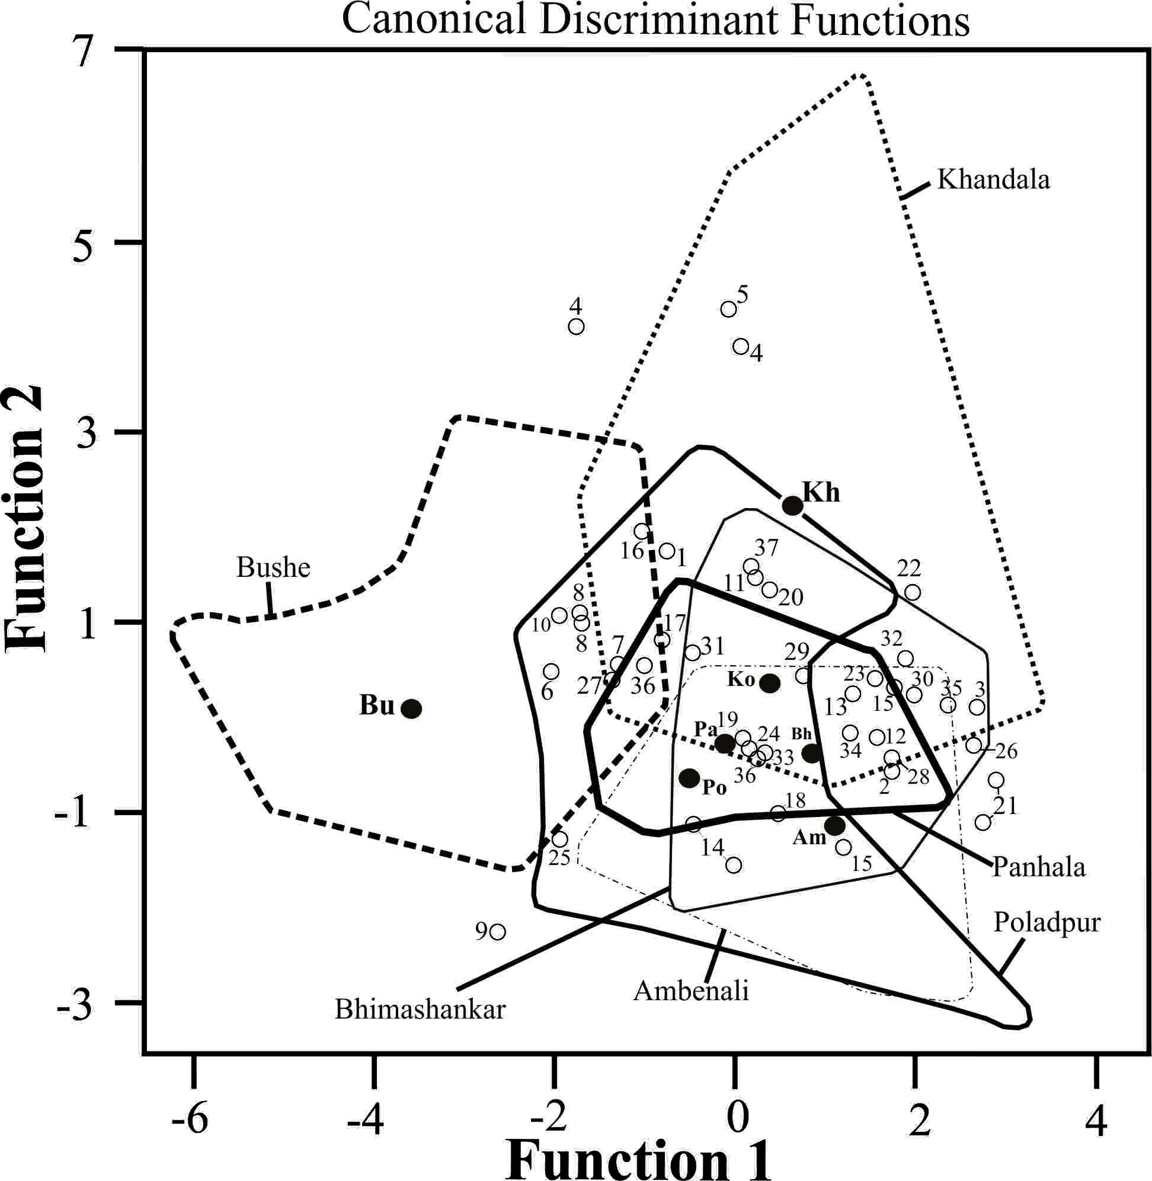

Figure B Sb Bivariate plots according to DFA results:

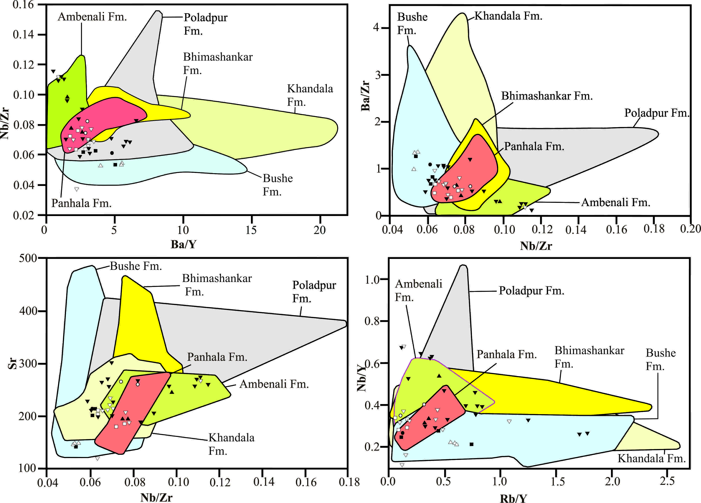

Figure B Sc Mantle-Normalized diagram according to DFA results:
