Supplementary data file A

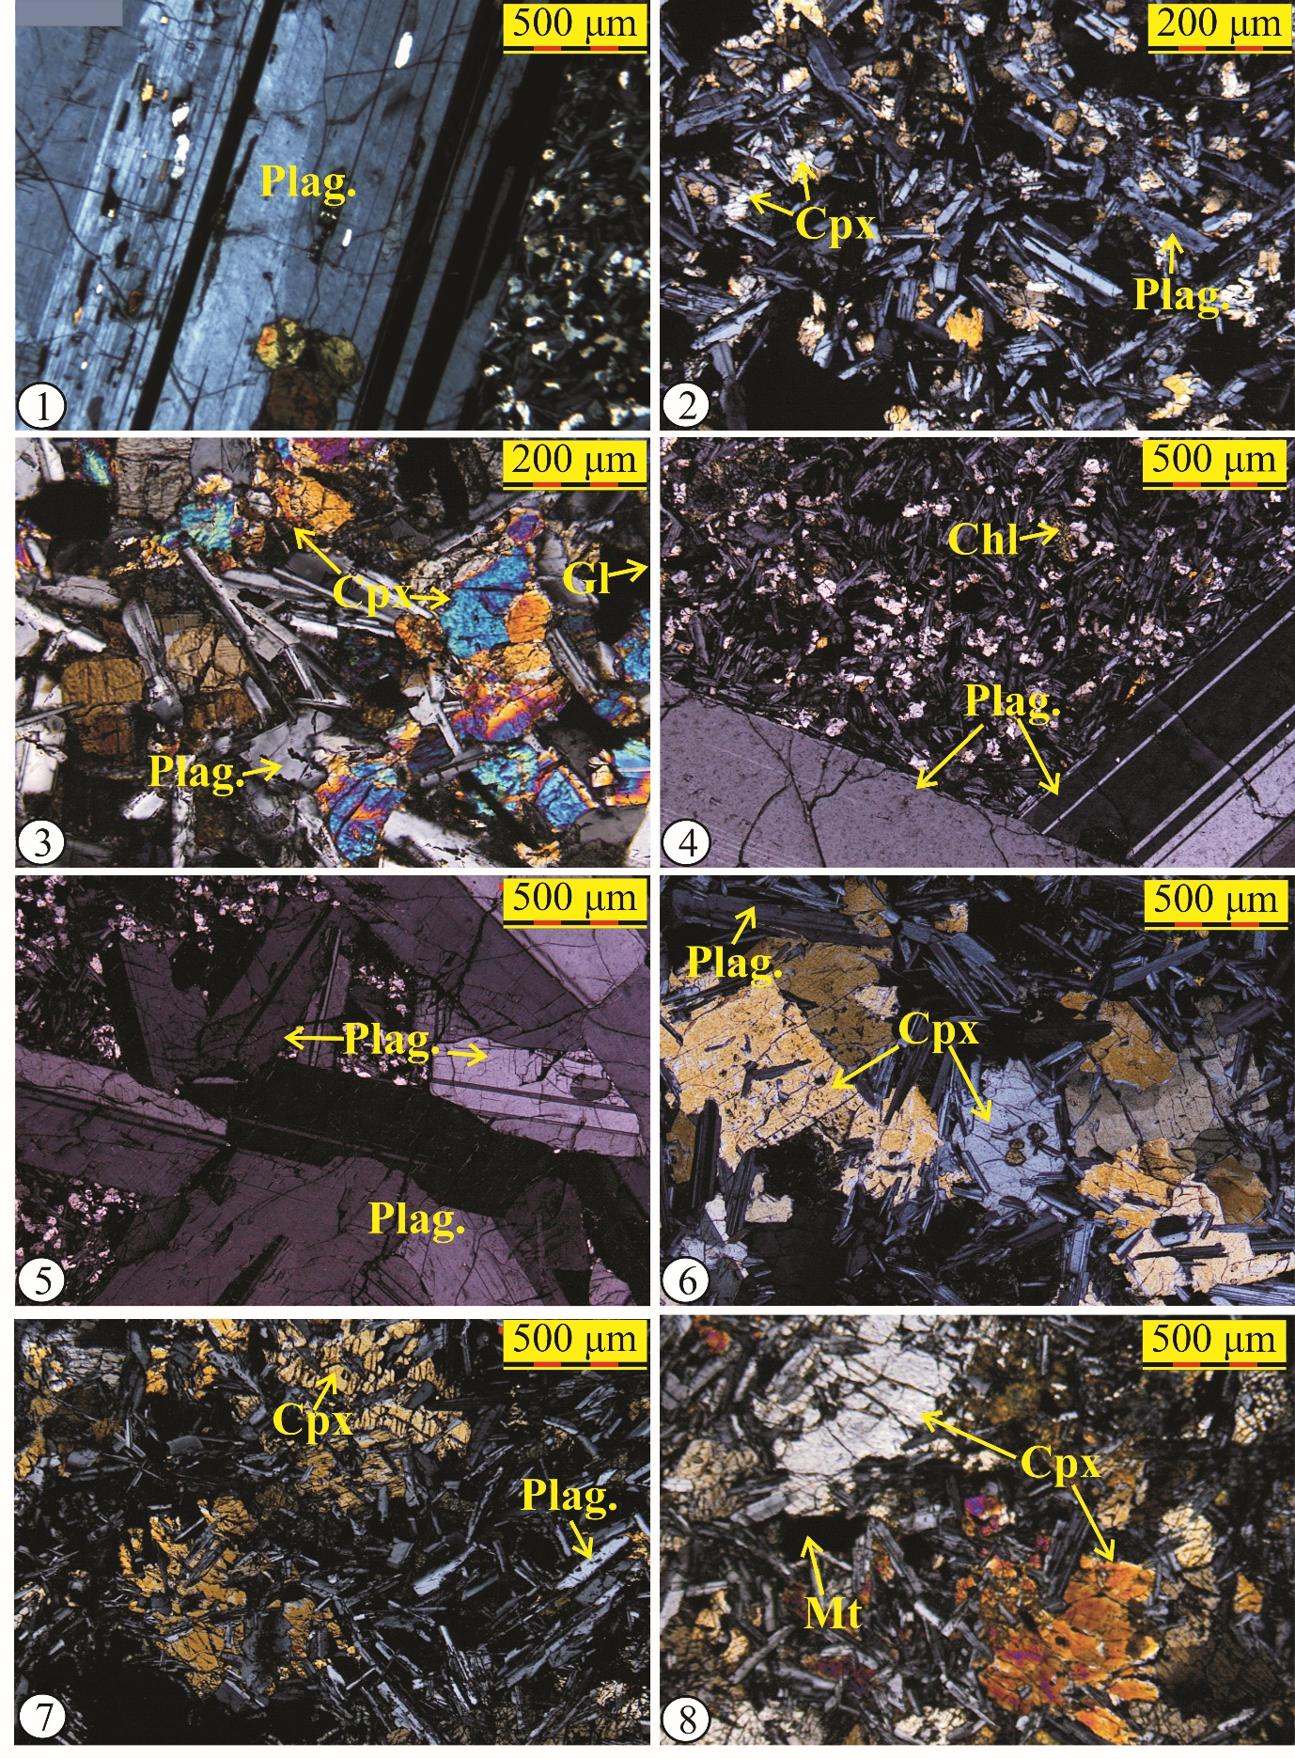

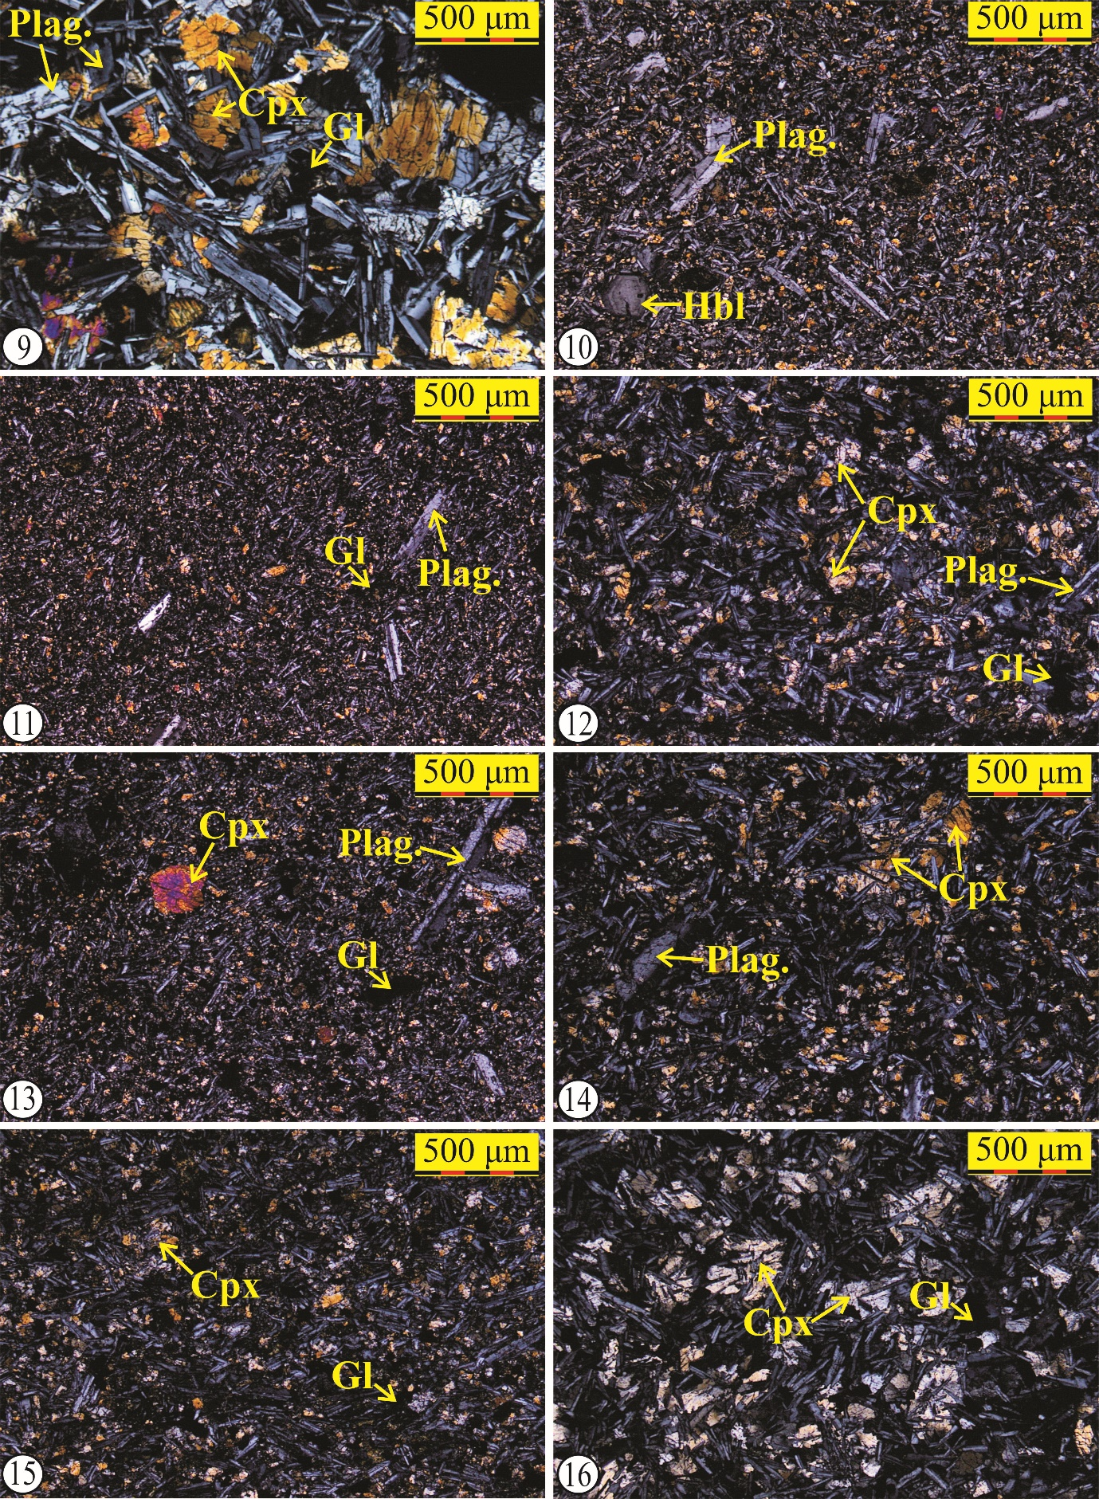
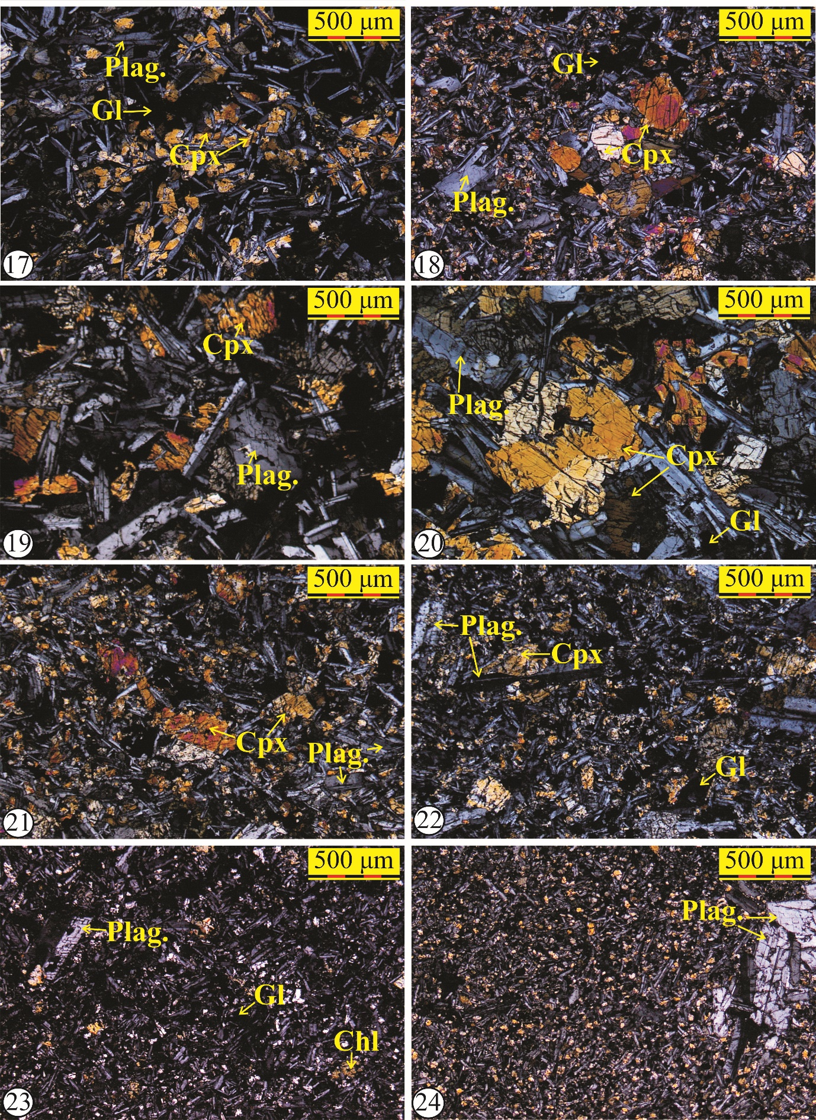

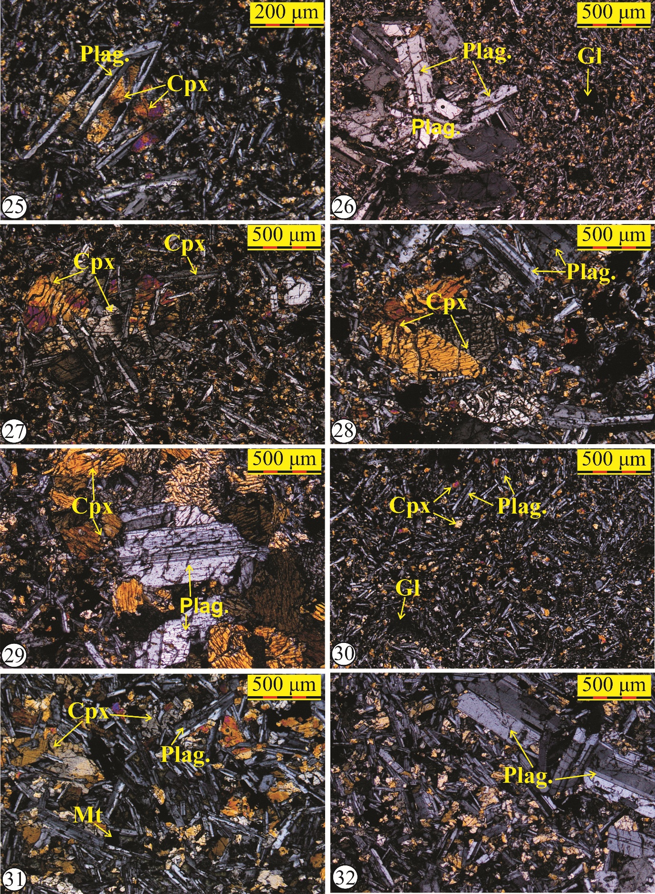

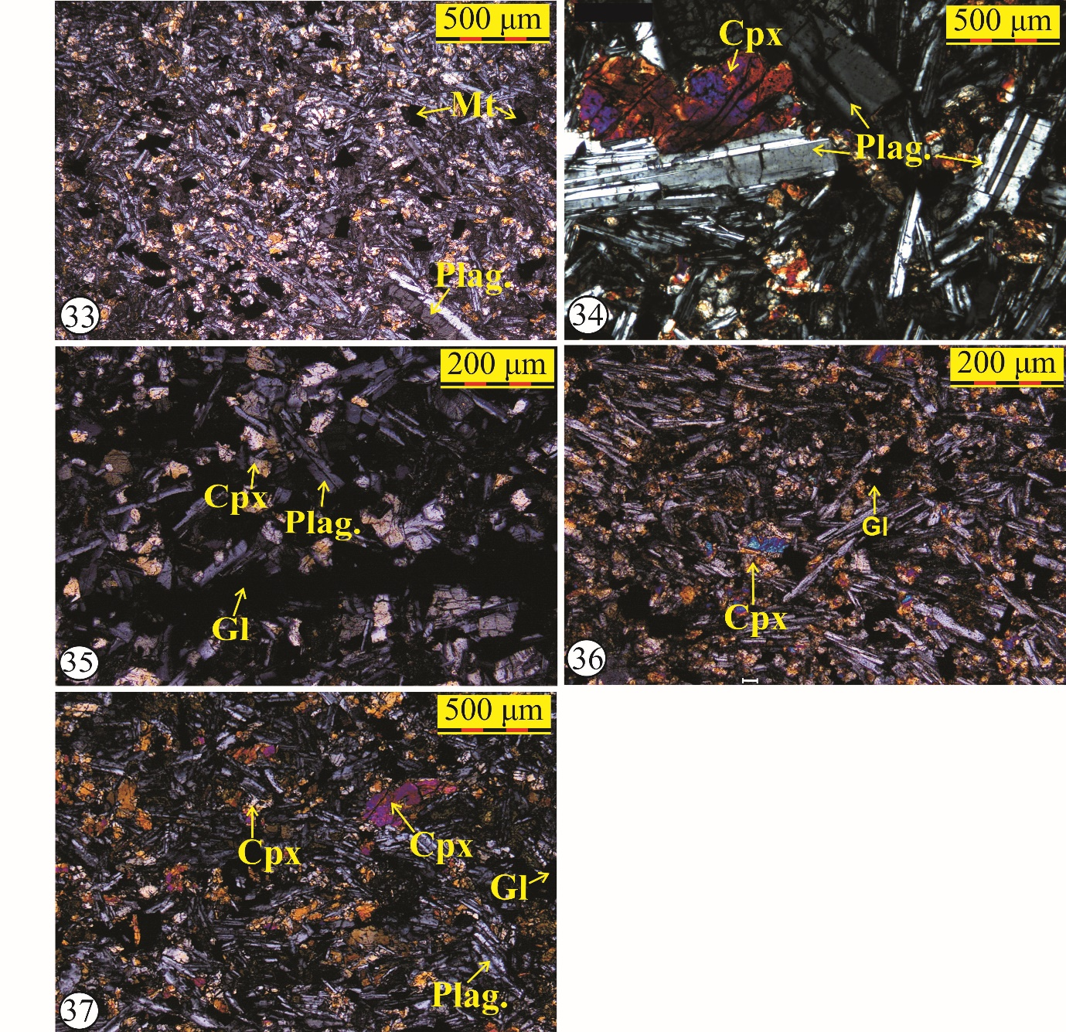
Fig. 1S. Photomicrographs showing textural and structural signatures in 37 lava flows. The number encircled corresponds to flow number showing textural characters. Abbreviations: Plag. = Plagioclase; Cpx. = Clinopyroxene; Mt. = Magnetite; Il. = Ilmenite, Ch = Chlorophaeite; Ol = olivine and Pala = Palagonite, Gl= glass, De. = Delesite, Id. = Iddingsite, M = Microcryst, P = Phenocryst, SM = Secondary Mineral.

Table 1S. Major oxide analyses of basalt standards (BHVO-1 and BIR-1) done for quality control of the data, 1σ values were calculated between present analytical data and standard values of Govindaraju (1994).
Major oxides | BHVO-1 |  | 1 σ | BIR-1 |  | 1 σ
 | Published data * | Present data |  | Published data * | Present data
SiO₂ | 49.94 | 49.88 | 0.04 | 47.77 | 48.26 | 0.35
TiO₂ | 2.71 | 2.74 | 0.02 | 0.96 | 0.95 | 0.00
Al₂O₃ | 13.80 | 13.86 | 0.04 | 15.35 | 15.36 | 0.01
Fe₂O₃^{(T)} | 12.23 | 12.11 | 0.09 | 11.26 | 11.25 | 0.01
MnO | 0.16 | 0.16 | 0.00 | 0.17 | 0.16 | 0.00
MgO | 7.23 | 7.19 | 0.03 | 9.68 | 9.44 | 0.17
CaO | 11.40 | 11.38 | 0.01 | 13.24 | 13.42 | 0.13
Na₂O | 2.26 | 2.29 | 0.02 | 1.75 | 1.71 | 0.02
K₂O | 0.52 | 0.54 | 0.01 | 0.03 | 0.03 | 0.00
P₂O₅ | 0.273 | 0.263 | 0.01 | 0.05 | 0.04 | 0.00
Symbols: *= Govindaraju (1994).
Table 2S. Trace element analyses of basalt standard (BHVO-1) done for quality control of the data, 1σ values were calculated between present analytical data and standard values of Govindaraju (1994).

Elements | BHVO-1
 | Proposed value | Obtained value |  |  |  |  |  |  | 1 σ
 | Govindraju (1994) | Present work (1) | (2) | (3) | (4) | (5) | (6) | (7)
Trace
Cs | 0.13 | 0.12 | 0.13 | 0.12 | 0.13 | 0.13 | 0.14 | 0.13 | 0.01
Rb | 11 | 11.02 | 11.34 | 10.84 | 10.80 | 11.09 | 11.23 | 10.92 | 0.17
Ba | 139 | 140.72 | 141.62 | 137.36 | 140.84 | 144.23 | 148.74 | 138.61 | 3.40
Th | 1.08 | 1.08 | 1.17 | 1.04 | 1.06 | 1.10 | 1.13 | 1.08 | 0.04
U | 0.42 | 0.42 | 0.48 | 0.38 | 0.41 | 0.43 | 0.45 | 0.42 | 0.03
Ta | 1.23 | 1.24 | 1.24 | 1.23 | 1.24 | 1.24 | 1.24 | 1.25 | 0.01
Nb | 19.00 | 18.83 | 18.93 | 19.10 | 18.90 | 19.19 | 19.04 | 19.04 | 0.11
Sr | 403.00 | 388.34 | 391.72 | 398.60 | 404.90 | 405.37 | 409.71 | 403.94 | 6.84
Zr | 179.00 | 176.82 | 178.25 | 178.94 | 177.74 | 180.20 | 180.24 | 181.02 | 1.32
Hf | 4.38 | 4.33 | 4.44 | 4.36 | 4.36 | 4.45 | 4.42 | 4.45 | 0.04
Y | 27.60 | 27.46 | 27.61 | 27.58 | 27.54 | 27.92 | 28.02 | 27.59 | 0.19
Ga | 21.00 | 20.96 | 21.22 | 20.68 | 21.20 | 21.61 | 22.99 | 21.13 | 0.67
Cu | 136.00 | 136.14 | 137.61 | 135.14 | 134.52 | 135.12 | 146.17 | 134.92 | 3.60
Sc | 31.80 | 32.16 | 32.41 | 31.55 | 31.92 | 32.50 | 33.21 | 31.67 | 0.51
V | 317.00 | 319.70 | 320.75 | 319.44 | 319.47 | 314.57 | 310.96 | 315.59 | 3.11
Cr | 289.00 | 292.67 | 294.13 | 289.34 | 289.63 | 294.34 | 292.13 | 287.69 | 2.36
Co | 45.00 | 45.71 | 45.55 | 44.66 | 44.80 | 45.18 | 45.30 | 44.71 | 0.36
Ni | 121.00 | 121.76 | 123.54 | 120.08 | 120.77 | 120.48 | 124.19 | 119.66 | 1.53
Zn | 105.00 | 104.77 | 128.06 | 93.11 | 91.17 | 105.28 | 108.48 | 103.88 | 10.48
REE
La | 15.80 | 15.93 | 15.97 | 15.63 | 16.00 | 16.23 | 16.47 | 15.65 | 0.27
Ce | 39.00 | 39.51 | 39.43 | 38.76 | 39.55 | 40.19 | 40.69 | 38.71 | 0.65
Pr | 5.70 | 5.75 | 5.77 | 5.65 | 5.77 | 5.85 | 5.93 | 5.72 | 0.08
Nd | 25.20 | 25.20 | 25.34 | 25.12 | 25.67 | 26.27 | 26.65 | 25.12 | 0.55
Sm | 6.20 | 6.26 | 6.33 | 6.19 | 6.30 | 6.29 | 6.39 | 6.18 | 0.07
Eu | 2.06 | 2.06 | 2.05 | 2.06 | 2.08 | 2.10 | 2.13 | 2.05 | 0.03
Gd | 6.400 | 6.42 | 6.49 | 6.33 | 6.44 | 6.63 | 6.87 | 6.30 | 0.17
Tb | 0.96 | 0.97 | 0.98 | 0.96 | 0.94 | 0.99 | 1.00 | 0.94 | 0.02
Dy | 5.20 | 5.26 | 5.31 | 5.21 | 5.17 | 5.28 | 5.39 | 5.13 | 0.08
Ho | 0.990 | 0.99 | 1.00 | 0.99 | 1.00 | 1.00 | 1.02 | 0.97 | 0.01
Er | 2.40 | 2.45 | 2.42 | 2.43 | 2.47 | 2.47 | 2.52 | 2.41 | 0.04
Tm | 0.33 | 0.33 | 0.33 | 0.32 | 0.33 | 0.33 | 0.33 | 0.32 | 0.00
Yb | 2.02 | 2.02 | 2.06 | 1.99 | 1.99 | 2.01 | 2.08 | 1.96 | 0.03
Lu | 0.29 | 0.29 | 0.29 | 0.28 | 0.28 | 0.30 | 0.30 | 0.28 | 0.01

Table 3S. Modal percentages of mineral phases and glass present in the 37 lava flow samples.
Flows | Py(t) | Py(p) | Pl(t) | Pl(p) | Ol | Mt+ opq | SM | Glass
37 | 49.23 | 48.65 | 5.4 | 3.27 | 0 | 0.14 | 0.5 | 18.47
36 | 60.98 | 1.23 | 25.0 | 1.38 | 0 | 1.16 | 0 | 12.88
35 | 32.66 | 0 | 27.0 | 4.64 | 0.14 | 0.07 | 2.5 | 37.31
34 | 52.49 | 51.78 | 40 | 19.27 | 0 | 0.15 | 0.71 | 6.58
33 | 44.15 | 39.08 | 34 | 12.83 | 0 | 0.58 | 0.65 | 20.37
32 | 21.2 | 13.87 | 65 | 55.86 | 0.14 | 0.14 | 1.06 | 12.81
31 | 30.4 | 26.46 | 56 | 27.37 | 0 | 0 | 1.44 | 11.86
30 | 38.19 | 0 | 33 | 1.61 | 0.14 | 0.66 | 5.07 | 22.36
29 | 60.24 | 57.62 | 29 | 19.54 | 0.21 | 0 | 0.21 | 10.72
28 | 55.54 | 50.76 | 34 | 22.48 | 0.14 | 9.57 | 0.14 | 1.08
27 | 52.9 | 44 | 27 | 7.72 | 0.07 | 1.98 | 0.36 | 17.51
26 | 38.16 | 2.63 | 47 | 31.35 | 0.21 | 0.95 | 0.21 | 13.18
25 | 47.61 | 37.63 | 30 | 4.01 | 0.29 | 1.67 | 0.43 | 19.69
24 | 43.99 | 2.55 | 30 | 1.02 | 0.29 | 1.16 | 1.75 | 22.71
23 | 29.91 | 0.58 | 56 | 52.83 | 0.36 | 2.6 | 0.93 | 12.78
22 | 51.72 | 49.85 | 28 | 13.51 | 0.36 | 2.6 | 0.93 | 12.78
21 | 59.29 | 38.3 | 34 | 8.54 | 0.94 | 1.95 | 0.57 | 17.95
20 | 48.99 | 48.85 | 33 | 25.38 | 0.95 | 0.59 | 1.99 | 14.02
19 | 34.14 | 32.07 | 39 | 32.53 | 0.23 | 0.15 | 1.07 | 25.61
18 | 49.08 | 43.93 | 43.0 | 15.0 | 0.45 | 1.28 | 1.59 | 15.98
17 | 28.22 | 23.92 | 39.0 | 5.32 | 1.96 | 0.87 | 0.65 | 29.24
16 | 35.0 | 30.21 | 45 | 9.07 | 0.36 | 1.67 | 0.72 | 17.64
15 | 15.28 | 1.66 | 66.0 | 0 | 1.81 | 2.17 | 1.52 | 13.55
14 | 37.46 | 20.81 | 38 | 2.04 | 0.98 | 2.49 | 1.66 | 19.37
13 | 37.03 | 6.76 | 43 | 22.78 | 0.14 | 2.47 | 0.26 | 16.81
12 | 5.57 | 0 | 73 | 0 | 0.94 | 2.31 | 1.3 | 17.17
11 | 48.09 | 0 | 30 | 1.79 | 3.59 | 2.01 | 2.15 | 14.09
10 | 29.77 | 2.03 | 58 | 1.03 | 0.58 | 1.96 | 1.01 | 9.01
9 | 31.66 | 29.55 | 47 | 37.79 | 2.56 | 1.2 | 0 | 17.3
8 | 56.1 | 55.61 | 31 | 23.57 | 0.42 | 0 | 1.19 | 11.5
7 | 42.29 | 35.5 | 26 | 10.5 | 0 | 0.50 | 2.51 | 12.25
6 | 47.29 | 40.5 | 35 | 16.87 | 1.79 | 1.07 | 3.30 | 16.29
5 | 10.86 | 9.42 | 85 | 79.34 | 0 | 0.21 | 0.14 | 3.91
4 | 9.54 | 7.25 | 54 | 24.07 | 5.77 | 0.24 | 2.51 | 1.87
3 | 40.76 | 40.04 | 37 | 32.31 | 1.02 | 0.72 | 3.93 | 16.55
2 | 13.89 | 12.66 | 14 | 11.56 | 0.68 | 1.02 | 1.91 | 65.77
1 | 29.15 | 25.88 | 65.0 | 31.57 | 1.2 | 1.55 | 1.02 | 1.56
Abbreviation: Mt = Magnetite, opq = opaque, Ol = Olivine, p = phenocryst, Pl = Plagioclase, Py = Pyroxene, SM = Secondary Minerals and t = total

