Supplementary material
1. Analytical details and instrumentation parameters (U-Pb and Lu-Hf isotopic analysis)
Laboratory & Sample Preparation
Laboratory name | GEOTOP; Université du Québec à Montréal
Sample type/mineral | Zircon
Sample preparation | Conventional mineral separation, 1 inch resin mount, 1μm polish to finish and thin section
Imaging | Centorus CL imager on a Hitachi S3400N SEM
Laser ablation system
Make, Model & type | Photon-Machines G2
Ablation cell | Helix two-volume cell
Laser wavelength (nm) | 193 nm
Pulse width (ns) | 4 ns
Fluence (J.cm⁻²) | 3 Jcm⁻² (U-Pb) / 9Jcm⁻² (Lu-Hf)
Repetition rate (Hz) | 5 Hz (U-Pb)/ 15 Hz (Lu-Hf)
Ablation duration (secs) | 30 secs (U-Pb)/ 25 secs (Lu-Hf)
Ablation pit depth / ablation rate | Not available
Spot diameter (μm) nominal/actual | 25 μm (U-Pb)/ 50μm (Lu-Hf)
Sampling mode / pattern | Static spot ablation
Carrier gas | 100% He in ablation cell, Ar make-up gas combined using a Y-piece 35% along the sample transport line to the torch.
Cell carrier gas flow (l/min) | 0.7 l/min in first volume cell  0.5 l/min in second volume cell
ICP-MS Instruments
Make, Model & type | Nu Instruments, Nu Attom HR-ICP-MS and NuPlasmaII MC-ICP-MS
Sample introduction | Ablation aerosol
RF power (W) | 1300W
Make-up gas flow (l/min) | Ar (ca. 0.75 l/min, optimized daily)
Detection system | Attom: Ion counter; full size discrete dynode type  NuPlasma II : Faraday cups, 10^11 ohms resistors
Masses measured | 202, 204, 206, 207, 208, 232, 235, 238 for Attom  171 to 182 (Hf, Lu, Yb, Ta) for NPII
Integration time per peak/dwell times (µs) | 500µs per isotope, 20 sweeps per cycle for Attom  0.2 sec for NPII
Total integration time per output datapoint (secs) | - seconds  - seconds
‘Sensitivity’ as useful yield (%, element) | 0.4%U (NIST 610 = 500ppm, #atoms sampled:  500ppm*85um*5hz*3J/cm2: >20Mcps ²³⁸U) for Attom  Ca. 550 V/ppm Hf with Aridu II for NPII
IC Dead time (ns) | 12 ns
Data Processing
Gas blank | 30 second on-peak zero subtracted
Calibration strategy | 91500 used as primary reference material
Reference Material info | 91500 (Wiedenbeck et al. 1995)
Data processing package used / Correction for LIEF | Nu Instruments TRA and Iolite (Paton et al., 2011) for data normalization, uncertainty propagation and age calculation. LIEF correction assumes reference material and samples behave identically.
Mass discrimination | Down-hole correction and sample-standard bracketing (Iolite)
Common-Pb correction, composition and uncertainty | No common-Pb correction applied to the data.
Uncertainty level & propagation | Ages are quoted at 2s absolute, error propagation is by Iolite.
Quality control / Validation | Secondary reference materials (BB9, GJ-1, and Mudtank for U-Pb; Figure 1), (SA01, Plesovice, and MunZirc for Lu-Hf; Figure 2)
Other information

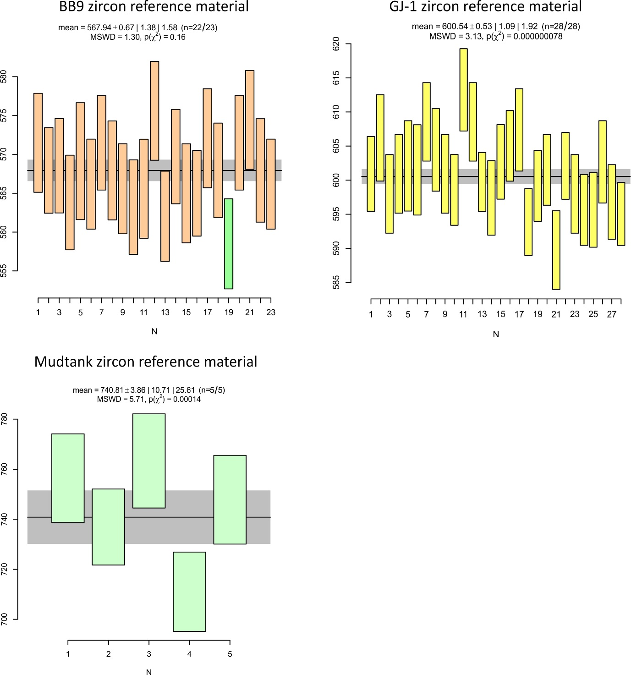
Figure 1. Weighted average ²⁰⁶Pb/²³⁸U ages of the secondary reference materials BB9, GJ-1, and Mudtank that were interspersed with the unknowns during the U-Pb analytical sessions

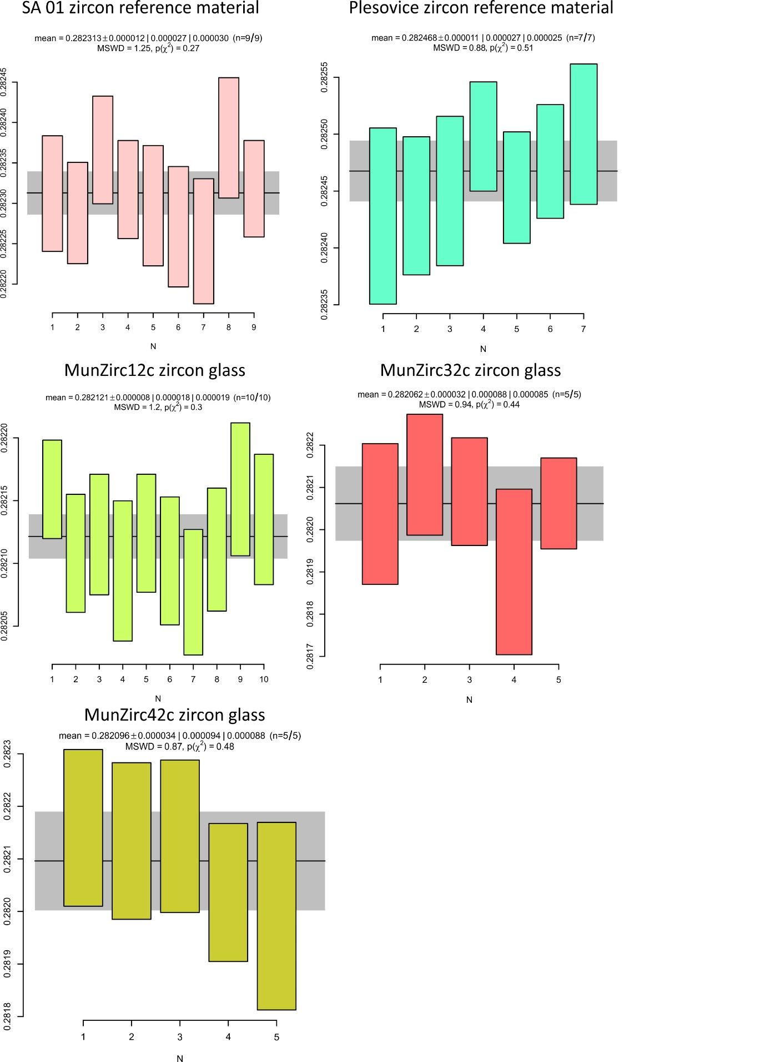
Figure 2. Weighted average ¹⁷⁶Hf/¹⁷⁷Hf isotopic ratios of secondary reference materials interspersed with the unknowns during the Lu-Hf analytical session

2. Lu-Hf analytical details and methodology
Mass bias and isobaric interference corrections of ¹⁷⁶Yb and ¹⁷⁶Lu on ¹⁷⁶Hf were made following the guidelines of previous studies (Woodhead et al., 2004, Fisher et al., 2014). The βYb (Yb mass bias) was determined by measuring the ¹⁷³Yb/¹⁷¹Yb ratio relative to ¹⁷³Yb/¹⁷¹Yb = 1.132685 (Chu et al., 2002). Following the calculation of βYb, the contribution of ¹⁷⁶Yb on ¹⁷⁶Hf was subtracted using the intensity of the interference-free ¹⁷³Yb and a ¹⁷⁶Yb/¹⁷³Yb = 0.79618 (Chu et al., 2002). The contribution of the ¹⁷⁶Lu on ¹⁷⁶Hf signal was estimated assuming that βLu = βYb using the intensity of the interference-free ¹⁷⁵Lu with a ¹⁷⁶Lu/¹⁷⁵Lu = 0.02656 (Blichert-Toft et al., 1997). The mass bias correction on the ¹⁷⁶Hf/¹⁷⁷Hf ratios was estimated using ¹⁷⁹Hf/¹⁷⁷Hf = 0.7325 (Patchett et al., 1981). Mass bias corrections for Yb, Hf, and Lu were made using an exponential law. For quality control on the mass bias corrections, the ¹⁷⁸Hf/¹⁷⁷Hf ratio on the analysed standards yielded a value of 1.46729 ± 10 (1s) in agreement with the published value of 1.46735 (Thirlwall and Anczkwiewicz., 2004). The 91500 was used as the primary standard using a ¹⁷⁶Hf/¹⁷⁷Hf value of 0.282298 ± 2 and ¹⁷⁶Lu/¹⁷⁷Hf of 0.000319 ± 18 (Bauer and Horstwood., 2018).

References
Bauer, A. M., & Horstwood, M. S. A. (2018). Small-volume Lu-Hf and U-Pb isotope determination of complex zircons by solution and laser ablation MC-ICP-MS. Chemical Geology. https://doi.org/10.1016/j.chemgeo.2017.11.007
Blichert-Toft, J., & Albarède, F. (1997). The Lu-Hf isotope geochemistry of chondrites and the evolution of the mantle-crust system. Earth and Planetary Science Letters. https://doi.org/10.1016/s0012-821x(97)00040-x
Chu, N. C., Taylor, R. N., Chavagnac, V., Nesbitt, R. W., Boella, R. M., Milton, J. A., … Burton, K. (2002). Hf isotope ratio analysis using multi-collector inductively coupled plasma mass spectrometry: An evaluation of isobaric interference corrections. Journal of Analytical Atomic Spectrometry. https://doi.org/10.1039/b206707b
Fisher, C. M., Hanchar, J. M., Samson, S. D., Dhuime, B., Blichert-Toft, J., Vervoort, J. D., & Lam, R. (2011). Synthetic zircon doped with hafnium and rare earth elements: A reference material for in situ hafnium isotope analysis. Chemical Geology. https://doi.org/10.1016/j.chemgeo.2011.04.013
Jonathan Patchett, P., Kouvo, O., Hedge, C. E., & Tatsumoto, M. (1981). Evolution of continental crust and mantle heterogeneity: Evidence from Hf isotopes. Contributions to Mineralogy and Petrology. https://doi.org/10.1007/BF00398923
Thirlwall, M. F., & Anczkiewicz, R. (2004). Multidynamic isotope ratio analysis using MC-ICP-MS and the causes of secular drift in Hf, Nd and Pb isotope ratios. International Journal of Mass Spectrometry. https://doi.org/10.1016/j.ijms.2004.04.002
Woodhead, J., Hergt, J., Shelley, M., Eggins, S., & Kemp, R. (2004). Zircon Hf-isotope analysis with an excimer laser, depth profiling, ablation of complex geometries, and concomitant age estimation. Chemical Geology, 209(1–2), 121–135. https://doi.org/10.1016/j.chemgeo.2004.04.026

