Fig. S1 Sample locations in each geological formation and near the HTP and HYA mining areas in this study. Deposits are also shown in this map (after Zhang et al., 2020b).
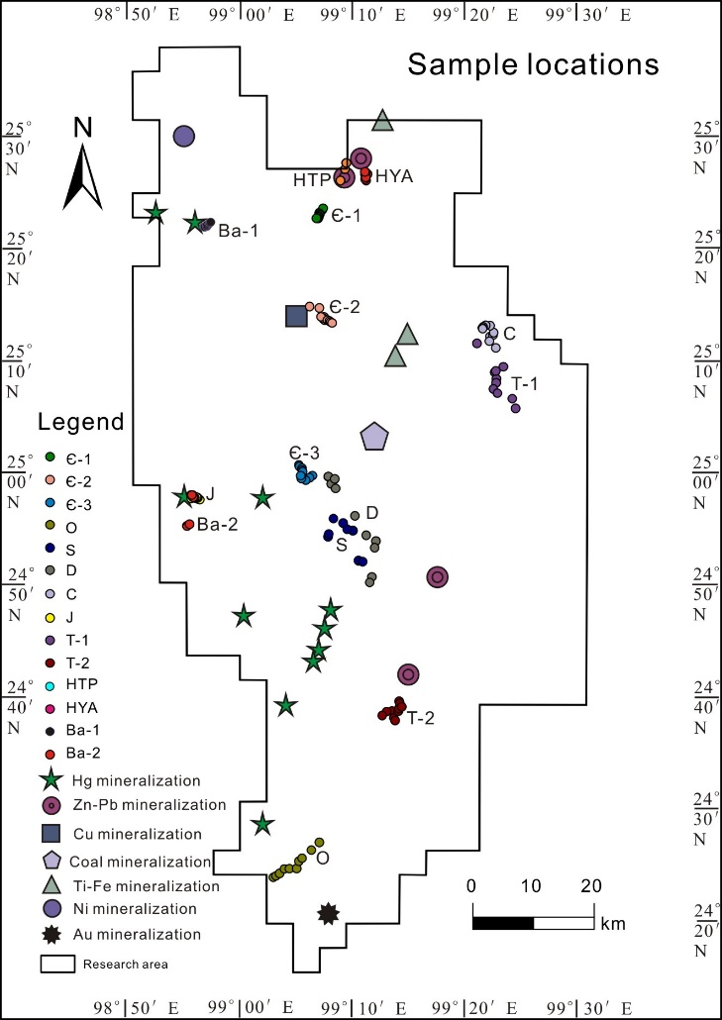

Table S1 Analytical methods, lower detection limits and digestion methods for analysis indictors.
Sample | Analysis Indicator | Analytical method | Digestion methods | Detection limits | Unit | CRMs
 |  |  |  |  |  | Rock/Ore | Soil
Rock/ore and soil | Al₂O₃ | XRF | Li₂B₄O₇ glass flux shee | 0.03 | % | GSR-1, GSR-2, GSR-3, GSR-5, GSR-6 | GSS-1, GSS-2, GSS-3, GSS-8
Rock/ore and soil | CaO | XRF | Li2B4O7 glass flux shee | 0.02 | % | GSR-1, GSR-2, GSR-3, GSR-5, GSR-6 | GSS-1, GSS-2, GSS-3, GSS-8
Rock/ore and soil | TFe₂O₃ | XRF | Li2B4O7 glass flux shee | 0.02 | % | GSR-1, GSR-2, GSR-3, GSR-5, GSR-6 | GSS-1, GSS-2, GSS-3, GSS-8
Rock/ore and soil | K₂O | XRF | Li2B4O7 glass flux shee | 0.03 | % | GSR-1, GSR-2, GSR-3, GSR-5, GSR-6 | GSS-1, GSS-2, GSS-3, GSS-8
Rock/ore and soil | Na₂O | XRF | Li2B4O7 glass flux shee | 0.02 | % | GSR-1, GSR-2, GSR-3, GSR-5, GSR-6 | GSS-1, GSS-2, GSS-3, GSS-8
Rock/ore and soil | MgO | XRF | Li2B4O7 glass flux shee | 0.02 | % | GSR-1, GSR-2, GSR-3, GSR-5, GSR-6 | GSS-1, GSS-2, GSS-3, GSS-8
Rock/ore and soil | SiO₂ | XRF | Li2B4O7 glass flux shee | 0.05 | % | GSR-1, GSR-2, GSR-3, GSR-5, GSR-6 | GSS-1, GSS-2, GSS-3, GSS-8
Rock/ore and soil | La | ICP-MS | HF, HCl, HNO₃, HClO₄ | 0.1 | μg/g | GSR-1, GSR-2, GSR-3, GSR-6 | GSS-30, GSS-33, GSS-34, GSS-35
Rock/ore and soil | Ce | ICP-MS | HF, HCl, HNO₃, HClO₄ | 0.2 | μg/g | GSR-1, GSR-2, GSR-3, GSR-6 | GSS-30, GSS-33, GSS-34, GSS-35
Rock/ore and soil | Pr | ICP-MS | HF, HCl, HNO₃, HClO₄ | 0.1 | μg/g | GSR-1, GSR-2, GSR-3, GSR-6 | GSS-30, GSS-33, GSS-34, GSS-35
Rock/ore and soil | Nd | ICP-MS | HF, HCl, HNO₃, HClO₄ | 0.1 | μg/g | GSR-1, GSR-2, GSR-3, GSR-6 | GSS-30, GSS-33, GSS-34, GSS-35
Rock/ore and soil | Sm | ICP-MS | HF, HCl, HNO₃, HClO₄ | 0.05 | μg/g | GSR-1, GSR-2, GSR-3, GSR-6 | GSS-30, GSS-33, GSS-34, GSS-35
Rock/ore and soil | Eu | ICP-MS | HF, HCl, HNO₃, HClO₄ | 0.03 | μg/g | GSR-1, GSR-2, GSR-3, GSR-6 | GSS-30, GSS-33, GSS-34, GSS-35
Rock/ore and soil | Cd | ICP-MS | HF, HCl, HNO₃, HClO₄ | 0.1 | μg/g | GSR-1, GSR-2, GSR-3, GSR-6 | GSS-30, GSS-33, GSS-34, GSS-35
Rock/ore and soil | Tb | ICP-MS | HF, HCl, HNO₃, HClO₄ | 0.05 | μg/g | GSR-1, GSR-2, GSR-3, GSR-6 | GSS-30, GSS-33, GSS-34, GSS-35
Rock/ore and soil | Dy | ICP-MS | HF, HCl, HNO₃, HClO₄ | 0.05 | μg/g | GSR-1, GSR-2, GSR-3, GSR-6 | GSS-30, GSS-33, GSS-34, GSS-35
Rock/ore and soil | Ho | ICP-MS | HF, HCl, HNO₃, HClO₄ | 0.01 | μg/g | GSR-1, GSR-2, GSR-3, GSR-6 | GSS-30, GSS-33, GSS-34, GSS-35
Rock/ore and soil | Er | ICP-MS | HF, HCl, HNO₃, HClO₄ | 0.05 | μg/g | GSR-1, GSR-2, GSR-3, GSR-6 | GSS-30, GSS-33, GSS-34, GSS-35
Rock/ore and soil | Tm | ICP-MS | HF, HCl, HNO₃, HClO₄ | 0.02 | μg/g | GSR-1, GSR-2, GSR-3, GSR-6 | GSS-30, GSS-33, GSS-34, GSS-35
Rock/ore and soil | Yb | ICP-MS | HF, HCl, HNO₃, HClO₄ | 0.05 | μg/g | GSR-1, GSR-2, GSR-3, GSR-6 | GSS-30, GSS-33, GSS-34, GSS-35
Rock/ore and soil | Lu | ICP-MS | HF, HCl, HNO₃, HClO₄ | 0.01 | μg/g | GSR-1, GSR-2, GSR-3, GSR-6 | GSS-30, GSS-33, GSS-34, GSS-35
Rock/ore and soil | Y | ICP-MS | HF, HCl, HNO₃, HClO₄ | 0.5 | μg/g | GSR-1, GSR-2, GSR-3, GSR-6 | GSS-30, GSS-33, GSS-34, GSS-35
Soil | C.org | VOL | K₂Cr₂O₇, H₂SO₄ | 0.02 | μg/g | - | GSS-21, GBW07431, GBW07435, GBW07432
Soil | pH | ISE | Water | 0.01 | - | - | GBW07412~GBW07417
CRMs: Certified reference materials.

Table S2 Allowance of accuracy and precision for routine analysis.
Concentration range | Accuracy | Precision
 | $Δlg\overline{C_{i}}=∣lg\overline{C_{i}}-\lg{C_{s}}∣$ | $$RD=\left|C_{1}-C_{2}\right|∕\frac{1}{2}\left(C_{1}+C_{2}\right)$$
＜3 detection limit | ≤0.17 | ≤50%
＞3 detection limit | ≤0.15
1-5% | ≤0.10
＞5% | ≤0.15
CRMs: Certified reference materials; $\overline{C_{i}}$, the average determined value of CRMi; Ci, the determined value of CRMi; Cs, the recommended value of CRMi.; C₁: the first determined value; C₂: the re-determined value.

