Supplementary Material S1 to S4
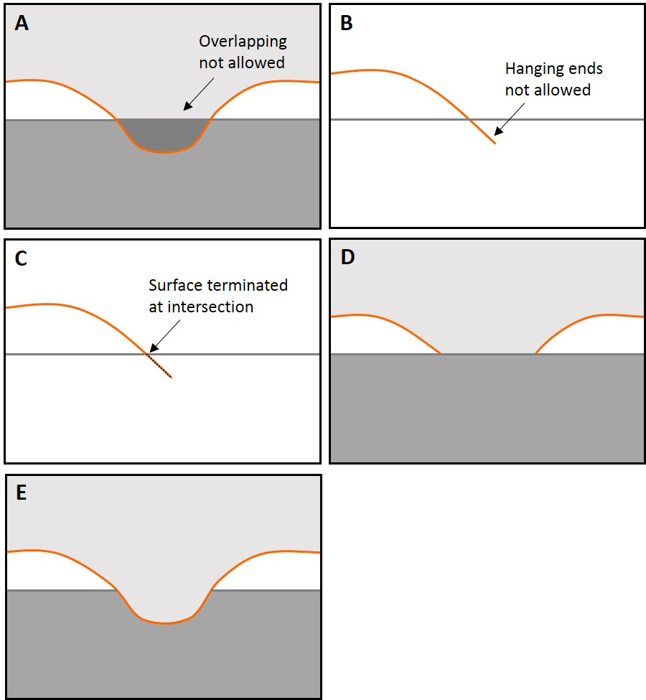

Fig. S1. Fundamental geologic rules for surface intersections in SBM (after Caumon et al., 2009). Surfaces that: (A) cross, and thus define overlapping geologic domains; and (B) end within a geologic domain are invalid. Surfaces that do not terminate against an existing surface (hanging surfaces, B) are cropped back to the intersection point (C). Valid surfaces may: (D) terminate at an existing surface; or (E) remove an existing surface.

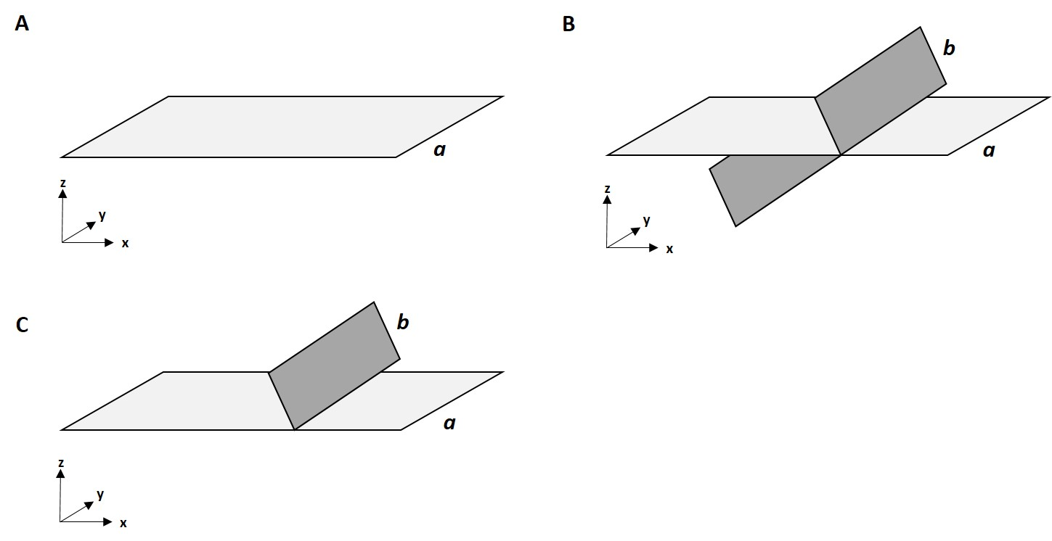

Fig. S2. These figures demonstrate the intersection of two stratigraphic surfaces. A shows the initial model state with a horizontal surface (a) aligned in the x-y plane. B demonstrates the intersection of a diagonal cross-cutting surface (b). Intersecting surfaces are not allowed. Thus, in C, only the segment of surface b that is above (z-positive) the reference surface a is preserved.

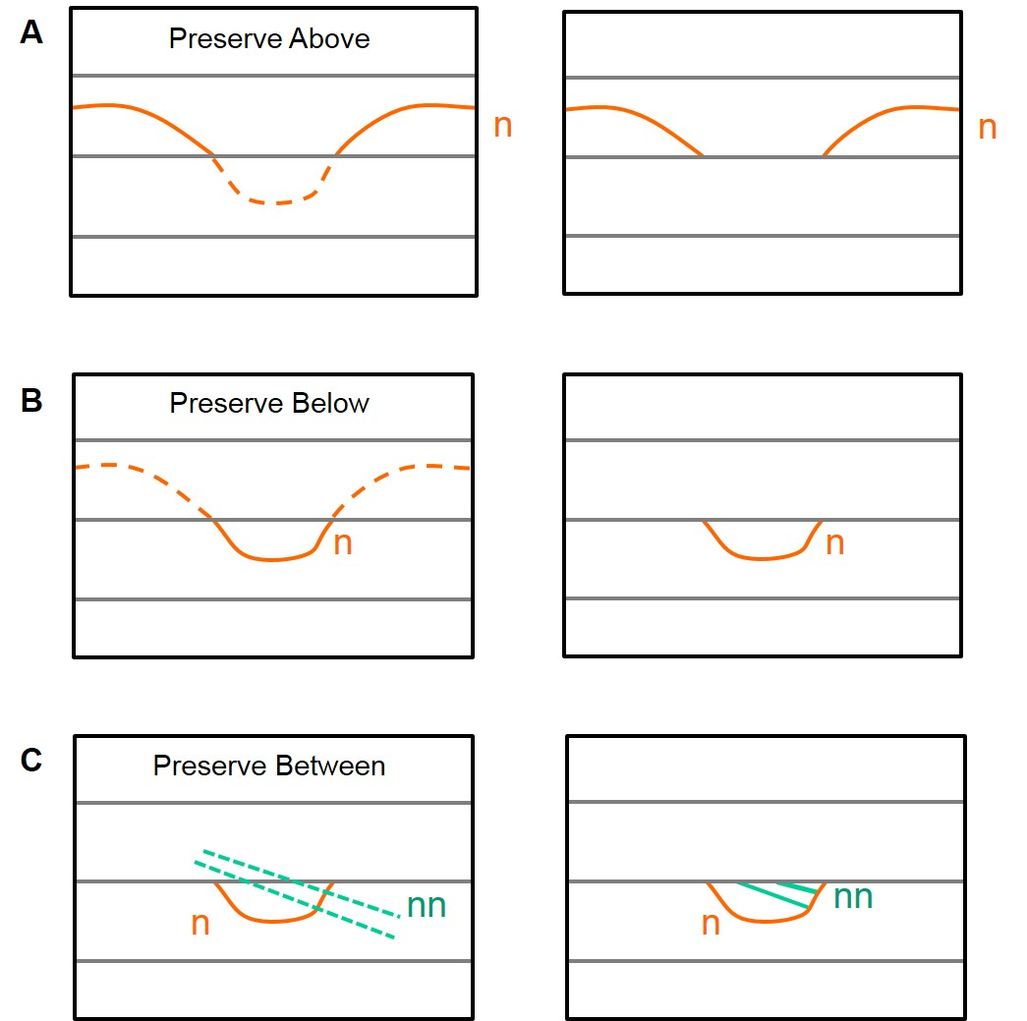

Fig. S3. These figures illustrate operators applied to a new surface n when it intersects the existing central surface. A shows the result of application of the Preserve Above (PA) operator, where only parts of new surface n that lie above the central surface are preserved. B shows the result of application of the Preserve Below (PB) operator, where only parts of new surface n that lie below the central surface are preserved. C shows the result of application of the Preserve Between (PBW) operator, where only parts of new surfaces nn that lie between the central surface and the channel form n are preserved. In C, the central surface and the channel form n are selected as the surfaces to Preserve Between (PBW); only the parts of new surfaces nn that are between the selected surfaces are preserved..

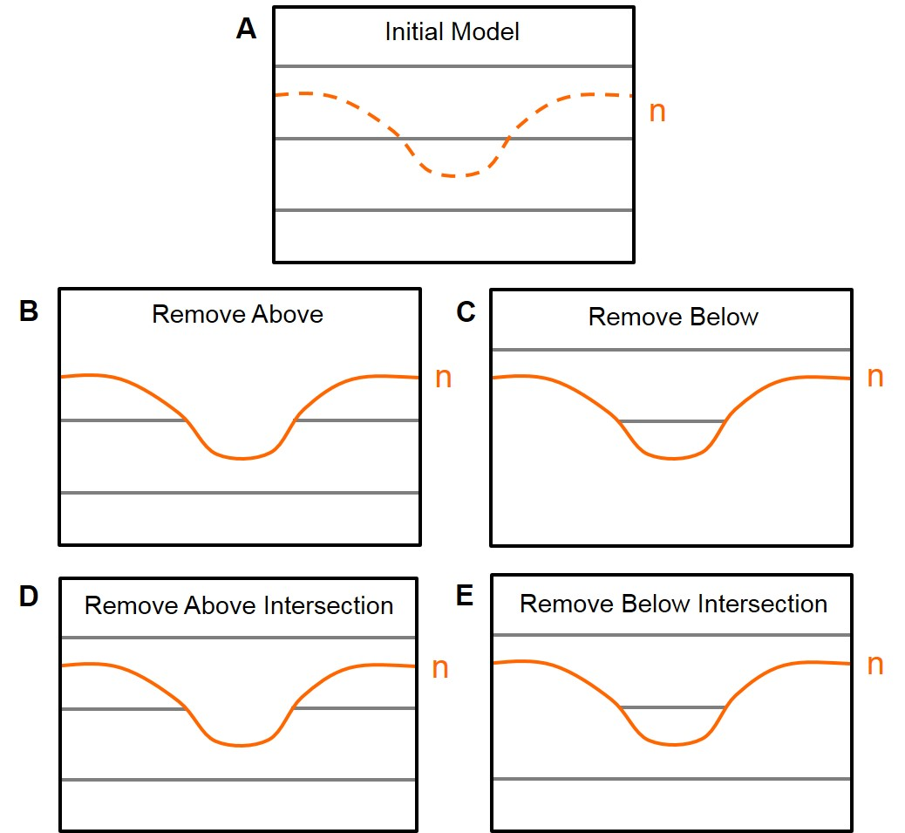Fig. S4. These figures illustrate operators applied to surfaces in an existing model (A) when a new surface n is inserted (dashed orange line). B shows the result of application of the Remove Above (RA) operator, where all surfaces that lie above n are removed. C shows the result of application of the Remove Below (RB) operator, where all surfaces that lie below n are removed. D shows the result of application of the Remove Above Intersection (RAI) operator, where only surfaces that are both above and intersected by n are removed. E shows the result of application of the Remove Below Intersection (RBI) operator, where only surfaces that are both below and intersected by n are removed.

