**Supplementary Material for article**

***Englacial tephra of East Antarctica***

Biancamaria Narcisi1* & Jean Robert Petit2

1*ENEA, C.R. Casaccia, I-00123 Roma, Italy*

2 *University Grenoble Alpes, CNRS, IRD, Grenoble INP, IGE, F-38000 Grenoble, France*

*\*Corresponding author (e-mail:* [*biancamaria.narcisi@enea.it*](mailto:biancamaria.narcisi@enea.it)

**Methodological aspects**

The study of englacial tephra layers in polar ice sequences requires careful techniques for extracting the sparse particulate matter often present in very small concentrations and for preparing the material for microanalysis (e.g. Kuehn & Froese 2010; Hayward, 2012; Iverson *et al*. 2017a) (Fig. S1). The successful recent results of EAIS tephra studies largely benefitted from significant advancement in the microanalysis of individual glass shards (Pearce *et al*. 2014; Lowe *et al.* 2017, and references therein). The major and trace element characterisation of a tephra is now routinely carried out through single-shard measurements that have successfully replaced bulk-sample analysis. These improved methods enable the characterisation of even a handful of minute glass-shards from faint volcanic horizons. A vast array of analytical data can be obtained that permit the identification of geochemical heterogeneities related to compositional zoning of magma body, feeding by multiple magma batches, or mixing of ash from simultaneous independent volcanic events (e.g. Basile *et al.* 2001; Narcisi *et al.* 2016) (Fig. S2).

A thorough discussion of methodological developments in tephra geochemical fingerprinting is far beyond the scope of the present review. The reader can conveniently refer to recent reviews (e.g. Lowe *et al.* 2017, and references therein). Here we briefly describe a number of recent techniques aside from geochemical techniques that could provide support for reliable palaeovolcanic reconstructions from englacial tephra sequences.

Firstly, there are two methods by which englacial ash layers invisible or barely visible to the naked eye (i.e. cryptotephra) can be identified. Identification of these cryptic layers can be routinely performed by continuous laser and visual scan profiling, either in situ or during ice-core processing (e.g. Svensson *et al.* 2005; The IceCube Collaboration 2013). These indirect techniques can be used for a systematic compilation of the inventory of tephra deposits within a given ice sequence. However, they need careful verification through microscopic inspection to confirm that signals are indeed related to tephra layers. Also useful are quantitative grain size and concentration  measurements of the volcanic samples. This analysis, performed using a Coulter Counter apparatus (Delmonte *et al.* 2002) or an Abakus laser particle detector (Koffman *et al.* 2013) gives the possibility of tracing cryptotephras either as anomalous mass concentration or as grain size values, compared to typical continental dust (Narcisi *et al.* 2012; Petit *et al.* 2016) (Fig. 3, main article). Particle-size distributions can be used to estimate how proximal or distal tephras are relative to their inferred source volcanoes, and provide useful quantitative information to deduce the magnitude of individual volcanic events (e.g. Narcisi *et al.* 2016).

Tephra particle morphology is a useful indicator of eruption style (e.g. Iverson *et al.* 2014). Following from early observations by Palais (1985) of tephra samples from a West Antarctic ice core, microscopic investigation and related imaging of volcanic ash has become an important aspect of tephra characterisation (Fig. S3). Micro-computed tomography (micro-CT) has recently been tested on fine-grained (~ 100 μm) tephras (Vonlanthen *et al.* 2015). This technique provides a 3D visualization of external and internal features of particles, along with quantitative calculations of morphological parameters. Micro-CT has been applied to West Antarctic englacial samples (~ 50 μm) along with geochemical analysis to suggest derivation of two layers from subglacial to emergent volcanism through the WAIS in the past 45 ka (Iverson *et al.* 2017b).

Finally, there have been advances in numerical and statistical methods of manipulating geochemical data, which enable more reliable tephra correlations and improve the reliability of identifying potential source (Lowe *et al.* 2017, and references therein).

**Chronological issues**

An accurate chronological framework for a sequence of englacial tephras is an essential prerequisite for its correct interpretation in terms of palaeovolcanic activity. Dating every ice-core tephra layer, particularly those occurring at very large distances from source as the EAIS interior sites, is impracticable with present instrumental capabilities because of their thin (a few mg of material) and fine-grained (mostly 10–20 µm in size) character. They are typically indirectly dated using sophisticated glaciological timescales developed for the whole ice core record using a combination of glaciological inputs and a wide range of relative and absolute gas and ice stratigraphic markers as constraints. Recent improvements in this respect have provided excellent results. For example, the timescale developed for central EAIS cores for the last 800 ka (Antarctic Ice Core Chronology 2012, AICC2012; Bazin *et al.* 2013; Veres *et al.* 2013) along with its recent extension to DF ice core (Dome Fuji Ice Core Project Members 2017) typically has an uncertainty of a few hundreds years for the postglacial period (~ 18 ka to present), ~ 2 ka for the Last Interglacial (~ 132 - 116 ka BP), and ~ 2-4 ka for earlier periods. As a result, the individual explosive episodes responsible for englacial tephras identified within these ice cores are now precisely dated. As a consequence, attempting to date englacial tephras directly are much less attractive (e.g. Fireman, 1989). Alternatively, dating can be obtained through geochemical correlation with radiometrically dated proximal counterparts in the source volcano. In these cases, successfully characterised and dated volcanic layers enable reliable chronologies to be extended over wide distances, to include undated but characterised layers in distant ice cores (e.g. Lemieux-Dudon *et al.* 2010).

However, chemically attributing few tiny englacial shards from distal sites to individual explosive episodes at the source can be problematic, for instance due to the fact that proximal and distal tephra components of a same eruption may have slightly different compositions or that a widespread tephra could have multiple fingerprints according to variable syn-eruptive dispersal. Therefore the target of such long-range correlations can be problematical and has seldom been achieved so far (e.g., Narcisi *et al.* 2006).

Englacial (blue ice) tephra outcrops are volumetrically larger and overcome the typical analytical limitations of ice cores. Those tephras derived from Antarctic volcanism are suitable targets for conventional radiometric dating as they contain alkali-rich mineral assemblages (alkali feldspar, sanidine). A few examples exist, e.g. 40Ar/39Ar dating of East Antarctic englacial tephra samples related to northern Victoria Land (Curzio *et al.* 2008) and Erebus volcanism (Kelly *et al.* 2008; Iverson *et al.* 2014). However, effects of potential contamination with older material need to be recognised and excluded. Similarly, the dating of meteorites incorporated into the ice series along with tephras appears problematic and sometimes provides incoherent ages (Folco *et al.* 2006). The most detailed example of a dated tephra sequence remains that of Mount Moulton blue ice archive in West Antarctica (Dunbar *et al.* 2008). Eight englacial tephra layers were directly dated, providing history of Marie Byrd Land explosive volcanism and geochemical evolution over the past 500 ka.

Direct dating of the ice matrix hosting a tephra is still challenging. The use of the radiocarbon method is limited to the last few ka and the related ages can be affected by background contamination and in situ 14C production leading to inaccuracies (de Jong *et al.* 2004; Van de Wal *et al.* 2007). Promising new radiometric techniques for dating ice have been tested recently (Goldstein *et al.* 2004; Aciego *et al.* 2011; Buizert *et al.* 2013) and raise the prospect of indirect dating of individual englacial tephra layers when detailed glaciological timescales are not available (Higgins *et al.* 2015).

**Concluding remarks**

Along with new tephra discoveries, it is hopeful that further analytical progresses and development of new techniques could push the boundariesof Antarctic englacial research far ahead. An interesting task that could be potentially accomplished could be the analysis of very distal cryptotephra with sizes even smaller than continental background dust. Volcanic events with bipolar occurrence (Palais *et al.* 1992) interpreted as related to tropical eruptions, e.g. the cataclysmic AD 1257 event of Samalas in the Indonesian Archipelago (Lavigne *et al*. 2013) are particularly interesting in this respect. A future task is also the routinely direct dating of englacial tephras, particularly those in ice cores, that so far has been very challenging due by the small concentrations of volcanic material.

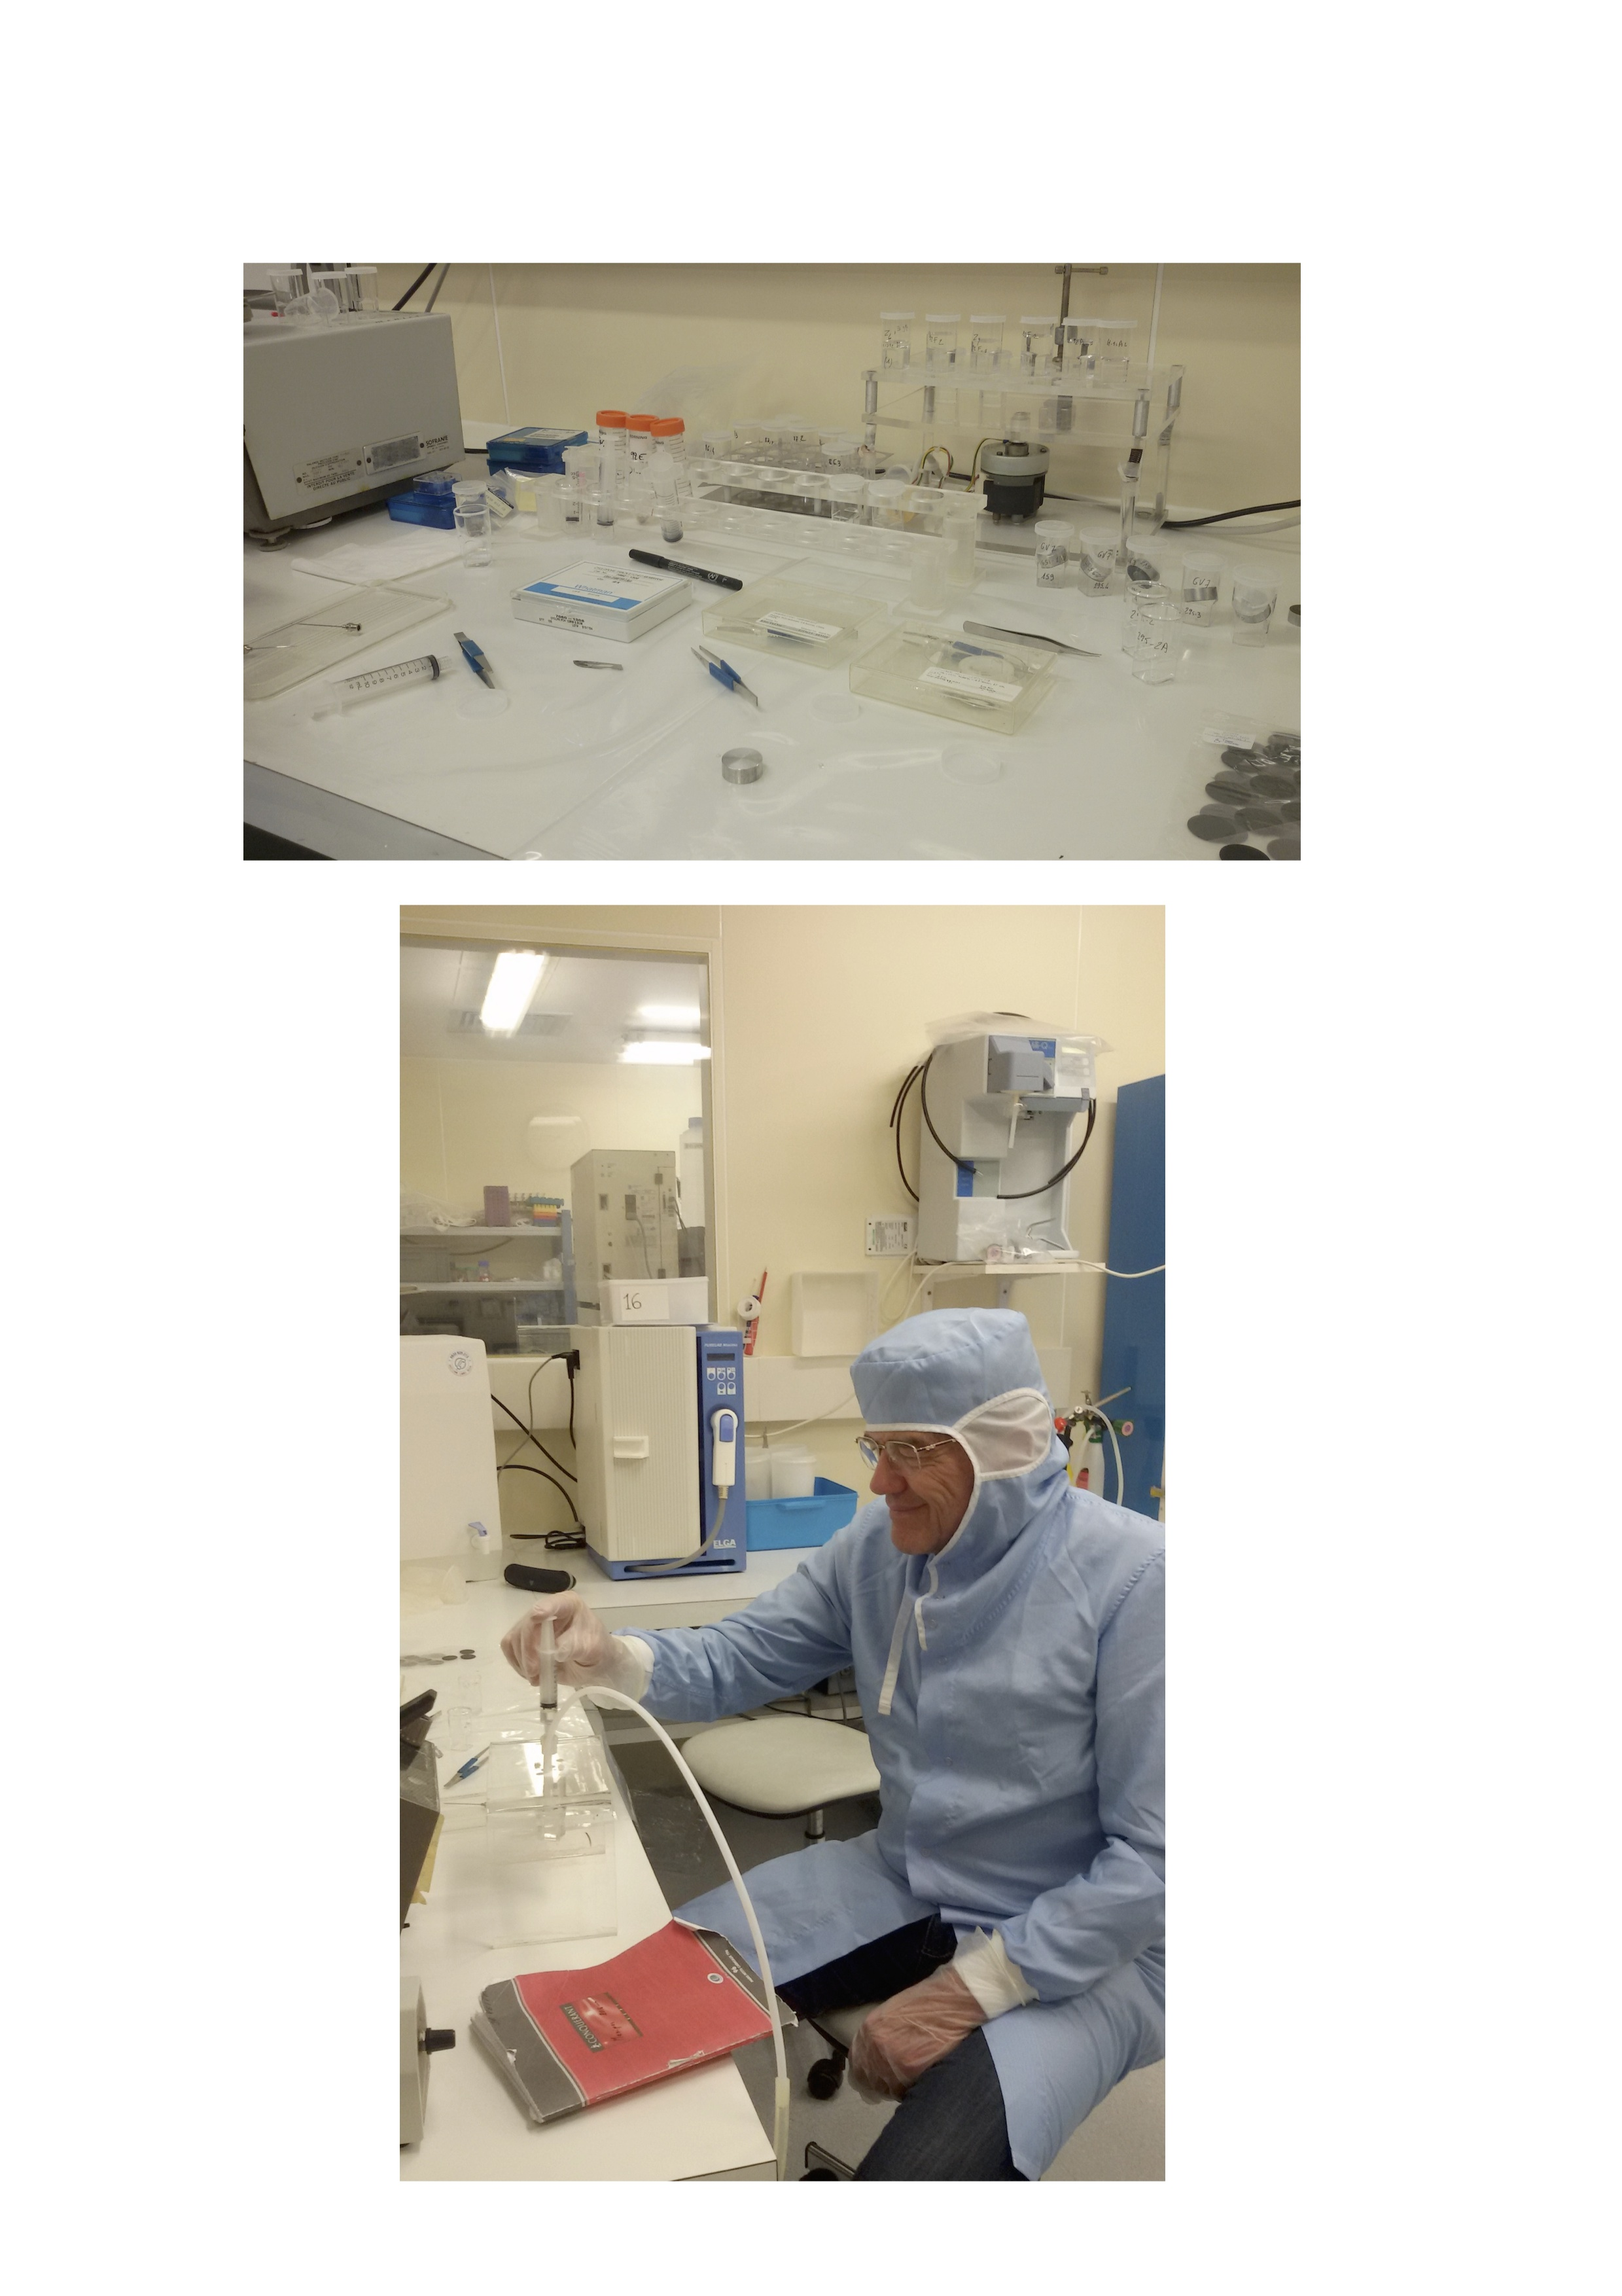

**Fig. S1**. The class-100 cleanroom at the LGGE (Laboratoire de Glaciologie et de Géophysique de l’Environnement, Grenoble) where processing of ice pieces containing volcanic ash from many Antarctic cores (VK, EDC, TALDICE, GV7, etc.) were performed. The upper picture shows the bench with various tools set up for ash recovery. Below, the phase of particle filtration. Sample manipulation and processing are carried out in clean conditions and following specialised protocols, in order to avoid contamination that could be critical due to typically low concentration of volcanic particulate, as well as its fine grain size. After repeated washings of the ice pieces with deionised water and melting at room temperature, an aliquot of meltwater from each sample is filtered through nucleopore polycarbonate membranes that will be then embedded into epoxy resin and polished for subsequent grain-specific geochemical analysis. Photos: B. Narcisi.



**Fig. S2**. In englacial tephra studies, single glass-shard geochemical measurements have fully replaced analysis of bulk samples because of their potential for precise correlation between widely separated records. Here the major element variability inside individual EDC samples as determined using an electron microprobe is illustrated (redrawn from Narcisi *et al.* 2005)**.** In(**a**)sample EDC 1732.5-m displays a very homogeneous trachytic composition.In (**b**)sample EDC 1796.3-m is very heterogeneous with particle composition falling along a fractionation trend ranging from basaltic trachyandesite to rhyolite. This variability representing an intrinsic unique signature of this layer has provided the means to identifying the same tephra in the DF ice core, ~ 2000 km away from Dome C.

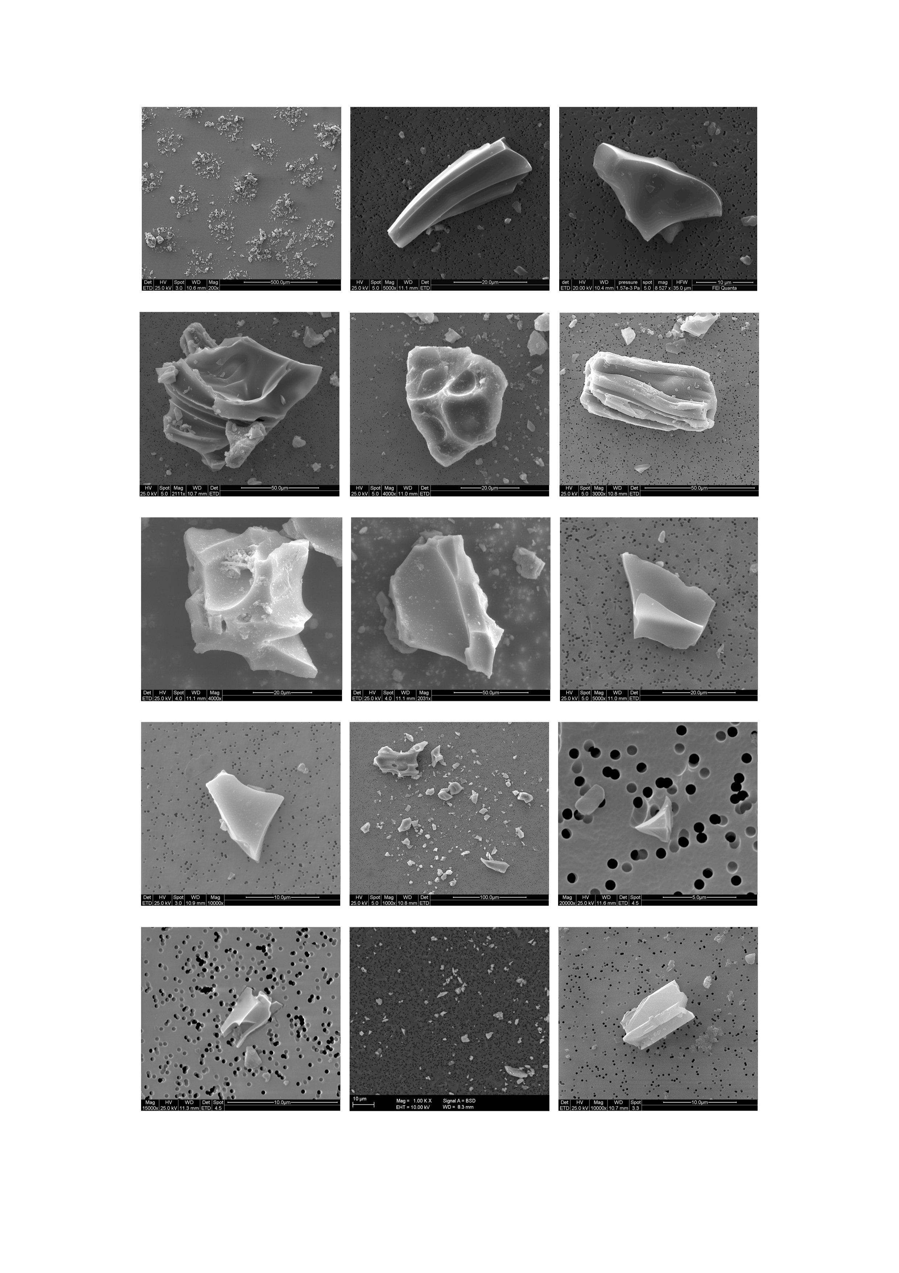

**Fig. S3**. Collection of SEM secondary electron photos showing filtered tephra particles from Antarctic englacial volcanic horizons occurring at various localities. A few show overviews of the filters. Note the different shapes and grain size, as well as the different concentrations. The last picture represents a feldspar crystal. Scale bar on the lower side of each photograph. Photos: B. Narcisi, J.R. Petit and M. Tonelli.

**References**

Aciego, S., Bourdon, B., Schwander, J., Baur, H. & Forieri, A. 2011. Toward a radiometric ice clock: Uranium ages of the Dome C ice core. *Quaternary Science Reviews*, **30** (19-20), 2389-2397.

Basile, I., Petit, J.R., Touron, S., Grousset, F.E. & Barkov, N. 2001. Volcanic layers in Antarctic (Vostok) ice cores: source identification and atmospheric implications. *Journal of Geophysical Research*, **106** (D23), 31915-31931.

Bazin, L., Landais, A., Lemieux-Dudon, B., Toyé Mahamadou Kele, H., Veres, D., Parrenin, F., Martinerie, P., Ritz, C., Capron, E., Lipenkov, V., Loutre, M.-F., Raynaud, D., Vinther, B., Svensson, A., Rasmussen, S.O., Severi, M., Blunier, T., Leuenberger, M., Fischer, H., Masson-Delmotte, V., Chappellaz, J. & Wolff, E. 2013. An optimized multi-proxy, multi-site Antarctic ice and gas orbital chronology (AICC2012): 120–800 ka. *Climate of the Past*, **9,** 1715–1731, <http://dx.doi.org/10.5194/cp-9-1715-2013>

Buizert, C., Baggenstos, D., Jiang, W., Purtschert, R., Petrenko, V.V., Lu, Z.T., Muller, P., Kuhl, T., Lee, J., Severinghaus, J.P. & Brook, E.J. 2014. Radiometric 81Kr dating identifies 120,000-year-old ice at Taylor Glacier, Antarctica. *Proceedings of the National Academy of Sciences*, **111**, 6876-6881, doi/10.1073/pnas.1320329111

Curzio, P., Folco, L., Laurenzi, M.A., Mellini, M. & Zeoli, A. 2008. A tephra chro- nostratigraphic framework for the Frontier Mountain blue-ice field (Northern Victoria Land, Antarctica). *Quaternary Science Reviews*, **27**, 602-620, http://dx.doi.org/ 10.1016/j.quascirev.2007.11.017

de Jong, A.E.M., Alderliesten, C., van der Borg, K., van der Veen, C. & van de Wal, R.S.W. 2004. Radiocarbon analysis of the EPICA Dome C ice core: no in-situ 14C from the firn observed. *Nuclear Instruments and Methods in Physics Research,* **B 223-224**, 516-520.

Delmonte, B., Petit, J.R. & Maggi, V. 2002. Glacial to Holocene implications of the new 27000-year dust record from the EPICA Dome C (East Antarctica) ice core. *Climate Dynamics*, **18**, 647-660.

Dome Fuji Ice Core Project Members 2017. State dependence of climatic instability over the past 720,000 years from Antarctic ice cores and climate modeling. *Science Advances*, **3**, no. 2, e1600446, DOI: 10.1126/sciadv.1600446

Dunbar, N.W., Mcintosh, W.C. & Esser, R.P. 2008. Physical setting and tephrochonology of the summit caldera ice record at Mt. Moulton, West Antarctica. *Geological Society of America Bulletin*, **120**, 796–812.

Fireman, E.L. 1989. Uraniam-series dating of tephra-banded Allan Hills ice. *Proceedings of the NIPR Symposium on Antarctic Meteorites*, **2**, 335-343.

Folco, L., Welten, K.C., Jull, A.J.T., Nishiizumi, K. & Zeoli, A. 2006. Meteorites constrain the age of Antarctic ice at the Frontier Mountain blue ice field (northern Victoria Land). *Earth and Planetary Science Letters*, **248**, 209-216.

Goldstein, S.J., Murrell, M.T., Nishiizumi, K. & Nunn, A.J. 2004. Uranium-series chronology and cosmogenic 10Be-36Cl record of Antarctic ice. *Chemical Geology*, **204**, 125–143.

Hayward, C. 2012. High spatial resolution electron probe microanalysis of tephras and melt inclusions without beam-induced chemical modification. *The Holocene*, 22, 119-125.

Higgins, J.A., Kurbatov, A.V., Spaulding, N.E., Brook, E., Introne, D. S., Chimiak, L.M., Yan, Y., Mayewski, P.A. & Bender, M.L. 2015. Atmospheric composition 1 million years ago from blue ice in the Allan Hills, Antarctica. *Proceedings of the National Academy of Sciences*, **112** (22), 6887-6891, DOI: 10.1073/pnas.1420232112

Kelly, P.J., Dunbar, N.W., Kyle, P.R. & McIntosh, W.C. 2008. Refinement of the late Quaternary geologic history of Erebus volcano, Antarctica using 40Ar/39Ar and 36Cl age determinations. *Journal of Volcanology and Geothermal Research*,**177**, 569–577, doi:10.1016/j.jvolgeores.2008.07.018

Koffman, B.G., Dowd, E.G., Osterberg, E.C., Ferris, D.G., Hartman, L.H., Wheatley, S.D., Kurbatov, A.V., Wong, G.J., Markle, B.R., Dunbar, N.W., Kreutz, K.J., & Yates, Y. 2017. [Rapid transport of ash and sulfate from the 2011 Puyehue-Cordón Caulle (Chile) eruption to West Antarctica](http://onlinelibrary.wiley.com/doi/10.1002/2017JD026893/abstract). *Journal of Geophysical Research Atmosphere*, **122**, 8908-8920, doi: 10.1002/2017JD026893

Kuehn, S. & Froese, D. 2010. Tephra from ice - A simple method to routinely mount, polish, and quantitatively analyze sparse fine particles. *Microscopy and Microanalysis,* **16**(2), 218-225, doi:10.1017/S1431927609991322

Iverson, N.A., Kyle, P.R., Dunbar, N.W., McIntosh, W.C. & Pearce, N.J.G. 2014. Eruptive history and magmatic stability of Erebus volcano, Antarctica: insights from englacial tephra. *Geochemistry, Geophysics, Geosystems,* **15**, 4180-4202, http://dx.doi.org/ 10.1002/2014GC005435

Iverson, N.A., Kalteyer, D., Dunbar, N.W. Kurbatov, A. & Yates, M. 2017a. Advancements and best practices for analysis and correlation of tephra and cryptotephra in ice. *Quaternary Geochronology*, **40**, 45-55, <https://doi.org/10.1016/j.quageo.2016.09.008>

Iverson, N.A., Lieb-Lappen, R., Dunbar, N.W. Obbard, R., Kim, E. & Golden, E. 2017b. The first physical evidence of subglacial volcanism under the West Antarctic Ice Sheet. *Scientific Reports* **7**, Article number: 11457, DOI:10.1038/s41598-017-11515-3

Lavigne, F., Degeai, J.-P., Komorowski, J.-C., Guillet, S., Robert, V., Lahitte, P., Oppenheimer, C., Stoffel, M., Vidal, C.M., Surono, Pratomo, I., Wassmer, P., Hajdas, I., Sri Hadmoko, D. & de Belizal, D. 2013. Source of the great A.D. 1257 mystery eruption unveiled, Salamas volcano, Rinjani Volcanic Complex, Indonesia. *Proceedings of the National Academy of Sciences*, **110**, 16742-16747, <https://doi.org/10.1073/pnas.1307520110>

Lemieux-Dudon, B., Blayo, E., Petit, J.-R., Waelbroeck, C., Svensson, A., Ritz, C., Barnola, J.-M., Narcisi, B. & Parrenin, F. 2010. Consistent dating for Antarctic and Greenland ice cores, *Quaternary Science Reviews*, **29**, 8-20, doi:10.1016/j.quascirev.2009.11.010

Lowe, D.J. Pearce, N.J.G. Jorgensen, M.A., Kuehn, S.C., Tryon, C.A. & Hayward, C.L. 2017. Correlating tephras and cryptotephras using glass compositional analyses and numerical and statistical methods: Review and evaluation, *Quaternary Science Reviews*, **175**, 1-44.

Narcisi, B., Petit, J.R., Delmonte, B., Basile-Doelsch, I. & Maggi, V. 2005. Characteristics and sources of tephra layers in the EPICA-Dome C ice record (East Antarctica): implications for past atmospheric circulation and ice core stratigraphic correlations. *Earth and Planetary Science Letters*, **239**, 253–265.

Narcisi, B., Petit, J.R. & Tiepolo, M. 2006. A volcanic marker (92 ka) for dating deep east Antarctic ice cores. *Quaternary Science Reviews*, **25**, 2682–2687.

Narcisi, B., Petit, J.R., Delmonte, B., Scarchilli, C. & Stenni, B. 2012. A 16,000-yr tephra framework for the Antarctic ice sheet: a contribution from the new Talos Dome core. *Quaternary Science Reviews*, **49**, 52-63, http://dx.doi.org/10.1016/j.quascirev.2012. 06.011

Narcisi, B., Petit, J.R., Langone, A. & Stenni, B. 2016. A new Eemian record of Antarctic tephra layers retrieved from the Talos Dome ice core (Northern Victoria Land). *Global and Planetary Change*, **137**, 69-78, <http://dx.doi.org/10.1016/j.gloplacha.2015.12.016>

Palais, J.M. 1985. Particle morphology, composition and associated ice chemistry of tephra layers in the Byrd ice core: evidence for hydrovolcanic eruptions. *Annals of Glaciology*, **7**, 42–48.

Palais, J.M, Germani, M.S. & Zielinski, G.A. 1992. Interhemispheric transport of volcanic ash from a 1259 A.D. volcanic eruption to the Greenland and Antarctic ice sheets. *Geophysical Research Letters* **19**, 801–804.

Pearce, N.J.G., Abbott, P.M. & Martin-Jones, C. 2014. Microbeam methods for the analysis of glass in fine-grained tephra deposits: a SMART perspective on current and future trends. Geological Society, London, Special Publications, **398**, 29-46.

Petit, J.R., Narcisi, B., Batanova, V.G., Savarino, J., Komorowsky, J.C., Michel, A., Metrich, N., Besson, P., Vidal, C. & Sobolev, A.V. 2016. Identifying the AD 1257 Salamas volcanic event from micron-size tephra composition in two East Antarctic ice cores. *Geophysical Research Abstracts* , **18**, EGU2016-5191.

Svensson, A., Nielsen, S.W., Kipfstuhl, S., Johnsen, S. J., Steffensen, J. P., Bigler, M., Ruth, U. & Röthlisberger, R. 2005. Visual stratigraphy of the North Greenland Ice Core Project (NorthGRIP) ice core during the last glacial period. *Journal of Geophysical Research*, **110**, D02108, doi: 10.1029/2004JD005134

The IceCube Collaboration 2013. South Pole glacial climate reconstruction from multi-borehole laser particulate stratigraphy. *Journal of Glaciology,* **59** (218), 1117-1128, doi:10.3189/2013JoG13J068

Van de Wal, R.S.W., Meijer, H.A.J., De Rooij, M. & Van Der Veen, C. 2007. Radiocarbon analyses along the EDML ice core in Antarctica. *Tellus B: Chemical and Physical Meteorology*, **59**, 157-165, DOI: [10.1111/j.1600-0889.2006.00243.x](https://doi.org/10.1111/j.1600-0889.2006.00243.x)

Veres, D., Bazin, L., Landais, A., Toyé Mahamadou Kele, H., Lemieux-Dudon, B., Parrenin, F., Martinerie, P., Blayo, E., Blunier, T., Capron, E., Chappellaz, J., Rasmussen, S.O., Severi, M., Svensson, A., Vinther, B. & Wolff, E.W. 2013. The Antarctic ice core chronology (AICC2012): an optimized multi-parameter and multi-site dating approach for the last 120 thousand years. *Climate of the Past,* **9**, 1733–1748, http://dx.doi.org/10.5194/cp-9- 1733-2013

Vonlanthen, P., Rausch, J., Ketcham, R.A., Putlitz, B., Baumgartner, L.P. & Grobéty, B. 2015. High-resolution 3D analyses of the shape and internal constituents of small volcanic ash particles: The contribution of SEM micro-computed tomography (SEM micro-CT). *Journal of Volcanology and Geothermal Research*, **293**, 1-12.