Appendix 1
Additional Instrument and Standard Details
Laser
Brand and Model | RESOlution-LR 193nm Excimer Laser System
Wavelength | 193 nm
Pulse Duration | ~5 ns
Spot Size (U-Pb analysis) | 29 μm
Repetition Rate | 5 Hz
Energy Attenuation | 50%
Laser Fluency | 3.5 J/cm²
ICPMS
Brand and Model | Agilent 7900x
Forward Power | 1350 W
Torch Depth | 4.5 mm
Gas Flows
Plasma (Ar)  Auxiliary (Ar) | 15 L/min  1 L/min
Carrier (He) | 07 L/min
Sample (Ar) | 0.88 L/min
Data Acquisition Parameters
Data Acquisition Protocol | Time-resolved analysis
Scanned Isotopes | ⁴³Ca, ²⁹Si, ³¹P, ³⁵Cl, ⁵¹V, ⁵⁵Mn, ⁸⁸Sr, ⁸⁹Y, ⁹⁰Zr, ¹³⁹La, ¹⁴⁰Ce, ¹⁴¹Pr, ¹⁴⁶Nd, ¹⁴⁷Sm, ¹⁵³Eu, ¹⁵⁷Gd, ¹⁵⁹Tb, ¹⁶³Dy, ¹⁶⁵Ho, ¹⁶⁶Er, ¹⁶⁹Tm, ¹⁷²Yb, ¹⁷⁵Lu, ²⁰¹Hg, ²⁰⁴Pb, ²⁰⁶Pb, ²⁰⁷Pb, ²⁰⁸Pb, ²³²Th & ²³⁸U
Detector Mode | Peak Hopping, Pulse & Analog counting
Background Collection | 28 s
Ablation for Age Calculation | 30 s
Washout | 20 s
Standards
Primary Standards (U–Pb analysis) | Madagascar apatite
Primary Standards (trace element) | NIST610
Secondary Standards | Durango apatite, McClure apatite
Table S1. LA–ICP–MS analytical parameters for apatite U–Pb dating and trace element quantification

Table S2. EPMA standard information, as referred to in Tables 2 and 3
Reference # | Mineral composition | Natural/Synthetic | Manufacturer
502 | Almandine garnet | Natural | Astimex
513 | Barite | Natural | Astimex
545 | Tugtupite | Natural | Astimex
557 | Rhodonite | Natural | Astimex
570 | Fluorite | Synthetic | Astimex
735 | Albite (Amelia) | Natural | P&H and Associates
736 | Apatite (Wilbeforce) | Natural | C.M. Taylor
1200 | Lanthanum Phosphate | Synthetic | Cherniak phosphate
1201 | Cerium Phosphate | Synthetic | Cherniak phosphate
1203 | Neodymium Phosphate | Synthetic | Cherniak phosphate
1214 | Yttrium Phosphate | Synthetic | Cherniak phosphate
1323 | Augite | Natural | NMNH
1335 | Olivine | Natural | NMNH
1342 | Rutile | Synthetic | In-house
1600 | MgF2 | Synthetic | In-house(Laser optic)

Evaluation of Accuracy of Analytical Methods
AUPb Secondary Standards
Secondary standards of Durango and McClure apatite were analysed alongside unknowns in each LA–ICP–MS analytical session to ensure confidence in analytical data obtained. Analysed Durango apatite AUPb ²⁰⁷Pb corrected ²⁰⁶Pb/²³⁸U weighted mean ages are shown in Fig. S1, and yield ages of 32.73 ± 1.22 Ma (Session LA-a) and 31.44 ± 1.73 Ma (Session LA-b). These weighted mean ages both lie in good agreement with the published ⁴⁰Ar/³⁹Ar age (31.44 ± 0.18 Ma; McDowell, McIntosh, & Farley 2005) and ²⁰⁷Pb corrected ages (32.20 ± 0.51 Ma; Chew, Petrus, & Kamber 2014). Analysed McClure apatite ²⁰⁷Pb corrected ²⁰⁶Pb/²³⁸U weighted mean ages are shown in Fig. S2, and yield weighted mean ages of 524.82 ± 6.42 Ma (Session LA-a) and 528.71±6.93 Ma (Session LA-b). McClure apatite ages are in agreement with the published TIMS age of 523.51 ± 1.47 Ma (Schoene & Bowring 2006). Observed agreement of secondary standard AUPb ages with published age constraints of these materials allows for confident use of AUPb isotopic data of unknowns analysed in this study.
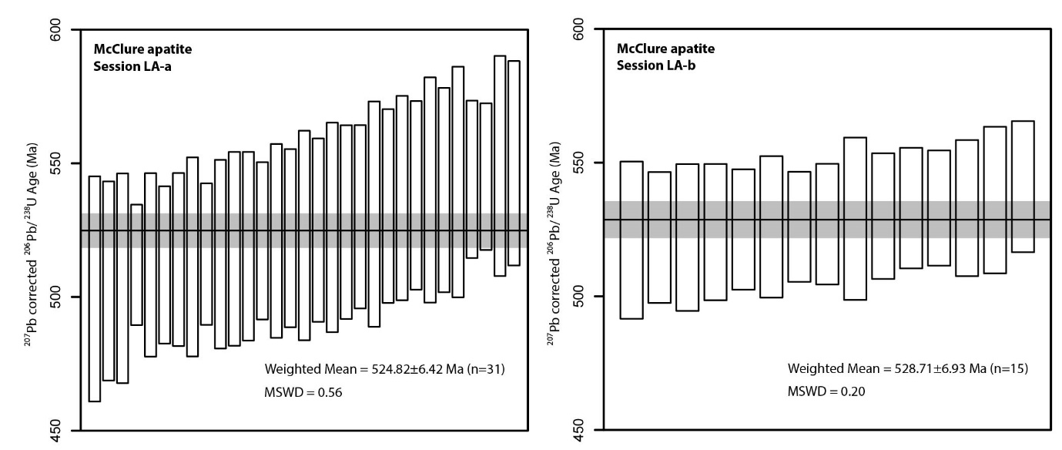
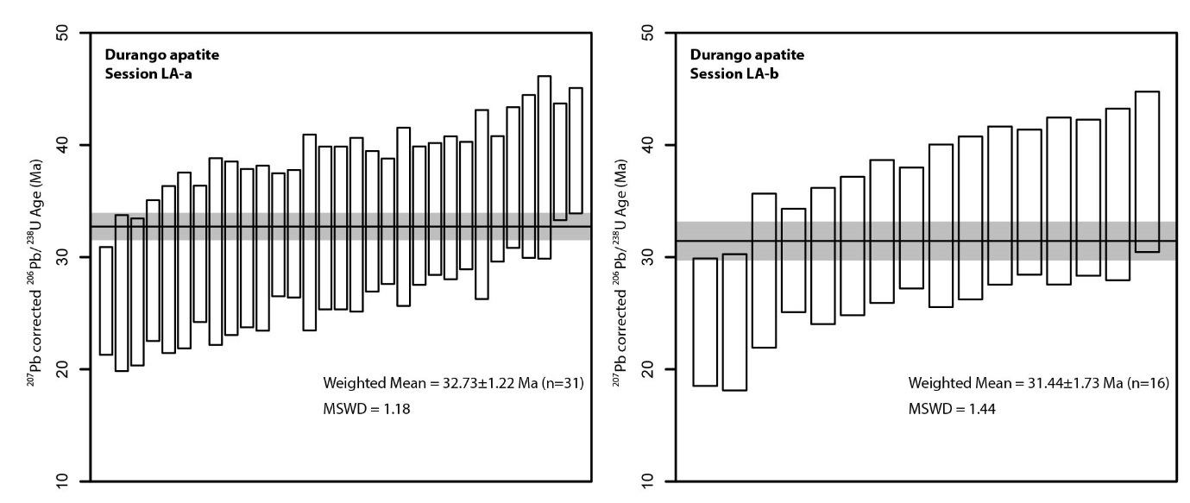
Fig. S1. Durango apatite ²⁰⁷Pb corrected ²⁰⁶Pb/²³⁸U age weighted mean for standards interspaced in LA–ICP–MS analytical sessions. Individual spot error bars and weighted mean uncertainty reflect 2σ errors. Two published ages of Durango apatite constrain standard age at 31.44 ± 0.18 Ma (McDowell, et al. 2005) and 32.20 ± 0.51 Ma (Chew et al. 2014).
Fig. S2. McClure apatite ²⁰⁷Pb corrected ²⁰⁶Pb/²³⁸U age weighted mean for standards interspaced in LA–ICP–MS analytical sessions. Individual spot error bars and weighted mean uncertainty reflect 2σ errors. McClure apatite age has been previously constrained at 523.51 ± 1.47 Ma (Schoene & Bowring 2006).

EPMA Secondary Standards
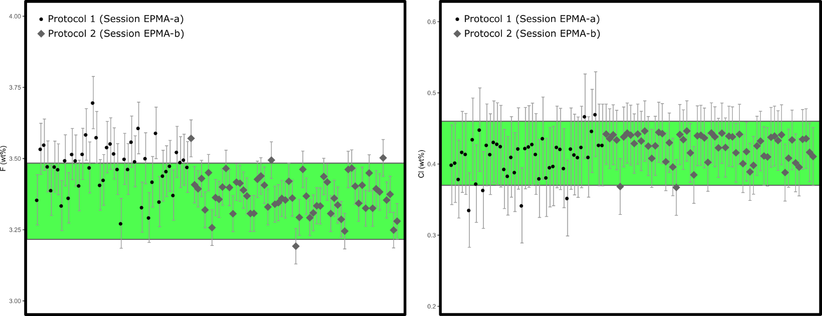
Durango apatite was used as a secondary standard for verification of the accuracy of geochemical data collected in EPMA sessions, and was interspaced throughout analytical sessions. The most important monitored elements for use in this study are the halogens F and Cl, which cannot be robustly measured by laser ablation methods, and are integral for calculation of the r_{mr0} multi-kinetic variable. Different Durango crystals were analysed in each session, in order to ensure sufficient distance allowed between analysed regions due to the highly mobile nature of F and Cl. Measured halogen content of Durango apatite is presented in Fig. S3. Across analytical sessions, Durango apatites yielded weighted mean abundances of 3.47 ± 0.01 wt% F (Protocol 1; Session EPMA-a) and 3.37 ± 0.01 wt% F (Protocol 2; Session EPMA-b); and 0.41 ± 0.01 wt% Cl (Protocol 1; Session EPMA-a) and 0.43 ± 0.01 wt% Cl (Protocol 2; Session EPMA-b). These halogen concentrations are consistent with published compositional data of this standard (3.35 ± 0.13 wt% F; Marks et al. 2012; c. 0.37–0.46 wt% Cl; Chew et al. 2016). Such consistency between protocols and with published Durango halogen content would suggest both analytical protocols are sufficiently accurate for robust r_{mr0} calculation.
Fig. S3. Measured oxide and elemental concentrations of interspaced Durango apatite standards from Protocol 1 (Session EPMA-a) and Protocol 2 (Session EPMA-b), where all error bars denote individual 2σ errors. Green shaded regions shows published Durango compositional ranges of Marks et al. (2012) and Chew et al. (2016) for comparison.
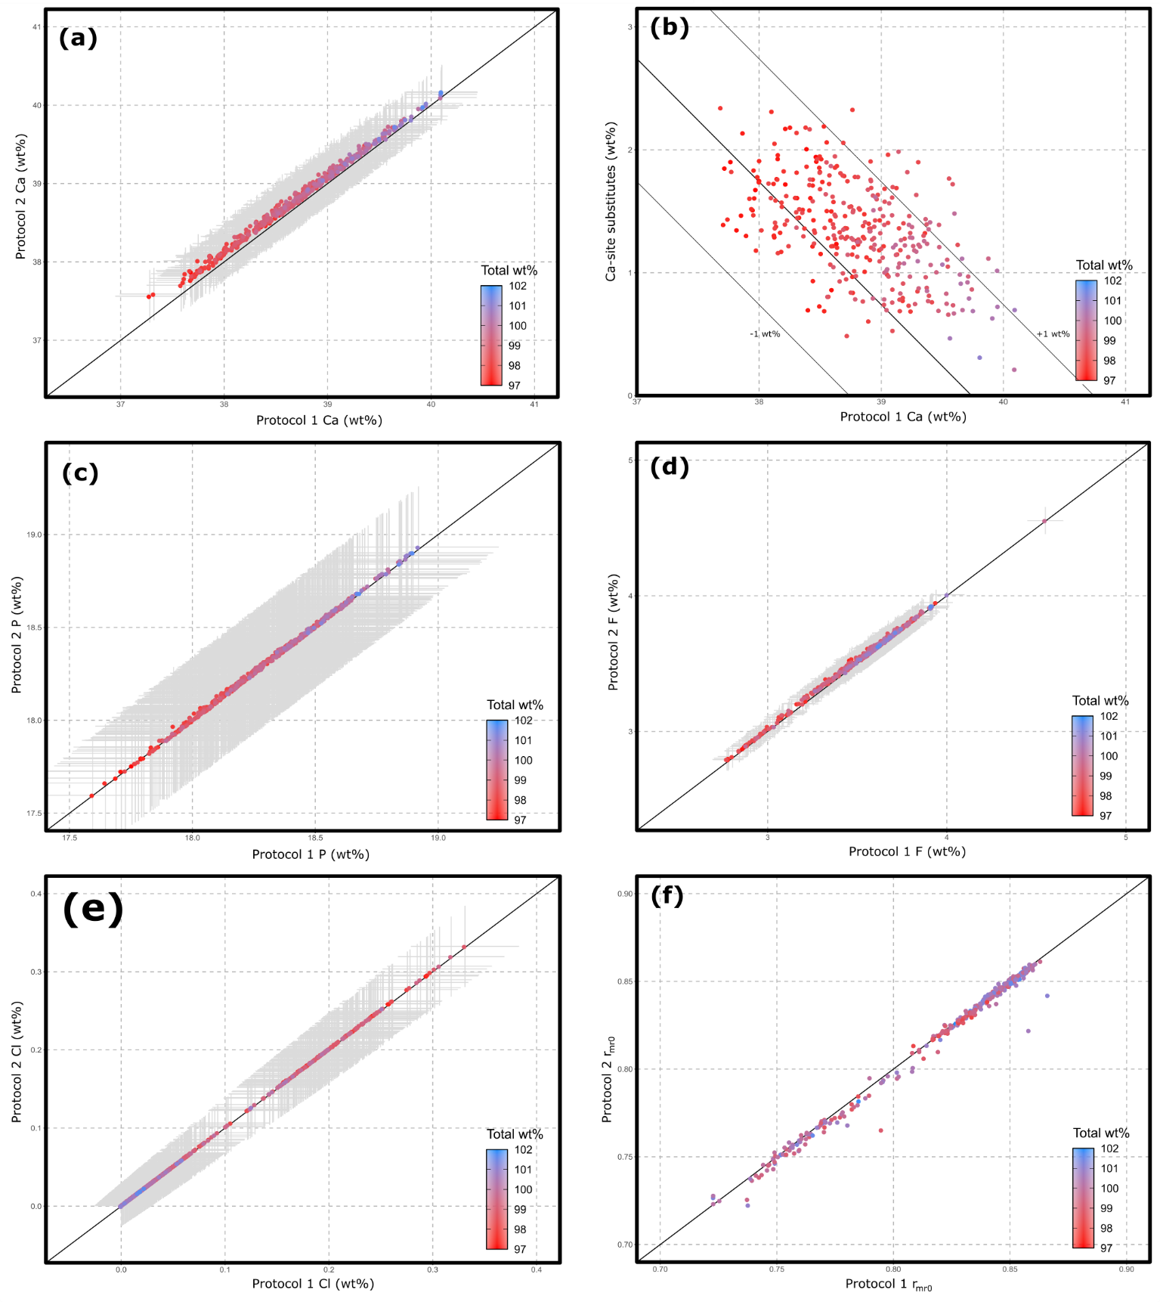
Fig. S4. Comparison of elemental determinations using apatite EPMA Protocol 1 (full suite analysis) and Protocol 2 (reduced suite analysis). Analytical data presented was collected in Session EPMA-a using EPMA parameters of Protocol 1, then raw data was subsequently reduced using Probe for EPMA software using 1) all elements measured in Protocol 1 and; 2) only elements which would be measured under Protocol 2. This allows for same-spot comparison between data reduction methods using elements measured in each protocol. Individual analyses are coloured based on the total weight percent of analysed elements reported for Protocol 2 which is used as an accuracy check, and error bars represent 2σ. Plots (a) and (c–f) have a 1:1 line for ease of comparison. Individual plots are as follows: (a) inter-protocol comparison of calculated calcium content. (b) Biplot of calculated Ca wt% as calculated under Protocol 1 plotted against sum of elements which substitute into the apatite Ca- site. Substitute ions used are Na, Mn, Sr, Y, Pb, La, Ce, Pr, Nd, Sm, Eu, Gd, Tb, Dy, Ho, Er, Tm, Yb and Lu (Hughes & Rakovan, 2002). A reference line of y = -x + 39.74 wt% has been included, such that with no Ca-site substitutes present Ca is stoichiometric, and an increase in Ca-site substitute ions is accompanied by an equivalent decrease in Ca. Additional reference lines at ± 1 wt% have also been included. (c) Inter-protocol comparison of calculated phosphorous content. (d) Inter-protocol comparison of calculated fluorine content. (e) Inter-protocol comparison of calculated chlorine content. (f) Inter-protocol comparison of calculated r_{mr0} values, where under Protocol 1 r_{mr0} has been calculated exclusively using EPMA data and under Protocol 2 r_{mr0} has been calculated using a combination of same grain EPMA and LA–ICP–MS data.
EPMA Methodology Comparison
To test the reliability of the reduced analytical procedure of Protocol 2, data collected under Protocol 1 in analytical Session EPMA-a were calculated using all elements determined (Ca, P, Cl, F, S, Si, Na, Sr, Mn, Fe, Al, Mg, Y, La, Ti, Ce and Nd) using Probe for EPMA software (distributed by Probe Software Inc.), and only those which would be determined under protocol 2 (Ca, P, Cl, F, S, Si, Na and Fe). Determination of Ca, P, F and Cl by both methods are given in Figs. S4a; c–e, which show excellent consistency between the two methods. Similarly, calculated r_{mr0} values calculated using Protocol 1 and data from Protocol 2 combined with LA–ICP–MS show good agreement between methods (Fig. S4f).
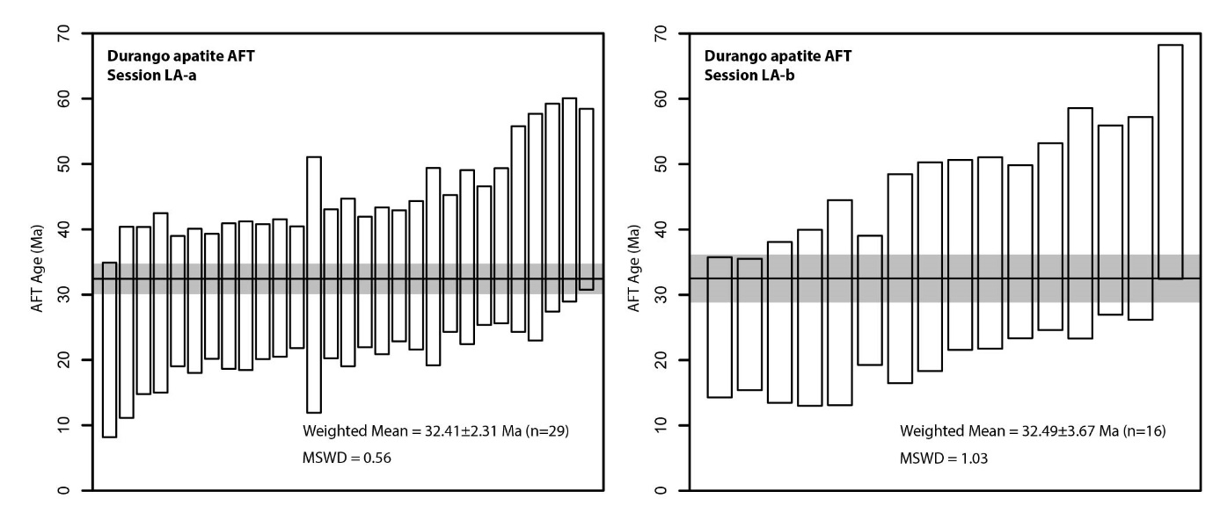
The most significant deviation in calculated elemental abundance between protocols is evident in the calculation of Ca, which is slightly overestimated by Protocol 2 with respect to Protocol 1 (Fig. S4a). Ca also demonstrates a significant positive correlation between Ca wt% and total wt% calculated in Protocol 2, where greater decoupling of calculated Ca is observed at lower measured abundance. Correlation between Ca wt% and total calculated wt% may be explained by the presence of REEs which occupy the Ca-site in apatite (Figs. S4a–b; Hughes & Rakovan 2002; Pan & Fleet 2002) and thus displace Ca from the lattice. Non-analysis of REEs and other Ca-site substitutes compromises the ZAF absorption correction which causes Ca to be overcorrected, thus Ca exhibits a tenancy to be overestimated in high REE apatites and becomes more appropriately corrected as Ca approaches stoichiometric abundance. For all analyses, however, Ca wt% calculated utilising Protocol 2 are within 2σ error of Protocol 1 values. Given the consistency demonstrated by direct protocol comparison, and observed agreement between analysed and published Durango elemental concentrations obtained under discretely analysed both protocols, Protocol 2 is considered a viable EPMA method for apatite thermochronology purposes.
Fig. S5. Durango apatite AFT ages for standards interspaced in LA–ICP–MS analytical sessions used for accuracy validation and session-specific zeta calculation (Vermeesch 2017). Individual spot error bars and weighted mean uncertainty reflect 2σ errors. Two published ages of Durango apatite constrain standard age at 31.44 ± 0.18 Ma (McDowell et al., 2005) and 32.20 ± 0.51 Ma (Chew et al. 2014).
AFT Secondary Standards
Durango apatite etched with 5.0 M HNO₃ was analysed alongside Pine Creek Orogen and Arnhem Province samples in respective LA–ICP–MS analytical sessions, both to evaluate data accuracy and to calculate a session-specific zeta factor to which unknown samples were normalised Vermeesch (2017). Durango apatite AFT ages are presented in Fig. S5, and yield weighted mean AFT ages of 32.4 ± 2.3 Ma (Session LA-a) and 32.5 ± 3.7 Ma (Session LA-b), which are within error of the published ⁴⁰Ar/³⁹Ar age (31.44 ± 0.18 Ma; McDowell et al. 2005). Agreement between published and calculated AFT ages for Durango apatite is supportive of reliable AFT data of Pine Creek Orogen and Arnhem Province samples presented in this study.
Apatite Thermal History Modelling
Table S3. Thermal history model input table for thermochronology simulations of Pine Creek Orogen and Arnhem Province samples, based on framework established by Flowers, Farley, and Ketcham (2015)
1. Themochronological data
Samples and data used in simulations
Simulation inputs |  |  |  | Data Source | All data needed for modelling published?
Sample | AFT |  | AHe
CS-1 | x |  | x | Appendix 3, 4 | Yes
CS-4 | x |  | x | Appendix 3, 4 | Yes
CS-5 | x |  |  | Appendix 3 | Yes
CS-6 | x |  |  | Appendix 3 | Yes
CS-8 | x |  | x | Appendix 3, 4 | Yes
CS-9 | x |  |  | Appendix 3 | Yes
CS-10 | x |  |  | Appendix 3 | Yes
CS-11 | x |  |  | Appendix 3 | Yes
CS-12 | x |  |  | Appendix 3 | Yes
PV-1 | x |  |  | Appendix 3 | Yes
GV14JAW182 | x |  |  | Appendix 3 | Yes
GV14JAW183 | x |  |  | Appendix 3 | Yes
AB14JAW004 | x |  |  | Appendix 3 | Yes
GV14SKR033 | x |  |  | Appendix 3 | Yes
GV15JAW261 | x |  |  | Appendix 3 | Yes
BM16JAW070 | x |  |  | Appendix 3 | Yes
Data treatment, uncertainties, and other relevant constraints
AHe Data
He dates (Ma): Single grain AHe ages were from Appendix 4 incorporated in modelling of AFT data
Error (Ma): applied in modelling: error of 1σ was used from Appendix 3
r (µm): Equivalent spherical radius of each grain
AFT data
r_{mr0}: From Appendix 3
Lengths: Length data for all samples is available in Appendix 3
Initial mean track length: 16.3 µm
Track length reduction standard: 0.893
2. Additional geological information
Assumption |  | Explanation and data source
Constraint at 500–400 Ma, 190–150ºC |  | Initial broad constraint to simulate cooling from depth.
Constraint at 213–183 Ma, 25–10ºC  (samples CS-1, CS-4, CS-5, CS-6, CS-8, CS-9, CS-10, CS-11, CS-12 & PV-1) |  | Unconformity observed above sampled Pine Creek Orogen basement suggests samples were previously at/near surface. Exact timing of unconformity is poorly constrained, however the directly overlying Plover Formation was deposited between 191–183 Ma (Lowe-Young et al. 2003), and additional leeway has been included in the constraint to allow for this uncertainty.
Constraint at 133-113 Ma, 25 -10ºC  (samples GV14JAW182, GV14JAW183, AB14JAW004, GV14SKR033, GV15JAW261 & BM16JAW070) |  | Unconformity observed above sampled Arnhem Province basement suggests samples were previously at/near surface. Exact timing of unconformity is poorly constrained, however the directly overlying Walker River Formation does not exceed Aptian age (Krassay 1994), and additional leeway has been included in the constraint to allow for this uncertainty.
3. System- and model-specific parameters
He radiation damage model: Flowers et al. 2009
FT annealing model: Ketcham et al. 2007
FT c-axis projection: Not used
Modelling Code: QTQt 5.6.0 PC
Statistical fitting criteria: Default QTQt values
MCMC Parameters: Burn-in = 50,000, Post-burn-in = 50,000
tT path characteristics: Not indicated
Individual sample radial plots and confined track length histograms are provided in Fig. 6. Samples from the Pine Creek Orogen yield central ages between 352 ± 14 Ma and 242 ± 6 Ma, and demonstrate no apparent intra-sample age variation with respect to composition. Samples from the Arnhem Province yield AFT central ages between 280 ± 21 Ma and 202 ± 8 Ma, and as observed in the Pine Creek Orogen samples demonstrate no apparent intra-sample age variation with respect to composition. Confined track distributions are unimodal, and broadly symmetrical to negatively skewed in both the Pine Creek Orogen and Arnhem Province, however, MTLs are biased c. 1 µm longer in the Arnhem Provence than in the Pine Creek Orogen.
Modelling was conducted using QTQt software (Gallagher, 2012), using inputs of AFT single grain age, confined tracks, and a kinetic parameter of r_{mr0} (Carlson, Donelick & Ketcham 1999). Samples CS-1,
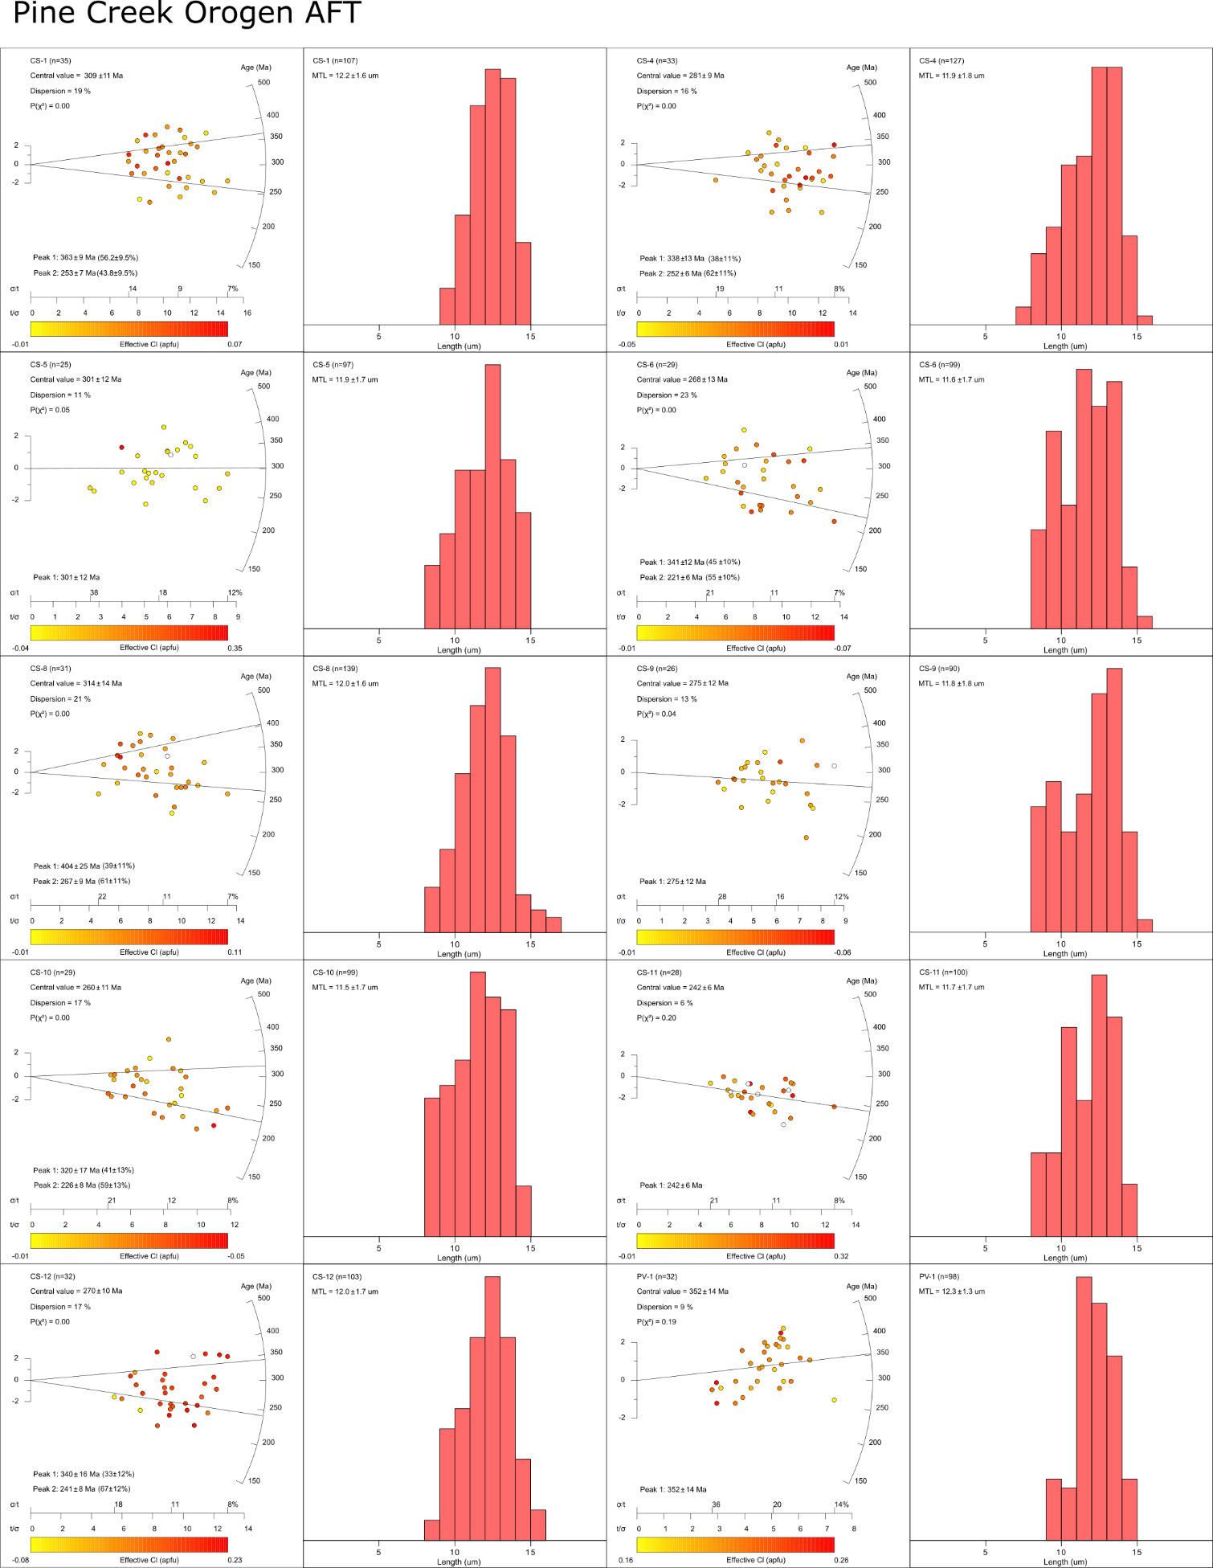

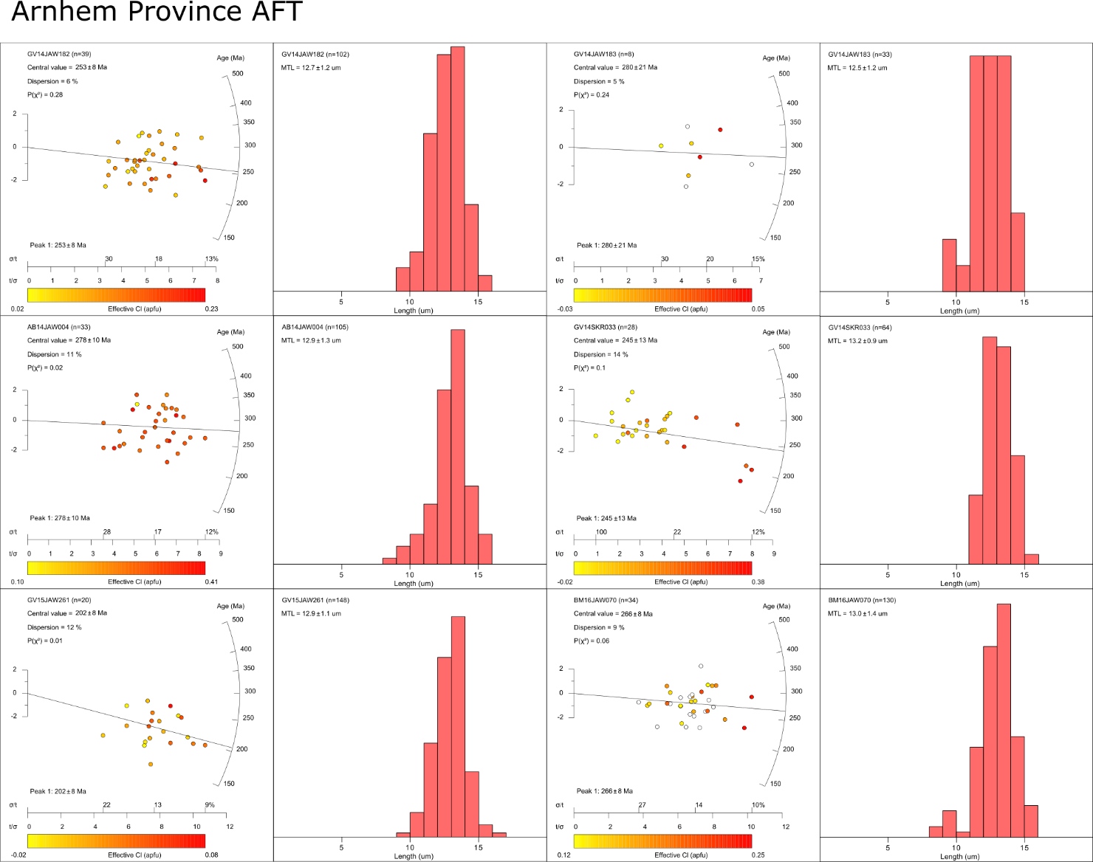
Fig. S6. Radial plots of AFT ages and confined track length histograms for Pine Creek Orogen and Arnhem Province samples. Radial plot ages are coloured by single-grain effective Cl composition, calculated from single-grain r_{mr0} as outlined in Ketcham et al. (1999). Ages are calculated using IsoplotR software (Vermeesch 2018), using the fission track radial plot function, in which more precise ages are given higher weighting to the population age. A central age has been calculated for all samples, which returns the weighted age for all grains in the population, while for samples which display P(χ²) < 0.05 and dispersion > 15% two ‘peak’ ages have also been calculated, which reflect mean ages of discrete statistically identified populations within the sample. In samples with only a single statistically identified population, the peak age is equal to the central age. No samples, however, exhibit significant open-jaw characteristics (O'Sullivan & Parrish 1995) which suggests the presence of multiple statistical age populations may reflect overdispersion of ages rather than multiple true age populations, hence the central age has been quoted as the preferred AFT sample age. Each radial plot is accompanied by confined track length histograms of the same sample. MTL = the mean confined track length of that sample. All errors for radial plots and length histograms are given as 1σ.
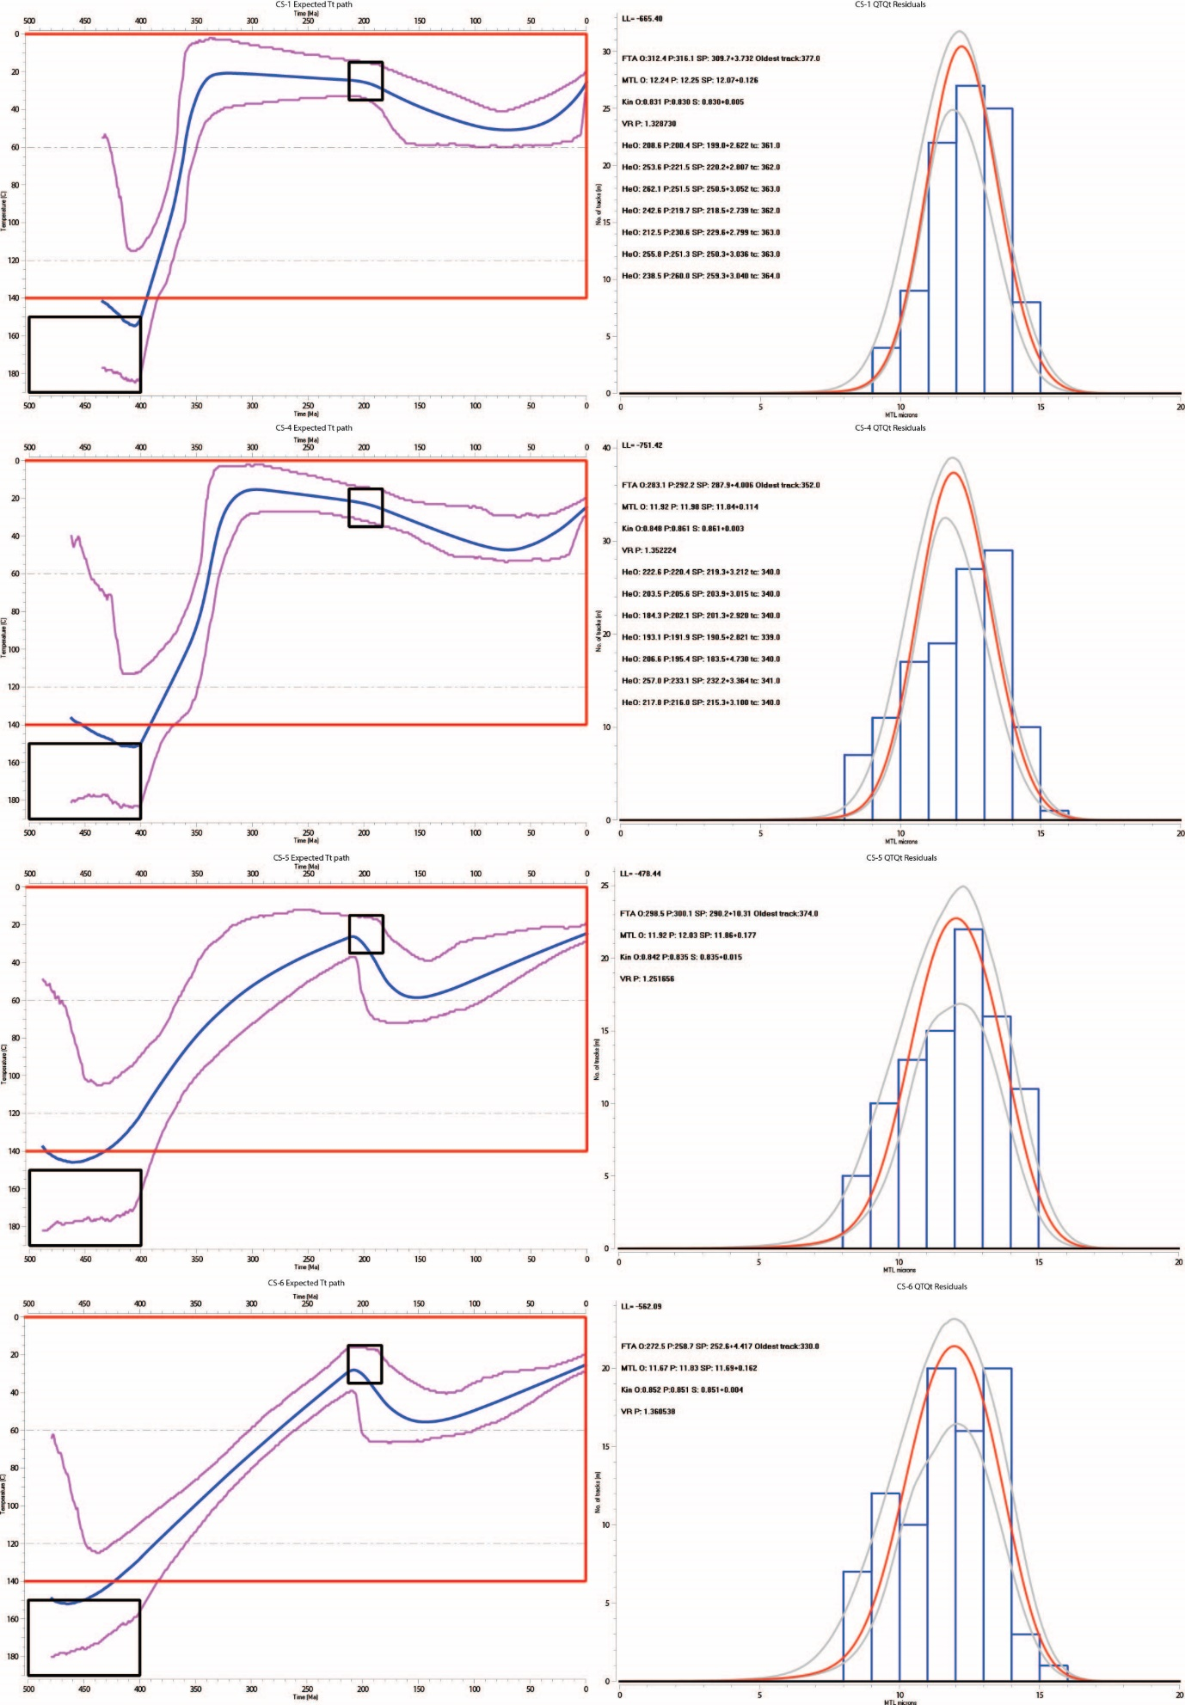
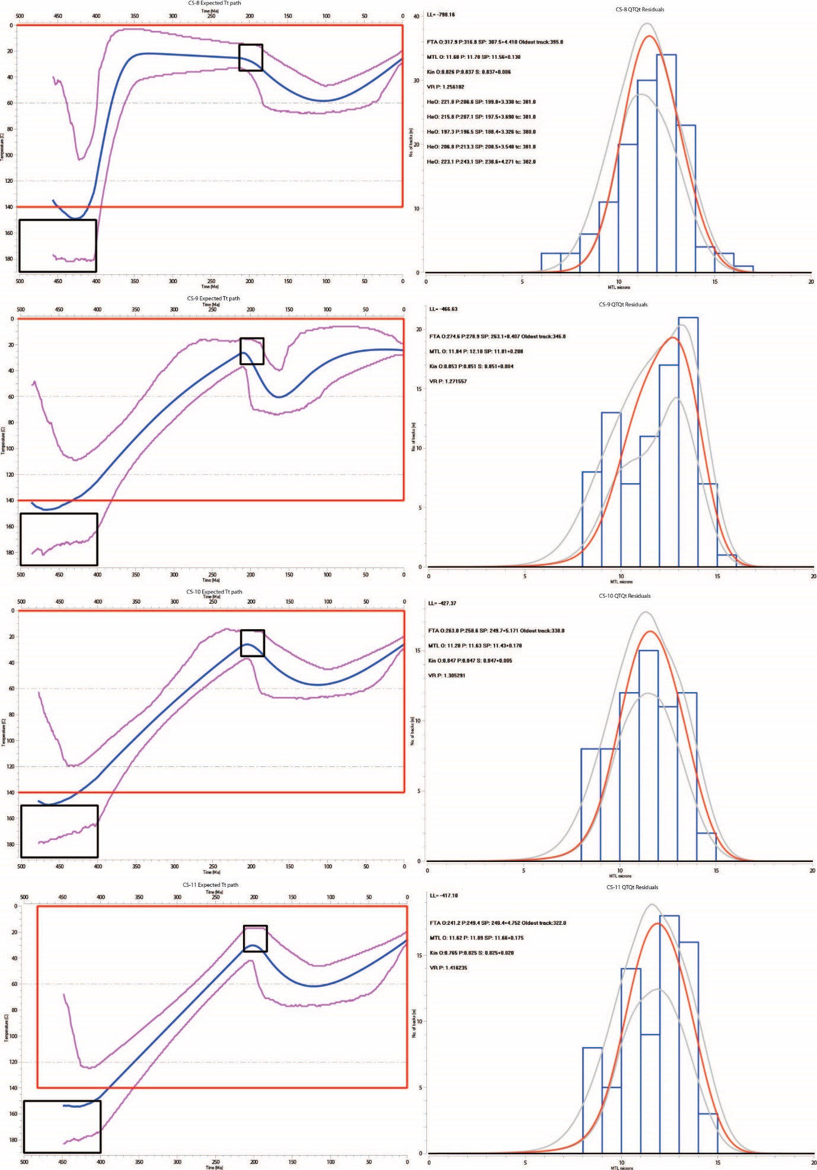

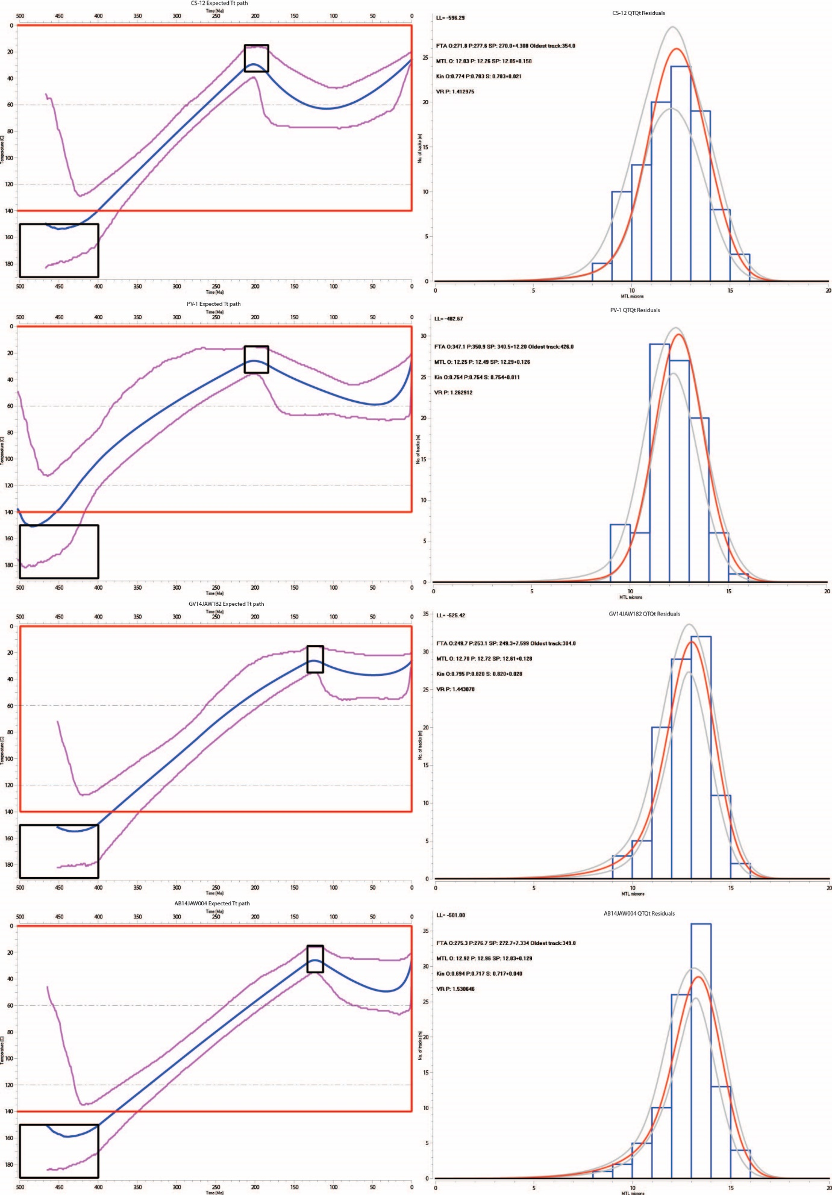
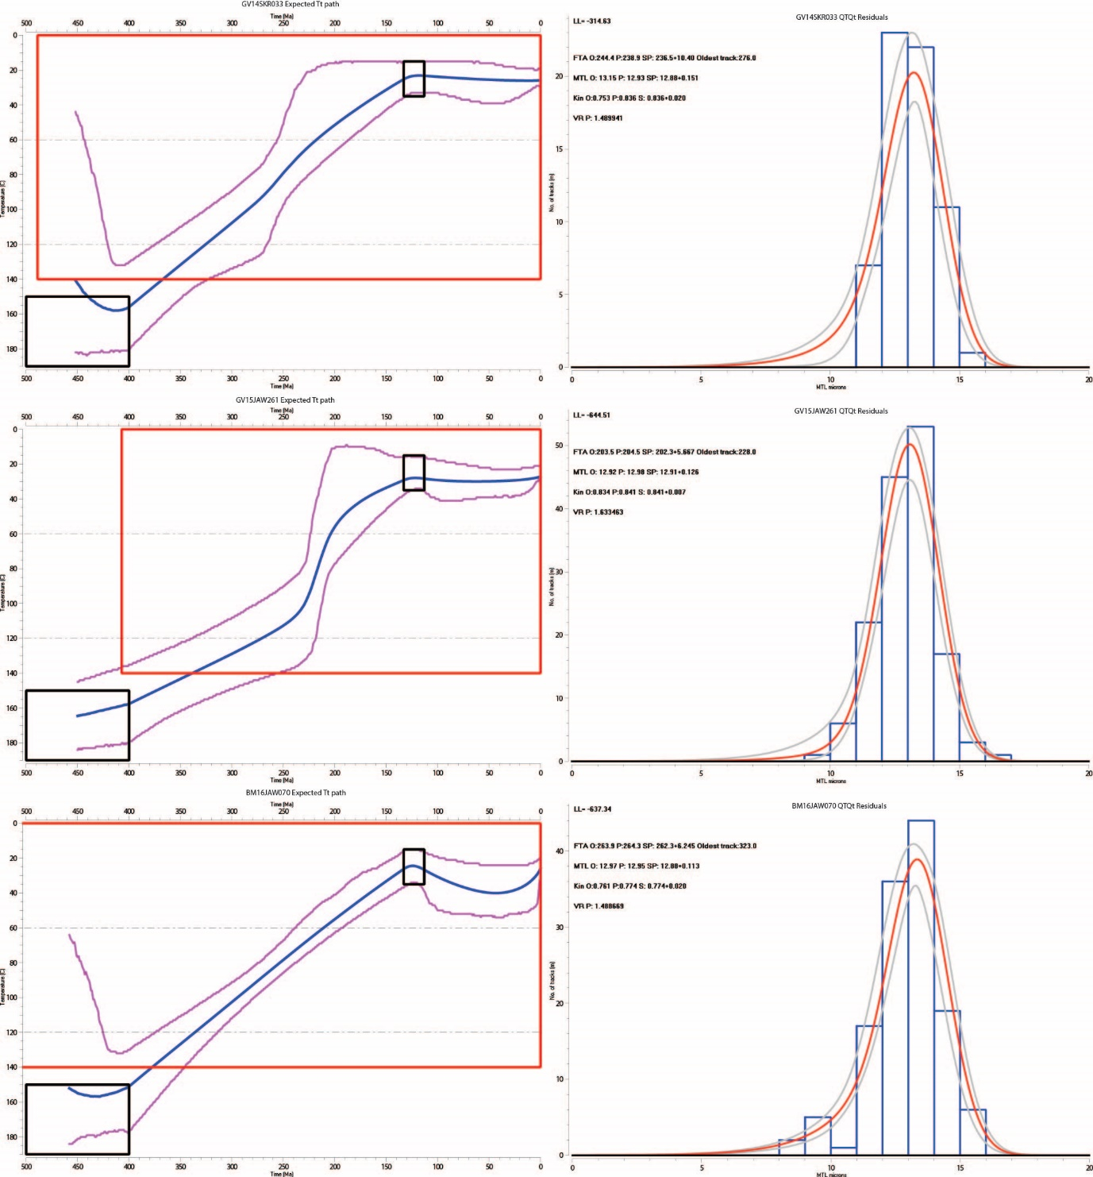
Fig. S7. Thermal history ‘expected’ model outputs and associated model residuals for all modelled Pine Creek Orogen and Arnhem Province samples (Gallagher 2012). Samples were modelled using r_{mr0} as the kinetic parameter, and inputs of AFT single-grain ages and confined tracks. Samples CS-1, CS-4 and CS-8 addiitonally were modeled using AHe data. Thermal history model input and rational is provded in Table S3.
CS-4 and CS-8 were modelled with additional AHe data. Modelling inputs are provided in Table S3 and individual sample model outputs shown in Fig. S7. Both Pine Creek Orogen and Arnhem Province samples display good agreement between ‘observed’ and ‘predicted’ ages and MTLs, and are all considered reliable models.

Pine Creek Orogen REE
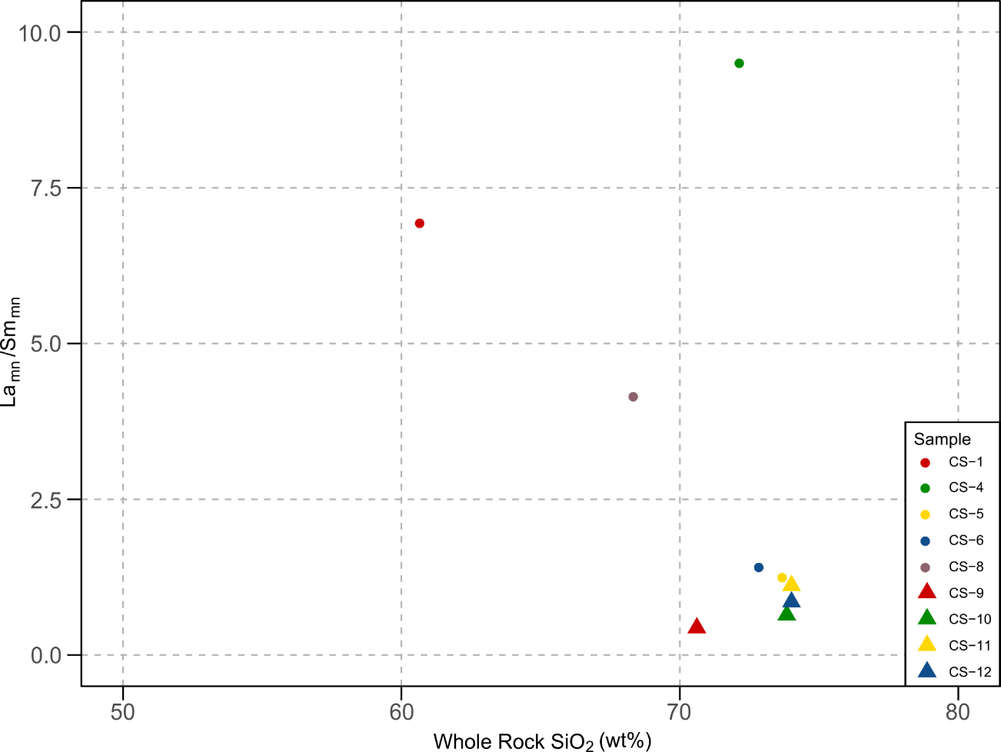
Depletion of LREE elements in apatite crystals from granitic samples from the Cullen Supersuite is observed proximal to the Pine Creek Shear-Zone, as expressed in a marked decrease in primitive mantle normalised La/Sm ratios (McDonough & Sun 1995) towards the shear-zone. This trend does not appear to be linked to SiO₂ content of sampled rocks (Fig. S8), which supports a process of fluid-rock interaction as responsible for LREE depletion in recrystallised apatite due to competition from coeval growth of epidote (Glorie et al. 2019). While no direct petrology exists for samples analysed in this study, metasomatism and fluid alteration of granitiods is common within the Pine Creek Orogen (Stuart-Smith et al. 1993).
Fig. S8. Comparison of average mantle normalised La/Sm ratios (McDonough & Sun 1995) of apatite crystals from granitiods from the Pine Creek Orogen with whole rock SiO₂ content of respective units. Whole rock SiO₂ is plotted as average SiO₂ content from each unit from data in Ahmad et al. (1993), Stuart-Smith et al. (1993) and Sheppard (1995).
Arnhem Province REE
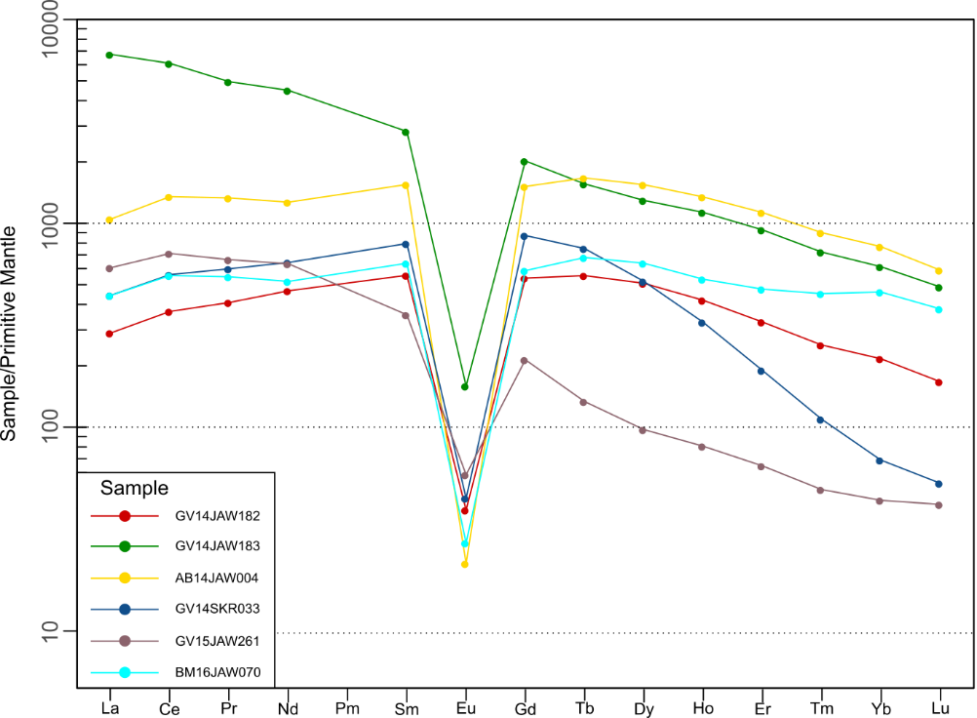
Apatite crystals from Arnhem Province samples yield broadly flat to negative normalised REE trends (Fig. S9), where the primary differentiation between samples is evident in REE abundance. Sample GV14JAW183 from the Giddy Granite displays a comparative elevation in light rare earth elements (LREEs) with respect to other Arnhem Province samples. Sample GV15JAW261 from the Sir Rodericks Metagabbro exhibits a comparative depletion in mid (MREEs) and heavy rare earth elements (HREEs), while sample GV14SKR033 from the Drimmie Head Granite is depleted only in HREEs. Samples AB14JAW004, BM16JAW070 and GV14JAW182 yield comparatively similar REE abundances, and also exhibit the flattest average REE trends.
Fig. S9. Apatite REE geochemistry of Arnhem Province samples. Spiderplots have been normalised to primitive mantle values of McDonough and Sun (1995).

References
Ahmad, M., Wygralak, A.S., Ferenczi, P.A. & Bajwah, Z.U. 1993. Pine Creek, Northern Territory. 1:250 000 geological map series explanatory notes, SE 52-8. Northern Territory Geological Survey, Darwin.

Carlson, W.D., Donelick, R.A. & Ketcham, R.A. 1999. Variability of apatite fission-track annealing kinetics: I. Experimental results. American Mineralogist, 84, 1213-1223, doi: https://doi.org/10.2138/am-1999-0901.

Chew, D.M., Babechuk, M.G., Cogné, N., Mark, C., O'Sullivan, G.J., Henrichs, I.A., Doepke, D. & McKenna, C.A. 2016. (LA,Q)-ICPMS trace-element analyses of Durango and McClure Mountain apatite and implications for making natural LA-ICPMS mineral standards. Chemical Geology, 435, 35-48, doi: https://doi.org/10.1016/j.chemgeo.2016.03.028.

Chew, D.M., Petrus, J.A. & Kamber, B.S. 2014. U-Pb LA-ICPMS dating using accessory mineral standards with variable common Pb. Chemical Geology, 363, 185-199, doi: https://doi.org/10.1016/j.chemgeo.2013.11.006.

Flowers, R.M., Farley, K.A. & Ketcham, R.A. 2015. A reporting protocol for thermochronologic modeling illustrated with data from the Grand Canyon. Earth and Planetary Science Letters, 432, 425-435, doi: https://doi.org/10.1016/j.epsl.2015.09.053.

Gallagher, K. 2012. Transdimensional inverse thermal history modeling for quantitative thermochronology. Journal of Geophysical Research: Solid Earth, 117, 1-16, doi: https://doi.org/10.1029/2011jb008825.

Glorie, S., Jepson, G., Konopelko, D., Mirkamalov, R., Meeuws, F., Gilbert, S., Gillespie, J., Collins, A.S., Xiao, W., Dewaele, S. & De Grave, J. 2019. Thermochronological and geochemical footprints of post-orogenic fluid alteration recorded in apatite: Implications for mineralisation in the Uzbek Tian Shan. Gondwana Research, 71, 1-15, doi: https://doi.org/10.1016/j.gr.2019.01.011.

Hughes, J.M. & Rakovan, J. 2002. The crystal structure of apatite, Ca5(PO4)3(F,OH,Cl). Reviews in Mineralogy and Geochemistry, 48, 1-12, doi: https://doi.org/10.2138/rmg.2002.48.1.

Ketcham, R.A., Donelick, R.A. & Carlson, W.D. 1999. Variability of apatite fission-track annealing kinetics: III. Extrapolation to geological time scales. American Mineralogist, 84, 1235-1255, doi: https://doi.org/10.2138/am-1999-0903.

Marks, M.A.W., Wenzel, T., Whitehouse, M.J., Loose, M., Zack, T., Barth, M., Worgard, L., Krasz, V., Eby, G.N., Stosnach, H. & Markl, G. 2012. The volatile inventory (F, Cl, Br, S, C) of magmatic apatite: An integrated analytical approach. Chemical Geology, 291, 241-255, doi: https://doi.org/10.1016/j.chemgeo.2011.10.026.

McDonough, W.F. & Sun, S.S. 1995. The composition of the Earth. Chemical Geology, 120, 223-253, doi: https://doi.org/10.1016/0009-2541(94)00140-4.

McDowell, F.W., McIntosh, W.C. & Farley, K.A. 2005. A precise Ar-40-Ar-39 reference age for the Durango apatite (U-Th)/He and fission-track dating standard. Chemical Geology, 214, 249-263, doi: https://doi.org/10.1016/j.chemgeo.2004.10.002.

O'Sullivan, P.B. & Parrish, R.R. 1995. The importance of apatite composition and single-grain ages when interpreting fission track data from plutonic rocks: a case study from the Coast Ranges, British Columbia. Earth and Planetary Science Letters, 132, 213-224, doi: https://doi.org/10.1016/0012-821X(95)00058-K.

Pan, Y. & Fleet, M.E. 2002. Compositions of the apatite-group minerals: substitution mechanisms and controlling factors. Reviews in Mineralogy and Geochemistry, 48, 13-49, doi: https://doi.org/10.2138/rmg.2002.48.2.

Schoene, B. & Bowring, S.A. 2006. U–Pb systematics of the McClure Mountain syenite: thermochronological constraints on the age of the 40Ar/39Ar standard MMhb. Contributions to Mineralogy and Petrology, 151, 615, doi: https://doi.org/10.1007/s00410-006-0077-4.

Sheppard, S. 1995. Hybridization of shoshonitic lamprophyre and calc‐alkaline granite magma in the early Proterozoic Mt Bundey igneous suite, Northern Territory. Australian Journal of Earth Sciences, 42, 173-185, doi: https://doi.org/10.1080/08120099508728190.

Stuart-Smith, P.G., Needham, R.S., Page, R.W. & Wyborn, L.A.I. 1993. Geology and mineral deposits of the Cullen Mineral Field, Northern Territory. Bureau of Mineral Resources, Australia, 229.

Vermeesch, P. 2017. Statistics for LA-ICP-MS based fission track dating. Chemical Geology, 456, 19-27, doi: https://doi.org/10.1016/j.chemgeo.2017.03.002.

Vermeesch, P. 2018. IsoplotR: A free and open toolbox for geochronology. Geoscience Frontiers, 9, 1479-1493, doi: https://doi.org/10.1016/j.gsf.2018.04.001.

