Pliocene river capture and incision of the northern Altiplano: Machu Picchu, Peru

Benjamin Gérard^{1*}, Laurence Audin¹, Xavier Robert¹, Cécile Gautheron², Peter van der Beek^{1,3}, Matthias Bernet¹, Carlos Benavente^{4,5} & Fabrizio Delgado^{4,5}

¹Univ. Grenoble Alpes, Univ. Savoie Mont Blanc, CNRS, IRD, IFSTTAR, ISTerre, 38000 Grenoble, France
²Université Paris-Saclay, CNRS, GEOPS, 91405, Orsay, France
³Institut für Geowissenschaften, Universität Potsdam, 14476 Potsdam, Germany
⁴INGEMMET, Instituto Geológico, Minero y Metalúrgico, Lima, Perú
⁵Facultad de Ciencias e Ingeniería, Pontificia Universidad Católica del Perú, Lima, Perú
*Now at GET, Université de Toulouse, CNRS, IRD, UPS, (Toulouse), France. Correspondence (e-mail: benjamin.gerard.alpes@gmail.com)

Supplementary Material

- Introduction
- Supplementary Figure 1: Swath profiles around Machu Picchu to estimate the relief wavelength (λ) for relief amplitude > 1 km
- Supplementary Figure 2: Present-day rainfall pattern of southern Peru
- Supplementary Figure 3: Thermochronological sampling
- Supplementary Figure 4: AFT single-grain data and radial plot for sample AB-17-20
- Supplementary Figure 5: AFT single-grain data and radial plot for sample AB-17-64
- Supplementary Figure 6: AFT single-grain data and radial plot for sample AB-17-67
- Supplementary Figure 7: AFT single-grain data and radial plot for sample AB-17-68
- Supplementary Figure 8: AFT single-grain data and radial plot for sample AB-17-69
- Supplementary Figure 9: Comparison of time-temperature (T-t) modelling predictions using the Gautheron et al. (2009) and the Flowers et al. (2009) AHe radiation-damage models.
- Supplementary Figure 10: QTQt inversion outcomes from Ruiz et al. (2009) data.
- Supplementary Table 1. Apatite (U-Th-Sm)/He data – Durango standard
- Supplementary Table 2: track-length measurements for AB-17-69
- Supplementary References cited
Introduction

This document includes additional information addressing the Machu Picchu study area. We constructed swath profiles around the study area to extract the present-day relief in order to quantify the relief wavelength of the region to reliably interpret our results (Supplementary Figure 1). The present-day climatic context is presented in Supplementary Figure 2. We sampled 7 sites forming an altitudinal profile on the flanks of the deeply incised Urubamba valley (Supplementary Figure 3) in the Machu Picchu Geopark. Single-grain apatite fission track ages for each sample are displayed in the Supplementary Figures 4 to 8 and in Supplementary Table 2. For AHe dating, we present the standard measurement during He extraction associated to each sample (Supplementary Figure 1) in order to show that there are no measurement biases during the extraction protocol. Consequently, He concentrations measured from aliquots and derived ages are reliable (Table 2). We furthermore performed additional time-temperature inversions using QTQt (Gallagher 2012) to test the potential influence of the radiation-damage model used (Flowers et al. (2009) vs. Gautheron et al. (2009); Supplementary Figure 9) and to reexamine data and derived cooling/exhumation rates reported by Ruiz et al. (2009) (Supplementary Figure 10).

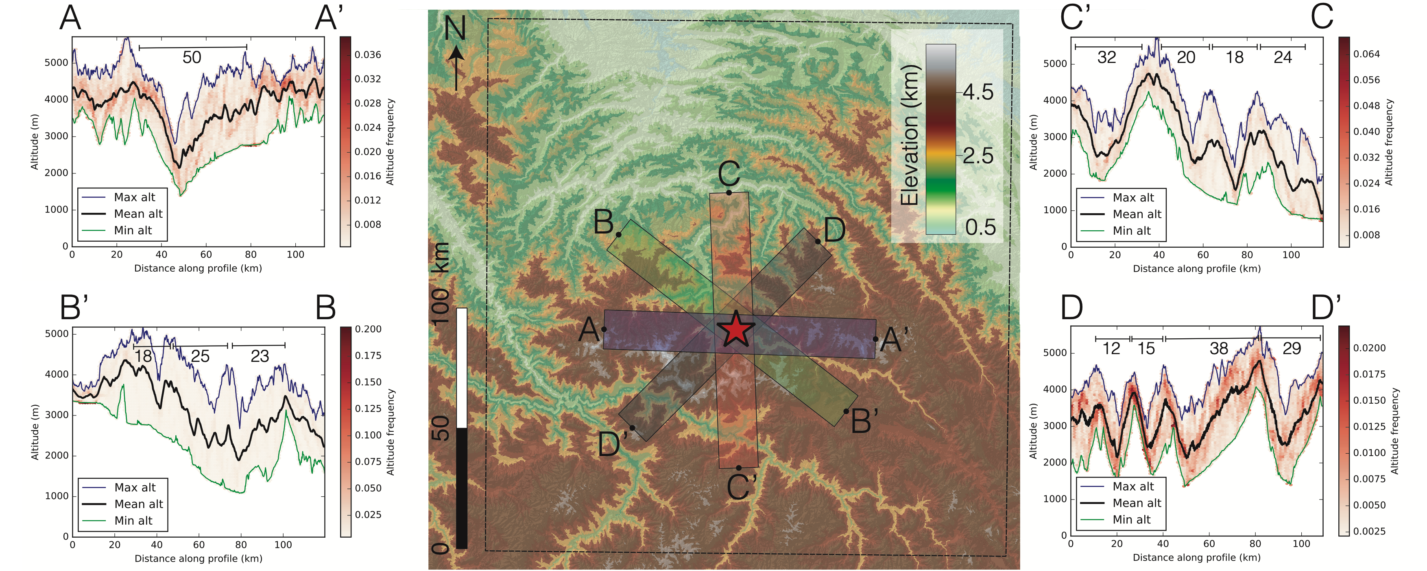
Supplementary Figure 1. Swath profiles around Machu Picchu constructed to estimate the relief wavelength (λ) for relief amplitude >1 km. Boxwidth is ∼15 km and sampling is every 100 m from a SRTM DEM (90 m resolution). The red star corresponds to the vertical profile location. Numbers on topographic plots are the local wavelength between two topographic maxima. Mean λ = 25±8 km. Swath profile acquisition was done using the Python code available at https://github.com/robertxa/pyswath.

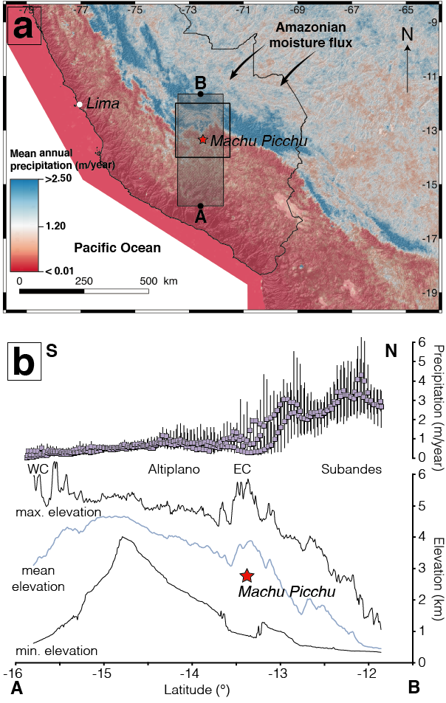
Supplementary Figure 2. Present-day rainfall pattern of southern Peru. a) Map showing the mean annual precipitation rates for southern Peru between 1998 and 2009 (Tropical Rainfall Measuring Mission TRMM; NASA). The black square is the Abancay Deflection. The shaded rectangle (AB) is the location of the latitudinal topographic and rainfall swath profile presented in b. b) Precipitation rates (extracted from TRMM data for the same swath rectangle (AB)) correlated to topography through the Abancay Deflection along the AB swath profile. Rainfall is strongly controlled by the orographic barrier formed by the high Eastern Cordillera (EC) associated with a drastic southward decrease in precipitation rates. Other abbreviation: WC: Western Cordillera
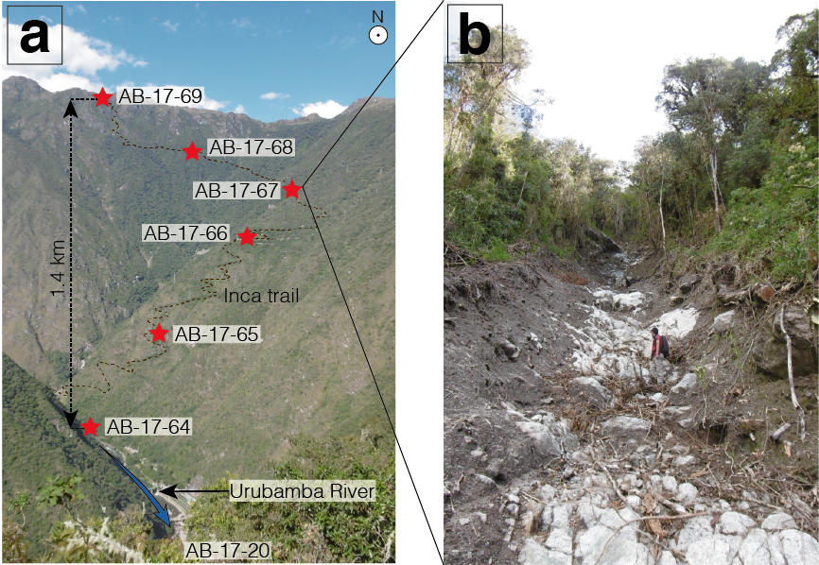
Supplementary Figure 3. Thermochronological sampling. a) Sample locations (red stars) along the Inca trail in the Machu Picchu Geopark. The photo is taken from the Puerta del Sol entrance to the Machu Picchu site, with the Urubamba River flowing toward the viewer (blue arrow). b) Location of sampling site AB-17-67 below an active debris-flow corridor, allowing sampling of fresh bedrock.

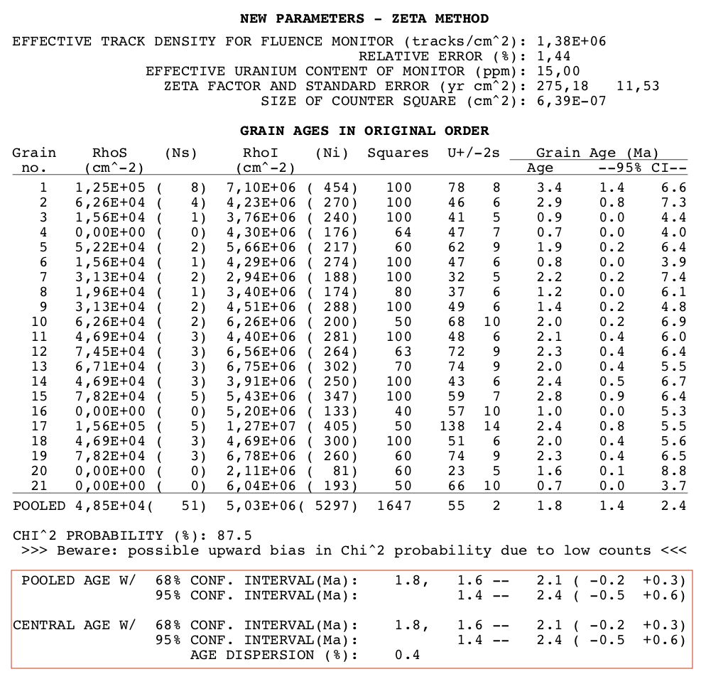
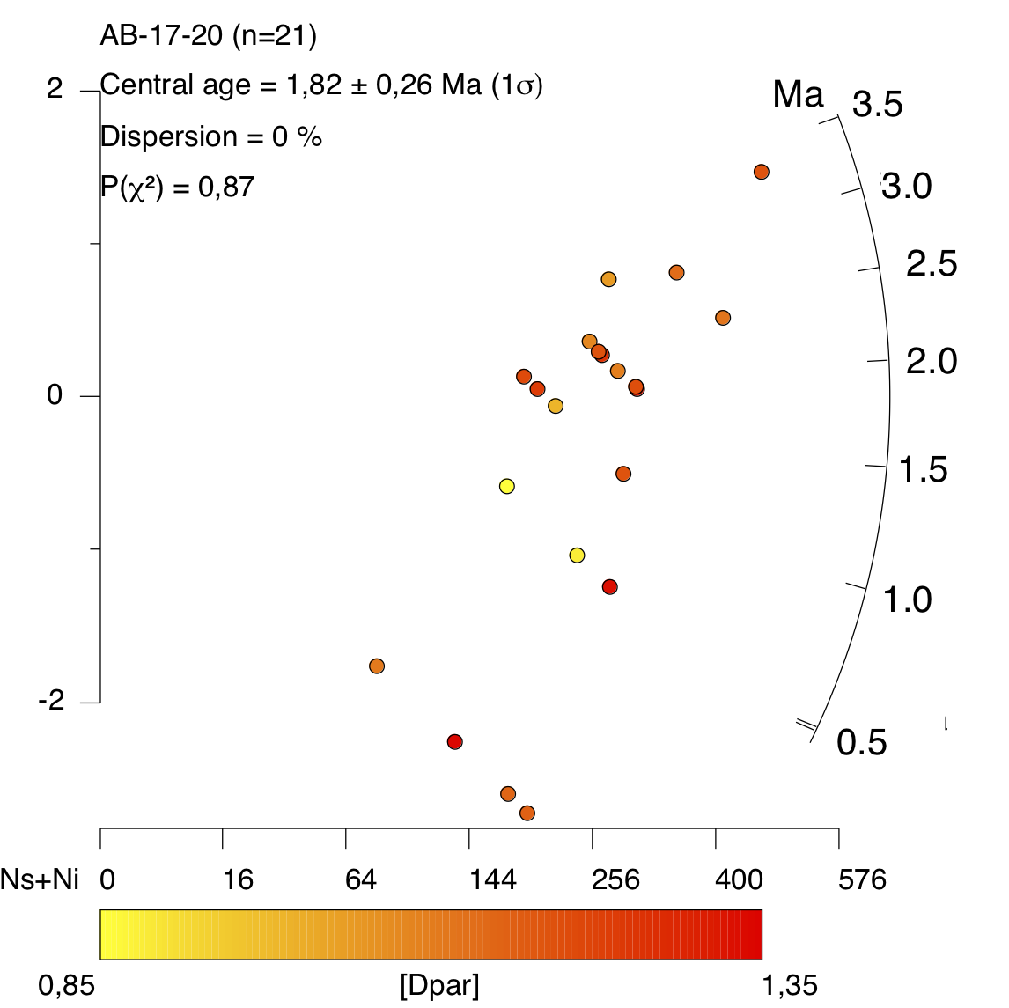

Supplementary Figure 4. AFT single-grain data and radial plot for sample AB-17-20
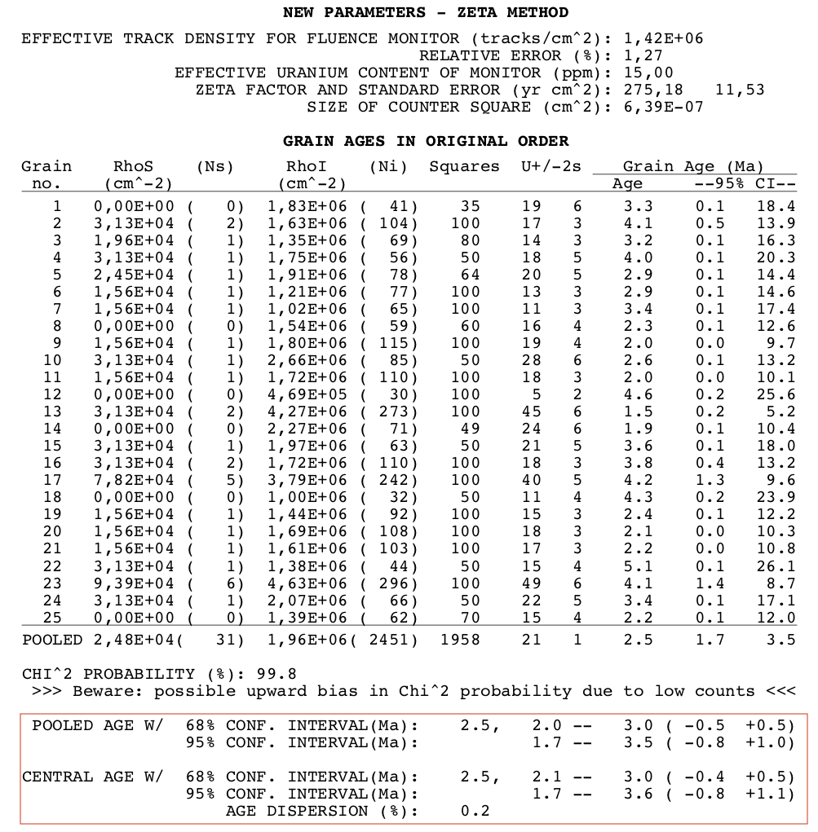
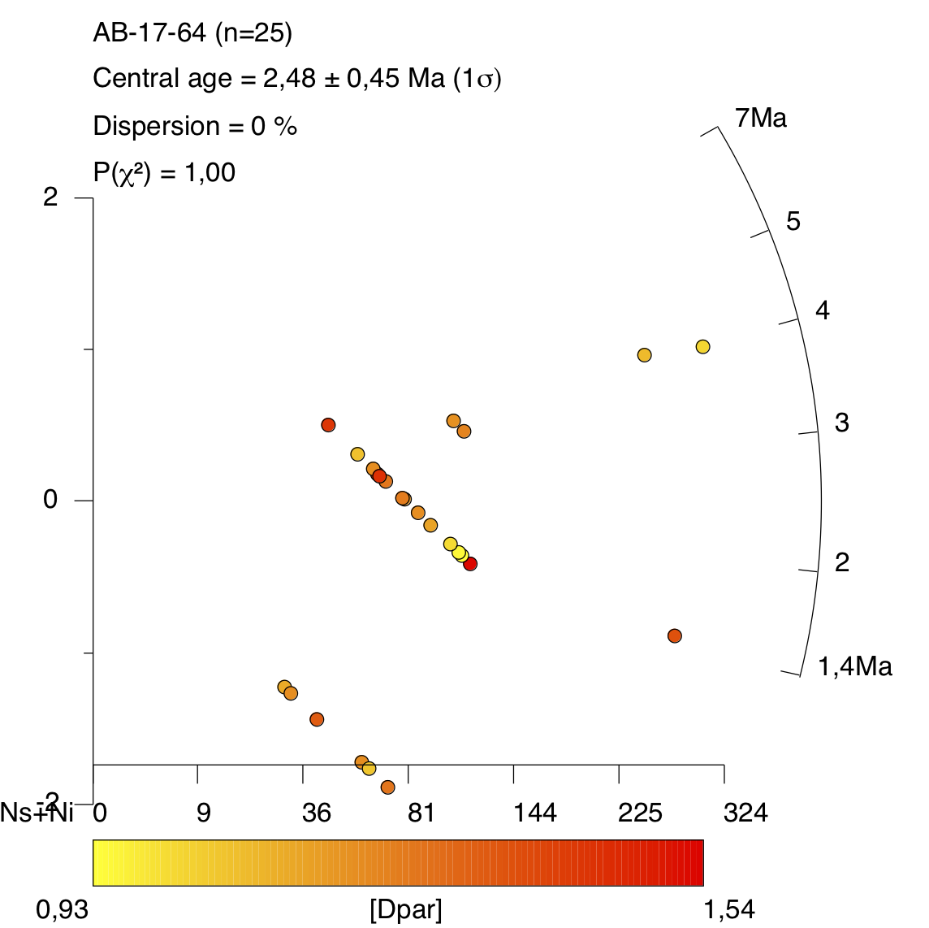
Supplementary Figure 5. AFT single-grain data and radial plot for sample AB-17-64

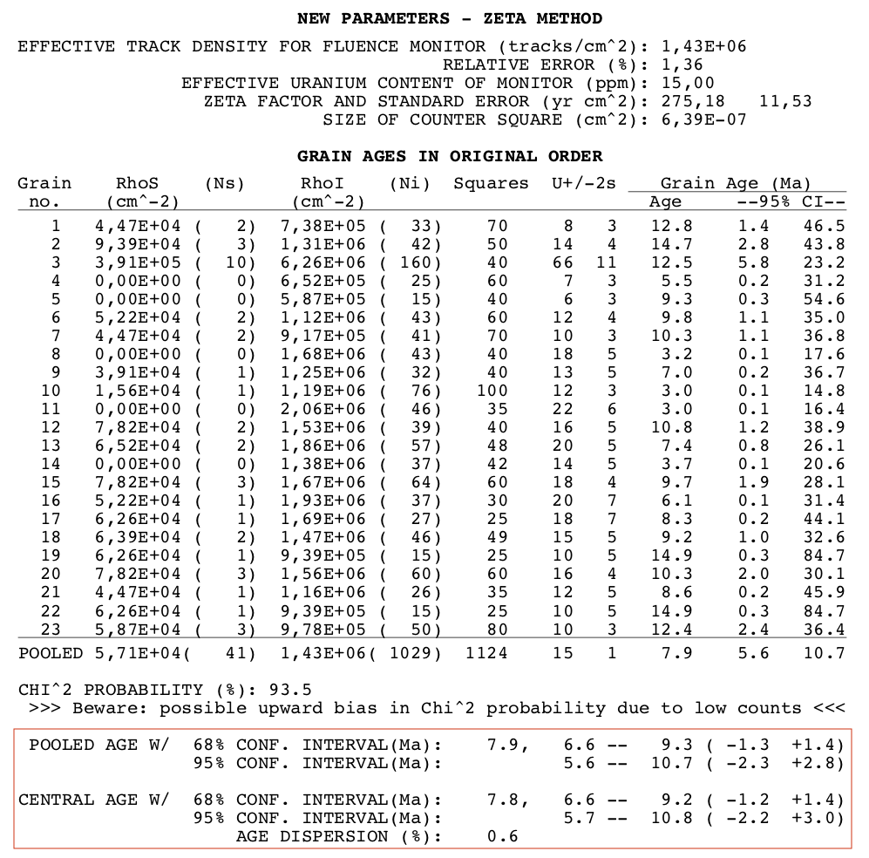
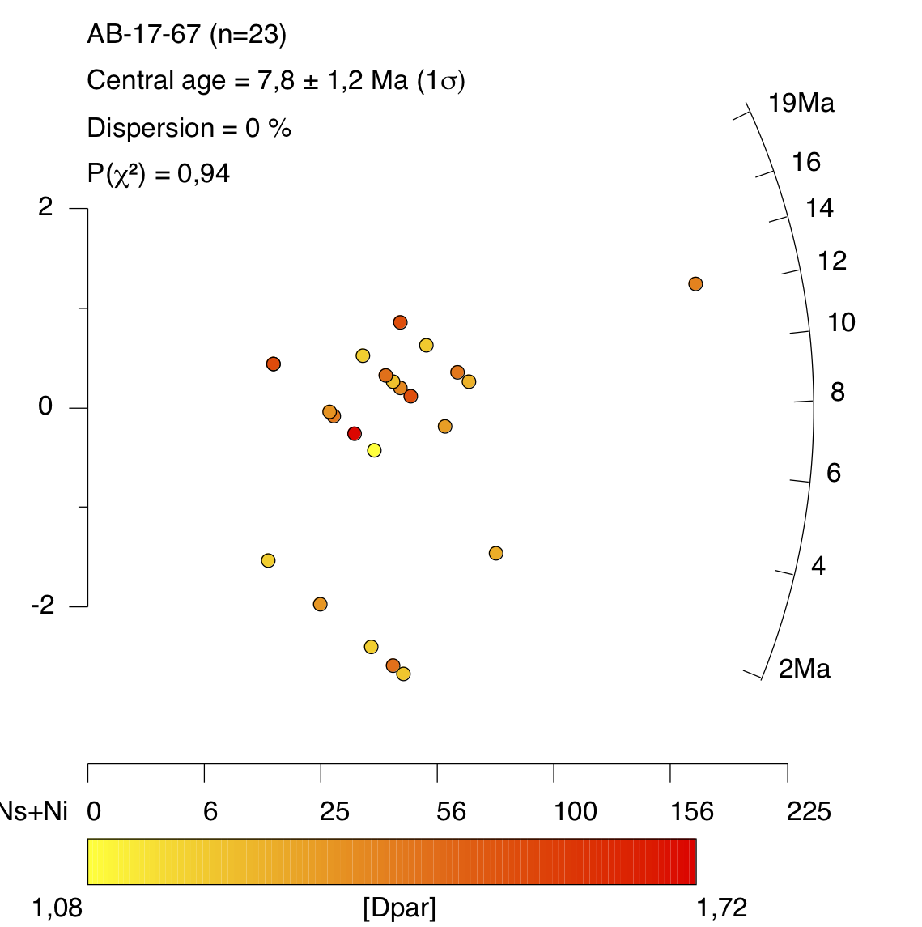
Supplementary Figure 6. AFT single-grain data and radial plot for sample AB-17-67
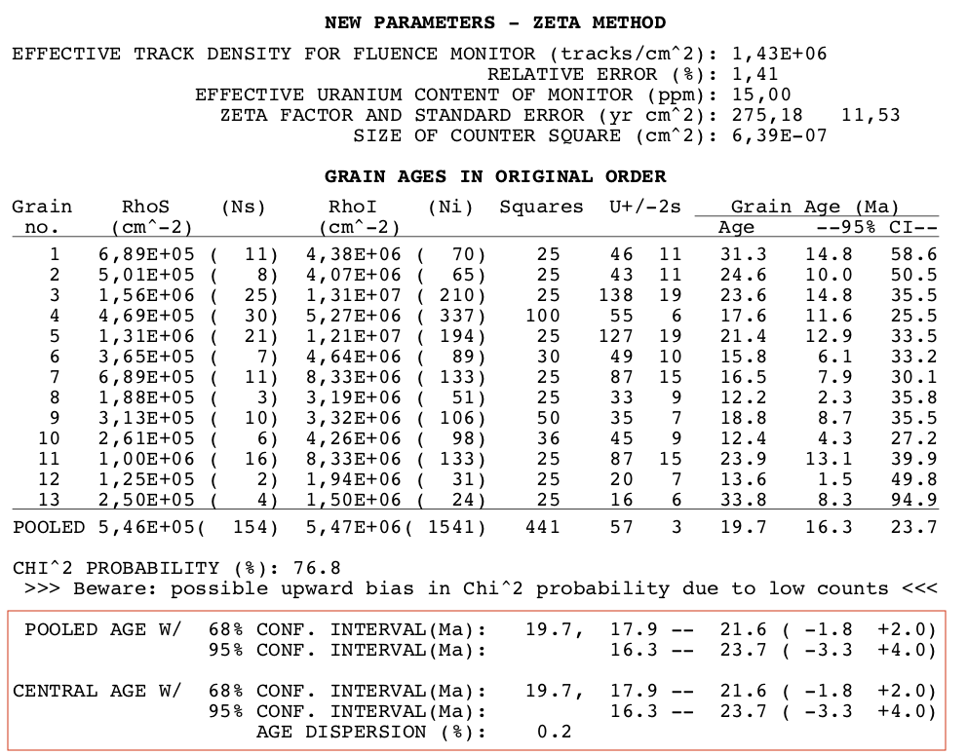
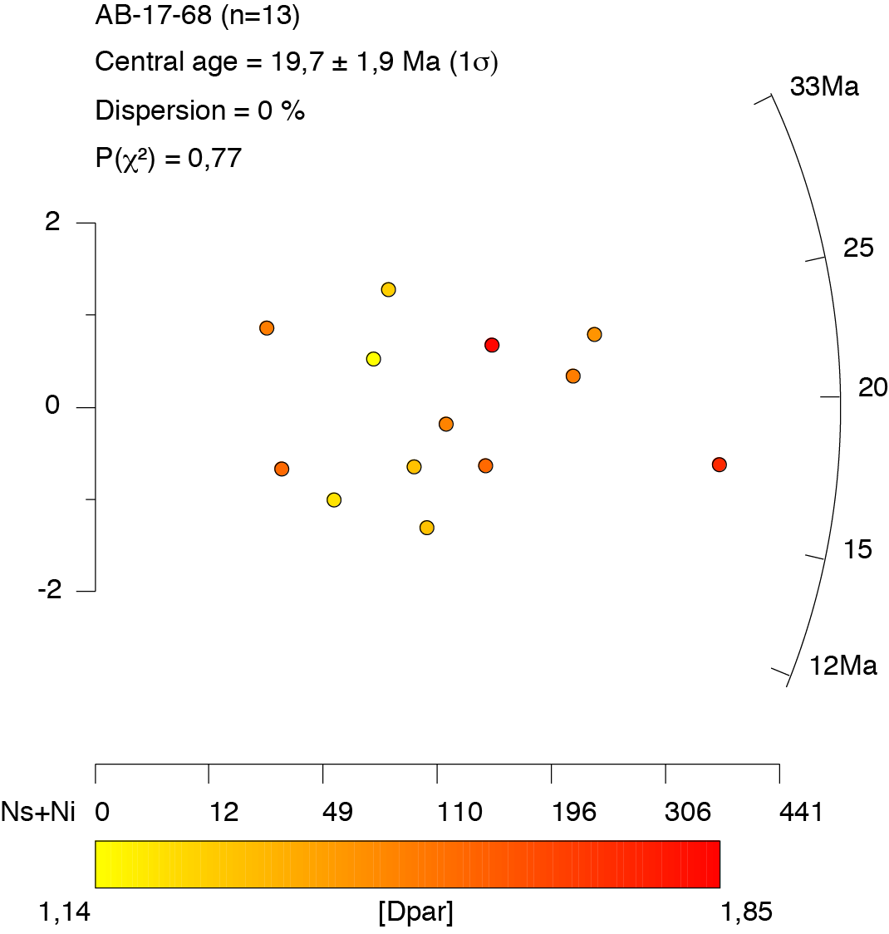
Supplementary Figure 7. AFT single-grain data and radial plot for sample AB-17-68
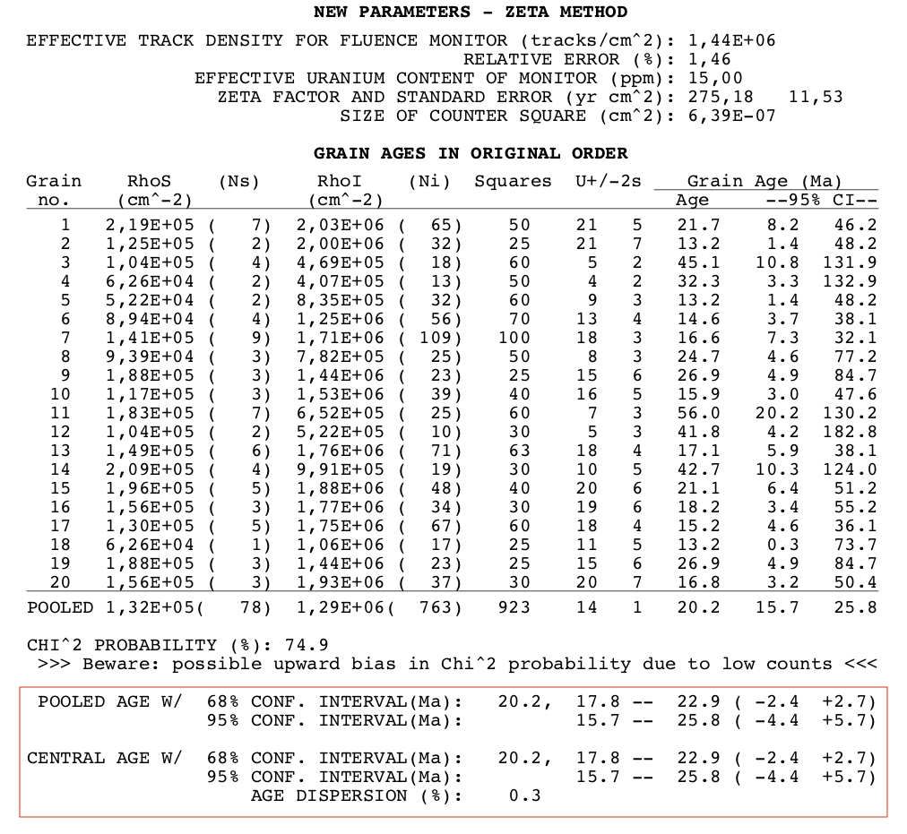
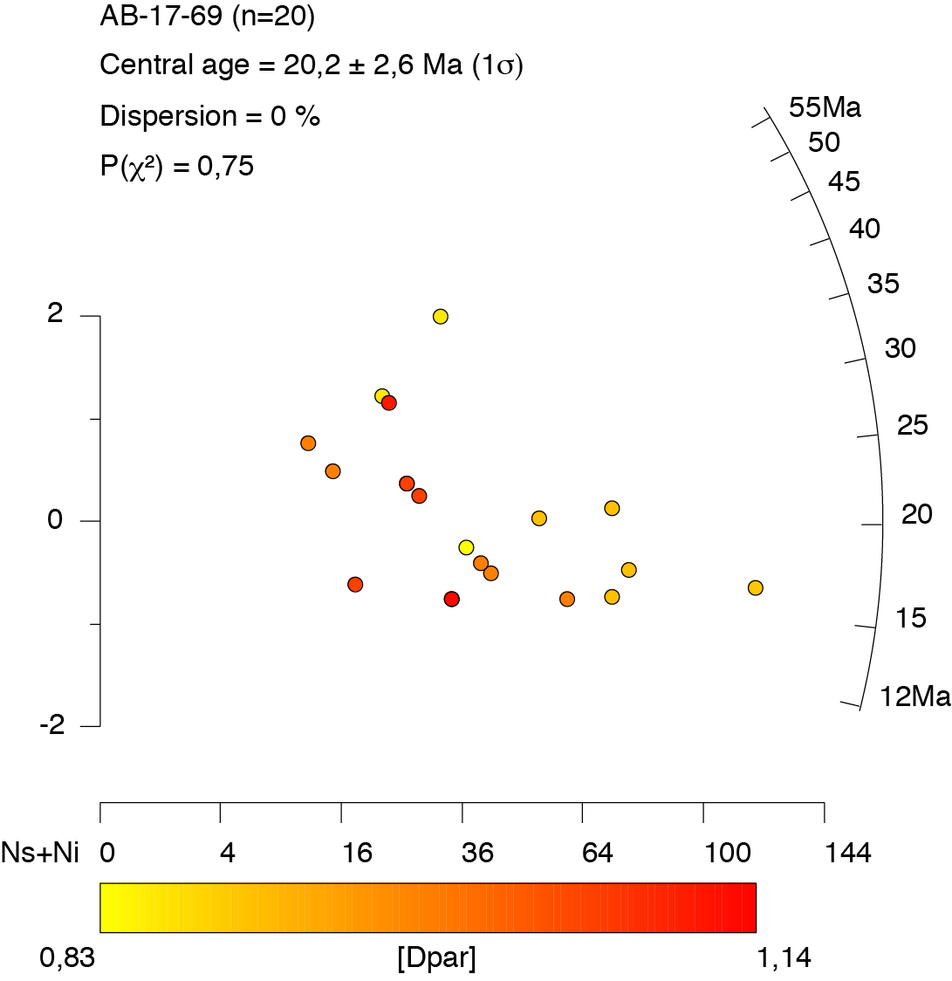
Supplementary Figure 8. AFT single-grain data and radial plot for sample AB-17-69

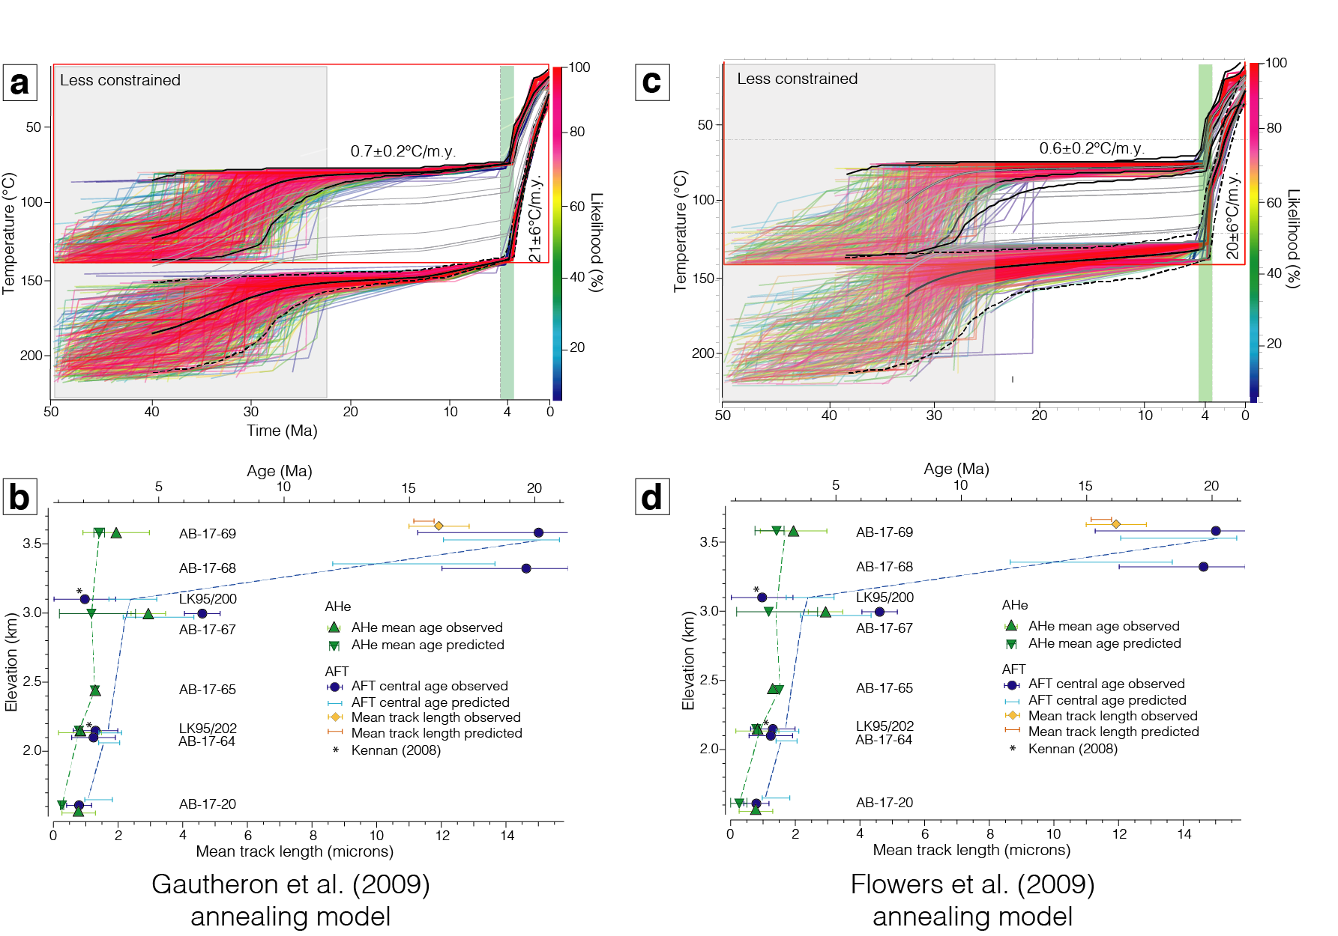
Supplementary Figure 9. Comparison of time-temperature (T-t) modelling predictions using the Gautheron et al. (2009) (a & b) and the Flowers et al. (2009) (c & d) AHe radiation-damage models. a & c) Time-temperature paths obtained by inversion of AHe and AFT thermochronology data using QTQt. The red square shows the explored T-t range for inversion. Coloured lines show the T-t paths for the top and the bottom samples with their respective likelihood (colour scale on right). Solid and dashed black lines show the expected model and its 95% reliable interval for the thermal histories of the top and bottom samples, respectively. Grey lines represent the expected cooling paths for intermediate samples. The green vertical band indicates acceleration of cooling at ∼4.0 Ma. Cooling rates derived from QTQt are indicated on the graph. b & d) Fit of best-fit QTQt model predictions to the data for the Machu Picchu elevation profile. Whatever the radiation damage model processed, there are no significant change of the best-fitting cooling paths.

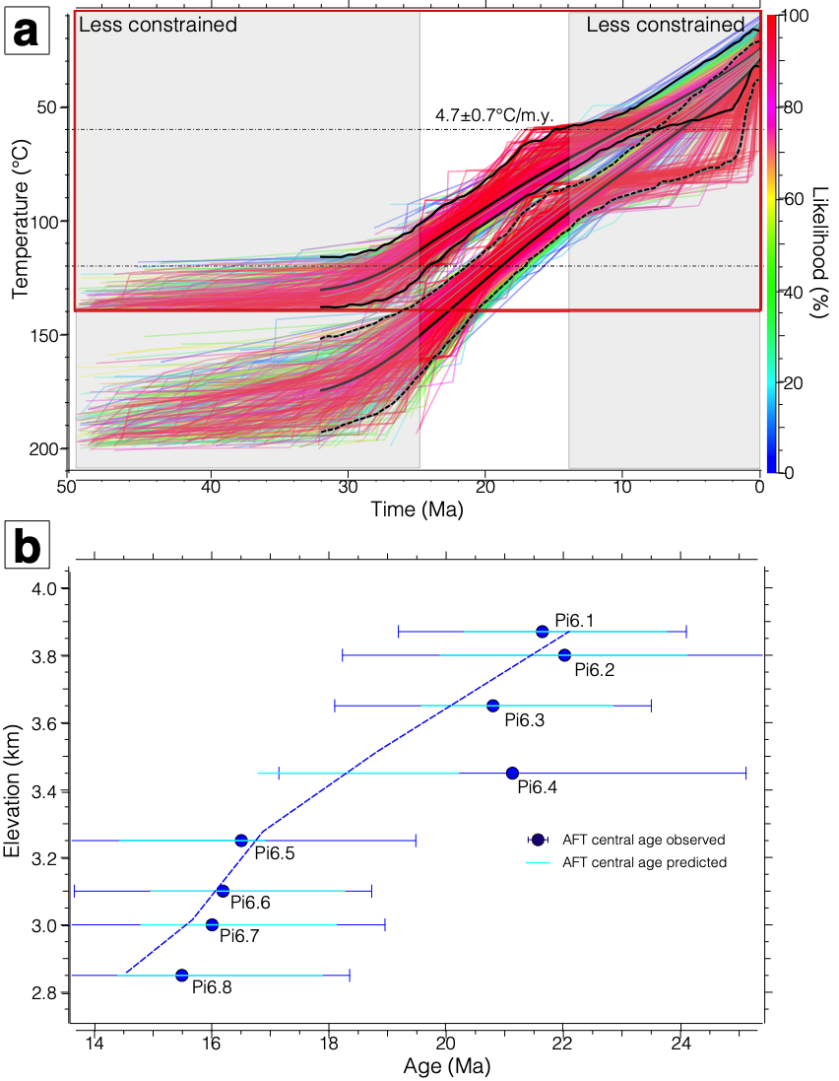
Supplementary Figure 10. QTQt inversion outcomes from Ruiz et al. (2009) data in order to compare the derived exhumation rates with our results. a) Time-temperature paths obtained by inversion of AFT thermochronology data (#4 on Fig. 1) using QTQt. The red square shows the explored time and temperature range for inversion. The colored lines show the T-t paths for the top and the bottom samples with their respective likelihood (see color scale on right). The solid and dashed black lines show the expected model and its 95% reliable interval for the thermal histories of the top and bottom samples, respectively. The grey lines represent the expected cooling paths for the intermediate samples. Cooling rates derived from QTQt are indicated on the graph. Using a geothermal gradient of 47±10°C/km (Ruiz et al. 2009), we can derive an exhumation rate of 0.10±0.02 km/m.y. between ∼25 and ∼15 Ma for the Altiplano area. b) Fit of best-fit model predictions to the data.

Supplementary Table 1. Apatite (U-Th-Sm)/He data – Durango standard
Standard sample number | Associated sample | ⁴He  (nccSTP/g) | ²³⁸U  (ppm) | ²³²Th  (ppm) | ¹⁴⁷Sm  (ppm) | Th/U | eU  (ppm) | Corrected age  (Ma) | ± 1 σ
DURMT20 | AB-17-20 | 300252 | 12.9 | 277.1 | 33.3 | 21.5 | 80 | 31.7 | 2.5
DURPT3 | AB-17-64 | 385719 | 15.1 | 312.9 | 36.6 | 20.7 | 90 | 35.8 | 2.9
D19P1Ub | AB-17-64 | 448701 | 21.9 | 441.6 | 50.1 | 20.1 | 127.9 | 29.3 | 1.8
DUR325 | AB-17-65 | 364303 | 16.3 | 319.8 | 31.3 | 19.6 | 93.2 | 32.8 | 2.6
D19P1Vb | AB-17-67 | 47214 | 2.3 | 47.1 | 5.8 | 20.4 | 13.6 | 29.0 | 1.7
DURFA30 | AB-17-67 | 137300 | 7.3 | 118.4 | 12.9 | 16.3 | 35.8 | 32.2 | 2.6
DURFA32 | AB-17-69 | 133150 | 6.2 | 123.8 | 13.1 | 19.8 | 36.0 | 31.0 | 2.5
D19P2Bb | AB-17-69 | 437762 | 19.8 | 404.7 | 48.3 | 20.4 | 117.0 | 31.3 | 1.9

Supplementary Table 2. Track-length measurements for AB-17-69
Grain number | Track length  (μm) | Dpar  (μm) | Deviation angle from C axis  (°)
1 | 11.22 | 1.49 | 87
1 | 11.73 | 1.49 | 6
17 | 12.82 | 1.01 | 40

Supplementary references cited

Flowers, R.M., Ketcham, R.A., Shuster, D.L. & Farley, K.A. 2009. Apatite (U-Th)/He thermochronometry using a radiation damage accumulation and annealing model. Geochimica et Cosmochimica Acta, 73, 2347–2365, https://doi.org/10.1016/j.gca.2009.01.015.
Gallagher, K. 2012. Transdimensional inverse thermal history modeling for quantitative thermochronology. Journal of Geophysical Research: Solid Earth, 117, 1–16, https://doi.org/10.1029/2011JB008825.
Gautheron, C., Tassan-Got, L., Barbarand, J. & Pagel, M. 2009. Effect of alpha-damage annealing on apatite (U-Th)/He thermochronology. Chemical Geology, 266, 166–179, https://doi.org/10.1016/j.chemgeo.2009.06.001.
Ruiz, G.M.H., Carlotto, V., Van Heiningen, P. V. & Andriessen, P.A.M. 2009. Steady-state exhumation pattern in the Central Andes – SE Peru. Geological Society, London, Special Publications, 324, 307–316, https://doi.org/10.1144/SP324.20.

