Jgs2020_101 Campbell et al.
Stress fields of ancient seismicity recorded in the dynamic geometry of pseudotachylyte in the Outer Hebrides Fault Zone, UK
Supplementary Information
Supplementary part 1: Palaeostress inversion parameters and sensitivity analysis
The input parameters set in the palaeostress analysis software “T-Tecto” for inverse analysis include; q1 , the angle of slope for the Mohr’s circle failure lines for intact failure (this approximates the tangent to the Mohr’s circle of a failure line incorporating cohesive strength); q2, the angle of slope for frictional sliding of an existing surface; the stress parameter; d, the threshold value for mechanical compatibility; s, the dispersion parameter for the distribution of angular misfit between the ideal and real slip directions along the faults used to construct the stress tensor; and α, the angular misfit allowed for faults to be attributed to the stress tensor. d is calculated using α, q₁, q₂ and s and cannot be smaller than α.
For the published results we set the parameters as α = 30°, s = 30, d = 30, q₁ = 40°, q₂ = 20°. We use a moderately large value for α because we expect some heterogeneity in the fault orientation and/or slip direction across the large spatial area considered in this study, which might arise from the variable orientation of major fault structures or from temporal variations following nearby slip events. We also consider that with smaller values of α and d, increasing numbers of stress tensors are required to explain the fault slip dataset (see below), resulting in ever-smaller numbers of faults being attributable to each stress tensor, potentially rendering the stress tensor unstable (typically if n < 9, Orife & Lisle, 2006). Hence, we do not restrict α and d too far.
We tested the stability of the published results in response to changes in the input parameters. Increasing d to 60 whilst keeping all other parameters constant produces very similar strike slip and compressional stress tensors to the d = 30 results (Supp. Fig. 1). The extension-dominant strike-slip stress tensor in the manuscript (the orange paleaostress solution in Fig. 8) is a true extensional stress tensor when d = 60, although the principal stress orientations are the same and σ₁ and σ₂ (which have similar magnitude) have merely switched – hence we do consider this consistent with our interpretation in the manuscript. Decreasing d to 15 (meaning α is also restricted to a maximum of 15°) does generate some significant changes in the stress tensor results; three compressional fields are now defined, with NW-SE, NNE-SSW and E-W orientations for σ₁, plus two strike-slip fields, one of which is very similar to the strike-slip stress tensor produced at higher values of d with ENE-WNW σ₃ (Supp. Fig. 1). In each of these stress tensors, the number of compatible faults is never higher than n = 7. We therefore consider that these subsets have become too fragmented to reliably interpret (Nemcok & Lisle, 1995) and prefer to use d = 60 since it produces similar results to d = 30. Using a higher d value also allows us to increase α to 30 to incorporate faults with greater misfits in the slip directions.
Decreasing s to 15 produces similar results to s = 30, except that an extra compressional field with NW-SE σ₁ is generated to explain the population of NE-dipping strike slip faults (Supp. Fig. 1). With a smaller s, even if d is relatively large, the stress tensor is influenced more by results that cluster closer to ideal mechanical compatibility (Fig. 2 in Žalohar & Vrabec, 2007). We therefore consider that this rotation of compression may in fact suggest a real feature of the OHFZ deformation history.
q₂ is kept at 20° to represent a lower-bound strength of some surface that theoretically might be reactivated as a slip surface, for example the foliation, although we argue against this in general for the OHFZ pseudotachylyte faults. q₁ is chosen at 40° but could be increased to reflect higher values of cohesion and/or higher differential strength of the rock (i.e. a larger Mohrs circle). At q₁ = 50°, the stress tensors are very similar to q₁ = 40°, however at q₁ = 60°, an additional compressional stress tensor is introduced with σ₁ trending WNW-ESE. This seems to replace the strike slip stress field as the remaining stress tensor with > 3 faults attributed has principal stress orientations similar to other iterations (Supp. Fig. 1).
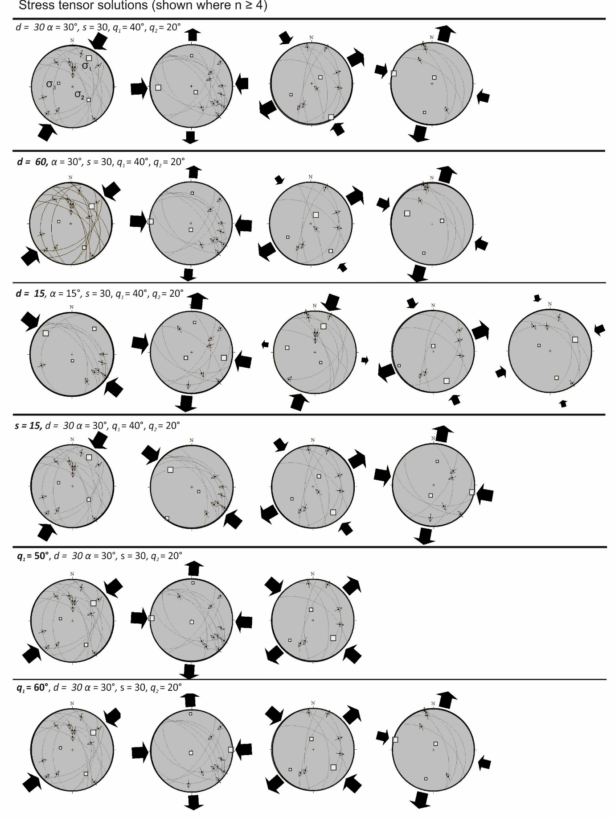

Supplementary Figure 1. Stress tensor solutions using variable parameters. Only solutions compatible with ≥ 4 faults are shown.

