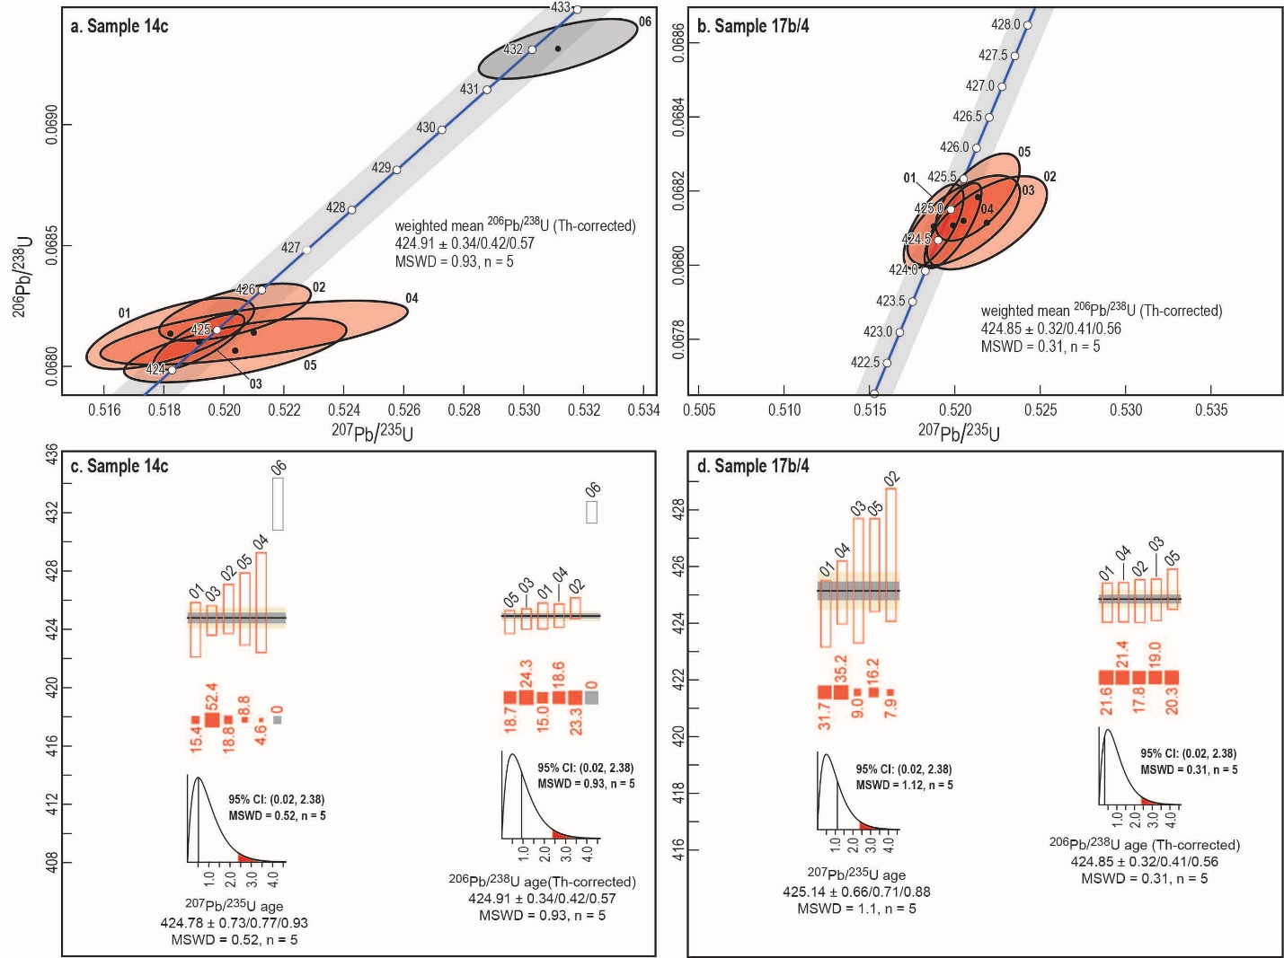
Figure S2. Concordia diagrams for zircon grains dated using CA-ID-TIMS from (a) sample 14c and (b) sample 17b/4. In panels (c) and (d), hollow bars show the ²³⁵U-²⁰⁷Pb and ²³⁸U-²⁰⁶Pb (Th corrected) ages for each grain with the length of the bar indicating the uncertainty for samples 14c and 17b/4, respectively. The bar that runs through the hollow bars is the weighted mean average with bars indicating confidence intervals. In panels (c) and (d), the red bars are the degree of weight given used in the statistical calculations, and the inset graphs are the 95% confidence intervals for the ²³⁵U-²⁰⁷Pb, ²³⁸U-²⁰⁶Pb and ²³⁸U-²⁰⁶Pb (Th corrected) ages. The summary of each of these age groups including errors estimated using different statistically approaches, MSWD and number of grains is provided beneath the confidence intervals. CA-ID-TIMS age data are presented as 2-sigma in the format ± X/Y/Z , where X represents the analytical uncertainty only, Y includes the uncertainty in the composition of the SK5a isotopic tracer, and Z includes all systematic uncertainties including those that arise from the decay constants (Schoene et al., 2006).

