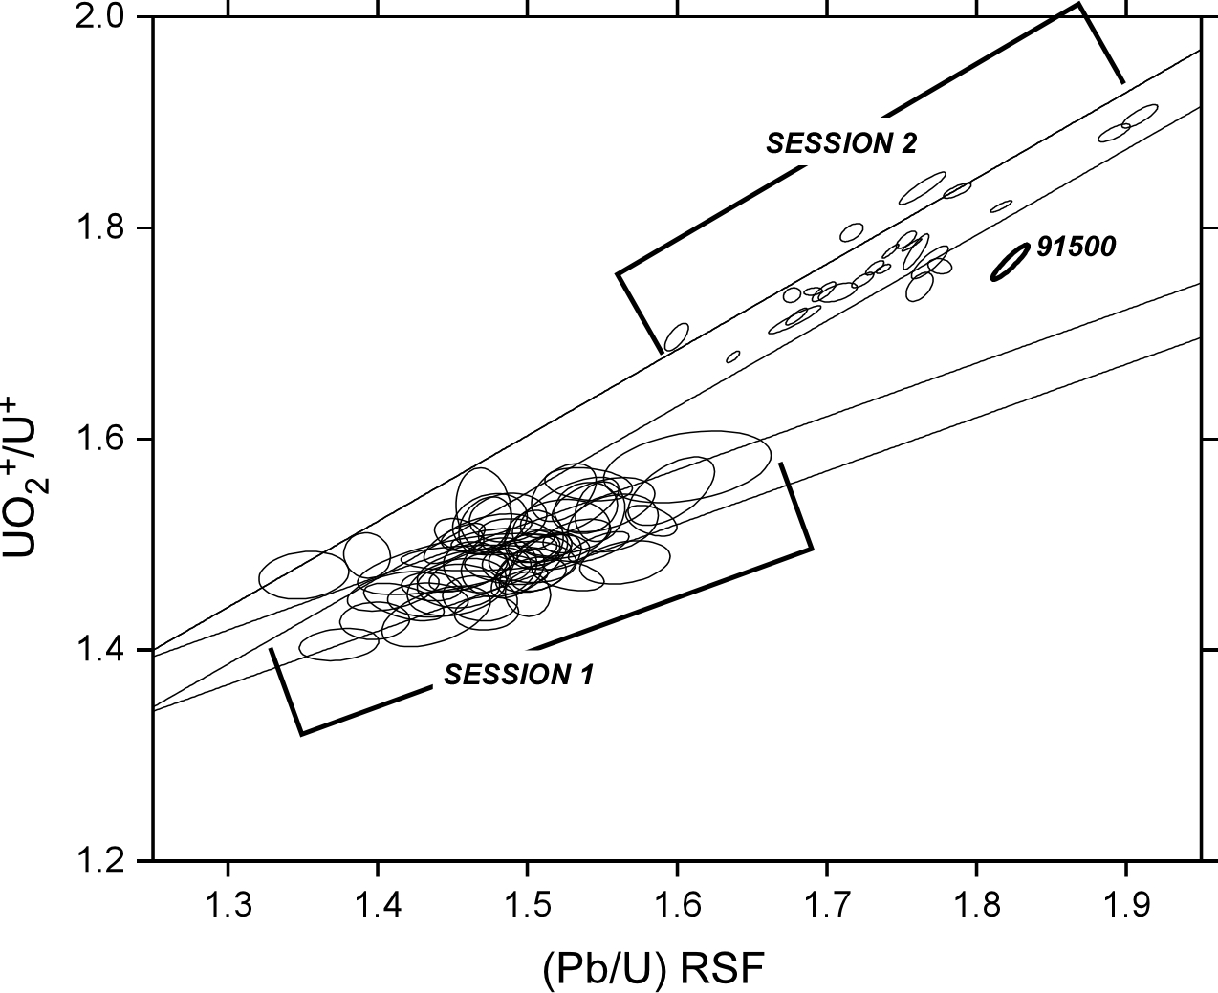

S1 Figure. Calibration curves (UO₂⁺/U⁺) vs. (Pb/U)Relative Sensitivity Factor for AS3 and 91500 standards (indicated) sputtered over sessions 1 and 2. See manuscript text for details regarding the calibration. Straight lines outline the ±1σ regression.

