Supplementary Material

The supplementary material includes 10 figures (Figs. S1-10) and 6 tables (Table S1-6).

Table captions:
Table S1. Crystal sizes and aspect ratios from 197 zircon grains for K-bentonites in Ordovician-Silurian transition across in nine sections in South China
Table S2. LA-ICP-SFMS zircon U-Pb isotopic and analysis of the K-bentonite samples B2, B14 and B18 in the Songmutang section of the Upper Yangtze region
Table S3. Zircon trace element data (in ppm) of the K-bentonite samples B2, B14 and B18 in the Songmutang section of the Upper Yangtze region
Table S4. Major element concentrations of K-bentonites in the Songmutang section of the Upper Yangtze region (wt%)
Table S5. Trace-element concentrations of K-bentonites in the Songmutang section of the Upper Yangtze region (ppm)
Table S6. Mineralogical and geochemical characteristics of K-bentonites from Songmutang section and global K-bentonites

Figure captions:
Fig. S1. Comparative X-ray diffraction patterns of Songmutang K-bentonites and those of South China elsewhere. Data source: YC0709 from Hu et al. (2009); D006X2 from Wang et al. (2015); PY1-V5 from Ge et al. (2019).
Fig. S2. The relation of zircon crystal size and aspect ratio for K-bentonites from South China (A) and Th vs U concentrations of K-bentonite beds from Zhoujiaxi group in Songmutang section (B). Data source: Mayangzhai from Luo et al. (2017b); Taoyuan from Xie et al. (2012); Lunshan from Yang et al. (2019); Anji from Wang et al. (2015); Xinwen, Wuxing and Liangba from Ge et al. (2019) ; Wangjiawan from Hu et al. (2008).
Fig. S3. Comparison of chondrite-normalized REE diagrams for K-bentonite from O-S transition in South China with those of the worldwide elsewhere. The normalization values are from Sun & McDonough (1989), Wangjiawan and Huanghuachang from Hu et al. (2009); Yanzixiang and Liziping from Xiong et al. (2019); Anji from Wang et al. (2015); Mayangzhai from Luo et al. (2017b); Lunshan from Yang et al. (2019); Tianjiawan, Liangbai, Liangcun, Fenghuang and Wuxing date from Ge et al. (2019); Subduction-related dacite from Yi et al. (2014); Precordillera argentine from Huff et al. (1998); Appalachian from Bergström et al. (1998); Podolia from Huff et al. (2000); Isles from Huff et al. (1991).
Fig. S4. Comparison of primitive mantle-normalized multi-elemental patterns for K-bentonite from O-S transition in South China with those in the world elsewhere. The normalization values are from Sun & McDonough (1989), Wangjiawan and Huanghuachang from Hu et al. (2009); Yanzixiang and Liziping from Xiong et al. (2019); Anji from Wang et al. (2015); Mayangzhai from Luo et al. (2017b); Lunshan from Yang et al. (2019); Tianjiawan, Liangbai, Liangcun, Fenghuang and Wuxing from Ge et al. (2019); Subduction-related dacite from Yi et al. (2014); Precordillera argentine from Huff et al. (1998); Appalachian from Bergström et al. (1998); Podolia from Huff et al. (2000); Isles from Huff et al. (1991).
Fig. S5. Temporal-spatial distribution of volcanic events within the global scale during O-S transition from South China, North America, Norway, Sweden and Denmark. Isotopic geochronological dates obtained from K-bentonites in South China (Hu et al. 2008; Xie et al. 2012; Luo et al. 2016; Xiong et al. 2017; Xiong et al. 2019; Yang et al., 2019); North America (Tucker & McKerrow 1995; Min et al. 2001; Smith et al. 2011; Sell et al. 2013); Norway (Sell et al. 2013; Svensen et al. 2015; Ballo et al. 2019), Sweden (Tucker & McKerrow 1995; Min et al. 2001; Bergström et al. 2008; Bauert et al. 2014); Denmark (Min et al. 2001; Sell et al. 2013); Estonia (Sell et al. 2013; Bauert et al. 2014).
Fig. S6. Nb vs Y tectonic discriminant diagrams after Pearce et al. (1984). (A) Comparison of K-bentonites from O-S transition in South China and Early Paleozoic granitoids in Qinling area; (B) Comparison of K-bentonites from O-S transition and Early Paleozoic granitoids in South China. Granitoids in Dabie from Ma et al. (2004) and Zhang et al. (2007); Granitoids in northern Qinling area from Li et al. (2001); Qin et al. (2015); Wang et al. (2009); Ren et al. (2008); Wang et al. (2018); Xu et al. (2018); Yuan et al. (2017); Yao et al. (2017); Abdallsamed et al. (2017); Central Qinling from Qin et al. (2014) and Wang et al. (2017b); Eastern Qinling from Li et al. (2019); Granitoids date in Tongbai from Jiang et al. (2009); Li et al. (2018); Wang et al. (2017a). Granitoids date in eastern Guangxi from Li et al. (2017); Nong et al. (2017); Zou et al. (2017); Jiang et al. (2017); northeastern Guangxi from Bai et al. (2015); Cheng et al. (2016); Chen et al. (2012); Wugongshan from Zhong et al. (2016); Lou et al. (2002); Wu & Zhang (2003); Xu et al. (2006); Cheng et al. (2009); Yunkai area from Peng et al. (2006); Yu et al. (2018); Yan et al. (2017); Wuyi area from Liu et al. (2008); Zeng et al. (2008); Xia et al. (2014); Wang et al. (2011); Southern Jiangxi-Northern Guangdong from Meng et al. (2016); Qin et al. (2018); Luo et al. (2017a); K-bentonite from Hu et al. (2009); Su et al. (2009); Yi et al. (2014); Xiong et al. (2019); Luo et al. (2017b). ORG, ocean ridge granites, VAG, volcanic arc granites, WPG, within-plate granites, Syn-COLG, syn-collision granites.
Fig. S7. The tectonic-lithofacies paleogeographic map show the development of a diachronous and progressive clastic wedge from the southeastern to the northwestern foreland basin in Central Hunan Province during Late Ordovician to Early Silurian (modified from Xiao et al. 2017). (A) Tianmashan Fm, 5-10 cm thick sandstones display Ta-Tc-Td members of Bouma sequence in Daoxian area；(B) Tianmashan Fm, exhibits Bouma Tc and Td divisions in Daoxian area; (C) Zhoujiaxi Gp, thin-bedded facies of sandstones with Bouma Tc-Td-Te members; (D) Zhoujiaxi Gp, thin-bedded facies of siltstone shows are composed of amalgamated Td and Te division; (E) Xiaoheba Fm, the littoral-neritic facies of sandstone; (F) Huixingsao Fm, greyish green siltstones intercalated with mudstones; (G) Rongxi Fm, purple siltstone with mudstone intercalation; (H) Xiushan Fm, alternating sandstone and mudstone.
Fig. S8. Representative field photographs of unconformity interface in Central Hunan Province. (I) Unconformity between the Tianmashan and Tiaomajian Fm in Yongzhou area; (J) Unconformity between the Tianmashan and Tiaomajian Fm in Jiangyong area; (K) Unconformity between the Zhoujixi Gp and Tiaomajian Fm in Xinhua area; (L) Unconformity between the Zhoujixi Gp and Tiaomajian Fm in Dongkou area. The position of unconformity in Fig. S7 are included.
Fig. S9. Regional correlation of Late Ordovician to Early Silurian stratum from SE Cathaysia to the Yangtze region through Xuefeng mountain, South China. Orange areas denote sequence missing; dark and grey, black shales; yellow zones, K-bentonite beds; red zones, shallow marine red beds. Chronostratigraphic subdivision after International Commission on Stratigraphy 2018 (ICS); strata division and contrast mainly after Chen et al. (2014) and Su et al. (2009); K-bentonites chronological data from Ge et al. (2019); Hu et al. (2008) and this study.
Fig. S10. Simpliﬁed geological map of South China Sea and adjacent regions showing the possible Nanhai blocks with Precambrian basement. Some major faults and the location of blocks are modified after Ye et al. (2018); Yang et al. (2017); Guo et al. (2016). The distribution of well and trawl from Liu et al. (2012) and Zhu et al. (2017).

Fig. S1

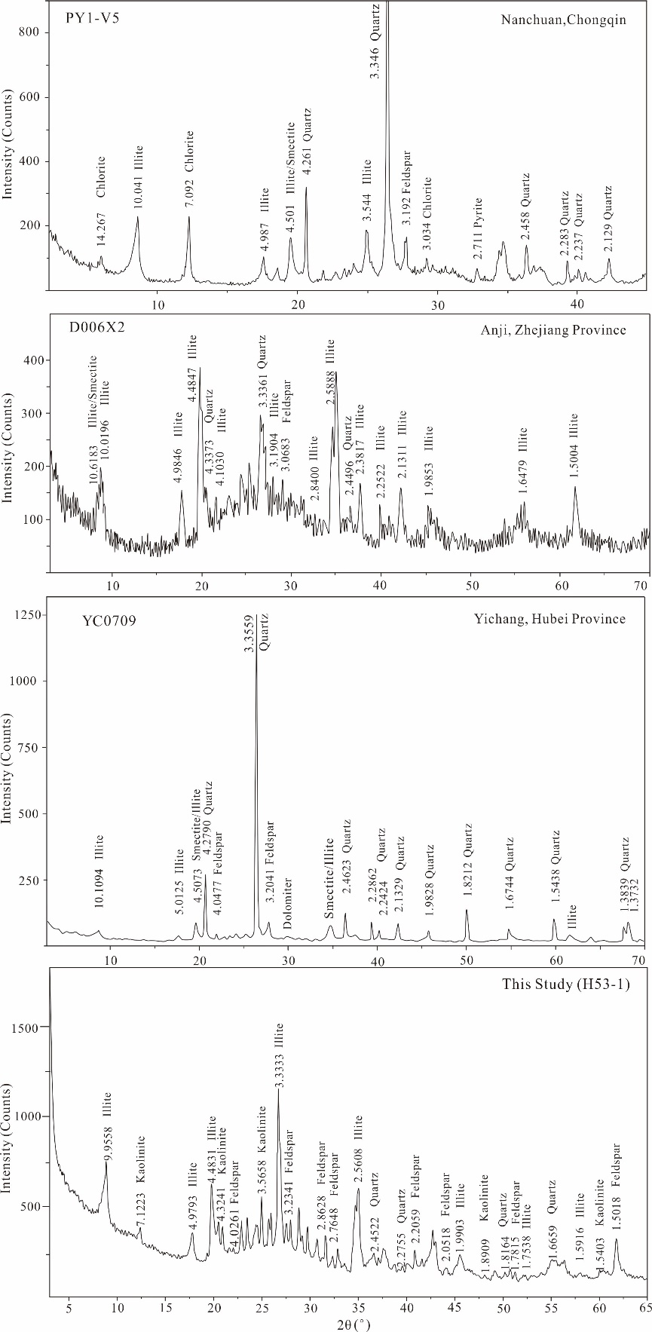

Fig. S2

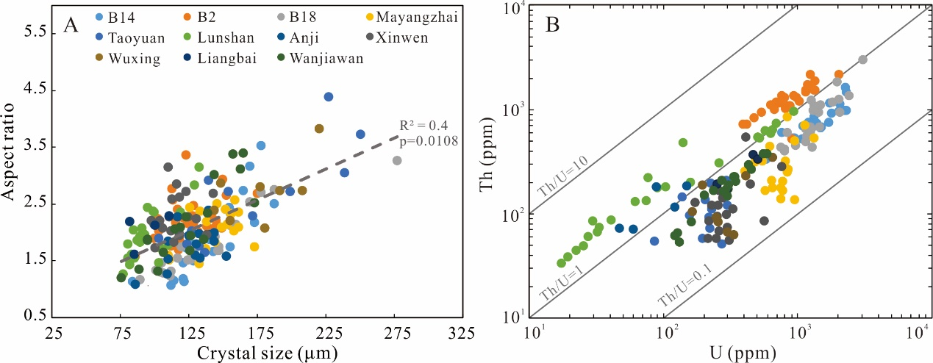

Fig. S3

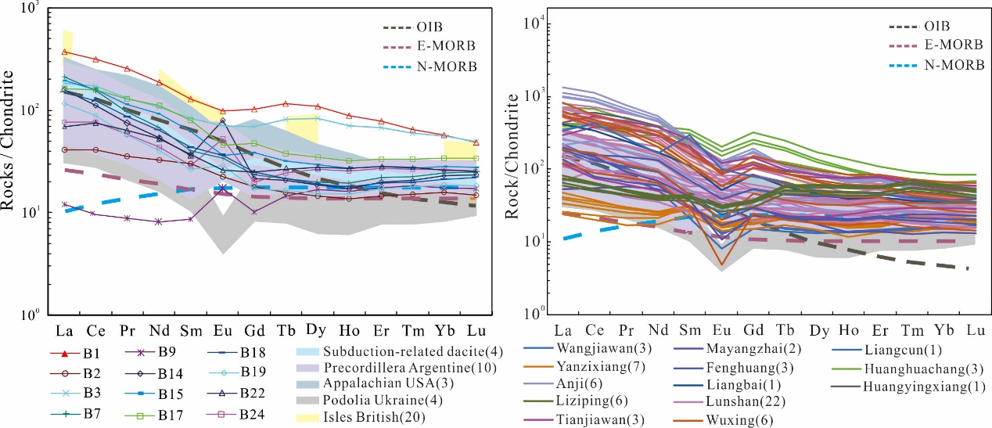

Fig. S4

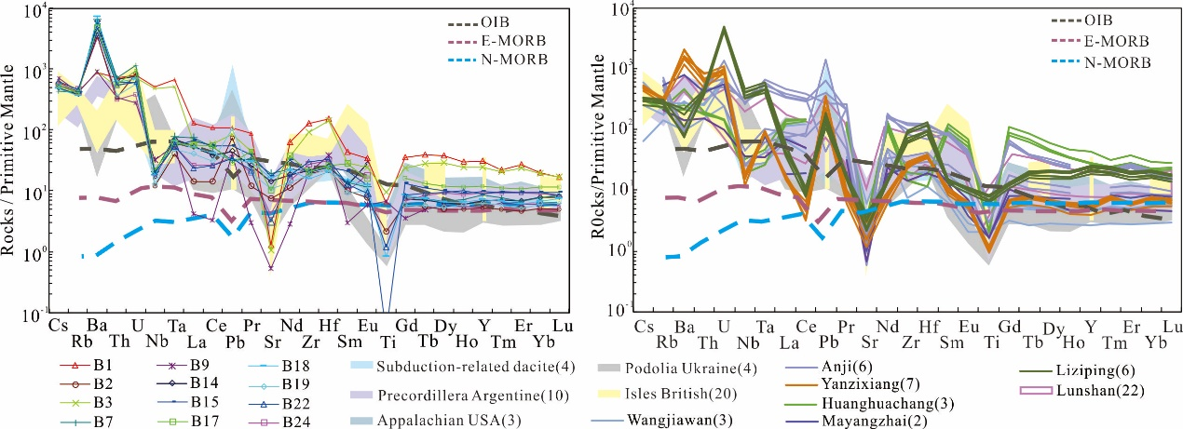

Fig. S5

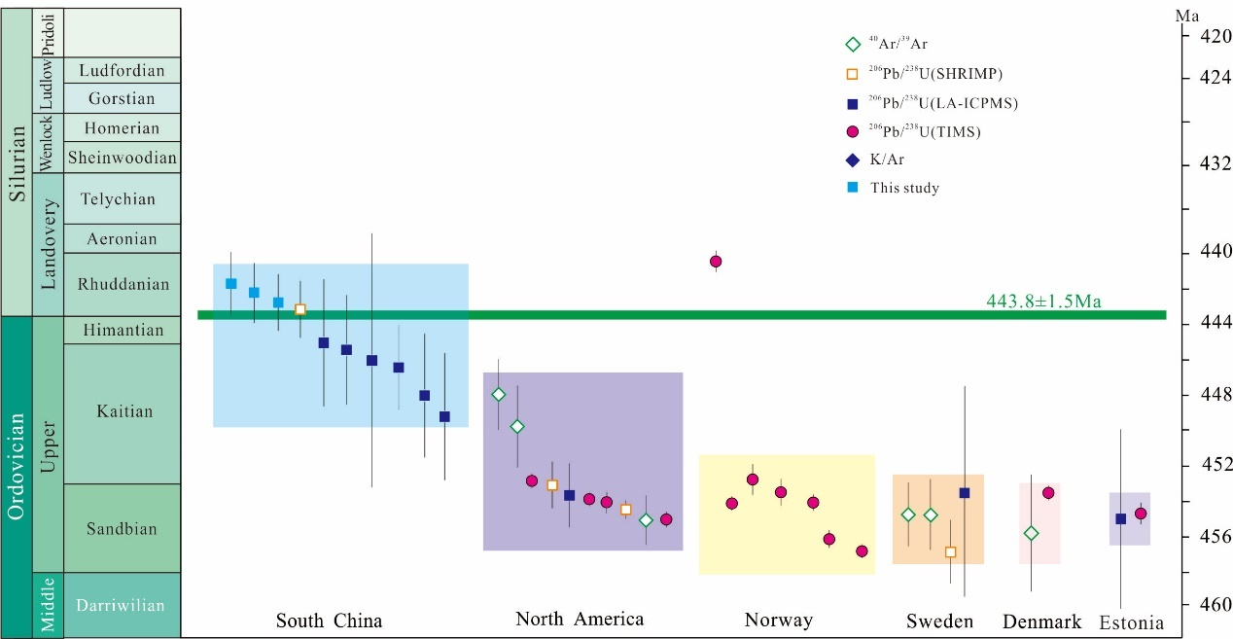

Fig. S6

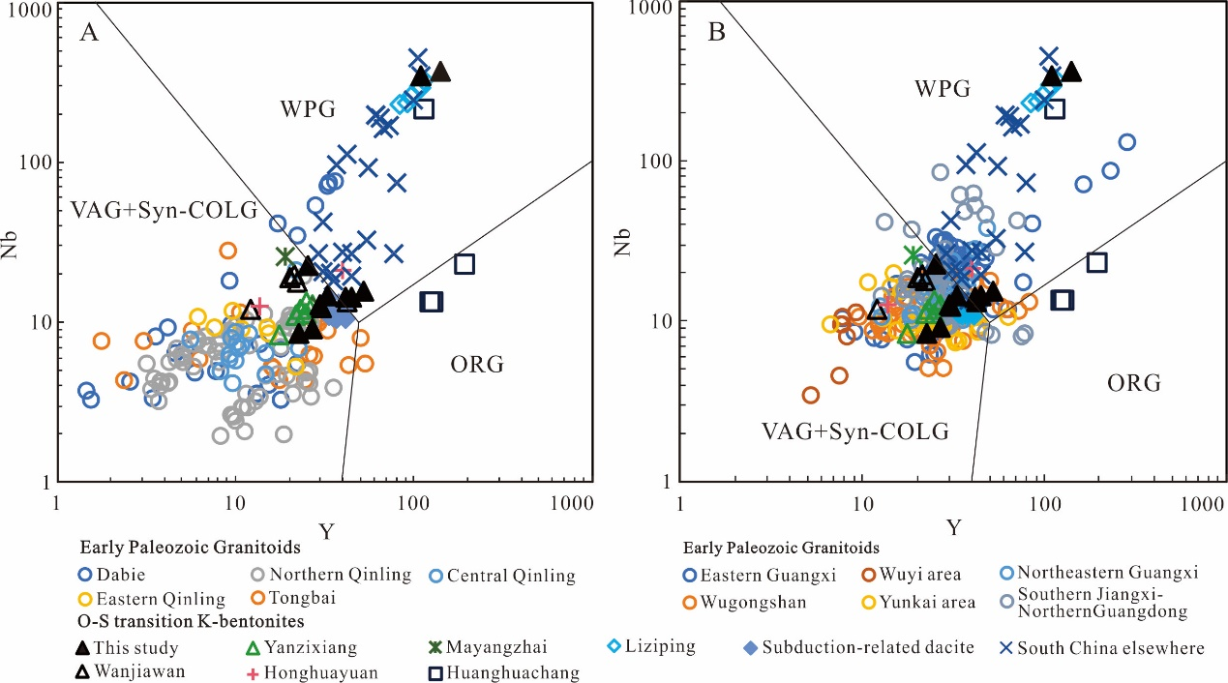

Fig. S7

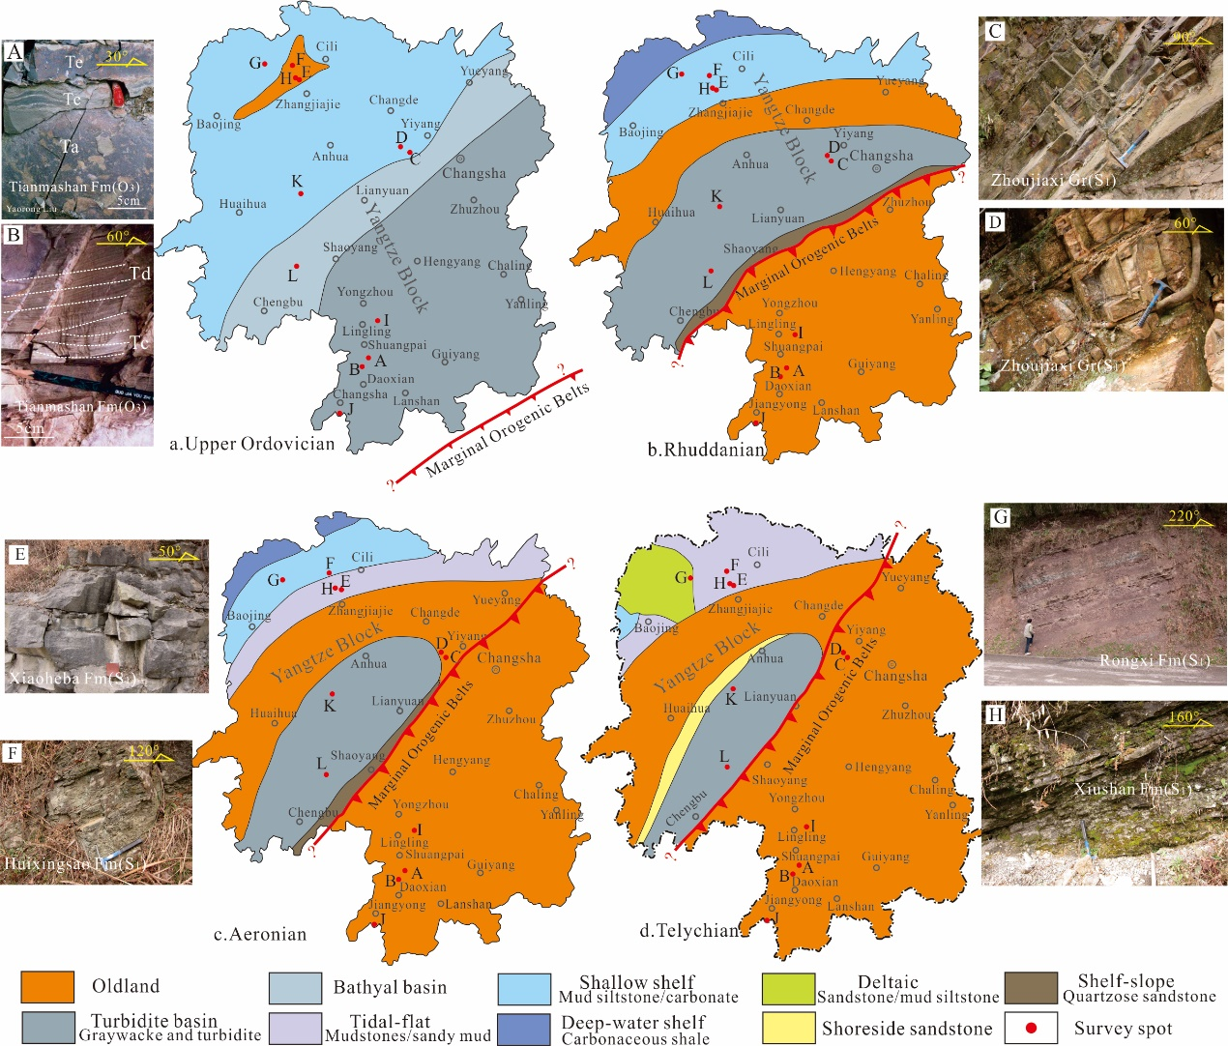

Fig. S8

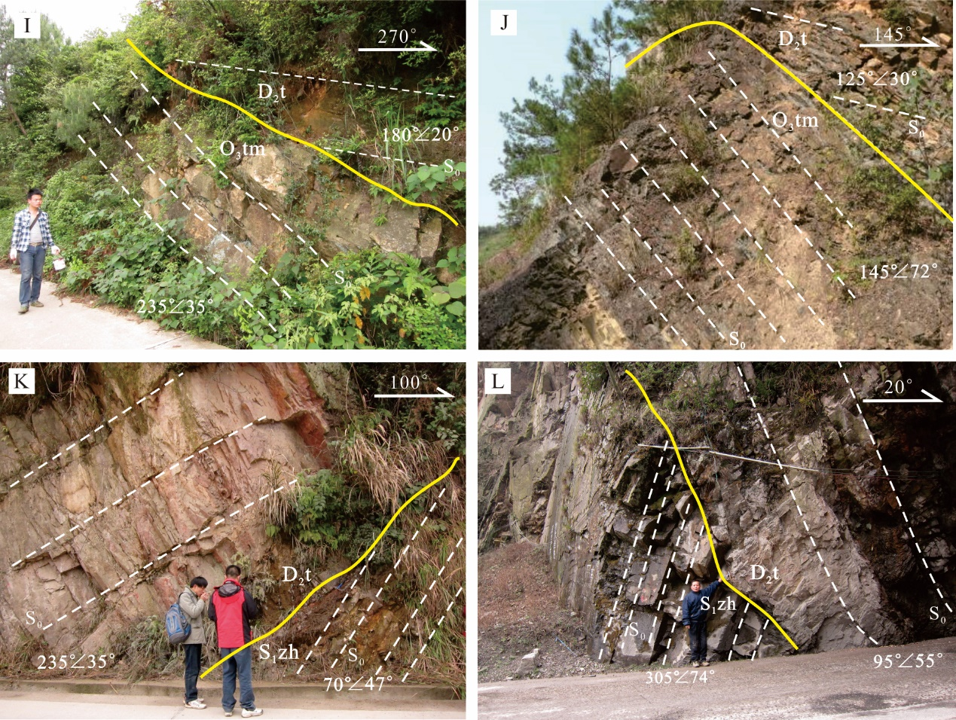

Fig. S9

. 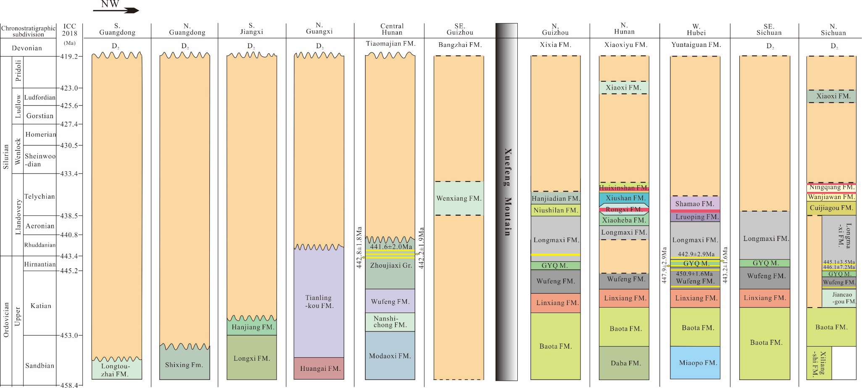

Fig. S10

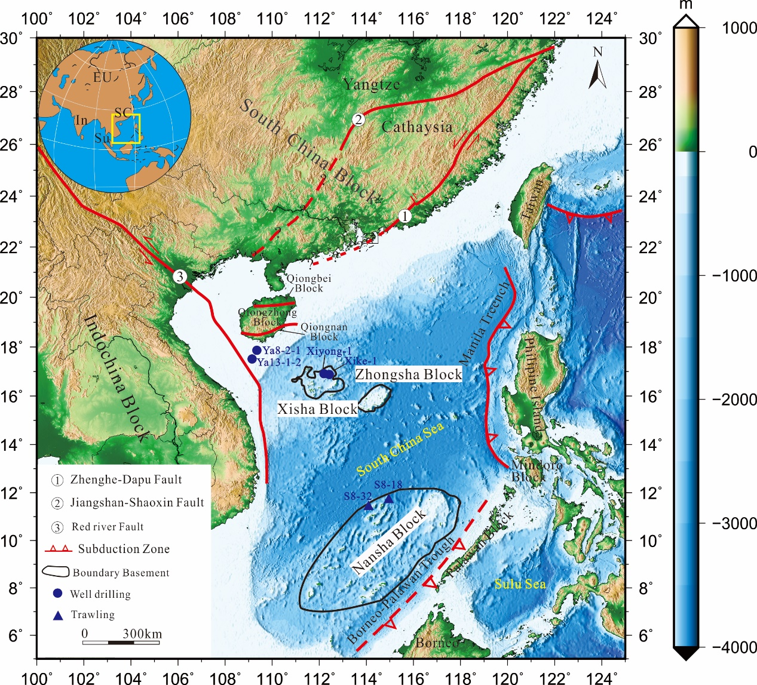

References
Abdallsamed, M.I.M., Wu, Y.B., Zhang, W., Zhou, G., Wang, H., Yang, S., 2017. Early Paleozoic high-Mg granodiorite from the Erlangping unit, North Qinling orogen, central China: Partial melting of metasomatic mantle during the initial back-arc opening. Lithos, 288–289, 282–294, https://doi.org/ 10.1016/j.lithos.2017.07.016
Bai, D., Zhong, X., Pengyuan, J., Xiong, X., Wenyi, H., 2015. The zircon SHRIMP U–Pb dating, geochemical characteristics and tectonic setting of Caledonian Yuechengling pluton in the western segment of the Nanling Mountains. Cheochimica, 44, 27–42 [in Chinese with English abstract].
Ballo, E.G., Augland, L.E., Hammer, Ø., Svensen, H.H., 2019. A new age model for the Ordovician (Sandbian) K-bentonites in Oslo, Norway. Palaeogeography, Palaeoclimatology, Palaeoecology, 520, 203–213, https://doi.org/10.10 16/j.palaeo.2019.01.016
Bauert, H., Isozaki, Y., Holmer, L.E., Aoki, K., Sakata, S., Hirata, T., 2014. New U–Pb zircon ages of the Sandbian (Upper Ordovician) "Big K-bentonite" in Baltoscandia (Estonia and Sweden) by LA-ICPMS. GFF, 136, 30–33, https://doi.org/ 10.1080/11035897.2013.862854
Bergström, S., Huff, W., Kolata, D., 1998. Early Silurian (Llandoverian) K-bentonites discovered in the southern Appalachian thrust belts, eastern USA: Stratigraphy, geochemistry, and tectonomagmatic and paleogeographic implications. GFF, 120, 149–158, https://doi.org/10.1080/11035899801202149
Bergström, S., Toprak, F.Ö., Huff, W., Mundil, R., 2008. Implications of a new, biostratigraphically well-controlled, radio-isotopic age for the lower Telychian Stage of the Llandovery Series (Lower Silurian, Sweden). Episodes, 31, 309–314, https://doi.org/10.18814/epiiugs/2008/v31i3/004
Chen, S., Fu, J., Chen, X., Ma, L., Lu, Y., 2012. Zircon SHRIMP U–Pb dating and geochemical characteristics of Haiyangshan monzogranitic batholith, northeast Guangxi. Geology and Mineral Resources of South China, 28, 132–140 [in Chinese with English abstract].
Chen, X., Fan, J.X., Chen, Q., Tang, L., Hou, X.D., 2014. Toward a stepwise Kwangsian Orogeny. Science China Earth Sciences, 57, 379–387.
Cheng, S., Jianming, F.U., Deming, X.U., Liyan, M.A., Pang, Y., Cao, L., 2009. Geochemical characteristics and petrogenensis of Xuehuading granitic batholith and its enclaves,South China. Geotectonica Et Metallogenia, 33, 588–597 [in Chinese with English abstract].
Cheng, S., Jianming, F.U., Liyan, M.A., Youyue, L.U., Kou, X., Zhang, L., Huang, H., 2016. Origin of the Yuechengling Caledonian granitic batholith, northeastern Guangxi: constraint from zircon U–Pb geochronology, geochemistry and Nd-Hf isotopes. Geotectonica Et Metallogenia, 40, 853–872 [in Chinese with English abstract].
Ge, X.Y., Mou, C.L., Wang, C.S., Men, X., Chen, C., Hou, Q., 2019. Mineralogical and geochemical characteristics of K-bentonites from the Late Ordovician to the Early Silurian in South China and their geological significance. Geological Journal, 54, 514–528, https://doi.org/10.1002/gj.3201
Guo, X.R., Zhao, M.H., Huang, H.B., Qiu, X.L., Wang, J., He, E.Y., Zhang, J.Z., 2016. Crustal structure of Xisha Block and its tectonic attributes. Chinese Journal of Geophysics, 59, 288–300 [in Chinese with English abstract].
Hu, Y.H., Zhou, J.B., Song, B., Wei, L., Sun, W.D., 2008. SHRIMP zircon U–Pb dating from K-bentonite in the top of Ordovician of Wangjiawan section, Yichang, Hubei, China. Science in China, 51, 493–498.
Hu, Y.H., Sun, W.D., Ding, X., Wang, F., Ling, M., LIU, J., 2009. Volcanic event at the Ordovician-Silurian Boundary: The message from K-bentonite of Yangtze Block. Acta Ptrologica Sinica, 25, 3298–3308 [in Chinese with English abstract].
Huff, W., Anderson, T., Rundle, C., Odin, G., 1991. Chemostratigraphy, K–Ar ages and illitization of Silurian K-bentonites from the Central Belt of the Southern Uplands-Down-Longford terrane, British Isles. Journal of the Geological Society, London, 148, 861–868, https://doi.org/10.1144/gsjgs. 148.5.0861
Huff, W., Bergstrom, S., Kolata, D., 2000. Silurian K-bentonites of the Dnestr Basin, Podolia, Ukraine. Journal of the Geological Society, London, 157, 493–504, https://doi.org/10.1144/jgs.157.2.493
Huff, W.D., Bergström, S.M., Kolata, D.R., Sun, H., 1997. The Lower Silurian Osmundsberg K-bentonite. Part II: Mineralogy, geochemistry, chemostratigraphy and tectonomagmatic significance. Geological Magazine, 135, 15–26, https://doi.org/10.1017/s0016756897007887
Huff, W.D., Bergstrom, S.M., Kolata, D.R., Cingolani, C.A., Astini, R.A., 1998. Ordovician K-bentonites in the Argentine Precordillera of Argentina: relations to Gondwana margin evolution. Journal of the Geological Society, London, 142, 107–126, https://doi.org/10.1144/gsl.sp.1998.142.01.06
Jiang, S., Nie, F., Fang, D., Liu, Y., 2009. Geochronology and geochemical features of the main intrusive rocks in the Weishancheng area , Tongbai County , Henan. Acta Geologica Sinica, 83, 1011–1029 [in Chinese with English abstract].
Jiang, X., Kang, Z., Xu, J., Feng, Z., Pang, C., Fang, G., Wu, J., Xiong, S., 2017. Early paleozoic granodioritic plutons in the Shedong W–Mo ore district, Guangxi, southern China: Products of re-melting of middle Proterozoic crust due to magma underplating. Journal of Asian Earth Sciences, 141, 59–73, https://doi.org/10.1016/j.jseaes.2016.11.004
Li, K., Fang, H., Guo, J., Liu, K., Wang, X., 2019. Petrogeochemistry, zircon U-Pb dating and geological significance of two-mica granites from Wuduoshan granite in Nanzhao county, eastern Qinling Mountains. Earth Science—Journal of China University of geosciences, 44, 123–134 [in Chinese with English abstract].
Li, W., Wang, T., Wang, X., 2001. Source of Huichizi granitoid complex pluton in northern Qinling, Central China: constrained in element and isotopic geochemistry. Earth Science Journal of China —University of Geosciences, 26, 269–278 [in Chinese with English abstract].
Li, X., Yu, Y., Wang, C., 2017. Caledonian granitoids in the Jinxiu area, Guangxi, South China: Implications for their tectonic setting. Lithos, 272–273, 249–260, https://doi.org/10.1016/j.lithos.2016. 12.016
Li, Y., Zhang, P., He, X., Zhang, S., 2018. Zircon U–Pb Dating, geochemical characteristics of the gneissic granite from North Qinling terrain in Tongbai area and their geological significance. Northwestern Geology, 51, 82–96 [in Chinese with English abstract].
Liu, B., Wu, S., Long, G., Guo, X., 2012. Basement characteristics and tectonic evolution in Qiongdongnan basin. Precess in geophys, 27, 1465–1475 [in Chinese with English abstract].
Liu, R., Zhang, L., Zhou, H., Zhong, Z., Zeng, W., Xiang, H., Jin, S., Lu, X., Li, C., 2008. Petrogenesis of the Caledonian migmatites and related granites in northwestern Fujian Province, South China: syn-deformational crustal anaexis. Acta Geologica Sinica, 24, 1205–1222 [in Chinese with English abstract].
Lou, F., Shu, L., Yu, J., Wang, D., 2002. Petrological and geochemical characteristics and origin of the Wugongshan dome granite, Jiangxi Province. Geological Review, 48, 80–88 [in Chinese with English abstract].
Luo, C., Liu, G., Zuo, Z., 2017a. LA-ICP-MS Zircon U-Pb ages and geochemical characteristics of the Pingshi granitic pluton in southern Jiangxi and their tectonic significance. East China Geology, 37, 79–88 [in Chinese with English abstract].
Luo, H., He, R., Pan, l., Yang, C., Yu, G., 2016. LA-ICP-MS Zircon U-Pb age and its significance of late Ordovician-early Silurian Longmaxi Bentonites. Resources Environment ＆ Engineering, 30, 547–550 [in Chinese with English abstract].
Luo, H., Pan, L.K., He, R.L., 2017b. Geochemical characteristics and geological significance of Longmaxi Formation of late Ordovician-early Silurian in Mayangzhai area，Hubei Province. Resources Environment ＆ Engineering, 31, 1–12 [in Chinese with English abstract].
Ma, C., Ming, H., Yang, K., 2004. An Ordovician magmatic arc at the northern foot of Dabie mountains: Evidence from geochronology and geochemistry of intrusive rocks. Acta Petrologica Sinica, 20, 393–402 [in Chinese with English abstract].
Meng, L., Zhang, Z., Wu, Y., Liu, J., Shao, F., Hua, J., Chen, R., 2016. The geochemistry features and petrogenesis of Dabu Caledonian granite in southern Jiangxi Province. Uranium Geology, 32, 13–22 [in Chinese with English abstract].
Min, K., Renne, P.R., Huff, W.D., 2001. ⁴⁰Ar/³⁹Ar dating of Ordovician K-bentonites in Laurentia and Baltoscandia. Earth and Planetary Science Letters, 185, 121–134, http://doi.org/10.1016/ S0012-821X(00)00365-4
Nong, J., Zou, Y., Qiu, E., Guo, S., Ye, X., Xiang, F., Wen, M., Lu, S., 2017. Petrogenesis of Dacun and Gulong plutons in southeast Guangxi: Constraints from geochemistry, zircon U–Pb ages and Hf isotope. Geological Bulletin of China, 36, 224–237 [in Chinese with English abstract].
Pearce, J.A., Harris, N.B.W., Tindle, A.G., 1984. Trace element discrimination diagrams for the tectonic interpretation of Granitic rocks. Journal of Petrology, 25, 956–983, https://doi.org/10.1093/ petrology/25.4.956
Peng, S., Jin, Z., Liu, Y., Fu, J., He, L., Cai, M., Wang, Y., 2006. Petrochemistry, chronology and tectonic setting of strong peraluminous anatectic granitoids in Yunkai Orogenic Belt, western Guangdong Province, China. Journal of China University of Geosciences, 17, 1–12 [in Chinese with English abstract].
Qin, Z.W., Wu, Y.B., Wang, H., Gao, S., Zhu, L.Q., Zhou, L., Yang, S.H., 2014. Geochronology, geochemistry, and isotope compositions of Piaochi S-type granitic intrusion in the Qinling orogen, central China: petrogenesis and tectonic significance. Lithos, 202–203, 347–362, http://doi.org/10.1016/j.lithos.2014.06.006
Qin, Z., Wu, Y., Siebel, W., Shan, G., Hao, W., Abdallsamed, M.I.M., Zhang, W., Yang, S., 2015. Genesis of adakitic granitoids by partial melting of thickened lower crust and its implications for early crustal growth: A case study from the Huichizi pluton, Qinling orogen, central China. Lithos, 238, 1–12, http://doi.org/10.1016/j.lithos.2015.09.017
Qin, Z., Fu, J., Lu, Y., Ma, L., Cheng, S., 2018. Petrogenesis and geological significance of the early Paleozoic Huashan pluton in northern Guangdong Huashan pluton in northern Guangdong. Geological Science and Technology Information, 37, 1–12 [in Chinese with English abstract].
Ren, Q., Chen, J., Wang, Z., Yan, Z., Wang, T., 2008. Zircon U-Pb and geochemical analyses for leucocratic intrusive rocks in pillow lavas in the Danfeng Group, north Qinling Mountains, China. Science in China, 51, 249–262.
Sell, B., Ainsaar, L., Leslie, S., 2013. Precise timing of the Late Ordovician (Sandbian) supereruptions and associated environmental, biological, and climatological events. Journal of the Geological Society, London, 170, 711–714, https://doi.org/10.1144/jgs2012-148
Smith, M., Singer, B., Simo, T., 2011. A time like our own? Radioisotopic calibration of the Ordovician greenhouse to icehouse transition. Earth and Planetary Science Letters, 311, 634–374, https://doi.org/ 10.1016/j.epsl.2011.09.014
Su, W.B., Huff, W.D., Ettensohn, F.R., Liu, X.M., Zhang, J.E., Li, Z.M., 2009. K-bentonite, black-shale and flysch successions at the Ordovician–Silurian transition, South China: Possible sedimentary responses to the accretion of Cathaysia to the Yangtze Block and its implications for the evolution of Gondwana. Gondwana Research, 15, 111–130, https://doi.org/10.1016/j.gr.2008.06.004
Sun, W., McDonough, W., 1989. Chemical and isotopic systematics of oceanic basalts: Implications for mantle composition and processes. Geological Society of London Special Publications, 42, 313–345, http://dx.doi.org /10.1144/GSL.SP.1989.042.01.19
Svensen, H.H., Hammer, Ø., Corfu, F., 2015. Astronomically forced cyclicity in the upper Ordovician and U–Pb ages of interlayered tephra, Oslo Region, Norway. Palaeogeography, Palaeoclimatology, Palaeoecology, 418, 150–159, https://doi.org/10.1016/j.palaeo.2014.11.001
Tucker, R.D., McKerrow, W., 1995. Early Paleozoic chronology: A review in light of new U–Pb zircon ages from Newfoundland and Britain. Canadian Journal of Earth Sciences, 32, 368-379, https://doi.org/10.1139/e95-032
Wang, H., Wu, Y.B., Yang, J.H., Qin, Z.W., Duan, R.C., Zhou, L., Yang, S.H., 2017a. Crustal basement controls granitoid magmatism, and implications for generation of continental crust in subduction zones: A Sr–Nd–Hf–O isotopic study from the Paleozoic Tongbai orogen, central China. Lithos, 282-283, 298–315, https://doi.org/10.1016/j.lithos. 2017.03.014
Wang, J., Qin, J., Hu, P., Zhang, L., Zhao, Y., Zhang, Z., 2018. Zircon U-Pb ages and geochemical characteristics of the two-stage granitic magamtism from the Kuanping pluton in the northern Qinling Mountains: petrogenesis and tectonic Implication. Geological Review, 64, 127–140 [in Chinese with English abstract].
Wang, L.W., Zhao, J.F., Chen, J.H., Zhang, Y.D., Chen, X.Y., Zhu, C.H., LIU, J., Hu, Y.H., Ma, X., 2015. Characterristics of Ktian (Late Ordovician) K-bentonites from Anji, Zhejiang Province. Journal of Stratigraphy, 39, 155–168 [in Chinese with English abstract].
Wang, R., Xu, Z., Santosh, M., Liang, F., Fu, X., 2017b. Petrogenesis and tectonic implications of the early Paleozoic intermediate and mafic intrusions in the South Qinling Belt, Central China: Constraints from geochemistry, zircon U–Pb geochronology and Hf isotopes. Tectonophysics, 712–713, 270–288, https://doi.org/10.1016/j.tecto.2017.05.021
Wang, T., Wang, X., Tian, W., Zhang, C., Li, W., 2009. North Qinling Paleozoic granite associations and their variation in space and time: Implications for orogenic processes in the orogens of central China. Science in China, 52, 1359–1384.
Wang, Y.J., Zhang, A.M., Fan, W.M., Zhao, G.C., Zhang, G.W., Zhang, Y.z., Zhang, F.f., Li, S.Z., 2011. Kwangsian crustal anatexis within the eastern South China Block: Geochemical, zircon U–Pb geochronological and Hf isotopic fingerprints from the gneissoid granites of Wugong and Wuyi–Yunkai Domains. Lithos, 127, 239–260, https://doi.org /10.1016 /j.lithos.2011.07.027
Watson, E., Wark, D., Thomas, J., 2006. Crystallization thermometers for zircon and rutile. Contributions to Mineralogy and Petrology, 151, 413–433, https://doi.org/10.1007/s00410-006-0068-5
Wu, F., Zhang, F., 2003. Features and genesis of Caledonian granites in the Wugongshan in the eastern segment of the northern margin of South China plate. Geology in China, 30, 166-172 [in Chinese with English abstract].
Xia, Y., Xu, X., Zou, H., Liu, L., 2014. Early Paleozoic crust–mantle interaction and lithosphere delamination in South China Block: Evidence from geochronology, geochemistry, and Sr–Nd–Hf isotopes of granites. Lithos, 184–187, 416–435, https://doi.org/10.1016/j.lithos.2013.11.014
Xiao, P., Guo, J., Li, J., Wang, Z., Xikai, W., 2017. Sedimentary evolution and shale gas exploration potential of the Lower Silurian strata in Hunan. Sedimentary Geology and Tethyan Geology, 37, 79–87 [in Chinese with English abstract].
Xie, S., Wang, Z., Wang, J., Jiewen, Z., 2012. LAICP-MS zircon U–Pb dating of the bentonites from the uppermost part of the Ordovician Wufeng Formation in the Haoping section, Taoyuan, Hunan. Sedimentary Geology and Tethyan Geology, 32, 65–69 [in Chinese with English abstract].
Xiong, G., Wang, J., Li, Y., Yu, Q., Men, Y., Zhou, X., Xiaohui, X., Zhou, Y., Yang, X., 2017. Zircon U–Pb dating and geological significance of the bentonites from the upper Ordovician Wufeng Formation and lower Silurian Longmaxi Formation in western Daba Mountains. Sedimentary Geology and Tethyan Geology, 37, 46–58 [in Chinese with English abstract].
Xiong, G.Q., Wang, J., Li, Y.Y., Yu, Q., Men, Y.P., Zhou, X.L., Xiong, X.H., Zhou, Y.X., Yang, X., 2019. Zircon U–Pb dating of K-bentonite from late Ordovician Wufeng Formation and earlier Silurian Longmaxi Formation in the eastern section of south Dbashan and its tectonic signification. Acta Geologica Sinica, 93, 843–864 [in Chinese with English abstract].
Xu, D., Chen, G., Xia, B., Li, P., He, Z., 2006. The Caledonian adakite-Like granodiorites in Banshanpu area, eastern Hunan Province, South China: petrogenesis and geological significance. Geological Journal of China Universities, 12, 507–521 [in Chinese with English abstract].
Xu, T., Guo, Q., Chen, Q., Wang, Q., Zhang, S., Zuo, W., Ren, C., 2018. Age and Geochemical features of the early Silurian Jiguanya highly fractionated Syn-collisional granites in the Baoji area of north Qinling Orogen and their geological significance. Age and Geological Science and Technology Information, 37, 79–87 [in Chinese with English abstract].
Yan, C., Shu, L., Michel, F., Chen, Y., Li, C., 2017. Early Paleozoic intracontinental orogeny in the Yunkai domain, South China Block: New insights from field observations, zircon U–Pb geochronological and geochemical investigations. Lithos, 268–271, 320–333, https://doi.org/10.1016/ j.lithos.2016.11.013
Yang, M., Zhang, H., Liao, Z., Luo, X., Lei, Z., Zhang, S., Zhang, Y., Li, Y., 2017. Tectonic evolution and hydrocarbon accumulation of the sedimentary Basins in Nansha Sea Waters (South China Sea). Geotectonica Et Metallogenia, 41, 710–720 [in Chinese with English abstract].
Yang, S.C., Hu, W.X., Wang, X.L., Jiang, B.Y., Yao, S.P., Sun, F.N., Huang, Z.C., Zhu, F., 2019. Duration, evolution, and implications of volcanic activity across the Ordovician–Silurian transition in the Lower Yangtze region, South China. Earth and Planetary Science Letters, 518, 13–25, http://doi.org /10.1016/j.epsl.2019.04.020
Yao, Z., Zhang, Y., Yang, T., Pengfei, Y.I., Zheng, S., 2017. Zircon U–Pb Geochronology, Petrogeochemistry of Huangniupu plutons in western section of the north Qinling Mountains and their geological significance. Geoscience, 31, 1157–1169 [in Chinese with English abstract].
Ye, Q., Mei, L., Shi, H., Camanni, G., Shu, Y., Wu, J., Yu, L., Deng, P., Li, G., 2018. The Late Cretaceous tectonic evolution of the South China Sea area: An overview, and new perspectives from 3D seismic reflection data. Earth-Science Reviews, 187, 186–204, http://doi.org /10.1016/j.earscirev. 2018.09.013
Yi, L.W., Ma, C.Q., Wang, L.X., Lai, Z.X., Li, X.Y., Yang, Y.N., Wu, F., Hu, Y.R., 2014. Discovery of late Ordovician subvolcanic rocks in South China existence of subduction-related dacite from early Paleozoic ? Earth Science—Journal of China University of geosciences, 39, 637–653 [in Chinese with English abstract].
Yu, Y., Huang, X.L., Sun, M., He, P.L., 2018. Petrogenesis of granitoids and associated xenoliths in the early Paleozoic Baoxu and Enping plutons, South China: Implications for the evolution of the Wuyi-Yunkai intracontinental orogen. Journal of Asian Earth Sciences, 156, 59–74, http://doi.org /10.1016/j.jseaes.2018.01.012
Yuan, F., Liu, J., Lu, G., Sha, Y., Zhang, S., Zhai, D., Wang, G., Zhang, H., Liu, G., Yang, S., Wang, J., Ren, W., 2017. Zircon U–Pb geochronology, geochemistry and petrogenesis of the granites and pegmatites from the Guangshigou uranium deposit in the northern Qinling Orogen, China. Earth Science Frontiers, 24, 025–045 [in Chinese with English abstract].
Zeng, W., Li, Z., Zhou, H., Zhong, Z., Xiang, H., Liu, R., Jin, S., Lü, X., Li, C., 2008. Caledonian reworking of Paleoproterozoic basement in the Cathaysia Block: Constraints from zircon U–Pb dating, Hf isotopes and trace elements. Chinese Science Bulletin, 53, 97–106.
Zhang, J., Ma, C., She, Z., Zhang, X., Zhou, H., 2007. The early Paleozoic Tiefosi syn-collisional granite in the northern Dabie Orogen: geochronological and geochemical constraints. Science in China Series D-Earth Science, 50, 847–856.
Zhong, Y., Wang, L., Zhao, J., Liu, L., Ma, C., Zheng, J., Zhang, Z., Luo, B., 2016. Partial melting of an ancient sub-continental lithospheric mantle in the early Paleozoic intracontinental regime and its contribution to petrogenesis of the coeval peraluminous granites in South China. Lithos, 264, 224–238, http://doi.org/10.1016/j.lithos.2016.08.026
Zhu, R., Liu, H., Yao, Y., Zhou, Y., Wang, Y., Li, Y., 2017. A preliminary analysis of Pre-Cenozoic tectonic deformation of Zhongsha-xisha Block in South China Sea. Marine Geology & Quaternary Geology, 37, 67–74 [in Chinese with English abstract].
Zou, Y., Nong, J., Guo, S., Huang, X., Sun, M., Deng, B., 2017. Petrogenesis of the Shangmushui pluton in southeast Guangxi Province: constraints from petrochemistry, zircon U–Pb ages and Hf isotope. Journal of Mineralogy and Petrology, 37, 52–62 [in Chinese with English abstract].

