Late Mesozoic and Cenozoic Thermo-Tectonic History of Eastern, Central and Southern Mexico as Determined Through Integrated Thermochronology, with Implications for Sediment Delivery to the Gulf of Mexico.

Gary G. Gray^{1*}, Diego Villagomez^{2,3}, James Pindell^{2,1}, Roberto Molina-Garza⁴, Paul O’Sullivan⁵, Daniel Stockli⁶, William Farrell^{1,7}, David Blank¹, and Jonathan Schuba^{8,9}

Supplemental materials

- Procedure for modeling AFT data with HeFTy as employed for this project

The overriding considerations for the modeling work were to create models that employed the minimum number of constraints possible, and to do this as consistently as possible across all samples. The three types of samples, sedimentary, igneous/metamorphic, and subsurface, all require a slightly different modeling procedure or a change in some parameters. All surface sample models were run using 10,000 forward iterations and random segment lengths. Both Ketcham (1999) and Ketcham (2007a) kinetic annealing models were employed, using Donelick et al. (1999) and Ketcham et al. (2007b) c-axis projection models, respectively. Testing on many samples demonstrated that neither kinetic model had an appreciable effect on the mean thermal history, although the model goodness-of-fit parameters were better for the more recent sample data when the Ketcham et al. (2007b) kinetics were employed, and the older data were better fit by the Ketcham et al. (1999) kinetics.
For sedimentary samples, the depositional age constraint box set at +/- 10 Ma around stratigraphic age and +/5 ºC on surface temperature, which was set at 20 ºC. The pre-depositional (or intrusive) thermal history of the source region was generally not a factor in these models as they mostly experienced some resetting of the thermochronometer after deposition/crystallization. However, a box centered around 200 ºC and 10-20 Ma older than the depositional, or intrusive age was typically employed. For crystalline samples, we often had U/Pb ages on zircons, and so these provided a similar constraint for the crystallization history. For all samples, this part of the t-T curve was truncated for the overburden mapping and analysis.
HeFTy has the ability to simultaneously invert for thermal histories satisfying AFT, apatite-Helium (AHe) and zircon-Helium (ZHe) data. An example of this is shown in Figure 5. However, this multi-thermochronometer modeling within HeFTy seldom results in a model with high goodness-of-fit statistics. Our preferred way of modeling multiple thermochronometers was to model the apatite pooled age and track lengths, and include the He-based chronometers with a constraint box. The age bounds on all of the constraint boxes are +/- 10 Ma, and the temperature bounds are +/- 10 ºC, so that the centroid of the constraint box is at the radiometric age, and either 180, 120, or 60 ºC for ZHe, AFT, and AHe, respectively.
Igneous and metamorphic samples pose a problem when integrating with the sedimentary samples. For many samples, a traditional U-Pb crystallization age was available. This may represent a temperature in excess of 600 ºC, but may also be late Paleozoic to preCambrian. Our attempt was to reduce the thermal history to temperatures similar to those experienced by the sedimentary samples, so the thermal histories are truncated to not include temperatures higher than those constrained by the thermochronometers. Therefore a sample with a ZHe age, the thermal history begins at 180 ºC, while one constrained by AFT begins at 140-120 ºC. An outcome of this process is that the crystalline samples appear at the relevant time at the given depth, and may cause some discord with nearby sedimentary samples.
All of the above rock types were collected at the surface. Six subsurface core samples comprise a third type of sample, as far as modeling procedure is concerned. These samples come from depths where temperatures put them into the partial annealing zone today (e.g. Braun, et al, 2006). These samples therefore had fewer fission tracks and lower mean track lengths. Inverse modeling with only 10,000 iterations would not produce a single acceptable model. These models were run however long it took to achieve ten “good” inversions. One model required 1.3 million iterations to achieve 10 acceptable results. Additional differences for the subsurface core samples included setting the “depositional age’ as the age of the oldest strata overlying basement, as that represents when the sample was at surface temperature of 20 ºC. These samples also differed from the rest of the dataset in that the present-day temperature for these samples is higher than surface temperature.
Bottom-hole temperature (BHT) data were available only for the Trincheras, Linares and Chaneque wells, and these temperatures were used for the endpoint of the HeFTy models. Present-day sample temperatures for the remaining three wells was estimated using the average geotherm from the limited temperature data available. The present-day temperature constraint box was left relatively open (±10°C) for all 6 models, to account for uncertainty in these estimates.

2: General Mapping and Calculation of volumes in ArcGIS Pro.

All contour maps were made with ArcGIS Pro, version 2.1.3. All samples do not have values for each time step presented. Some are younger than that time interval. Therefore, each map was filtered prior to contouring so as to contain the correct subset of data. This also results in a different area being shown on many maps. Contouring of point values was done using the nearest neighbor algorithm in ArcGIS Pro.
ArcGIS pro was also used to calculate the total volumes shown in Figure 10. After each “delta-overburden” isopach map (Fig. 9A-N) was created, an isopach value, based upon nearest neighbor contouring, was interpolated for each 5 km x 5 km map grid cell. The isopach value was multiplied by the 25 km² to obtain a volume for each grid cell. The sum of the grid cell volumes for each map area is the total volume for each timestep. The 70_65 map has the smallest total map area and the 5_0 map has the greatest, so there should be a bias towards increasing volumes through time, solely by virtue of the changes in map coverage. It was decided not to normalize this data to a particular set area, so the effect of this area gain on the overall erosion/eposition trends has not been formally evaluated. This geospatial processing was done using ModelBuilder, a visual programming language in ArcGIS Pro, within the Esri ArcGIS Pro 2.1.3 platform.

Figure S1. Topography of the Mexican Cordillera showing the mean elevation of 2 km. Red dots represent individual fluid inclusion homogenization temperatures projected onto the line of section. Red lines are contours of these data. These data demonstrate that the present land surface approximates an isothermal 200 ºC surface in this area, and that the present elevation of the plateau post-dates the imposition of the thermal structure of the region. Fluid inclusion data are from Gray, et al., 2001. Carlos Lopez provided the temperature plot. Vertical exaggeration for topo profile = 100. Topo + bathymetry display made with GeoMapAp.

Figure S2, Same as Figure 6 in text: but with a horizontal rule pattern denoting mid-Cenozoic to Recent volcanic cover.

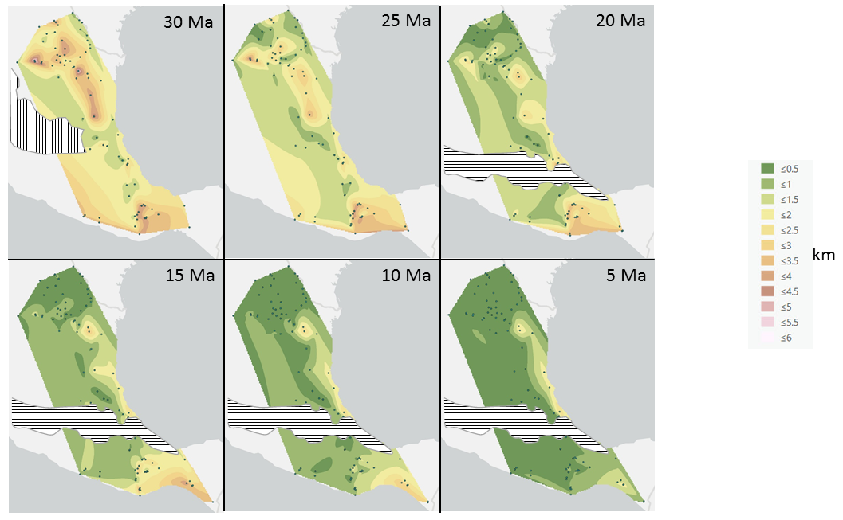

Figure S3. Same as the lower two panels in Figure 8 in text: but with an a vertical ruled pattern on the 30 Ma map to show the extent of the 32-28 Ma Sierra Madre Occidental volcanic cover. The horizontal ruled pattern on the 20, 15, 10, and 5 Ma maps is the 20 Ma-present Trans Mexican Volcanic Belt.

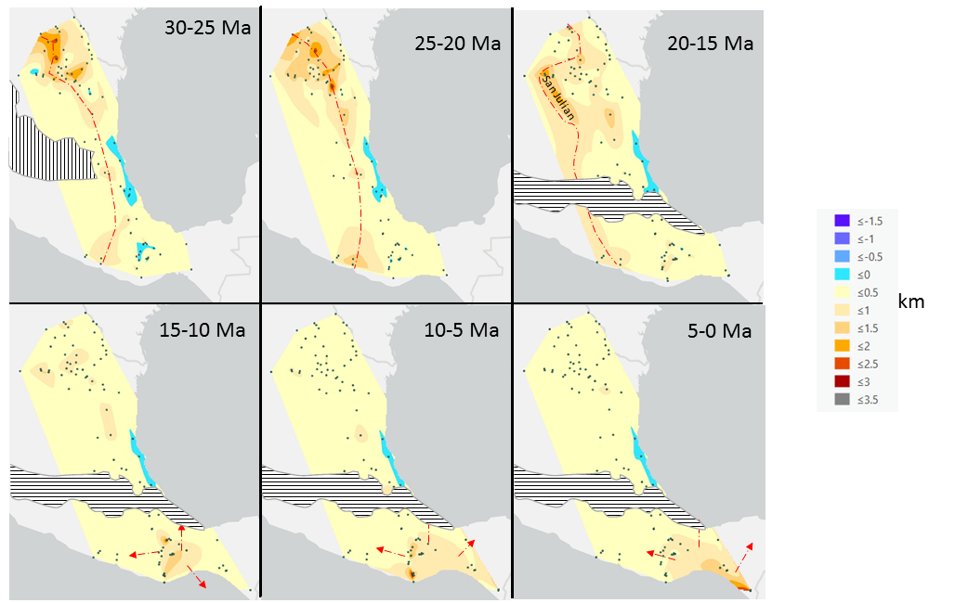

Figure S4. Same maps as in Figure 9, part 2, but with an a vertical ruled pattern on the 30 Ma map to show the extent of the 32-28 Ma Sierra Madre Occidental volcanic cover. The horizontal ruled pattern on the 20, 15, 10, and 5 Ma maps is the 20 Ma-present Trans Mexican Volcanic Belt.

