Spatial and temporal influence of Pacific subduction on South China: geochemical migration of Cretaceous mafic-intermediate rocks

Chengshi Gan ^{1, 2}, Yuejun Wang ^{1, 2} *, Tiffany L. Barry ³,
Yuzhi Zhang ^{1, 2}, Xin Qian ^{1, 2}

¹ Guangdong Provincial Key Lab of Geodynamics and Geohazards, School of Earth Sciences and Engineering, Sun Yat-sen University, Guangzhou, 510275, China
² Southern Laboratory of Ocean Science and Engineering, Zhuhai, 519082, China
³ School of Geography, Geology and the Environment, University of Leicester, University Road, Leicester, LE1 7RH, UK

* Corresponding author’s address:
School of Earth Sciences and Engineering, Sun Yat-sen University,
No. 135, Xingang Xi Road, Guangzhou, 510275, P.R. China
Tel: 86-20-84111209;
Email: wangyuejun@mail.sysu.edu.cn
Contents of this file
Figures S1 to S4; Tables S1 to S3.

Introduction
This supporting information provides supplementary evidences and detailed data to support the main article’s viewpoints.

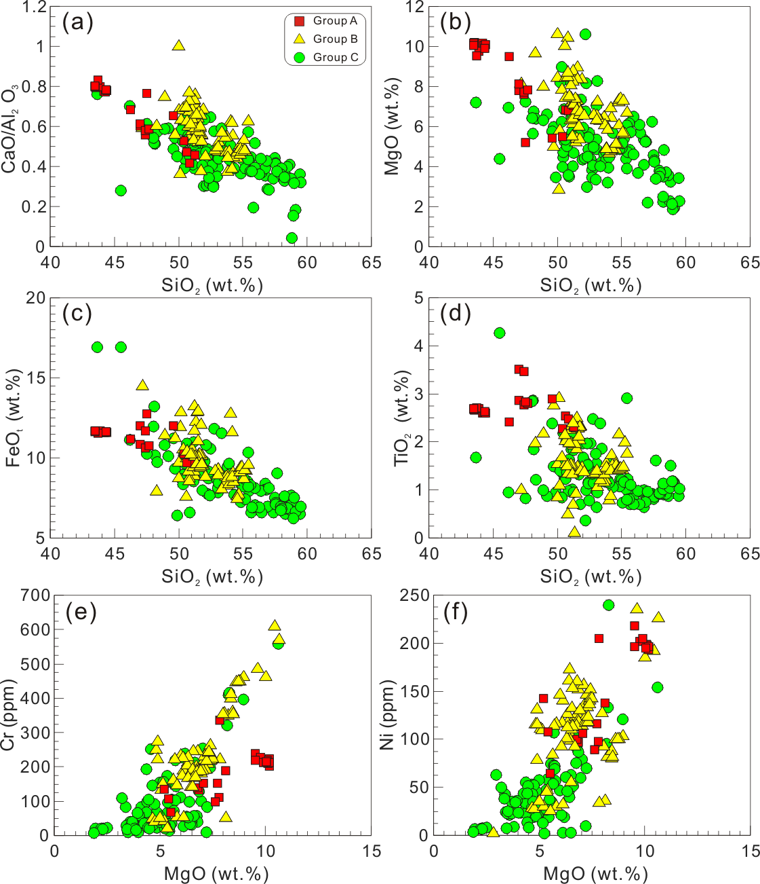
Fig. S1 SiO₂-CaO/Al₂O₃ (a), MgO (b), FeO_{t} (c) and TiO₂ (d), and MgO-Cr (e) and Ni (f) diagrams for the Cretaceous mafic-intermediate igneous rocks in the southeastern SCB. Geochemical data of the Cretaceous mafic-intermediate igneous rocks are listed in Table S1.

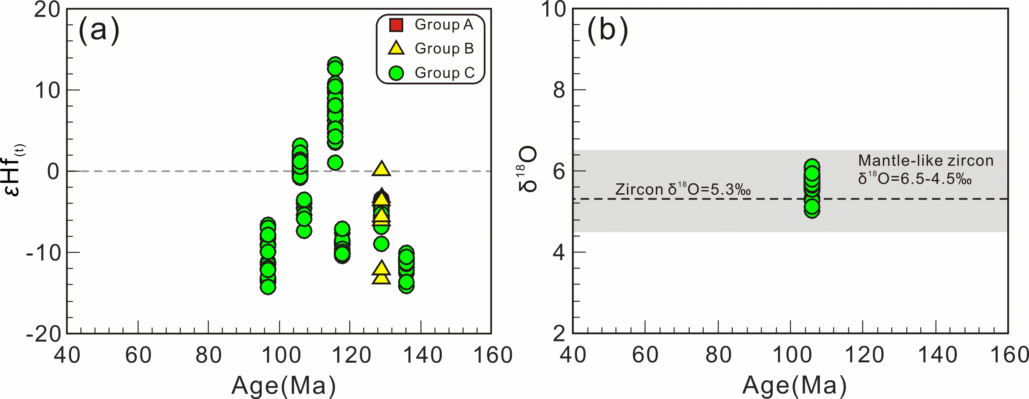
Fig. S2 Age-εHf_{(t)} (a) and δ¹⁸O (b) for the Cretaceous mafic-intermediate igneous rocks in the southeastern SCB. The field of mantle-like zircon δ¹⁸O value (6.5-4.5 ‰) is from Valley et al. (1998). Geochemical data of the Cretaceous mafic-intermediate igneous rocks are listed in Table S3.

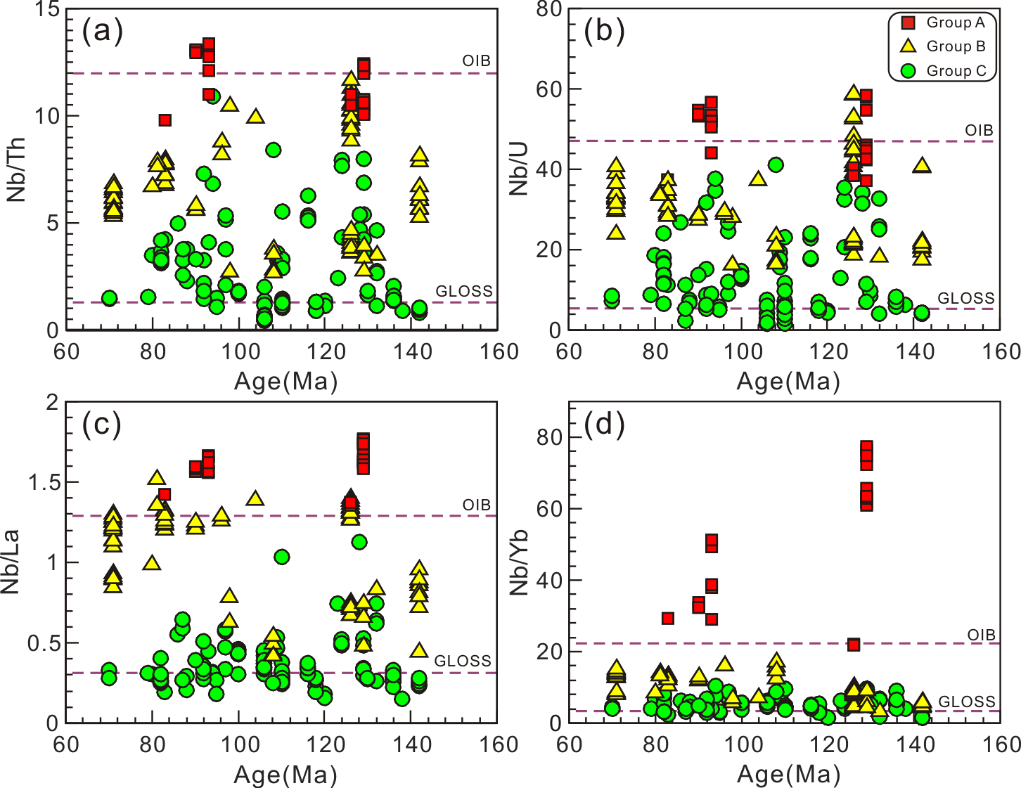Fig. S3 Variations of trace element ratios for the Cretaceous mafic-intermediate igneous rocks in the southeastern SCB. Fields of GLOSS and OIB are from Plank & Langmuir (1998) and Sun & McDonough (1989), respectively. Geochemical data of the Cretaceous mafic-intermediate igneous rocks are listed in Table S1.

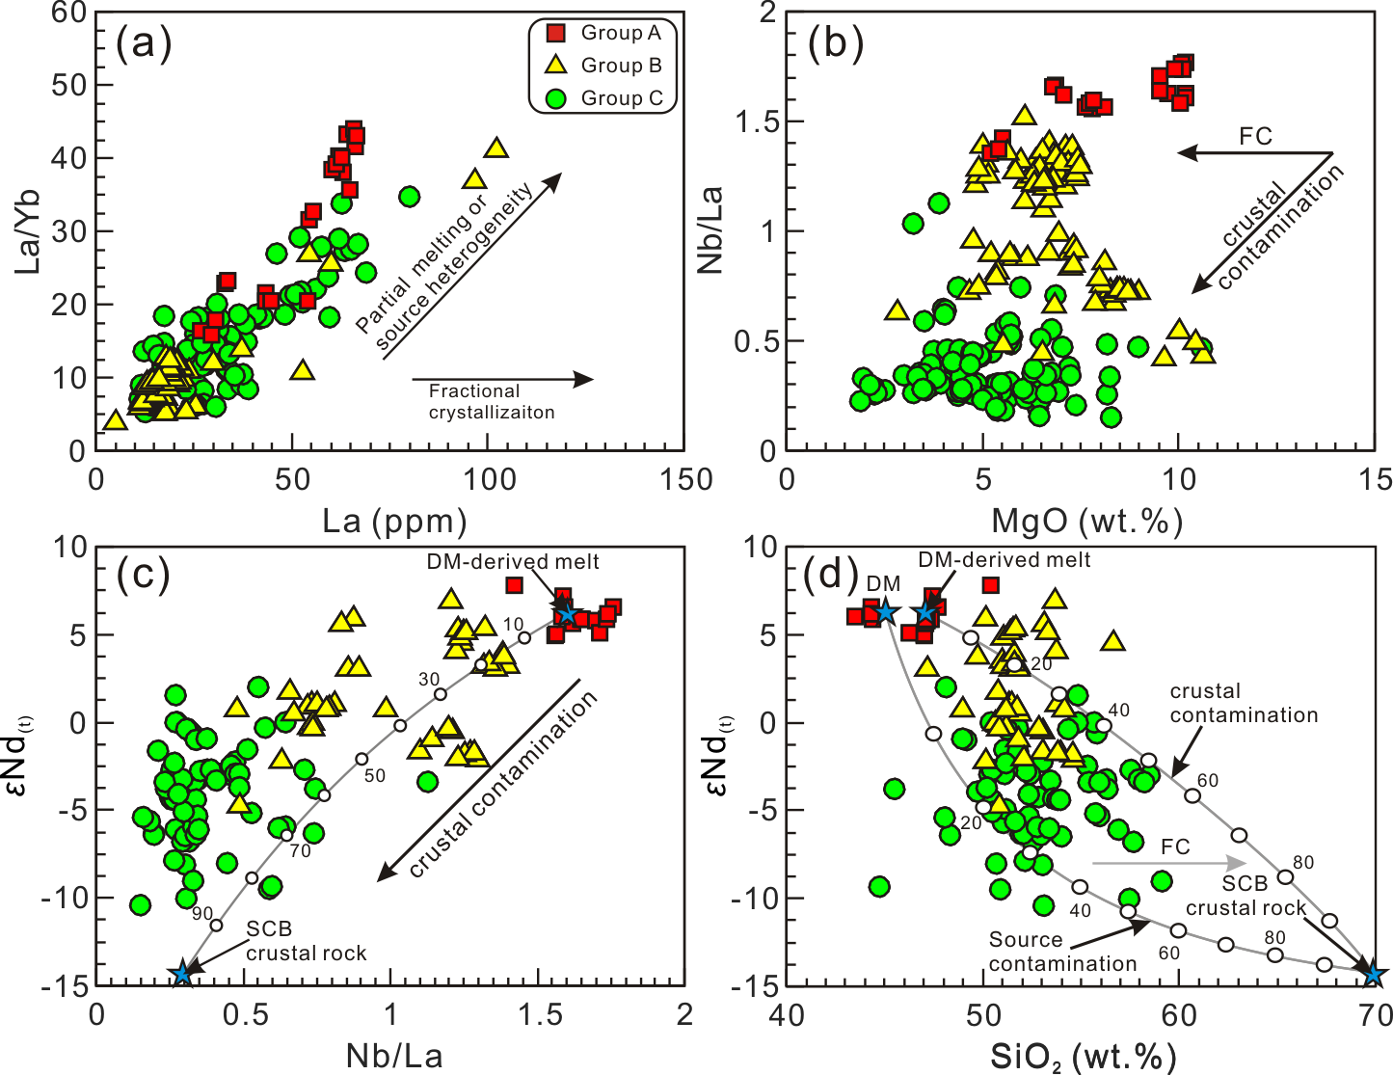
Fig. S4 (a) La-La/Yb, (b) MgO-Nb/La, (c) Nb/La-εNd_{(t)} and (d) SiO₂-εNd_{(t)} for the Cretaceous mafic-intermediate igneous rocks in the southeastern SCB. DM is represented by Nd = 6.6 ppm, SiO₂ =45.0% and εNd_{(t)} = +6.3, and its derived melt by Nd = 45.3 ppm, Nb = 85.0 ppm, La = 53.0 ppm, SiO₂ =47.0% and εNd_{(t)} = +6.3 (Wang et al. 2003, 2008; Meng et al. 2012; Qi et al. 2016); SCB crustal rock by Nd = 31.1 ppm, Nb = 18.0 ppm, La = 61.0 ppm, SiO₂ =70.0 wt% and εNd_{(t)} = -14.3 (Zhao et al. 2012; Wang et al. 2013). Geochemical data of the Cretaceous mafic-intermediate igneous rocks are listed in Table S1 and S2.

Supplemental table captions
Table S1 Major oxide (wt%) and trace element (ppm) compositions for the Cretaceous mafic-intermediate igneous rocks in the southeastern SCB

Table S2 Sr-Nd isotope compositions for the Cretaceous mafic-intermediate igneous rocks in the southeastern SCB

Table S3 Zircon Hf-O isotope compositions for the Cretaceous mafic-intermediate igneous rocks in the southeastern SCB

References:
Meng, L.F., Li, Z.X., Chen, H.L., Li, X.H. & Wang, X.C. 2012. Geochronological and geochemical results from Mesozoic basalts in southern South China Block support the flat-slab subduction model. Lithos, 132, 127-140, http://doi.org/DOI 10.1016/j.lithos.2011.11.022.
Plank, T. & Langmuir, C.H. 1998. The chemical composition of subducting sediment and its consequences for the crust and mantle. Chemical Geology, 145, 325-394.
Qi, Y.Q., Hu, R.Z., Liu, S., Coulson, I.M., Qi, H.W., Tian, J.J. & Zhu, J.J. 2016. Petrogenesis and geodynamic setting of Early Cretaceous mafic–ultramafic intrusions, South China: A case study from the Gan–Hang tectonic belt. Lithos, 258–259, 149-162.
Sun, S.S. & McDonough, W.F. 1989. Chemical and isotopic systematics of oceanic basalts: implications for mantle composition and processes. Geological Society, London, Special Publications, 42, 313-345, http://doi.org/10.1144/GSL.SP.1989.042.01.19.
Valley, J.W., Kinny, P.D., Schulze, D.J. & Spicuzza, M.J. 1998. Zircon megacrysts from kimberlite: oxygen isotope variability among mantle melts. Contributions to Mineralogy and Petrology, 133, 1-11, http://doi.org/DOI 10.1007/s004100050432.
Wang, Y.J., Fan, W.M., Cawood, P.A. & Li, S.Z. 2008. Sr-Nd-Pb isotopic constraints on multiple mantle domains for Mesozoic mafic rocks beneath the South China Block hinterland. Lithos, 106, 297-308, http://doi.org/DOI 10.1016/j.lithos.2008.07.019.
Wang, Y.J., Fan, W.M., Guo, F., Peng, T.P. & Li, C.W. 2003. Geochemistry of Mesozoic mafic rocks adjacent to the Chenzhou-Linwu fault, South China: Implications for the lithospheric boundary between the Yangtze and Cathaysia blocks. International Geology Review, 45, 263-286, http://doi.org/Doi 10.2747/0020-6814.45.3.263.
Wang, Y.J., Zhang, A.M., Fan, W.M., Zhang, Y.H. & Zhang, Y.Z. 2013b. Origin of paleosubduction-modified mantle for Silurian gabbro in the Cathaysia Block: Geochronological and geochemical evidence. Lithos, 160-161, 37-54, http://doi.org/DOI 10.1016/j.lithos.2012.11.004.
Zhao, L., Guo, F., Fan, W.M., Li, C.W., Qin, X.F. & Li, H.X. 2012. Origin of the granulite enclaves in Indo-Sinian peraluminous granites, South China and its implication for crustal anatexis. Lithos, 150, 209-226, http://doi.org/10.1016/j.lithos.2012.02.015.

