SUPPLEMENTARY MATERIALS
Patterns of Silurian deformation and magmatism during sinistral oblique convergence, northern Scottish Caledonides.
R.A. Strachan, G.I. Alsop, J. Ramezani, R.E. Frazer, I.M. Burns & R.E. Holdsworth
U-Pb zircon geochronology

Analytical procedures

Sample preparation−Granitic samples were processed by standard methods and separated zircons were analyzed for U-Pb geochronology by the CA-ID-TIMS method at the Massachusetts Institute of Technology (MIT) Isotope Laboratory, following the general procedures outlined in Ramezani et al. (2011). Zircon grains ranged in morphology from stubby bipyramids (RS14-26) to elongate prisms (RS14-18) (Fig. S1). Preference in zircon selection were given to the latter, which are less likely to contain xenocrystic cores. Selected zircons for analysis were pre-treated by a chemical abrasion technique modified after Mattinson (2005), which involved thermal annealing in a furnace at 900°C for 60 hours, followed by partial dissolution in 29M HF at 210°C in high pressure vessels for 12 hours in order to mitigate the effects of radiation-induced Pb loss in zircon. Acid-leached zircon grains where fluxed successively in dilute nitric acid and 6N HCl, on a hot plate and inside an ultrasonic cleaner, and rinsed with several tens of microliters of Milli-Q® water in between to remove the leachates.

CA-IDTIMS analysis−Pre-treated and thoroughly rinsed zircons were spiked with the EARTHTIME ET535 mixed ²⁰⁵Pb-²³³U-²³⁵U isotopic tracer (Condon et al. 2015; McLean et al. 2015) prior to complete dissolution and Pb and U purification by an HCl-based ion-exchange column chemistry (Krogh 1973). Isotopic measurements were made on a VG Sector 54 multi-collector thermal ionization mass spectrometer equipped with a Daly photomultiplier ion-counting system at MIT. Pb isotopes were measured as mono-atomic ions in a peak hopping mode on the ion-counter and were corrected for a mass-dependent isotope fractionation of 0.24% ± 0.05% per atomic mass unit (2σ). U isotopes were measured as dioxide ions in a static mode using three Faraday collectors, while subjected to a within-run mass fractionation correction using the ²³³U/²³⁵U ratio of the spike and a predicted sample ²³⁸U/²³⁵U ratio of 137.818 ± 0.045 (Hiess et al. 2012). Atomic ratios were calculated from measured oxide ratios after an oxide correction based on an ¹⁸O/¹⁶O ratio of 0.00205 ± 0.00005.

U-Pb date calculation−Complete Pb and U isotopic data are given in Table S1 and the results are illustrated on the standard concordia plots (Fig. 8). Data reduction, calculation of dates and propagation of uncertainties used the Tripoli and ET Redux applications and algorithms (Bowring et al. 2011; McLean et al. 2011). The zircon ²⁰⁶Pb/²³⁸U dates were corrected for initial ²³⁰Th disequilibrium based on a felsic magma Th/U ratio of 2.8 ± 1.0 (2σ). Where possible, a sample date was calculated based on the weighted mean ²⁰⁶Pb/²³⁸U date of all overlapping analyses and is reported at 95% confidence level in the ±X/Y/Z Ma format (Table S2), where X is the analytical error in the absence of all external sources of uncertainty, Y incorporates X and the U-Pb tracer calibration errors, and Z includes Y in addition to the U decay constant uncertainties of Jaffey et al. (1971). Tracer calibration errors need to be taken into account when comparing U-Pb results generated using different isotopic tracers of different methods (e.g., ID-TIMS versus SIMS).

References

Bowring, J.F., McLean, N.M. & Bowring, S.A. 2011. Engineering cyber infrastructure for U-Pb geochronology: Tripoli and U-Pb_Redux. Geochemistry Geophysics Geosystems, 12.

Condon, D.J., Schoene, B., McLean, N.M., Bowring, S.A. & Parrish, R.R. 2015. Metrology and traceability of U-Pb isotope dilution geochronology (EARTHTIME Tracer Calibration Part I). Geochimica et Cosmochimica Acta, 164, 464-480.

Hiess, J., Condon, D.J., McLean, N. & Noble, S.R. 2012. 238U/235U Systematics in Terrestrial Uranium-Bearing Minerals. Science, 335, 1610-1614, http://doi.org/10.1126/science.1215507.

Jaffey, A.H., Flynn, K.F., Glendenin, L.E., Bentley, W.C. & Essling, A.M. 1971. Precision Measurement of Half-Lives and Specific Activities of ²³⁵U and ²³⁸U. Physical Review C, 4, 1889-1906.

Krogh, T.E. 1973. Low-Contamination Method for Hydrothermal Decomposition of Zircon and Extraction of U and Pb for Isotopic Age Determinations. Geochimica et Cosmochimica Acta, 37, 485-494, http://doi.org/Doi 10.1016/0016-7037(73)90213-5.

Mattinson, J.M. 2005. Zircon U/Pb chemical abrasion (CA-TIMS) method; combined annealing and multi-step partial dissolution analysis for improved precision and accuracy of zircon ages. Chemical Geology, 220, 47-66.

McLean, N.M., Bowring, J.F. & Bowring, S.A. 2011. An algorithm for U-Pb isotope dilution data reduction and uncertainty propagation. Geochemistry Geophysics Geosystems, 12.

McLean, N.M., Condon, D.J., Schoene, B. & Bowring, S.A. 2015. Evaluating uncertainties in the calibration of isotopic reference materials and multi-element isotopic tracers (EARTHTIME Tracer Calibration Part II). Geochimica et Cosmochimica Acta, 164, 481-501.

Ramezani, J., Hoke, G.D., Fastovsky, D.E., Bowring, S.A., Therrien, F., Dworkin, S.I., Atchley, S.C. & Nordt, L.C. 2011. High-precision U-Pb zircon geochronology of the Late Triassic Chinle Formation, Petrified Forest National Park (Arizona, USA): Temporal constraints on the early evolution of dinosaurs. Geological Society of America Bulletin, 123, 2142-2159, http://doi.org/10.1130/b30433.1.

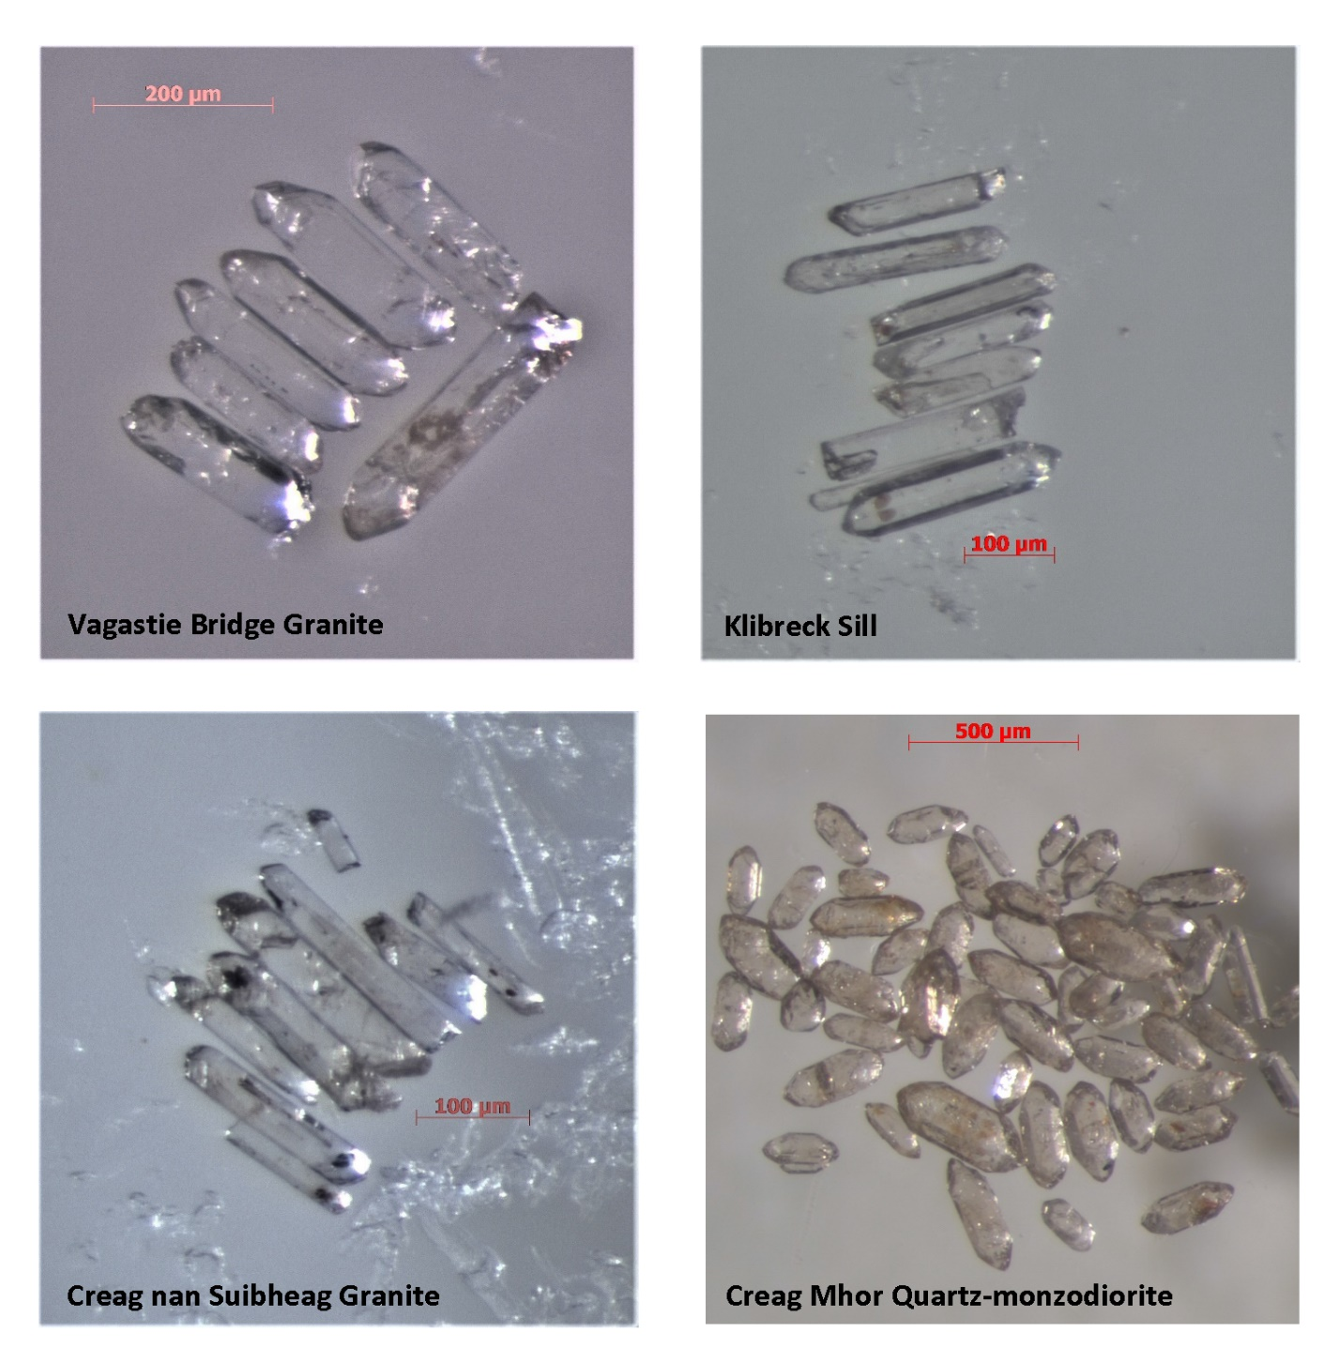
Figure S1. Photomicrograph of zircons from the analyzed rocks of the northern Scottish Caledonides.

