Structural evolution and medium-temperature thermochronology of central Madagascar: implications for Gondwana amalgamation

Supplementary A

Structural geology methods

Remote sensing methods
We used high resolution aerial imagery and Landsat 8 data to define the structural framework for the study area (Supplementary D). We have integrated our new interpretation from remotely sensed data with new 1:100,000 mapping and available structural data (Macey et al., 2009), to interpret the deformation history of the Ikalamavony, Itremo and Antananarivo (sub)domains. Structural trends and lithological boundaries were delineated from the ESRI world imagery basemap and Landsat 8 data in ArcGIS. Examples of Landsat images and bands used as well as our structural interpretation are documented in Supplementary D. Structures in the Itremo Group are easily identifiable due to relatively low vegetation cover and a strong contrast between quartzites and other rock types. Faults were defined by small offsets in lithologies or as large linear features. Lithologies were identified by similar signals in Landsat data and aerial imagery and boundaries were determined accordingly. Following the identification of major rock packages, lithological trends (S1, S2 etc.) and faults, we were able to identify fold interference patterns and interpret the major deformation events responsible for producing these poly-deformed folds.

Field methods
Several hundred new structural measurements were taken from over 70 localities. Data collected by the Council for Geoscience during the World Bank project in Madagascar were also used, which contains measurements for bedding and foliation (Macey et al., 2009). We additionally georeferenced geological maps (Moine, 1968; Service Géologique de Madagascar, 1962; Service Géologique de Madagascar, 1963a; Service Géologique de Madagascar, 1963b) and extracted structural readings. Based on broad lithological and structural styles across the region, we have divided the study area into three sections. The Ikalamavony transect was conducted along the ~east–west road between Miandrivazo and the boundary of the Ikalamavony Domain (Figure 5), the Itremo section was conducted along the same road from the Ikalamavony-Itremo boundary toward the east approximately 50 km. The Antananarivo section was conducted east of the main road between Antananarivo and Antisrabe. The strike of S1 fabrics interpreted from remotely sensed data very closely match those measured at outcrops, we can therefore be confident that our interpretation of S1 structures from remotely sensed data is reliable.
We have constructed several cross-sections of the three central Madagascan domains and key type 2 fold interference patterns (Figure 5, Figure 6, Figure 7, and Figure 8; main text). We used the QGIS qProf plugin to construct cross-sections. Structural data within ~2 km of the section were included and projected onto the profile. The Africa Digital Elevation Model (30 m resolution) was used to construct the topographic profile.

Analytical methods

Zircon U–Pb
Thirteen rock samples were crushed and the zircon fraction (sieved 79–425 μm) was separated by panning. Zircons were hand-picked and mounted in epoxy resin. The zircon mount was polished; carbon coated and imaged using a Gatan cathodoluminescence (CL) detector attached to Quanta 600 MLA Scanning Electron Microscope to identify suitable domains for analysis. Zircon U–Pb geochronology was undertaken at the University of Adelaide using an Agilent 7900x ICP-MS with attached ASI Resolution excimer 193nm laser ablation system. A spot size of 29 µm and frequency of 5 Hz was used. Isotopes ⁹⁰Zr, ²⁰¹Hg, ²⁰⁴Pb, ²⁰⁶Pb, ²⁰⁷Pb, ²⁰⁸Pb, ²³²Th and ²³⁸U were measured. Each analysis comprised a 20s background and 30s ablation. GEMOC GJ-1 zircon (TIMS normalising ages ²⁰⁷Pb/²⁰⁶Pb = 607.7 ± 4.3 Ma, ²⁰⁶Pb/²³⁸U = 600.7 ± 1.1 Ma and ²⁰⁷Pb/²³⁵U = 602.0 ± 1.0 Ma; Jackson et al. 2004) was used to correct for U–Pb fractionation. The Plešovice zircon standard (ID TIMS ²⁰⁶Pb/²³⁸U = 337.13 ± 0.37 Ma; Sláma et al. (2008)) was used to assess accuracy over the course of the laser session; a total of 52 Plešovice standard analyses were made and yield a weighted average ²⁰⁶Pb/²³⁸U age of 338.41± 0.69 Ma (95% confidence limits) which closely matches the ID TIMS age. Data were processed using Iolite (Paton et al., 2011).

Apatite U–Pb
Apatite grains were picked from the zircon fraction (see previous section) for 13 samples and mounted in epoxy resin. Prior to analysis, samples were chemically etched in a 5 M HNO3 solution for 20s at 20°C to identify whether apatite was present in the sample (Hasebe et al., 2009). Ten of these samples yielded sufficient apatite to be analysed. Apatite U–Pb thermochronology was undertaken at the University of Adelaide using an Agilent 7900x ICP-MS with attached ASI Resolution excimer 193nm laser ablation system. A spot size of 29 µm and frequency of 5 Hz was used. Isotopes ⁴³Ca, ²⁰¹Hg, ²⁰⁴Pb, ²⁰⁶Pb, ²⁰⁷Pb, ²⁰⁸Pb, ²³²Th and ²³⁸U were measured. Each analysis comprised a 30s background and 30s ablation. McClure Mountain syenite apatite was used as the primary standard (Schoene and Bowring, 2006), and the Madagascar apatite (Thomson et al., 2012) was used as a secondary standard. Data reduction was performed using the “VisualAge_UcomPbine” DRS (Chew et al., 2014) in the Iolite software package (Paton et al., 2011). This data reduction scheme can account for variable common Pb in the standards and unknowns, and was used to apply baseline, downhole fractionation, and long-term drift corrections. The Madagascar apatite standard yielded a ²⁰⁷Pb-corrected age of 468 ± 5 Ma (n=70), which closely matches the published value of 474.25 ± 0.41 (Thomson et al., 2012). Concordia diagrams were made using the isoplot plugin in Microsoft Excel (Ludwig, 2003).

Mica Rb–Sr
Muscovite and biotite grains were picked from the coarse fraction (>425 μm) of the same 13 samples used for zircon and apatite U–Pb geochronology and mounted in epoxy resin. Of these, nine samples yielded sufficient muscovite and 12 samples yielded sufficient biotite for analysis (although one of these did not yield data that formed a reasonable isochron age). Mica Rb–Sr geochronology was undertaken at the University of Adelaide using an Agilent 8900x QQQ-ICP-MS with attached ASI Resolution excimer 193nm laser ablation system. The CRPG reference material Mica-Mg (Govindaraju et al., 1994) prepared as a pressed power pellet was used as the primary standard (Hogmalm et al., 2017), and a mineral phlogopite (MDC) sourced from the same quarry in the Bekily area of Madagascar as Mica-Mg and assumed to be of the same age, was used as a secondary standard. We also analysed standards NIST612, NIST610, and BCR-2G; as well as biotite samples of known age, KW and LP6. We used a Rb decay constant of 1.393 x10⁻¹¹ (Nebel et al., 2011). The Isoplot add-in in excel was used to calculate isochron ages (Ludwig, 2003). The mineral standard MDC was tied to ⁸⁷Rb/⁸⁶Sr = 0.00001±0.00001 and ⁸⁷Sr/⁸⁶Sr = 0.72607±0.00363 initial ratios and yielded an isochron age of 535 ± 11 Ma (MSWD=2.8). While this is within uncertainty of the published value (519.4 ± 6.5 Ma; Hogmalm et al. (2017)), it is at the very limits of this range. To be conservative we have incorporated additional uncertainty into our calculated age uncertainties, based on the difference between the expected and measured age values. Using this approach, the accuracy of this technique within our setup is out by 3.68%. This adds further uncertainty to any ages calculated from this dataset, and we have added an uncertainty of 3.68% in quadrature to all calculated isochron age uncertainties.
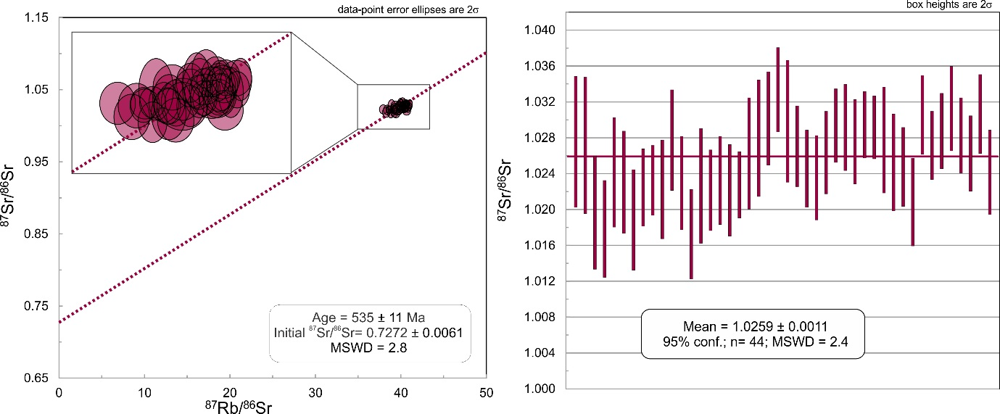
Figure A.1 ⁸⁷Sr/⁸⁶Sr vs ⁸⁷Rb/⁸⁶Sr plot and weighted average plot of ⁸⁷Sr/⁸⁶Sr for Mica mineral standard.

Detailed thermochronology results

Zircon U–Pb data
Thirteen magmatic samples from six key localities were analysed for U–Pb zircon geochronology. Concordia plots are shown for each locality in Supplementary B; Figure A.2 and age data is summarised in Table 1 of the manuscript. Samples were generally very discordant and difficult to interpret magmatic crystallisation ages. This is not surprising given all samples have been isotopically disturbed during a younger event, as revealed by both the apatite U–Pb and mica Rb–Sr results. If samples contained sufficient concordant data, we used a weighted average to calculate the magmatic crystallisation age (e.g. M16-45). However, as most data were discordant we generally calculated upper intercept ages of discordia lines of those data that appeared to form a linear trend away from the concordia curve. Data points that were very discordant and did not plot along a linear trend with other data ellipses, were generally excluded from age calculations. Many of these points may represent inherited zircons that have become discordant, or zircons that have undergone a complex history of multi-stage lead-loss. However, without several analyses forming a trend, it is impossible to interpret these ‘outliers’ with confidence.

Key locality 1 (western transect)
M16-24 was the only sample analysed from locality one and contains analyses that have undergone a degree of lead-loss, as indicated by their slip down the concordia. We therefore calculated an upper intercept age of the analyses that cluster on the concordia, and those that appear to form a lead-loss trend with these analyses. The upper intercept age of these analyses is 576 ± 24 Ma.

Key locality 2 (western transect)
Four samples were analysed from locality two. Twenty-one analyses from sample M16-32 were used to calculate an upper intercept age of 2553 ± 24 Ma. Sample M16-33 is comprised of mostly discordant data. Five analyses form a discordia trend with an upper intercept age of 798 ± 24 Ma. Several older discordant analyses from this sample may represent c. 815 Ma inherited zircons. M16-34 contains thirteen analyses that form a discordia trend with an upper intercept age of 2511 ± 14 Ma. Sample M16-35 contains analyses that appear to form two distinct populations. The first population has an upper intercept age of 2583 ± 26 Ma (MSWD=2.8, n=13), which we interpret as the magmatic crystallisation age. A second population of mostly zircon rims identified from CL images, forms a discordia trend with upper intercept age of 2494 ± 14 Ma (MSWD=1.5, n=10), which we interpret as a metamorphic age.

Key locality 3 (western transect)
Three samples from locality three were analysed for U–Pb zircon geochronology. Several analyses in sample M16-15 form a discordia trend with upper intercept age of 2456 ± 17 Ma, which we interpret as the crystallisation age of this orthogneiss. Sample M16-16 comprises several analyses that together form a discordia line with an upper intercept age of 795 ± 24 Ma. Sample M16-17 contained analyses that were very scattered on concordia plots with no distinct trends. Two data points plot near the cluster of points at c. 795 Ma for sample M16-16 and field relationships suggest that M16-17 pegmatite cross-cuts the M16-16 granite – suggesting that they are either coeval or that M16-17 post-dates the main granite. Based on so few data, the age of this sample is inconclusive.

Key locality 4 (eastern transect)
Analyses in sample M16-46 form a discordia trend with upper intercept age of 2522 ± 8 Ma and lower intercept age of 543 ± 27 Ma (Figure A.2). We suggest 2522 ± 8 Ma is the magmatic crystallisation age of this orthogneiss and that the isotopic system was disturbed during an event at c. 543 Ma. Analyses from sample M16-47 show significant scatter along the concordia line, which makes the identification of a lead-loss trend difficult. Given that Sample M16-46 from the same outcrop has a lower intercept age of c. 543 Ma that we interpret as isotopic disturbance, it is probable that sample M16-47 has also been disturbed at this time. If this is the case, the majority of analyses intersect a line between c. 800 Ma and c. 543 Ma, and potentially represent a coherent population that was disturbed at c. 543 Ma. Analyses that form along this general trend produce a discordia line with upper intercept age of 798 ± 48 Ma and lower intercept age of 532 ± 44 Ma (MSWD=1.4, n=18). We therefore suggest that the magmatic crystallisation age of this granite is 798 ± 48 Ma, and that isotopic disturbance occurred at 532 ± 44 Ma.

Key locality 5 (eastern transect)
The majority of analyses from M16-45 plot as part of a cluster on the concordia line. A weighted average of all of these analyses does not yield a reasonable MSWD (6.0), and show a decrease trend more than expected for normal variability in a magmatic population. We suggest the younger analyses in this group are the result of lead-loss following Spencer et al. (2016). Seventeen near-concordant analyses yield a ²⁰⁶Pb/²³⁸U weighted average of 543 ± 18 Ma (MSWD=0.68), which we interpret as the magmatic crystallisation age of this granite.

Key locality 6 (eastern transect)
The majority of analyses in sample M16-52 plot near the concordia line at c. 570 Ma. A calculated upper intercept age for these analyses is 568 ± 16 Ma (MSWD=2.2, n=18), which we interpret as the magmatic crystallisation age of this granite. Sample M16-53 contains very scattered data, with only one analysis intersecting the concordia line. This analysis clusters with three other analyses near c. 570 Ma, however these do not form a statistically robust weighted average or a concordia age. From field relationships, this sample cross-cuts sample M16-52 and therefore cannot be older than c. 568 Ma. We suggest this sample is most likely c. 568 Ma that formed during a magmatic event contemporaneously with M16-52.
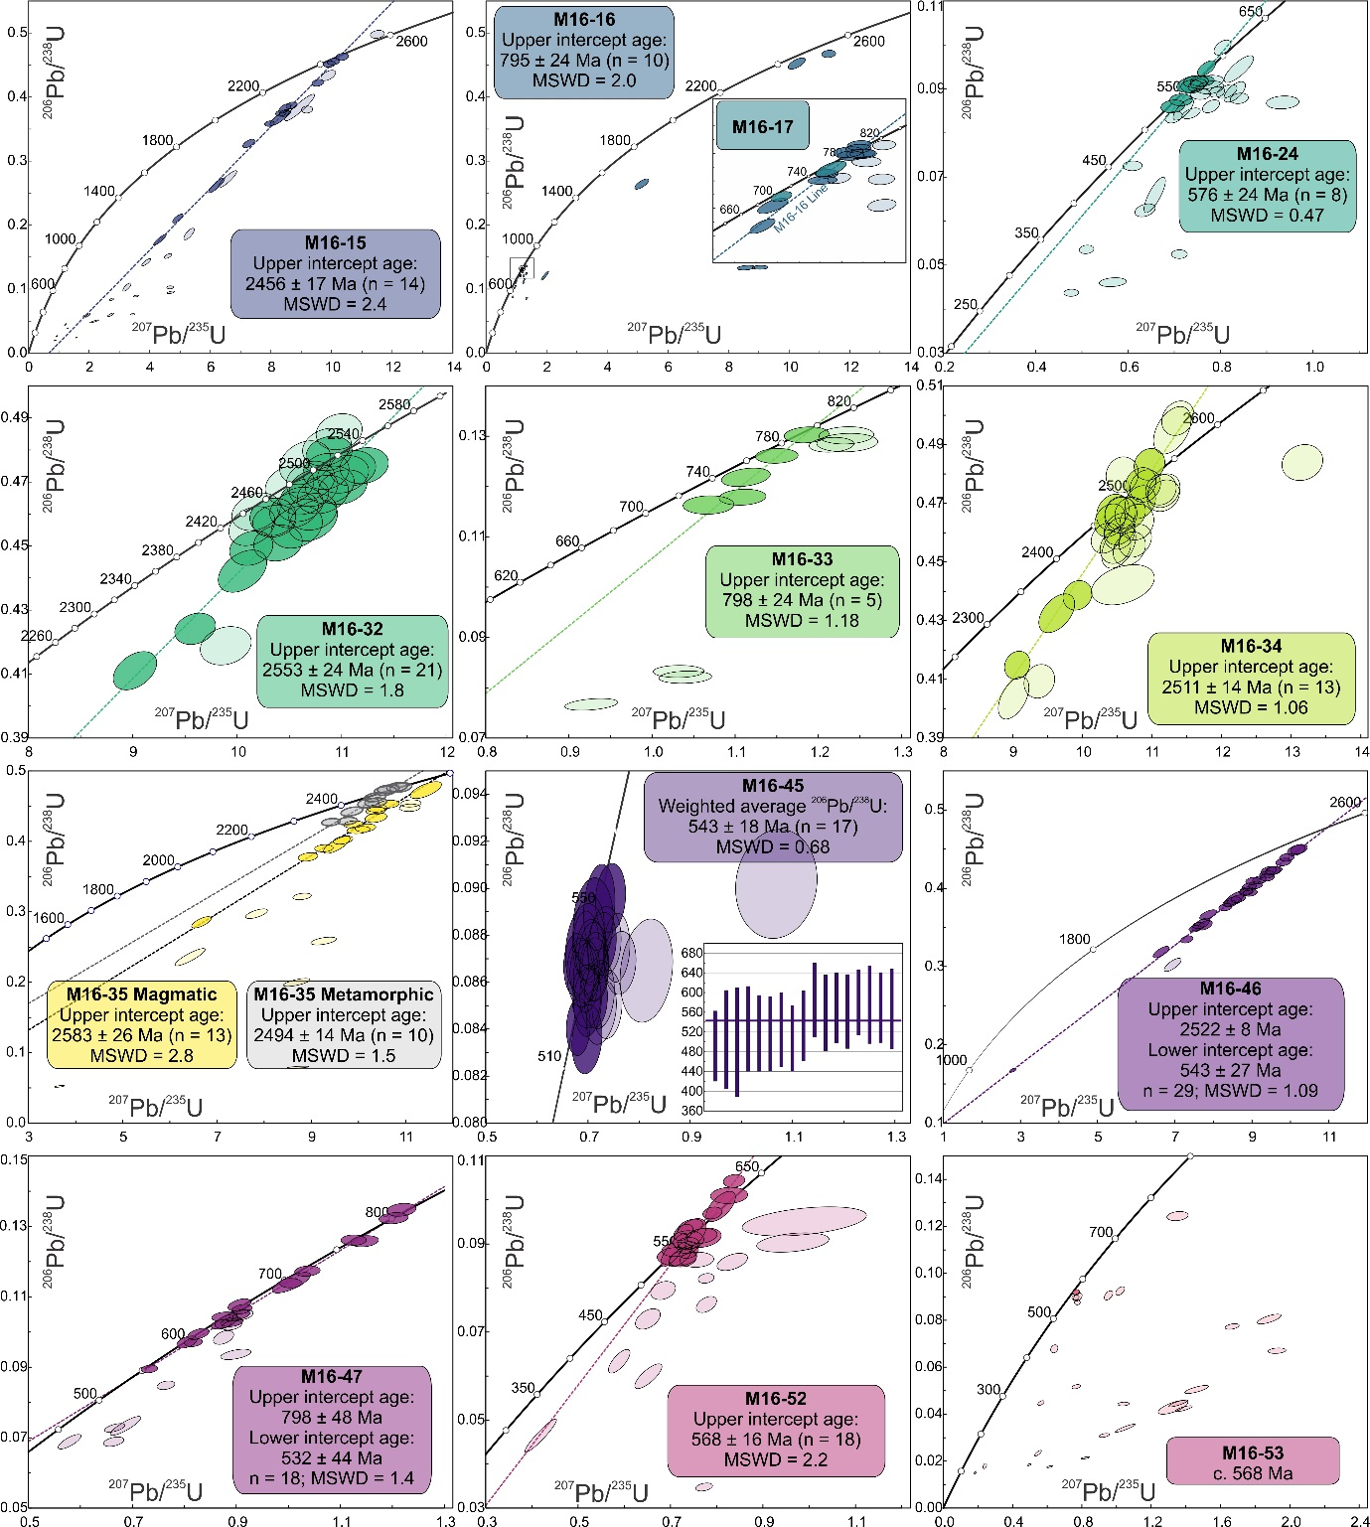
Figure A.2 Zircon U–Pb concordia plots for each sample, locations indicated on the map in Figure 2. X and Y axes are the same on all plots. Ellipses with higher transparency were not used to calculate ages.

Apatite U–Pb data
Apatite has a U–Pb closure temperature of ~450–550ºC (Chamberlain and Bowring, 2001; Schoene and Bowring, 2007), which makes it a potentially useful system for understanding the thermal evolution of orogenic events. Coupled with other minerals with different closure temperatures, we can reconstruct the thermal and tectonic evolution of central Madagascar.
Of the thirteen samples separated for heavy mineral analysis, ten yielded sufficient apatite for U–Pb analysis. Supplementary B; Figure A.3 shows Concordia plots for all samples analysed, and grouped by locality. Discordia lines were calculated for each sample. Some analyses in each sample plotted significantly off the discordia lines, and were excluded from the calculated intercept ages (higher transparency ellipses in Supplementary B; Figure A.3). Some of these analyses appear to form a distinct trend, and so we calculated an intercept age based on these analyses for each locality, as indicated by the red discordia lines and red outlined ellipses in Supplementary B; Figure A.3.

Key locality 1 (western transect)
Magmatic crystallisation ages interpreted from U–Pb zircon data for samples M16-15, M16-16 and M16-17 are c. 2500 Ma, c. 795 Ma and c. 787 Ma respectively. All three samples have very similar apatite U–Pb ages that are within uncertainty of each other, suggesting that they were thermally reset during a later event, and cooled below ~450–550ºC at c. 495 Ma. Sample ages, the number of analyses and MSWDs are given in (Figure A.3). Several analyses from locality 1 fall off the regression lines. A calculated regression line through the analyses of all three samples combined produced an age of 493 ± 19 Ma, which is indistinguishable from the ages calculated for the main analysis populations in these samples.

Key locality 3 (western transect)
Magmatic crystallisation ages interpreted from U–Pb zircon data for samples M16-32, M16-34 and M16-35 are all c. 2500 Ma. All samples have been reset during a later event and cooled through ~450–550ºC at c. 510 Ma. Several analyses fall off these discordia lines and were excluded from the sample age calculations. Together these four ‘discordant’ analyses produce a regression line and lower intercept age of c. 613 ± 25 Ma. These analyses potentially record an earlier event that post-dates magmatic emplacement, and pre-dates the main phase of thermal resetting of the majority of analyses.

Key locality 4/5 (eastern transect)
We have grouped samples M16-45 and M16-46 together due to the geographic proximity and similarity in apatite U–Pb age. The magmatic ages calculated from U–Pb zircon data are c. 543 Ma and c. 2500 Ma for samples M16-45 and M16-46 respectively. Apatite U–Pb data reveals that these samples have been thermally reset during a later event, and cooled through ~450–550ºC at c. 500 Ma. Several analyses do not overlap the regression lines and together produce an age of 559 ± 89 Ma. Although this apatite U–Pb age is older than the main sample population ages, it is still within uncertainty. These analyses either represent partial lead diffusion during reheating or record an age closer to the magmatic crystallisation age of M16-45 at c. 543 Ma.

Key locality 6 (eastern transect)
Samples M16-52 and M16-53 have zircon U–Pb magmatic crystallisation ages of c. 565 Ma. Apatite U–Pb ages for these samples are 484 ± 14 Ma and 500 ± 10 Ma respectively. This suggests that these rocks either slowly cooled from the time of magmatic crystallisation to ~450–550ºC over a protracted period of c. 60 Ma, or that these magmatic rocks were thermally reset during a younger event. Several analyses do not overlap the apatite U–Pb regression lines, and together produce an intercept age of 547 ± 25 Ma. Unlike key locality 4/5, this age is not within uncertainty of the main apatite U–Pb population, and more closely matches the age of zircon crystallisation. We therefore suggest that the U–Pb system closed in these grains earlier than the majority of grains analysed.
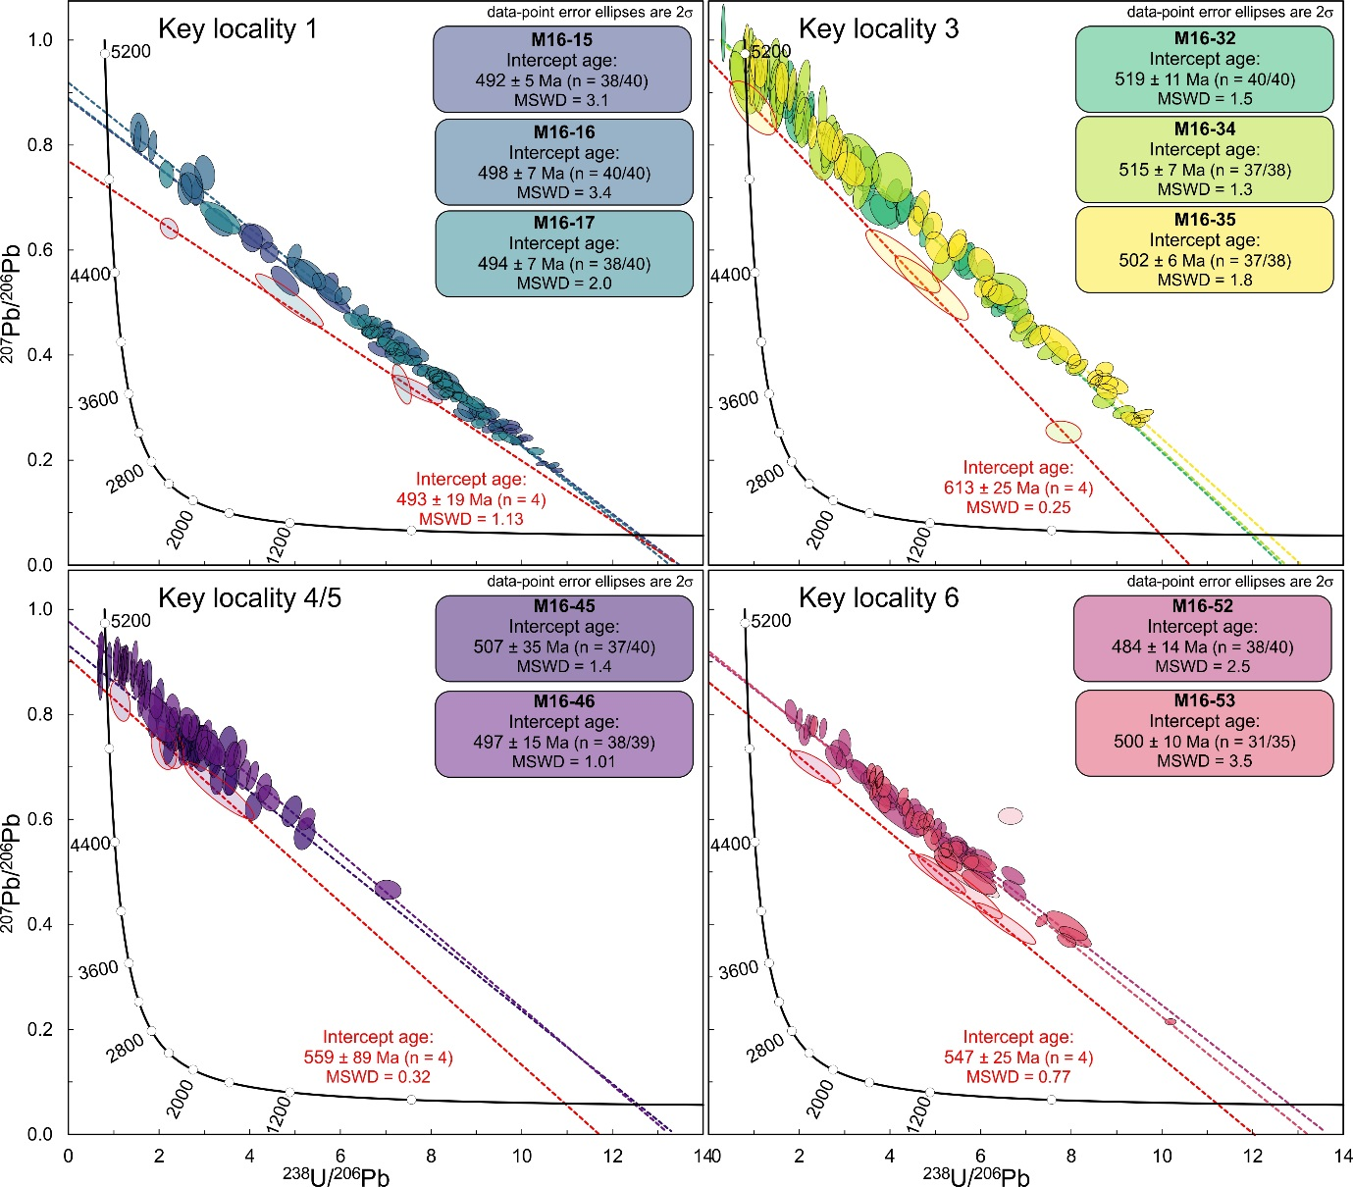
Figure A.3 Apatite U–Pb concordia plots of data analysed from key localities indicated on the map in Figure 2 of the manuscript. X and Y axes are the same on all plots. Ellipses with higher transparency were not used to calculate the intercept age.

Biotite and muscovite Rb–Sr data
Muscovite and biotite have closure temperatures of ~500–600ºC (Armstrong et al., 1966) and ~300–400ºC (Del Moro et al., 1982; Jenkin et al., 2001; Verschure et al., 1980) respectively, which makes them useful for understanding medium-temperature geological events. Supplementary B; Figure A.4 and Figure A.5 show isochron plots for all samples that produced reasonable age calculations, and are grouped by locality. Isochron lines were calculated for each sample. Some analyses in each sample plotted significantly off the isochron lines, and were excluded from the calculated intercept ages (higher transparency ellipses in Supplementary B; Figure A.4 and Figure A.5).

Key locality 1
All three samples from key locality one were analysed for biotite and muscovite Rb–Sr dating. Biotite isochron ages for samples M16-15, M16-16 and M16-17 are 528 ± 18 Ma, 499 ± 68 Ma and 492 ± 51 Ma (2σ) respectively. Muscovite isochron ages for samples M16-15, M16-16 and M16-17 are 624 ± 152 Ma, 506 ± 82 Ma and 526 ± 39 Ma (2σ) respectively. Taking into account the uncertainties on these ages, we suggest that both muscovite and biotite cooled through their closure temperatures at c. 500 Ma. ε

Key locality 2
Sample M16-24 yielded a biotite isochron age of 505 ± 59 Ma and a muscovite age of 519 ± 69 Ma. These ages are within uncertainty of each other, so we suggest this sample was heated to at least ~300–600ºC at this time. These are broadly consistent with ages obtained from key locality 1, suggesting that thermal activity was regionally widespread.

Key locality 3
Samples M16-32 and M16-35 yielded biotite ages of 502 ± 20 Ma and 513 ± 18 Ma respectively. Sample M16-32 yielded a muscovite isochron age of 446 ± 161 Ma. Given the large uncertainty for the muscovite age, we suggest that these samples underwent temperatures of ~300–600ºC at c. 500 Ma, based on the biotite age.

Key locality 4/5
Sample M16-45 has a biotite age of 512 ± 16 Ma. Sample M16-46 has a biotite age of 512 ± 24 Ma, and a muscovite age of 604 ± 211 Ma. Sample M16-47 has a muscovite age of 657 ± 98 Ma. Given the uncertainties of these ages, we cannot reconcile whether there is an older c. 650–600 Ma event recorded here, or if these ages represent an event similar to other samples at c. 500 Ma.

Key locality 6
Samples M16-52 and M16-53 have biotite ages of 511 ± 16 Ma and 521 ± 18 Ma respectively. These samples have muscovite ages of 527 ± 51 Ma and 537 ± 35 Ma. The muscovite samples are slightly older, although still within uncertainty, of the biotite ages. We therefore suggest these samples cooled through ~300–600ºC at c. 530–510 Ma.
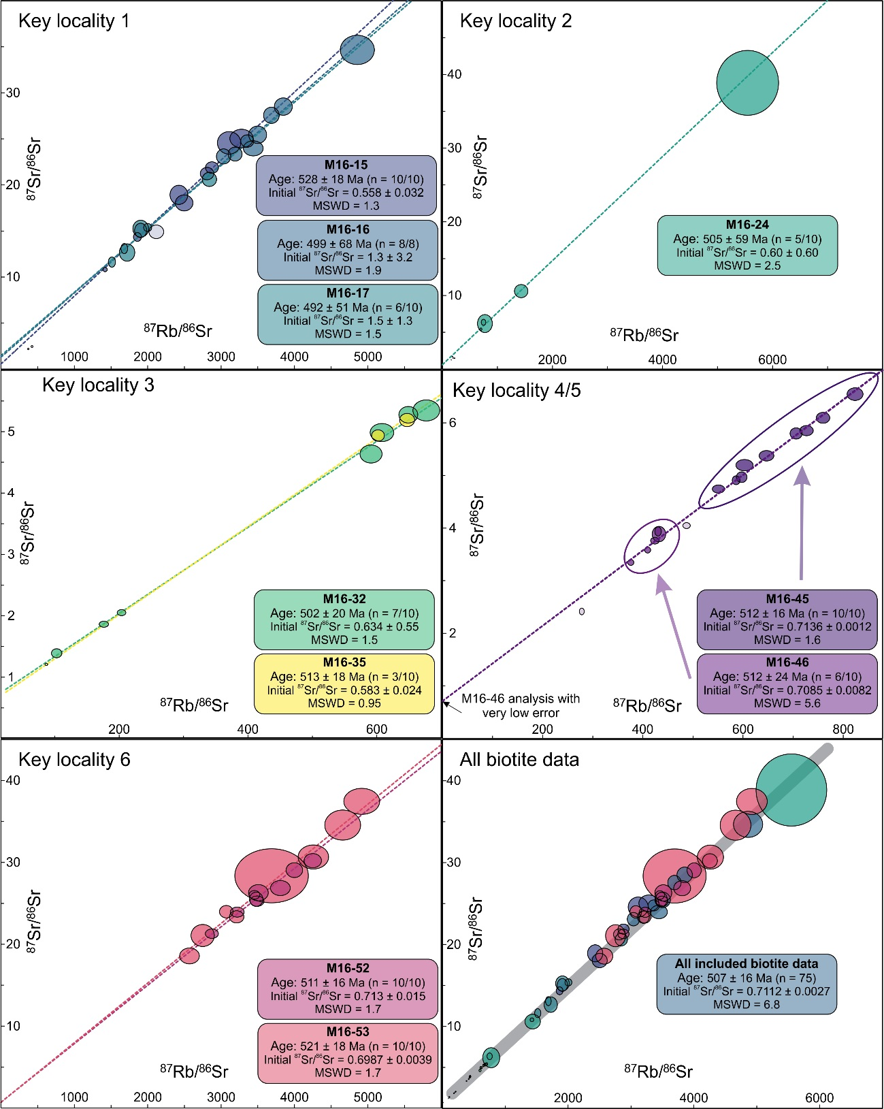
Figure A.4 Biotite Rb–Sr data plotted for each locality and coloured by sample. Isochrons calculated for each sample. High transparency ellipses were excluded from age calculations. Due to some very low values and associated low errors, not all data is visible on the plots, see supplementary B for isotopic data. Data-point error ellipses are 2σ.
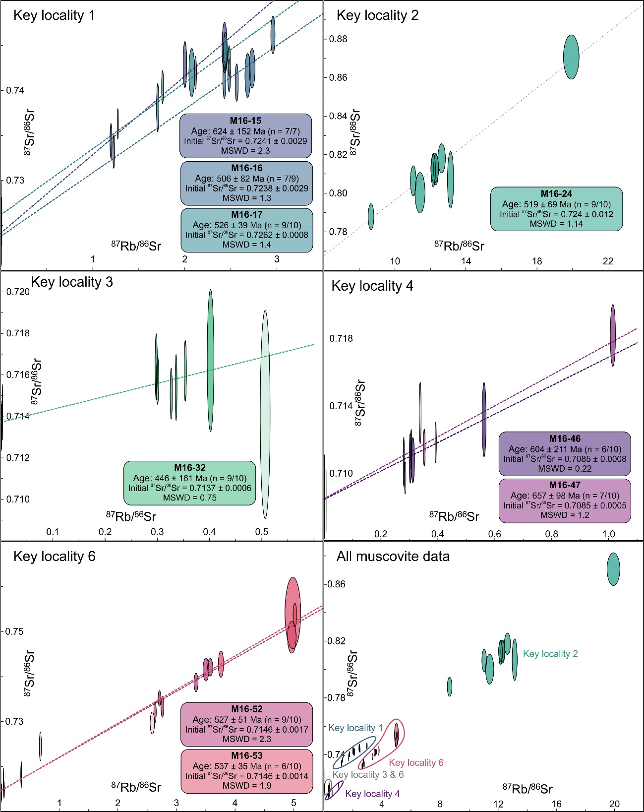
Figure A.5 Muscovite Rb–Sr data plotted for each locality and coloured by sample. Isochrons calculated for each sample. High transparency ellipses were excluded from age calculations. Due to some very low values and associated low errors, not all data is visible on the plots, see supplementary B for isotopic data. Data-point error ellipses are 2σ.

References
Armstrong, R.L., Jäger, E. and Eberhardt, P., 1966. A comparison of K-Ar and Rb-Sr ages on Alpine biotites. Earth and Planetary Science Letters, 1(1): 13-19.
Chamberlain, K.R. and Bowring, S.A., 2001. Apatite–feldspar U–Pb thermochronometer: a reliable, mid-range (∼450°C), diffusion-controlled system. Chemical Geology, 172(1): 173-200.
Chew, D., Petrus, J. and Kamber, B., 2014. U–Pb LA–ICPMS dating using accessory mineral standards with variable common Pb. Chemical Geology, 363: 185-199.
Del Moro, A., Puxeddu, M., di Brozolo, F.R. and Villa, I.M., 1982. Rb-Sr and K-Ar ages on minerals at temperatures of 300°–400° C from deep wells in the Larderello geothermal field (Italy). Contributions to Mineralogy and Petrology, 81(4): 340-349.
Govindaraju, K., RUBESKA, I. and PAUKERT, T., 1994. 1994 Report on Zinnwaldite ZW‐C analysed by ninety‐two GIT‐IWG member‐laboratories. Geostandards Newsletter, 18(1): 1-42.
Hasebe, N., Carter, A., Hurford, A.J. and Arai, S., 2009. The effect of chemical etching on LA–ICP-MS analysis in determining uranium concentration for fission-track chronometry. Geological Society, London, Special Publications, 324(1): 37-46.
Hogmalm, K.J., Zack, T., Karlsson, A.K.-O., Sjöqvist, A.S. and Garbe-Schönberg, D., 2017. In situ Rb–Sr and K–Ca dating by LA-ICP-MS/MS: an evaluation of N 2 O and SF 6 as reaction gases. Journal of Analytical Atomic Spectrometry, 32(2): 305-313.
Jenkin, G.R.T., Ellam, R.M., Rogers, G. and Stuart, F.M., 2001. An investigation of closure temperature of the biotite Rb-Sr system: The importance of cation exchange. Geochimica et Cosmochimica Acta, 65(7): 1141-1160.
Ludwig, K.R., 2003. User's manual for Isoplot 3.00: a geochronological toolkit for Microsoft Excel. Kenneth R. Ludwig.
Macey, P.H., Bisnath, A., Yibas, B., Robson, L. and Andriamanantsoa, E., 2009. Carte Geologique de Madagascar, Council for Geoscience, Pretoria, Afrique du Sud.
Moine, B., 1968. Massif Schisto-Quartzo-Dolomitique: Reion d'Ambatofinandrahana centre-ouest du socle cristallin precambrien de Madagascar In: N. Sciences de la terre (Editor). Centre de l'Institut Géographique National à Tananarive.
Nebel, O., Scherer, E.E. and Mezger, K., 2011. Evaluation of the 87Rb decay constant by age comparison against the U–Pb system. Earth and Planetary Science Letters, 301(1-2): 1-8.
Paton, C., Hellstrom, J., Paul, B., Woodhead, J. and Hergt, J., 2011. Iolite: Freeware for the visualisation and processing of mass spectrometric data. Journal of Analytical Atomic Spectrometry, 26(12): 2508-2518.
Schoene, B. and Bowring, S.A., 2006. U–Pb systematics of the McClure Mountain syenite: thermochronological constraints on the age of the 40 Ar/39 Ar standard MMhb. Contributions to Mineralogy and Petrology, 151(5): 615.
Schoene, B. and Bowring, S.A., 2007. Determining accurate temperature–time paths from U–Pb thermochronology: An example from the Kaapvaal craton, southern Africa. Geochimica et Cosmochimica Acta, 71(1): 165-185.
Service Géologique de Madagascar, T., 1962. Moramanga-Brickaville.
Service Géologique de Madagascar, T., 1963a. Antsirabe-Ampatolampy
Service Géologique de Madagascar, T., 1963b. Miarinarivo-Tanarive.
Sláma, J., Košler, J., Condon, D.J., Crowley, J.L., Gerdes, A., Hanchar, J.M., Horstwood, M.S., Morris, G.A., Nasdala, L. and Norberg, N., 2008. Plešovice zircon—a new natural reference material for U–Pb and Hf isotopic microanalysis. Chemical Geology, 249(1): 1-35.
Spencer, C.J., Kirkland, C.L. and Taylor, R.J., 2016. Strategies towards statistically robust interpretations of in situ U–Pb zircon geochronology. Geoscience Frontiers, 7(4): 581-589.
Thomson, S.N., Gehrels, G.E., Ruiz, J. and Buchwaldt, R., 2012. Routine low‐damage apatite U‐Pb dating using laser ablation–multicollector–ICPMS. Geochemistry, Geophysics, Geosystems, 13(2).
Verschure, R.H., Andriessen, P.A.M., Boelrijk, N.A.I.M., Hebeda, E.H., Maijer, C., Priem, H.N.A. and Verdurmen, E.A.T., 1980. On the thermal stability of Rb-Sr and K-Ar biotite systems: Evidence from coexisting Sveconorwegian (ca 870 Ma) and Caledonian (ca 400 Ma) biotites in SW Norway. Contributions to Mineralogy and Petrology, 74(3): 245-252.

