Journal of the Geological Society

Supporting Information for
Evolution of a shear zone before, during and after melting
Amicia L. Lee1,2*, Geoffrey E. Lloyd1, Taija Torvela1 & Andrew M. Walker1

1School of Earth and Environment, University of Leeds, Leeds, UK
2Department of Geology, University of Tromsø, Tromsø, Norway
*Corresponding author (e-mail: amicia.lee@uit.no)

Introduction
Supporting information provides additional dihedral angle and EBSD data that was used in this study. Data includes dihedral angle plots to illustrate the data and trends in dihedral angles. Addition EBSD data of Euler maps for quartz-bearing samples (SIP24, 23/22, 21, 20,19,18,17,16, 15, 43, 12, 11), recrystallised and relict grain maps as generated by GOS analysis after Cross et al., (2017) and point per grain CPO pole figures.

Figure S1: Dihedral angle data for paragneiss samples in the ØSZ. (a) Representative photomicrographs of dihedral angles. (b) Distribution of the dihedral angles between mineral grain triple junctions for solid-solid-melt and solid-solid-solid triple junctions. (c) Holness-style plot of standard deviation vs. median angle for the two dihedral angle populations. Solid-solid-melt boundaries, , and solid-solid-solid boundaries, . Also shown is a schematic diagram showing end-member solid-solid-melt dihedral angle populations (Adapted from Holness et al., 2006).
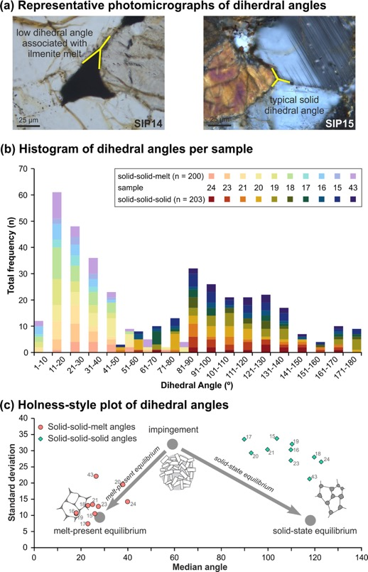
Figure S2: EBSD maps for quartz grains in ØSZ samples. Euler angle maps are shown first and correlate to the spectrum colour key below. Recrystallised and relict grains maps as generated by GOS analysis using the Cross et al., (2017) methodology. The key for recrystallised and relict grains is shown below for reference.

Euler colour key: Recrystallised/relict grain key
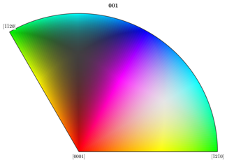
Recrystallised grains

Relict grains

SIP24:
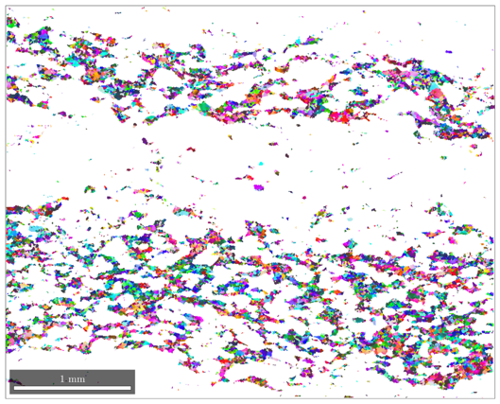
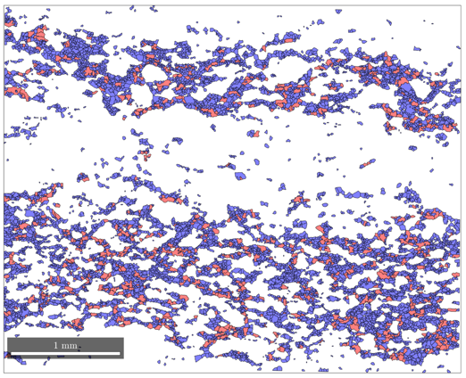
SIP23:
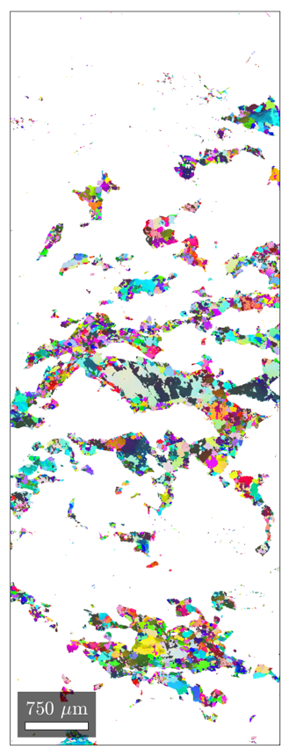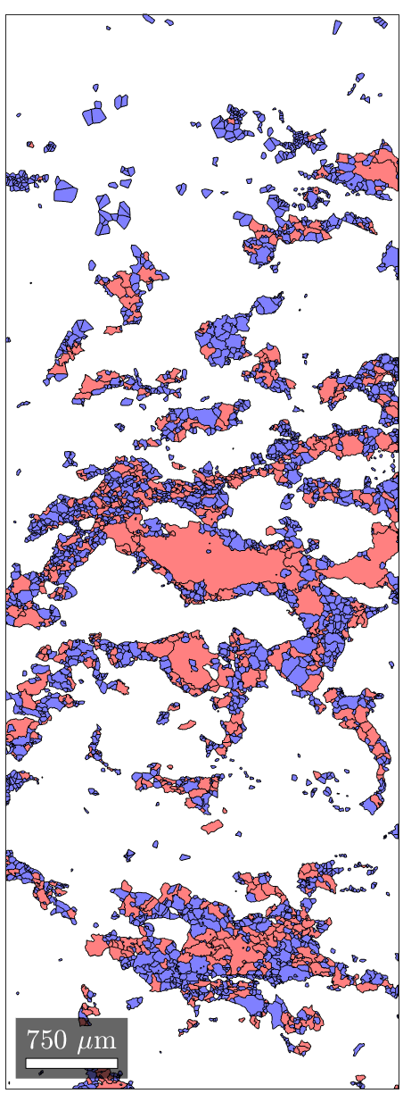
SIP21:
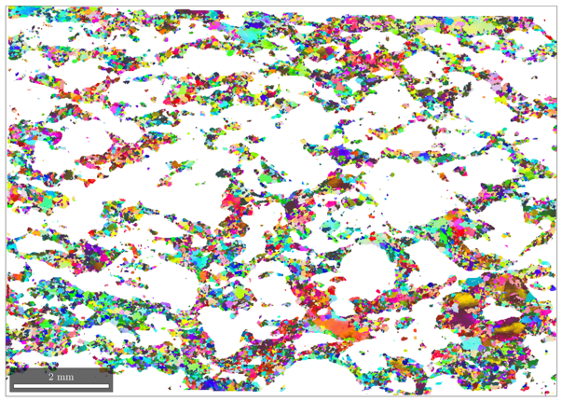
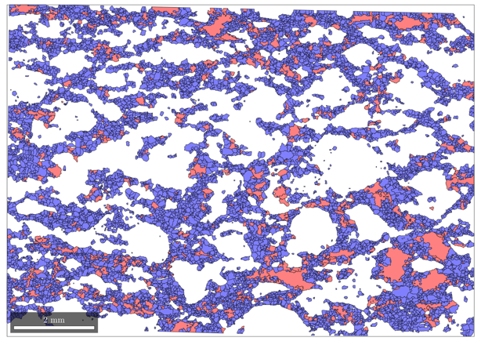
SIP20:
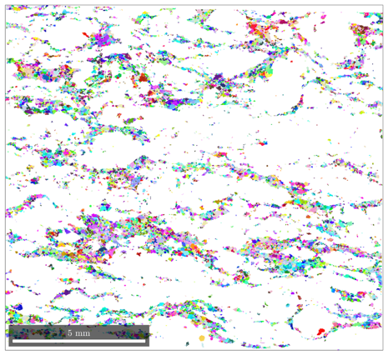
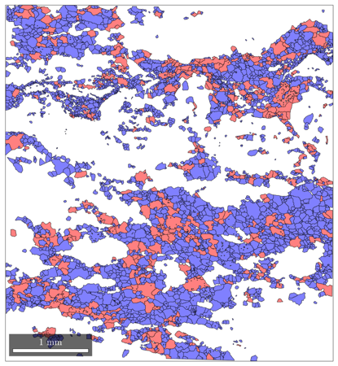
SIP19:
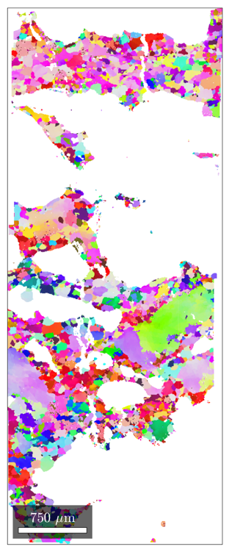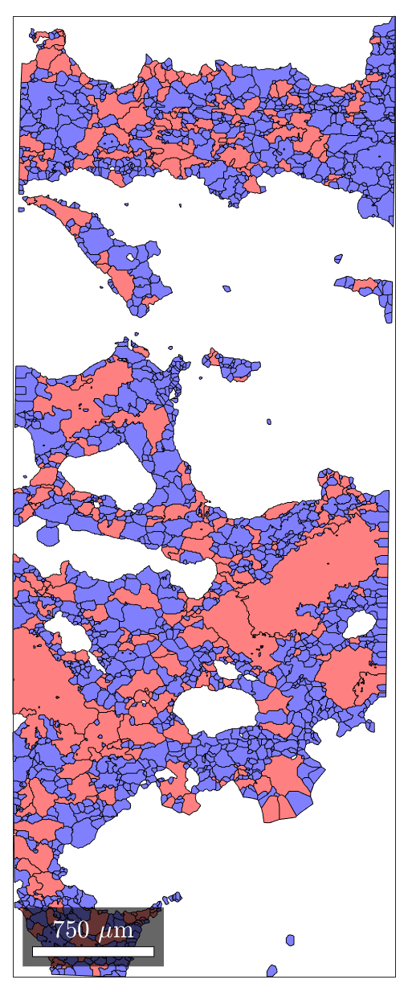

SIP18:
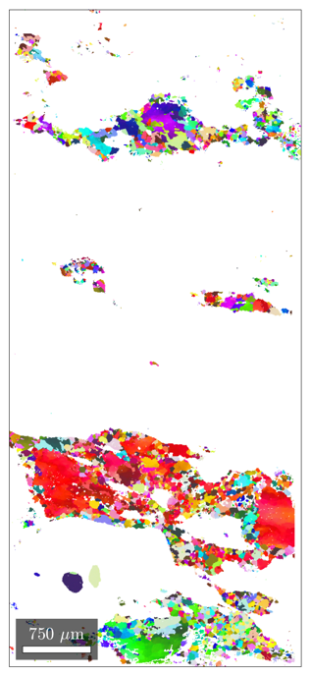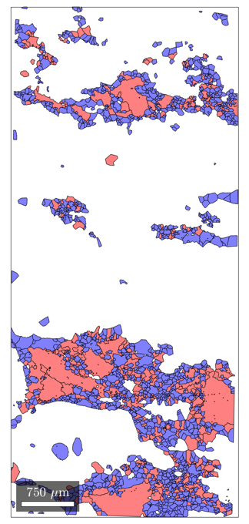

SIP17:
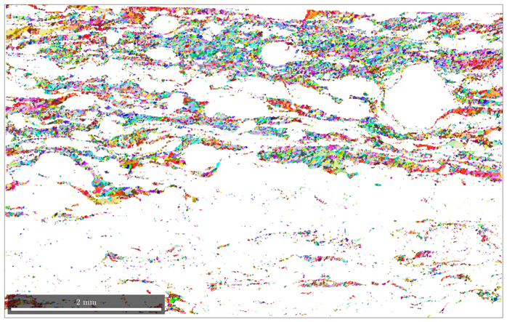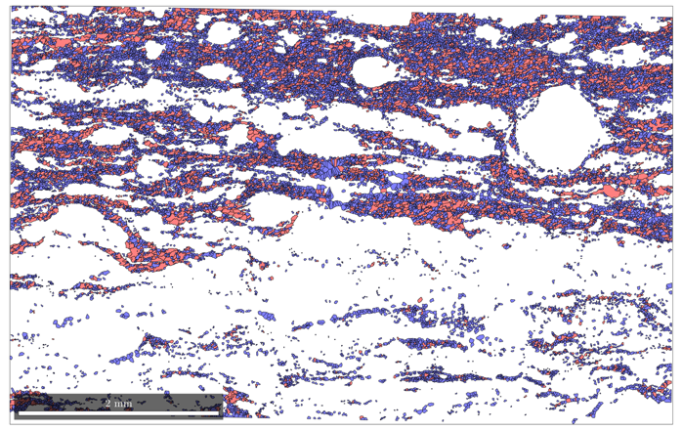
SIP16:
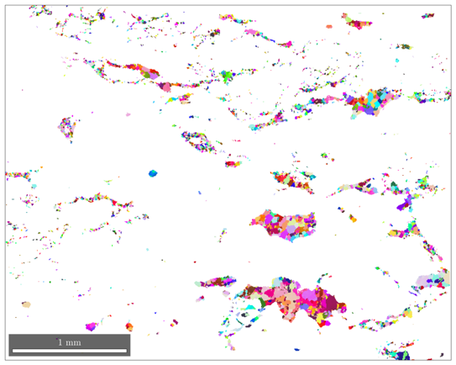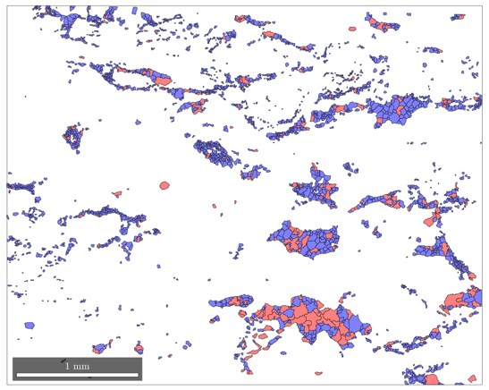
SIP15:
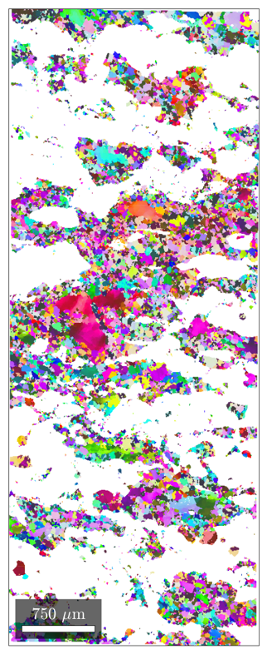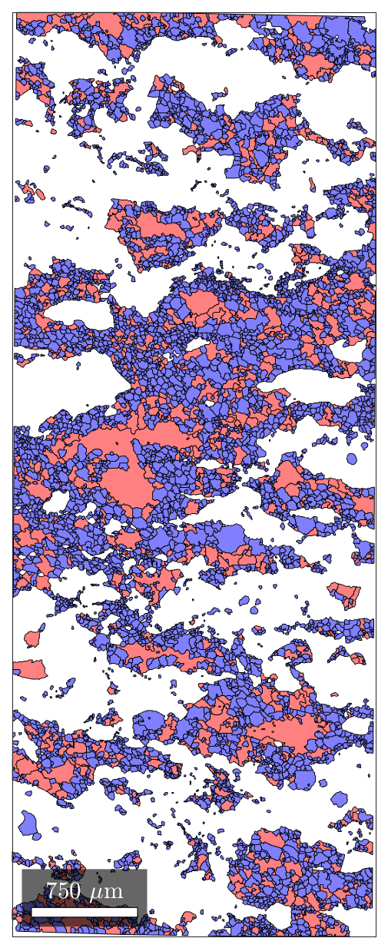

SIP43:
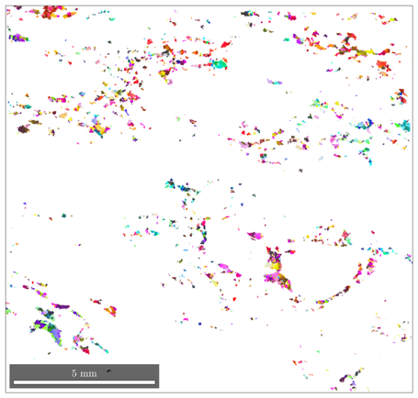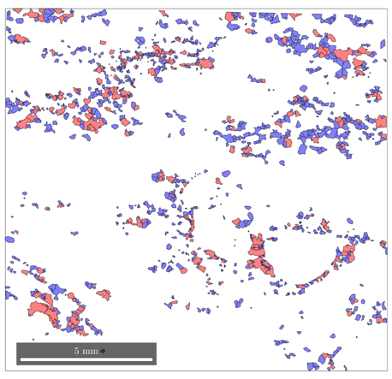
SIP12:
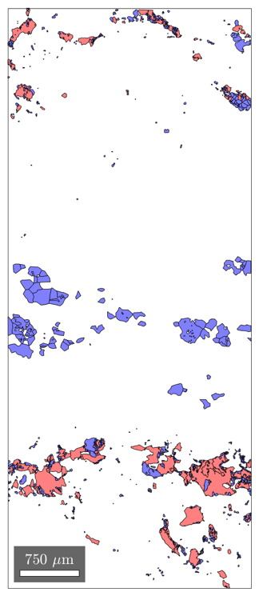

SIP11:
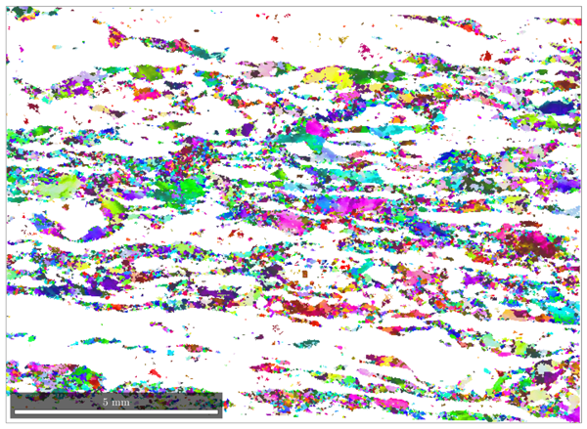
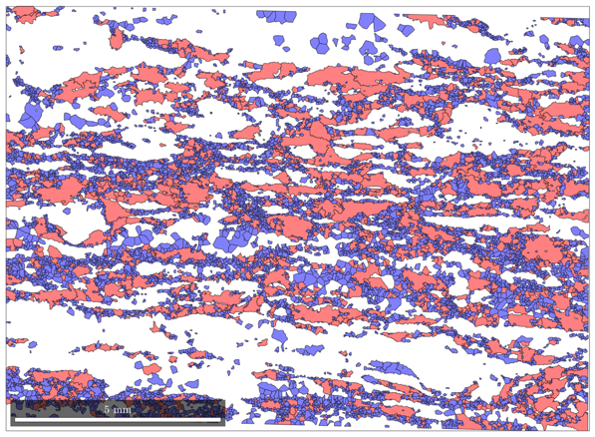
Figure S3: Relative frequency histograms of relict and recrystallised grain size for grain maps shown in Figure S2. These plots are generated during GOS analysis in the Cross et al., (2017) scripts.
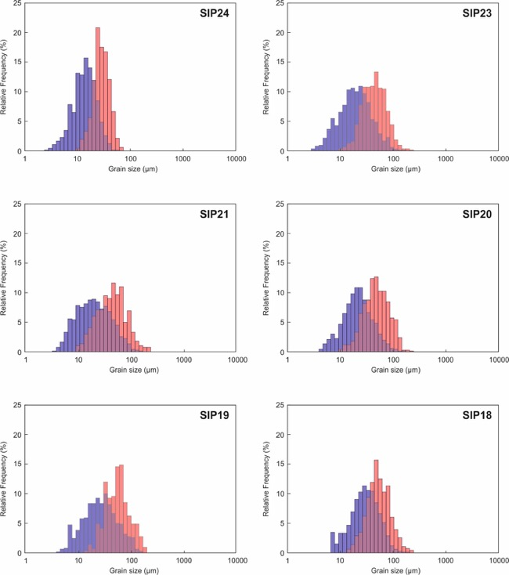

Recrystallised grains Relict grains Overlap

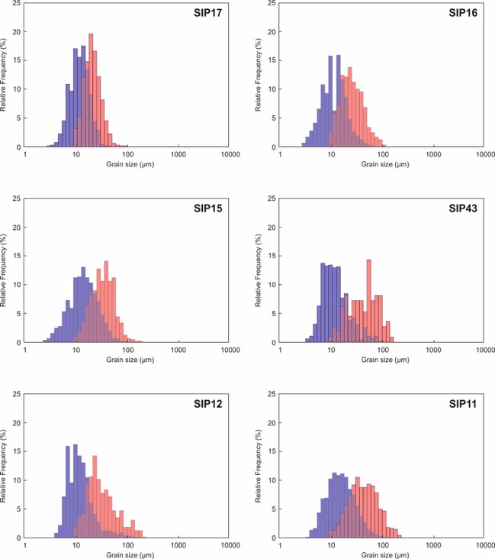

Recrystallised grains Relict grains Overlap

Figure S4: Point per grain CPO pole figures for quartz-bearing samples within the ØSZ.

SIP24 | 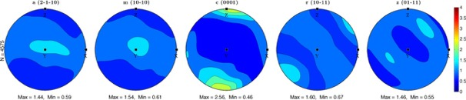
SIP23 | 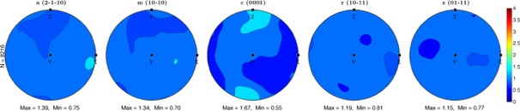
SIP22 | 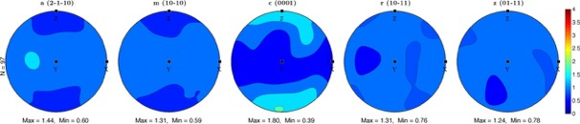
SIP21 | 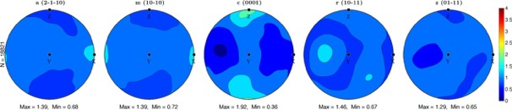
SIP20 | 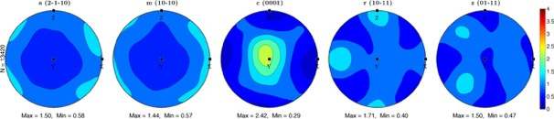
SIP19 | 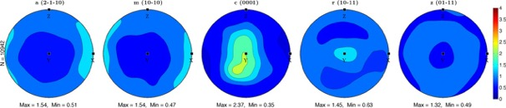
SIP18 | 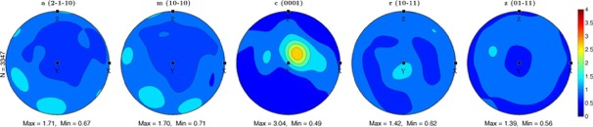
SIP17 | 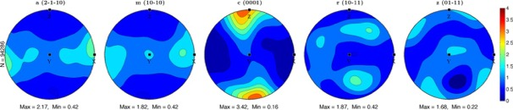
SIP16 | 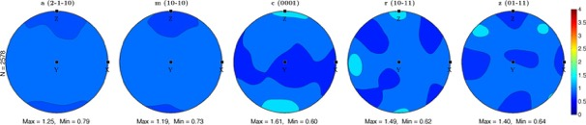
SIP15 | 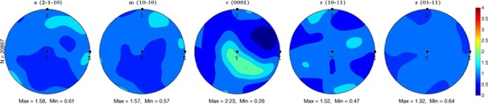
SIP43 | 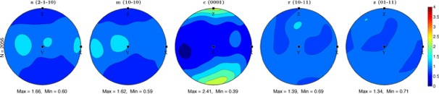
SIP12 | 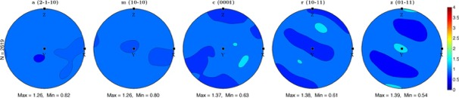
SIP11 | 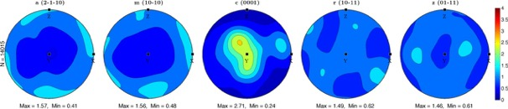
References
Cross, A. J., Prior, D. J., Stipp, M., and Kidder, S. (2017). The recrystallized grain size piezometer for quartz: An EBSD-based calibration. Geophysical Research Letters, 44:6667–6674.
Holness, M. B. (2006). Melt-solid dihedral angles of common minerals in natural rocks. Journal of Petrology, 47(4):791–800.

