Appendix

- Simulation Setup

  - History Matching Approach

Limited core and log data was available for geologic modelling. The information was used to define structural and stratigraphic framework, and identify three petrophysical classes (Wang et al. 1998). The main reservoir zones are composed of grainstones and packstones (Petrophysical class 1 and 2) interbedded with low permeability shaley mudstones (Petrophysical class 3). The range in permeability values for class 1 and 2 arises from dissolution of carbonate material resulting in high local values of permeability. The layers – 4, 8, 10 and 16, which correspond to the grain dominated facies of Petrophysical class 1, were input deterministically after the initial geomodel was built. Petrophysical properties for these ‘Enhanced Permeability Zones’ were assigned a constant value throughout the layer. The details on the geologic and reservoir modelling are available in Sharma et al. (2017) and Alcorn et al. (2018). Fig. 1 shows the permeability distribution in the initial geologic model for a cross-section connecting wells 8, 3, 1, 5 and 10, highlighting the vertical heterogeneity in the reservoir. The historical injection rates for wells 6, 7, 8, 9, 10 and 11 were adjusted corresponding to the area the well was feeding in the sector model for simulation purpose, as shown in Fig. 2.

    - Setting up an Uncertainty Matrix

To begin with, a matrix was setup with uncertainty parameters (UPs) after discussion with different stakeholders, which listed important model parameters, their ranges and distributions. The framing discussion was based on the review of the prior knowledge of the field including previous uncertainty work about volumetrics, and the available historical data.

    - Setting up the Objective Function

The progress of the history matching process depends on the quality of the setup of the objective function, which is the misfit or mismatch between the observed data and the simulator response. The objective function is minimized for a set of uncertain parameters using optimisation algorithms. Since different data types carry different values during model calibration, it was necessary to identify whether each type of data should be included as a target for matching or simply monitored. Also, it is important to place more emphasis on data which has a lower error associated with the measurements. The available historical data was therefore evaluated to eliminate outliers. Judgements about the weighting of different data types were made, and misfits for different wells and data types were used to obtain the global objective function value as
$$GV= \sum_{i}{\sum_{j}{{W_{i}{ W}_{j}\left(\frac{{Sim}_{i}^{j}-{Obs}_{i}^{j}}{{Std}_{i}}\right)}^{2}}} (1)$$

where GV is the global value, i refers to the mismatch parameter (MP) like observations of oil rate at a well, j refers to an individual time step that contains an observation, $W_{i}$ is the global weight factor of MP i which defaults to 1, $W_{j}$ is the weight of timestep j which defaults to equal weighting for all time steps, ${Sim}_{i}^{j}$ refers to the simulated value of observation i at time j, ${Obs}_{i}^{j}$ refers to the observed history match value of parameter i at time j and ${Std}_{i}$ is the standard deviation of MP i.

    - Model Validation

A well set up assisted history matching workflow has advantages over trial and error approaches, provided the initial-set up is good and the range of UPs is validated. The validation stage involved:
- Sensitivity analysis: Running simulations by varying one variable at a time to get relative impact of each UP on various MPs in form of Tornado plots.
- Boundary analysis: Running simulations using Plackett-Burmann (PB) sampling, where low values of some UPs were combined with high values of other UPs. This was used to ensure that simulations based on the input range of UPs cover measured data and match shape for simulated cases. A wider range of the solution space gets sampled with the Plackett-Burmann experiment compared to Latin Hypercube runs, and is therefore an efficient (in terms of simulations required) method to validate UPs’ ranges.

    - Selecting Starting Points for Assisted History Matching

Once the model was validated by adjusting range of UPs and adding more UPs if required, Latin Hypercube (LHC) sampling technique was used to generate approximately 10 times the number of UPs simulations. Pareto plots and Correlation charts were generated based on LHC runs to understand the relation among MPs and dependence of MPs on UPs. Multiple start points were selected, with large initial step sizes for UPs to initialize an efficient search process and obtain a range of alternate HM solutions.

    - Completing History Matching Phase

Evolution strategy (ES) was used for assisted history matching, which is one implementation of an evolutionary algorithm (Back 1996, Schulze-Riegert et al. 2002) with local and global search capabilities. Evolutionary algorithms are widely used to solve complex optimization problems. They use only the objective function value to determine new search steps and do not require any gradient information. They can be used in cases where traditional algorithms fail because of significant non-linearities or discontinuities in the search space. In ES, transition functions describe a process of transforming a set of candidate solutions into a subsequent one by applying mutation operators and selection criteria. In addition to a sufficient match quality, the other criteria that were found important for a successful HM were to have sampled a wide enough selection from the input UP distribution and to have obtained as many alternative solutions as realistically possible.

  - Prediction Approach

    - Transition to Prediction Phase

The well controls typically changes from controlling on set rates (voidage rate, liquid rate, oil rate) for history matching to controlling on set pressures (normally tubing-head pressure) for prediction, which introduces a discontinuity in well performance. This can be avoided by calibrating well productivities when starting predictions to ensure smooth transition between the history match phase and the prediction phase. Where a single history matched model is being sought, this is usually overcome by adjusting well productivity index (PI) multipliers or skin to reproduce flowing bottom-hole pressure and rate behaviour. The process however is extraordinarily time consuming, particularly if a large number of wells are involved. Where multiple history matched models are sought, such a process is impractical because of the engineering intervention required in each model.
We handled this issue of a smooth and physically reasonable transition into prediction by applying the same process to the prediction as applied during history matching. The injectors will operate on a constant injection rate at levels almost half of historic injection rate, which is used as primary constraint for prediction. Well injectivity was tuned to reduce the misfit between observed data and model’s response before using flowing bottom-hole pressure as secondary constraint. All producers in the field have been on artificial lift for a very long time, with no flowing bottom hole pressure data available. The producers are kept on constant liquid rate at same level reported on last step in historic data, assuming no modification in the lift capacity during prediction phase.

    - Modelling Foam Rheology

The expressions for different constituents of MRF are given below:

$$F_{water}=0.5+\frac{arctan\left[epdry(S_{w}-fmdry)\right]}{π} (2)$$

$$F_{shear}=\left\{ _{\begin{aligned} \\ 1 otherwise\end{aligned}}^{{\left(\frac{fmcap}{N_{ca}}\right)}^{epcap} if N_{ca} > fmcap} \right. (3)$$

$$F_{surf}= {\left(\frac{Surfactant concentration}{fmsurf}\right)}^{epsurf} (4)$$

$$F_{oil}= {\left(\frac{fmoil-S_{o}}{fmoil}\right)}^{epoil} (5)$$

Three sets of experiments – EOR, foam quality scan and foam rate scan, were performed with the chosen surfactant, reservoir core and fluids under representative conditions. The foam quality scan (Osterloh and Jante 1992, Xu and Rossen 2004, Kim et al. 2005) involved obtaining steady state pressure drop for constant total injection rate with foam quality varying between 0.3 to 1, and was used to obtain values for fmmob, fmdry and epdry. The foam rate scan, on the other hand, involved obtaining steady state pressure drop for constant foam quality (below transition foam quality from quality scan) with total injection rate varying between 1 to 8 ft/d. fmcap and epcap were obtained by fitting rate scan, instead of using lowest capillary number in dynamic model as fmcap. The details on experimental setup and analysis are available in Alcorn et al. 2018, Rognmo et al. 2018 and Fredriksen et al. 2018, and are not repeated here. Foam model parameters were obtained by fitting different set of laboratory data, and are presented further in section 3. The surfactant selected for the pilot shows very low adsorption of 0.08 mg/g (Jian et al. 2016) on reservoir material. Surfactant adsorption and wettability alteration were therefore not considered in this study because of runtime issues.
In order to account for the effect of permeability, the grid was divided into three regions depending upon the grid cell permeability- less than 10mD, 10-50 mD and greater than 50mD. These regions were assigned different fmmob, fmdry and epdry. The grid cells connecting to proposed injector were refined areally from 50 ft x 50 ft to 10 ft x 10 ft by introducing local grid refinement. In order to model foam dry-out during SAG near injector, cells (within refined grid) connecting to injector were assigned an fmmob of 0 to mimic foam absence within a radius of 5 ft around injector.

- Simulation Results

  - Waterflood Match

Based on the regional data, it has been identified that the reservoir consists of two zones (Fig. 3):
- Main Pay Zone (MPZ), which has produced by primary depletion and waterflood
- Residual Oil Zone (ROZ), which is thought to be formed by structural tilting or seal breach events, and has been naturally waterflooded over geologic time. This zone has significant immobile oil (20-40% of OIIP), which cannot be technically drained by primary or secondary mechanisms.
The only information available on reservoir pressure was that the reservoir stayed close to hydrostatic condition during the waterflood. The bubble point pressure for the reservoir fluid was measured to be 1400 psi, which is lower than hydrostatic pressure of 2300 psi at top of MPZ at 5300 ft. A black oil fluid model with oil and water phase was therefore found sufficient to model waterflood. Fluids were assumed to have constant compressibility and viscosity. The relative permeability curves were based upon SCAL measurement with fit using Modified Brooks-Corey relation for oil and water respectively:

$$k_{row}=k_{row}^{0}{\left(\frac{S_{o}-S_{orw}}{1-S_{orw}-S_{wcon}}\right)}^{n_{ow}} (6)$$

$$k_{rw}=k_{rw}^{0}{\left(\frac{S_{w}-S_{wcon}}{1-S_{orw}-S_{wcon}}\right)}^{n_{w}} (7)$$

where, $k_{row}^{0}$ and $k_{rw}^{0}$ are oil and water end-point relative permeability, while $n_{ow}$ and $n_{w}$ are Corey exponents for oil (in presence of water) and water respectively.
The water saturation in the model was assigned through enumeration, with MPZ at initial saturation of 0.1 and ROZ at higher saturation of 0.68 in base model (Honarpour et al. 2010). The wells were completed in MPZ only. Monthly production and injection data was available for each well during waterflood period. Simulations were run with producers on historic liquid rate control and injectors on historic water injection rate adjusted as shown in Fig. 2. The objective function was setup by adding mismatch between simulated and observed cumulative oil production for each producer. The weighting was assigned in proportion to fraction of cumulative oil produced by each well at sector level to improve the match for P-1, P-2 and P-4. As shown in Fig. 4, the response from the base geologic model deviates significantly from the observed behaviour for all the producers.
Table 1 lists the 48 UPs that were initially identified around pore volume, permeability, and oil and water relative permeabilities based on initial discussions with various stakeholders. 97 experiments were run as part of Sensitivity analysis, and 49 additional experiments were run as part of Boundary analysis. Fig. 5 shows the tornado plot for various MPs which became available after Sensitivity analysis. The x-axis shows the relative change in mismatch of cumulative oil production from base, which is the geologic model at this point. Each UP in the model has its own bar, where red and blue bars corresponds to low and high values of that UP, respectively.
200 experiments were run with LHC sampling to search the possible solution space and identify requirement to introduce more UPs or revise the range of existing ones. As shown in Fig. 6, Pareto plots for MPs were generated based on the results from LHC runs to understand the relative impact of an UP on a MP. Fig. 6a shows that the mismatch in cumulative oil production for P-1 is positively correlated to the UP – PORVMULT, which is the pore volume multiplier for the entire sector. This means that reducing the value of PORVMULT will reduce the mismatch in cumulative oil production for P-1. Similarly, increasing the value of the UP – PERMMULT08, which is the areal permeability multiplier for layer 8, will reduce the mismatch in cumulative oil production for P-1 because of the negative correlation between them. On the other hand, Figs. 6b and 6c suggest that the same UPs – PORVMULT and PERMMULT08 have a reverse relation with the mismatch in cumulative oil production for P-2 and P-4. The correlations of various MP to the global value, and among themselves were also analysed using cross plots. A trend with negative correlation between two MPs suggests that they cannot be reduced at the same time, without introducing local updates around wells. Figs. 7a through 7c shows that mismatch in cumulative oil production for P-1 is negatively correlated to the mismatch for P-2 and P-4, and positively correlated to mismatch for P-5.
Findings from LHC runs were then used to identify four regions marked A to F, as shown in Fig. 8 to make local update within MPZ. Because of absence of seismic data, the geologic model was setup as layer cake model with areal continuity in individual layer. This may not be the case in the reservoir owing to discontinuity of facies or presence of faults. The initial results from an interwell tracer study also confirm a discontinuity between wells 1 and 2, and wells 1 and 4. The list with UPs was further revised, and Sensitivity analysis was rerun. Only 15 most significant UPs, which were found to influence the mismatch in the cumulative oil production the most, were carried forward. These UPs are listed in Table 2. The Boundary analysis was also rerun. Figs. 9a and 9b compare the simulation response for the PB experiments with the observed data for the entire sector for cumulative oil production and water-cut respectively. Fig. 10 shows the simulation response for cumulative oil production for each producer for the experiments generated using PB, and suggests that the optimizer will more likely provide a successful history match with the screened UPs. 150 LHC experiments were run, and four start points were identified for running ES to reduce the global objective function value. Fig. 11 compare the water-cut respectively for the five producers (P-1, P-2, P-3, P-4 and P-5) for the selected cases. Table 2 shows the range and distribution for various UPs after match.

  - CO₂ Injection Match

A compositional fluid model was used to simulate historical CO₂ injection, for which Peng-Robinson Equation of State model was tuned to available PVT data with six components, including CO₂ as a separate component (Sharma et al. 2017). Because of the assumption that the reservoir pressure does not go below bubble point pressure, only oil and water phases were considered to be present at the start of simulation of CO₂ injection. The pressure and water saturation in the model were initialized from the saturation state post waterflood simulation. The oil composition was based on composition data available from PVT study, and was assumed uniform in all cells at start of simulation for this phase.
Wettability measurements (Honarpour et al. 2010) showed mixed-wet behaviour with a tendency toward oil-wet condition similar to most carbonate reservoirs. In order to model hysteresis, separate saturation functions were specified for drainage and imbibition processes, which were parameterized to allow variation in critical gas saturation, relative permeability end-points, and Corey exponents during history match process, using relations below:

$$k_{rog}=k_{rog}^{0}{\left(\frac{S_{l}-S_{org}-S_{wcon}}{1-S_{gcon}- S_{org}-S_{wcon}}\right)}^{n_{og}} (8)$$

$$k_{rg}=k_{rg}^{0}{\left(\frac{S_{g}-S_{gcon}}{1-S_{gcon}- S_{org}-S_{wcon}}\right)}^{n_{g}} (9)$$

where, $k_{rog}^{0}$ and $k_{rg}^{0}$ are oil and gas end-point relative permeability, while $n_{og}$ and $n_{g}$ are Corey exponents to oil (in presence of gas) and gas respectively. Killough’s non-wetting model was used to model hysteresis, the mathematical details for which are available in the ECLIPSE Technical Description (Schlumberger 2018) and are not discussed here.
Monthly oil and water production, and injection volumes were available for each well. Gas production, however, could only be measured from January 2016 onwards because of facility constraints in field. Shut-in reservoir pressure was not recorded for wells in the pilot area during CO₂ injection phase. Only one measurement was available for reservoir pressure from a well outside of pilot area but at a close distance, which suggested that the reservoir pressure increased from hydrostatic (2300 psi) in October 2013 to 3300 psi in July 2017. Flowing tubing-head pressure data was available for injectors since January 2016, with producers on artificial lift and no flowing pressure measurement. Because of presence of lift equipment in well, low well productivity and high operational costs involved in running a production log, there exists a large uncertainty around how much fluid is being produced from each reservoir layer.
The producers and CO₂ injectors were completed in both MPZ and ROZ in the model, in-line with the perforation activities performed in field at the start of CO₂ injection. Simulations were run with producers on liquid rate control, with an objective to match cumulative oil and water production, and gas-oil ratio for last two years. The injectors were set on historic water and CO₂ injection rate with adjustments as shown in Fig. 2. The objective function was setup by adding mismatch between simulated and observed response for – cumulative oil production for each producer, gas production rate for last two years and flowing bottom-hole pressure for injectors. The weighting was assigned in proportion to fraction of cumulative oil produced by each well at sector level to improve the match for P-3 and P-5, which are the key producers for pilot with surfactant injection planned in well 1.
Deepening of producers into ROZ resulted in significant amount of water production in field, which could not be matched until introduction of aquifer support to ROZ in the model. Once all the wells could produce on liquid rate control with bottom-hole pressure above 1000 psi, runs for Sensitivity analysis were made. 70 UPs were identified in addition to the 15 UPs from waterflood match, mainly around pore volume and transmissibility in interwell regions for MPZ and ROZ; three-phase relative permeabilities; and well injectivities. All studies for CO₂ match were performed by fixing the 15 UPs from waterflood match at their mean values. Based on the results from sensitivity analysis, 43 (out of 70) UPs were carried forward in history matching, which are listed in Table 3. 200 LHC experiments were run, and four start points were identified for running ES to reduce the global objective function value.
The well injectivity indices were modified for the injectors to get a match on flowing bottom-hole pressure, which were estimated from tubing-head pressure using correlations for water and CO₂ phases. Because of absence of flowing gradient surveys, the vertical lift performance could not be validated, and the estimated flowing bottom-hole pressure was expected to have error of a few 100 psi. This, however, was not a concern for prediction because of change in operation strategy from injection at fixed pressure to a fixed rate at levels half of the historic rates. The weight assigned to the mismatch for bottom-hole pressure was therefore kept low in the objective function setup. Fig. 12 compares the observed and simulation response for flowing bottom-hole pressure after match for well 1. The cell connection (transmissibility) factor, which is defined below, had to be significantly reduced for most of the wells:

$$Cell Connection Factor=\frac{PIMULT*Kh}{ln\left(\frac{r_{o}}{r_{w}}\right){+} s} (10)$$

where PIMULT is a user-specified number, Kh is the effective permeability times the net thickness of the connection, $r_{o}$ is the ‘pressure equivalent radius’ of the grid block, $r_{w}$ is the wellbore radius and s is the skin factor. For well 1, the ratio between the connection factors for history matched models to the geologic model, which was setup using petrophysical logs, was found to be 0.1 to 0.4. Fig. 13 shows that the reservoir pressure at the sector level in March 2018 (at the end of CO₂ injection match) for cases selected to update posterior UPs lies in the range of 2800 – 3000 psi, close to the expected value.

  - Foam Pilot Performance Prediction

In order to simulate foam behaviour in the reservoir model, a surfactant component was added to the aqueous phase which had the water component present during CO₂ history match as default (Islam and Farouq-Ali 1990). As mentioned earlier, the dynamic model was divided into three regions to capture effect of permeability on foam behaviour – Region 1 with permeability less than 10 mD, Region 2 with permeability in range of 10 to 50 mD and Region 3 with permeability greater than 50 mD. Before using a specific model for forecasting, an external script was run to assign regions based on the permeability in that model. Fig. 14a shows permeability distribution for a cross-section along wells 3, 1 and 5 for one the models after history match, while the regions for same are shown in Fig. 14b.
Most of the experiments in laboratory were performed with reservoir cores having permeability in range of 20 to 30 mD. The experiments were performed using reservoir oil and brine under representative conditions. The base values for foam model parameters - fmmob, fmdry and epdry for Region 2 were obtained by performing regression on the quality scan data to fit the empirical foam model as shown in Fig. 15a. The base values for fmcap and epcap were obtained by performing regression on the rate scan data to fit the empirical foam model as shown in Fig. 15b, assuming fmmob, fmdry and epdry (estimated earlier) to be invariable while fitting rate scan data. The details on fitting the empirical foam model are available in Zeng et al. (2016). In absence of cores from Region 1 and Region 3, assumptions were made about fmmob, fmdry and epdry to characterize foam behaviour. The values were assumed such that no foam generates in Region 1, and apparent viscosity of foam in Region 3 is twice of that in Region 2. Table 4 lists the base values of these parameters along with the range considered for pilot performance prediction.
The minimum concentration for foam generation in numerical model was set at the critical micellar concentration (CMC), which was found to be 0.01 wt% (0.035 lb/bbl) for the selected surfactant. The experiments for foam quality scan and foam rate scan were performed with 0.5 wt% and 1 wt% surfactant solutions in laboratory, and based upon the finding that 0.5 wt% solution yields equally strong foam as 1 wt% solution, injection in well 1 is planned at 0.5 wt% concentration. The base value of fmsurf, which corresponds to reference concentration for transition from weak to strong foam was assumed to be 0.05 wt% (0.175 lb/bbl), which is five times the CMC. The base value for epsurf, which controls the steepness in the change of mobility reduction due to surfactant concentration, was assumed 1. The base value of fmoil, which corresponds to maximum oil saturation above which foam ceases to exist, was considered as 0.28 based upon CO₂-Foam EOR experiments. The base value of epoil, which controls the steepness in the change of mobility reduction due to oil saturation, was assumed 1. Table 4 lists the range of values for all foam model parameters which were considered for pilot performance prediction.
Fig. 16 shows the forecasts for gas-oil ratio for both the scenarios from LHC cases. Even though water injection reduces gas recycling, it is not significant enough compared to mobility control provided by foam, even with continuous CO₂ injection after pilot. CO₂ storage is slightly different from CO₂ retention, as given below (Melzer 2012),

$${CO}_{2} Storage =\frac{{CO}_{2} Injected-{CO}_{2} Produced-{CO}_{2} Losses}{Purchased {CO}_{2} Injected} (11)$$

Since the above definition requires the operator to disclose the purchased volumes in addition to measurement of losses, CO₂ retention was found a more suitable metric for this study. Fig. 17 shows the correlation between the two KPIs – incremental oil and increase in CO₂ retention with respect to various UPs after 2 years of start of pilot based upon the 100 LHC cases. A higher value of a particular UP which is positively correlated with a particular KPI will result in higher KPI, like ‘M9’ in Fig. 17a. Most of the UP were found to have weak correlation with the KPIs, and the relevant UPs were not only limited to foam model parameters.

Nomenclature

epcap Parameter that captures shear-thinning behavior in the low quality regime
epdry Parameter controlling the abruptness of foam collapse
epoil Parameter controlling the effect of oil saturation
epsurf Parameter controlling the effect of surfactant concentration
fmcap Parameter set to the smallest capillary number expected in the simulation
fmdry Water saturation in vicinity of which foam collapses
fmmob Reference gas mobility-reduction factor for foam
fmsurf Reference surfactant concentration
fmoil Reference high oil saturation for foam collapse
Kh Permeability-thickness
s Skin factor
$k_{rg}^{nf}$ Gas relative permeability without foam
$k_{rg}^{f}$ Gas relative permeability with foam
$k_{rg}^{0}$ Gas end-point relative permeability
$k_{rog}^{0}$ Oil end-point relative permeability in presence of gas (and connate water)
$k_{row}^{0}$ Oil end-point relative permeability
$k_{rw}^{0}$ Water end-point relative permeability
$n_{g}$ Corey exponents to gas
$n_{og}$ Corey exponents to oil in presence of gas and connate water
$n_{ow}$ Corey exponent to oil in presence of water
$n_{w}$ Corey exponent for water
$r_{o}$ Pressure equivalent radius of a grid
$r_{w}$ Wellbore radius
$N_{ca}$ Capillary number
${Obs}_{i}^{j}$ Observed history match value of parameter i at time j
${Sim}_{i}^{j}$ Simulated value of observation i at time j
${Std}_{i}$ Standard deviation of mismatch parameter i
S_{orw} Residual oil saturation to waterflood
S_{wcon} Connate water saturation
$W_{i}$ Global weight factor of mismatch parameter i
$W_{j}$ Weight of timestep j

Abbreviations

CCUS Carbon capture, utilization and storage
CMC Critical micellar concentration
EOR Enhanced oil recovery
ES Evolution strategy
GV Global objective function value
KPI Key performance indicator
LHC Latin hypercube
Mscfd Thousand standard cubic feet per day
MP Mismatch parameter
MPZ Main producing zone
MRF Mobility reduction factor
OIIP Oil Initially In-Place
PB Plackett-Burmann
PI Productivity (injectivity) index
PIMULT Productivity (Injectivity) index multiplier
PV Pore volume
PVT Pressure Volume Temperature
ROZ Residual oil zone
SAG Surfactant alternating gas
SCAL Special core analysis
STB/D Stock tank barrels per day
UP Uncertainty parameter
WAG Water alternating gas
Wt % Weight percent

References

Alcorn, Z.P., Fredriksen, S., Sharma, M., Rognmo, A., Fernø, M. and Graue, A. 2018. An Integrated CO₂ Foam EOR Pilot Program with Combined CCUS in an Onshore Texas Heterogeneous Carbonate Field. SPE Improved Oil Recovery Conference, Tulsa, USA, 14-18 April

Back, T., 1996. Evolutionary Algorithms in Theory and Practice. Oxford U. Press, Oxford, U.K.

Fredriksen, S. B., Alcorn, Z. P., Sharma, M., Wergeland, C., Fernø, M.A., Graue, A. and Ersland, G. 2018. Core-Scale Sensitivity Study of CO₂ Foam Injection Strategies for Mobility Control, Enhanced Oil Recovery and CO2 Storage. Manuscript submitted for publication in SPE Journal.

Honarpour, M.M., Nagarajan, N.R., Grijalba Cuenca, A., Valle, M. and Adesoye, K., 2010. Rock-Fluid Characterization for Miscible CO₂ Injection: Residual Oil Zone, Seminole Field, Permian Basin. SPE Annual Technical Conference and Exhibition, Florence, Italy, 19-22 September.

Islam, M.R. and Farouq-Ali, S.M., 1990. Numerical Simulation of Foam Flow in Porous Media. J. Can. Pet. Tech. 29(4), 47-51.

Jian, G., Puerto, M.C., Wehowsky, A., Dong, P., Johnston, K.P. and Hirasaki, G.J., 2016. Static Adsorption of an Ethoxylated Nonionic Surfactant on Carbonate Minerals. Langmuir 32(40), 10244-10252.

Kim, J.S., Dong, Y. and Rossen, W.R., 2005. Steady-State Flow Behavior of CO₂ Foam. SPE J. 10, 405-415.

Melzer, L.S., 2012. Carbon Dioxide Enhanced Oil Recovery (CO₂ EOR): Factors Involved in Adding Carbon Capture, Utilization and Storage (CCUS) to Enhanced Oil Recovery. Report prepared for the National Enhanced Oil Recovery Initiative, Center for Climate and Energy Solutions.

Osterloh, W.T. and Jante, M.J., 1992. Effects of Gas and Liquid Velocity on Steady-State Foam Flow at High Temperature. SPE/DOE EOR symposium, Tulsa, OK, April 22-24.

Rognmo, A.U., Fredriksen, S., Eide, Ø., Føyen, T.L., Graue, A., Alcorn, Z.P., Sharma, M., Fernø, M., 2018. Pore-to Core EOR Upscaling for CO₂-Foam for CCUS. SPE EUROPEC featured at 80th EAGE Conference and Exhibition, Copenhagen, Denmark, 11-14 June.

Rossen, W.R., Zeilinger, S.C., Shi, J.X. and Lim, M.T., 1999. Simplified Mechanistic Simulation of Foam Processes in Porous Media. SPE J. 4, 279-287.

Schlumberger, 2018. Technical Description. ECLIPSE Reservoir Simulation Software.

Schulze-Riegert, R.W., Axmann, J.K., Haase, O., Rian, D.T. and You, Y.,-L., 2002. Evolutionary Algorithms Applied to History Matching of Complex Reservoirs. SPE Res. Eval. Eng. 5 (2), 163-173.

Sharma, M., Alcorn, Z.P., Fredriksen, S., Fernø, M. and Graue, A. 2017. Numerical Modelling Study for Designing CO₂-Foam Field Pilot. IOR 2017 – 19th European Symposium on Improved Oil Recovery, Stavanger, Norway, 24-27 April.

Wang, F.P., Lucia, J.F. and Kerans, C., 1998. Integrated Reservoir Characterization Study of a Carbonate Ramp Reservoir: Seminole San Andres Unit, Gaines County, Texas. SPE Res. Eval. Eng. 1(2), 105-113.

Xu, Q. and Rossen, W.R., 2004. Experimental Study of Gas Injection in Surfactant-Alternating-Gas Foam Process. SPE Res. Eval. Eng. 7, 438-448.

Zeng, Y., Muthuswamy, A., Ma, K., Wang, L., Farajzadeh, F., Puerto, M., Vincent-Bonnieu, S., Eftekhari, A.A., Wang, Y., Da, C., Joyce, J.C., Biswal, S.L. and Hirasaki, G.J., 2016. Insights on Foam Transport from a Texture-Implicit Local Equilibrium Model with an Improved Parameter Estimation Algorithm. Ind. Eng. Chem. Res., 2016, 55 (28), 7819–7829.

Parameter | Scope | Distribution | Min | Mean | Max | Count
SwCrit | Entire Model | Uniform | 0.1 | 0.2 | 0.25 | 1
Sor | Entire Model | Uniform | 0.3 | 0.35 | 0.4 | 1
KroSwMin | Entire Model | Uniform | 0.65 | 0.75 | 0.85 | 1
KrwSor | Entire Model | Uniform | 0.6 | 0.7 | 0.8 | 1
Nw | Entire Model | Uniform | 1.2 | 1.4 | 3.0 | 1
No | Entire Model | Uniform | 4.0 | 4.5 | 5.0 | 1
PORVMULT (Pore Volume Multiplier) | Entire Model | Uniform | 0.7 | 1.0 | 1.3 | 1
PERMMULT (Permeability Multplier) | Layer-based | Uniform | 0.7 | 1.0 | 1.3 | 20
KYKX | Entire Model | Uniform | 0.7 | 1.0 | 1.3 | 1
KVKH: Good layers | Layer-based | Uniform | 0.4 | 0.6 | 0.8 | 17
KVKH: Poor layers | Layer-based | Uniform | 0 | 0.16 | 0.25 | 3

Table 1—Initial uncertainty matrix for water injection match.

Parameter | Region | Layer(s) | Distribution | Min | Max | Mean | Std. Dev. | P10 | P90
SwCrit | All | All | Log Normal |  |  | 0.24 | 0.03 | 0.21 | 0.27
Sorw | All | All | Normal |  |  | 0.41 | 0.03 | 0.37 | 0.44
KroSwMin | All | All | Uniform | 0.59 | 0.80 |  |  | 0.61 | 0.78
KrwSorw | All | All | Uniform | 0.61 | 0.80 |  |  | 0.63 | 0.78
Nw | All | All | Uniform | 1.04 | 1.31 |  |  | 1.07 | 1.28
Now | All | All | Log Normal |  |  | 5.03 | 0.44 | 4.48 | 5.60
PVMult1 | A | 1 - 16 | Triangular |  |  | 1.91 | 0.02 | 1.72 | 2.14
PVMult2 | B | 1 - 16 | Log Normal |  |  | 0.98 | 0.08 | 0.88 | 1.08
PVMult3 | C | 1 - 16 | Normal |  |  | 0.10 | 0.01 | 0.08 | 0.11
PVMult4 | D | 1 - 16 | Uniform | 0.08 | 0.12 |  |  | 0.08 | 0.12
PVMult5 | E | 1 - 16 | Uniform | 6.52 | 8.45 |  |  | 6.71 | 8.25
PVMult6 | F | 1 - 16 | Uniform | 0.08 | 0.12 |  |  | 0.08 | 0.12
PermMult1 | A, B, E | 1 - 16 | Uniform | 0.43 | 0.58 |  |  | 0.44 | 0.57
PermMult2 | C, D, F | 1 - 16 | Uniform | 1.28 | 1.72 |  |  | 1.32 | 1.68
KYKX | All | All | Uniform | 0.59 | 0.79 |  |  | 0.61 | 0.77

Table 2—Updated uncertainty parameters (range and distribution) based upon waterflood match.

Parameter | Layer(s) | Distribution | Min | Max | Mean | Std. Dev. | P10 | P90
Krg@Connate Liquid | All | Uniform | 0.90 | 1.00 |  |  | 0.91 | 0.99
Ng | All | Uniform | 1.00 | 1.10 |  |  | 1.01 | 1.09
Nog | All | Uniform | 1.00 | 1.20 |  |  | 1.02 | 1.08
SgCritIMB | All | Log-Normal |  |  | 0.28 | 0.01 | 0.26 | 0.29
SgCritDRN | All | Triangular |  |  | 0.32 | 2E-4 | 0.30 | 0.34
SwCritDRN | All | Normal |  |  | 0.33 | 0.02 | 0.31 | 0.36
M4 (Wells 1 - 5: PV Mult) | 1 - 16 | Log-Normal |  |  | 5.03 | 0.27 | 4.69 | 5.38
M5 (Wells 1 - 5: Trans Mult) | 1 - 16 | Normal |  |  | 0.20 | 0.02 | 0.17 | 0.23
M6 (Wells 5 - 10: PV Mult) | 1 - 16 | Log-Normal |  |  | 5.01 | 0.29 | 4.64 | 5.38
M7 (Wells 5 - 10: Trans Mult) | 1 - 16 | Uniform | 0.80 | 1.00 |  |  | 0.82 | 0.98
M9 (Wells 1 - 3: Trans Mult) | 1 - 16 | Uniform | 0.17 | 0.24 |  |  | 0.17 | 0.24
LY8A (Wells 1 - 3: Trans Mult) | 8 | Log-Normal |  |  | 1.99 | 0.22 | 1.72 | 2.27
LY8B (Wells 3 - 8: Trans Mult) | 8 | Uniform | 1.64 | 2.44 |  |  | 1.72 | 2.36
OP2 (Wells 1 - 3 Inner Region: Trans Mult) | 4 | Uniform | 1.65 | 2.38 |  |  | 1.72 | 2.31
OP3 (Wells 1 - 3 Outer Region: Trans Mult) | 4 | Log-Normal |  |  | 1.97 | 0.22 | 1.70 | 2.25
OP4 (Wells 1 - 3 Inner Region: Trans Mult) | 7, 8 | Log-Normal |  |  | 1.99 | 0.23 | 1.71 | 2.28
OP5 (Wells 1 - 3 Outer Region: Trans Mult) | 7, 8 | Uniform | 1.58 | 2.42 |  |  | 1.66 | 2.34
OP6 (Wells 1 - 3 Inner Region: Trans Mult) | 10 | Uniform | 1.64 | 2.39 |  |  | 1.72 | 2.32
OP7 (Wells 1 - 3 Outer Region: Trans Mult) | 10 | Uniform | 1.56 | 2.40 |  |  | 1.64 | 2.32
OP10 (Wells 1 - 5 Inner Region: Trans Mult) | 4 | Normal |  |  | 1.00 | 0.13 | 0.84 | 1.16
OP11 (Wells 1 - 5 Outer Region: Trans Mult) | 4 | Log-Normal |  |  | 1.92 | 0.22 | 1.65 | 2.21
OP12 (Wells 1 - 5 Inner Region: Trans Mult) | 7, 8 | Uniform | 0.80 | 1.21 |  |  | 0.84 | 1.17
OP13 (Wells 1 - 5 Outer Region: Trans Mult) | 7, 8 | Log-Normal |  |  | 1.97 | 0.23 | 1.68 | 2.27
OP14 (Wells 1 - 5 Inner Region: Trans Mult) | 10 | Uniform | 0.80 | 1.20 |  |  | 0.84 | 1.16
OP15 (Wells 1 - 5 Outer Region: Trans Mult) | 10 | Uniform | 1.61 | 2.39 |  |  | 1.69 | 2.31
R7 (Wells 5 - 10: PV Mult) | 18 - 28 | Log-Normal |  |  | 0.10 | 0.01 | 0.09 | 0.11
R9 (Wells 2 - 6: PV Mult) | 18 - 28 | Log-Normal |  |  | 0.10 | 0.01 | 0.09 | 0.11
R10 (Wells 2 - 6: Trans Mult) | 18 - 28 | Uniform | 0.40 | 0.60 |  |  | 0.42 | 0.58
R14 (Wells 3 - 8: Trans Mult) | 18 - 28 | Uniform | 1.23 | 1.81 |  |  | 1.29 | 1.75
R16 (Wells 1 - 5: Trans Mult) | 18 - 28 | Log-Normal |  |  | 2.07 | 0.18 | 1.85 | 2.31
R18 (Wells 2 - 6: Trans Mult) | 19 | Uniform | 0.40 | 0.61 |  |  | 0.42 | 0.59
WPIMULT_GI1 | Completion | Log-Normal |  |  | 0.06 | 0.01 | 0.05 | 0.06
WPIMULT_GI6 | Completion | Uniform | 0.25 | 0.35 |  |  | 0.26 | 0.34
WPIMULT_GI8 | Completion | Uniform | 0.45 | 0.66 |  |  | 0.47 | 0.64
WPIMULT_GI9 | Completion | Uniform | 2.00 | 3.03 |  |  | 2.10 | 2.93
WPIMULT_GI10 | Completion | Uniform | 0.04 | 0.08 |  |  | 0.04 | 0.08
WPIMULT_WI1 | Completion | Uniform | 0.30 | 0.50 |  |  | 0.32 | 0.48
WPIMULT_WI6 | Completion | Uniform | 0.20 | 0.30 |  |  | 0.21 | 0.29
WPIMULT_WI7 | Completion | Uniform | 0.15 | 0.20 |  |  | 0.16 | 0.19
WPIMULT_WI8 | Completion | Uniform | 1.99 | 3.03 |  |  | 2.09 | 2.93
WPIMULT_WI9 | Completion | Uniform | 6.98 | 8.04 |  |  | 7.09 | 7.94
WPIMULT_WI10 | Completion | Uniform | 1.98 | 2.93 |  |  | 2.08 | 2.84
WPIMULT_WI11 | Completion | Uniform | 0.20 | 0.30 |  |  | 0.21 | 0.29

Table 3—Updated uncertainty parameters (range and distribution) based upon CO₂ injection match.

Parameter | Region | Low | Base | High | Distribution | Remarks
Fmmob | 1 |  | 0 |  |  | Assumed no foam generation
 | 2 | 500 | 630 | 750 | Uniform | Base value based on Quality Scan
 | 3 | 900 | 1200 | 1500 | Uniform
Fmdry | 1 |  | 0.32
 | 2 | 0.243 | 0.27 | 0.297 | Uniform | Base value based on Quality Scan
 | 3 | 0.198 | 0.22 | 0.297 | Uniform
Epdry | 1 |  | 500
 | 2 | 80 | 100 | 120 | Uniform | Base value based on Quality Scan
 | 3 | 20 | 25 | 30 | Uniform
Fmcap | All | 6.2e-7 | 7.8e-7 | 9.4e-7 | Uniform | Base value based on Rate Scan
Epcap | All | 0.52 | 0.65 | 0.78 | Uniform | Base value based on Rate Scan
Fmsurf | All | 0.14 | 0.175 | 0.21 | Uniform | Base value assumed 5 times of CMC
Epsuf | All | 0.8 | 1 | 1.2 | Uniform
Fmoil | All | 0.21 | 0.28 | 0.35 | Uniform | Base value from EOR experiments
Epoil | All | 0.5 | 1 | 2 | Uniform

Table 4—Uncertainties in foam model parameters considered for forecasting.

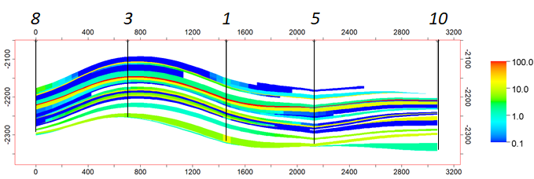
Fig. 1—Cross-section along wells 8, 3, 1, 5 and 10 showing permeability in geologic model.

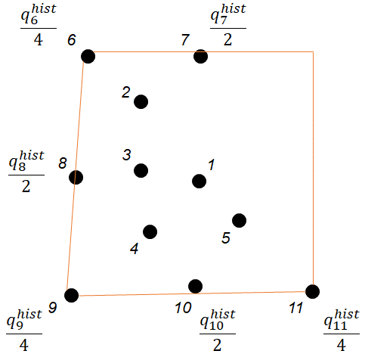
Fig. 2—Injection rates for wells at boundary of sector model - 6, 7, 8, 9, 10 and 11.

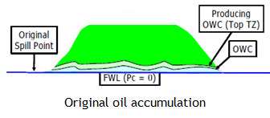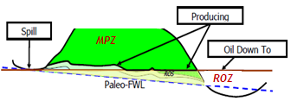
Fig. 3—Effect of tilting on initial hydrocarbon distribution.

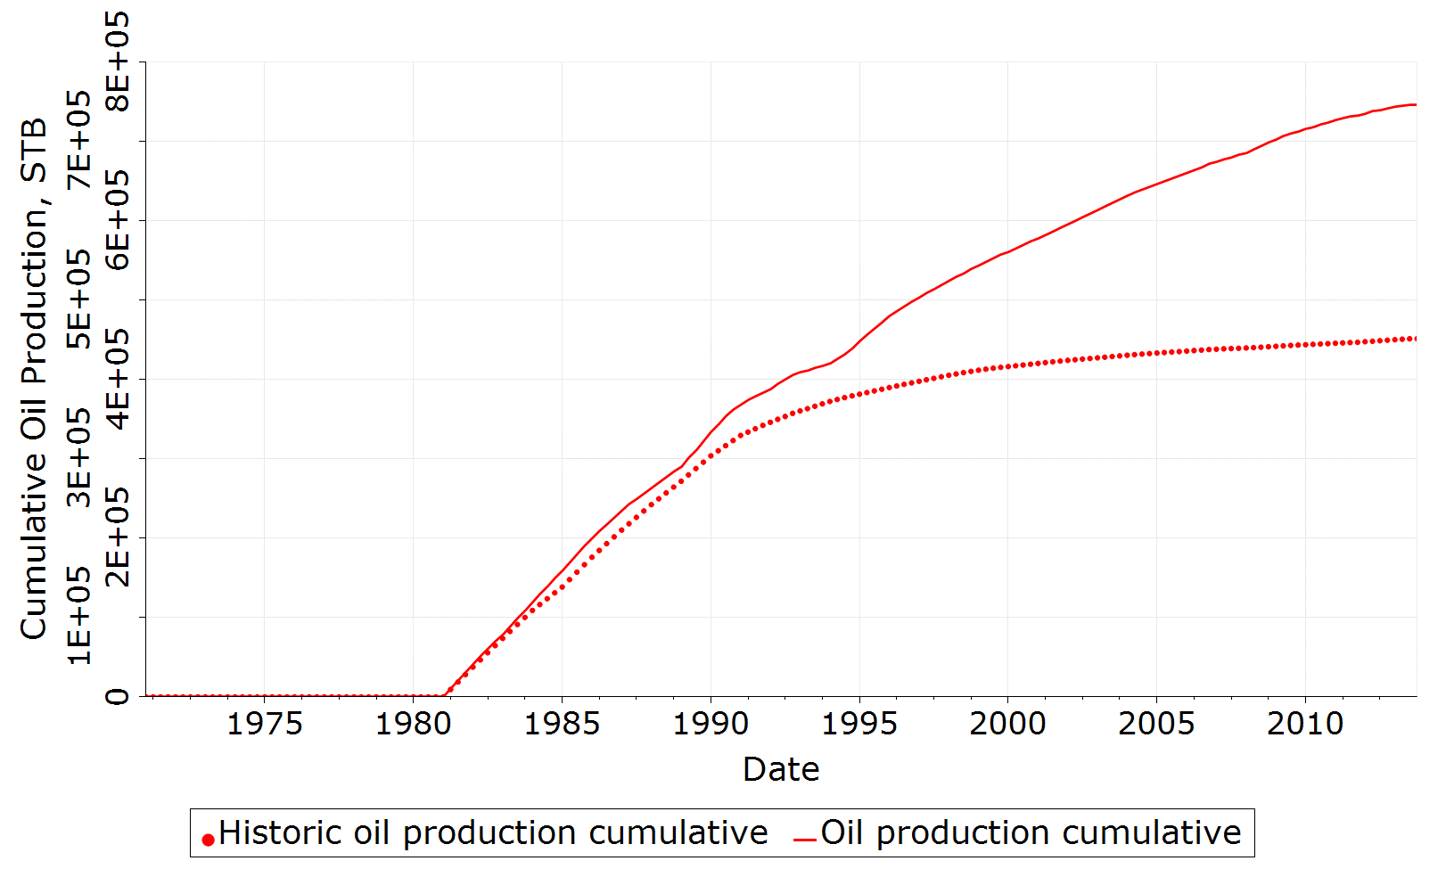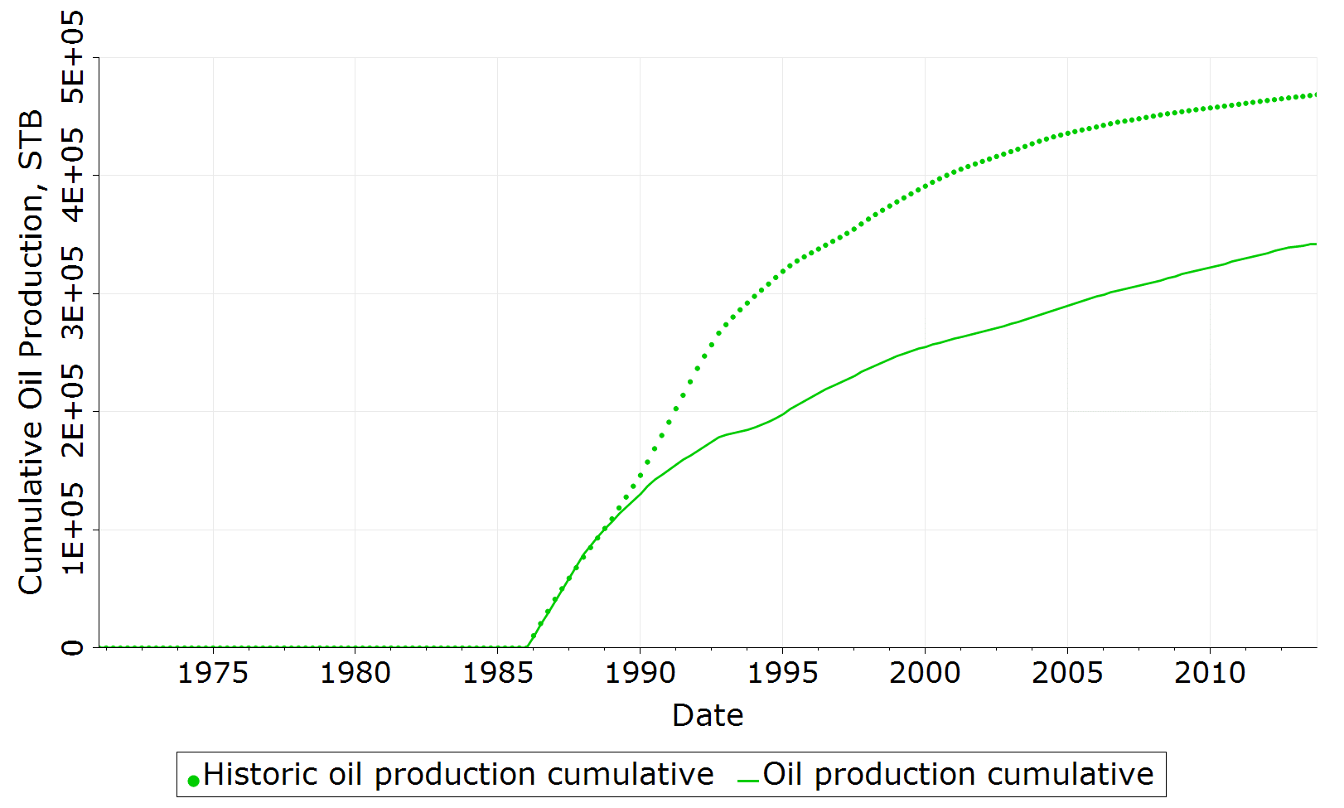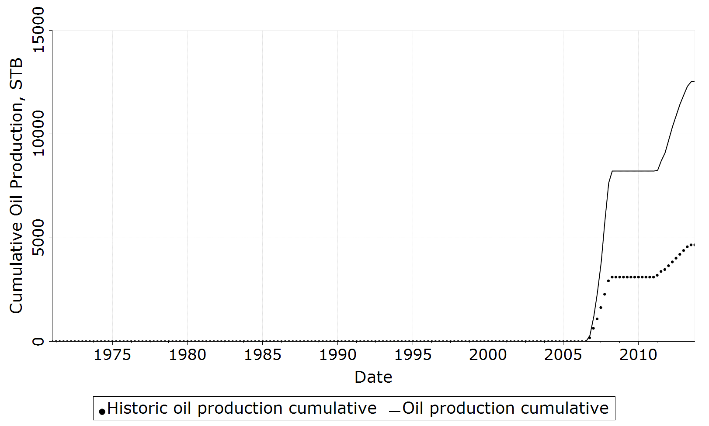
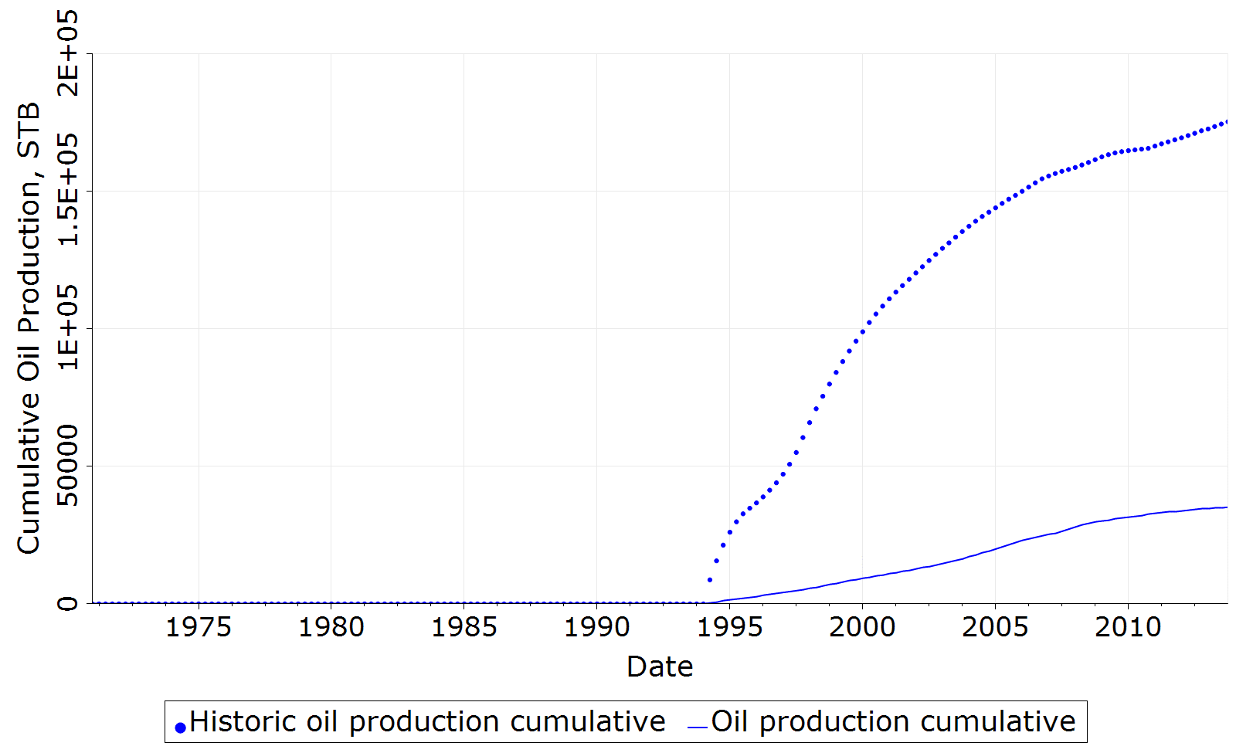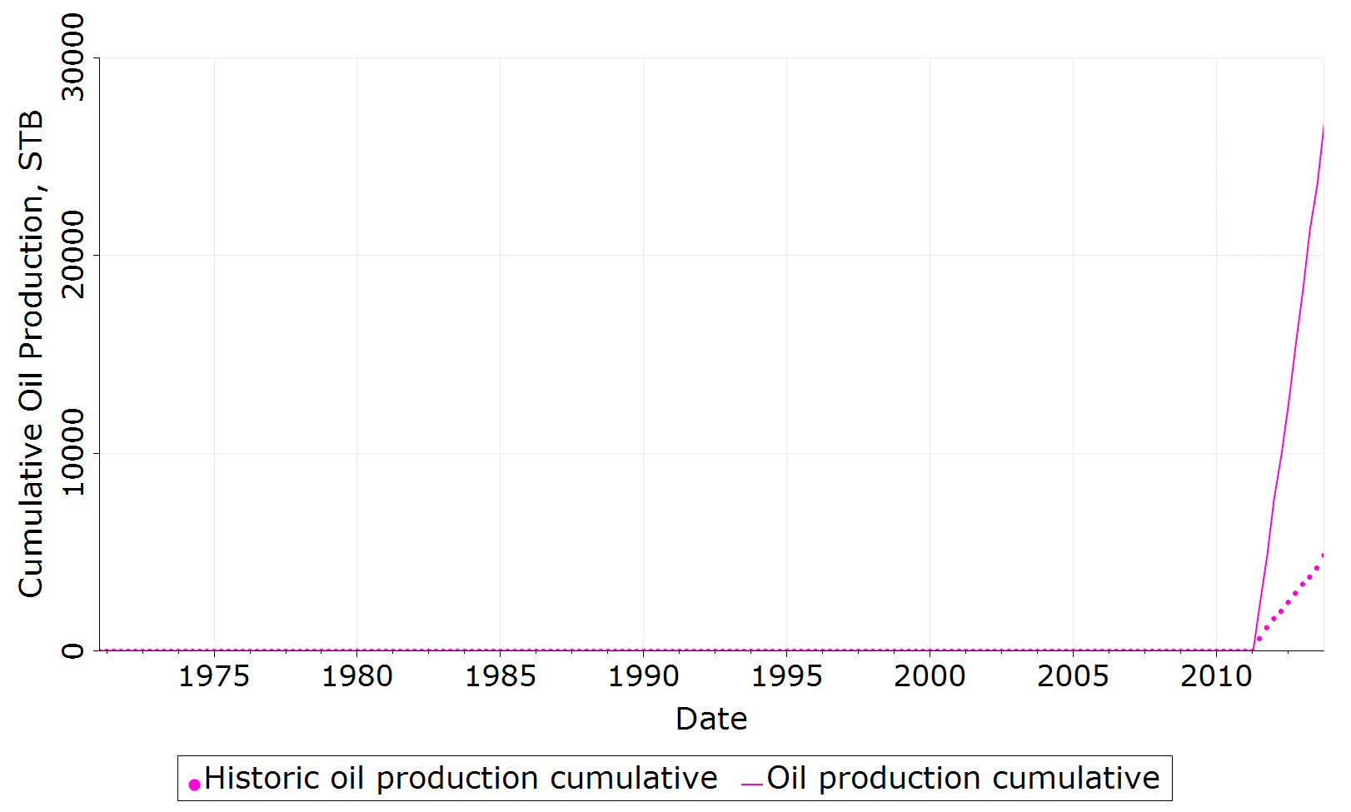
Fig. 4—Mismatch in cumulative oil production based upon base geologic model for producers P-1, P-2, P-3, P-4 and P-5.

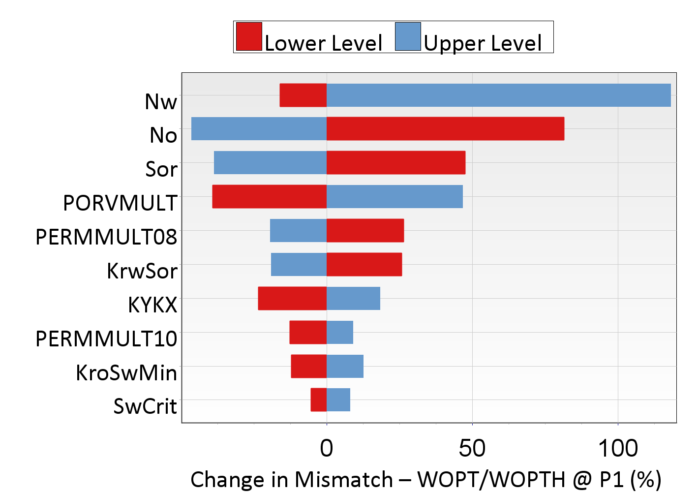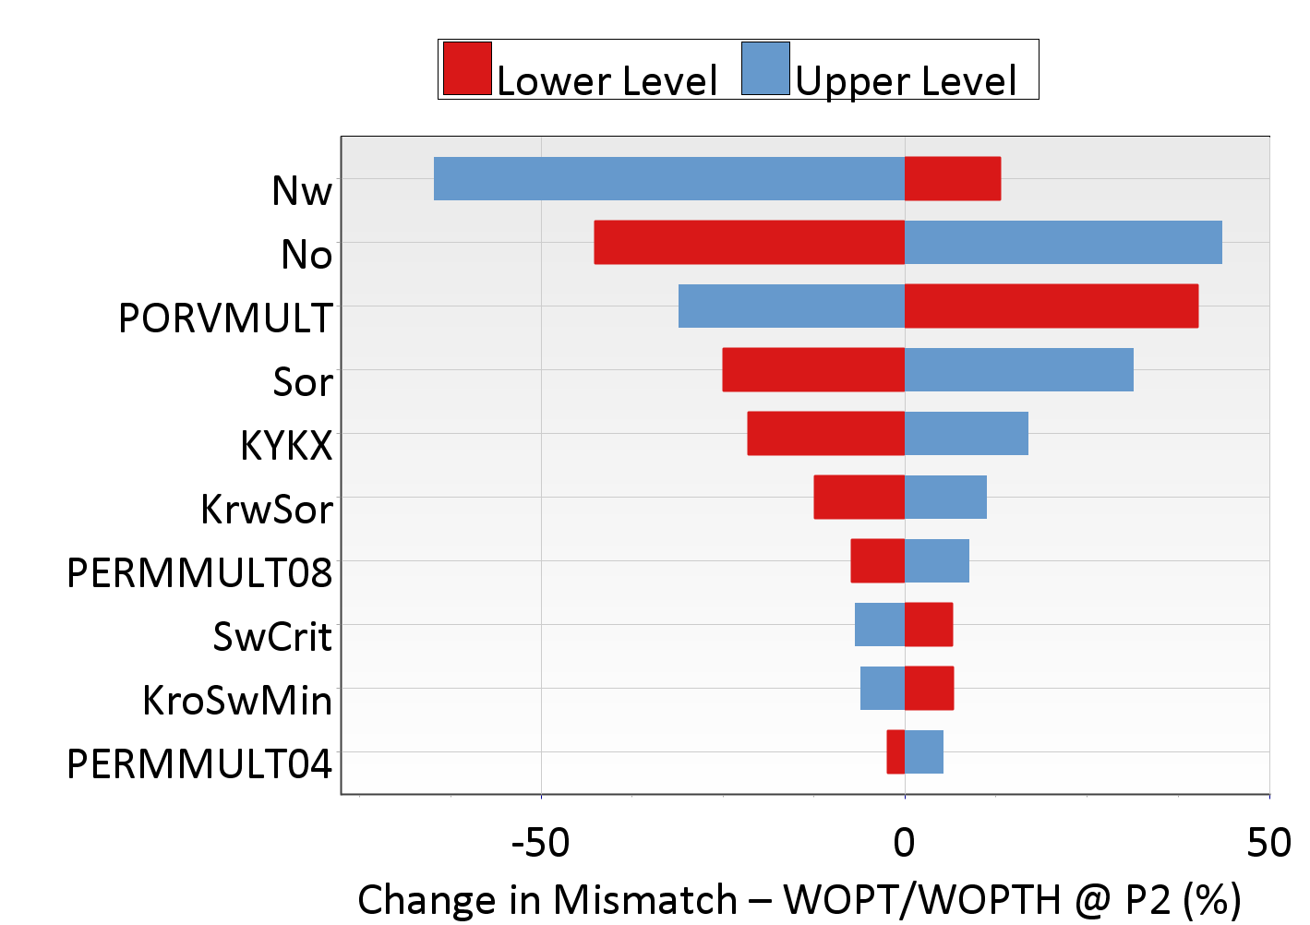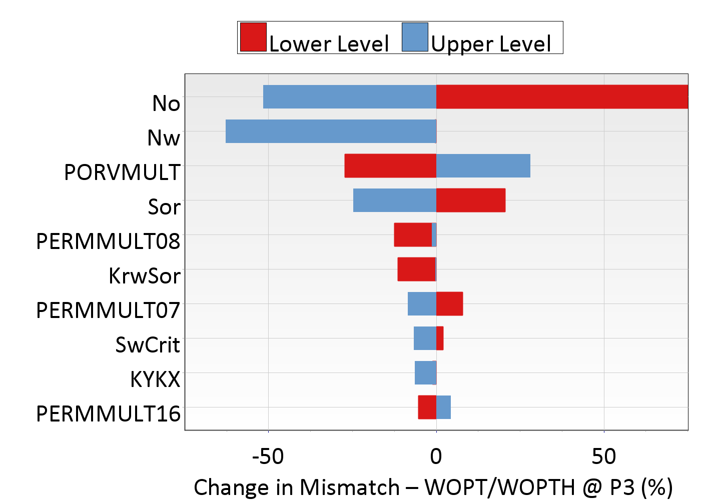

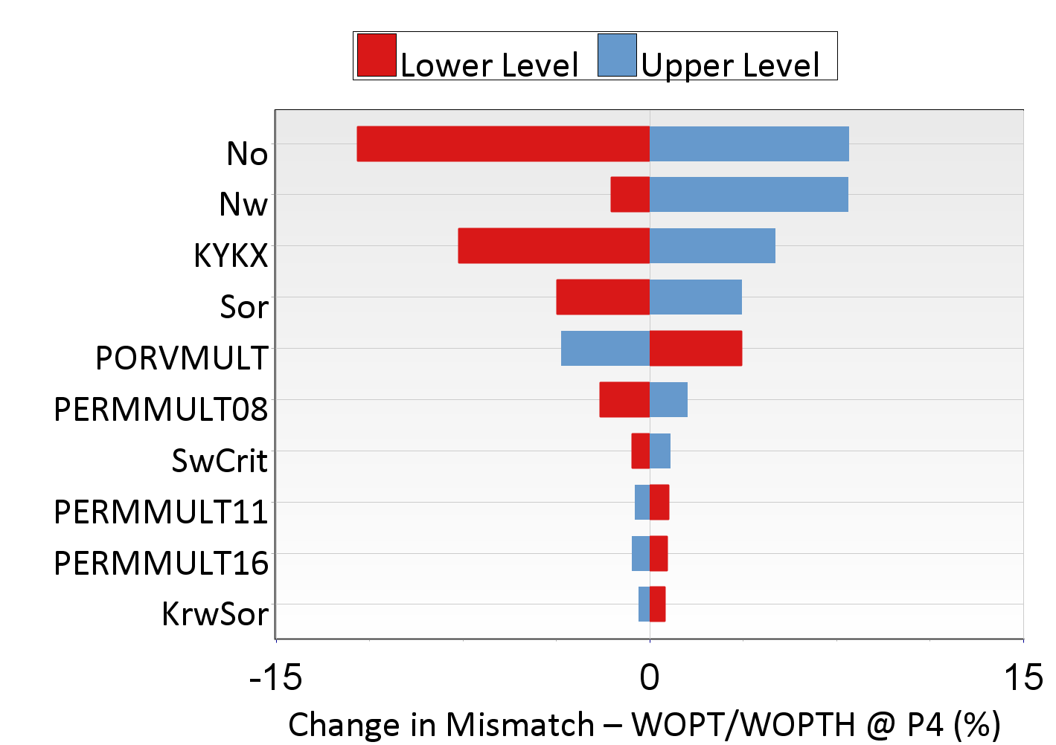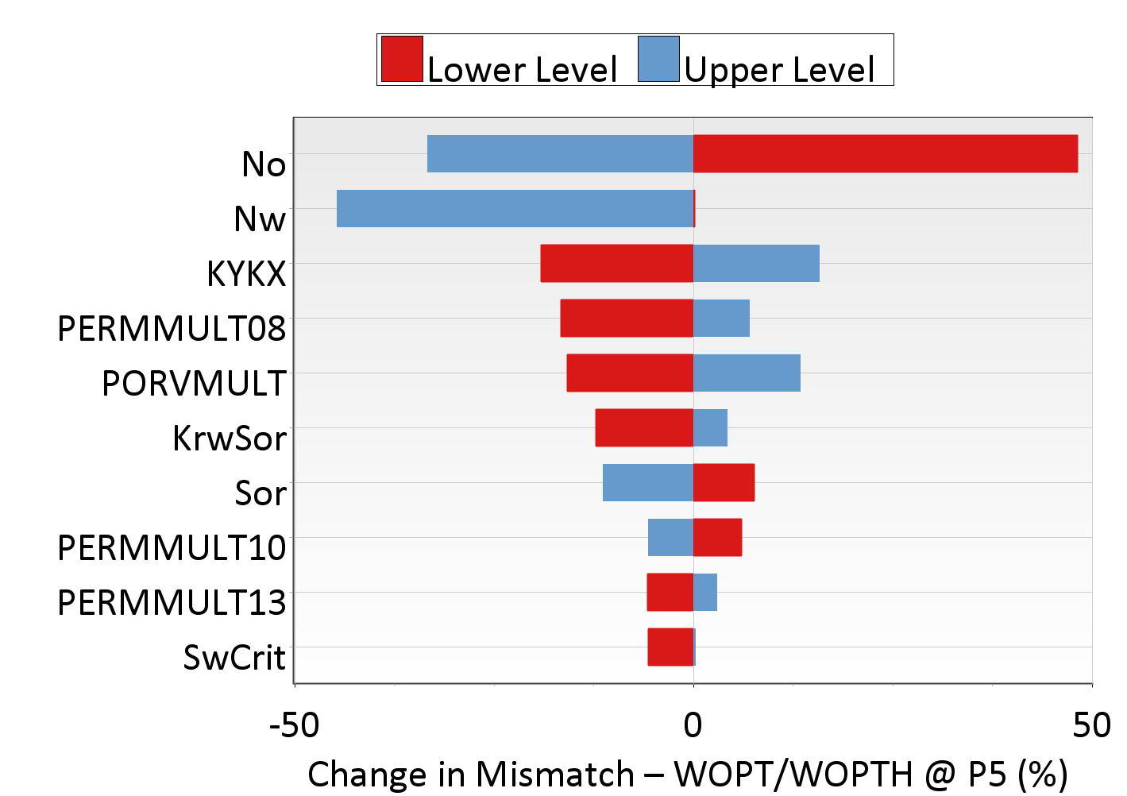
Fig. 5—Sensitivity analysis showing the key uncertainty parameters influencing change in mismatch between observed and simulated cumulative oil production for producers P-1, P-2, P-3, P-4 and P-5.

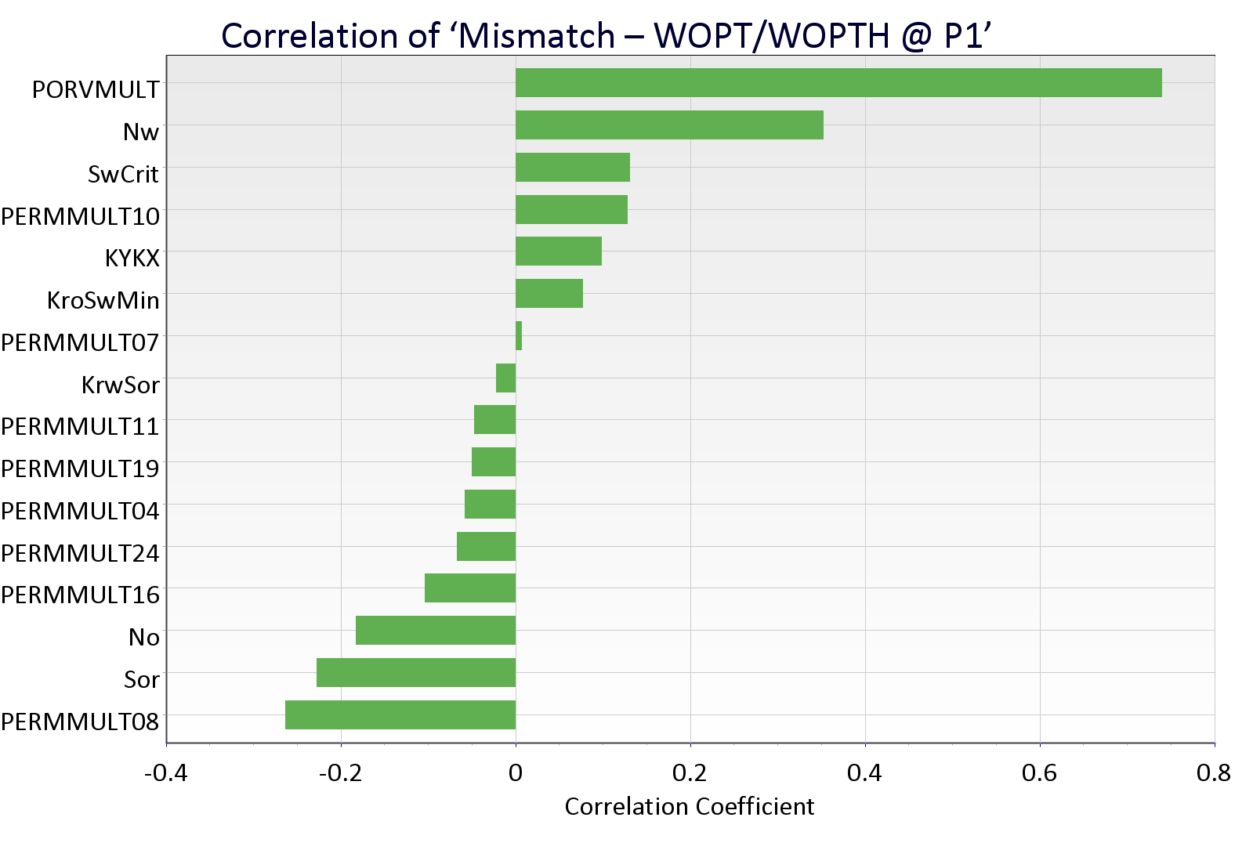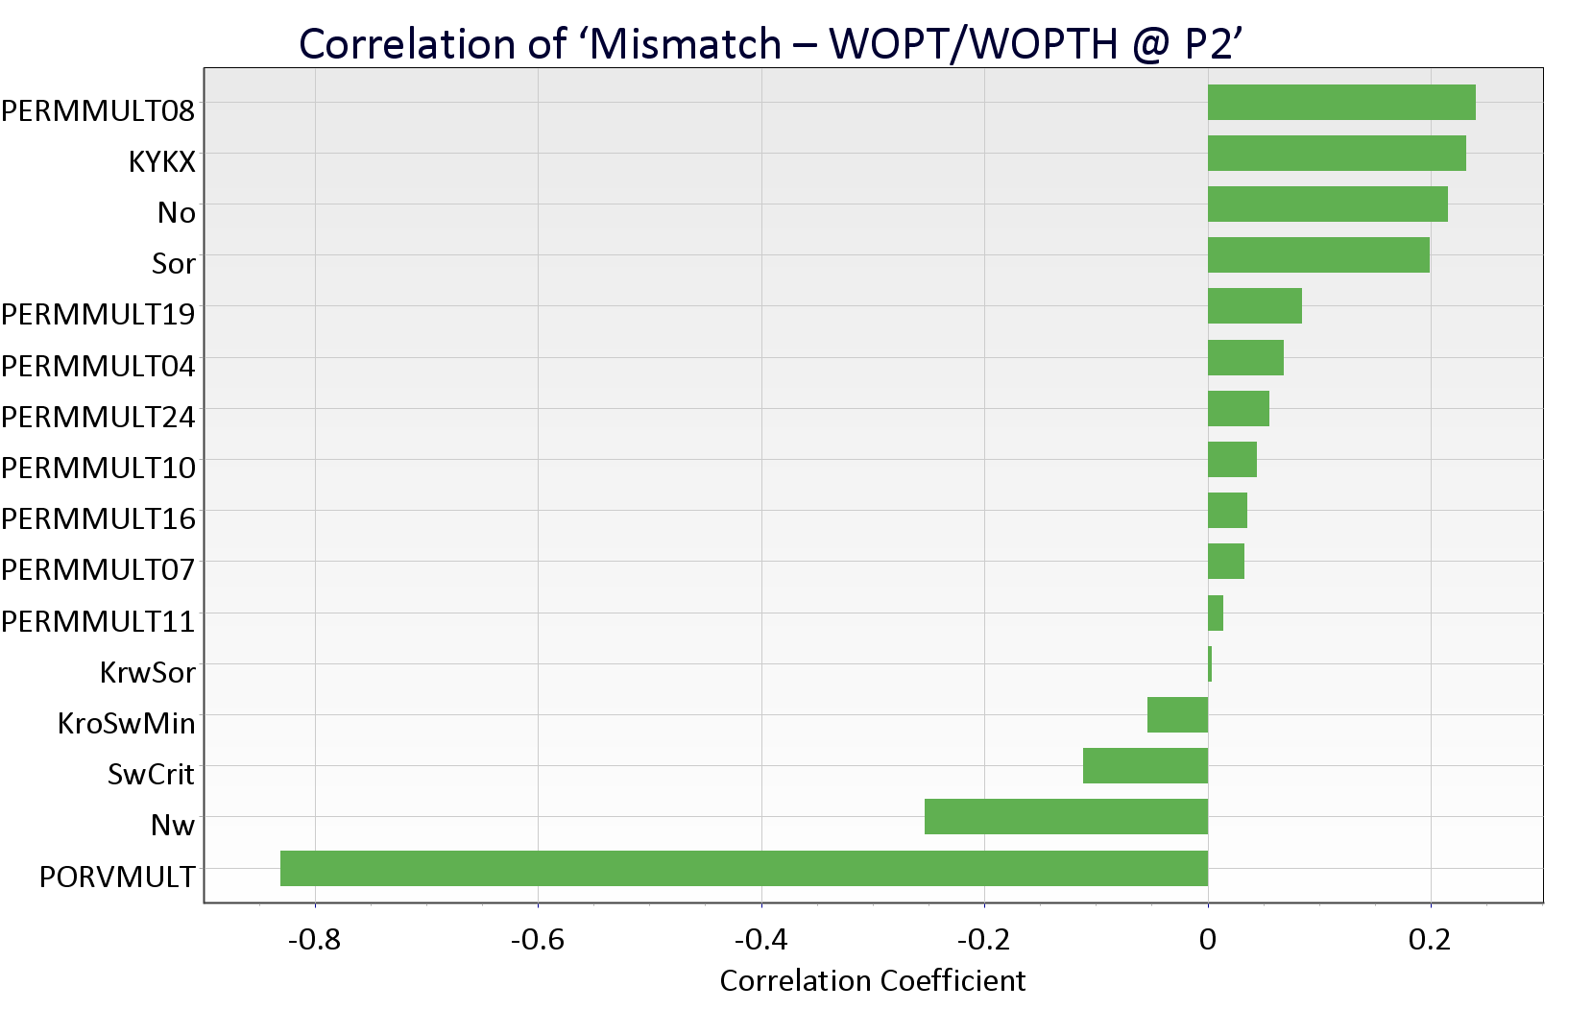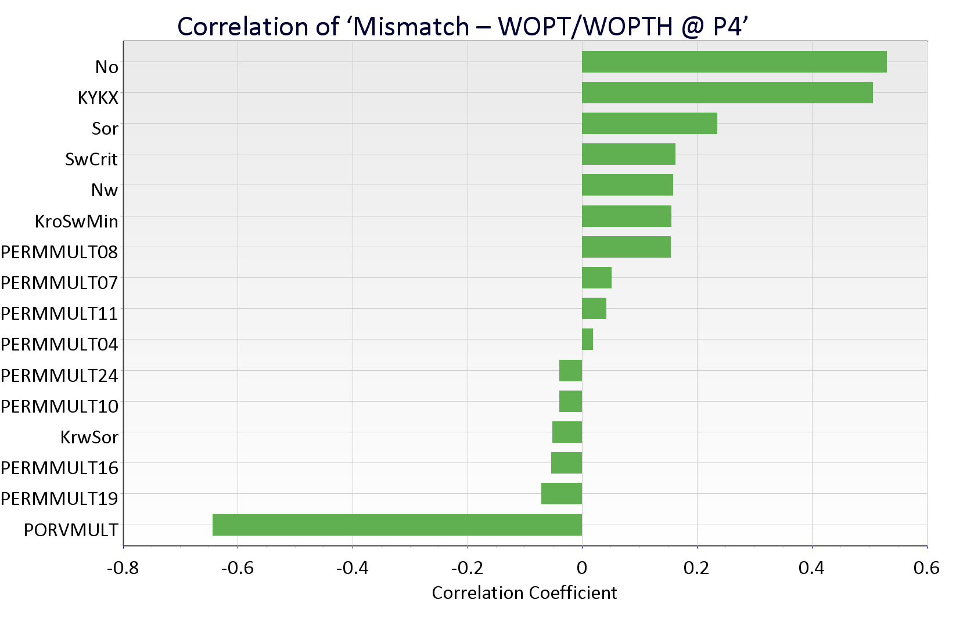
Fig. 6—Pareto plots showing correlation of mismatch between observed and simulated cumulative oil production to the uncertainty parameters based upon LHC runs for producers P-1, P-2 and P-4.

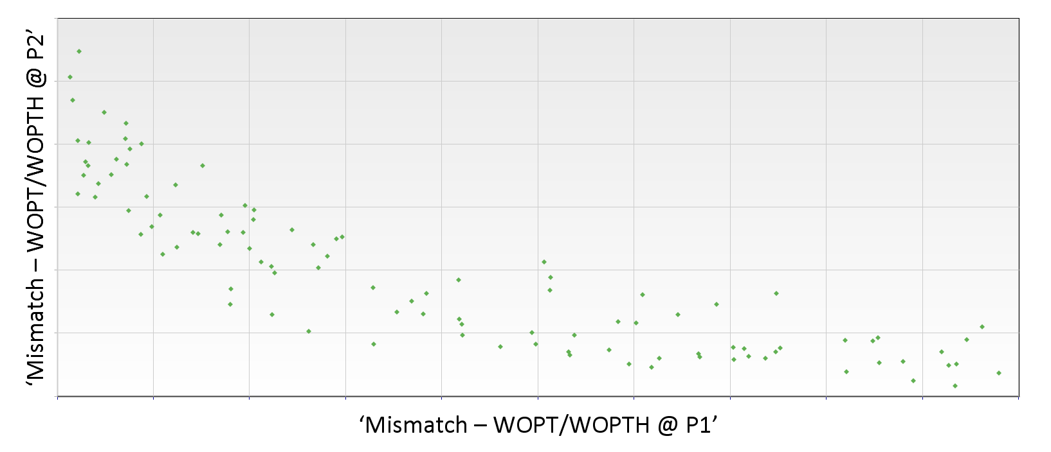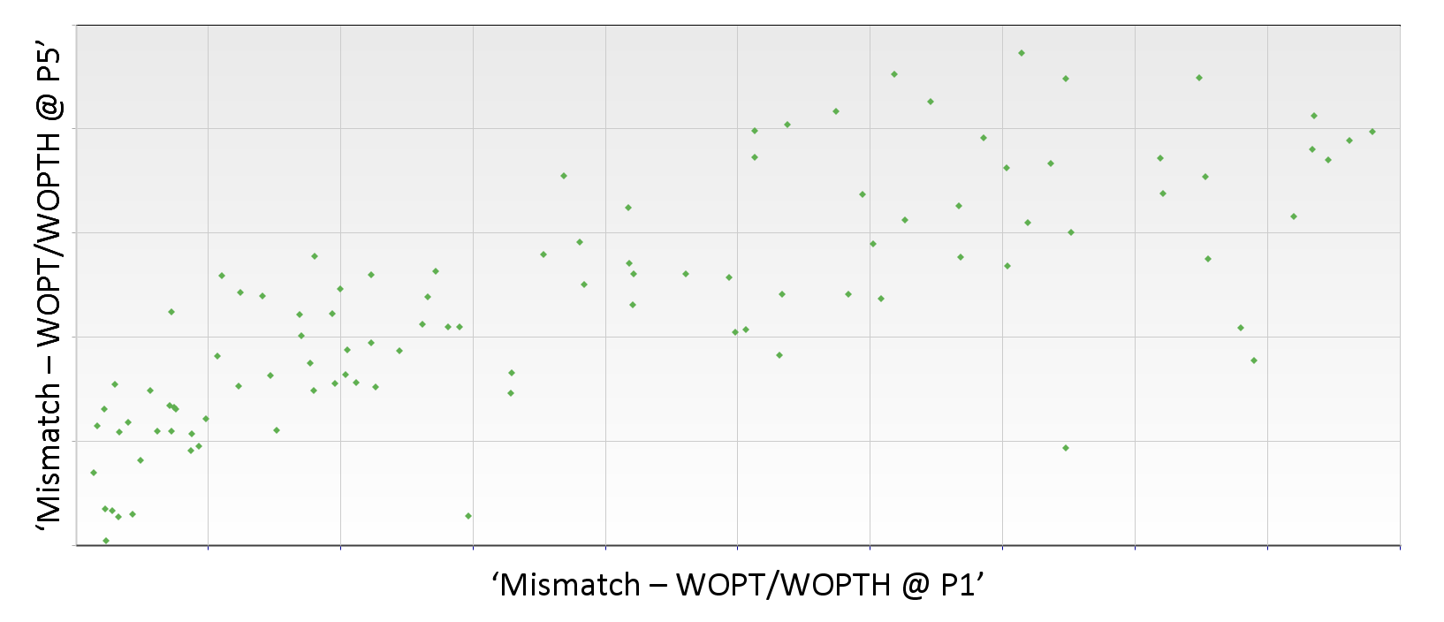

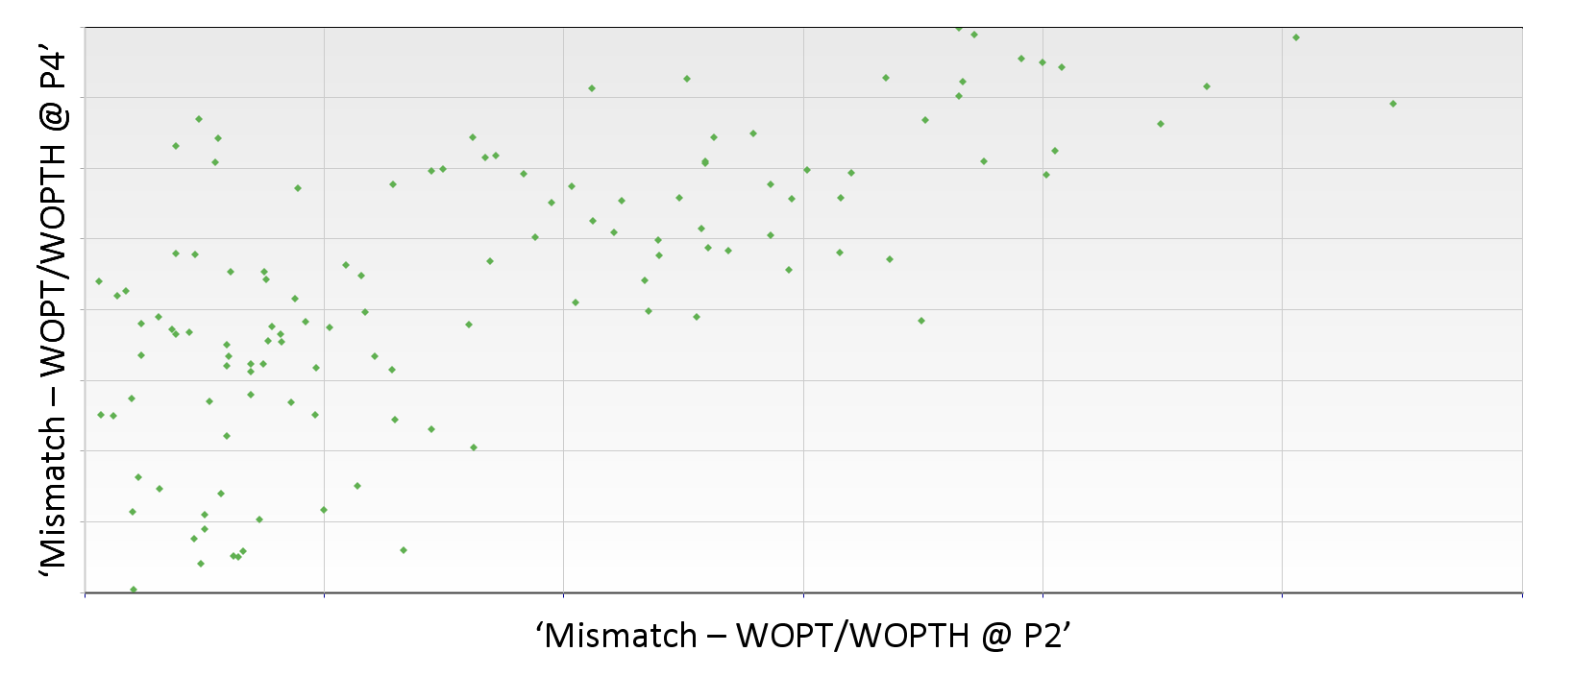

Fig. 7—Plots showing correlation for mismatch between observed and simulated cumulative oil production based upon LHC runs for (a) P-1 vs. P-2 (b) P-1 vs. P-5 and (c) P-2 vs. P-4.

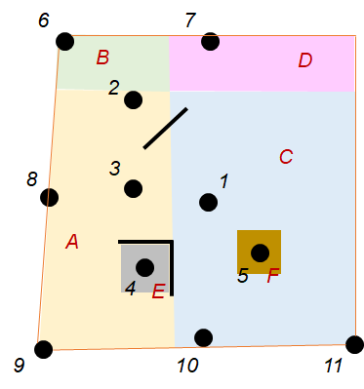
Fig. 8—Regions identified for modification based upon LHC runs, and considered for history matching using ES.

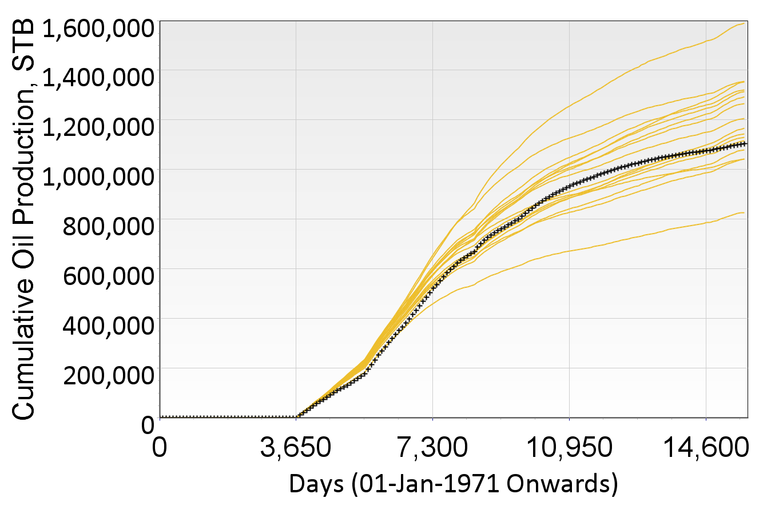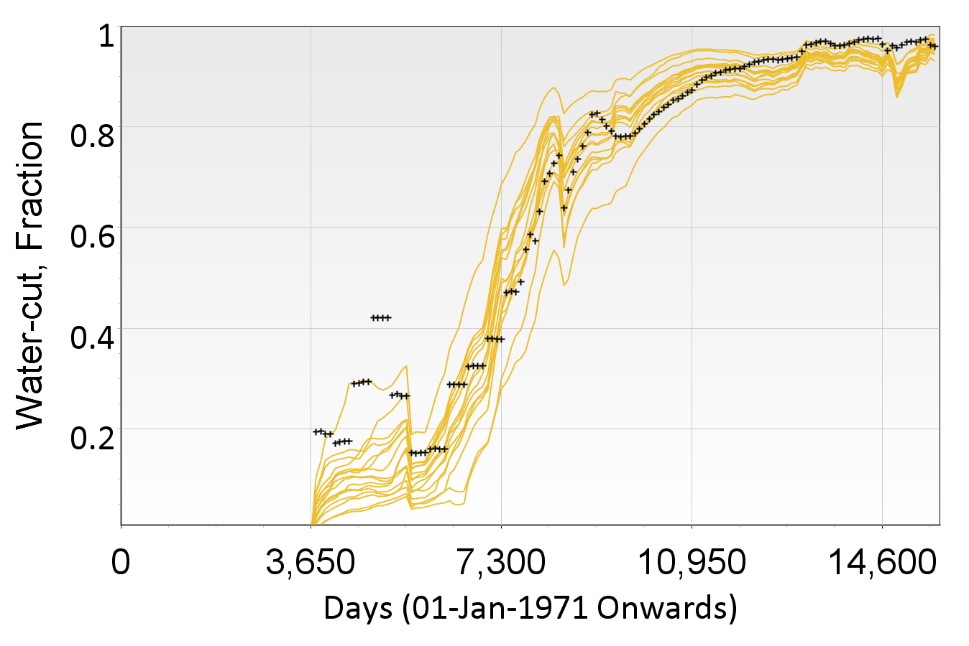

Fig. 9—PB experiments with revised uncertainty parameters showing simulation results covering the observed data at sector level (a) Cumulative oil production (b) Water-cut.

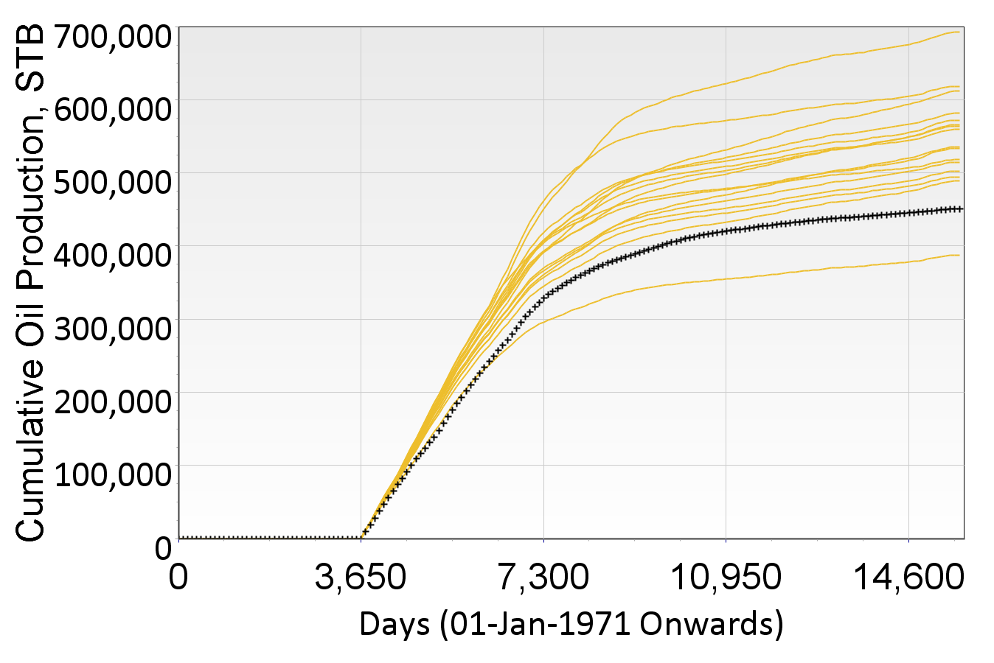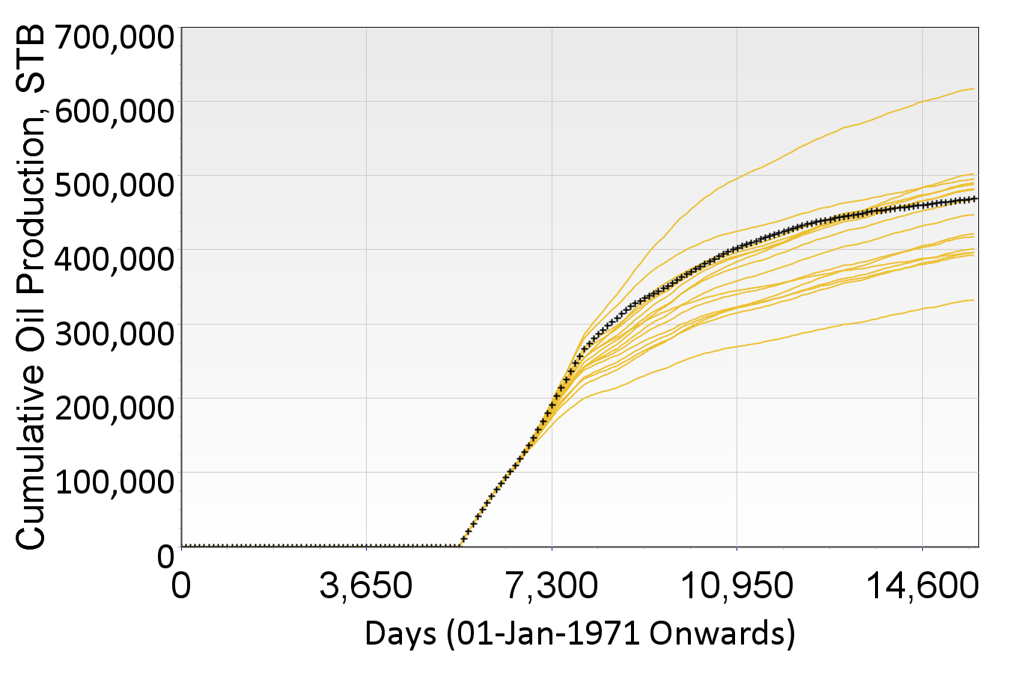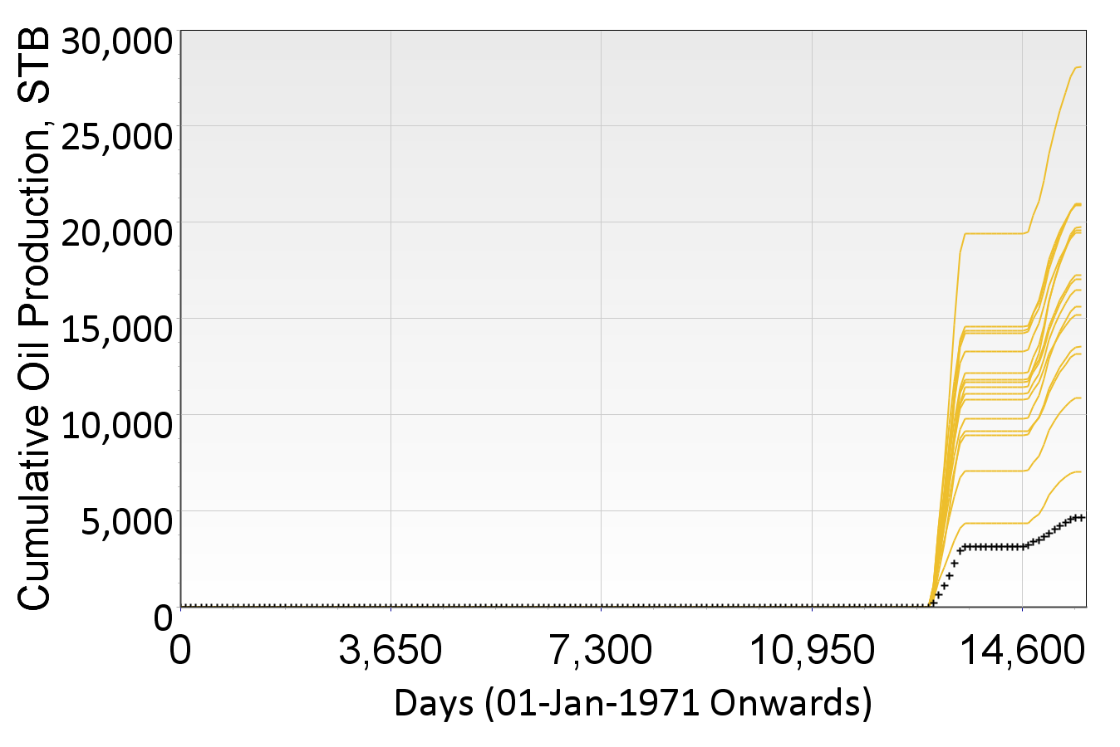

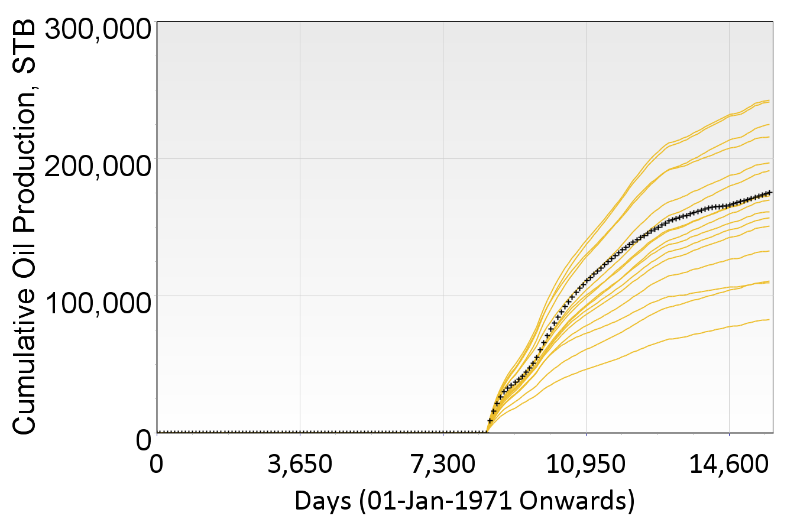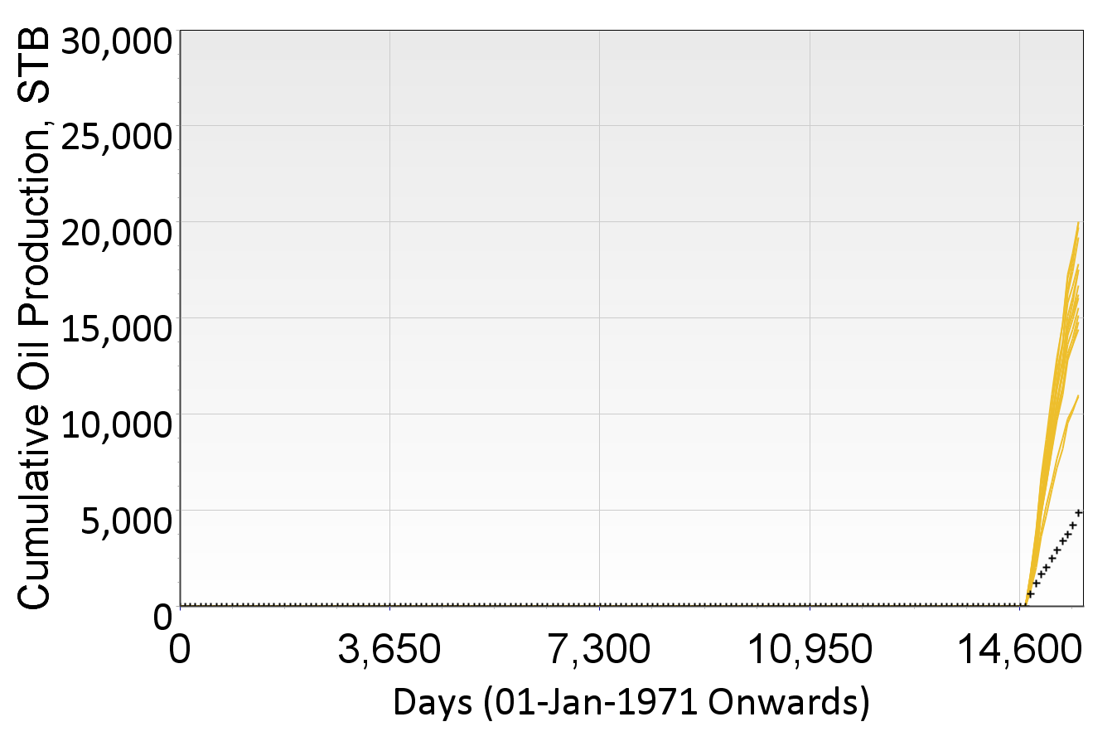
Fig. 10—PB experiments showing cumulative oil production for producers P-1, P-2, P-3, P-4 and P-5.

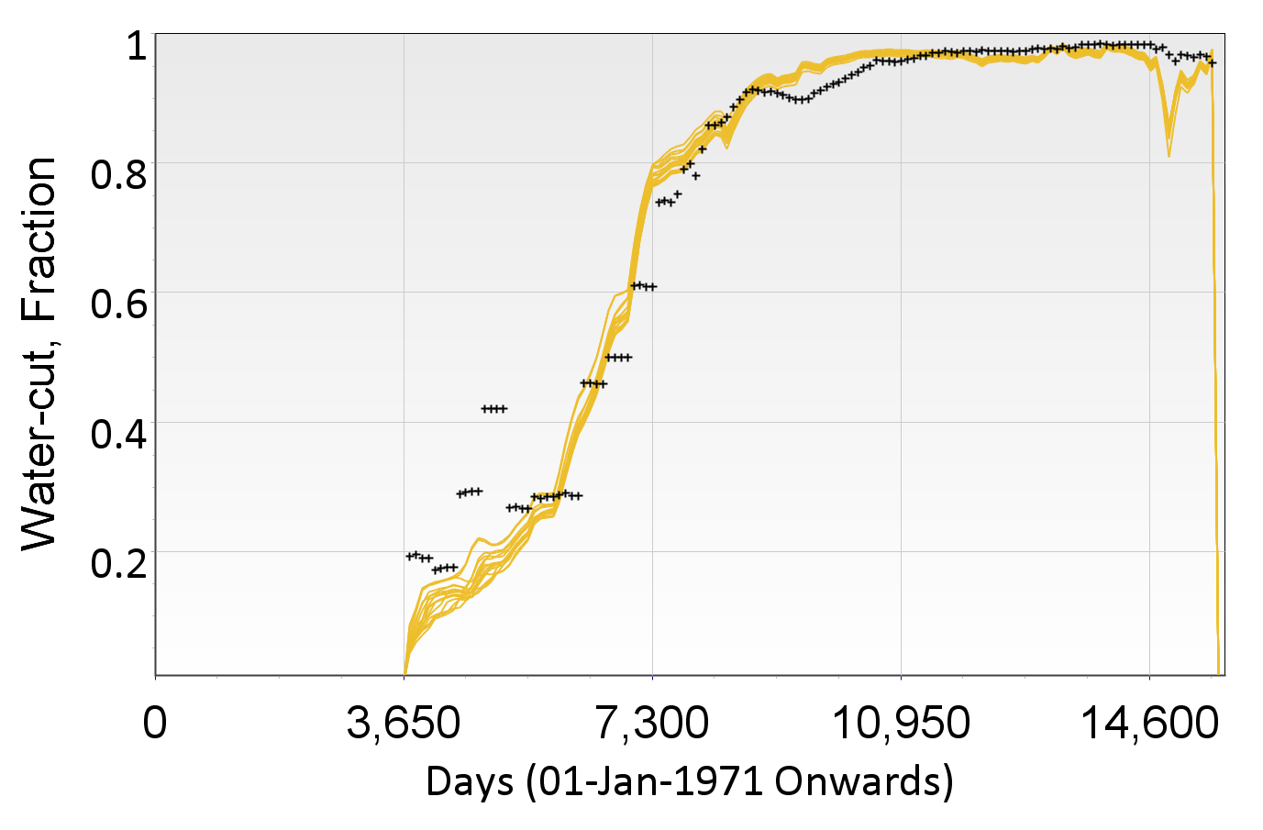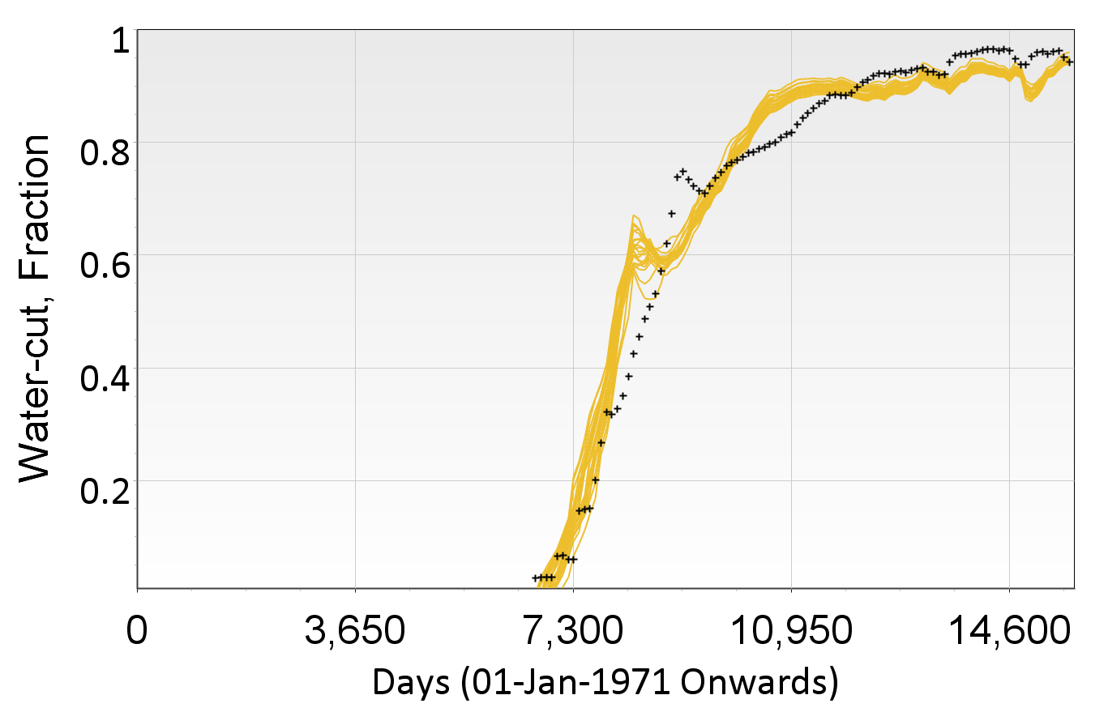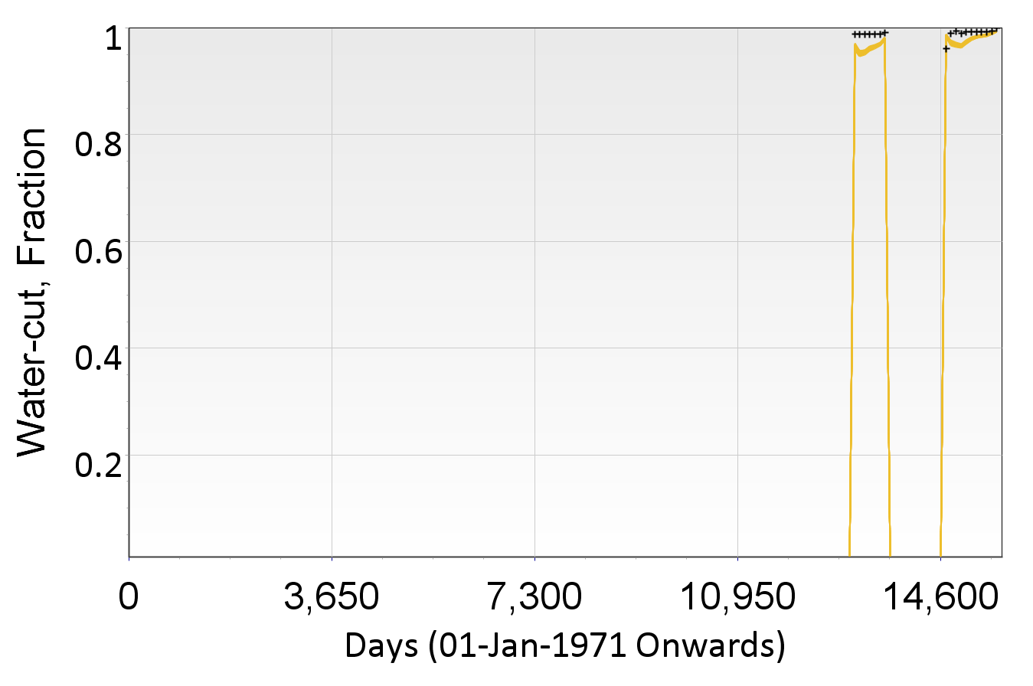
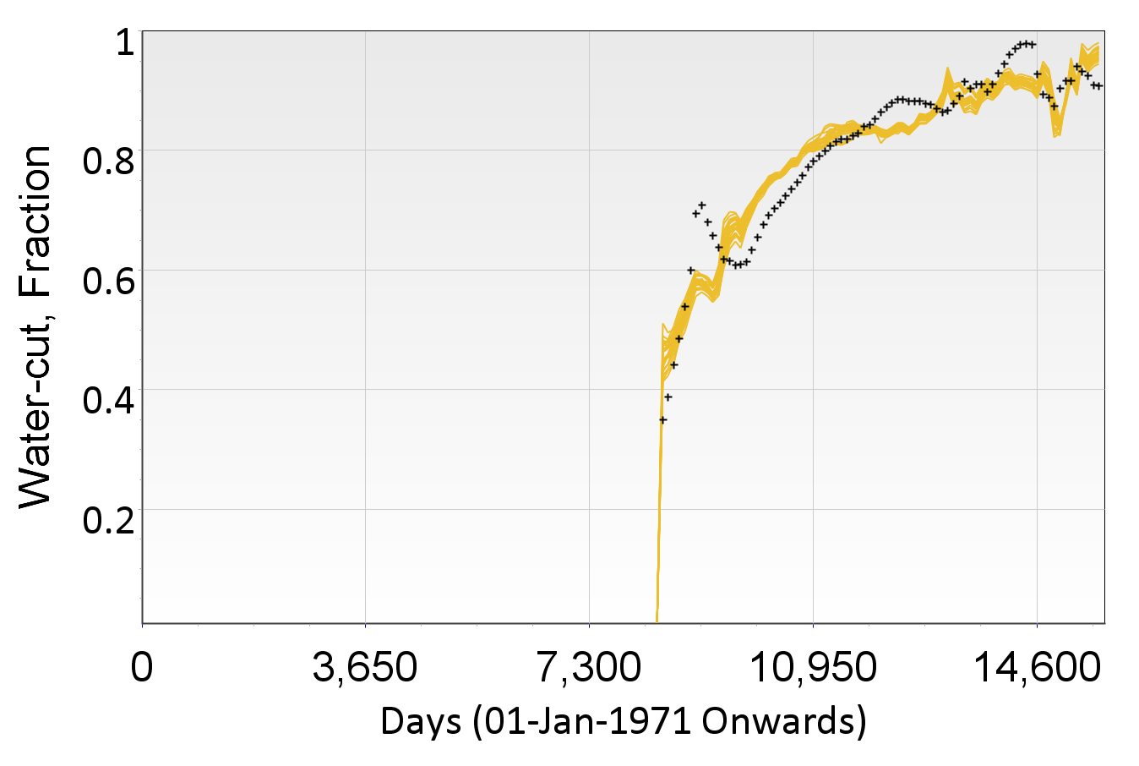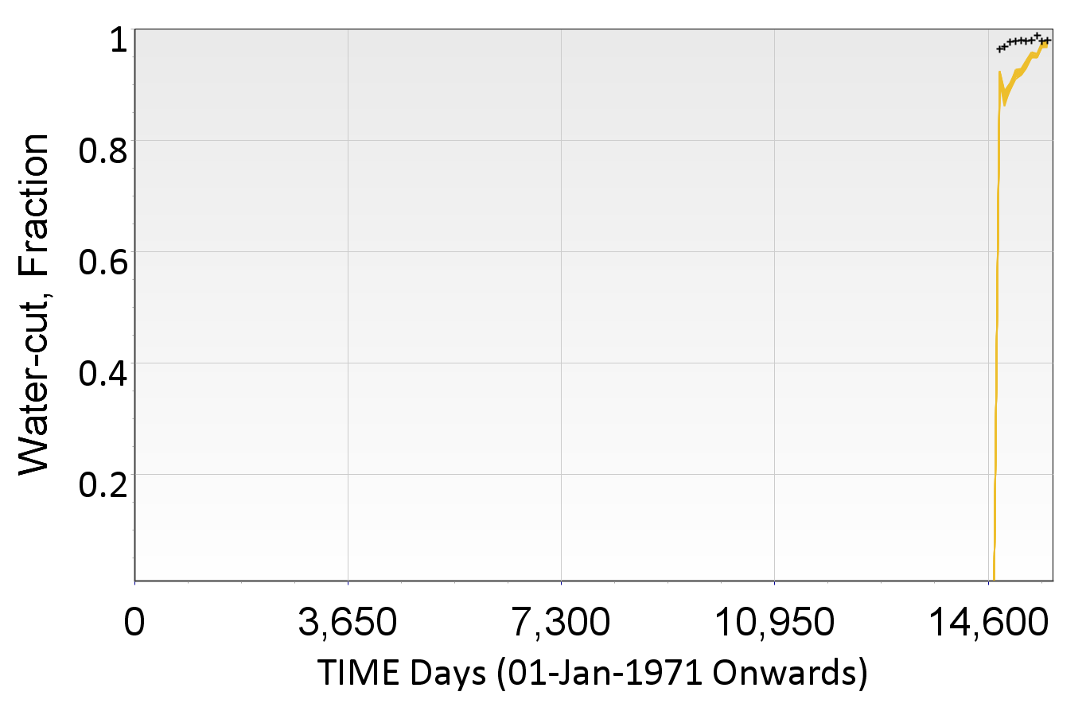
Fig. 11—Water-cut for producers P-1, P-2, P-3, P-4 and P-5, for cases selected to update (posterior) uncertainty parameter ranges after running ES.

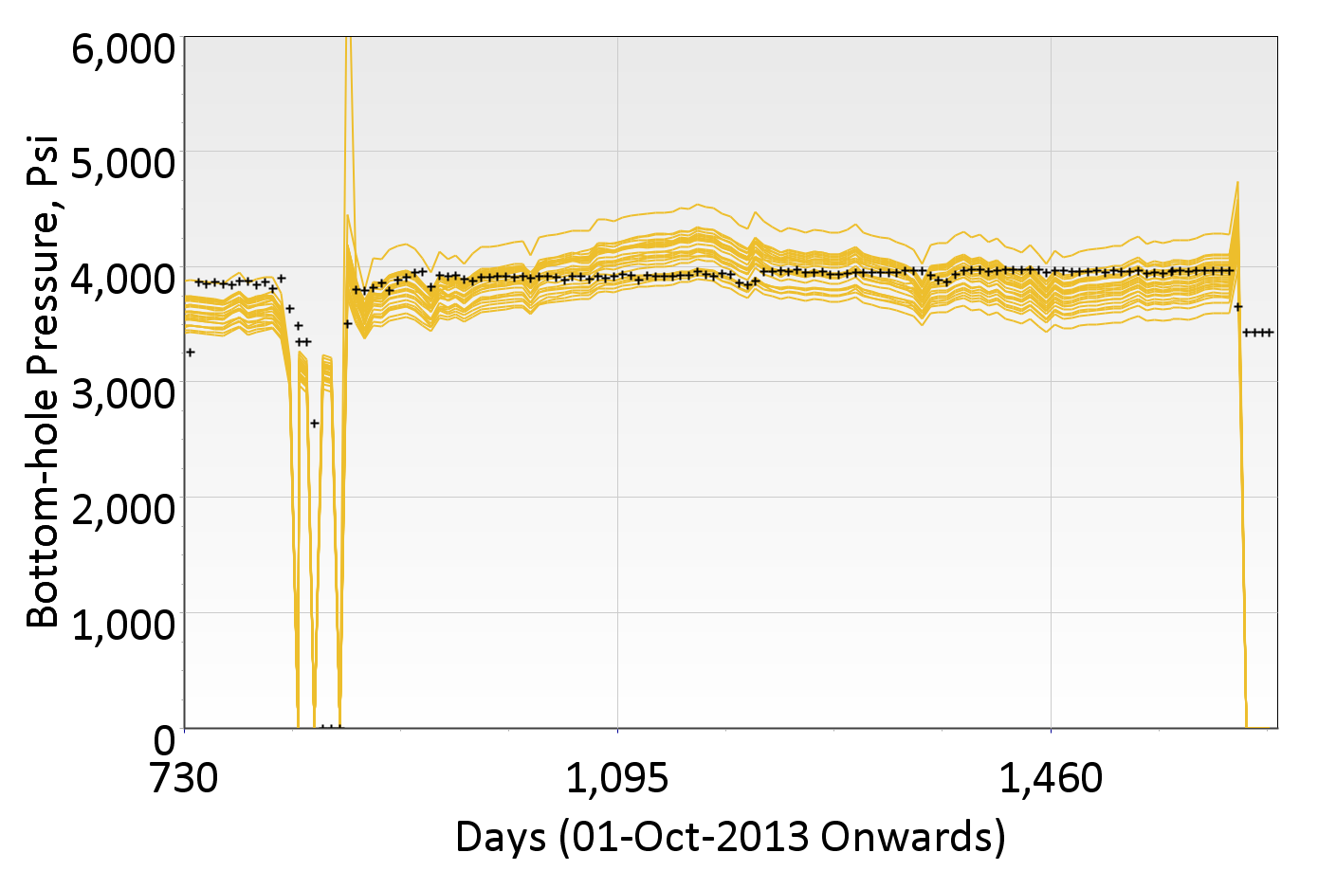
Fig. 12—Flowing bottom-hole pressure for GI-1 for cases selected to update posterior uncertainty parameter ranges.

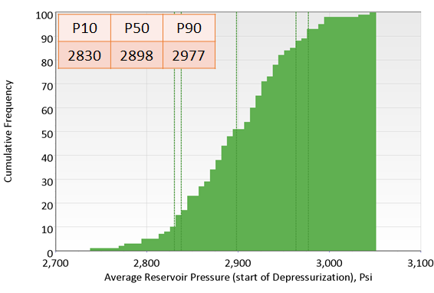
Fig. 13—Cumulative distribution for reservoir pressure at sector level at the start of depressurization (in April 2018) for cases selected to update posterior uncertainty parameter ranges.

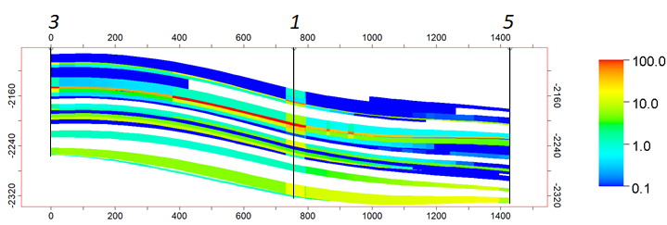
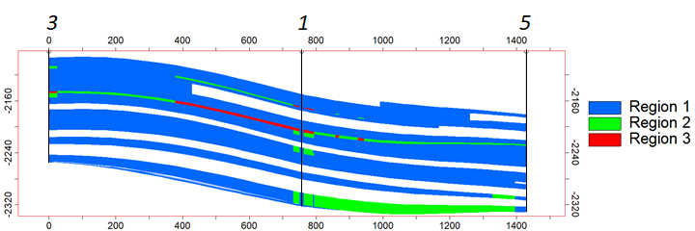

Fig. 14—Cross-section along wells 3, 1 and 5 showing (a) Permeability for a realization after history match (b) Regions identified for that realization based upon permeability. The innermost grid within LGR around well 1 also assigned region 1 irrespective of permeability of cell connecting to that well.

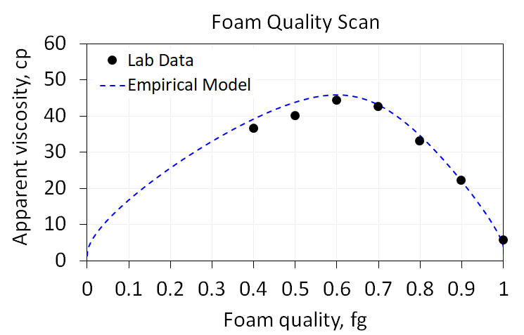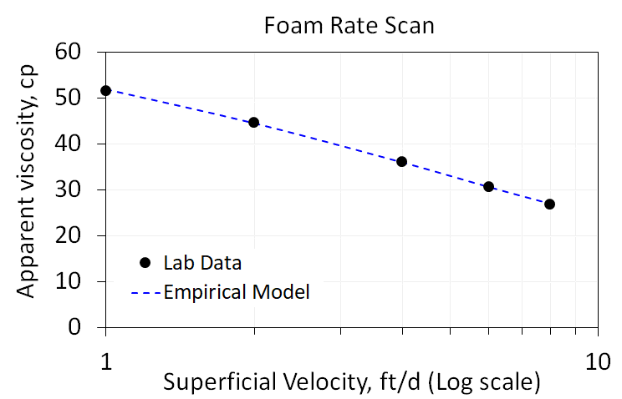
Fig. 15—Experimental data and empirical foam model fit to (a) Quality scan (b) Rate scan.

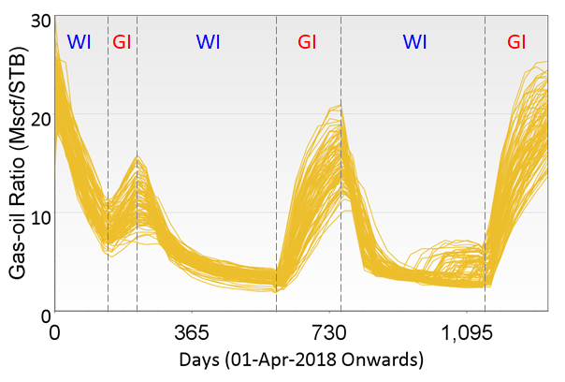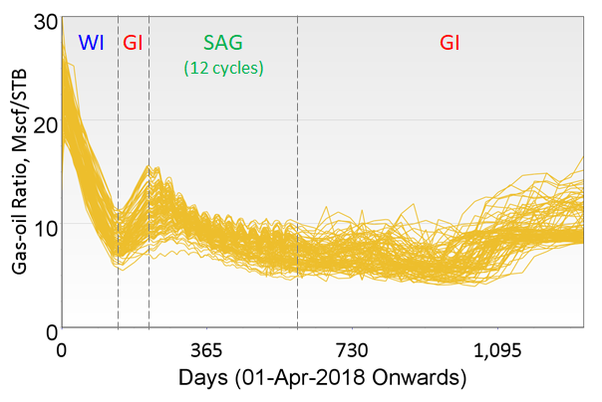
Fig. 16—Gas-oil ratio at the sector level for (a) Base case (b) With SAG.

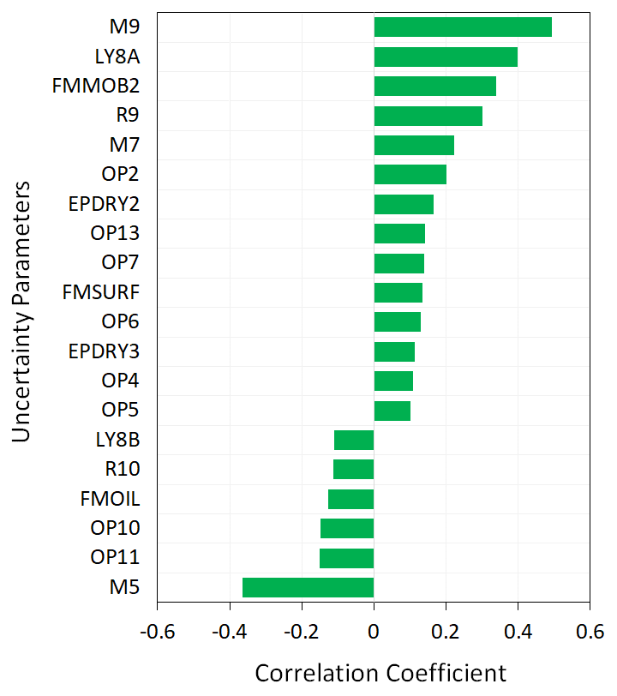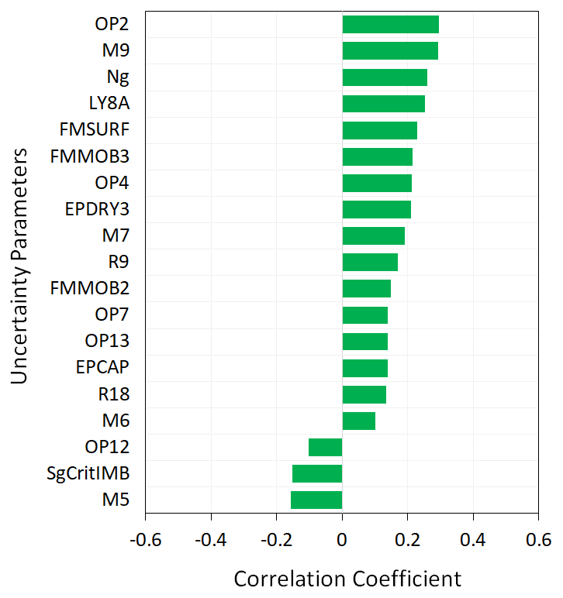

Fig. 17—Pareto plots showing the influence of uncertainty parameters on KPI’s after two years of start of pilot (a) Incremental oil (b) Increase in CO₂ retention factor.

