Transpression and the build-up of the Cordillera: the example of the Bucaramanga fault (Eastern Cordillera, Colombia).
The supplementary materials contain methodological information on the thermochronologic procedures.

S1. Low-T thermochronology
S1.1 Zircon (U-Th)/He (ZHe) sample preparation and analytical techniques
We selected tetragonal prism zircons that are undamaged, clear, and free of inclusions, with a width of at least 60 μm and with a total length much larger than the sum of the tip heights. Each grain was photographed to measure its dimension (length, width, thickness, tip height) for the FT factor calculation following Ketcham et al. (2011). Grains were wrapped in Pt foil and loaded into an evacuated laser chamber. ⁴He abundances for each grain were determined by degassing with a diode laser at 1075 °C for 45 minutes and measuring the released gas on a magnet sector-field mass spectrometer equipped with a Baur-Signer ion source at ETH Zürich. For grains with large amounts of ⁴He, second and third extractions were performed at progressively higher temperatures. The baseline-corrected ion beam intensities are plotted against time and extrapolated back to the time of sample gas inlet into the mass-spectrometer in order to calculate signal intensities of all species at that time. The detected ⁴He amounts are then calculated by comparing blank-corrected sample measurements to the identical analyses of well-known amounts of ⁴He from standard bottle gas. To measure the parent nuclide contents of degassed zircons, grains were retrieved from the Pt foils, transferred to Teflon vials, and finally spiked with an isotopically distinct U-Th solution. Zircon-spike pairs were dissolved in concentrated HF at 225 °C for 72 hours in Parbombs. A second Parbomb step in HCl at 200 °C for 24 hours we needed to dissolve refractory fluorides salts. U and Th concentrations were measured on an inductively coupled plasma mass spectrometer at ETH Zurich (ElementXR).
In this study we provide twenty new ZHe samples that were dated together with twelve zircons from the age standard Fish Canyon Tuff, which gave a mean age of 27.8±0.9 Ma (1σ, Table S1).

S1.1.1 Radiation damage, U-Th zonation, and grain size
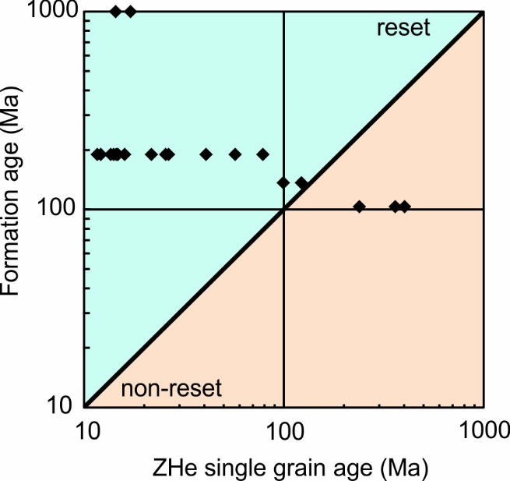
The ZHe grain ages range between 11.6 Ma and 402 Ma (Fig. S1) and they give mean ages from 12.5 Ma to 333 Ma. ZHe ages younger than the rock formation ages are considered to be reset, and therefore contain information on the thermal history of the sample. ZHe ages older than the rock formation age are instead not reset. ZHe ages that overlap or are very near to the age of formation of the sampled rock are partially reset. Figure S1 shows the relation between single grain ZHe ages of our samples versus the rock age as derived from previous studies. Most of the obtained single grain ages (85 %) are younger than the formation age and, thus, are reset (samples CG36, CG42, CG43, CG67, CG68, and CG69). Only the mean ages of these samples are used to calculate erosion rates and the non-reset ages are excluded from the inversion to exhumation rates (sample CG44). Sample CG48 give scattered single grain ages that differ from the formation age by only 33Ma and 13 Ma. Therefore, this is sample is considered to be partially reset.
Figure S1: ZHe Single grain ages versus rock formation ages. ZHe ages younger than age of formation are reset and contain information on the cooling history of the sampled rock. ZHe ages overlapping or older than the age of formation are most likely partially and not reset and, therefore, are excluded from the exhumation rates calculations.

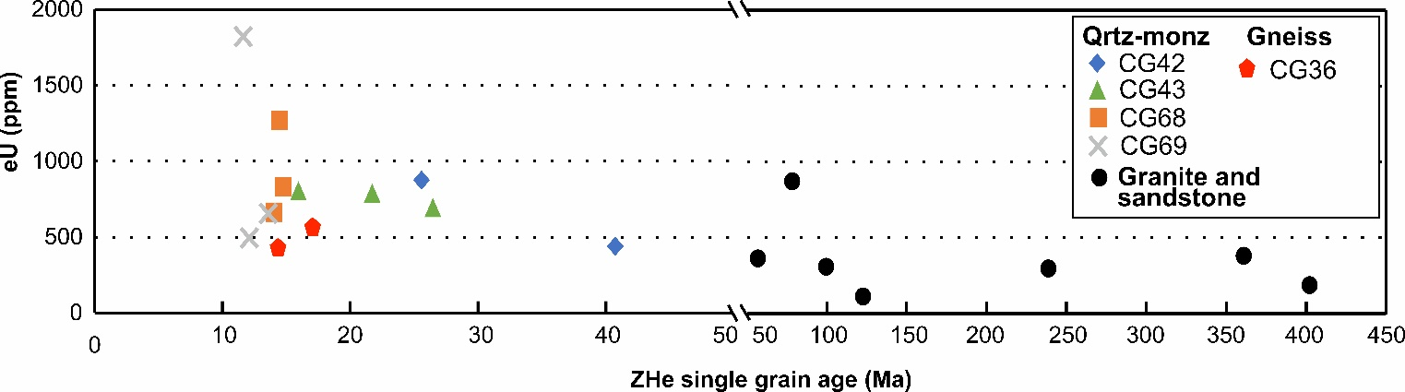
In order to estimate the influence of radiation damage associated with U and Th decay on He diffusivity, we calculate the effective uranium concentration (eU) of our grains (Fig. S2). eU is a first order estimate of the radiation damage of a crystal (Flowers et al., 2007; Shuster et al., 2006). eU values of our grains are medium to high and vary from 113 ppm to1800 ppm (Table 2 main text and Fig. S2). Grain ages < 50 Ma have a high eU range, from <500 ppm to >1000 ppm, whereas grain ages >50 Ma display mostly values < 500 ppm, with the exception of one grain (Fig. S2). This pattern reflects the sampled type of rock. Indeed, quartzomonzonitc and gneiss samples (CG42, CG43, CG68, CG69, and CG36) provided eU values ≥ 500 ppm, while others types of sampled rocks provide eU content <500 ppm (Fig. S2). Despite the large eU range for samples CG68 and CG69, their single grain ages replicate well. This is also true for sample CG 36. Therefore, for these samples we exclude any influence of the eU content on the obtained ages, which likely relates to fast cooling. Samples CG42 and CG43 show scattered single grain ages and slightly negative relation with eU content. In this case, it is possible that radiation damage partially affected the dated zircons. However, these two samples are located at more than 10 km away from the Bucaramanga fault trace and this single grain age distribution is compatible with slow cooling trough the partial retention zone. Samples from granites and sandstones are generally older than 50 Ma and have eU values <500 ppm, without any clear relation between ages and eU. Therefore, for these samples we exclude any influence of the radiation damage on He diffusivity.
Figure S2: ZHe single grain ages versus effective Uranium (eU) content. Time spacing changes after 50 Ma in the chart to better visualize all the data. eU content of our ZHe ages largely depends on the sampled rocks. Quartzomonzonitc (Qrtz-monz) and Gneiss samples are the youngest and have the highest eU values whereas others type of rocks have older ages and lower eU. Most of our young ages replicate well suggesting little or no influence of radiation damage on He diffusivity.
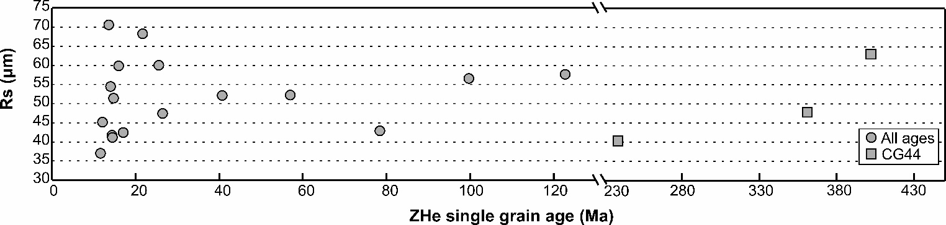
The diffusivity of He depends also on the size of the diffusion domain, which corresponds to the grain size, and this in turn affects the ZHe ages. Our ZHe ages are measured on crystal grains with width and thickness of at least 60 μm. Their equivalent spherical radius (Rs; Meesters & Dunai, 2002) range from 37 μm to 70 μm (Fig. S3). Ages younger than 50 Ma show a poor positive correlation with Rs. Ages between 50 Ma and 120 Ma are composed by only two grains, for which is impossible to unravel any pattern. Sample CG44 is the only one that shows a clear positive relation between obtained ages and Rs suggesting that the obtained ages are influenced by the dimension of the measured grains. However, these ages are not reset and are not inverted to exhumation rates.
Figure S3: ZHe single grain ages versus spherical radius. For ages younger than 50 Ma there is no clear relation between obtained age and Rs. Time spacing changes after 150 Ma in the chart to better visualize all the data. Samples comprised between 50 Ma and 150 Ma have only 2 grains preventing observations of any pattern. Sample CG44 shows a clear positive relation. In this case, the obtained ages could be affected by the mineral grain dimensions.

Both theoretical and empirical evidence show that intracrystalline U-Th heterogeneity in zircons can lead to biases in (U-Th)/He ages if not accurately accounting for the alpha-ejection correction factor (Hourigan et al., 2005). We measured U-Th concentrations of single zircons along depth profiles into the grains by Laser-Ablation Mass-Spectrometry on 3 out of 32 total dated grains. We dated only 3 grains after technical problems prevented other dating. The amount of ablated material has been calculated for each grain by measuring the geometric features of the produced pit under a stereoscope. Mean percentage of volume loss due to ablation is 0.35 % and is between 0.31% (FCT, Z15) and 0.4% (CG48_, Z2). For the grains where the U-Th zonation profiles were measured, we calculated bulk He retention assuming self-similar growth condition as in Hourigan et al. (2005). The corresponding alpha ejection factor is reported as FTZK in Table 2. For the remaining grains we calculated the alpha-ejection factor assuming no zonation and following Ketcham et al. (2011). The resulting alpha-ejection correction factor for these grains is reported as FTK in Table 2.

S1.2 Apatite (U-Th)/He (AHe) sample preparation and analytical techniques
Apatite grains with euhedral morphology and no visible inclusions were selected under a polarized microscope. The dimensions of each grain were measured and only grains > 60 μm in both length and width were considered to be suitable for (U-Th)/He dating. Each grain was then wrapped in a platinum foil and loaded into an evacuated laser chamber. ⁴He abundances for each grain were determined by degassing at a fixed temperature heated by a diode laser (in the range of 800-900°C) for three minutes and measuring the released gas on a magnet sector-field mass spectrometer equipped with a Baur-Signer ion source at ETH Zurich. After degassing, each crystal was weighed before and after adding the U-Th-Sm isotope spike. The grain was then dissolved in HNO₃. The U-Th-Sm concentration of each dissolved grain was measured on an inductively coupled plasma quadrupole mass spectrometer at ETH Zurich (PerkinElmer ElanDRC-e). The age calculation was processed by applying the α-ejection correction factor, F_{T} (Ketcham et al., 2011) to each crystal to derive a corrected (U-Th)/He age (Table 3). The age error was derived from the analytical uncertainties in U, Th, and Sm measurements, and the variance of the single grain ages. Four fragments of an apatite crystal of the standard Durango were processed together with and identically to our samples to validate the reproducibility and accuracy of our measurements and AHe age determinations. The obtained mean age is 30.79 ±0.003 (1σ; Table S2), which is in very good agreement with the nominal age of the Durango apatite (31.44 ± 0.18 Ma, McDowell et al., 2005) and differs by only 2.0%.
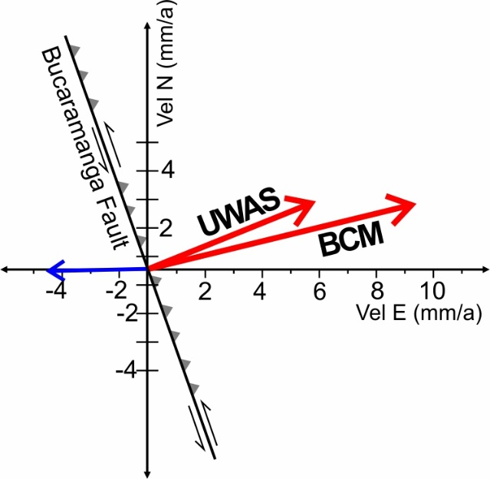
Figure S4: Expected hangingwall movement (blue arrow) of the Bucaramanga fault, obtained taking into account orientation of the fault and present day block movement as from GPS horizontal vectors (red arrows; from Perez et al., 2018)

References
Flowers, R.M., Shuster, D.L., Wernicke, B.P., Farley, K.A., 2007. Radiation damage control on apatite (U-Th)/He dates from the Grand Canyon region, Colorado Plateau. Geology 35, 447. doi:10.1130/G23471A.101.024
Guenthner, W.R., Reiners, P.W., Ketcham, R.A., Nasdala, L., Giester, G., 2013. Helium diffusion in natural zircon: Radiation damage, anisotropy, and the interpretation of zircon (U-Th)/He thermochronology.
Hourigan, J.K., Reiners, P.W., Brandon, M.T., 2005. U-Th zonation-dependent alpha-ejection in (U-Th)/He chronometry. Geochimica et Cosmochimica Acta 69, 3349–3365. doi:10.1016/j.gca.2005.
Ketcham, R. A., Gautheron, C., & Tassan-Got, L. 2011. Accounting for long alpha-particle stopping distances in (U–Th–Sm)/He geochronology: Refinement of the baseline case. Geochimica et Cosmochimica Acta, 75(24), 7779-7791.
McDowell, F.W., McIntosh, W.C., Farley, K.A., 2005. A precise 40 Ar– 39 Ar reference age for the Durango apatite (U–Th)/He and fission-track dating standard. Chemical Geology 214, 249–263.
Meesters, A. G. C. A., & Dunai, T. J. (2002). Solving the production–diffusion equation for finite diffusion domains of various shapes: Part II. Application to cases with α-ejection and nonhomogeneous distribution of the source. Chemical Geology, 186(1-2), 57-73.
Shuster, D. L., Flowers, R. M., & Farley, K. A. (2006). The influence of natural radiation damage on helium diffusion kinetics in apatite. Earth and Planetary Science Letters, 249(3), 148-161.

