Supplementary material S2. X-ray diffraction patterns of the silt+clay fractions from sample 2, which represents a sample from Group 1 and sample 8, which is representative of a sample from Group 3.
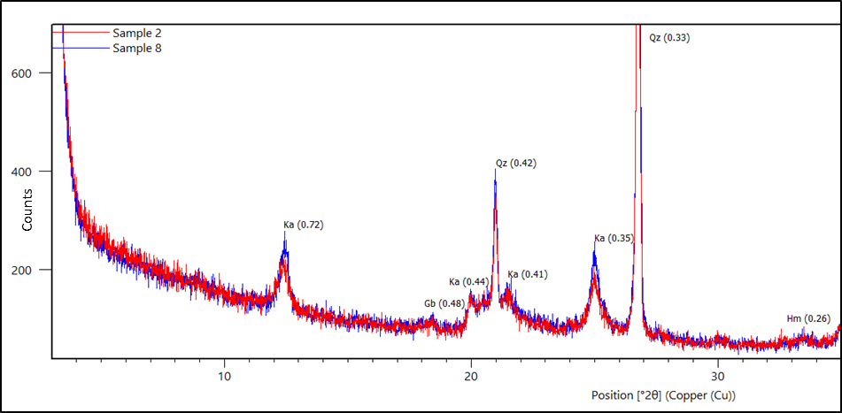
Note: Ka – Kaolinite; Gb – Gibbsite; Qz – Quartz; Hm – Hematite. The interlayer distances in nanometres (nm) are presented in parenthesis

