Supplementary Information - Where does the time go? Assessing the chronostratigraphic fidelity of sedimentary rock outcrops in the Pliocene-Pleistocene Red Crag Formation, eastern England
Neil S. Davies¹*, Anthony P. Shillito¹, William J. McMahon²
¹Department of Earth Sciences, University of Cambridge, Downing Street, Cambridge CB2 3EQ, United Kingdom.
²Faculty of Geosciences, Utrecht University, Princetonlaan 8a, Utrecht, 3584 CB, Netherlands.
*Corresponding Author: nsd27@cam.ac.uk
LOCAL STRATIGRAPHY AND OUTCROP DETAILS
Late Cenozoic shallow marine sediments in the counties of Suffolk, Norfolk and Essex, eastern England (Figure S1), are collectively described as “crag” (an archaic Suffolk-dialect word for shelly sand (Riches, 2012)). They are regionally notable as the youngest sedimentary material to be considered bedrock, rather than ‘drift’, by the British Geological Survey (Mathers and Hamblin, 2015). They are also notable from an historic perspective: they were the focus of some of the earliest scientific geological investigations worldwide (Dale, 1703), and the succession features prominently in Charles Lyell’s “Principles of Geology” (Lyell, 1833).
Stratigraphy and age
The Crag Group is a single mapping unit (Lee et al., 2015) which consists of four discrete transgressive formations, each separated by regional unconformities (Figure S1). From oldest to youngest, these are the Coralline Crag Formation, the Red Crag Formation, the Norwich Crag Formation, and the Wroxham Crag Formation (McMillan et al., 2011; Mathers and Hamblin, 2015). The geographic extent of the four units is variable and, while the stratigraphic order of the formations can be confirmed at particular localities (e.g., Lee et al., 2018; their Fig. 4), there is no location where all four units can be witnessed. Strata of a similar age to the Crag Group are definitively known offshore in the North Sea and onshore in Belgium and the Netherlands, but precise lithostratigraphic correlation across the southern North Sea region remains debatable (e.g., Long et al., 1988; Lott and Knox, 1994; Funnell, 1996; Hamblin et al., 1997; Kuhlmann et al., 2006; Riches, 2012; Lee et al., 2018).
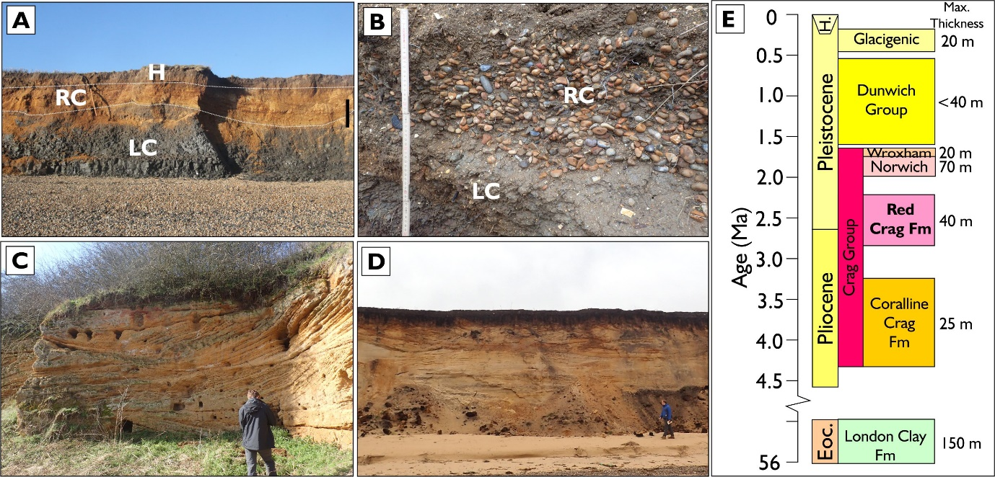
Figure S1. Stratigraphic context of the Red Crag Formation. A) Unconformable base of Red Crag Formation (RC) on Eocene London Clay Formation (LC). Erosionally-clipped RC is overlain by Holocene sediment (H). Irregular base and internal soft-sediment deformation due to glacio-tectonism. Bawdsey Cliffs. Scale bar 1 metre. B) Discontinuous gravel lag at base of Red Crag Formation, resting directly on top of Eocene London Clay Formation. Bawdsey Cliffs. Visible ruler is 49 cm. C) Early Pliocene Coralline Crag Formation, typified by burrowed, shell-rich trough cross-bedded sandstone. Gedgrave. Scale bar 1 metre. D) Early Pleistocene Norwich Crag Formation, typified by occasionally burrowed, occasionally shell-rich, trough cross-bedded sandstone. Southwold. Scale bar 1 metre. E) Simplified local stratigraphy (adapted from McMillan et al., 2011, and Wood, 2012). Note that ages are approximate (see text) and maximum thicknesses are from borehole data only. Individual Crag Group formations considered to have internal unconformities. No outcrop exists where a full transect through the known stratigraphy occurs.

This paper focusses on the second oldest formation of the Crag Group, the Red Crag Formation (hereafter, “Red Crag”), which crops out most extensively in eastern Suffolk, and can be seen to rest on top of either the Eocene London Clay Formation or Pliocene Coralline Crag Formation and to underlie either the Pleistocene Norwich Crag Formation or Quaternary drift deposits (Mathers and Hamblin, 2015). The age of the Red Crag itself has been variously determined from pollen and dinoflagellate microfossils (Head, 1998), the palaeozoogeography of cold-water ostracods (Wood, 2009), and magnetostratigraphy (Zalaciewicz et al., 1988; Hallam and Maher, 1994; Maher and Hallam, 2005). Different dating methods mean that there is some uncertainty in the formation’s precise age, but the oldest parts of the unit are agreed to be latest Pliocene (Piacenzian) while the youngest parts are earliest Pleistocene (Gelasian), and the duration of Red Crag deposition is consistently reported to be between 600-800 ka (e.g., Zalaciewicz et al., 1988; Hallam and Maher, 1994; Gibbard et al., 1998; Head, 1998; Maher and Hallam, 2005; Williams et al., 2009; Wood, 2009; Wood et al., 2009; McMillan et al., 2011; Riches, 2012; Mathers and Hamblin, 2015). Additionally, it has long been recognised that the unit is diachronous and becomes older southwards (Riches, 2012): the oldest and most southern strata are seen in an outlier at Walton-on-the-Naze, Essex, and may be separated from the rest of the unit by an unconformity (e.g., Wood et al., 2009).
At present, the base of the westernmost outcrop of the Red Crag (at Rothamstead, Hertfordshire) is 130 metres above sea-level, elevated approximately 195 metres above the base of the easternmost onshore outcrop (at Lowestoft, Suffolk). This altitudinal change, over a distance of 160 km, attests to significant differential crustal movement (uplift to the west, subsidence to the east) across eastern England, during and after deposition of the Crag Group (Hillis et al., 2008; Mathers and Hamblin, 2015). Although the relative role of tectonics and erosion in generating accommodation for the Red Crag is debated (see Riches, 2012 and Lee et al., 2018 for summaries), it is generally agreed that the amount of accommodation space decreased during deposition due to increased sedimentation rates and falling eustatic sea-level (Mathers and Zalasiewicz, 1988). The combination of limited accommodation and later truncation by Quaternary fluvial and glacial activity means that the maximum vertical stratigraphic thickness of the Red Crag Formation is 40 metres, and typically much less than this (McMillan et al., 2011).
Sedimentary environments
The Red Crag was deposited near the landward head of the Crag Basin, a localized embayment in the south-west corner of what is now the North Sea (Figure S2). At the time of deposition, the North Sea was an enclosed seaway which only opened to the Atlantic at the north, and terminated against a contiguous British-European land mass in the location of the present-day English Channel (Funnell, 1995; Lee et al., 2018). The Crag Basin received some direct clastic input from minor fluvial systems draining this British peninsula (Rose, 2009), but was sedimentologically-distinct from the eastern margins of the North Sea, where continent-scale rivers fed the major Eridanos Delta, prograding westwards from the present-day Baltic region (Overeem et al., 2001).
There is no evidence for non-marine sediments in the Red Crag, and it accumulated wholly within an open marine to nearshore setting (Figure S2). Lithologically, it consists of poorly-sorted, semi-consolidated, coarse-grained shelly quartz and carbonate sands which are dark green and glauconitic at depth, but which have been weathered to an iron-stained orange-red colour at outcrop (Humphreys and Balson, 1985; McMillan et al., 2011). The sediment usually has an extremely high content of aragonitic and calcitic shell debris, although at some locations the upper part of the unit has been decalcified to pure quartz sand as a result of later Pleistocene soil development (Kendall and Clegg, 2001). The base of the formation is marked by a prominent lag of rounded flint pebbles, and other pebble lags are common along bounding surfaces throughout the unit, often including reworked phosphatic coprolites and bromalites (e.g., Hunt et al., 2015) and occasional Miocene(?) to early Pliocene fossils (Balson, 1990; Gibbard et al., 1998) (Figure S1B). Variable palaeocurrent indicators, large-scale cross-bedding, and sedimentary structures including flaser bedding, and bioturbation, indicate that the unit was primarily deposited by migrating large-scale subtidal sandwaves (Figures 4-5) (Dixon, 1979, 2005, 2011, Mathers and Zalasiewicz, 1988, Zalasiewicz et al., 1988, Balson et al., 1991, Hamblin et al., 1997).
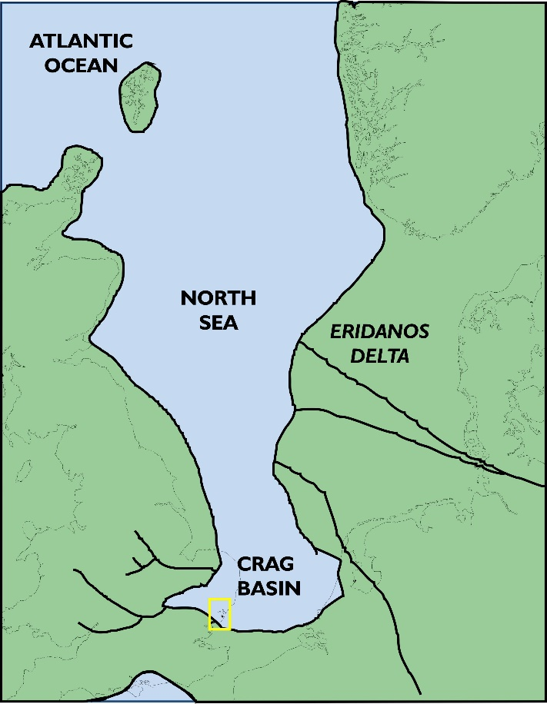
Figure S2. Palaeogeographic reconstruction of the Crag Basin during the late Pliocene/early Pleistocene. Yellow box highlights study area. After Rose (2009) and Lee et al. (2018).
The Red Crag is a fossil-rich unit and has been the focus of extensive palaeontological investigation into its mollusc fauna (Dixon, 1977), palynology (Head, 1998; Riding et al., 2000), ostracods (Wood, 2009), and coprolites (Hunt et al., 2015), as well as being noted for other invertebrate (bryozoans, corals and echinoderms; Humphreys and Balson, 1985) and vertebrate remains (shark and whale; Fitzgerald, 2011, Pimiento and Balk, 2015). However, despite being extensively burrowed, only its largest trace fossils – Psilonichnus – have previously been described in detail (Humphreys and Balson, 1988).
Outcrops of the Red Crag Formation
Outcrops of the Red Crag Formation are typically of limited extent, but of good quality for discerning its internal sedimentary architecture. No individual outcrop approaches the full 40 metre thickness of the unit, but this is ascertained from some of the hundreds of boreholes that have been made across unexposed parts of the regional outcrop belt (Figure 7; British Geological Survey, 2018). Two primary types of exposed outcrop exist and have formed the focus of this study: crag pits, and coastal outcrop. The distinct nature of these outcrops as geomorphological entities is detailed below, as they have direct implications for the understanding of the preservation of time at outcrop.
Crag pits: Static outcrops
Sediment from the Red Crag has historically had agricultural uses, particularly after the 1840’s when it was recognised that the unit yielded extensive phosphatic concretions, and there was coincident invention of a sulphuric acid treatment that enabled their synthesis into a chemical fertilizer (O’Connor and Ford, 2001). As a result of this, a series of defunct ‘crag pits’ exist at inland locations across Suffolk. Due to later infilling or vegetation overgrowth, the abundance of pits is clearly less than during the earliest geological work in the 19th Century (Riches, 2012) and accessible localities have even diminished since modern sedimentological investigations began (e.g., Dixon, 1979). Nonetheless, artificial outcrops still occur where relatively clean, three-dimensional vertical exposure of the Red Crag can be seen, and where moderate recent weathering has highlighted internal sedimentary characteristics. The localities and dimensions of crag pit outcrops visited in this study are: (1) Capel Green (52°05’31.91”N, 1°27’13.25”E; 4 metres maximum height by 45 metres total cliff length outcrop); (2) Boyton Marshes (52°06’13.96”N, 1°29’20.47”E; 8 m by 93 m); (3) Buckanay Farm (52°01’48.03”N, 1°26’00.92”E; 7 m by 168 m); (4) Shottisham (52°03’40.24”N, 1°22’46.71”E; 4 m by 70 m); (5) Neutral Farm (52°06’25.22”N, 1°27’42.69”E; 5 m by 100 m) and (6) Chillesford (52°03’04.23”N, 1°28’44.39”E; 5 m by 85 m).
Coastal exposure: Dynamic outcrops
Two distinct exposed coastal outcrops have been used in this study, at Bawdsey and Walton-on-the-Naze, to provide more extensive and dynamic outcrops than the inland crag pits (Figure 6B-C). The cliffs at Bawdsey extend for 2550 metres between Bawdsey Manor in the south (51°59’25.44”N, 1°24’11.93”E) and East Lane in the north (52°00’20.11”N, 1°25’48.65”E), and are intermittently obscured by slumping, vegetation or beach material along their length. The cliffs expose up to 10 metres vertically of Red Crag, resting directly on top of the Eocene London Clay Formation, and terminating beneath soil or glacial sediment (Figure 2A). The exposure of the Bawdsey cliffs is seasonally to annually changeable due to the susceptibility of the semi-consolidated Red Crag to coastal erosion. Near Bawdsey Manor, recent build-up of beach material has protected the cliff face such that formerly extensive exposure of sedimentary architecture (e.g., as described Balson et al., 1991) is no longer regularly washed by wave action, and presently obscured by vegetation. In contrast, the north of the cliff outcrop has seen significant change in recent years because sea defences at East Lane have deflected waves approaching from the north, reducing the supply of beach sediment (i.e., from the spit located at Orford Ness). As a protective beach barrier is no longer sustained in front of the northern Bawdsey cliffs, wave erosion has forced the outcrop exposure to retreat landwards by 38 metres between 1991-2010 (Environment Agency, 2015), entraining Red Crag sediment into the modern system as it has done so. However, most recently (although possibly temporarily), beach level has raised in front of the cliff between 2017-2018 such that the visible outcrop has diminished (in this paper, images from the East Lane end of the Bawdsey cliffs date from 2014-2016, an interval of active retreat).
Cliff outcrop at Walton-on-the-Naze comprises the southernmost and stratigraphically-oldest exposure of the Red Crag, and extends for 560 metres between 51°51’49.53”N, 1°17’21.19”E and 51°52’08.24”N, 1°17’26.67”E. Accessibility is intermittent due to slumped and vegetated material. The upper part of the Red Crag Formation is often decalcified (Kendall and Clegg, 2001) and sometimes cryoturbated (Figure S1A). The lower parts of the cliffs comprise the London Clay Formation, and vertical sections of Red Crag Formation reach up to 8 metres, where they terminate at the cliff top or below slumped Quaternary glacial sediment. The buffer against coastal erosion that is provided by the London Clay and slumped material, plus nearby artificial sea defences, mean that the Red Crag outcrop at Walton-on-the-Naze has been less changeable than at Bawdsey during recent decades.
REFERENCES
Balson, P.S., Humphreys, B. and Zalasiewicz, J.A., 1991, Coralline and Red Crags of East Anglia. 13th International Sedimentological Congress Field Guide No. 3, 48 pp.
British Geological Survey, 2018a, Borehole materials. Available from: https://www.bgs.ac.uk/data/bmd.html
British Geological Survey, 2018b, MAREMAP Marine Environmental Mapping Programme. Available online at: http://www.maremap.ac.uk/view/search/searchMaps.html
Dale, S., 1703. A Letter from Mr Samuel Dale to Mr Edward Lhwyd, Keeper of the Ashmolean Repository in Oxford, concerning Harwich Cliff, and the Fossil Shells There. Philosophical Transactions of the Royal Society, 24, p.1568-1578.
Dixon, R.G., 1977. Studies on the Mollusca of the Red Crag (Pleistocene, East Anglia) (Ph.D. thesis, University of London). Available from: https://ethos.bl.uk/OrderDetails.do;jsessionid=96A650B463046ED4DE5A5441565AA764?uin=uk.bl.ethos.453719
Dixon, R.G., 1979, Sedimentary facies in the Red Crag (Lower Pleistocene, East Anglia). Proceedings of the Geologists' Association, v. 90, p.117-132.
Dixon, R.G., 2005. Field meeting: Coastal Suffolk Crag weekend, 23–25 April 2004. Proceedings of the Geologists' Association, 116(2), pp.149-160.
Dixon, R.G., 2011, Field Meeting to the Bawdsey Peninsula, Suffolk, England, 22nd May 2010, to examine London Clay, Coralline Crag and Red Crag deposits: Leaders: Roger Dixon and Bob Markham. Proceedings of the Geologists' Association, v. 122, p.514-523.
Environment Agency, 2015, Coastal Processes Study: East Lane, Bawdsey, Draft Report. Available at: http://www.bawdseycoastalpartnership.org.uk/uploads/bcp/Bawdsey%20Coastal%20Erosion%20Study%20Draft%20Report_FINAL_RevB_Issued%20(1).pdf.
Fitzgerald, E.M., 2011. A fossil sperm whale (Cetacea, Physeteroidea) from the Pleistocene of Nauru, equatorial southwest Pacific. Journal of Vertebrate Paleontology, 31(4), pp.929-931.
Funnell, B.M., 1995, Global sea-level and the (pen-) insularity of late Cenozoic Britain. In: Preece, R.G. (ed.), Island Britain: A Quaternary Perspective. Geological Society, London, Special Publications, v. 96, p.3-13.
Funnell, B.M., 1996, Plio-Pleistocene palaeogeography of the southern North Sea basin (3.75-0.60 Ma). Quaternary Science Reviews, v. 15, p.391-405.
Gibbard, P.L., Zalasiewicz, J.A. and Mathers, S.J.,1998. Stratigraphy of the marine Plio-Pleistocene crag deposits of East Anglia. Mededelingen Nederlands Instituut voor Toegpaste Geowetenschappen TNO, 60, 239-262.
Hallam, D.F. and Maher, B.A., 1994. A record of reversed polarity carried by the iron sulphide greigite in British early Pleistocene sediments. Earth and Planetary Science Letters, 121(1-2), pp.71-80.
Hamblin, R.J.O., Moorlock, B.S.P., Booth, S.J., Jeffery, D.H. and Morigi, A.N., 1997, The Red Crag and Norwich Crag formations in eastern Suffolk. Proceedings of the Geologists' Association, v. 108, p.11-23.
Head, M.J., 1998. Pollen and dinoflagellates from the Red Crag at Walton-on-the-Naze, Essex: evidence for a mild climatic phase during the early Late Pliocene of eastern England. Geological Magazine, 135(6), pp.803-817.
Hillis, R.R., Holford, S.P., Green, P.F., Doré, A.G., Gatliff, R.W., Stoker, M.S., Thomson, K., Turner, J.P., Underhill, J.R. and Williams, G.A., 2008. Cenozoic exhumation of the southern British Isles. Geology, 36, 371-374.
Humphreys, B. and Balson, P.S., 1985. Authigenic glaucony in the East Anglian crags. Proceedings of the Geologists' Association, 96(2), pp.183-188.
Humphreys, B. and Balson, P.S., 1988, Psilonichnus (Fürsich) in late Pliocene subtidal marine sands of eastern England. Journal of Paleontology, v. 62, p.168-172.
Hunt, A.P., Lucas, S.G. and Lichtig, A.J., 2015. A helical coprolite from the Red Crag Formation (Plio-Pleistocene) of England. New Mexico Museum of Natural History Bulletin, 67, p.59-62.
Kendall, A.C. and Clegg, N.M., 2000, Pleistocene decalcification of Late Pliocene Red Crag shelly sands from Walton‐on‐the‐Naze, England. Sedimentology, v. 47, p.1199-1209.
Kuhlmann, G., Langereis, C.G., Munsterman, D., Van Leeuwen, R.J., Verreussel, R., Meulenkamp, J.E. and Wong, T.E., 2006. Integrated chronostratigraphy of the Pliocene-Pleistocene interval and its relation to the regional stratigraphical stages in the southern North Sea region. Netherlands Journal of Geosciences, 85(1), pp.19-35.
Lee, J.R., Woods, M.A., Moorlock, B.S.P., eds., 2015, British Regional Geology: East Anglia. British Geological Survey, Keyworth Nottingham, 273 pp.
Lee, J.R., Candy, I. and Haslam, R., 2018. The Neogene and Quaternary of England: landscape evolution, tectonics, climate change and their expression in the geological record. Proceedings of the Geologists' Association, 129, 452-481.
Long, D., Laban, C., Streif, H., Cameron, T.D.J. and Schüttenhelm, R.T.E., 1988. The sedimentary record of climatic variation in the southern North Sea. Phil. Trans. R. Soc. Lond. B, 318(1191), pp.523-537.
Lott, G.K. and Knox, R.W.O’B., 1994, Post-Triassic of the southern North Sea. In: Knox, R.W.O’B. and Cordey, W.G. (eds.) Lithostratigraphic nomenclature of the UK North Sea. British Geological Survey, Nottingham, 206 pp.
Lyell, C., 1833. Principles of Geology: being an attempt to explain the former changes of the Earth’s surface, by reference to causes now in operation, Volume III. London, John Murray.
Maher, B.A. and Hallam, D.F., 2005. Palaeomagnetic correlation and dating of Plio/Pleistocene sediments at the southern margins of the North Sea Basin. Journal of Quaternary Science, 20(1), pp.67-77.
Mathers, S.J. and Zalasiewicz, J.A., 1988, The Red Crag and Norwich Crag formations of southern East Anglia. Proceedings of the Geologists' Association, v. 99, p.261-278.
Mathers, S.J. and Hamblin, R.J.O., 2015. Late Pliocene and Pleistocene marine deposits. In Lee, J.R., Woods, M.A., Moorlock, B.S.P., (eds.) British Regional Geology: East Anglia. British Geological Survey, Keyworth Nottingham. pp. 110-129.
McMillan, A.A., Hamblin, R.J.O. and Merritt, J.W., 2011, A lithostratigraphical framework for onshore Quaternary and Neogene (Tertiary) superficial deposits of Great Britain and the Isle of Man. British Geological Survey Research Report 10/03, 343 pp.
O’Connor, B., Ford, T.D., 2001. The origins and development of the British coprolite industry. The Bulletin of the Peak District Mines Historical Society, 14(5), pp.46-57.
Overeem, I., Weltje, G.J., Bishop-Kay, C. and Kroonenberg, S.B., 2001. The Late Cenozoic Eridanos delta system in the Southern North Sea Basin: a climate signal in sediment supply?. Basin Research, 13(3), pp.293-312.
Pimiento, C. and Balk, M.A., 2015. Body-size trends of the extinct giant shark Carcharocles megalodon: a deep-time perspective on marine apex predators. Paleobiology, 41(3), pp.479-490.
Riches, P.F., 2012, The palaeoenvironmental and neotectonic history of the Early Pleistocene Crag basin in East Anglia. Ph.D. thesis, Royal Holloway, University of London. Available from: https://repository.royalholloway.ac.uk/file/eb59ceaa-948a-01c8-30e1-4c06a764447a/8/2012richespfphd.pdf
Riding, J.B., Head, M.J., and Moorlock, B.S.P., 2000. Reworked palynomorphs from the Red Crag and Norwich Crag formations (Early Pleistocene) of the Ludham borehole, Norfolk. Proceedings of the Geologists’ Association, 111, 161-171.
Rose, J., 2009. Early and Middle Pleistocene landscapes of eastern England. Proceedings of the Geologists' Association, 120(1), pp.3-33.
Williams, M., Haywood, A.M., Harper, E.M., Johnson, A.L., Knowles, T., Leng, M.J., Lunt, D.J., Okamura, B., Taylor, P.D. and Zalasiewicz, J., 2009. Pliocene climate and seasonality in North Atlantic shelf seas. Philosophical Transactions of the Royal Society of London A: Mathematical, Physical and Engineering Sciences, 367(1886), pp.85-108.
Wood, A.M., 2009, The phylogeny and palaeozoogeography of cold-water species of ostracod (Crustacea) from the Pre-Ludhamian Stage (late Pliocene-early Pleistocene), Red Crag Formation, East Anglia, England; with reference to the earliest arrival of Pacific species. Paleontological Research, v, 13, p.345-366.
Wood, A.M., Wilkinson, I.P., Maybury, C.A., Whatley, R.C., 2009, Neogene. In: Whitaker, J.E., Hart, M.B. (eds.) Ostracods in British Stratigraphy. The Micropalaeontological Society, Special Publications, 411-446.
Zalasiewicz, J.A., Mathers, S.J., Hughes, M.J., Gibbard, P.L., Peglar, S.M., Harland, R., Nicholson, R.A., Boulton, G.S., Cambridge, P. and Wealthall, G.P., 1988, Stratigraphy and palaeoenvironments of the Red Crag and Norwich Crag formations between Aldeburgh and Sizewell, Suffolk, England. Philosophical Transactions of the Royal Society of London B, v. 322, p.221-272.

