**Supplementary Material**

**The forensic comparison of trace amounts of soil on a pyjama top with hypersulfidic subaqueous soil from a river as evidence in a homicide cold case**

Robert W Fitzpatrick1,2* & Mark D Raven1

*1Centre for Australian Forensic Soil Science (CAFSS), CSIRO Land and Water, Waite Campus, Locked Bag 2, Urrbrae, South Australia, Australia 5064.*

*2Acid Sulfate Soils Centre (ASSC) the University of Adelaide, North Terrace, Adelaide, South Australia. 5000*

*\*Corresponding author (e-mail:* [*rob.fitzpatrick@csiro.au*](mailto:rob.fitzpatrick@csiro.au)*)*

**Supplementary Material S1: SEM Images and Spectra of samples listed in Table 1**

**CAFSS_138.1 – hem area (#138p) - 001**

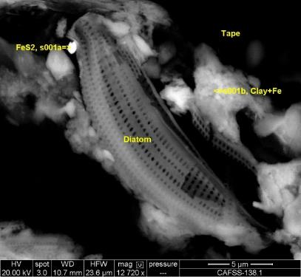

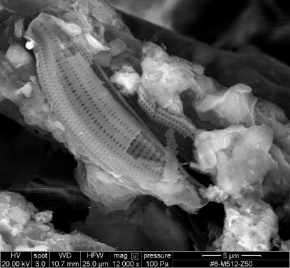

**Fig. S1.1: Back-scattered electron (BE) image (top) and secondary electron (SE) image (below) of sample CAFSS_138.1 (hem area: Image #138p–001 and 004)**

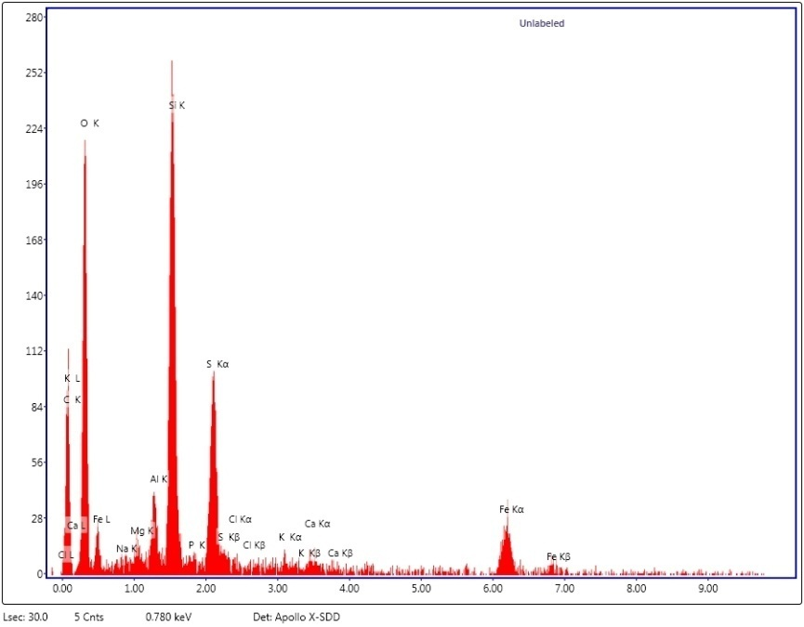

**Fig. S1.2: EDX spectra collected from region marked s001a in Figure S1.1 for CAFSS_138.1 (hem area: #138p –s001a), which is the mineral pyrite**

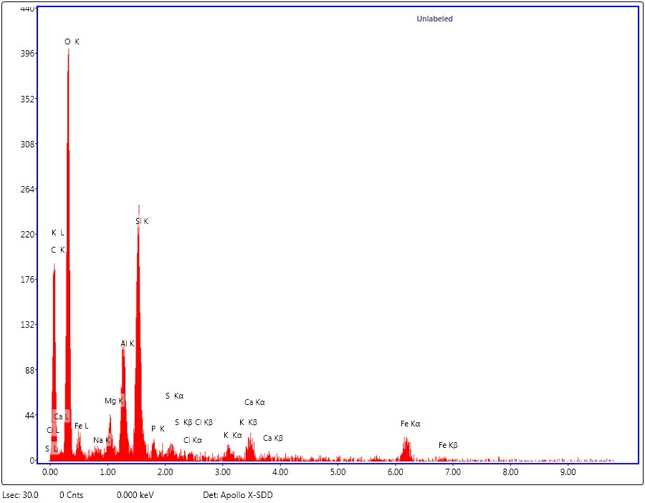



**Fig. S1.3: EDX spectra collected from region marked s001b in Figure S1.1 for CAFSS_138.1 (hem area (#138p –s001a), which is for layer silicate minerals (mica/illite) in CAFSS_138.1 – seam area (#138p) – 001b**

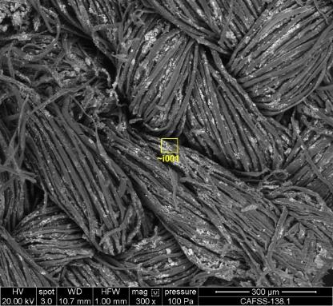 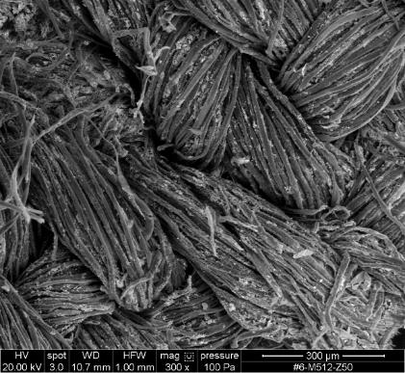

**Figure S1.4: Back-scattered electron (BE) image on left and secondary electron (SE) image on right of for CAFSS_138.1 (hem area; Image #138p– 002)**

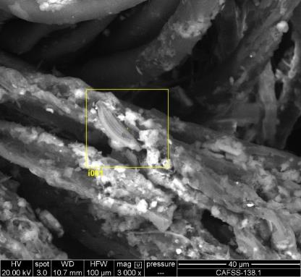 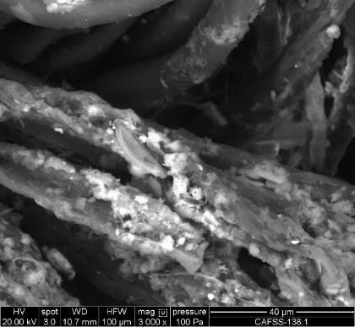

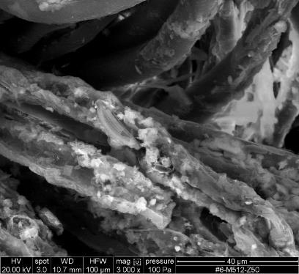 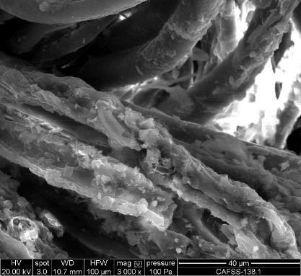

**Fig. S1.5: Back-scattered electron (BE) image (left hand side) and secondary electron (SE) image (right hand side) of sample CAFSS_138.1 (hem area: Image #138p–003)**

**CAFSS_138.1 – hem area (#138p) – 006**

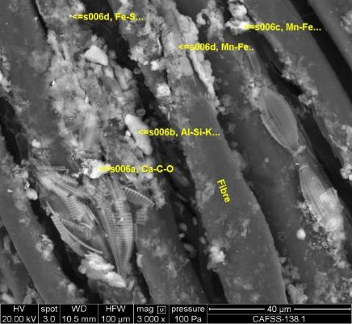

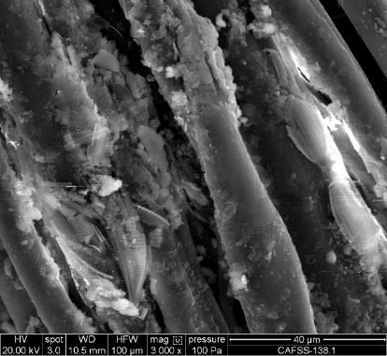

**Fig. S1.6: Back-scattered electron (BE) image (top) and secondary electron (SE) image (below) of sample**

**CAFSS_138.1 (hem area: Image #138p–006)**

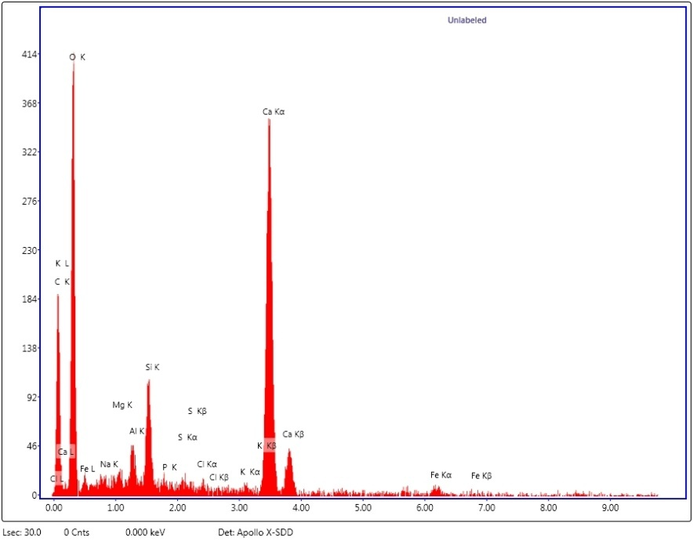

**Fig. S1.7: EDX spectra collected from region marked s006a in Figure S1.6 for CAFSS_138.1 (hem area (#138p –s006a), which is for the mineral calcite**

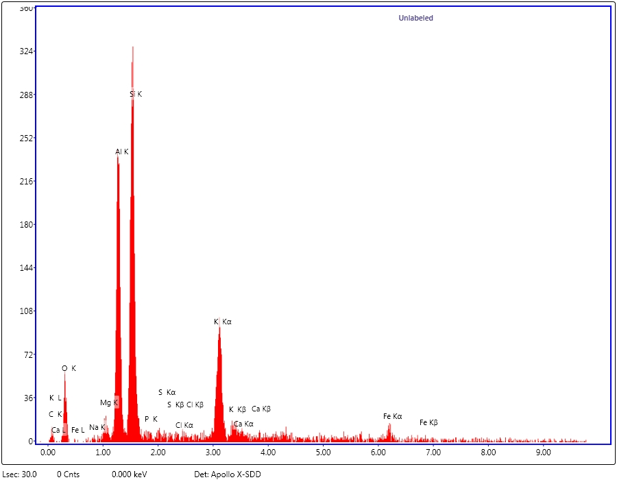

**Fig. S1.8: EDX spectra collected from region marked s006b in Figure S1.6 for CAFSS_138.1 (hem area (#138p –s006a), which is for aluminium silicate minerals (mica/ illite) in clay aggregates**

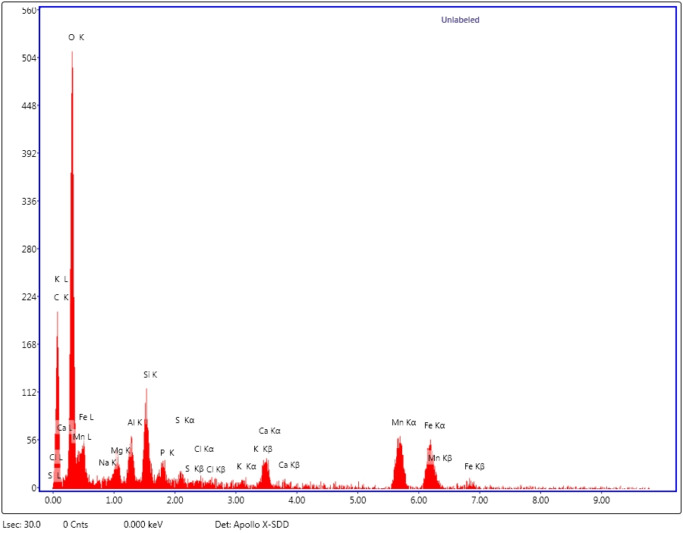

**Fig. S1.9: EDX spectra collected from region marked s006c in Figure S1.6 for CAFSS_138.1 (hem area (#138p –s006c), which is for Mn-rich mineral aggregates**

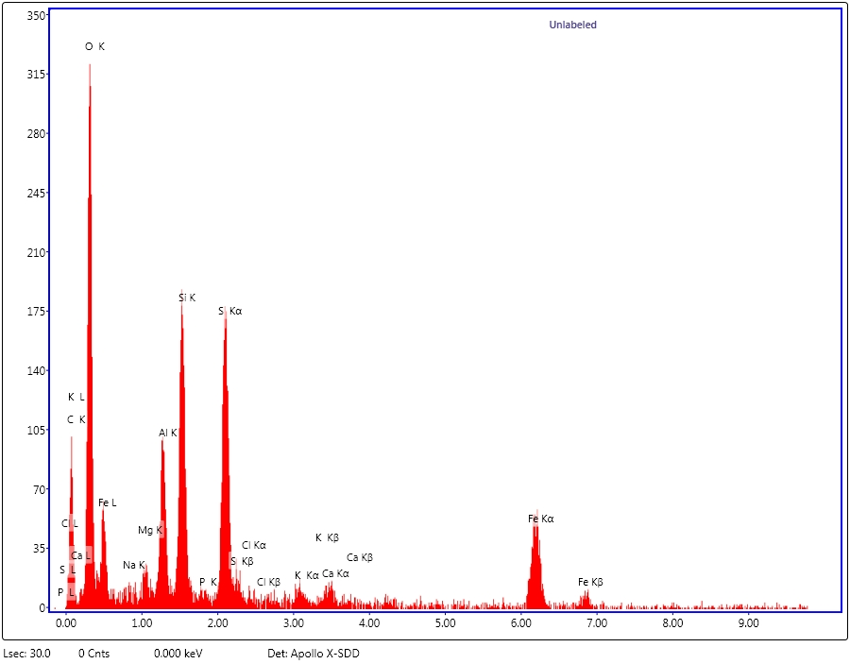

**Fig. S1.10: EDX spectra collected from region marked s006d in Figure S1.6 for CAFSS_138.1 (hem area (#138p –s006d), which is for the mineral pyrite**

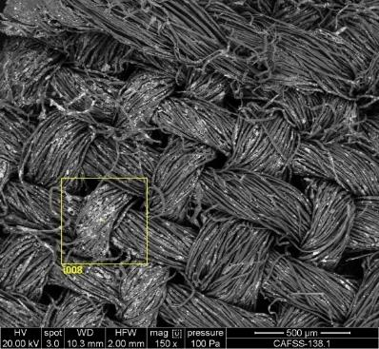 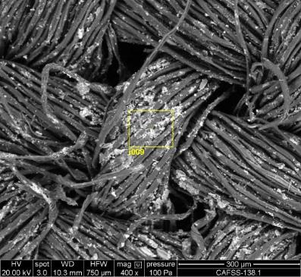

**Fig. S3.11: Back-scattered electron (BE) image of sample CAFSS_138.1 hem area; #138p1-AN_007 and 008**

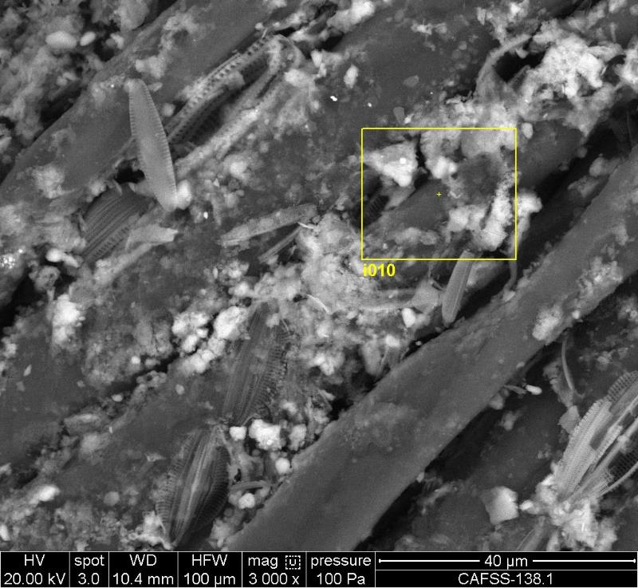

**Fig. S1.12: Secondary electron (SE) image of sample CAFSS_138.1 – hem area; #138p1-AN_009**

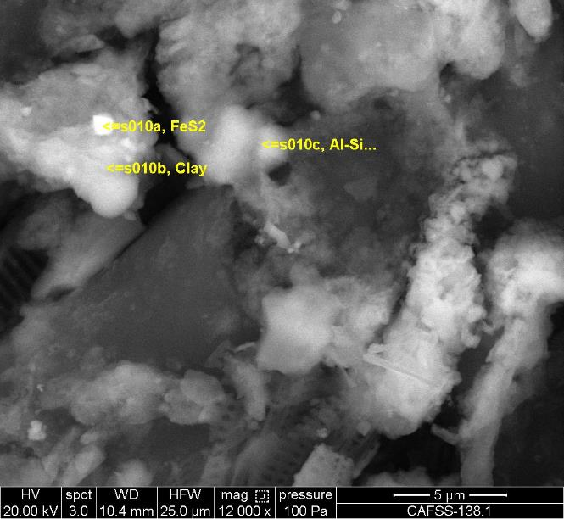

**Fig. S1.13: Back-scattered electron (BE) image of sample CAFSS_138.1 – hem area; #138p1-AN_010**

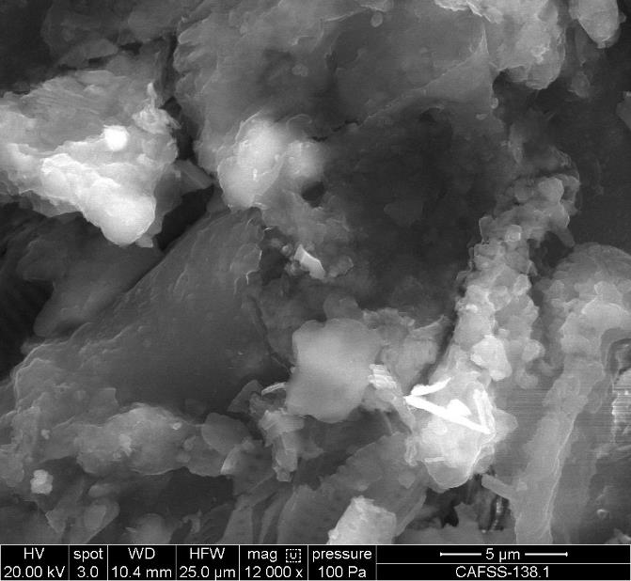

**Fig. S1.14: Secondary electron (SE) image of sample CAFSS_138.1– hem area; #138p1-SE_010**

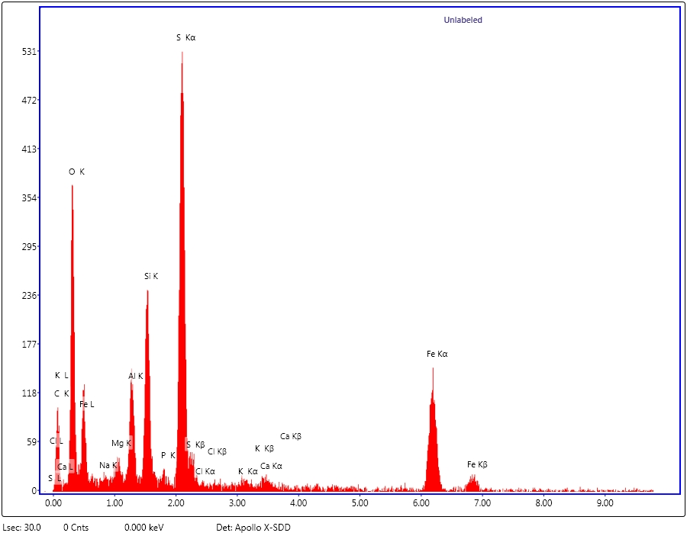

**Fig. S1.15: EDX spectra collected from region marked s010a in Figure S1.13 for CAFSS_138.1 (hem area: #138p –s010a), which is for the mineral pyrite**

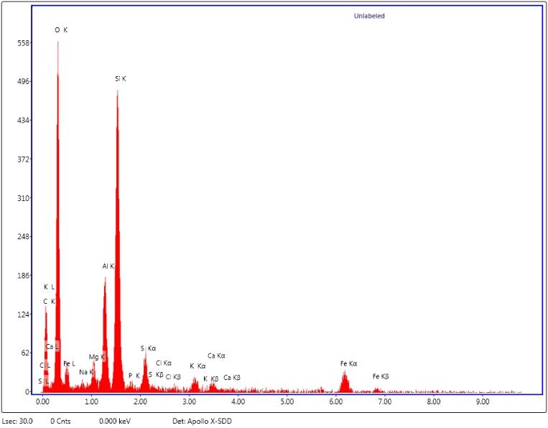

**Fig. S1.16: EDX spectra collected from region marked s010c in Figure S1.13 for CAFSS_138.1 (hem area: #138p –s010c (clay – aluminium silicate)**

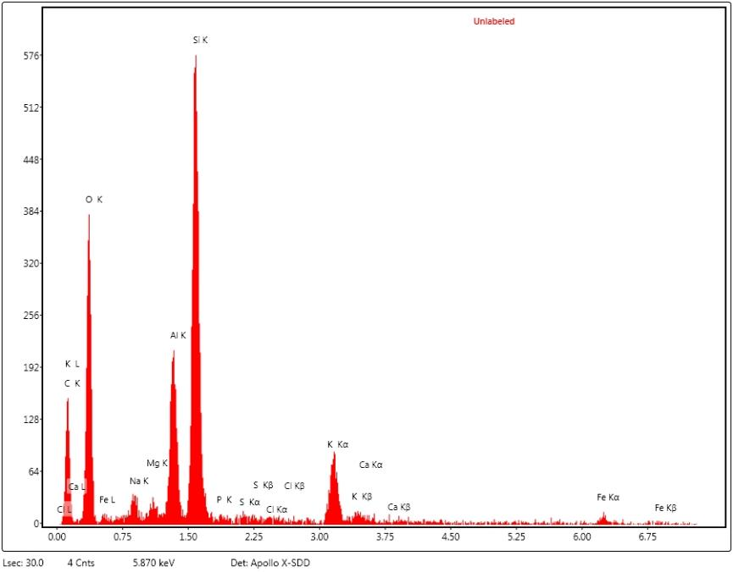

**Fig. S1.17: EDX spectra collected from region marked s010c in Figure S1.13 for CAFSS_138.1 (hem area: #138p –s010c), which is for clay – aluminium silicate: mica / illite**

**CAFSS_138.2: Showing small soil fragment or aggregate between fibres (#138p)**

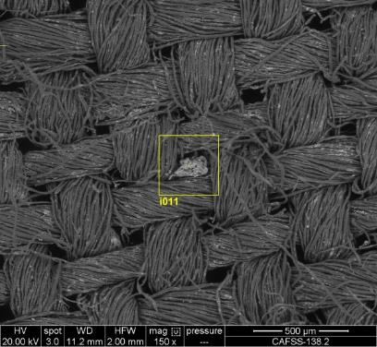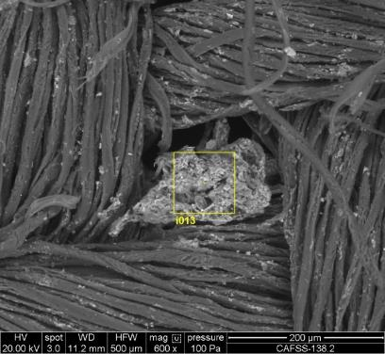

**Fig. S1.18: Back-scattered electron (BE) image of sample CAFSS_138.2 (Images #138p2-AN_011 & 012)**

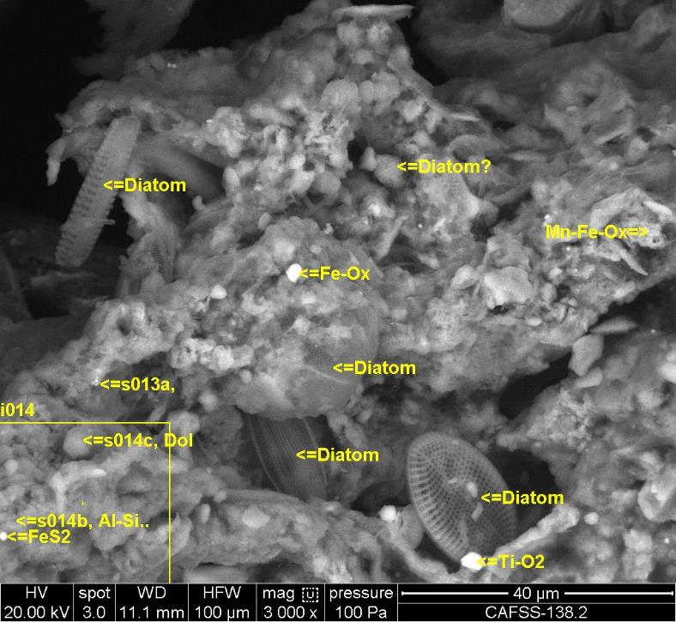

**Fig. S1.19: Back-scattered electron (BE) image of CAFSS_138.2 #138p2-AN_013 Small soil fragment / soil aggregate between fibres (#138p): Close-up view showing diatoms (range of different species), pyrite, layer silicates (mica/illite), manganese-iron rich mineral; rutile / anatase (TiO2) and dolomite.**

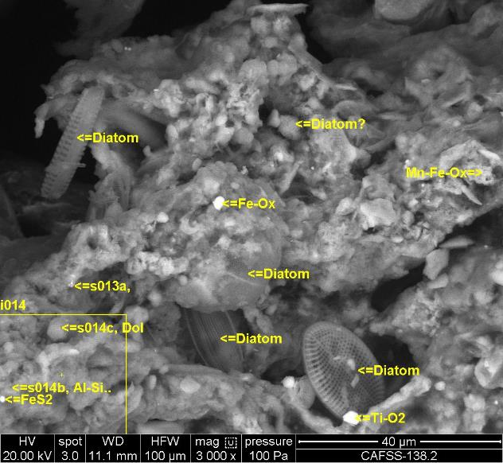

**Fig. S1.20: Back-scattered electron (BE) image of CAFSS_138.2 (image #138p2-AN_013)**

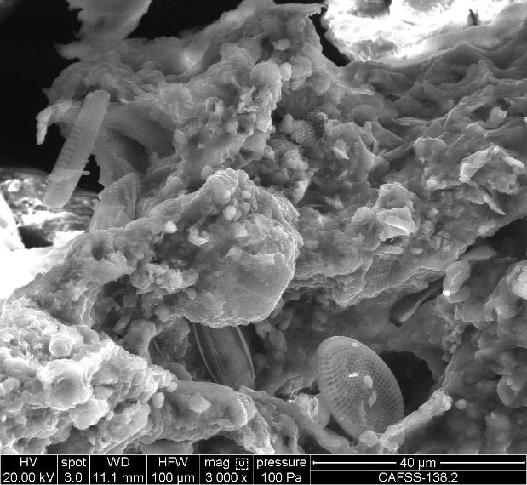

**Fig. S1.21: Secondary electron (SE) image of CAFSS_138.2 Small soil fragment / soil aggregate between fibres (Image #138p2-SE_013). Close-up view showing diatoms (range of different species), pyrite, layer silicates (mica/illite), manganese-iron rich mineral; rutile and dolomite**

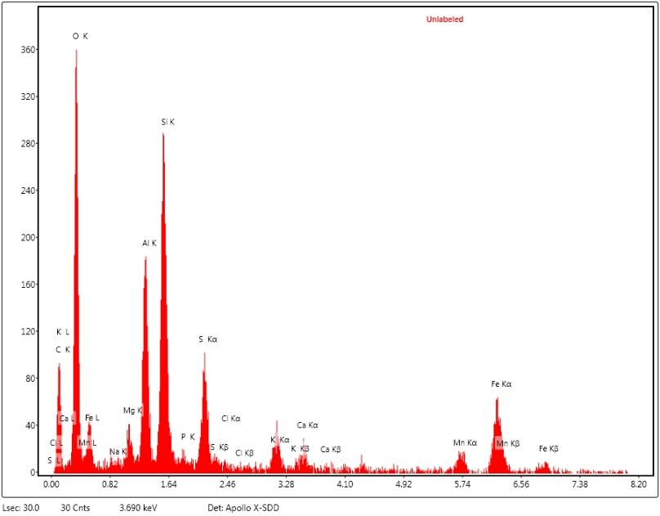

**Fig. S1.22: EDX spectra collected from region marked s013a in Figure S1.20 for CAFSS_138.2 (Spectra #138p2-SP_013a) for layer silicates (mica/illite) and manganese-iron rich mineral**

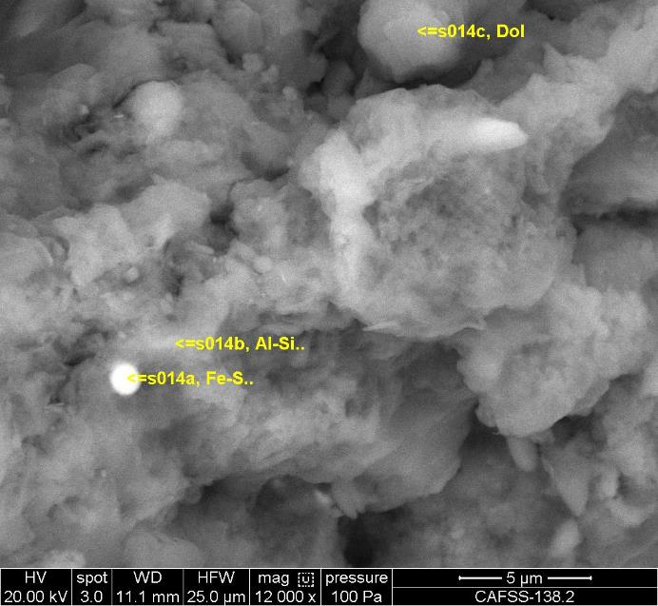

**Fig. S1.23: Back-scattered electron (BE) image of CAFSS_138.2 Small soil fragment / soil aggregate between fibres (Image #138p2-AN_014); Close-up view showing layer silicates (mica/illite), pyrite framboid and dolomite.**

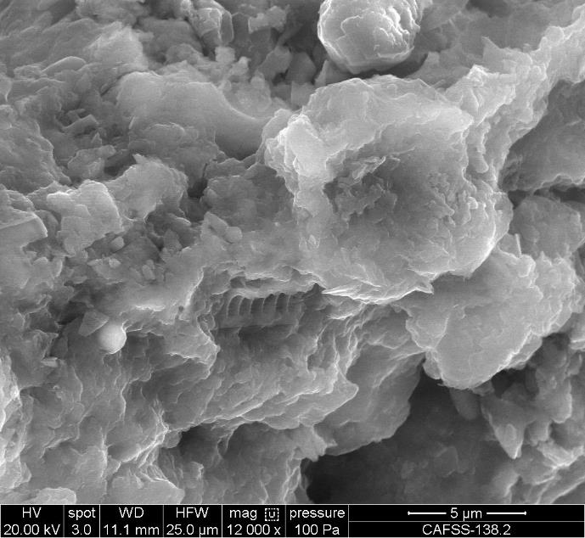

**Fig. S1.24: Secondary electron (SE) image of CAFSS_138.2 Small soil fragment / soil aggregate between fibres (Image #138p2-SE_014); Close-up view showing layer silicates (mica/illite), pyrite framboid and dolomite.**

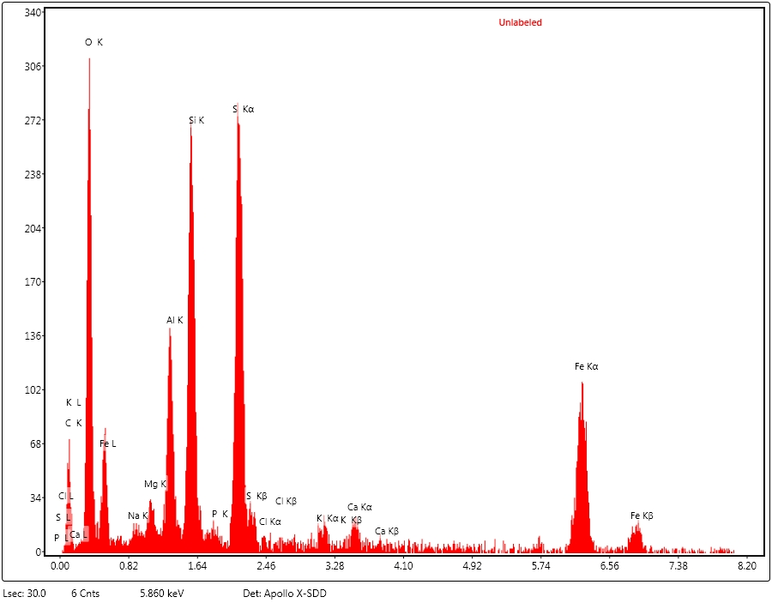



**Fig. S1.25: EDX spectra collected from region marked s014a in Figure S1.23 of CAFSS_138.2 Small soil fragment / soil aggregate between fibres (Spectra #SP_014a_1), which identifies pyrite with layer silicates (mica/illite) in background.**

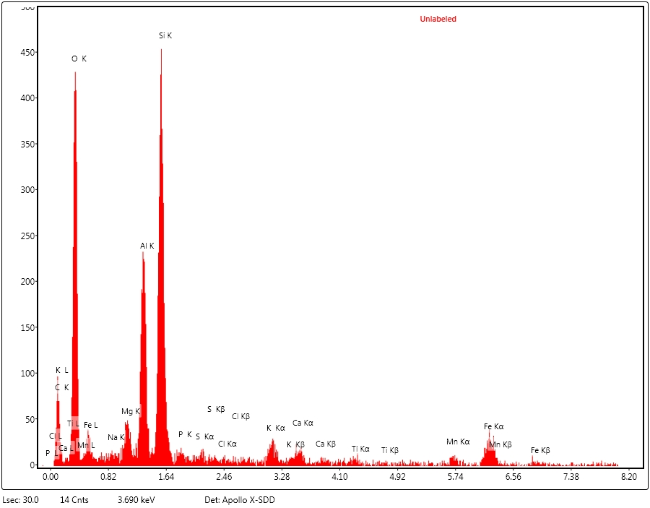

**Fig. S1.26: EDX spectra collected from region marked s014b in Figure S1.23 of CAFSS_138.2 Small soil fragment / soil aggregate between fibres (Spectra SP_014b_1; Identifying layer silicates (mica/illite)**

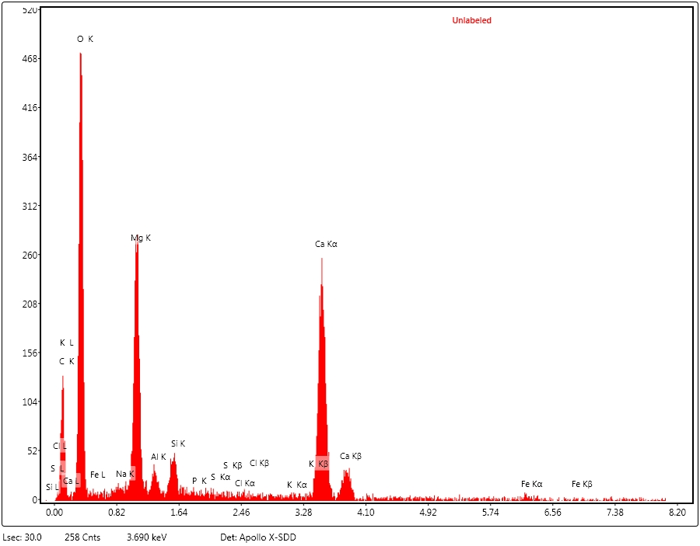



**Fig. S1.27: EDX spectra collected from region marked s014c in Figure S1.23 for CAFSS_138.2 Small soil fragment / soil aggregate between fibres (Spectra #SP_014c_1), which identifies the mineral dolomite.**

**CAFSS_138.3 – Soil particles and aggregates on surface and mainly between fibres**

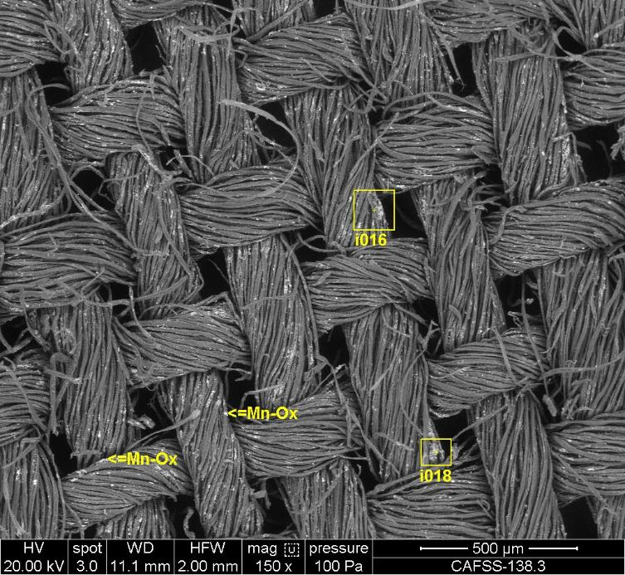

**Fig. S1.28: Back-scattered electron (BE) image of sample CAFSS_138.3 #138p3 (Image #138p3-AN_015). Soil particles and aggregates on surface and mainly between fibres (#138p):**

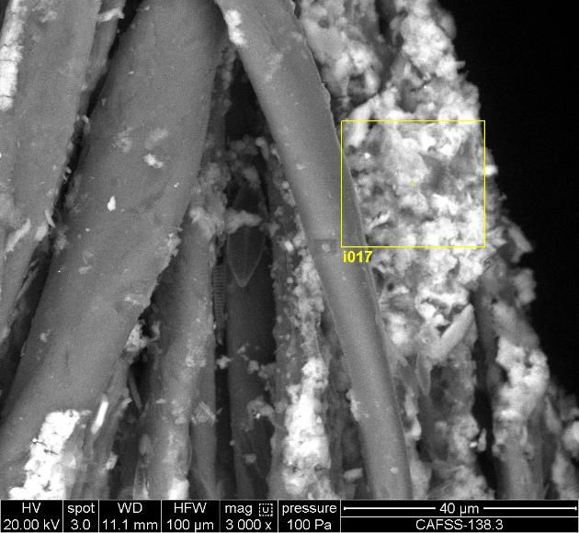

**Fig. S1.29: Back-scattered electron (BE) image of sample CAFSS_138.3 Soil particles and aggregates on surface and mainly between fibres (#138p): #138p3. #138p3-AN_016.**

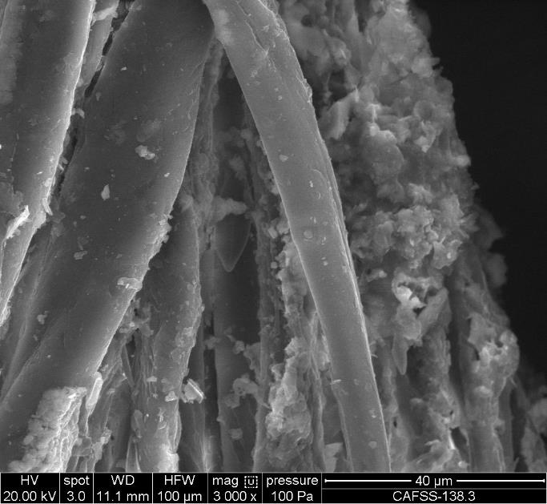

**Fig. S1.30: Secondary electron (SE) image of CAFSS_138.3 Soil particles and aggregates on surface and mainly between fibres (#138p): #138p3. #138p3-SE_016.**

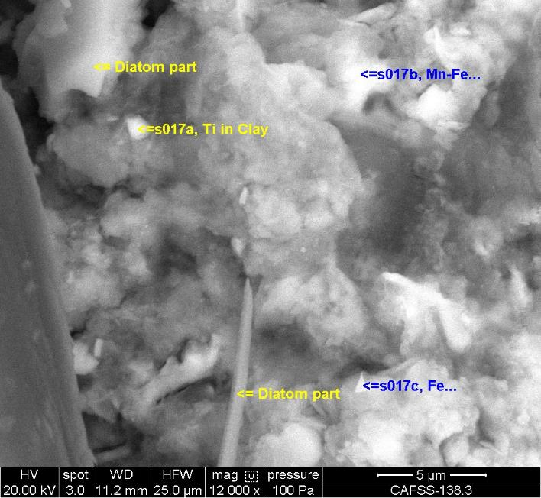

**Fig. S1.31: Back-scattered electron (BE) image of CAFSS_138.3 Soil particles and aggregates on surface and mainly between fibres (Image #138p3-AN_017).**

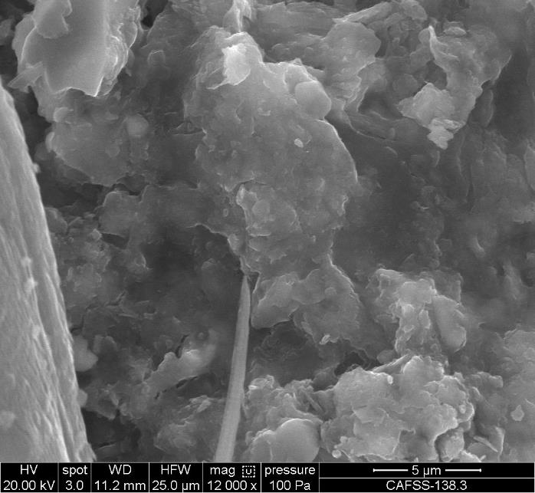

**Fig. S1.32: Secondary electron (SE) image of CAFSS_138.3 Soil particles and aggregates on surface and mainly between fibres (Image #138p3-SE_017).**

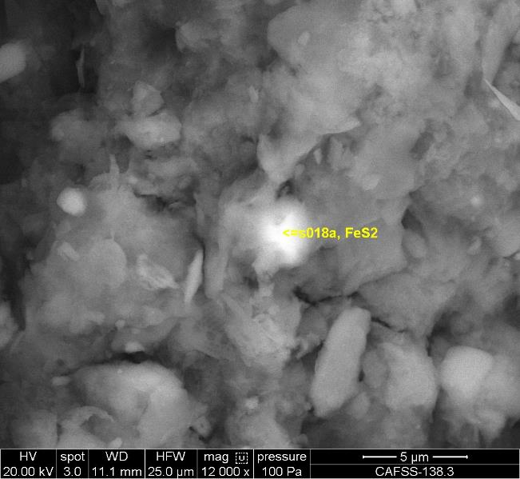

**Fig. S1.33: Back-scattered electron (BE) image of CAFSS_138.3 Soil particles and aggregates on surface and mainly between fibres (Image #138p3-AN_018).**

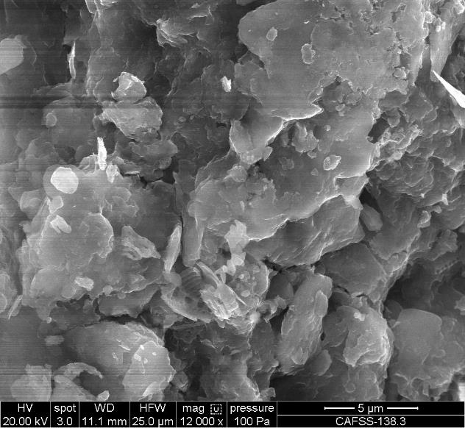

**Fig. S1.34: Secondary electron (SE) image of CAFSS_138.3 Soil particles and aggregates on surface and mainly between fibres (Image #138p3-SE_018).**

**CAFSS_138.4 – showing soil particles and aggregates mainly on the surface of fibres**

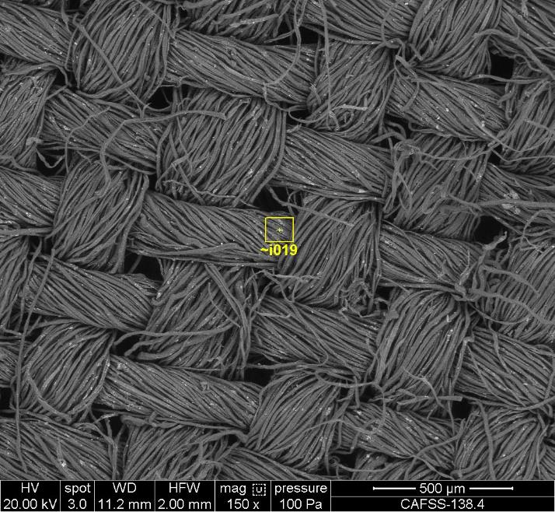

**Fig. S1.35: Back-scattered electron (BE) image of CAFSS_138.4 Soil particles and aggregates on surface and mainly between fibres (Image #138p4-AN_019).**

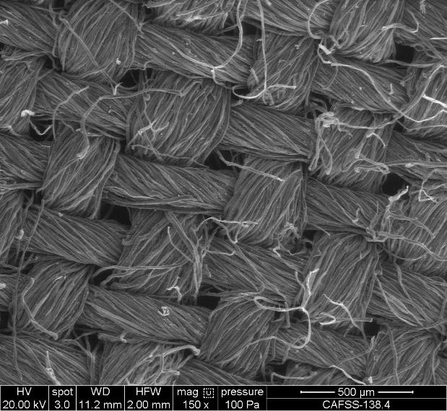

**Fig. S1.36: Secondary electron (SE) image of CAFSS_138.4 Soil particles and aggregates on surface and mainly between fibres (Image #138p4-AN_019).**

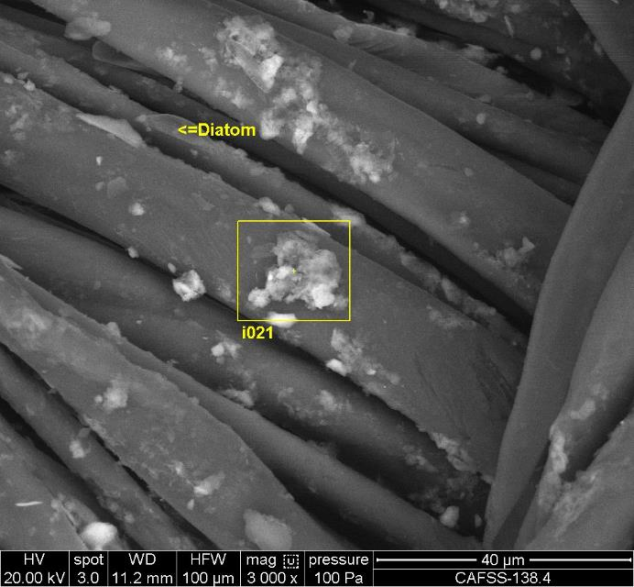

**Fig. S1.37: Back-scattered electron (BE) image of CAFSS_138.4 Soil particles and aggregates mainly on the surface of fibres (Image #138p4-AN_020).**

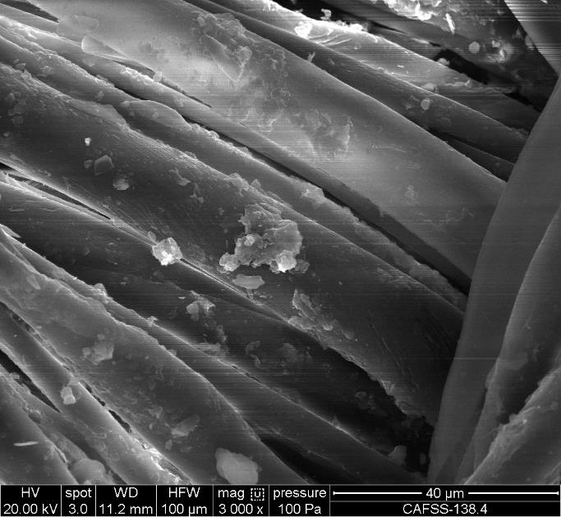

**Fig. S1.38: Secondary electron (SE) image of CAFSS_138.4 Soil particles and aggregates mainly on the surface of fibres (Image #138p4-SE_020).**

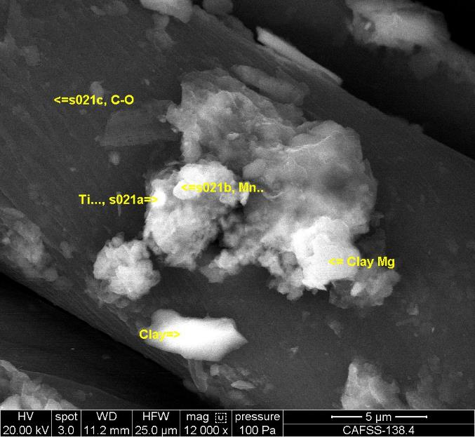

**Fig. S1.39: Back-scattered electron (BE) image of CAFSS_138.4 Soil particles and aggregates mainly on the surface of fibres (Image #138p4-AN_021).**

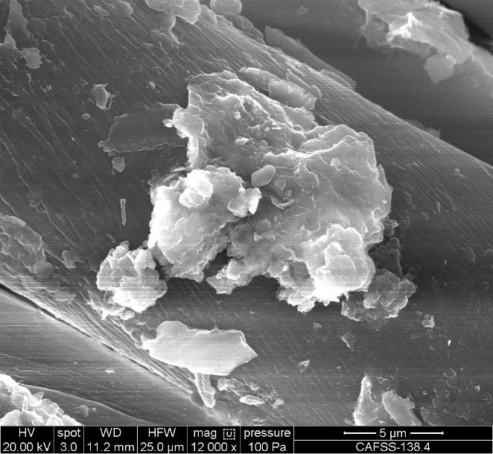

**Fig. S1.40: Secondary electron (SE) image of CAFSS_138.4 Soil particles and aggregates on surface of fibres (Image #138p4-SE_021).**

**CAFSS_138.5a Transference test mixing swatch (CAFSS_138.03) and control soil (CAFSS_138.16a)**

**Showing Soil particles and aggregates mainly on the surface of fibres**

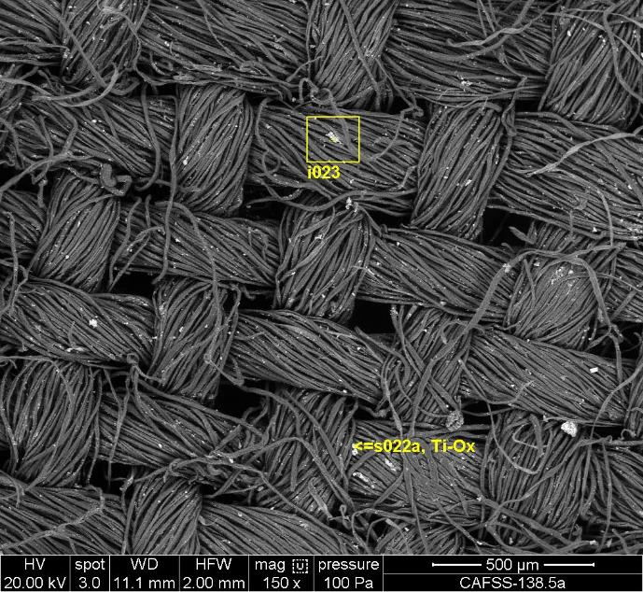

**Fig. S1.41: Back-scattered electron (BE) image of CAFSS_138.5a Soil particles and aggregates on surface and mainly between fibres (#138p): #138p4. #138p4-AN_022.**

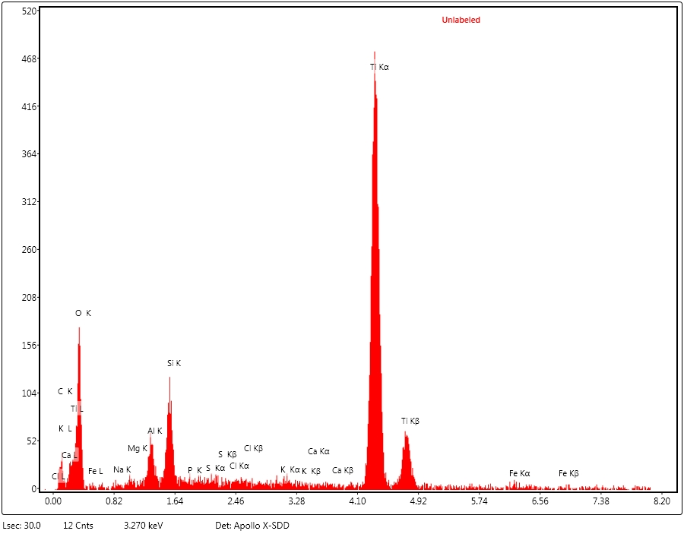

**Fig. S1.42: EDX spectra collected from region marked s022a in Figure A3.41 of CAFSS_138.5a Soil particles and aggregates mainly on the surface of fibres (Spectra #138p4-SP_022a), which Identifies rutile .**

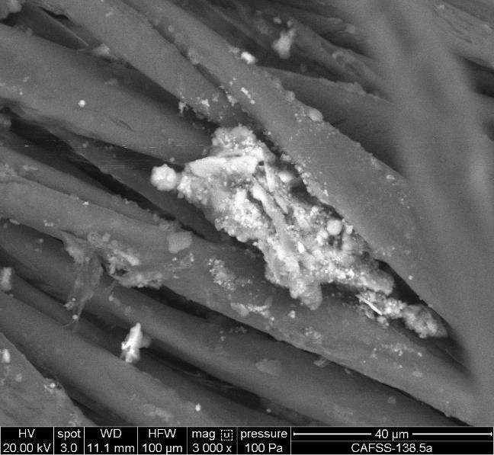

**Fig. S1.43: Back-scattered electron (BE) image of CAFSS_138.5a Soil particles and aggregates mainly on the surface of fibres (Image #138p4-AN_023).**

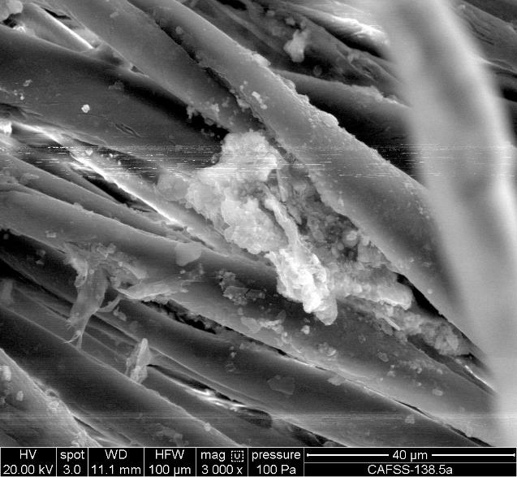

**Fig. S1.44: Secondary electron (SE) image of CAFSS_138.5a Soil particles and aggregates mainly on the surface of fibres (image #138p4-SE_023).**

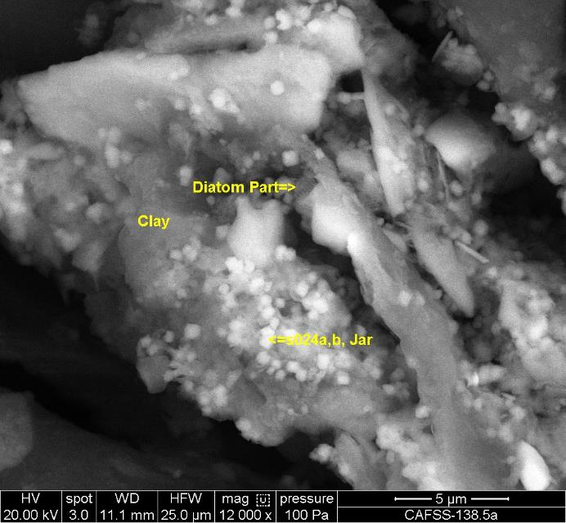

**Fig. S1.45: Back-scattered electron (BE) image of CAFSS_138.5a Soil particles and aggregates mainly on the surface of fibres (Image #138p4-AN_024)**

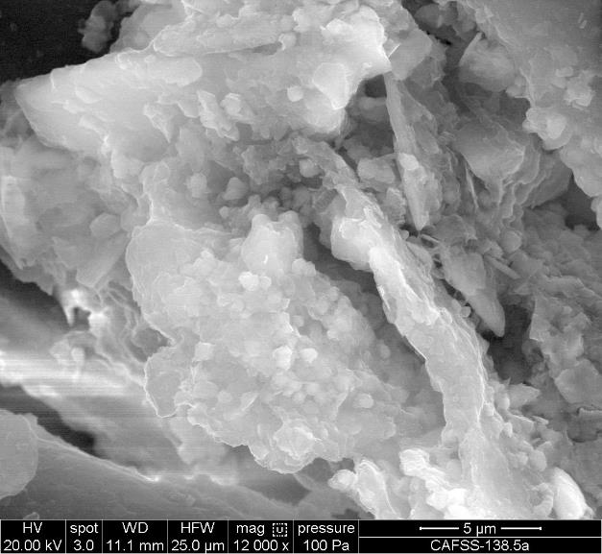

**Fig. S1.46: Secondary electron (SE) image of CAFSS_138.5a Soil particles and aggregates mainly on the surface of fibres (Image #138p4-SE_024).**

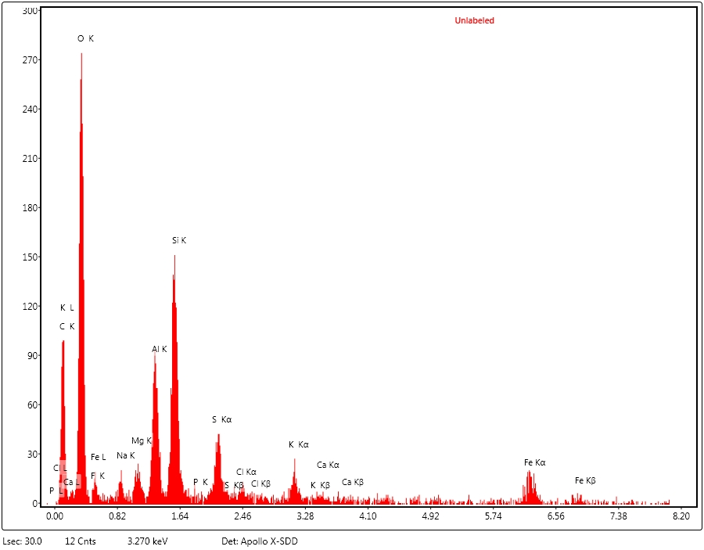



**Fig. S1.47: EDX spectra collected from region marked s024a in Figure S1.45 for CAFSS_138.5a Soil particles and aggregates mainly on the surface of fibres (Spectra #138p4-SP_024a), which identifies the mineral jarosite.**

**CAFSS_138.5b Transference test by mixing swatch (CAFSS_138.03) and control soil (CAFSS_138.19)**

**Showing Soil particles and aggregates on surface and mainly between fibre**

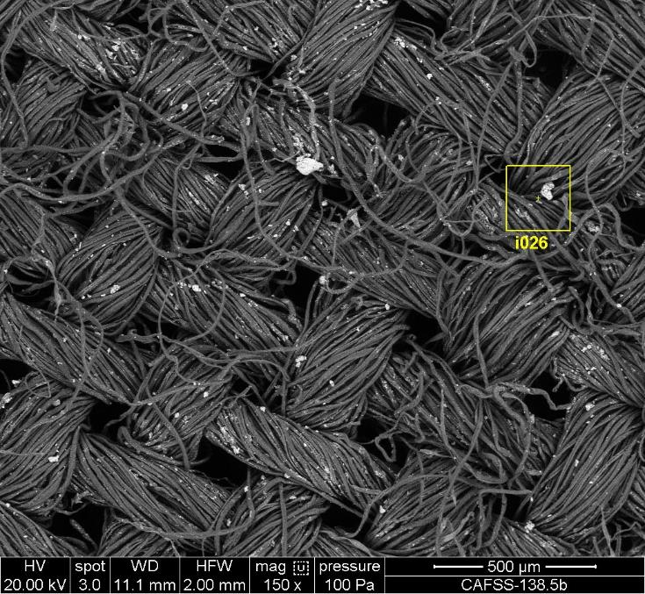

**Fig. S1.48: Back-scattered electron (BE) image of CAFSS_138.5b Soil particles and aggregates on the surface of fibres (Image #138p5b-AN_025).**

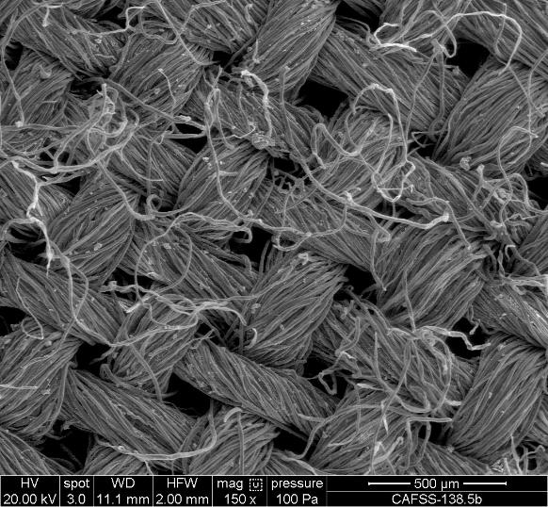

**Fig. S1.49: CAFSS_138.5b Soil particles and aggregates on the surface of fibres (Image #138p5b-SE_025).**

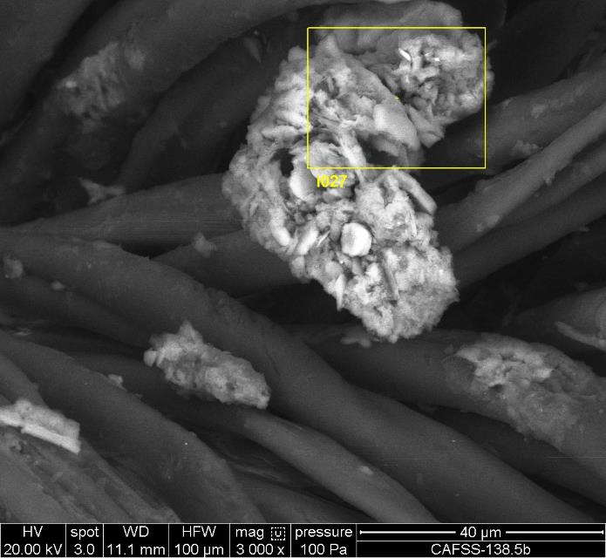

**Fig. S1.50: Back-scattered electron (BE) image of CAFSS_138.5b Soil particles and aggregates on the surface of fibres (Image #138p5b-AN_026).**

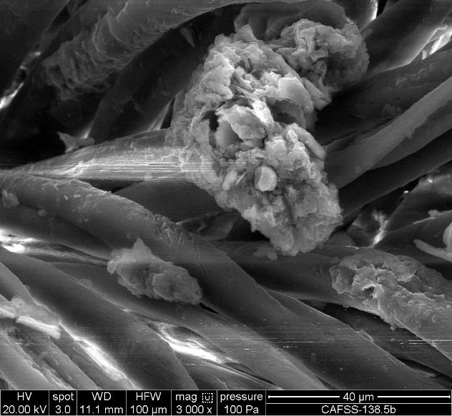

**Fig. S1.51: Secondary electron (SE) image of CAFSS_138.5b Soil particles and aggregates on the surface of fibres (Image #138p5b-SE_026).**

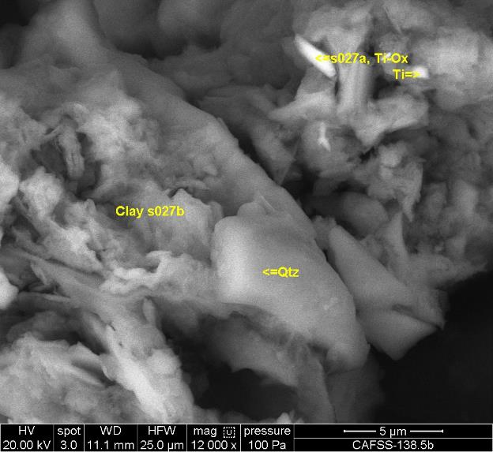

**Fig. S1.52: Back-scattered electron (BE) image of CAFSS_138.5b Soil particles and aggregates on surface and mainly between fibres (#138p): #138p5b; #138p5b-AN_027. Identification of quartz, rutile and clay (layer silicate) soil particles**

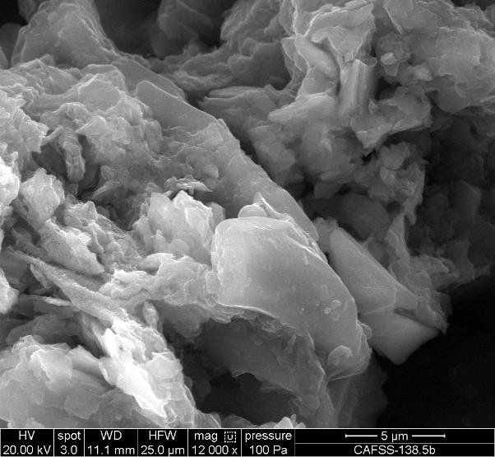

**Fig. S1.53: Secondary electron (SE) image of CAFSS_138.5b Soil particles and aggregates on surface and mainly between fibres (#138p): #138p5b; #138p5b-SE_027. Identification of quartz, rutile and clay (layer silicate) soil particles**

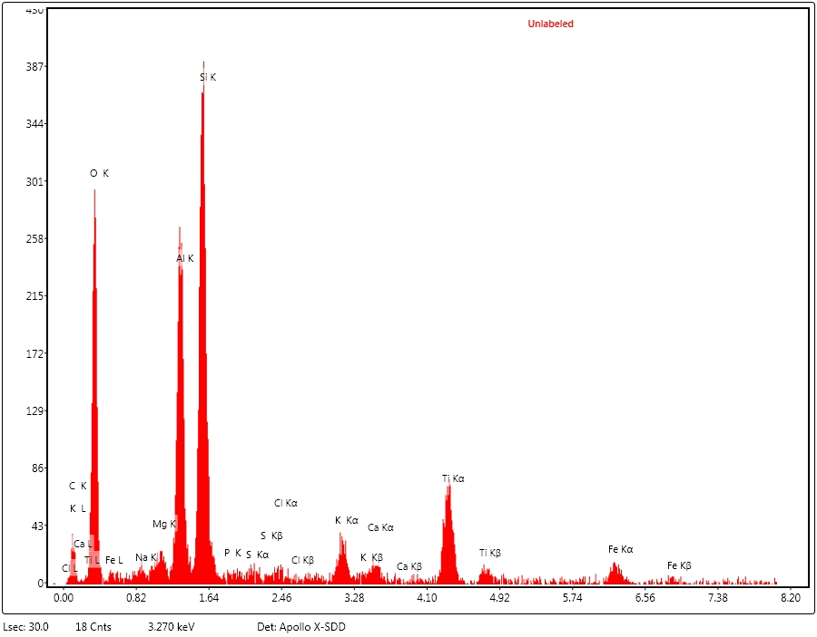

**Fig. S1.54: EDX spectra collected from region marked s027a in Figure S1.52 in CAFSS_138.5b Soil particles and aggregates on surface and mainly between fibres (#138p): #138p5b; #138p5b-SP_027a. Identification of rutile in layer silicates (Mica / illite)**

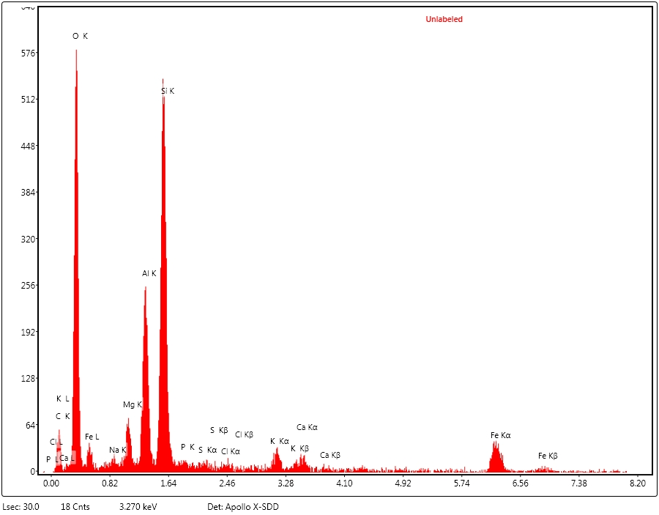

**Fig. S1.55: EDX spectra collected from region marked s027b in Figure S1.52 in CAFSS_138.5b Soil particles and aggregates on surface and mainly between fibres (#138p): #138p5b; #138p5b-SP_027b Identification of layer silicates (Mica / illite)**

**Supplementary Material S2: Mineralogical composition from synchrotron source X-ray diffraction analysis of two control samples transferred to a small swatch sub-sample from the pyjama top with no visual staining and one questioned sample**



**Fig. S2.1** XRD pattern of sample CAFSS_138.16b (=0.8254Å) transferred to a small swatch sub-sample from the pyjama top with no visual staining



**Fig. S2.2** XRD pattern of sample CAFSS_138.19 (=0.8254Å) transferred to a small swatch sub-sample from the pyjama top with no visual staining



**Fig. S2.3** XRD pattern of sample CAFSS_138.01 (=0.8254Å) on pyjama top