DATE: | Start: TIME End: |  | GRID ID |  |  | For Certification  ( Yes / No ) |  |  | Pass Certification  ( Yes / No )
RECORDER: CONTRACTOR:
Site #
Lat / Long
Location
Where Platform, channel bank, edge of mangroves, etc.
Hardness
Oil Type + %
Recent oil + %
Stumps %
Live Mangrove %: |  | Nypa %: |  |  | Live Mangrove %: |  |  | Nypa %:
Regeneration: Yes / No |  | Crabs: None/ Few / Many |  |  | Regeneration Yes / No |  |  | Crabs: None/ Few / Many
Plant ready: Yes / No |  | Periwinkles: None/ Few / Many |  |  | Plant ready: Yes / No |  |  | Periwinkles: None / Few /Many
SUBSURFACE OIL AP=Asphalt, BO=Black Oil, BR0+Brown Oil, NO=No Oil, SS=Silver or Rainbow sheen, TR=Trace.
Sketch pit |  |  |  |  | Oil type  % Oil:  Depth:
Oil type
% in pit
Depth: | -5  -15  -25 |  |  |  | -5  -15  -25
Cleanup  Method(s)  Phase 1 | Where? Channel, banks, platform, strand line?  Depth of most oiling? |  |  |  | Where? Channel, banks, platform, strand line?  Depth of most oiling?
Notes  Restrictions | Avoid live mangroves  PREVIOUS WORK OBSERVED ( Yes / No ) |  |  |  | Avoid live mangroves  PREVIOUS WORK OBSERVED ( Yes / No )
Phase 2
Actions

Chemistry | 0-5 cm 15-20 cm Regulator |  |  |  | 0-5 cm 15-20 cm Regulator
Signatories: | Name / Signature |  |  | Bodo Community:
SCAT Leader |  |  |  | Chemistry:
DPR: |  |  |  | SPDC:
NOSDRA: |  |  |  | Other(s):
RSMENV:

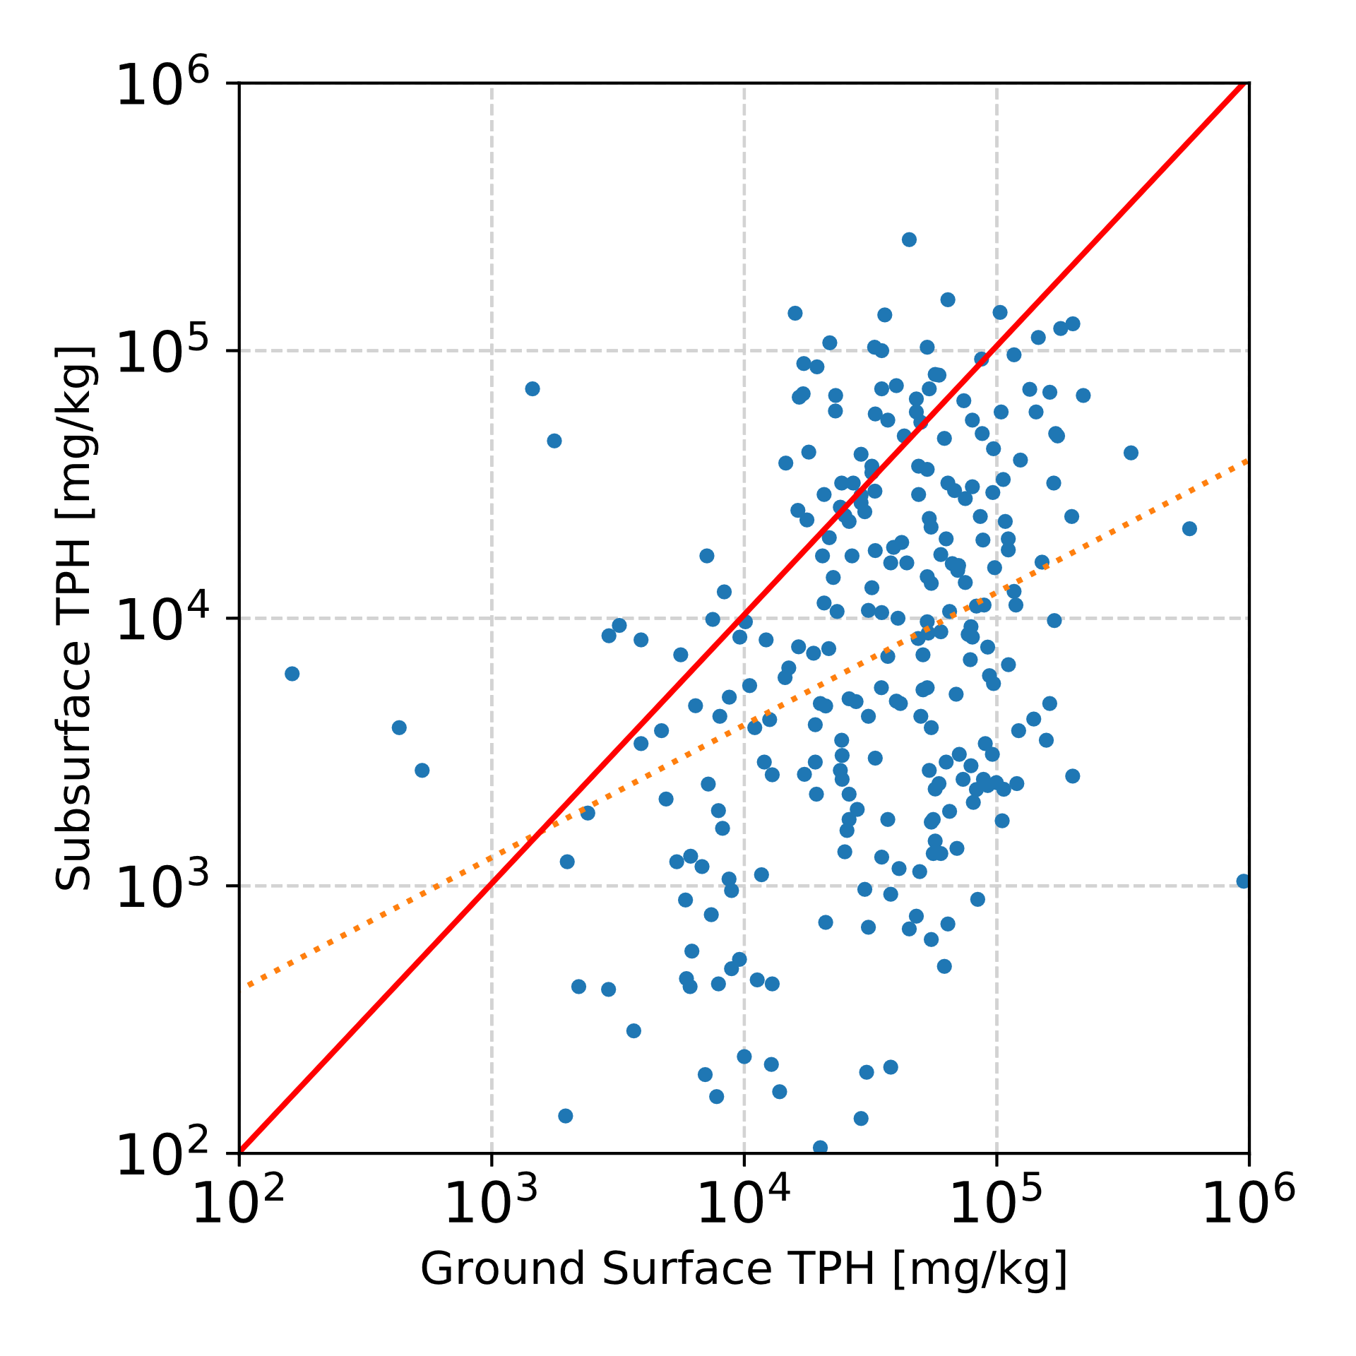
Figure SI-1 Subsurface TPH versus ground surface TPH. The solid red line represents a 1:1 line. The dashed red line is a linear regression line of Log transformed TPH values (R² =0.12).

Table SI-1 Statistic characteristics of TPH in sediment samples classified per SCAT pit oil observation class. Std: standard deviation, RSD: Relative standard deviation (100% x standard deviation / mean). The classification in this table corresponds to the Box plots shown in Figure 11 in the main paper.
 | None | Silver sheen | Brown oil | Black oil | Tar | Recent
Ground surface
count | 65 | 95 | 11 | 3 | 9 | 103
mean | 68200 | 45876 | 55700 | 21867 | 50333 | 73266
std | 70874 | 42563 | 43164 | 18051 | 39460 | 113141
RSD | 104% | 93% | 77% | 83% | 78% | 154%
min | 510 | 430 | 4900 | 3900 | 3900 | 162
25%-ile | 10000 | 19200 | 30000 | 12800 | 20700 | 21150
50%-ile | 38000 | 33000 | 35000 | 21700 | 40000 | 54000
75%-ile | 97000 | 59500 | 76000 | 30850 | 60000 | 87000
max | 320000 | 220000 | 140000 | 40000 | 121000 | 950000
Subsurface
count | 0 | 83 | 142 | 113 | 0 | 0
mean |  | 6085 | 22457 | 37479
std |  | 13310 | 31825 | 43204
RSD |  | 219% | 142% | 115%
min |  | 0 | 138 | 450
25%-ile |  | 535 | 2520 | 7200
50%-ile |  | 1870 | 9750 | 19800
75%-ile |  | 4300 | 29000 | 59000
max |  | 87000 | 184000 | 260000

Table SI-2 Statistic characteristics of TPH in sediment samples classified according to a proposed close-out criterion for Phase 2 under which SS plus BO ≤25%. SS indicates silver sheen, BO indicates black oil and BRO indicates brown oil. The classification in this table corresponds to the Box plots shown in Figure 12 in the main paper.
 | None | Silver sheen | SS or BO <=25% | BO/BRO >25% | Tar | Recent
Ground surface
count | 35 | 30 | 21 | 2 | 4 | 82
mean | 86493 | 33230 | 22009 | 17950 | 66725 | 65228
std | 76504 | 34544 | 24989 | 19870 | 55915 | 110532
RSD | 88% | 104% | 114% | 111% | 84% | 169%
min | 510 | 430 | 430 | 3900 | 3900 | 162
25%-ile | 17150 | 9425 | 6800 | 10925 | 27975 | 19175
50%-ile | 90000 | 23500 | 12900 | 17950 | 71000 | 52000
75%-ile | 137000 | 34500 | 31000 | 24975 | 109750 | 85500
max | 320000 | 143000 | 96000 | 32000 | 121000 | 950000
Subsurface
count | 0 | 46 | 112 | 48 | 0 | 0
mean |  | 5006 | 13282 | 28373
std |  | 13419 | 21665 | 32206
RSD |  | 268% | 163% | 114%
min |  | 0 | 0 | 920
25%-ile |  | 485 | 1195 | 7100
50%-ile |  | 1610 | 3800 | 17950
75%-ile |  | 3675 | 11025 | 36250
max |  | 87000 | 93000 | 184000

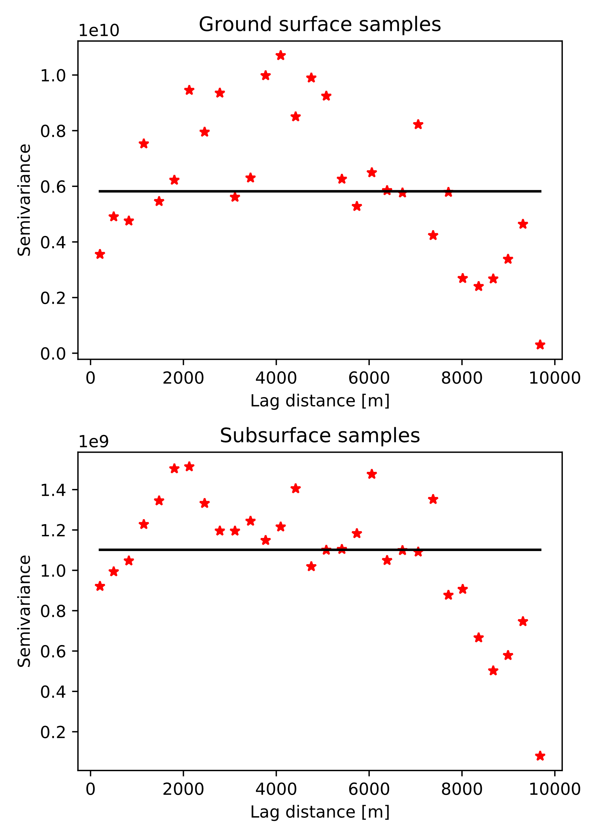
Figure SI-2 Variogram of TPH measured on the ground surface samples (top) and in the subsurface samples (bottom). The experimental data is shown with the red dots and the black line represents an exponential variogram model fitted to the data

Table SI-3 Results of 5 replicate SCAT oil in pit observations at a SCAT site. BO+BRO = Black Oil + Brown Oil. SS = Sheen
Site | Oil type | %Oil observed in Scat Pits |  |  |  |  | Average % oil coverage | Standard deviation (%) | Relative SD (%)
 |  | Pit 1 | Pit 2 | Pit 3 | Pit 4 | Pit 5
1-H10-1 | BO+BRO | 65 | 5 | 0 | 20 | 50 | 28 | 28 | 101%
1-I10-1 | BO+BRO | 50 | 25 | 20 | 70 | 50 | 43 | 20 | 48%
1-K10-1 | BO+BRO | 85 | 75 | 80 | 50 | 100 | 78 | 18 | 23%
1-L10-1 | BO+BRO | 80 | 98 | 80 | 70 | 60 | 77.6 | 14 | 18%
1-N10-1 | BO+BRO | 75 | 80 | 85 | 55 | 80 | 75 | 12 | 16%
2-F15-1 | BO+BRO | 65 | 60 | 5 | 65 | 9 | 40.8 | 31 | 76%
2-I15-1 | BO+BRO | 5 | 1 | 5 | 20 | 40 | 14.2 | 16 | 114%
2-L15-1 | SS | 80 | 98 | 99 | 95 | 95 | 93.4 | 8 | 8%
2-K15-1 | BO+BRO | 15 | 65 | 20 | 65 | 35 | 40 | 24 | 60%
3-H18-1 | BO+BRO | 95 | 90 | 98 | 60 | 50 | 78.6 | 22 | 28%
3-I18-1 | BO+BRO | 45 | 70 | 30 | 100 | 98 | 68.6 | 31 | 46%
3-K18-1 | BO+BRO | 20 | 50 | 40 | 30 | 75 | 43 | 21 | 49%
3-M18-1 | BO+BRO | 65 | 20 | 65 | 40 | 35 | 45 | 20 | 44%
4-E23-1 | BO+BRO | 70 | 80 | 85 | 90 | 90 | 83 | 8 | 10%
4-G23-1 | BO+BRO | 10 | 80 | 5 | 0 | 0 | 19 | 34 | 181%
4-L23-1 | BO+BRO | 1 | 5 | 70 | 5 | 1 | 16.4 | 30 | 183%
4-M23-1 | BO+BRO | 50 | 98 | 100 | 90 | 6 | 68.8 | 41 | 59%
4-P23-1 | BO+BRO | 90 | 40 | 2 | 10 | 65 | 41.4 | 37 | 89%
4-Q23-1 | BO+BRO | 80 | 60 | 75 | 65 | 6 | 57.2 | 30 | 52%
5-L26-1 | SS | 95 | 80 | 60 | 70 | 90 | 79 | 14 | 18%
5-M26-1 | BO+BRO | 2 | 2 | 1 | 35 | 10 | 10 | 14 | 144%
5-O26-1 | BO+BRO | 55 | 65 | 25 | 15 | 50 | 42 | 21 | 50%
5-R26-1 | BO+BRO | 0 | 5 | 2 | 0 | 20 | 5.4 | 8 | 156%
6-K30-1 | BO+BRO | 10 | 20 | 20 | 30 | 9 | 17.8 | 9 | 48%
6-O30-1 | SS | 80 | 99 | 90 | 95 | 80 | 88.8 | 9 | 10%
6-Q30-1 | BO+BRO | 98 | 90 | 100 | 98 | 90 | 95.2 | 5 | 5%
6-S30-1 | SS | 98 | 95 | 70 | 20 | 60 | 68.6 | 32 | 46%
6-V30-1 | SS | 95 | 60 | 20 | 20 | 40 | 47 | 32 | 67%
 |  |  |  |  |  | Average relative standard deviation |  |  |  | 62%
 |  |  |  |  |  | Minimum relative standard deviation |  |  |  | 5%
 |  |  |  |  |  | Maximum relative standard deviation |  |  |  | 183%

