Appendix 1 for

Middle-late Mesoproterozoic tectonic geography of the North Australia Craton: U–Pb and Hf isotopes of detrital zircons in the Beetaloo Sub-basin, Northern Territory, Australia
Bo Yang¹, Alan S. Collins¹, Morgan L. Blades¹, Nicholas Capogreco¹, Justin L. Payne^{1, 2}, Tim J. Munson³, Grant M. Cox¹
¹Centre for Tectonics, Resources and Exploration (TRaX), Department of Earth Sciences, The University of Adelaide, SA 5005, Australia.
²School of Natural and Built Environments, Mawson Lakes Campus, University of South Australia, SA 5095, Australia.
³NT Geological Survey, Department of Primary Industry and Resources, GPO Box 4550, Darwin NT 0801.
Sample description
- U-Pb dating samples
Three sandstone samples were selected for U–Pb analysis and the sample information is presented in Table 1. Detrital Zircon U–Pb discordance was calculated by dividing the ²⁰⁶Pb/²³⁸U age by the ²⁰⁷Pb/²⁰⁶Pb age and multiplying by 100. The ²⁰⁷Pb/²⁰⁶Pb ages are used and results were plotted using Excel add-in Isoplot (Ludwig 2003).
Table 1 Summary of detrital zircon U–Pb samples
Core drill | Coordinate | Sample | Depth (m) | Formation | concordant/total analyses | Lithology
Elliott-1 | E: 133.7551°  S:17.4025° | EN-Ky4 | 1021.5 | Kyalla Fm | 92/127 | fine-grained sandstone with interlaminated siltstone/shale
 |  | EN-Mo8 | 1367.3 | Moroak Sst. | 59/113 | quartz-granule-  rich medium to coarse-grained sandstone
Jamison-1 | E: 133.7672°  S: 16.7749° | JN-Ky6 | 1587.0 | Kyalla Fm | 36/57 | fine-grained sandstone

Kyalla Formation (EN-Ky4)
One hundred and sixteen zircons were analysed from EN-Ky4 and of these, ninety one are within 10% of concordance. These zircons range in Pb²⁰⁷/Pb²⁰⁶ age from 2991 Ma to 1517 Ma. A major peak is identified on the kernel density plot at 1727 Ma, with majority of the analyses sitting between 2073–1571 Ma. Minor peaks are seen at 1781 and 1622 Ma. The youngest near concordant grain within EN-Ky4 is 1517 ± 58 Ma.

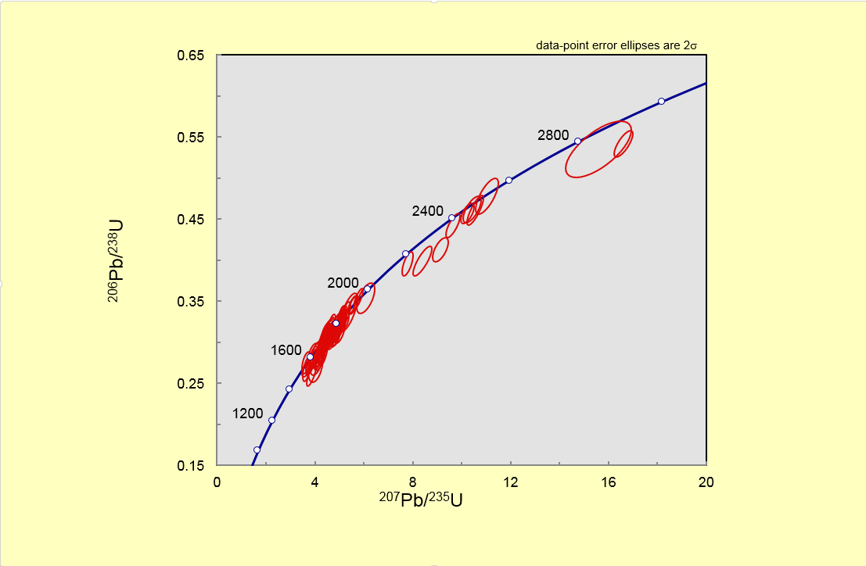
Fig 1 Detrital zircon U–Pb Wetherill concordia plot of sample EN-Ky4

Moroak Sandstone (EN-Mo8)
One hundred and thirteen zircons were analysed. Of these seventy seven are within 10% of concordance and have a range of Pb²⁰⁷/Pb²⁰⁶ ages between 3073–1502 Ma. The kernel density plot highlights one major peak at 1697 Ma, with majority of the data sitting between 1823–1502 Ma. A minor peak is seen at 1561 Ma, with one solitary grain at 3073 ± 26 Ma. The youngest analysis yielded a Pb²⁰⁷/Pb²⁰⁶ age of 1502 Ma ± 75 Ma.
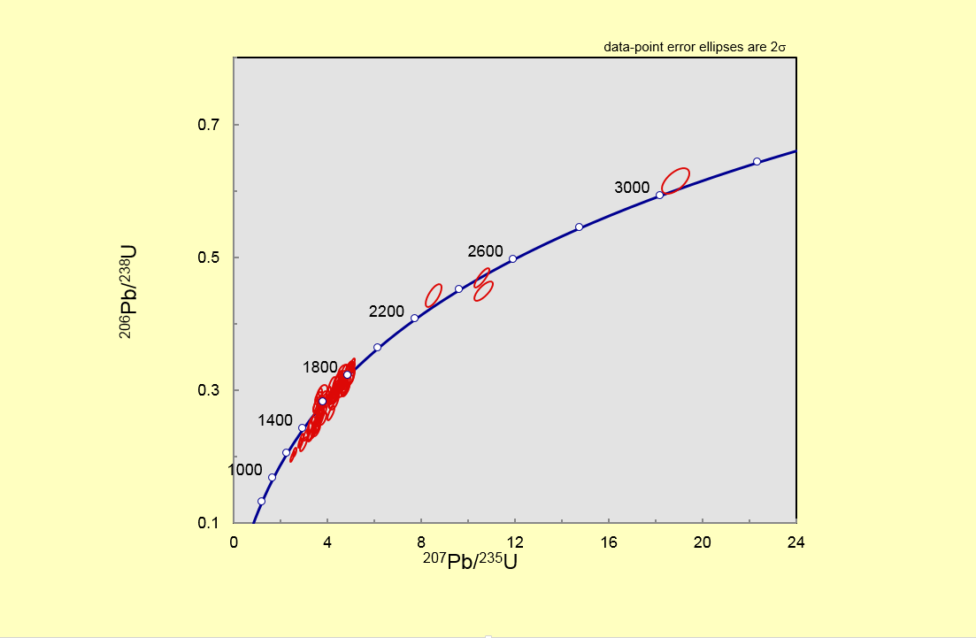
Fig 2 Detrital zircon U–Pb Wetherill concordia plot of sample EN-Mo8

Kyalla Formation (JN-Ky6)
Thirty six, less than 10% discordant analyses (n=57), yielded Pb²⁰⁷/Pb²⁰⁶ ages between 1883 and 1360 Ma. A majority of the data sit between 1794–1647 Ma, with a dominated peak and a minor peak highlighted in the kernel density estimates at 1723 Ma and 1795 Ma, respectively. The youngest grain analysed in this sample yielded a Pb²⁰⁷/Pb²⁰⁶ age of 1360 ± 47 Ma.

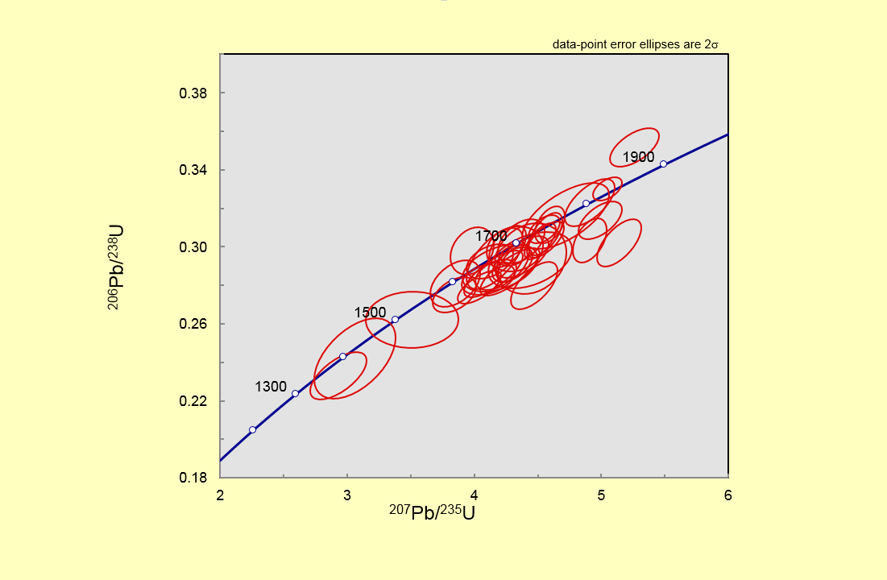
Fig 3 Detrital zircon U-Pb Wetherill concordia plot of sample JN-Ky6

- Lu–Hf isotope sample
Detrital zircon hafnium data were collected from fourteen samples that previously published by Yang et al. (2018). Individual zircon initial ¹⁷⁶Hf/¹⁷⁷Hf value (¹⁷⁶Hf/¹⁷⁷Hf_{i}) and epsilon hafnium (ε_{Hf}(t)) was calculated and plotted according to the published age. Detailed sample information is presented in Table 2.
Table 2 Summary of detrital zircon Lu–Hf samples
Core drill | Coordinate | Sample | Formation | Number of analyses | Rock type
Elliott-1 | E: 133.7551°  S:17.4025° | E-LJ2 | lower Jamison sst. | 13 | coarse-grained sandstone
 |  | E-Ky7 | Kyalla Fm | 24 | medium-grained sandstone
 |  | E-Mo13 | Moroak Sst. | 15 | coarse-grained sandstone
 |  | E-Vel18 | Velkerri Fm. | 17 | fine-grained siltstone
Jamison-1 | E: 133.7672°  S: 16.7749° | J-UJ3 | upper Jamison sst. | 16 | coarse-grained sandstone
 |  | J-Ky8 | Kyalla Fm | 16 | fine to medium- grained sandstone
 |  | J-Mo13 | Moroak Sst. | 16 | coarse-grained sandstone
Walton-2 | E: 133.6388°  S: 15.9051° | W-UJ9 | upper Jamison sst. | 16 | coarse-grained sandstone
 |  | W-BC1 | Bessie Creek Sst. | 15 | coarse-grained sandstone
McManus-1 | E: 133.6242°  S: 15.919° | M-LJ3 | lower Jamison sst. | 11 | coarse-grained sandstone
Altree-2 | E: 133.786592°  S:15.923645° | A-UJ1 | upper Jamison sst. | 15 | coarse-grained sandstone
 |  | A-BC13 | Bessie Creek Sst. | 12 | coarse-grained sandstone
Sever-1 | E: 132.843963° S:15.24646° | S-BC1 | Bessie Creek Sst. | 19 | coarse-grained sandstone
Birdum Creek-1 | E: 133.1395°  S: 15.625° | BirC-Ky1 | Kyalla Fm | 16 | fine to medium- grained siltstone

References
Ludwig, K.R. (2003). User's manual for Isoplot 3.00: a geochronological toolkit for Microsoft Excel (No. 4). Kenneth R. Ludwig.

Yang, B., Smith, T.M., Collins, A.S., Munson, T.J., Schoemaker, B., Nicholls, D., Cox, G., Farkas, J. & Glorie, S. (2018). Spatial and temporal detrital zircon U–Pb provenance of the hydrocarbon-bearing upper Roper Group, Beetaloo Sub-Basin, Northern Territory, Australia. Precambrian Research, 304, 140-155.

