Mineral chemistry information

The main compositional features of plagioclase and K-feldspar from the studied trondhjemitic and granitic rocks are schematically reported in Fig. S1.
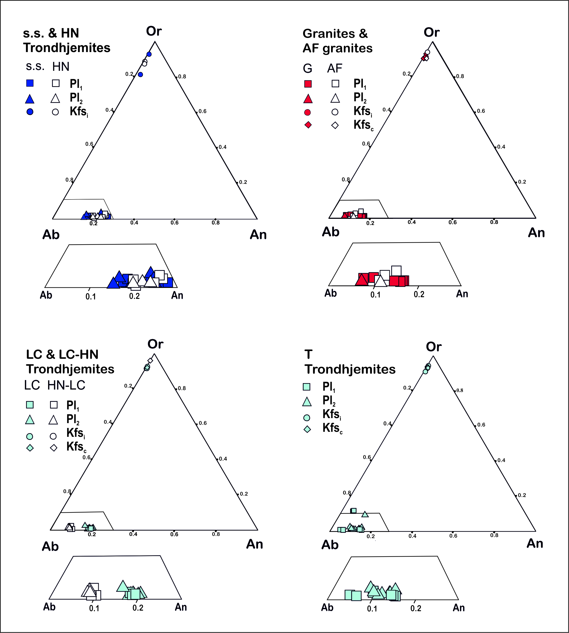
Fig. S1. Feldspar compositions for the studied granitoid rocks. Pl1: plagioclase with magmatic features;
Pl2: plagioclase with secondary features; Kfsi: K-feldspar island in Pl2; Kfsc: individual K-feldspar crystal.

Plagioclase is oligoclase in either the s.s. and HN trondhjemites, with a slight tendency of secondary plagioclase (Pl₂) to have more albitic compositions than plagioclase with magmatic features (Pl₁).
Single spot and averaged multipoint analyses for plagioclase inner core, outer core and rim portions indicate An_{16.8-26.6} and An_{18.8-20.1} for Pl₁ crystals of s.s. and HN trondhjemites, respectively, and An_{14.9-24.1} and An_{19.2-23} for the corresponding Pl₂ crystals. Compositions reflect a dominant weak oscillatory zoning and rare normal zoning for both Pl₁ and Pl₂ crystals; compositional variations rarely reach 5-6 % An in single crystals of trondhjemites s.s., while variations up to 12-13 % An have been recorded in some crystals of HN trondhjemites. K-feldspar compositions are in the range Or_{81.7-92.9}.
Plagioclase from LC trondhjemites is mostly oligoclase, with averaged An_{17.3-18.7} in Pl₁ crystals and An_{15.2-19.9} in Pl₂ crystals, with some albitic compositions occurring among the latter types; plagioclase from HN-LC is albite, with nearly identical average compositions in Pl₁ (An_{8.5-9.9}) and Pl₂ (An_{7.7-8.2}) and only three spots (two Pl₁ and one Pl₂) having An_{10.2-11.4} (Fig. 5). K-feldspar has composition Or_{91.6-92.6} and Or_{91.7-95.8} in LC and HN-LC trondhjemites, respectively, with no systematic variation between crystals internal or external to plagioclase.
Plagioclase composition is mostly oligoclase in the T trondhjemites, with X_{An} up to 14.7 and 14.1 in Pl₁ and Pl₂ types, respectively; a few albitic compositions also occur, with lowest values of An_{4.3} in Pl₁ and An_{8.3} in Pl₂ crystals. String and patch perthite plagioclase also has a rather constant albitic composition, with average values of An_{2.43}. Some unusually Or-rich compositions, with X_{Or} around 10 have been reported by Stella (2010); it is however to be reported that feldspars affected by fluid interaction can contain sub-micron inclusions of sericite, that can lead to overestimation of the K content of plagioclase (e.g. Plumper & Putnis, 2009). K-feldspar is in the range Or_{91.3-94.3}, with no variation between crystals in different textural relationships with plagioclase.
Granites have Pl₁ crystals characterized by normal zoning and dominant oligoclase composition (An_{14.2-16.4}); a few albite compositions of An_{9.2} and An_{7.0} have been measured in outer core and rim portions, respectively. Albite compositions (An_{7.0}) have been also obtained for Pl₂ in myrmekites, as well as for string and patch perthites, with average An contents in the range 2.59-4.63 and 2.59-3.35, respectively. K-felsdpar composition (Or_{90.7-93.3}) is nearly the same in either island and large individual crystals.
Finally, in the alkali feldspar granites Pl₁ displays oscillatory zoning in the range An_{10.8-13.}, while myrmekitic plagioclase has an average composition of An_{11.4} that, however, results from an average of only two, quite distant values of An_{5.1} and An_{17.6}; string and patch perthites have average similar average An contents, with average compositions of An_{3.6}Ab_{90.8}Or_{5.7} and An_{3.5}Ab_{94.5}Or_{2.1}, respectively. K-feldspar island inclusions in plagioclase have a slightly higher average Or content (Or_{94.4}) than K-feldspar in individual crystals (Or_{90.7}) but, on the whole, the compositions of all feldspar types overlap with those observed for the granites s.s..

