Supporting Information

Kinetics of selenite removal by Boom Clay - adsorption-reduction interplay

Alwina L. Hoving a,*, Melanie A. Münch a, Christophe Bruggemanb, Dipanjan Banerjee c and Thilo Behrends a

a *Department of Earth Sciences - Geochemistry, Faculty of Geosciences, Utrecht University, Princetonplein 9, 3584 CC Utrecht, The Netherlands*

b *Waste & Disposal Expert Group, Unit R&D Disposal, Belgian Nuclear Research Centre (SCK•CEN), Boeretang 200, B‑2400, Mol, Belgium*

*c Dutch-Belgian Beamline (DUBBLE), ESRF-The European Synchrotron, CS 40220, 38043 Grenoble, France Dutch-Belgian Beamline (DUBBLE), ESRF-The European Synchrotron, CS 40220, 38043 Grenoble, France*

*To whom correspondence should be addressed

Email: [A.L.Hoving@uu.nl](mailto:A.L.Hoving@uu.nl)

This Supporting Information covers 12 pages, including 9 figures and 4 tables.

**S.1 X-ray diffractogram of Clay, Silt and Total of Boom Clay sediment**



*Figure S.1 X-ray diffractograms of the clay and silt fractions and total sample of Boom Clay core III (103-ST5, slice 12-22) used for the 150 μM SeO32- batch experiment. Only the main peaks of the different minerals are indicated. Chl =chlorite, Mica = illite/muscovite, I-S = interstratified illite-smectite, K= kaolinite, Qtz= quartz, Fsp = feldspars, P= pyrite, Glauc = glauconite, C = calcite. The diffractograms were horizontally shifted to facilitate comparison.*

**S.2 Particle size distributions of Clay, Silt and Total of Boom Clay sediment**



*Figure S.2. Particle size distribution of the clay and silt fraction and total sample of the three different core slices I, II and III.*

**S.3 Scanning Electron Microscopy images of Clay, Silt and Total of Boom Clay sediment**





*Figure S.3 Scanning Electron Microscopy images (backscatter electrons) of C150, S150 and T150. Top: two micrographs of C150 showing the presence of platy clay minerals and a few white spot which are pyrite micro‑crystallites. Bottom: From left to right, C150 with large aggregates of clay minerals, S150 with large quartz and mica grains, clay aggregates and pyrite framboids, and T150 with large quartz grains, clay aggregates and pyrite framboids.*

**S.4 XANES and EXAFS**

### S.4.1 Standards

The red Se0 was synthesized by reducing dissolved SeO32- with ascorbic acid. The red precipitate that formed was immediately filtered in the glovebox (0.2µm) and stored under anoxic conditions in a freezer. The grey Se0 (Se0grey) was obtained by aging red Se0 at elevated temperatures (in crimp flask sealed in PETP/Al/PE-bag for anoxic conditions; oven at 50oC). FeSe and Na2SeO3.5H2O were obtained from Sigma-Aldrich and the FeSe2 sample originated from Temple MTN, Utah, USA (Smithsonian).

**S.4.2 Collection of XANES and EXAFS spectra**

The energy calibration was performed by assigning an energy of 13035 eV to the steepest part of the Pb‑LIII‑edge. Details about the design of the beamline are described in Nikitenko *et al.* (2008) and Borsboom *et al.* (1998). The Athena software package (Ravel & Newville 2005) was used for merging and normalising the spectra, removing the background for analyzing the extended x‑ray fine structures (EXAFS), and performing linear combination fitting. For the fitting of EXAFS spectra the program Artemis was used (Ravel & Newville 2005).

**S.4.3 Fitting EXAFS spectra**

Component analysis indicated that the Se EXAFS spectra collected from the various samples can be reproduced by combining the EXAFS spectra of the reference materials red Se0 and SeIV adsorbed onto montmorillonite. To illustrate the underlying change in Se coordination, representative EXAFS spectra were further analysed by shell fitting. The software Artemis (Ravel et al., 2005) was used for fitting. Fitting was done by simultaneously optimising the fit of the k, k2, and k3 weighted EXAFS spectra in the k-range 3 – 10 Å-1 using a Hanning window with a dk of 3.

The results from the shell fitting demonstrate that the main features of the measured spectra can be explained by SeIV which is threefold coordinated to oxygen and Se0 which is bound in a Se8 ring, respectively (Fig. S.3). For the adsorbed SeIV, the optimized Se-O distance (Table S.1) is not significantly different from that reported in previous studies using EXAFS to explore selenite adsorption onto montmorillonite (Peak *et al.* 2006) . Due to the relatively low quality of the EXAFS spectra, no further attempts were done to analyse the adsorption complex in more detail in view of the involved metal center(s) in the clay mineral structure as well as the geometry of the adsorbate complex.

Amorphous Se0 as well as the α‑Se0 and β‑Se0 form of monoclinic Se0 consists of Se8 rings which are arranged in different ways. The EXAFS spectrum of Se in samples after 30 d reaction with total Boom Clay can be reproduced by including the neighbouring Se atoms and the Se atoms after the next Se in the S8 rings. The optimized distances are in agreement to those reported for the structure of α‑monoclinic Se0  (Cherin and Unger, 1972). The distance to Se atoms in possibly surrounding other Se8 rings is too far to be unraveled based on EXAFS fitting. Hence, the EXAFS fitting indicates that after reaction with Boom Clay, SeIV is in the form of Se0 which is bound in Se8 rings. However, the fitting does not allow to identify the mineral structure of Se0 or to evaluate whether the precipitated Se0 is amorphous.



*Fig S.4. EXAFS spectra of Se from sample T150 after 30 d reaction (top) and SeIV adsorbed onto montmorillonite (bottom). The right figure shows the k2 weighted EXAFS spectra and the middle and right figures show the envelop and real part after Fourier transformation, respectively. The black lines are the results from fitting the EXAFS spectra. The blue lines represent the contribution of the X-ray scattering by the first shell of atoms surrounding Se, which has been obtained from the fitting. For the sample T150 after 30d reaction these are Se atoms at a distance of 2.37 ± 0.01 Å (CN = 2,* σ *2 = 0.0006 ± 0.00035) and for adsorbed SeIV oxygen atoms at a distance of 1.70 ± 0.01 Å (CN = 3,* σ *2 = 0.0012 ± 0.002)*

Table S.1. Results from shell fitting of the EXAFS spectra.

|  |  |  |  |  |
| --- | --- | --- | --- | --- |
| Sample / Path | ∆E0 [eV] | Na | Rfit [Å] | σ2 [10-3 Å2] |
| T150 after 30d reaction | | | | |
| Se→Se1 | 12.6 ± 4 | 2 | 2.37 ± 0.04 | 0.6 ± 0.35 |
| Se→Se2 | 12.6 ± 4 | 2 | 3.67 ± 0.03 | 5.5 ± 0.30 |
| SeIV adsorbed onto montmorillonite | | | | |
| Se→O1 | 14.5 ± 0.5 | 3 | 1.70 ± 0.01 | 1.2 ± 2.0 |

a The coordination numbers (degeneracy) of the paths were fixed

### S.4.4 Iterative Target test Factor Analysis (ITFA) on XANES and EXAFS

As an alternative approach to identify and quantify different Se species in the spectra, Iterative Target Test **(**ITT) analysis was performed, which is part of the ITFA software (Roßberg *et al.* 2003). For obtaining these results, all XANES spectra collected from 35 samples were complemented with spectra from reference materials, SeIVadsorbed to montmorillonite, FeSe, FeSe2, Se0grey, Se0red, Na2SeO3.5H2O and Na2SeO4. Depending on the loading of the vectors after the varimax rotation, reference spectra, which were related to vectors with low loading on the spectra from the experiments, were stepwise removed until only two spectra of reference materials remained. The spectra of the data set with all sample spectra plus the remaining reference spectra could be very well reproduced using two components. The two extracted components by ITT analysis can be assigned to Se0red and SeIVads (Fig.S.4).



*Figure S.5. Selenium K-edge XANES spectra of component 1 and component 2 extracted by ITFA analysis in comparison with the normalized spectra from standards Se0red and SeIVadsorbed-clay.*

**Table S.2** *Selenium speciation obtained by linear combination fitting of XANES and EXAFS data, using Se0red and SeO3ads-clay as standards, and the relative amounts of component 1 and 2 obtained by iterative target test factor analysis (ITFA).*

|  |  |  |  |  |  |  |  |  |  |
| --- | --- | --- | --- | --- | --- | --- | --- | --- | --- |
|  | **LCF** | | | | | | **ITFA** | | |
|  | EXAFS | XANES | EXAFS | XANES | R2 | R2 | XANES | | |
|  | **Se_red_pellet** | **Se_red_pellet** | **SeO3_ads** | **SeO3ads** | **EXAFS** | **XANES** | **Comp1** | **Comp2** |  |
| C150_8h | 0.635 | 0.565 | 0.365 | 0.435 | 0.618 | 0.995 | 0.646 | 0.354 |  |
| C150_1d | 0.719 | 0.644 | 0.267 | 0.356 | 0.86 | 0.994 | 0.665 | 0.335 |  |
| C150_3d | 0.910 | 0.847 | 0.124 | 0.153 | 0.146 | 0.995 | 0.836 | 0.164 |  |
| C150_30d | 1.000 | 0.914 | 0.000 | 0.086 | 0.791 | 0.972 | 1 | 0 |  |
|  |  |  |  |  |  |  |  |  |  |
| S150_8h | 1.000 | 0.783 | 0.085 | 0.217 | 0.595 | 0.977 | 0.847 | 0.153 |  |
| S150_1d | 0.898 | 0.841 | 0.102 | 0.159 | 0.664 | 0.986 | 0.890 | 0.110 |  |
| S150_3d | 0.951 | 0.88 | 0.039 | 0.12 | 0.740 | 0.989 | 0.954 | 0.046 |  |
| S150_30d | 1.000 | 0.99 | 0.000 | 0.01 | 0.488 | 0.990 | 0.977 | 0.023 |  |
|  |  |  |  |  |  |  |  |  |  |
| T150_8h | 0.730 | 0.639 | 0.270 | 0.361 | 0.405 | 0.994 | 0.658 | 0.343 |  |
| T150_1d | 0.758 | 0.669 | 0.242 | 0.331 | 0.599 | 0.996 | 0.688 | 0.312 |  |
| T150_3d | 0.866 | 0.828 | 0.134 | 0.172 | 0.702 | 0.995 | 0.797 | 0.203 |  |
| T150_30d | 1.000 | 0.991 | 0.000 | 0.009 | 0.391 | 0.992 | 0.957 | 0.043 |  |

**Table S.3.** *SeIV and Se0 concentrations (Se/Setot) on Boom Clay samples Total, Silt and Clay at three timesteps. For each sample its Al content and pyrite content is listed.*

|  |  |  |  |  |  |
| --- | --- | --- | --- | --- | --- |
|  |  | Setot 125 μM | Setot 150 μM | Setot 125 μM | Setot 150 μM |
|  | **Time (h)** | **SeIV| Se0 (*Se/Setot*)** | **SeIV| Se0 (*Se/Setot*)** | **Al | pyr**  ***(g/L)*** | **Al | pyr**  ***(g/L)*** |
| **Total** | 24 | 0.069 | 0.27 | 0.094 | 0.21 | 3.15 | 0.58 | 3.34 | 1.48 |
|  | 72 | 0.061 | 0.46 | 0.080 | 0.43 |  |  |
|  | 720 | 0.007 | 0.99 | 0.008 | 0.99 |  |  |
| **Silt** | 24 | 0.040 | 0.084 | 0.049 | 0.33 | 1.72 | 0.40 | 3.23 | 1.06 |
|  | 72 | 0.039 | 0.19 | 0.061 | 0.57 |  |  |
|  | 720 | 0.015 | 0.96 | 0.000 | 0.99 |  |  |
| **Clay** | 24 |  | 0.185 | 0.38 |  | 4.89 | 0.38 |
|  | 72 |  | 0.125 | 0.75 |  |  |
|  | 720 |  | 0.005 | 0.99 |  |  |

### S.5 Kd values for SeIV in BC per clay mineral content



Figure S.6. *Kd values for SeIV in experiments with samples S125, T125, C150, S150 and T150 as a function of reaction time.* *Kd is calculated in mL/g clay mineral. The amount of clay minerals was based on Al content and particle size measurements.* *Error bars represent propagated errors from duplicate measurements of Se concentrations and errors arising from fitting Se speciation from XANES/EXAFS spectra.*

### S.6 Input parameters for kinetic model

### S.6.1 Integrated equations for fitting data of Se sorption on pyrite and clay minerals

To fit the curves of Se sorbed to clay minerals and pyrite, obtained from literature (Fig. 6), Eq 2. and Eq.3 were integrated. For Eq. 2 this resulted in:

With k1 representing the rate constant of the forward reaction (h-1 L m-2), A the reactive surface area of the clay minerals per volume of solution (m2/L), t is time (h), and Seads-eq the Se concentration of adsorbed Se on the clay in equilibrium (mol/g). The equation for Keq is:

$$K_{eq}=\frac{{Se}_{ads|eq}}{{Se}_{aq|eq}}=\frac{k_{1 }A}{k_{-1}}$$

Integrating the rate equation for pyrite, Eq. 3, gives:

${Se}_{pyr}^{0}={{Se}_{tot}- {Se}_{tot} e}^{-k_{2} At }$

Where Setot (mol/g) is the total amount of Se in the system and Se0pyr(mol/g) is the concentration of Se associated, sorbed or reduced, to pyrite. k2(L h-1 m-2) represents the rate constant, t (h) is time and A (m2/L) is the reactive surface area of pyrite per volume of solution (m2/L).

**S.6.2 Input parameters for kinetic model Se in Boom Clay**

**Table S.4**: *Input parameters for modeling SeIV sorption and reduction by Boom Clay and its clay and silt fractions*

|  |  |  |  |  |
| --- | --- | --- | --- | --- |
| **Sample** |  | **ESA\***  **(m2/L)** | **Pyrite\*\***  **(g/L)** | **Surface area pyrite\*\*\***  **(m2/g)** |
| Total | T150 | 171 | 1.48 | 4 |
|  | T125 | 182 | 0.58 | 4 |
|  | T50 | 162 | 0.71 | 4 |
| Silt | S150 | 224 | 1.06 | 2.3 |
|  | S125 | 134 | 0.40 | 2.3 |
|  | S50 | 128 | 0.94 | 2.3 |
| Clay | C150 | 502 | 0.38 | 4 |
|  | C50 | 438 | 0.28 | 4 |

*\*The edge surface area (ESA) of these samples is calculated based on the measured Al content, the percentage of particles <8 μm present, the structural formula of Boom Clay (1 mol BC: 1.45 mol Al* (Zeelmaekers *et al.* 2015)*), and the ESA of different clay minerals from literature assuming 17% illite, 73% smectite and 10% kaolinite (10.7 m2/g clay minerals).  
** Pyrite content based on results FeHNO3 from the Fe sequential extraction.  
*** The surface area of pyrite was estimated based on grain size information from SEM imaging and literature results relating grain size, pyrite shape and surface area.*

**S.7 Kinetic model: Rate constants of selenite sorption to clay mineral standards and to pyrite minerals**

To model selenite sorption onto BC, an iterative numerical (Euler) scheme using Eq.1, Eq.2 and Eq.3 was applied as described in section 2.3 in the main text of the article. To evaluate the fitted rate constants we compared them to rate constants from experiments with selenite and individual clay minerals and pyrite. These were not directly available from literature, but could be obtained by fitting literature data from SeIV experiments with clay minerals and with pyrite using integrated versions of Eq. 1 and Eq. 2 (SI, S.6), respectively (clay minerals: Bar-Yosef & Meek 1987; Bruggeman 2006; Missana *et al.* 2009 and pyrite: Bruggeman *et al.* 2005; Kang *et al.* 2011). These data and their modeled fits are shown in Fig. S.7 and the rate constants obtained are listed in Table 1 of the main text. The k1‑values vary between 0.00009 and 0.029 h-1 L m-2. The large range could be caused by the fact that the specific surface area is unknown and is now based on an estimated edge surface area. The k-1 range between 0.02 and 1.26 h‑1 and Kd‑values were between 105 and 215 mL/g for illite and smectite, 285 mL/g for kaolinite and 39 mL/g for the chemically‑reduced smectite. The latter is much lower compared to that of its oxidized counterpart, which has a Kd of 195 mL/g. Studies have shown that, upon reduction, the properties of clay minerals, such as surface area and CEC, can change dramatically (Stucki *et al.* 1984; Kostka *et al.* 1999). In reduced clay minerals, a lower specific surface area and a higher surface charge density were observed which may explain the observed lower affinity of the SeIV anion to the reduced clay minerals. Also the adsorption of SeIV on reduced smectite was slower compared to the adsorption on the oxidized smectite. The amount of adsorbed SeIV, extracted using a phosphate solution, was much lower on the reduced smectite than on the oxidized smectite which may suggest that part of the solid-bound Se became reduced (SI, Fig. S.8). This implies that the determined rate constant might reflect the combined action of adsorption and reduction. The average rate constant of SeIV sorption to pyrite, derived from reported experiments was 0.67 ± 0.25 10‑3 L h‑1 m‑2 (min: 0.28 10-3 L h-1 m-2 max: 2.6 10-3 L h-1 m-2).



***Figure S.7.*** *Results of fitting data of selenite adsorbed to various clay minerals (left panel) and selenium sorbed to pyrite (right panel).*

### S.8 Experimental results of SeO32- interaction with standard clay mineral samples

**

*Figure S.8. Left: Time evolution of solid bound Se. Smect red = SWa-1, ferruginous smectite chemically reduced with dithionite, Smect ox= SWa-1, ferruginous smectite in its natural state (oxidized), Illite ox = Fithian illite in its natural state (oxidized). Right: Adsorbed Se from the samples after 38 days reaction time, extracted using 0.1M NaPO4.*



*Figure S.9. Kd values for Se in experiments with standard clay minerals as a function of reaction time. Smect red = SWa-1, ferruginous smectite chemically reduced with dithionite, Smect ox= SWa-1, ferruginous smectite in its natural state (oxidized), Illite ox = Fithian illite in its natural state (oxidized).*

**S.9 Sensitivity analysis**

For the sensitivity analysis of the kinetic model, an uncertainty factor of 3 around the fitted values of k1, k-1 and k2 was used. The mode of k3 was set tok3=k-1/1000. In a second calculation, all parameters were the same as in the first calculation except the mode of k3 which was increased by a factor 10, k3=k-1/100.

Fig. S.10 shows that concentrations in the first 20u are mainly determined by the adsorption reaction, the reduction-reaction will take over after 40u. When using parameter set 1, k3 is not of much influence to the model result. Using parameter set 2 strongly increased the sensitivity of the result to k3 as it acts through the reduction of SeIVads, which cannot desorb anymore to form Seaq. Sensitivity curves of k2 and k3 are very similar, which indicates that it is hard to distinguish the two reduction processes.

**Table S.5** *Value range of the four fitting parameters in the kinetic model used for the sensitivity analysis. Two parameter sets were used one with a lower k3 values and a second set with a higher k3 values.*

|  |  |  |  |  |  |  |
| --- | --- | --- | --- | --- | --- | --- |
| **Parameter set** | **Variable** | **Min** | **Max** | **mode** |  | **UF** |
| 1 | k1 | 2,61E-04 | 2,35E-03 | 7,83E-04 |  | 3 |
|  | k-1 | 2,67E-01 | 2,40E+00 | 8,00E-01 |  |  |
|  | k2 | 1,57E-03 | 1,41E-02 | 4,70E-03 |  |  |
|  | k3 | 2,67E-04 | 2,40E-03 | 8,00E-04 |  |  |
| 2 | k1 | 2,61E-04 | 2,35E-03 | 7,83E-04 |  | 3 |
|  | k-1 | 2,67E-01 | 2,40E+00 | 8,00E-01 |  |  |
|  | k2 | 1,57E-03 | 1,41E-02 | 4,70E-03 |  |  |
|  | k3 | 2,67E-03 | 2,40E-02 | 8,00E-03 |  |  |

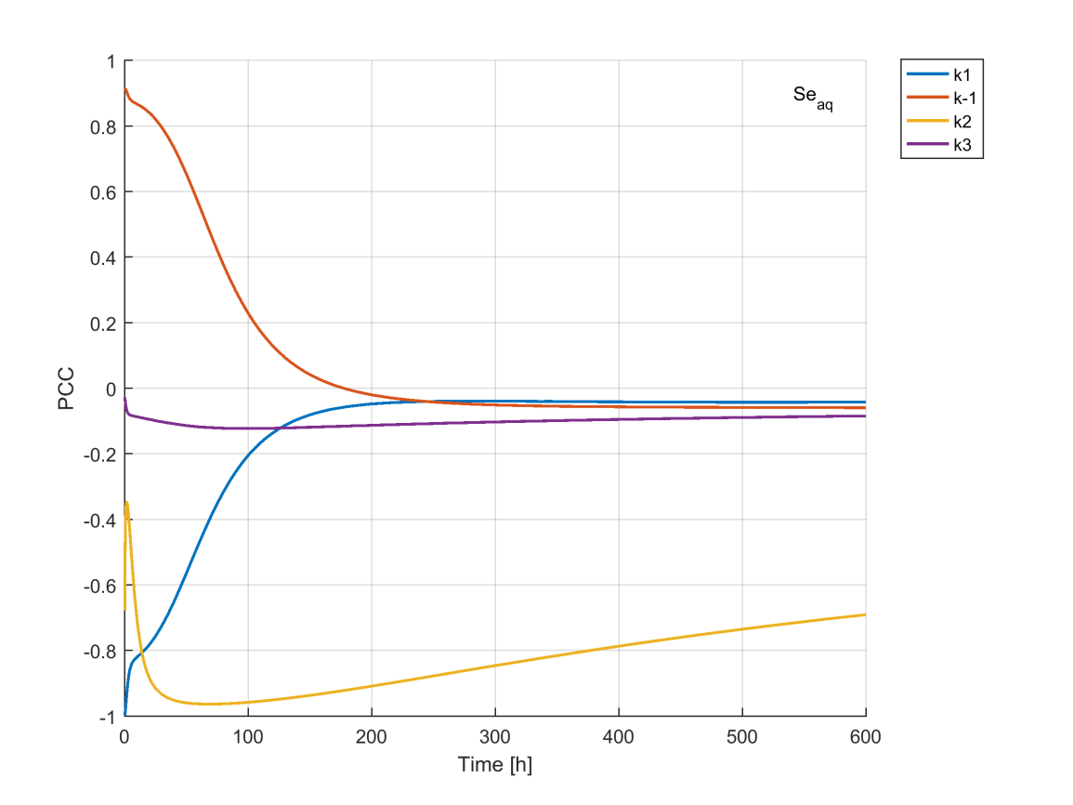

*Figure S.10. Partial correlation coefficients (PCC) of parameters k1, k-1, k2 and k3 for aqueous selenium plotted through time using parameter set 1.*

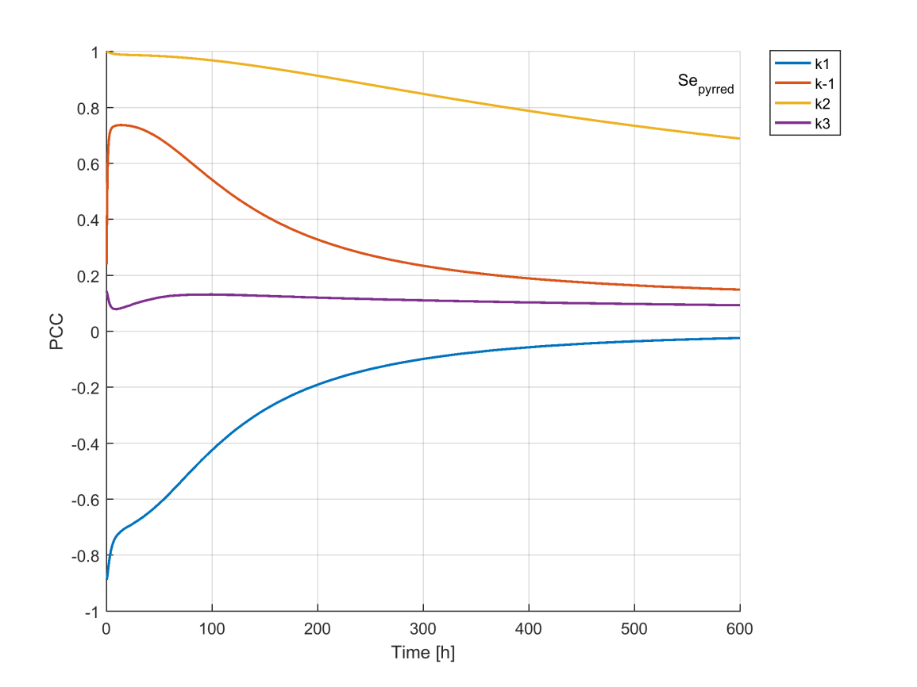

*Figure S.11. Partial correlation coefficients (PCC) of parameters k1, k-1, k2 and k3 for reduced Se on pyrite plotted through time using parameter set 1.*

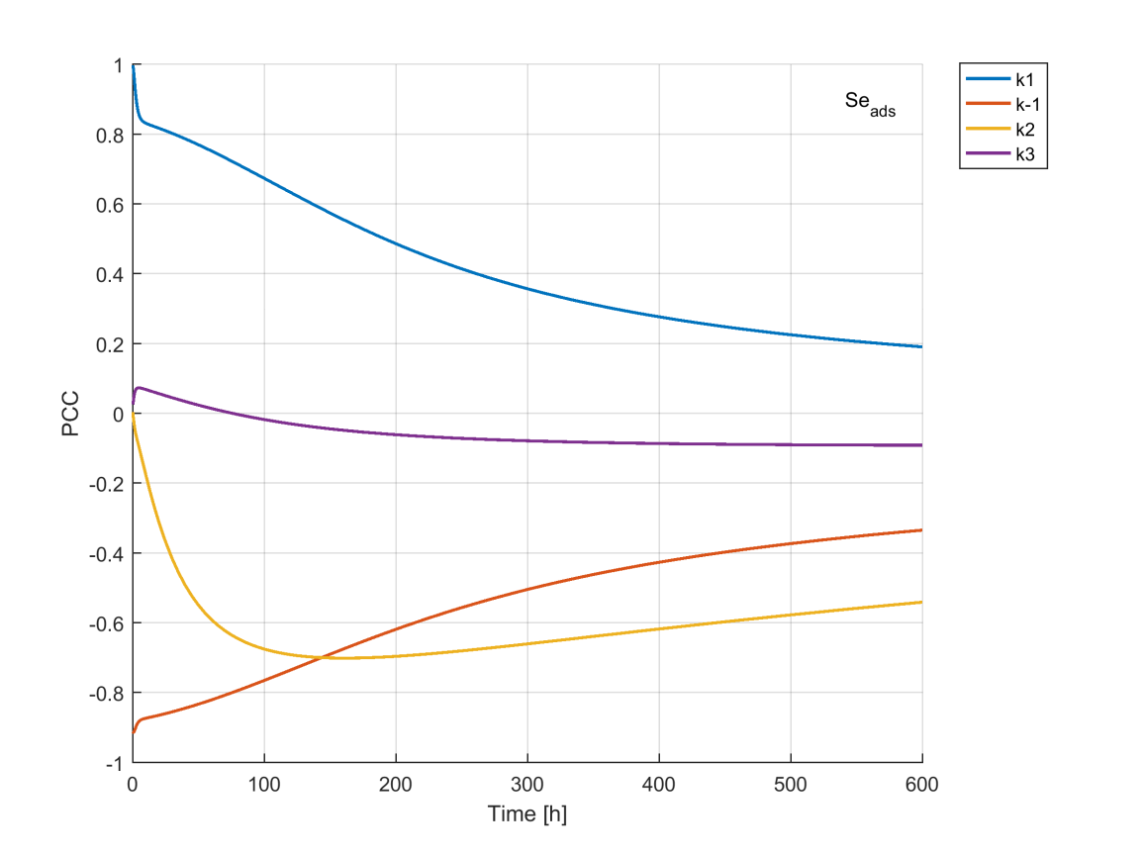

*Figure S.12 Partial correlation coefficients (PCC) of parameters k1, k-1, k2 and k3 for selenium adsorbed to clay minerals plotted through time using parameter set 1.*

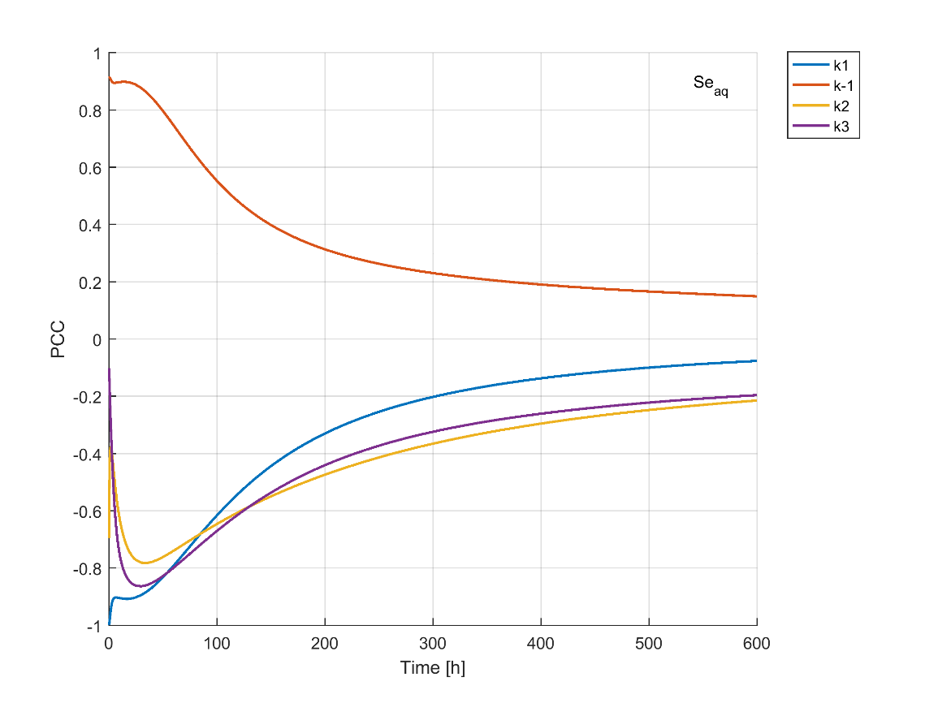

*Figure S.13 Partial correlation coefficients (PCC) of parameters k1, k-1, k2 and k3 for aqueous selenium plotted through time using parameter set 2.*

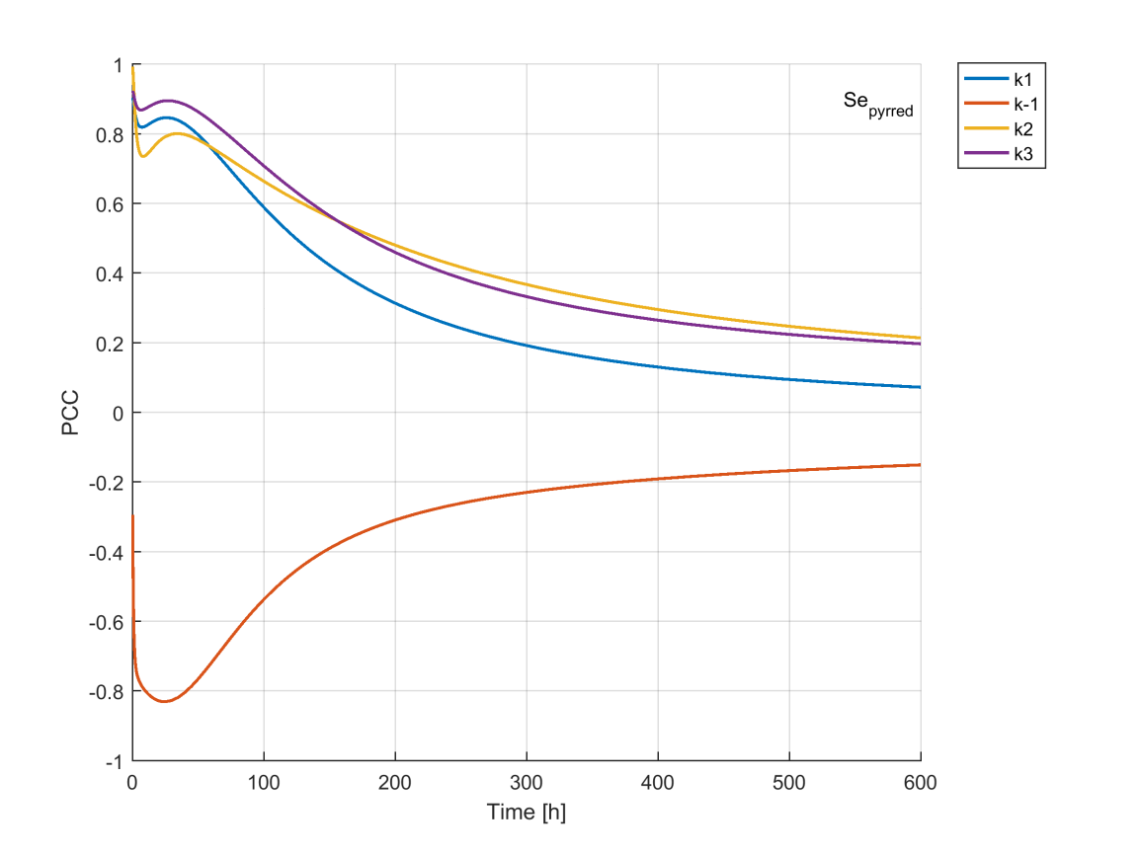

*Figure S.14. Partial correlation coefficients (PCC) of parameters k1, k-1, k2 and k3 for reduced Se on pyrite plotted through time using parameter set 2.*

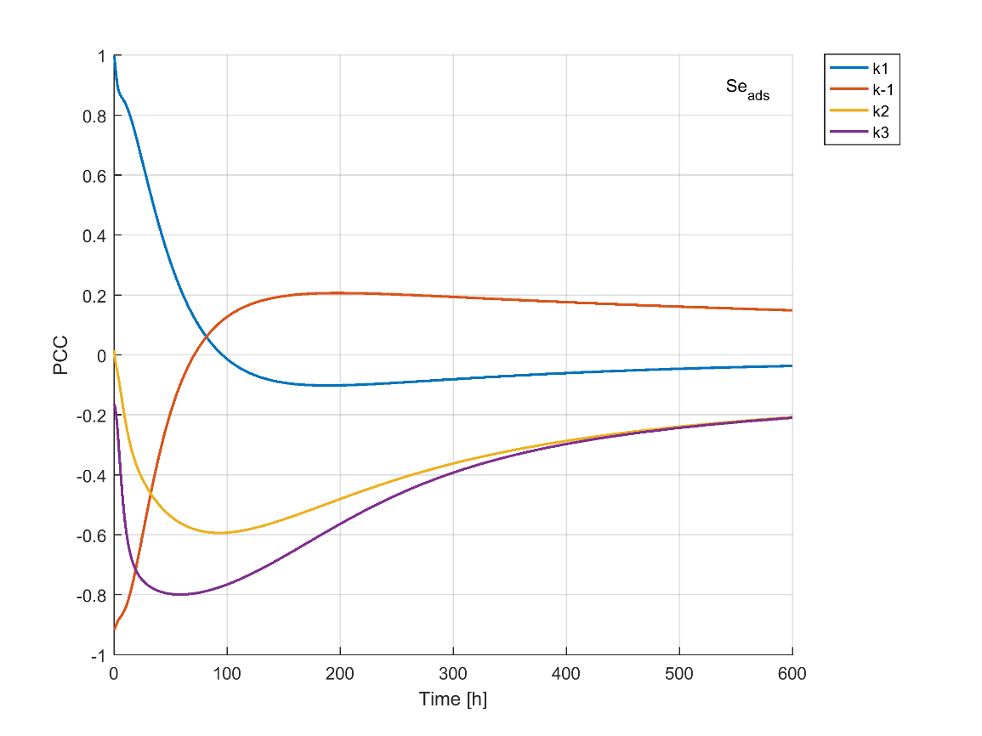

*Figure S.15. Partial correlation coefficients (PCC) of parameters k1, k-1, k2 and k3 for selenium adsorbed to clay minerals plotted through time using parameter set 2.*

**References**

Borsboom, M., Bras, W., et al. 1998. The Dutch-Belgian beamline at the ESRF. *Journal of Synchrotron Radiation*, **5**, 518–520, <https://doi.org/10.1107/S0909049597013484>.

Cherin, P., & Unger, P. 1972. Refinement of the crystal structure of α‐monoclinic Se. *Acta Crystallographica Section B*, *28*(1), 313-317.

Nikitenko, S., Beale, A.M., et al. 2008. Implementation of a combined SAXS/WAXS/QEXAFS set-up for time-resolved in situ experiments. *Journal of Synchrotron Radiation*, **15**, 632–640, https://doi.org/10.1107/S0909049508023327.

Ravel, B. & Newville, M. 2005. ATHENA, ARTEMIS, HEPHAESTUS: Data analysis for X-ray absorption spectroscopy using IFEFFIT. *Journal of Synchrotron Radiation*, **12**, 537–541, https://doi.org/10.1107/S0909049505012719.

Roßberg, A., Reich, T. & Bernhard, G. 2003. Complexation of uranium(VI) with protocatechuic acid-application of iterative transformation factor analysis to EXAFS spectroscopy. *Analytical and Bioanalytical Chemistry*, **376**, 631–638, https://doi.org/10.1007/s00216-003-1963-5.